Supplemental information:
Title: Surface modification of as-synthesized biochar-based polysulfone membranes for the adsorption and removal of disinfection by-products (DBPs) precursors.
Authors: Abelline Fionah¹, Kayla Daugherty², Nerissa Kiprotich³, and Isabel Escobar^{2*}
¹Department of Chemistry, University of Kentucky, Lexington, KY 40506, USA
²Department of Chemical and Materials Engineering, University of Kentucky, Lexington, KY 40506, USA
³Department of Human Health Sciences, University of Kentucky, Lexington, KY 40506, USA

*Corresponding Author: isabel.escobar@uky.edu

Table S1: BET surface area analysis of activated biochar activated with NaOH at various activator concentrations.
NaOH
Parameters | 2M | 4M | 8M
Single Point Surface Area (m²/g) | 1.82 | 1.94 | 0.41
BET Surface Area (m²/g) | 2.04 | 2.25 | 0.42
Langmuir Surface Area (m²/g) | 3.07 | 3.40 | 0.61
Micropore Area (m²/g) | 1.15 | 1.40 | 0.08
External Surface Area (m²/g) | 3.18 | 3.86 | 0.50
Micropore Volume (cm³/g) | 0.00 | 0.00 | 0.00
Average Pore Diameter (nm) | 7.94 | 9.53 | 10.31

Table S2: BET surface area analysis of activated biochar activated with H₂O₂ at varying activator concentrations.
H₂O₂
Parameters | 1% | 3% | 10%
Single Point Surface Area (m²/g) | 107.93 | 101.22 | 25.07
BET Surface Area (m²/g) | 105.50 | 97.58 | 25.44
Langmuir Surface Area (m²/g) | 135.76 | 127.12 | 34.56
Micropore Area (m²/g) | 98.49 | 91.69 | 6.23
External Surface Area (m²/g) | 7.02 | 5.90 | 19.20
Micropore Volume (cm³/g) | 0.05 | 0.05 | 0.01
Average Pore Diameter (nm) | 1.10 | 1.11 | 2.88

Table S3: BET surface area analysis of activated biochar activated with 8M NaOH at varying activation times.
Exposure time
Parameters | 2 Hrs. | 24 Hrs. | 72 Hrs.
Single Point Surface Area (m²/g) | 0.41 | 2.00 | 1.24
BET Surface Area (m²/g) | 0.42 | 2.21 | 1.27
Langmuir Surface Area (m²/g) | 0.61 | 3.25 | 2.72
Micropore Area (m²/g) | 0.08 | 3.25 | 3.15
External Surface Area (m²/g) | 0.50 | 3.23 | 3.37
Micropore Volume (cm³/g) | 0.00 | 0.00 | 0.00
Average Pore Diameter (nm) | 10.31 | 11.23 | 11.54

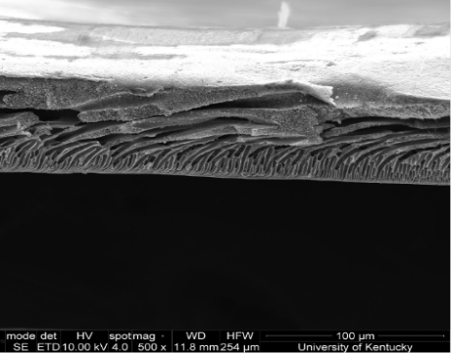
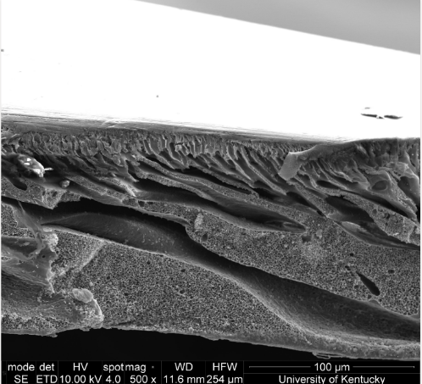
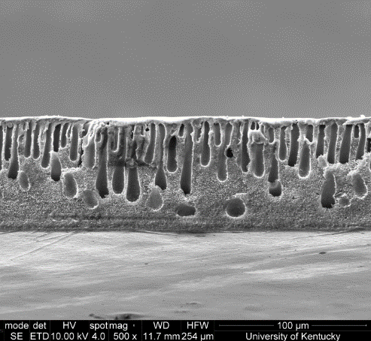
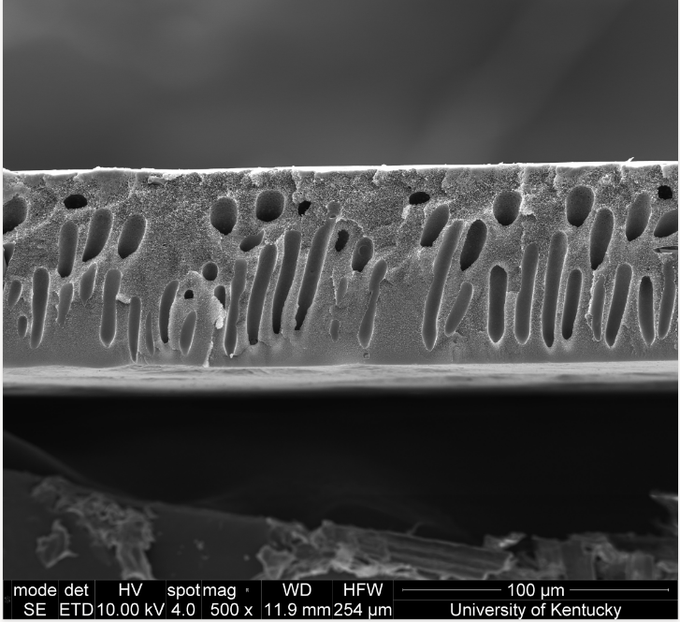
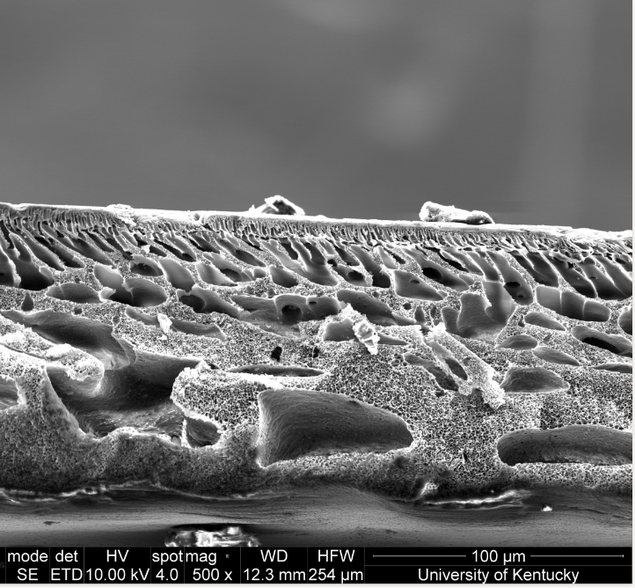
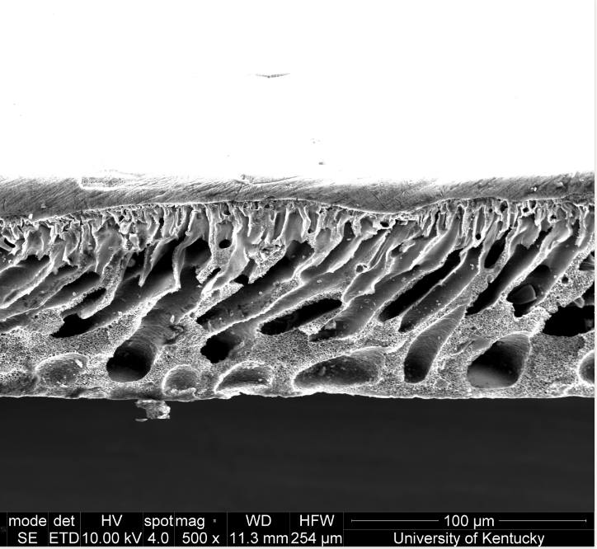
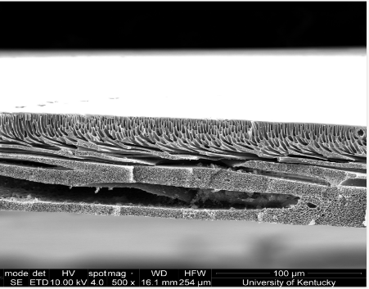
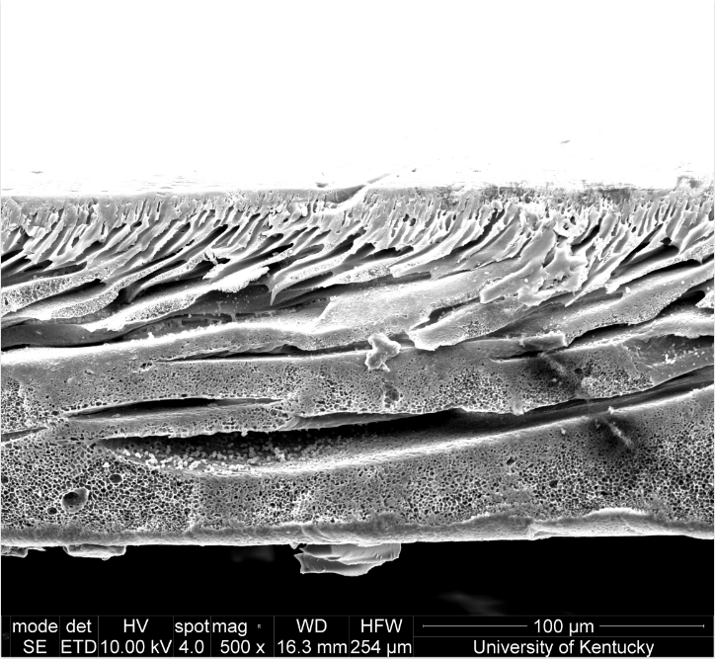
2 M NaOH
4 M NaOH
1% H₂O₂
^{3% H2O2}
10% H₂O₂
8 M NaOH
Figure S1: SEM cross-sectional images of PSf membranes with activated biochar additives activated with agents NaOH at 2M, 4M, and 8M as well as H₂O₂ at 1%, 3%, and 10% concentration in D, E, and F respectively concentrations.
A
E
D
B
F
C
8M Partial (24hrs)
8M 3 days (72hrs)
A B
Figure S2: SEM cross-sectional images of PSf membranes with additives of activated biochar activated with NaOH at varying activation times 24 hrs. in A and 72 hrs. in B.
Table S4: Porosity measurements of PSf membranes with additive biochar activated in activating agents NaOH (A) and H₂O₂ (B) at various concentrations.

NaOH A
Concentration (M) | Porosity (%) | +/- (%)
2 | 99.47 | 0.02
4 | 99.29 | 0.09
8 | 99.24 | 0.09
H₂O₂ B
Concentration (%) | Porosity (%) | +/- (%)
1 | 99.25 | 0.09
3 | 99.42 | 0.04
10 | 99.45 | 0.03
Table S5: Porosity measurements of PSf membranes with additives of activated biochar activated with NaOH at varying activation times.
8M NaOH exposure time
Time (hrs.) | Porosity (%) | +/- (%)
2 | 99.24 | 0.09
24 | 99.24 | 0.07
72 | 99.04 | 0.02

Table S6: Contact angle measurements to determine the wettability of PSf membranes with additive activated biochar, incorporated into them with biochar activated using activating agents NaOH and H₂O₂.

NaOH A
Concentration (M) | Contact Angle (°) | STD (°)
2 | 50.33 | 1.6
4 | 73.24 | 1.1
8 | 84.19 | 1
H₂O₂ B
Concentration (%) | Contact Angle (°) | STD (°)
1 | 65.92 | 0.6
3 | 78.51 | 0.4
10 | 82.58 | 1.1

Table S7: Contact angle measurements to determine the wettability of PSf membranes with additive activated biochar, with the biochar activated with 8M NaOH at various exposure times.
8M NaOH exposure time
Time (hrs.) | Contact Angle (°) | STD (°)
2 | 84.19 | 1
24 | 53.36 | 0.6
72 | 46.67 | 0.4

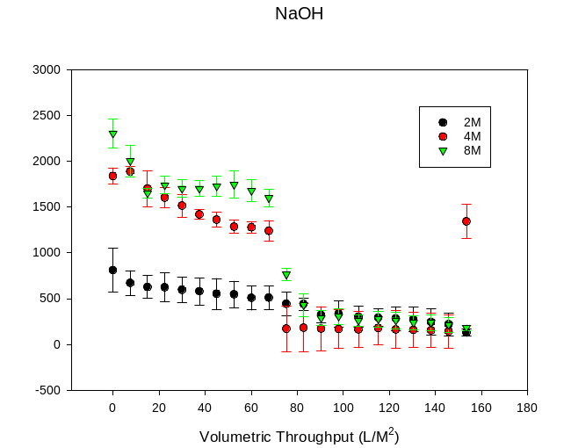
Figure S3: Graph comparing the performance of PSf membranes synthesized with additives activated biochar, with biochar activated in NaOH solutions at various concentrations.
Table S8: Rejection percentages of Humic Acid from membranes incorporated with activated biochar into them with biochar activated with NaOH at various concentrations.

NaOH
Concentration (M) | Rejection (%) | +/-(%)
2 | 56.9 | 3.0
4 | 68.2 | 4.8
8 | 73.5 | 4.8

H₂O₂
Concentration (%) | Rejection (%) | +/- (mg/L)
1 | 92.4 | 0.5
3 | 68.5 | 3.5
10 | 51.6 | 3.3
8M NaOH exposure time
Time (hrs.) | Rejection (%) | +/- (mg/L)
2 | 73.8 | 4.4
24 | 73.4 | 4.8
72 | 73.1 | 1.6
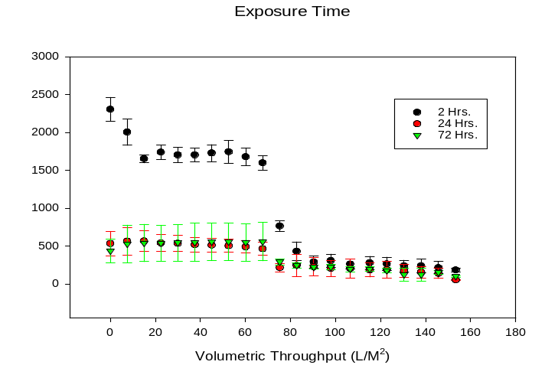
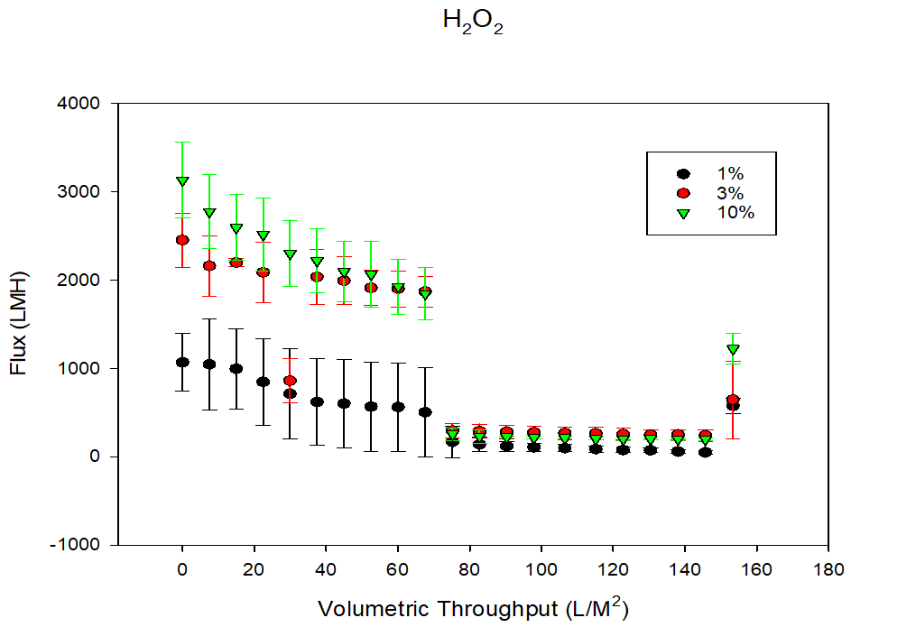
Figure S5: Graph comparing the performance of PSf membranes synthesized with additives activated biochar, with biochar activated in NaOH solutions at various activation times.
Table S10: Rejection percentages of Humic Acid from membranes incorporated with additives activated biochar into them with biochar activated at various 8M NaOH activation times.

Figure S4: Graph comparing the performance of PSf membranes synthesized with additive activated biochar, with biochar activated in H₂O₂ solutions at various concentrations.
Table S9: Rejection percentages of Humic Acid from membranes incorporated with additive activated biochar activated in H₂O₂ solutions at various concentrations.

