Supporting Information

Analysis of Chemical Exchange in Iridium N-Heterocyclic Carbene Complexes Using Heteronuclear Parahydrogen-Enhanced NMR

Charbel D. Assaf^{[a]*}, Xin Gui^{[b]}, Oleg G. Salnikov^{[c]}, Arne Brahms^{[d]}, Nikita V. Chukanov^{[c]}, Ivan V. Skovpin^{[c]}, Eduard Y. Chekmenev^{[e]}, Rainer Herges^{[d]}, Simon B. Duckett^{[f]}, Igor V. Koptyug^{[c]}, Kai Buckenmaier^{[g]}, Rainer Körber^{[h]}, Markus Plaumann^{[i]}, Jan-Bernd Hövener^{[a]}, Alexander Auer^{[b]}, Andrey N. Pravdivtsev^{[a]*}
[a] Section Biomedical Imaging, Molecular Imaging North Competence Center (MOIN CC), Department of Radiology and Neuroradiology, University Medical Center Kiel, Kiel University, Am Botanischen Garten 14, 24118, Kiel, Germany
[b] Max-Planck-Institut für Kohlenforschung, Kaiser-Wilhelm-Platz 1, 45470 Mülheim an der Ruhr
[c] International Tomography Center SB RAS, 3A Institutskaya St., 630090 Novosibirsk, Russia
[d] Otto Diels Institute for Organic Chemistry, Kiel University, Otto- Hahn Platz 4, 24118 Kiel, Germany
[e] Department of Chemistry, Integrative Biosciences (Ibio), Karmanos Cancer Institute (KCI), Wayne State University, Detroit, MI 48202, United States
[f] Centre for Hyperpolarization in Magnetic Resonance (CHyM), University of York, Heslington YO10 5NY, UK
[g] High-Field Magnetic Resonance Center, Max Planck Institute for Biological Cybernetics, Max-Planck-Ring 11, 72076 Tübingen, Germany
[h] Physikalisch-Technische Bundesanstalt (PTB), Abbestraße 2-12, 10587 Berlin, Germany
[i] Otto-von-Guericke-University Magdeburg Institute for Molecular Biology and Medicinal Chemistry, Leipziger Str. 44, 39120 Magdeburg, Germany

Contents
Calibration of variable temperature NMR unit S-3
Signal enhancement and polarization calculations S-4
Weighted mean k_{d} S-4
Fitting of exchange rate constants as a function of temperature S-5
¹⁵N chemical shifts of ligands and comparison of ESOTHERIC and phINEPT+ SOT performance S-6
Exchange rate constants measured with SABRE-ESOTHERIC S-7
Comparison of exchange rate constants with literature data S-13
Enthalpies and entropies of activation S-14
Analysis of SABRE complexes with metronidazole S-16
Quantum chemical calculations S-19
References S-21

Calibration of variable temperature NMR unit
We calibrated the variable temperature unit (VTU) of NMR spectrometer using a common method of observing the chemical shift separation Δ between the OH and CH₃ resonances of methanol. We prepared 600 µL of 4:96 mixture of isotopically unlabelled methanol and methanol-d₄ and measured its ¹H NMR spectra at different temperatures. Then we used the following two equations to calculate the actual temperature of the sample as in the Bruker Instruments Manual for VT-Calibration:
- For values between 230 – 270 K:
T = (3.92 – Δ)/0.008 (Eq. S1)
- For more accurate values between 270 – 300 K we used this equation:
T = (4.109 – Δ)/0.008708 (Eq. S2)

Table S1. The nominal NMR temperature set by the user and the calibrated temperature using Eqs. S1 and S2. Additionally, we showed the relative deviation between the calibrated and the nominal temperatures.
Nominal NMR T (K) | Calibrated T (K) | Deviation (%)
260 | 257.6 | –0.92
262.5 | 260.3 | –0.84
267 | 265.2 | –0.67
270 | 268.4 | –0.059
273 | 272 | –0.37
275 | 273.84 | –0.44
277 | 276 | –0.36
280 | 279.3 | –0.25
283 | 282.5 | –0.18
288 | 287.9 | –0.035
293 | 293.4 | +0.14

Signal enhancement and polarization calculations
Signal enhancement
The enhancement factor$ε$ of equatorial substrates was calculated using the signal intensities of the spectra of thermally polarized and hyperpolarized solutions, considering the differences in acquisition parameters. The signal intensities of the free and equatorial-bound substrate in the proton spectrum were used to assess the ratio of concentrations of these two forms in a case when the equatorial substrate peak in the thermal ¹⁵N spectra was negligible compared to the noise level. The following formula was used
$ε=\frac{{}_{ }^{15N}{I_{e}^{HP} }}{{}_{ }^{15N}{I_{f}^{TP}}}×\frac{{}_{ }^{1H}{I_{f}^{TP}}}{{}_{ }^{1H}{I_{e}^{TP}}}×\frac{sin⁡(α_{TP})}{sin⁡(α_{HP})}×\frac{{RG}_{TP}}{{RG}_{HP}}×\frac{{NS}_{TP}}{{NS}_{HP}}$ (Eq. S3)
where ${}_{ }^{15N}{I_{e}^{HP}}$ is the ¹⁵N integral of the hyperpolarized equatorial-bound substrate, ${}_{ }^{15N}{I_{f}^{TP}}$ is the ¹⁵N integral of the thermally polarized free substrate, ${}_{ }^{1H}{I_{f}^{TP}}$ is the ¹H integral of the free substrate at thermal equilibrium, ${}_{ }^{1H}{I_{e}^{TP}}$ is the ¹H integral of the equatorial-bound substrate at thermal equilibrium. NS_{TP} and NS_{HP} are the numbers of scans for the thermally polarized and hyperpolarized samples, and α_{TP} and α_{HP} are the excitation flip angles of RF pulses used to acquire the corresponding spectra. RG_{TP} and RG_{HP} are values of linear receiver gain.
Polarization
To compare the enhancements at 9.4 T more easily, the enhancement factors ε were converted to a polarization level, P, using Eq. S2, where, γ is the gyromagnetic ratio, B₀ is the detection field, T is the temperature, ħ is the reduced Planck’s constant, and k_{B} is Boltzmann’s constant.
$P= ε\frac{γB_{0}ħ}{2 k_{B}T}$ (Eq. S4)

Weighted mean k_{d}
We computed the weighted mean k_{d} values considering the uncertainties associated with three distinct measurements. This approach allowed us to account for our dataset's varying uncertainty levels. Subsequently, we derived the combined standard deviation of the weighted mean k_{d}, providing an overall variability in our data.
If values are $x_{i}$, and the corresponding standard deviations are $s_{xi}$, then the combined standard deviation is
$$s_{\overline{x}}=\frac{1}{\sqrt{\left(\sum_{i}{\frac{1}{s_{xi}^{2}}}\right)}}$$
(Eq. S5)
And the corresponding weighted mean is:
$$\overline{x}=\left(\sum_{i}{\frac{x_{i}}{s_{xi}^{2}}}\right)s_{\overline{x}}^{2}$$
(Eq. S6)

Fitting of exchange rate constants as a function of temperature
We estimated the entropy and enthalpy of activation using the Eyring equation in the form
$k_{d}=\frac{k_{B}T}{h}\exp\left(\frac{ΔS^{‡}}{R}-\frac{ΔH^{‡}}{RT}\right)$ (Eq. S7)
which is convenient to fit with a linear function when modified as follows:
$R ln\left(\frac{k_{d}∙h}{k_{B}∙T}\right)= -{ΔH}^{‡}\left(\frac{1}{T}\right)+{ΔS}^{‡}$ (Eq. S8)

¹⁵N chemical shifts of ligands and comparison of ESOTHERIC and phINEPT+ SOT performance

Table S2. ¹⁵N Chemical shifts for the bound and free substrates ¹⁵N-Py, ¹⁵N-4AP, ¹⁵N-NAM, ¹⁵N-ACN, and ¹⁵N₃-MNZ. The third column is the ratio of the maximal polarizations obtained with ESOTHERIC and phINEPT+ at optimal conditions and 288 K for all substrates except ¹⁵N₃-MNZ (and at 267 K for ¹⁵N₃-MNZ).
¹⁵N Chemical  Substrate shift | Bound substrate (ppm) | Free substrate (ppm) | $$\frac{P_{ESOTHERIC}^{max}}{P_{phINEPT+}^{max}}$$
[¹⁵N]pyridine | 256 | 300 | 1.08
4-amino[¹⁵N]pyridine | 215 | 256 | 1.38
[¹⁵N]nicotinamide | 256 | 302 | 1.3
[¹⁵N]acetonitrile | 179.5 | 240 | 1.28
[¹⁵N₃]metronidazole | 203.1 | 247.3 | 1.14

Exchange rate constants measured with SABRE-ESOTHERIC
All measured SABRE-ESOTHERIC kinetics and biexponential fittings are presented in Figures S1-S5. The resulting fitting parameters are provided in Table S3.
Table S3. Modeled substrate dissociation rate constants using SABRE-ESOTHERIC data and two exchange models (C_{S}S₂↔C_{S}S+S and C_{S}S₂↔S₂)¹⁰ for ¹⁵N-Py, ¹⁵N-4AP, ¹⁵N-NAM, ¹⁵N-ACN, and ¹⁵N₃-MNZ. Dissociation rate constants measured in the previous work using SEXSY experiments¹⁰ are presented for comparison (marked with asterisks). Error intervals are standard deviation values for the given variables obtained from fitting using MATLAB nonlinear regression function “nlinfit”. Weighted mean k_{d} values were calculated using Eq. S6. Note that for ¹⁵N₃-MNZ we considered total dissociation flux, which fit well only using biexponential fitting; therefore, other fields are left empty.
Substrate  (pH after bubbling) | Calibrated  T (K) | $$K=\frac{k_{d}}{k_{a}^{'}}=\frac{[S]}{[C_{S}S_{2}]}$$ | Model C_{S}S₂↔C_{S}S+S | Model  C_{S}S₂↔S₂ | Model C_{S}S₂↔S₂:  Eigenvalues analysis  (biexponential fitting) |  |  | Weighted mean  k_{d} (s⁻¹)
Substrate  (pH after bubbling) | Calibrated  T (K) | $$K=\frac{k_{d}}{k_{a}^{'}}=\frac{[S]}{[C_{S}S_{2}]}$$ | k_{d} (s⁻¹) | k_{d} (s⁻¹) | k (s⁻¹) | R (s⁻¹) | k_{d} (s⁻¹) from k | Weighted mean  k_{d} (s⁻¹)
¹⁵N-Py | 279.3 | 7.22  7.46* | 4.0 ± 0.4  1.9 ± 0.1* | 4.1 ± 0.5  1.7 ± 0.1* | 1.71 ± 0.05  1.55 ± 0.06* | 0.061 ± 0.001  0.15 ± 0.02* | 2.7 ± 0.1  2.4 ± 0.1* | 3.6 ± 0.3  1.8 ± 0.1*
¹⁵N-Py | 282.5 | 9.4  8.61* | 6.1 ± 0.5  3.4 ± 0.1* | 6.4 ± 0.8  3.0 ± 0.1* | 2.4 ± 0.1  2.6 ± 0.2* | 0.061 ± 0.001  0.10 ± 0.06* | 4.0 ± 0.2  4.2 ± 0.3* | 5.5 ± 0.5  3.1 ± 0.2*
¹⁵N-Py | 287.9 | 8.15  9.72* | 9.8 ± 0.8  7.6 ± 0.2* | 11 ± 1  6.4 ± 0.3* | 4.9 ± 0.3  4.6 ± 0.2* | 0.055 ± 0.002  0.08 ± 0.03* | 7.9 ± 0.4  7.7 ± 0.4 | 9.6 ± 0.7  6.3 ± 0.3
¹⁵N-Py | 293.4 | 6.7  15.82* | 17 ± 3  14.9 ± 0.9* | 21 ± 3  10.5 ± 0.8* | 8.5 ± 0.4  8.0 ± 0.6* | 0.054 ± 0.004  0.18 ± 0.06* | 13.2 ± 0.7  14 ± 1* | 17.1 ± 1.9  11.4 ± 0.9*
¹⁵N-4AP | 279.3 | 19.8  21.86* | 1.6 ± 0.1  0.80 ± 0.04* | 1.6 ± 0.1  0.90 ± 0.04* | 0.71 ± 0.02  0.82 ± 0.01* | 0.031 ± 0.001  0.08 ± 0.01* | 1.31 ± 0.04  1.51 ± 0.03* | 1.50 ± 0.08  0.97 ± 0.04*
¹⁵N-4AP | 282.5 | 19.3  20.83* | 2.1 ± 0.1  1.4 ± 0.1* | 2.2 ± 0.1  1.7 ± 0.1* | 1.12 ± 0.02  1.09 ± 0.03* | 0.028 ± 0.001  0.09 ± 0.01* | 1.99 ± 0.03  1.99 ± 0.05* | 2.11 ± 0.06  1.52 ± 0.09*
¹⁵N-4AP | 287.9 | 20.1  22.48* | 3.8 ± 0.1  3.6 ± 0.1* | 3.8 ± 0.1  3.6 ± 0.1* | 2.02 ± 0.03  2.01 ± 0.09* | 0.033 ± 0.001  0.09 ± 0.01* | 3.68 ± 0.06  3.7 ± 0.2* | 3.8 ± 0.1  3.2 ± 0.1*
¹⁵N-4AP | 293.4 | 21.3  23.85* | 6.7 ± 0.3  5.5 ± 0.6* | 6.7 ± 0.3  8 ± 3* | 3.47 ± 0.08  2.9 ± 0.5* | 0.034 ± 0.006  0.10 ± 0.02* | 6.4 ± 0.1  5.4 ± 0.8* | 6.6 ± 0.3  6 ± 1*
¹⁵N-NAM | 279.3 | 11.7  23.48* | 2.4 ± 0.3  1.5 ± 0.1* | 2.3 ± 0.4  1.3 ± 0.1* | 0.96 ± 0.07  1.20 ± 0.06* | 0.08 ± 0.01  0.16 ± 0.01* | 1.6 ± 0.1  2.2 ± 0.1* | 2.1 ± 0.3  1.40 ± 0.09*
¹⁵N-NAM | 282.5 | 14.3  24.25* | 3.0 ± 0.4  2.1 ± 0.1* | 3.8 ± 0.6  2.1 ± 0.1* | 1.4 ± 0.1  1.62 ± 0.09* | 0.08 ± 0.01  0.15 ± 0.01* | 2.4 ± 0.2  3.0 ± 0.2* | 3.1 ± 0.4  2.0 ± 0.1*
¹⁵N-NAM | 287.9 | 10.56  24.92* | 5.1 ± 0.2  3.5 ± 0.2* | 5.1 ± 0.2  5.8 ± 0.6* | 2.72 ± 0.07  1.73 ± 0.09* | 0.078 ± 0.005  0.16 ± 0.01* | 4.6± 0.1  3.2 ± 0.2* | 4.9 ± 0.2  3.7 ± 0.3*
¹⁵N-NAM | 293.4 | 12.24  26.37* | 10.0 ± 0.3  6.3 ± 0.4* | 10.0 ± 0.3  9.9 ± 0.8* | 4.63 ± 0.07  4.1 ± 0.3* | 0.085 ± 0.006  0.12 ± 0.01* | 8.0 ± 0.1  7.6 ± 0.6* | 9.3 ± 0.2  7.4 ± 0.6*
¹⁵N-ACN | 260.3 | 7.68 | 2.0 ± 0.1 | 2.0 ± 0.1 | 0.98 ± 0.04 | 0.042 ± 0.001 | 1.55 ± 0.06 | 1.9 ± 0.1
¹⁵N-ACN | 265.2 | 7.68 | 3.5 ± 0.2 | 3.5 ± 0.2 | 1.70 ± 0.05 | 0.036 ± 0.002 | 2.68 ± 0.07 | 3.2 ± 0.2
¹⁵N-ACN | 268.4 | 7.68 | 5.4 ± 0.2 | 5.4 ± 0.2 | 2.6 ± 0.1 | 0.034 ± 0.001 | 4.1 ± 0.2 | 5.0 ± 0.2
¹⁵N-ACN | 272 | 7.68 | 8.4 ± 0.4 | 8.4 ± 0.4 | 3.9 ± 0.2 | 0.037 ± 0.001 | 6.1 ± 0.3 | 7.7 ± 0.4
¹⁵N-ACN | 279.3 | 14.6 | 16.5 ± 0.4 | 16.5 ± 0.4 | 7.8 ± 0.1 | 0.023 ± 0.001 | 13.7 ± 0.2 | 15.6 ± 0.3
¹⁵N-ACN | 282.5 | 14.6 | 22.8 ± 0.5 | 23.8 ± 0.4 | 11.5 ± 0.2 | 0.019 ± 0.001 | 20.3 ± 0.3 | 22.3 ± 0.4
¹⁵N-ACN | 287.9 | 14.6 | 45.5 ± 0.9 | 45.6 ± 0.9 | 22.3 ± 0.5 | 0.028 ± 0.002 | 39.4 ± 0.8 | 43.4 ± 0.9
¹⁵N-ACN | 293.4 | 14.6 | 58 ± 2 | 60 ± 2 | 45 ± 2 | 0.047 ± 0.004 | 80 ± 3 | 66 ± 2
¹⁵N₃-MNZ | 257.6 | 6.64 |  |  | 0.67 ± 0.04 | 0.08 ± 0.01 | 1.03 ± 0.05
¹⁵N₃-MNZ | 260.3 | 6.64 |  |  | 0.94 ± 0.02 | 0.067 ± 0.003 | 1.45 ± 0.03
¹⁵N₃-MNZ | 265.2 | 6.64 |  |  | 1.40 ± 0.02 | 0.064 ± 0.002 | 2.16 ± 0.03
¹⁵N₃-MNZ | 268.4 | 6.64 |  |  | 1.99 ± 0.03 | 0.062 ± 0.001 | 3.06 ± 0.04
¹⁵N₃-MNZ | 272 | 6.64 |  |  | 2.82 ± 0.06 | 0.061 ± 0.001 | 4.3 ± 0.1
¹⁵N₃-MNZ | 273.84 | 6.64 |  |  | 3.6 ± 0.1 | 0.063 ± 0.002 | 5.6 ± 0.2
¹⁵N₃-MNZ | 276 | 6.64 |  |  | 4.69 ± 0.07 | 0.055 ± 0.001 | 7.2 ± 0.1
¹⁵N₃-MNZ | 279.3 | 6.64 |  |  | 6.9 ± 0.1 | 0.051 ± 0.001 | 10.7 ± 0.2
¹⁵N₃-MNZ | 282.5 | 6.64 |  |  | 9.8 ± 0.2 | 0.048 ± 0.001 | 15.1 ± 0.3
¹⁵N₃-MNZ | 286.8 | 6.64 |  |  | 15.5 ± 0.4 | 0.041 ± 0.001 | 23.8 ± 0.6

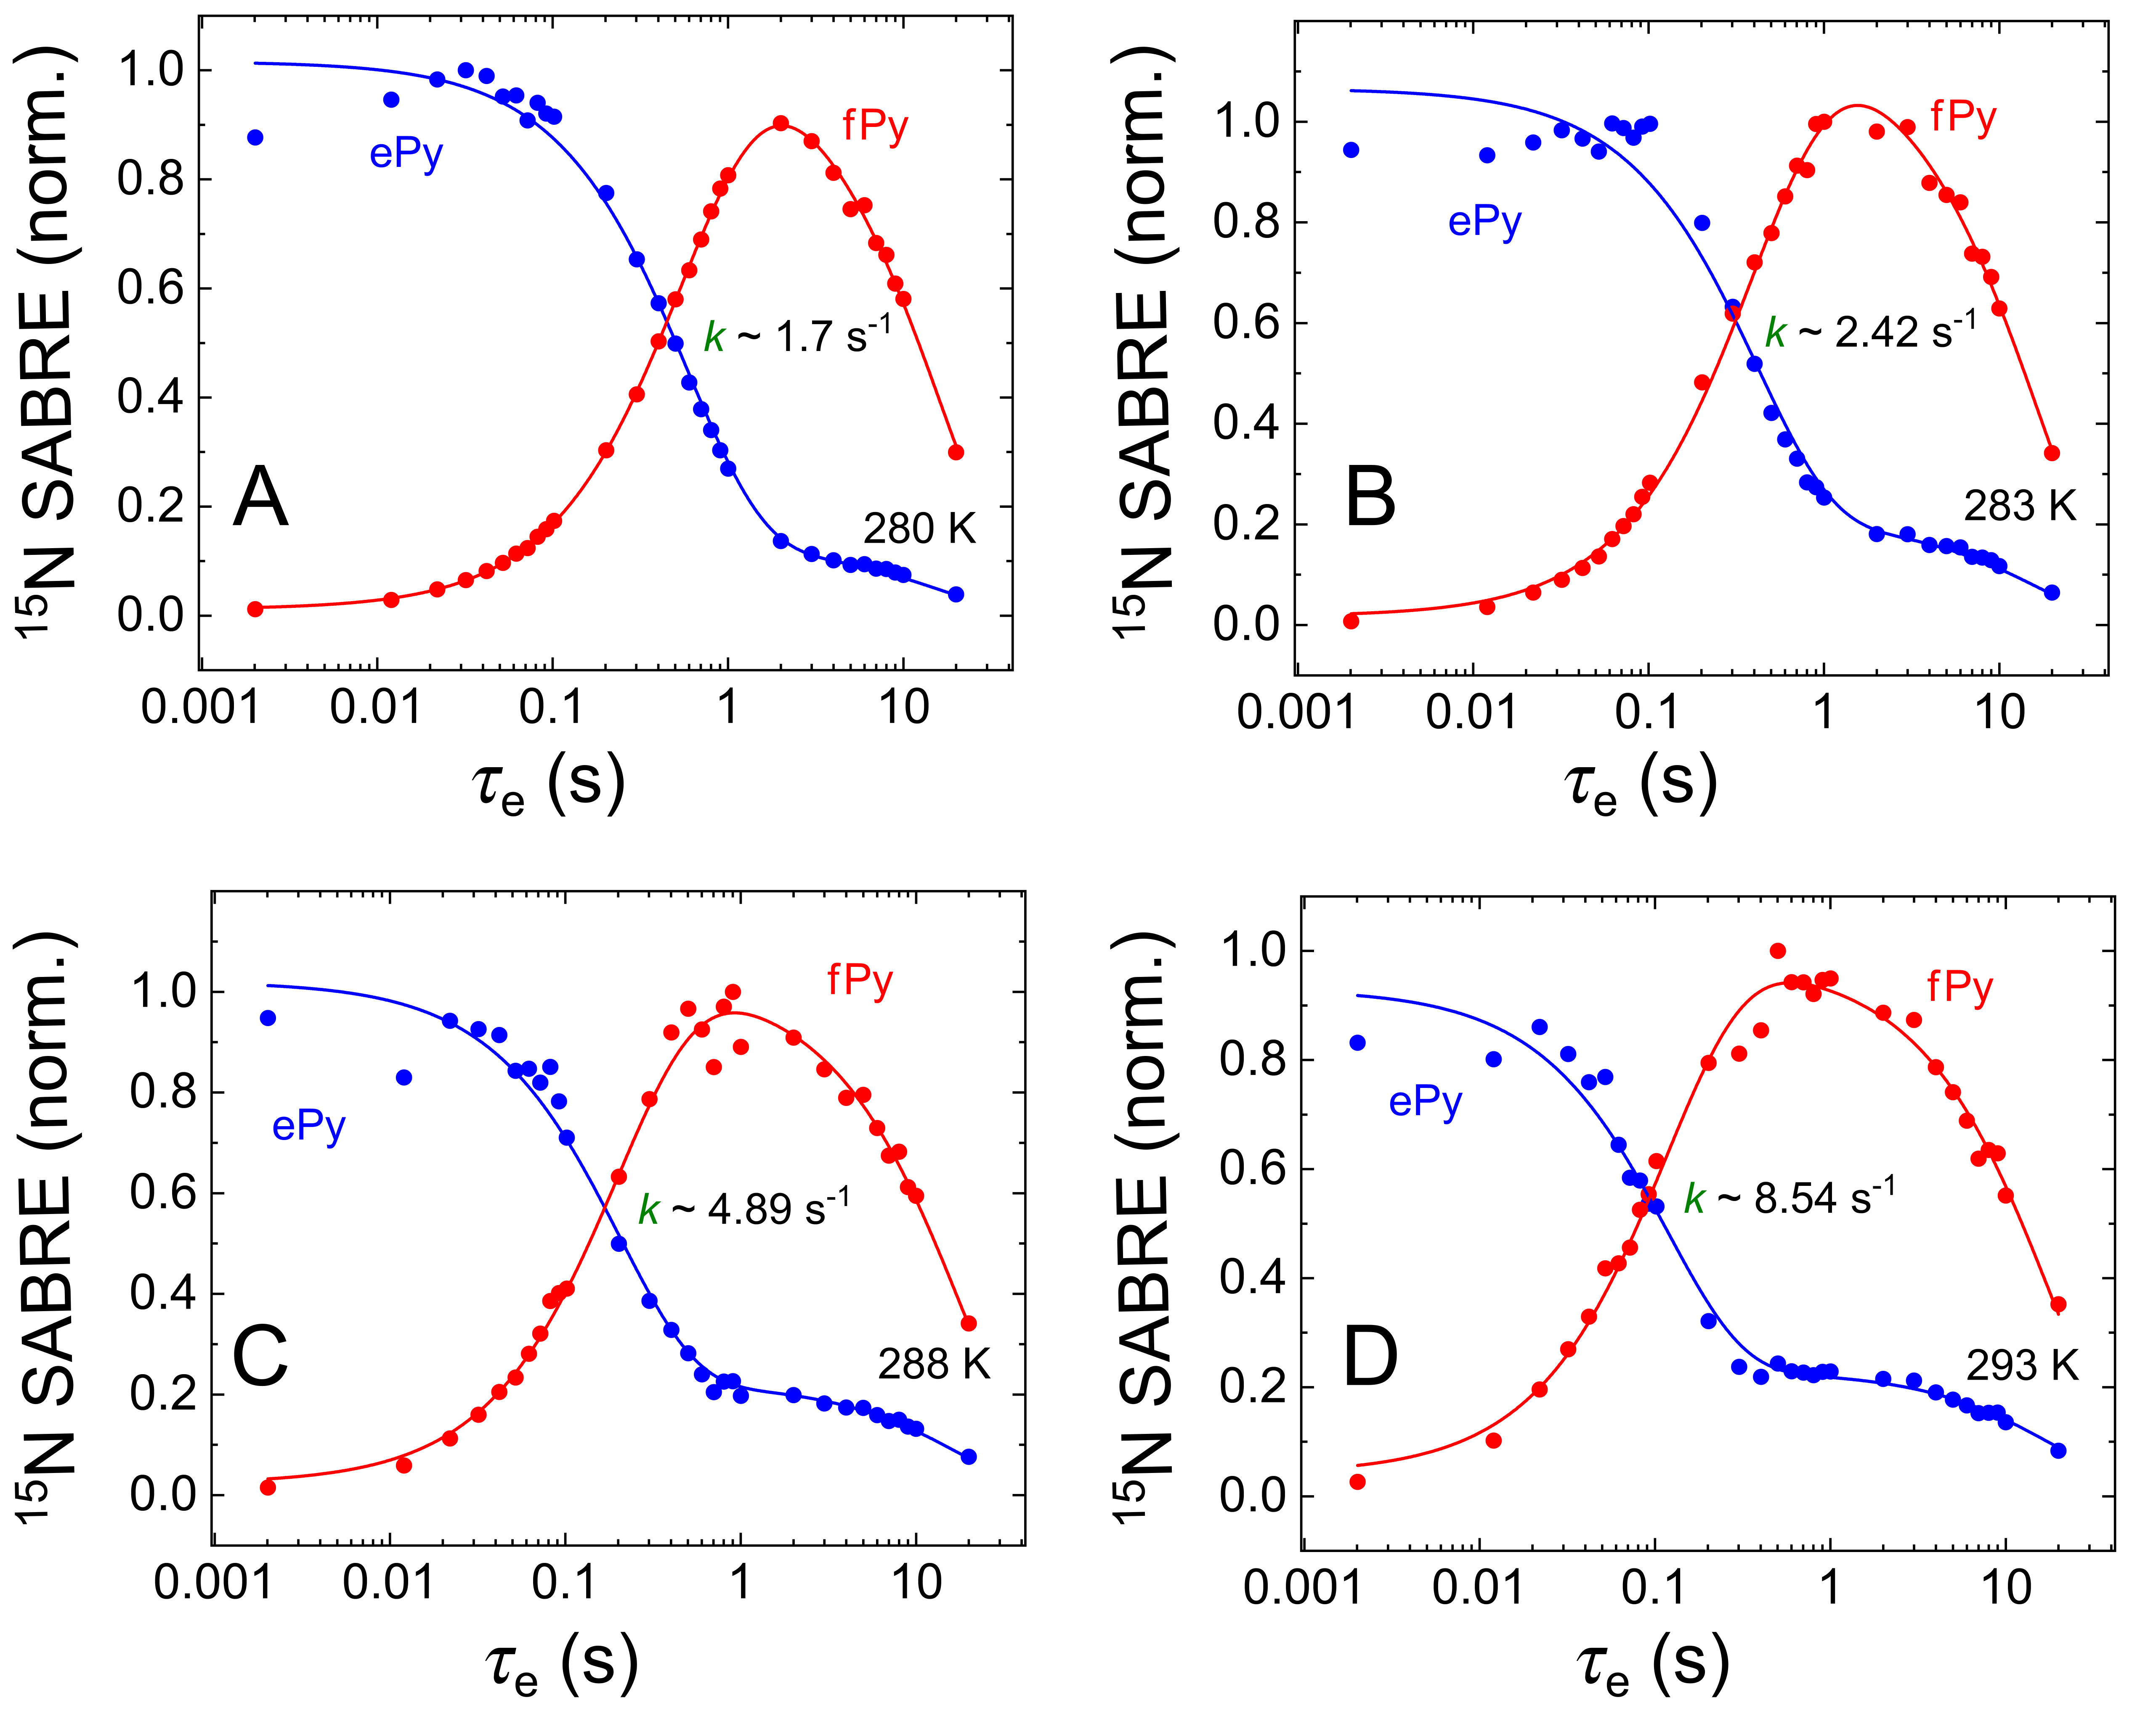
Figure S1. Dependences of the SABRE ESOTHERIC-enhanced ¹⁵N NMR signals of ¹⁵N-ePy (blue) and ¹⁵N-fPy (red) on the inter-pulse delay τ_{e} with τ₁ = 7 ms and τ₂ = 6 ms at the nominal temperatures of 280 K (A), 283 K (B), 288 K (C), and 293 K (D). The curves are fitted using biexponential global fit. Estimated exchange rate constants are given in Table S3.
Figure S2. Dependences of the SABRE ESOTHERIC-enhanced ¹⁵N NMR signals of ¹⁵N-e4AP (blue) and ¹⁵N-f4AP (red) on the inter-pulse delay τ_{e} with τ₁ = 7 ms and τ₂ = 5 ms at the nominal temperatures of 280 K (A), 283 K (B), 288 K (C), and 293 K (D). The curves are fitted using biexponential global fit. Estimated exchange rate constants are given in Table S3.
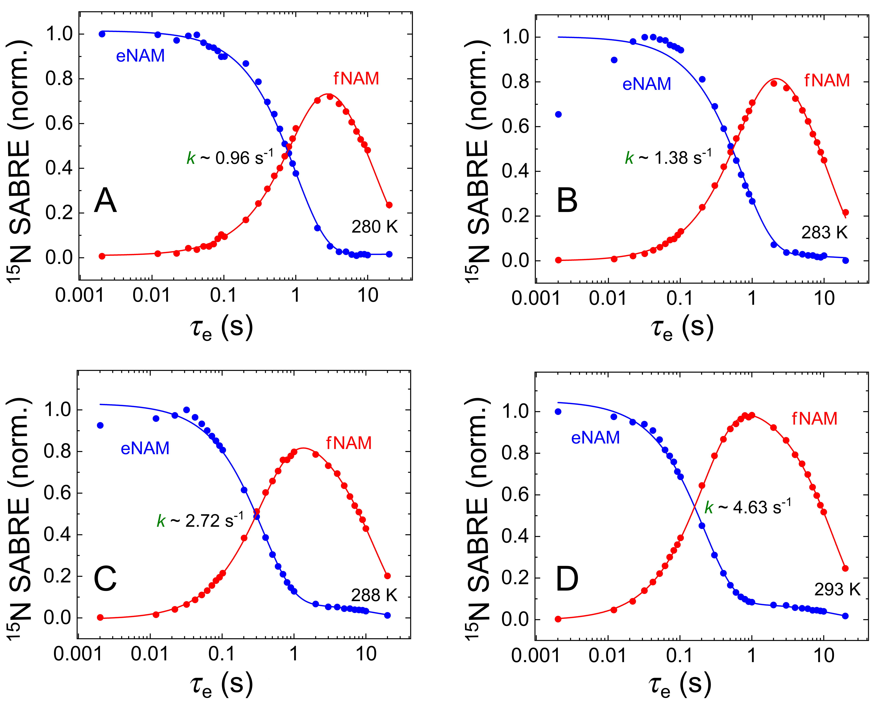
Figure S3. Dependences of the SABRE ESOTHERIC-enhanced ¹⁵N NMR signals of ¹⁵N-eNAM (blue) and ¹⁵N-fNAM (red) on the inter-pulse delay τ_{e} with τ₁ = 7 ms and τ₂ = 5 ms at the nominal temperatures of 280 K (A), 283 K (B), 288 K (C), and 293 K (D). The curves are fitted using biexponential global fit. Estimated exchange rate constants are given in Table S3.
Figure S4. Dependences of the SABRE ESOTHERIC-enhanced ¹⁵N NMR signals of ¹⁵N-eACN (blue) and ¹⁵N-fACN (red) on the inter-pulse delay τ_{e} with τ₁ = 5 ms and τ₂ = 4 ms at the nominal temperatures of 262.5 K (A), 267 K (B), 270 K (C), 273 K (D), 280 K (E), 283 K (F), 288 K (G), and 293 K (H). The curves are fitted using biexponential global fit. Estimated exchange rate constants are given in Table S3.
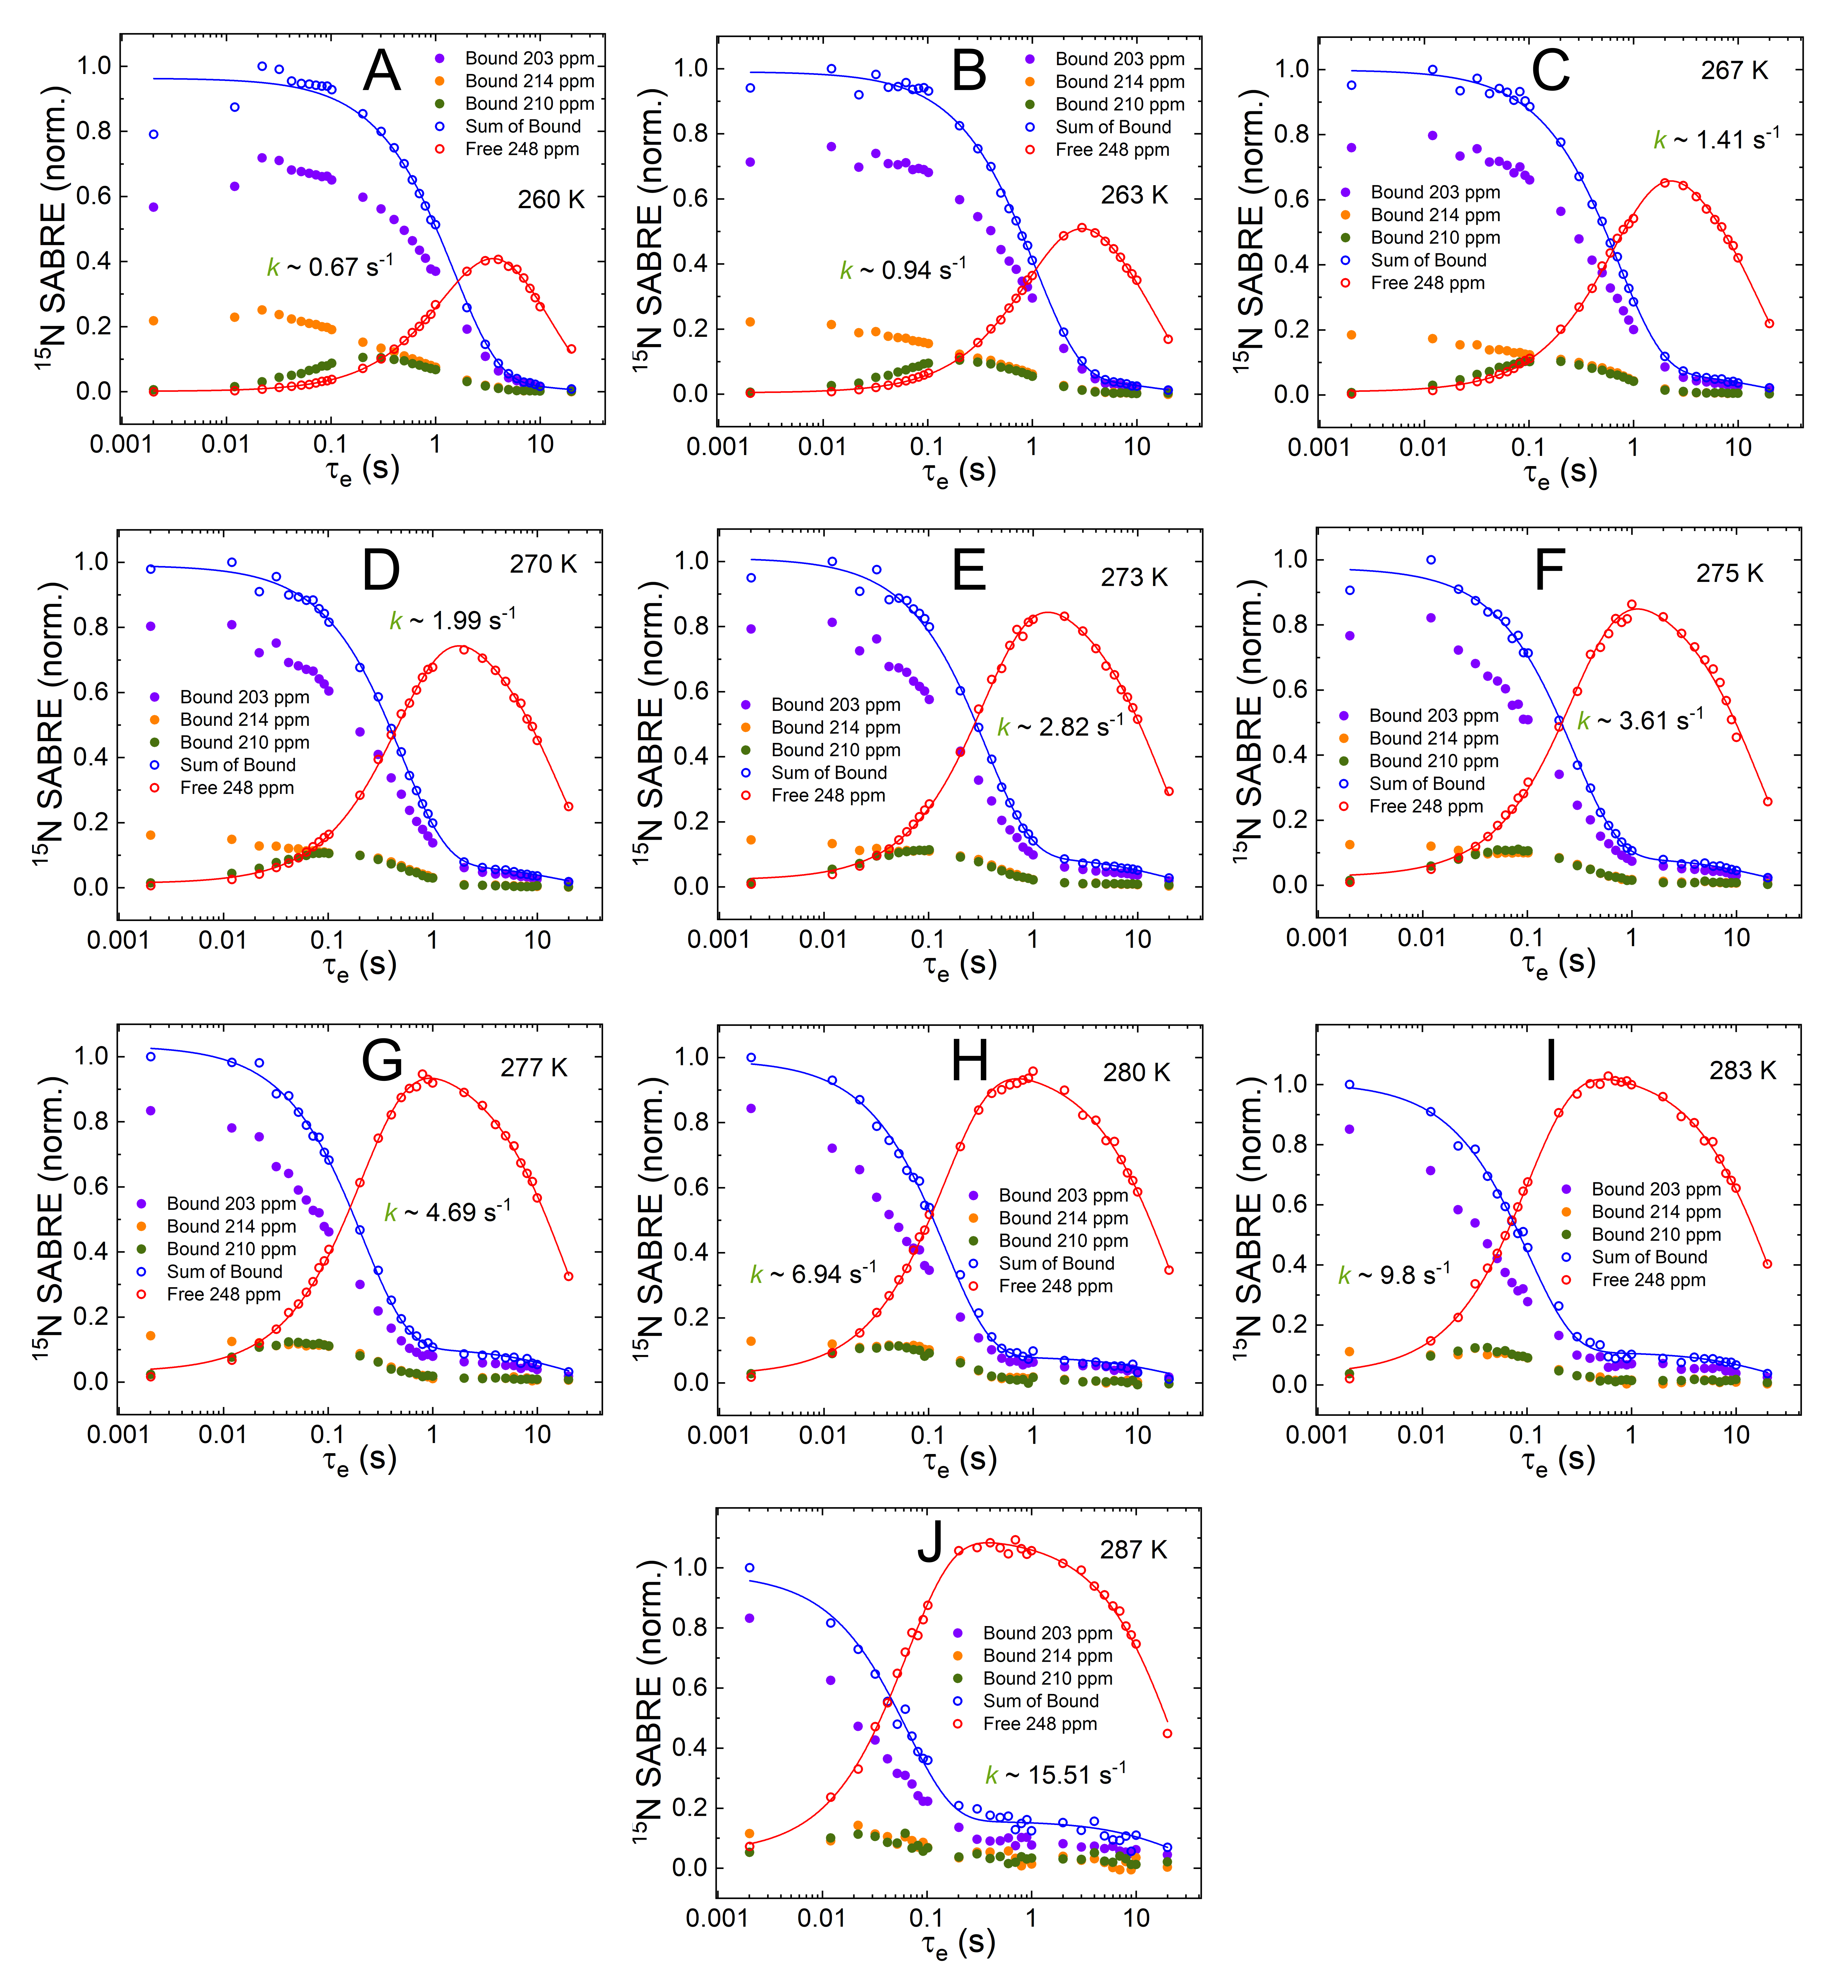
Figure S5. Dependences of the SABRE ESOTHERIC-enhanced ¹⁵N NMR signals of ¹⁵N₃-eMNZ (blue) and ¹⁵N₃-fMNZ (red) on the inter-pulse delay τ_{e} with τ₁ = 6 ms and τ₂ = 8 ms at the nominal temperatures of 260 K (A), 263 K (B), 267 K (C), 270 K (D), 273 K (E), 275 K (F), 277 K (G), 280 K (H), 283 K (I), and 287 K (J). The integrals of three signals of ¹⁵N₃-eMNZ in different complexes (see Figure S7 and Figure S9) with chemical shifts of 203 ppm (purple), 210 ppm (green), and 214 ppm (yellow) are presented as well as the sum of these integrals (blue). The curves are fitted using biexponential global fit. Estimated exchange rate constants are given in Table S3.

Comparison of exchange rate constants with literature data
Here we compare the exchange rate constants measured for pyridine using SABRE-ESOTHERIC with the data from previous studies where SABRE-INEPT¹¹ or SEXSY¹⁰ approaches were employed. The corresponding values are presented in Table S4A–S4C (eigenvalues analysis was used for data fitting). Ideally, the choice of method should not affect the obtained values; however, in reality, they can be different due to systematic or random errors of particular approaches. In the previous SABRE-INEPT study,¹¹ k_{d} values were originally calculated as $k_{d}=\frac{k}{1+\frac{\left[C_{S}S_{2}\right]}{\left[S\right]}}$ because single-site exchange model was used. Thus, we corrected these values by using our C_{S}S₂↔S₂ model which gives $k_{d}=\frac{k}{0.5+\frac{\left[C_{S}S_{2}\right]}{\left[S\right]}}$.
Table S4A. Exchange rate constants for pyridine obtained using SABRE-INEPT approach in Ref. ¹¹. Published values give Δ𝐻^{0‡} = 78 ± 2 kJ/mol, Δ𝑆^{0‡} = 41 ± 8 J/(mol·K). Recalculated values give Δ𝐻^{0‡} = 79 ± 2 kJ/mol, Δ𝑆^{0‡} = 48 ± 8 J/(mol·K).
T (K) | $k_{d}$ (s⁻¹) published | $k_{d}$ (s⁻¹) recalculated according to C_{S}S₂↔S₂ model (Eq. 2)
273.15 | 0.9 ± 0.1 | 1.6 ± 0.2
286.65 | 3.9 ± 0.1 | 7.2 ± 0.2
291.15 | 6.9 ± 0.2 | 12.6 ± 0.3
298.15 | 16.4 ± 0.9 | 30 ± 1
301.15 | 21 ± 3 | 38 ± 5
Table S4B. Exchange rate constants for pyridine obtained using SEXSY approach in Ref. ¹⁰. These values give Δ𝐻^{0‡} = 91 ± 2 kJ/mol, Δ𝑆^{0‡} = 90 ± 8 J/(mol·K).
T (K) | $k_{d}$ (s⁻¹)
280 | 2.4 ± 0.1
283 | 4.2 ± 0.3
288 | 7.7 ± 0.4
293 | 14 ± 1
298 | 29 ± 2
Table S4C. Exchange rate constants for pyridine were obtained using SABRE-ESOTHERIC approach in this work. These values give Δ𝐻^{0‡} = 83 ± 2 kJ/mol, Δ𝑆^{0‡} = 61 ± 7 J/(mol·K).
T (K) | $k_{d}$ (s⁻¹)
280 | 2.7 ± 0.1
283 | 4.0 ± 0.2
288 | 7.9 ± 0.4
293 | 13.2 ± 0.7

Enthalpies and entropies of activation
Eyring plots used for estimation of enthalpies and entropies of activation 𝛥𝐻‡ and 𝛥S‡ (from ligand dissociation rate constants k_{d} presented in Table S3) are shown in Figure S6.
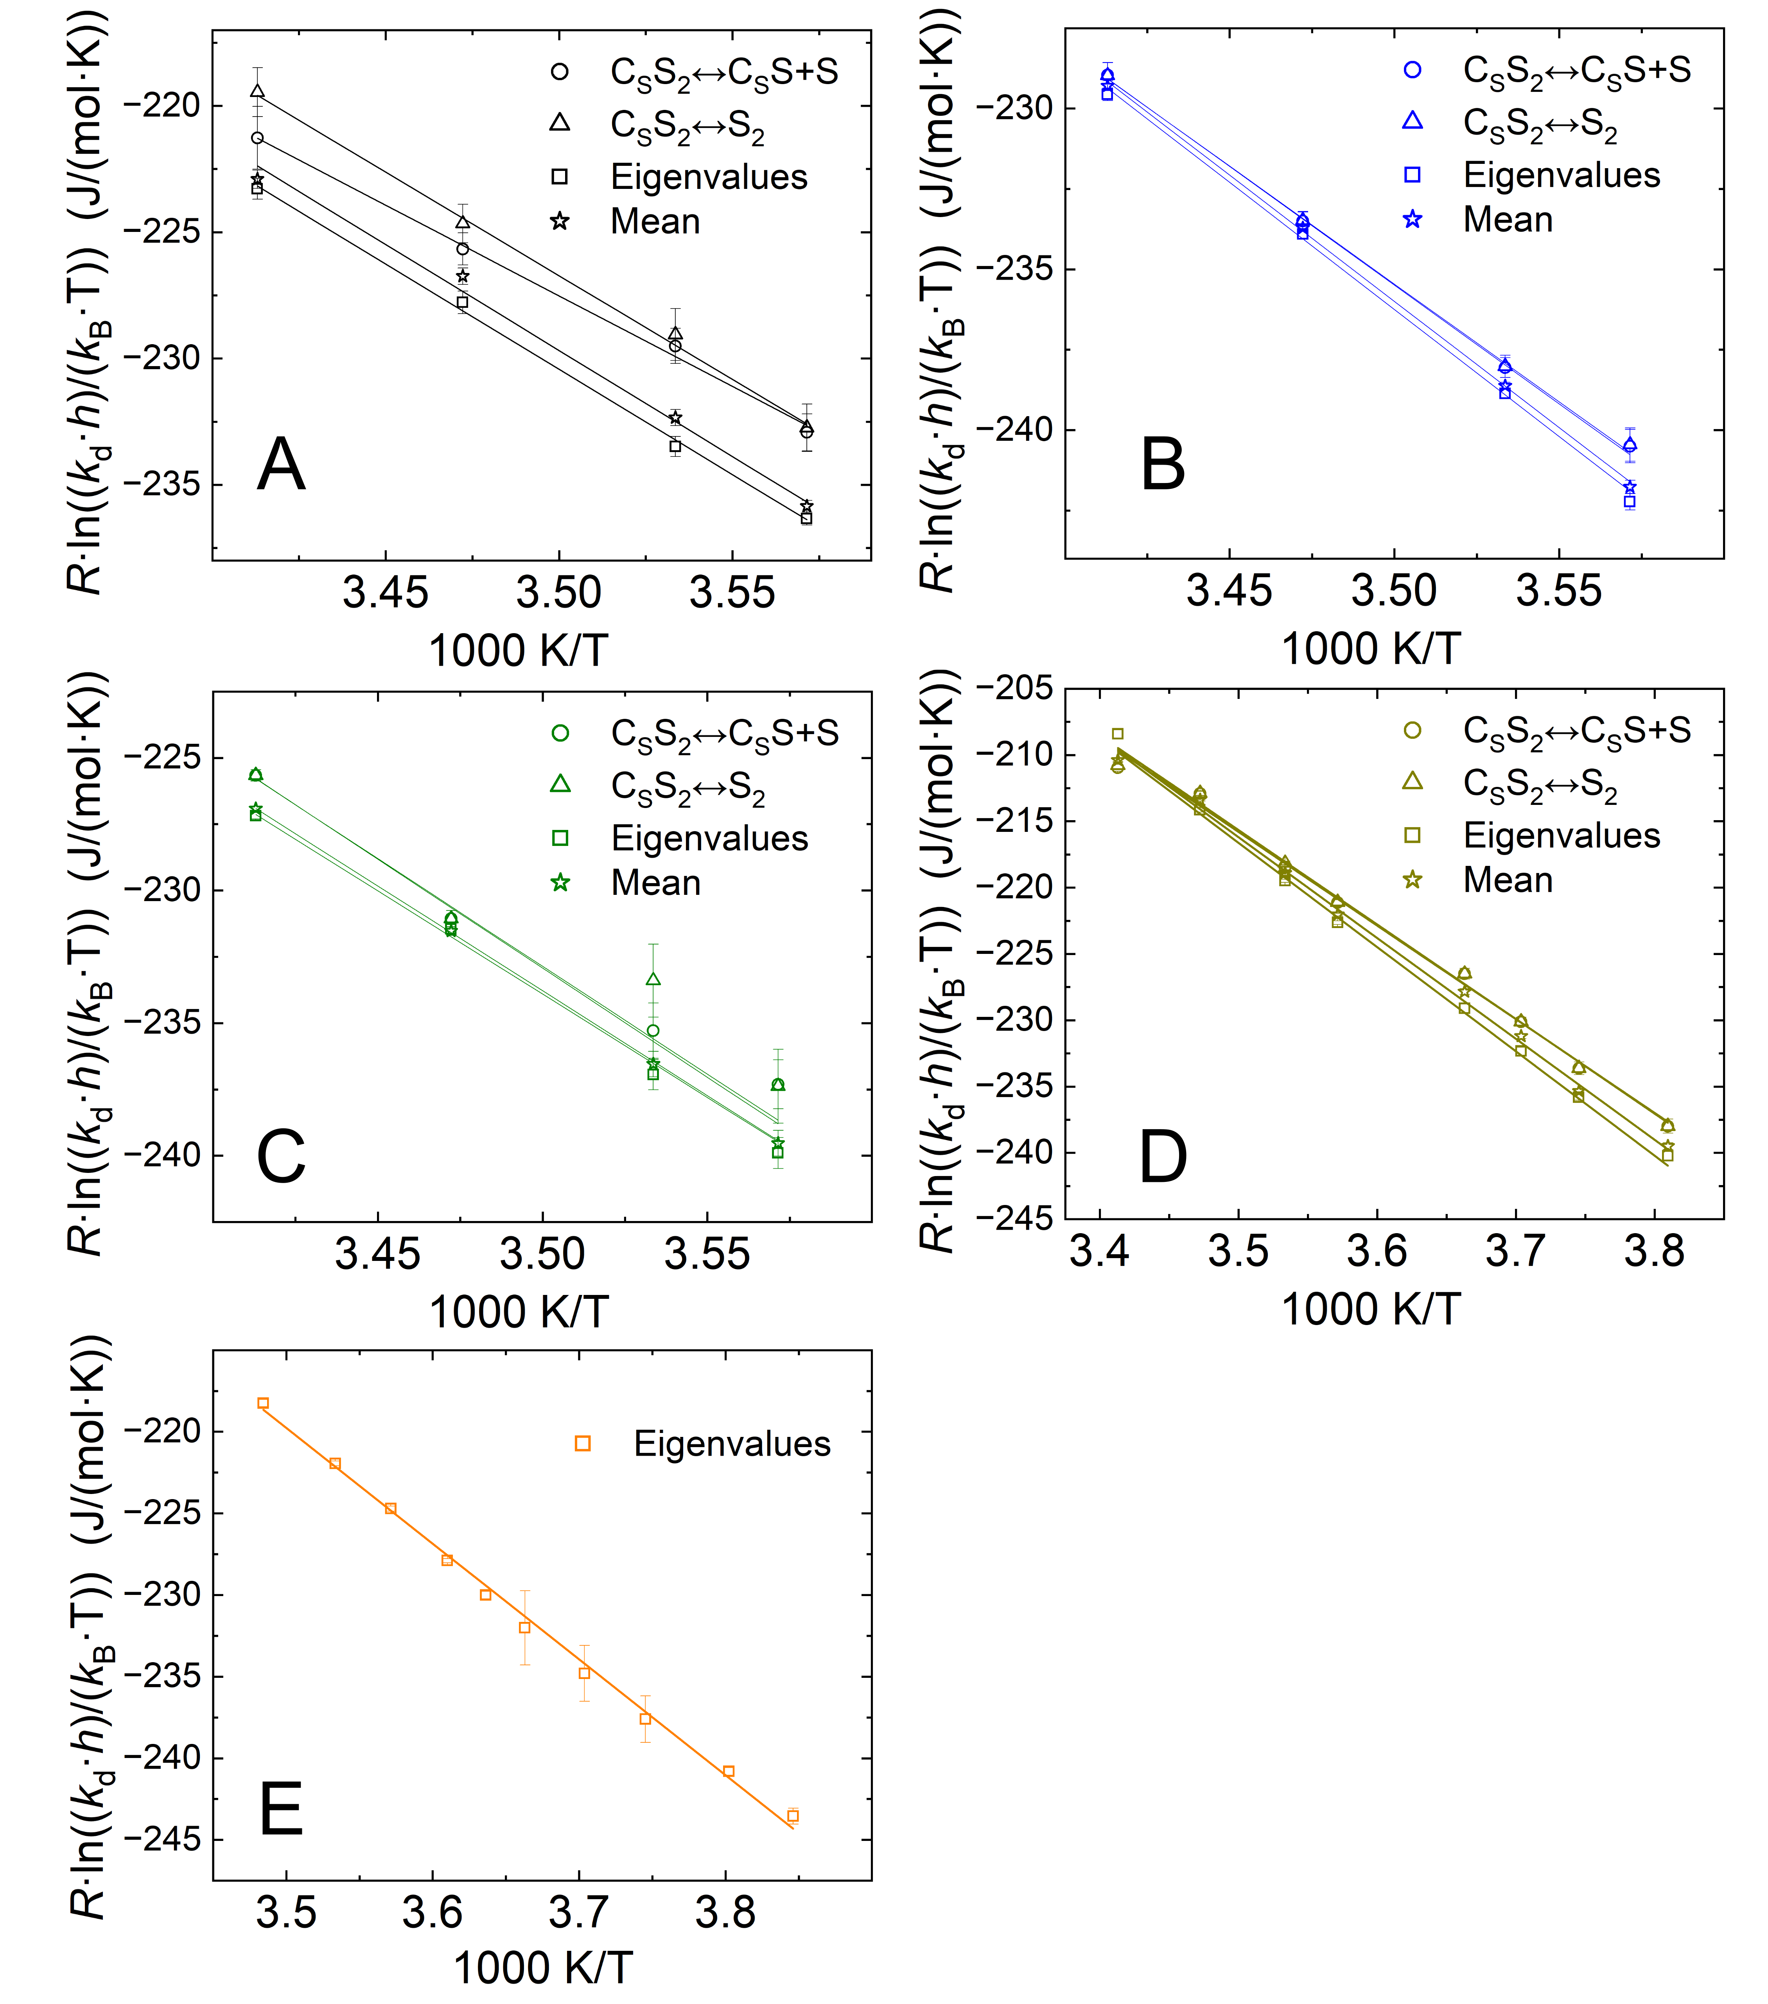
Figure S6. Eyring plots for (A) [¹⁵N]pyridine, (B) 4-amino[¹⁵N]pyridine, (C) [¹⁵N]nicotinamide, (D) [¹⁵N]acetonitrile, and (E) [¹⁵N₃]metronidazole. Dissociation rate constants k_{d} were obtained by fitting SABRE-ESOTHERIC kinetics with the models C_{S}S₂↔C_{S}S+S (circles), C_{S}S₂↔S₂ (triangles), eigenvalues analysis (squares), and weighted mean values across the three models (stars). Here, these values are displayed in Eyring coordinates.
In Table S5, the enthalpies 𝛥𝐻‡ and entropies 𝛥S‡ of activation for all substrates obtained from dissociation rate constants k_{d} (Table S3) measured in this work using SABRE-ESOTHERIC approach are presented. Additionally, we compared our results to the enthalpies 𝛥𝐻‡ and entropies 𝛥S‡ of activation for the substrates measured in the previous study¹⁰ using SEXSY approach (pyridine, 4-aminopyridine, and nicotinamide). The measurements conducted in this work appear to be more robust.
Table S5. Enthalpies 𝛥𝐻‡ and entropies 𝛥S‡ of activation for all substrates. 𝛥𝐻‡ and 𝛥S‡ were obtained from dissociation rate constants k_{d} (Table S3) and from the previous work¹⁰ (marked with asterisks). Measurements and fitting using SABRE-ESOTHERIC appear more robust than the SEXSY approach used in the previous study.¹⁰
Substrate | From mean $k_{d}$ values |  | Model C_{S}S₂↔C_{S}S+S |  | Model C_{S}S₂↔S₂ |  | Eigenvalues analysis: biexponential fitting
Substrate | $ΔH^{‡}$ (kJ/mol) | $ΔS^{‡}$ (J/(mol·K)) | $ΔH^{‡}$ (kJ/mol) | $ΔS^{‡}$ (J/(mol·K)) | $ΔH^{‡}$ (kJ/mol) | $ΔS^{‡}$ (J/(mol·K)) | $ΔH^{‡}$ (kJ/mol) | $ΔS^{‡}$ (J/(mol·K))
¹⁵N-Py | 84 ± 4  104 ± 5* | 64 ± 16  133 ± 17* | 72 ± 4  109 ± 3* | 24 ± 14  150 ± 11* | 82 ± 3  101 ± 6* | 61 ± 11  122 ± 21* | 83 ± 2  91 ± 2* | 61 ± 7  90 ± 7*
¹⁵N-4AP | 79 ± 1  95 ± 1* | 39 ± 5  98 ± 2* | 74 ± 2  101 ± 16* | 23 ± 6  115 ± 56* | 73 ± 2  112 ± 5* | 21 ± 6  115 ± 18* | 79 ± 2  71 ± 3* | 41 ± 8  12 ± 11*
¹⁵N-NAM | 79 ± 1  81 ± 2* | 42 ± 3  48 ± 6* | 81 ± 7  66 ± 3* | 52 ± 22  4 ± 13* | 82 ± 9  107 ± 6* | 55 ± 30  141 ± 21* | 78 ± 3  49 ± 12* | 39 ± 11  59 ± 43*
¹⁵N-ACN | 76 ± 2 | 71 ± 3 | 71 ± 3 | 32 ± 11 | 71 ± 3 | 33 ± 11 | 79 ± 2 | 59 ± 7
¹⁵N₃-MNZ |  |  |  |  |  |  | 71 ± 1 | 29 ± 5

Analysis of SABRE complexes with metronidazole
When ESOTHERIC or phINEPT+ SOTs were applied to [¹⁵N₃]MNZ, we observed multiple ¹⁵N peaks of ¹⁵N-3 sites of ¹⁵N₃-MNZ: one for the free substrate at 247.3 ppm, one for the equatorial-bound substrate in the [Ir(IMes)(H)₂(MNZ)₃] complex at 203.1 ppm and several additional peaks at 196, 205, 206.5, and 214 ppm (Figure S7). The latter peaks likely belong to various Ir complexes with MNZ and additional ligands: chloride or solvent^{12,13} (Figure S8A).
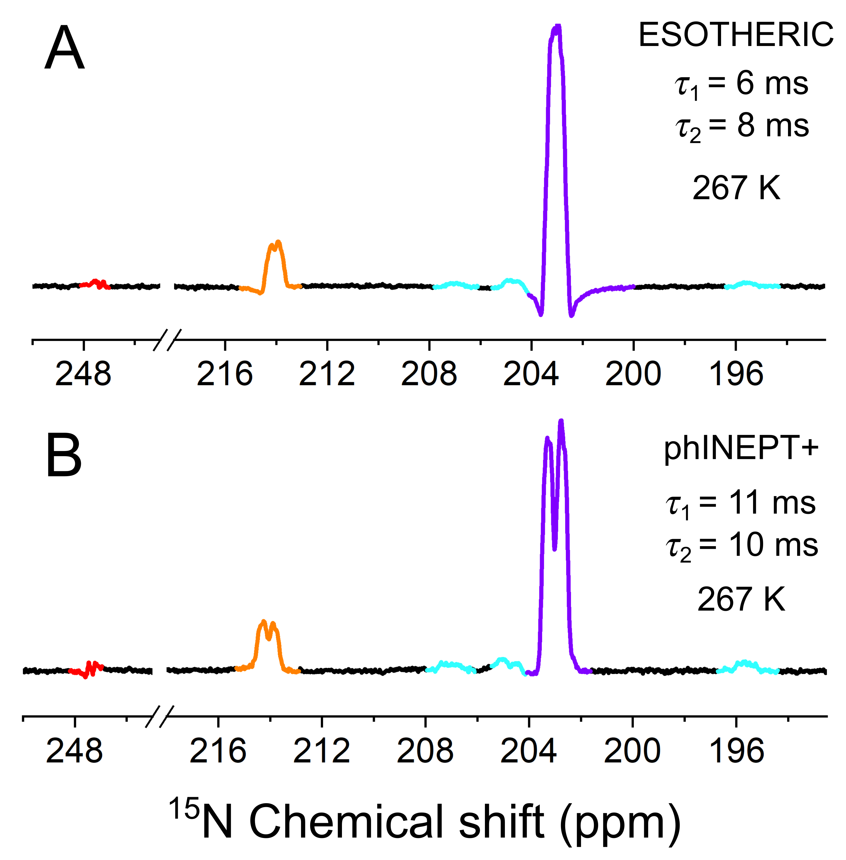
Figure S7. ¹⁵N ESOTHERIC (A) and phINEPT+ (B) NMR spectra of [¹⁵N₃]metronidazole. ¹⁵N symmetrically bound metronidazole resonances at 203.68 ppm (purple), at 214 ppm (orange), and the ¹⁵N free metronidazole resonance at 247.3 ppm (red). The peaks at 196, 205, and 206.5 ppm correspond to different confirmations of MNZ-Ir complexes (sky blue).
To assess the efficiency of polarization transfer to different Ir-MNZ complexes, we measured ¹H PASADENA spectra at various temperatures (Figure S8C). There are three major iridium complexes, which can be assigned as [Ir(IMes)(H)₂(MNZ)₃] (1), [Ir(IMes)(H)₂(MNZ)₂Cl] (2), and [Ir(IMes)(H)₂(MNZ)₂(Solv)] (3).¹² Increasing pH₂ pressure enhanced the polarization proportionally, and several minor hydride species, such as complex (3), became visible even better (Figure S8B). We found that at 8.3 bar, the highest polarization for complex (1) reached 277 K (Figure S8E), while for (2) the strongest polarization was observed at 260 K. The sample composition was [Ir] = 4 mM, [MNZ] = 80 mM in 400 µL of methanol-d₄.
Also, the performance of phINEPT+ and ESOTHERIC SOT sequences for polarization transfer in various ¹⁵N₃-MNZ-Ir complexes was experimentally evaluated (Figure S9). We found that the τ₁ and τ₂ delays optimized for the signal at 203.1 ppm (corresponding to complex (1)) are suboptimal for the polarization transfer in other complexes.

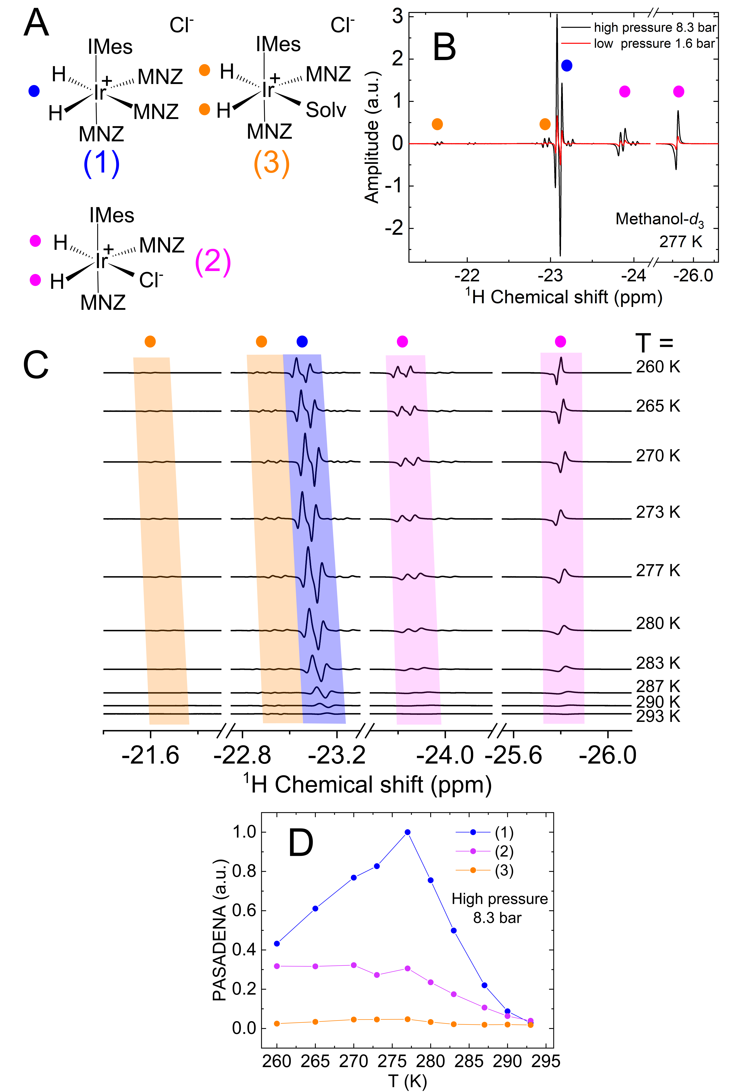
Figure S8. PASADENA ¹H NMR spectra of SABRE complexes with MNZ. (A) The structures of the three SABRE complexes with MNZ. (B) ¹H PASADENA spectra at high pressure (8.3 bar, black) and low pressure (1.6 bar, red). (C) ¹H PASADENA spectra as a function of temperature between 260 and 293 K recorded at 8.3 bar. ¹H PASADENA magnitude integrals of the three primary complexes (1)-(3) as a function of temperature at 8. 3 bar (D).
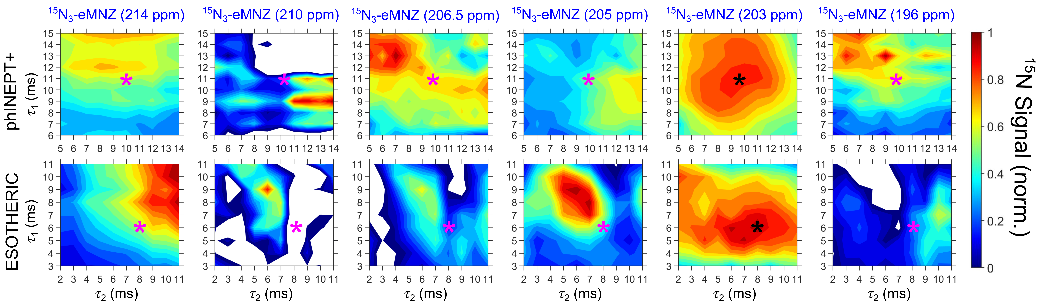
Figure S9. Performance of ESOTHERIC and phINEPT+ SOTs for various ¹⁵N NMR signals of Ir-bound ¹⁵N₃-MNZ. Experimentally measured ¹⁵N polarization of [¹⁵N₃]metronidazole (¹⁵N₃-MNZ) as a function of τ₁ and τ₂ delays of phINEPT+ (top) and ESOTHERIC (bottom) SOT sequences at 267 K and 9.4 T. The signals of the ¹⁵N-3 site at 196, 203, 205, 206.5, 210, and 214 ppm correspond to different MNZ-Ir complexes. The asterisks represent the τ₁ and τ₂ delays that were used to measure the ¹⁵N ESOTHERIC and phINEPT+ NMR spectra of [¹⁵N₃]metronidazole presented in Figure S7.

Quantum chemical calculations
All quantum chemical calculations were performed with the ORCA 5.0 program package.¹⁴ Geometries of [Ir(H)₂(IMes)(S)₃]⁺, [Ir(H)₂(IMes)(S)₂]⁺ and S (S = Py, 4AP, NAM, ACN, or MNZ) were optimized at the B3LYP-D4/def2-TZVP level of theory^{15–18}. Harmonic vibrational frequency analyses confirmed the optimized structures as true minima. At the optimized geometries, single-point energies were calculated at the DLPNO-CCSD(T)/def2-TZVP level of theory^{19,20}. The CPCM model was used to account for solvation effects in both geometry optimizations and single-point calculations.²¹
While great care has been taken to use well-established DFT functionals, state-of-the-art corrections for dispersion and solvation, and sufficiently large basis sets and grids, the overestimation of dissociation energies is very likely due to the insufficient description of the solvent stabilizing the dissociation products, or missing effects of similar origin.
To identify the transition state of ligand dissociation in [Ir(H)₂(IMes)(Py)₃]⁺, a relaxed potential energy surface (PES) scan was conducted at the B3LYP-D4/def2-SVP level of theory. The Ir–N distance was scanned from 2.3 Å to 5 Å with an increment step of 0.1 Å, giving a total of 28 steps. The dissociation of the pyridine ligand has a pronounced energy barrier (Figure S10). Hence, the experimentally observed "activation energy" represents the energy required for the ligand to diffuse away from the Ir complex, rather than the energy needed to overcome a distinct barrier. All calculated energies are summarized in Table S6.
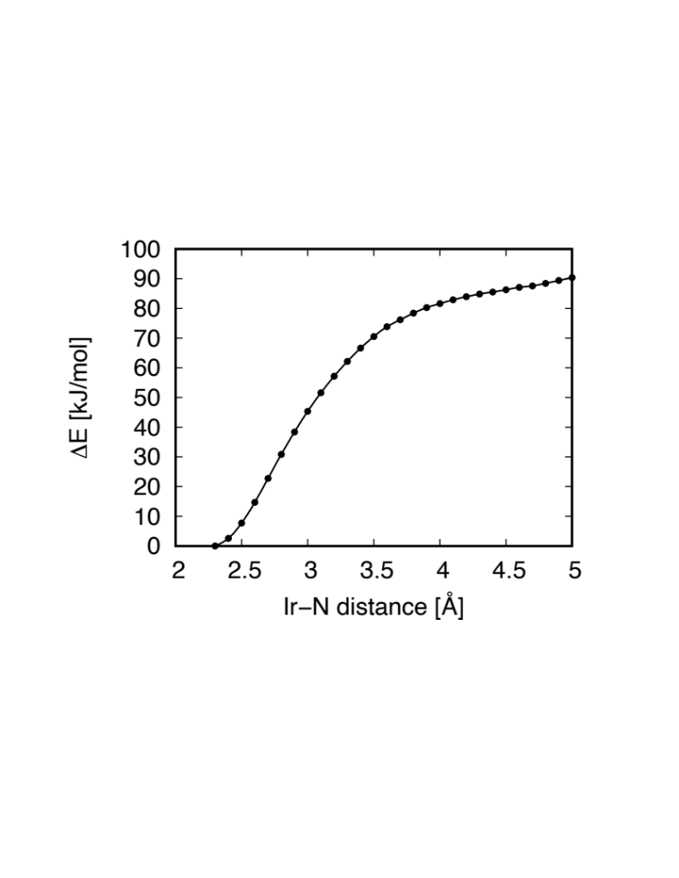
Figure S10. The obtained PES of ligand dissociation in [Ir(H)₂(IMes)(Py)₃]⁺.
Table S6. Summary of B3LYP-D4 energies with zero-point energy correction and CCSD(T) energies for [Ir(H)₂(IMes)(S)₃]⁺, [Ir(H)₂(IMes)(S)₂]⁺ and S (S = Py, 4AP, NAM, ACN, MNZ).
Substrate | Compound | E(DFT)  (Hartree) | ΔE(DFT)  (kJ/mol) | E(CCSD(T))  (Hartree) | ΔE(CCSD(T))  (kJ/mol)
Py | [Ir(H)₂(IMes)(Py)₃]⁺ | -1773.6626 | 103.9383 | -1771.0543 | 123.5654
Py | [Ir(H)₂(IMes)(Py)₂]⁺ | -1525.4642 | 103.9383 | -1523.1806 | 123.5654
Py | Py | -248.1588 | 103.9383 | -247.8267 | 123.5654
4AP | [Ir(H)₂(IMes)(4AP)₃]⁺ | -1939.7220 | 98.8423 | -1936.9116 | 120.8313
4AP | [Ir(H)₂(IMes)(4AP)₂]⁺ | -1636.1748 | 98.8423 | -1633.7554 | 120.8313
4AP | 4AP | -303.5096 | 98.8423 | -303.1102 | 120.8313
NAM | [Ir(H)₂(IMes)(NAM)₃]⁺ | -2279.7264 | 106.2501 | -2276.4594 | 125.1863
NAM | [Ir(H)₂(IMes)(NAM)₂]⁺ | -1862.8397 | 106.2501 | -1860.1169 | 125.1863
NAM | NAM | -416.8462 | 106.2501 | -416.2948 | 125.1863
ACN | [Ir(H)₂(IMes)(ACN)₃]⁺ | -1427.2491 | 72.9700 | -1425.1285 | 89.0197
ACN | [Ir(H)₂(IMes)(ACN)₂]⁺ | -1294.5224 | 72.9700 | -1292.5629 | 89.0197
ACN | ACN | -132.6989 | 72.9700 | -132.5317 | 89.0197
MNZ | [Ir(H)₂(IMes)(MNZ)₃]⁺ | -2900.2430 | 82.0146 | -2896.2835 | 107.3883
MNZ | [Ir(H)₂(IMes)(MNZ)₂]⁺ | -2276.5239 | 82.0146 | -2273.3383 | 107.3883
MNZ | MNZ | -623.6878 | 82.0146 | -622.9043 | 107.3883

References
(1) Rayner, P. J.; Burns, M. J.; Olaru, A. M.; Norcott, P.; Fekete, M.; Green, G. G. R.; Highton, L. A. R.; Mewis, R. E.; Duckett, S. B. Delivering Strong ¹ H Nuclear Hyperpolarization Levels and Long Magnetic Lifetimes through Signal Amplification by Reversible Exchange. Proc. Natl. Acad. Sci. 2017, 114 (16). https://doi.org/10.1073/pnas.1620457114.
(2) Chukanov, N. V.; Salnikov, O. G.; Trofimov, I. A.; Kabir, M. S. H.; Kovtunov, K. V.; Koptyug, I. V.; Chekmenev, E. Y. Synthesis and ¹⁵ N NMR Signal Amplification by Reversible Exchange of [ ¹⁵ N]Dalfampridine at Microtesla Magnetic Fields. ChemPhysChem 2021, 22 (10), 960–967. https://doi.org/10.1002/cphc.202100109.
(3) Shchepin, R. V.; Barskiy, D. A.; Mikhaylov, D. M.; Chekmenev, E. Y. Efficient Synthesis of Nicotinamide-1- ¹⁵ N for Ultrafast NMR Hyperpolarization Using Parahydrogen. Bioconjug. Chem. 2016, 27 (4), 878–882. https://doi.org/10.1021/acs.bioconjchem.6b00148.
(4) Peters, J. P.; Brahms, A.; Janicaud, V.; Anikeeva, M.; Peschke, E.; Ellermann, F.; Ferrari, A.; Hellmold, D.; Held-Feindt, J.; Kim, N.; Meiser, J.; Aden, K.; Herges, R.; Hövener, J.-B.; Pravdivtsev, A. N. Nitrogen-15 Dynamic Nuclear Polarization of Nicotinamide Derivatives in Biocompatible Solutions. Sci. Adv. 2023, 9 (34), eadd3643. https://doi.org/10.1126/sciadv.add3643.
(5) Shchepin, R. V.; Birchall, J. R.; Chukanov, N. V.; Kovtunov, K. V.; Koptyug, I. V.; Theis, T.; Warren, W. S.; Gelovani, J. G.; Goodson, B. M.; Shokouhi, S.; Rosen, M. S.; Yen, Y.; Pham, W.; Chekmenev, E. Y. Hyperpolarizing Concentrated Metronidazole ¹⁵ NO ₂ Group over Six Chemical Bonds with More than 15 % Polarization and a 20 Minute Lifetime. Chem. – Eur. J. 2019, 25 (37), 8829–8836. https://doi.org/10.1002/chem.201901192.
(6) Hövener, J.-B.; Bär, S.; Leupold, J.; Jenne, K.; Leibfritz, D.; Hennig, J.; Duckett, S. B.; von Elverfeldt, D. A Continuous-Flow, High-Throughput, High-Pressure Parahydrogen Converter for Hyperpolarization in a Clinical Setting: A HIGH-THROUGHPUT PARAHYDROGEN CONVERTER FOR HYPERPOLARIZATION. NMR Biomed. 2013, 26 (2), 124–131. https://doi.org/10.1002/nbm.2827.
(7) Ellermann, F.; Pravdivtsev, A.; Hövener, J.-B. Open-Source, Partially 3D-Printed, High-Pressure (50-Bar) Liquid-Nitrogen-Cooled Parahydrogen Generator. Magn. Reson. 2021, 2 (1), 49–62. https://doi.org/10.5194/mr-2-49-2021.
(8) Pravdivtsev, A. N.; Sönnichsen, F. D.; Hövener, J. Continuous Radio Amplification by Stimulated Emission of Radiation Using Parahydrogen Induced Polarization (PHIP‐RASER) at 14 Tesla. ChemPhysChem 2020, 21 (7), 667–672. https://doi.org/10.1002/cphc.201901056.
(9) Pravdivtsev, A. N.; Hövener, J.-B.; Schmidt, A. B. Frequency-Selective Manipulations of Spins Allow Effective and Robust Transfer of Spin Order from Parahydrogen to Heteronuclei in Weakly-Coupled Spin Systems. ChemPhysChem 2022, 23 (3), e202100721. https://doi.org/10.1002/cphc.202100721.
(10) Salnikov, O. G.; Assaf, C. D.; Yi, A. P.; Duckett, S. B.; Chekmenev, E. Y.; Hövener, J.-B.; Koptyug, I. V.; Pravdivtsev, A. N. Modeling Ligand Exchange Kinetics in Iridium Complexes Catalyzing SABRE Nuclear Spin Hyperpolarization. Anal. Chem. 2024, acs.analchem.4c01374. https://doi.org/10.1021/acs.analchem.4c01374.
(11) Pravdivtsev, A. N.; Yurkovskaya, A. V.; Zimmermann, H.; Vieth, H.-M.; Ivanov, K. L. Enhancing NMR of Insensitive Nuclei by Transfer of SABRE Spin Hyperpolarization. Chem. Phys. Lett. 2016, 661, 77–82. https://doi.org/10.1016/j.cplett.2016.08.037.
(12) Yi, A. P.; Salnikov, O. G.; Burueva, D. B.; Chukanov, N. V.; Chekmenev, E. Y.; Koptyug, I. V. Solvent Effects in Hyperpolarization of 15N Nuclei in [15N3]Metronidazole and [15N3]Nimorazole Antibiotics via SABRE‐SHEATH**. Anal. Sens. 2024, e202400045. https://doi.org/10.1002/anse.202400045.
(13) Knecht, S.; Hadjiali, S.; Barskiy, D. A.; Pines, A.; Sauer, G.; Kiryutin, A. S.; Ivanov, K. L.; Yurkovskaya, A. V.; Buntkowsky, G. Indirect Detection of Short-Lived Hydride Intermediates of Iridium N-Heterocyclic Carbene Complexes via Chemical Exchange Saturation Transfer Spectroscopy. J. Phys. Chem. C 2019, 123 (26), 16288–16293. https://doi.org/10.1021/acs.jpcc.9b04179.
(14) Neese, F.; Wennmohs, F.; Becker, U.; Riplinger, C. The ORCA Quantum Chemistry Program Package. J. Chem. Phys. 2020, 152 (22), 224108. https://doi.org/10.1063/5.0004608.
(15) Becke, A. D. A New Mixing of Hartree–Fock and Local Density-Functional Theories. J. Chem. Phys. 1993, 98 (2), 1372–1377. https://doi.org/10.1063/1.464304.
(16) Lee, C.; Yang, W.; Parr, R. G. Development of the Colle-Salvetti Correlation-Energy Formula into a Functional of the Electron Density. Phys. Rev. B 1988, 37 (2), 785–789. https://doi.org/10.1103/PhysRevB.37.785.
(17) Caldeweyher, E.; Bannwarth, C.; Grimme, S. Extension of the D3 Dispersion Coefficient Model. J. Chem. Phys. 2017, 147 (3), 034112. https://doi.org/10.1063/1.4993215.
(18) Weigend, F.; Ahlrichs, R. Balanced Basis Sets of Split Valence, Triple Zeta Valence and Quadruple Zeta Valence Quality for H to Rn: Design and Assessment of Accuracy. Phys. Chem. Chem. Phys. 2005, 7 (18), 3297. https://doi.org/10.1039/b508541a.
(19) Hellweg, A.; Hättig, C.; Höfener, S.; Klopper, W. Optimized Accurate Auxiliary Basis Sets for RI-MP2 and RI-CC2 Calculations for the Atoms Rb to Rn. Theor. Chem. Acc. 2007, 117 (4), 587–597. https://doi.org/10.1007/s00214-007-0250-5.
(20) Weigend, F. Hartree–Fock Exchange Fitting Basis Sets for H to Rn †. J. Comput. Chem. 2008, 29 (2), 167–175. https://doi.org/10.1002/jcc.20702.
(21) Barone, V.; Cossi, M. Quantum Calculation of Molecular Energies and Energy Gradients in Solution by a Conductor Solvent Model. J. Phys. Chem. A 1998, 102 (11), 1995–2001. https://doi.org/10.1021/jp9716997.

