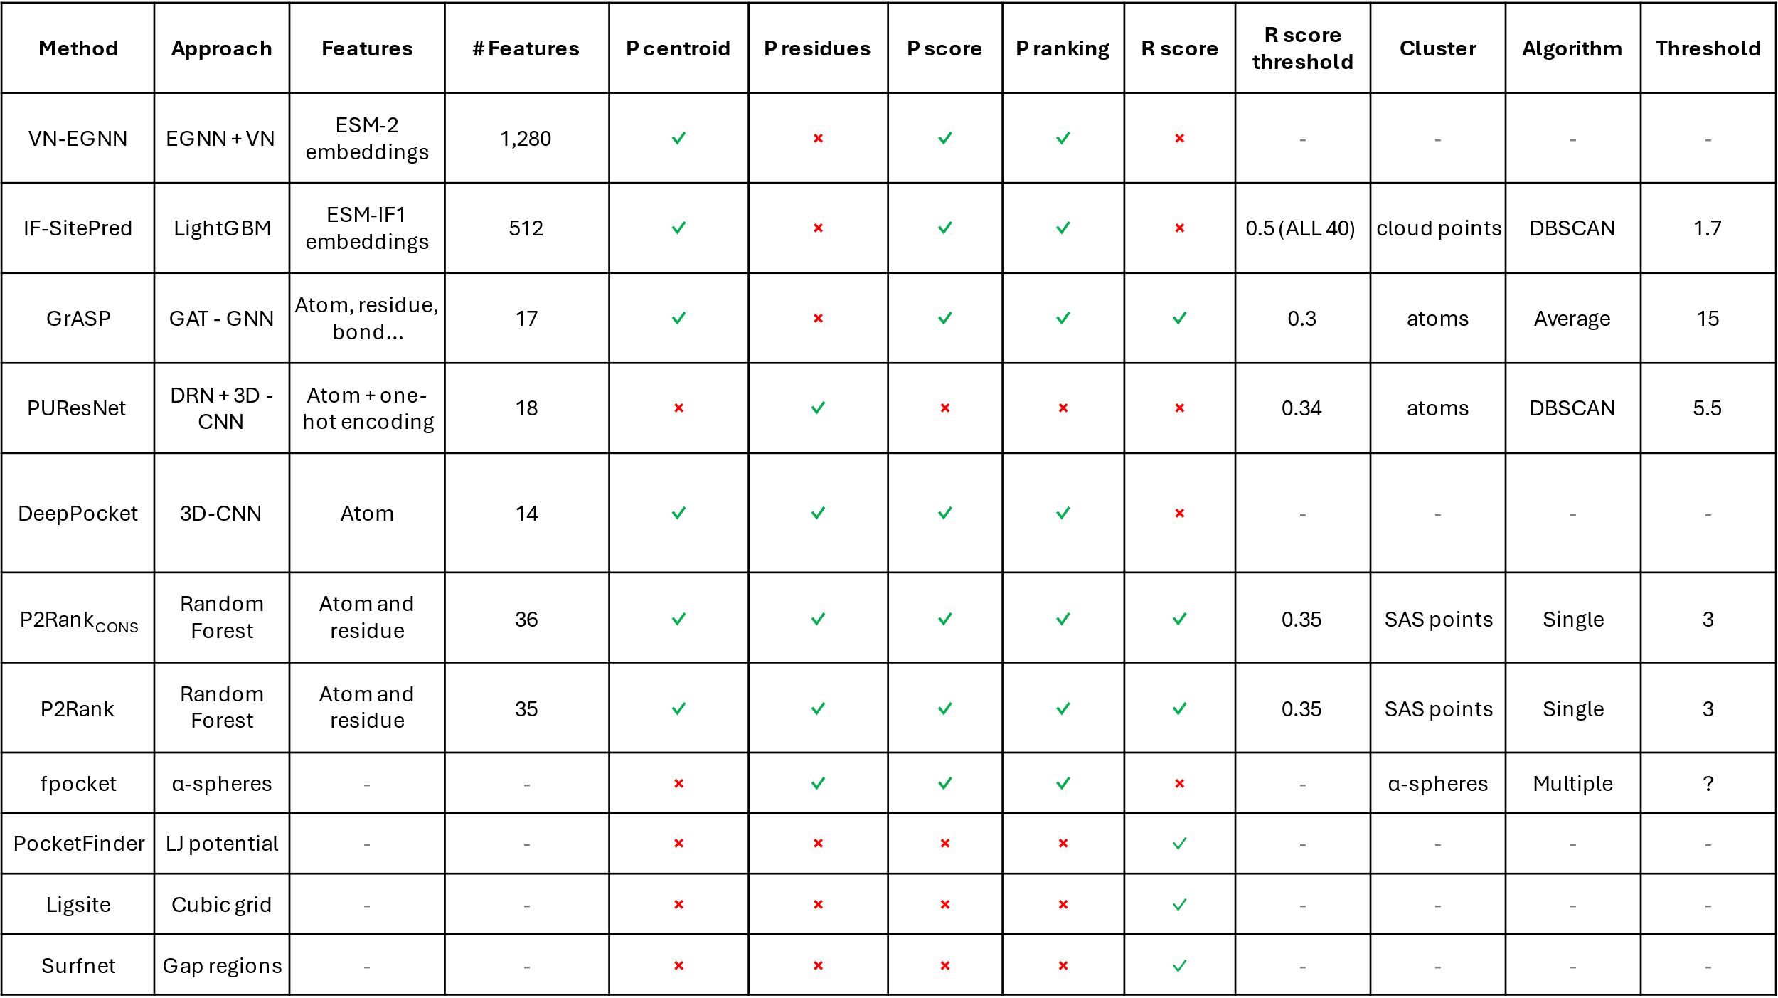
Table 1. Summary of ligand binding site prediction methods. Approach: the techniques applied by the method; Features/#Features: the Features and their number if the method is machine learning-based; P centroid/P residues/P score/P ranking/R score: whether the method reports the pocket centroid, pocket residues, pocket score, pocket ranking and residue ligandability score. Information about their clustering strategies is also relevant: whether the method uses a residue ligandability threshold (R score threshold), the instances they cluster (Cluster) to define the distinct pockets, the clustering algorithm used (Algorithm) and threshold employed (Threshold). For example, P2Rank uses a random forest classifier on SAS points represented by 35 atom and residue features. Points with a score > 0.35 are later clustered into binding sites using single linkage and a threshold of 3Å. EGNN + VN: equivariant graph neural network + virtual nodes; LightGBM: Light gradient boosting machine; GAT: graph attention network; GNN: graph neural network; DRN: deep residual network; 3D-CNN: three-dimensional convolutional neural network; LJ potential: Lennard-Jones potential.

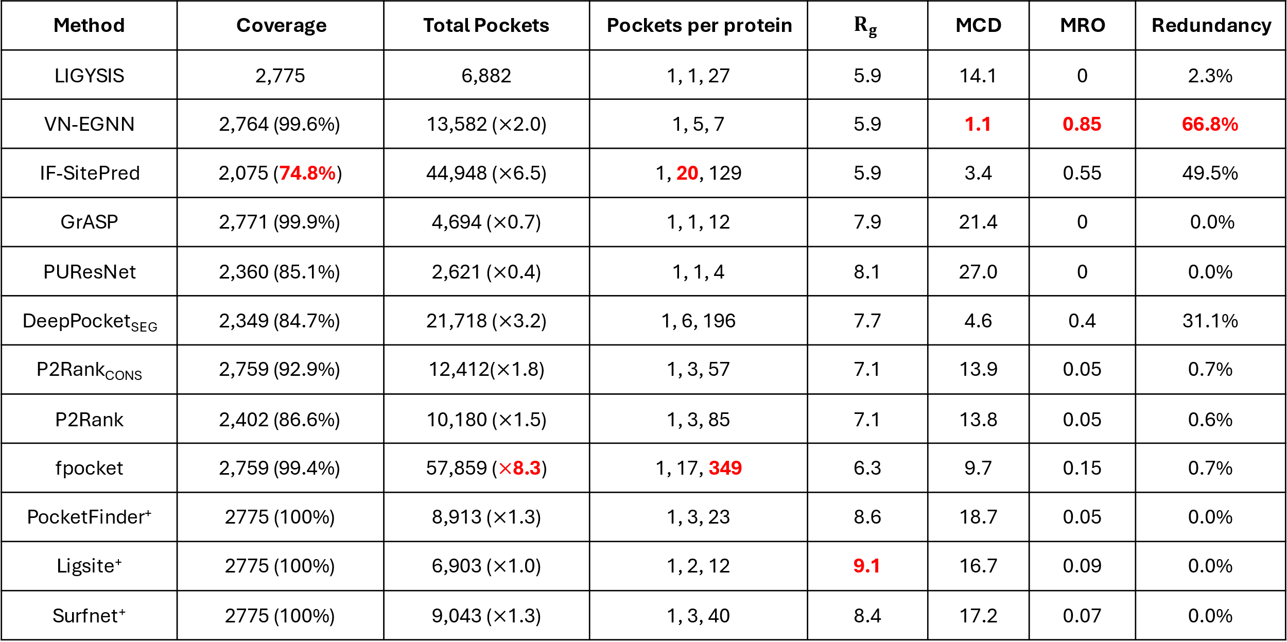
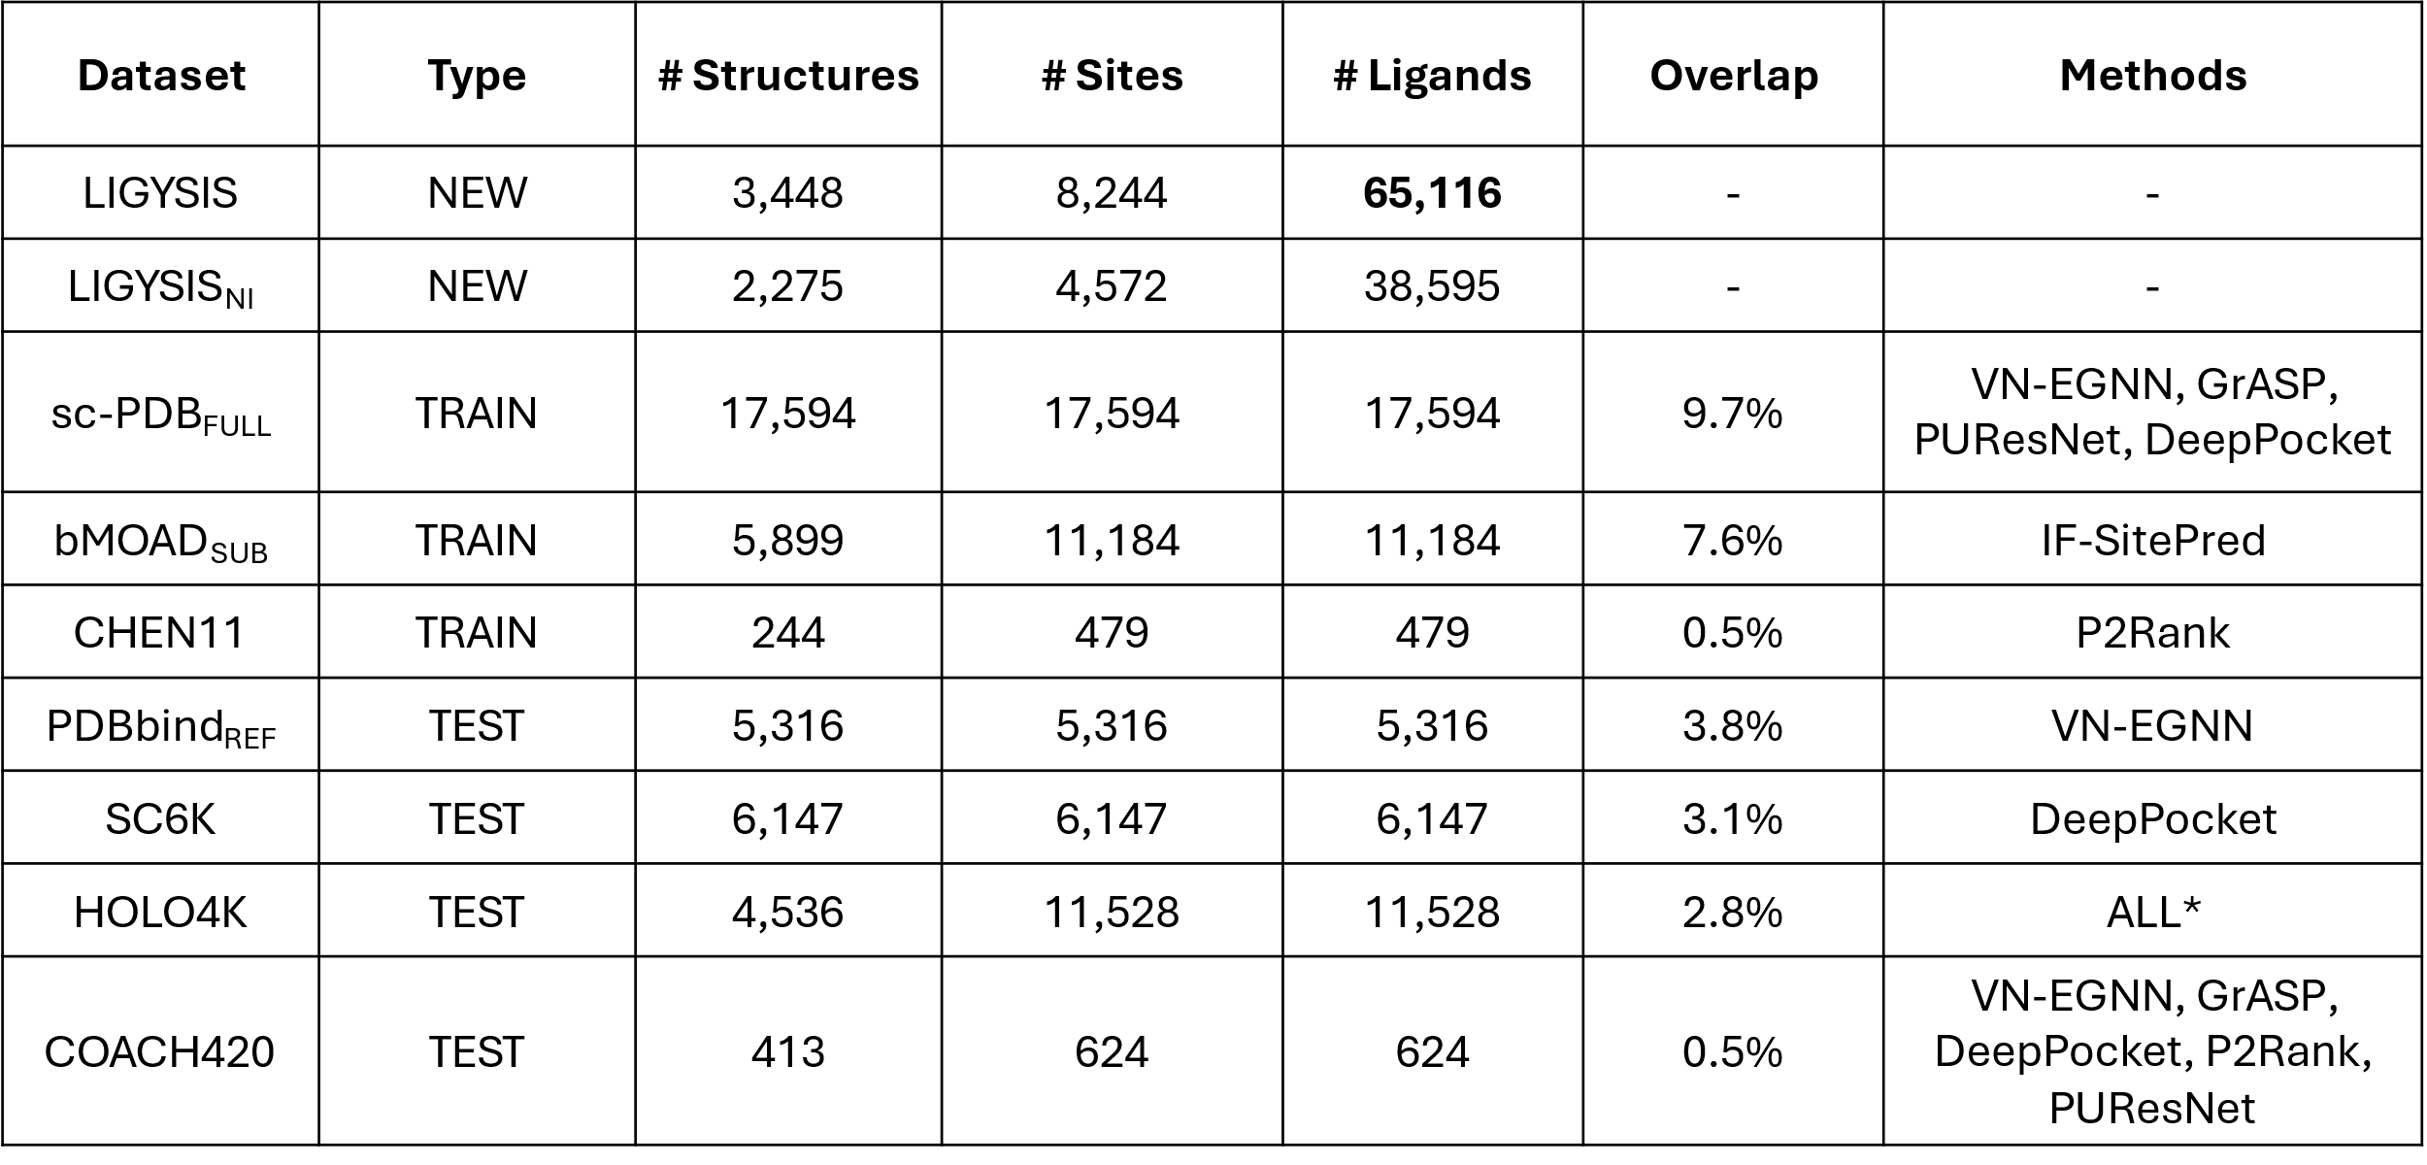
Table 2. Summary statistics of the different datasets analysed in this study. LIGYSIS is our reference dataset, LIGYSIS_{NI} is a subset with no ion (NI) ligand binding sites, sc-PDB_{FULL}, bMOAD_{SUB} and CHEN11 constitute the training datasets, whereas PDBbind_{REF}, SC6K, HOLO4K and COACH420 represent test sets. # Structures, # Sites and # Ligands represent the number of PDB structures, ligand sites and total number of ligands for each dataset. Note that for LIGYSIS and LIGYSIS_{NI}, 3,448 and 2,775, are the number of human structural segments considered, each represented by a single chain. For each segment, all biologically relevant ligand-binding structures were considered: N = 23,321 (LIGYSIS) and N = 19,012 (LIGYSIS_{NI}). The number of ligands is not equal to the number of sites for LIGYSIS, as data from multiple structures of the same protein are aggregated into unique sites, i.e., a LIGYSIS site often includes multiple ligands. Overlap is the percentage of protein-ligand complexes overlapping between these datasets and LIGYSIS. Methods represents the ligand site predictors that use these datasets for training or test. Only the original version of each dataset is considered in the analysis, e.g., HOLO4K is analysed, but not HOLO4K_{Mlig}, nor HOLO4K_{Mlig+} HAP, or HAP-small. The same goes for Mlig, Mlig+ versions of COACH420, sc-PDB_{SUB} and sc-PDB_{RICH}. ALL* represents all the methods compared in this work except for fpocket, PocketFinder⁺, Ligsite⁺ and Surfnet⁺.

Table 3. Ligand site characterisation summary. LIGYSIS is not a ligand binding site predictor, but a reference dataset curated from experimentally determined structures of biologically relevant protein-ligand complexes. Coverage represents the number of protein chains the different methods return at least one prediction. Percentage is relative to LIGYSIS sites. Protein chains not covered by VN-EGNN, GrASP and fpocket represent errors in the programme execution, and not absence of predicted sites; Total number of pockets and ratio of predicted pockets by reference pockets in parenthesis, e.g., for each LIGYSIS site, fpocket predicts in average 8.3 pockets; Minimum, median and maximum number of pockets per protein; Median pocket radius of gyration R_{g} (Å); Minimum centroid distance (MCD) (Å). For proteins where multiple pockets are predicted, MCD represents the distance to the closest pocket centroid for each of the different predicted pockets. This is a measure of how close predicted pockets are to each other; Maximum residue overlap (MRO). For a given pocket, MRO is the maximum overlap of the residues forming the pockets. MRO is a measure of how similar, in terms of shared residues, the predicted pockets are. For example, the median overlap between VN-EGNN predicted pockets is 85%. Redundancy represents the percentage of predicted pockets that are redundant, i.e., the closest pocket centroid is within 5Å or overlaps at least 3/4 (≥75%) residues. This is the case for 67% of VN-EGNN pockets on proteins, and 0% for GrASP pockets. Bold red font indicates the most extreme values within each column.

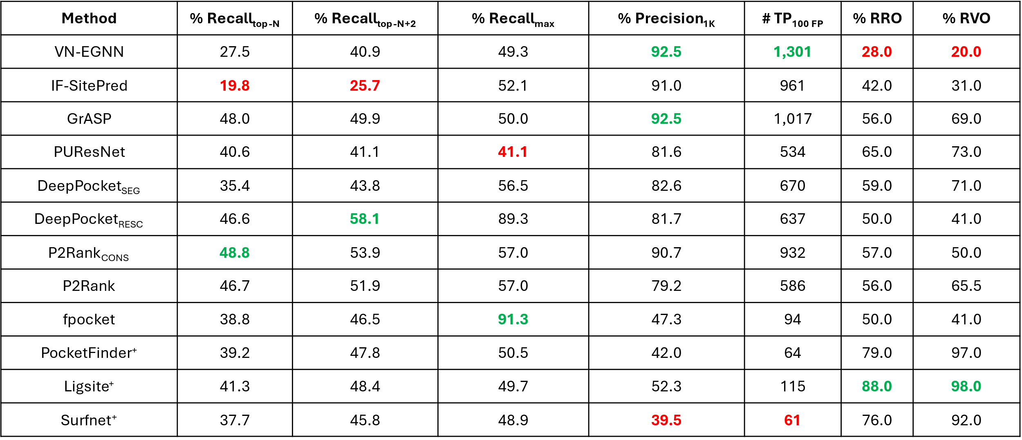
Table 4. Pocket level evaluation summary table. Recall for each method considering top-N, N+2 and all predictions (max) without taking rank into consideration, i.e., maximum recall. Precision of the method for the top-1,000 scored predictions. Number of TP reached for the first 100 FP (# TP_{100FP}). Median relative residue overlap (RRO) for those sites correctly predicted and relative volume overlap (RVO) only for correctly predicted sites that have a volume, i.e., are pockets or cavities, and not exposed sites, which don’t have a volume. These last two metrics represent the overlap in residues and volume relative to the observed site. Bold font indicates the best (green) and worst (red) performing methods for each metric.

Table 5. Residue level evaluation summary table. Ligand binding site prediction benchmark at the residue level was calculated from 2,775 protein chains in the LIGYSIS dataset. Median F1 score, median Matthews correlation coefficient (MCC), ROC area under the curve (AUC) and precision recall (PR) curve average precision (AP). Bold font indicates the best (green) and worst (red) performing methods.

