Supplementary Material

Spatial dynamics of caudatoside and ptaquiloside in bracken ferns in Northern Europe
Vaidotas Kisielius,,,*, Bo Markussen, Hans Christian Bruun Hansen², Lars Holm Rasmussen^{1,5}

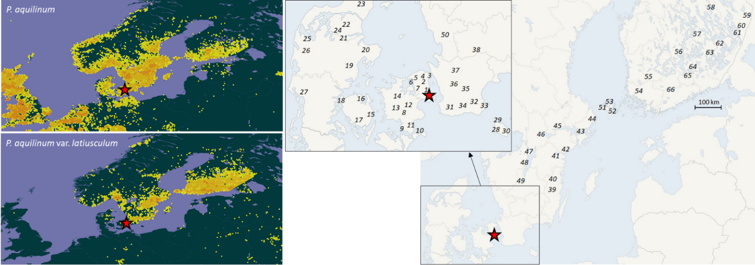
Figure S1. Recorded growing locations of Pteridium aquilinum (upper-left) and Pteridium aquilinum var. latiusculum (lower-right) (source: Global Biodiversity Information Facility, [Online]. Available: https://www.gbif.org/). Right: the selected sampling campaign with the star indicating location of the research laboratory.

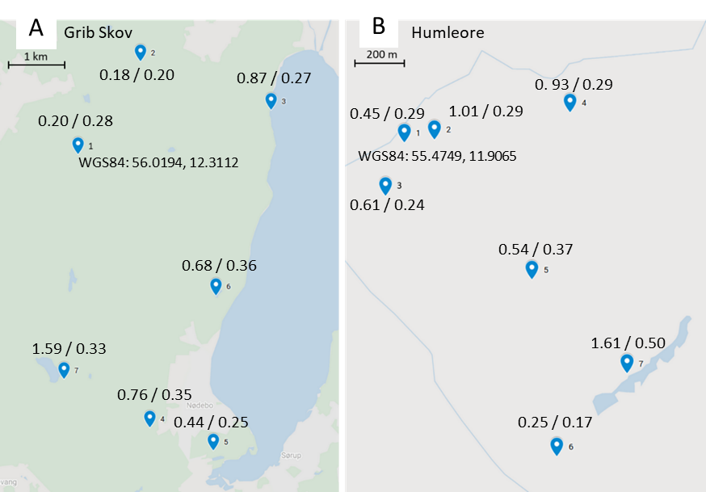
Figure S2. Average bracken contents (mg/g) of PTA and CAU for each sub. location over 6 months. Background map © Google maps.

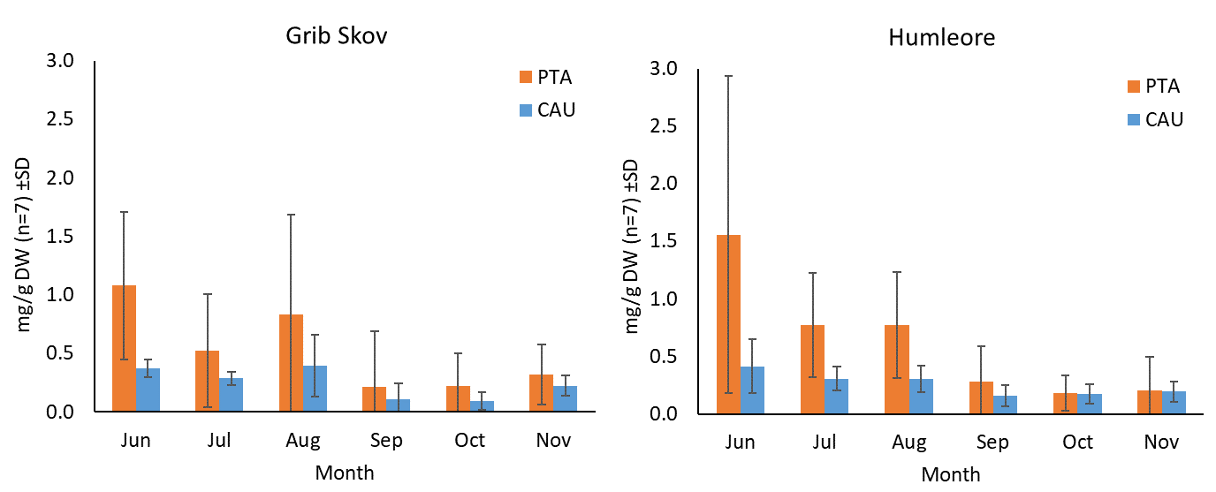
Figure S3. Average contents of PTA and CAU (mg/g DW) measured in bracken fronds in 7 sites in locations Grip Skov and Humleore. Statistically significant trend of compound decrease over time of the year was observed (tables 7 and 8 of the main text).
Table S1. Recorded information used for statistical analysis about the sampling locations.
Location No | latitude | longitude | Country | Taxonomic var. (Aquilinum/ Latiusculum) | direct sunshine | Tree type 1 | Tree type 2
1 | 56.54088 | 8.50665 | DK | A | no | deciduous | Light, Dark
2 | 56.25477 | 8.51052 | DK | A | no | deciduous | Light
3 | 55.54447 | 8.63914 | DK | A | no | deciduous | Light
4 | 56.72611 | 9.5338 | DK | A | no | deciduous | Light
5 | 56.5737 | 9.65237 | DK | A | no | deciduous | Dark
6 | 55.51496 | 9.69795 | DK | A | no | deciduous | Light, Dark
7 | 56.78236 | 9.75107 | DK | A | no | deciduous | Dark
8 | 56.12474 | 9.90716 | DK | A | yes | coniferous | Dark
9 | 57.26235 | 10.19518 | DK | A | no | coniferous | Dark
10 | 55.13785 | 10.34402 | DK | A | yes | coniferous | Dark
11 | 56.42987 | 10.51195 | DK | A | no | deciduous | Dark
12 | 55.534 | 10.52932 | DK | A | yes | deciduous, coniferous | Light, Dark
13 | 55.30091 | 10.82634 | DK | A | yes | deciduous, coniferous | Light, Dark
14 | 55.43796 | 11.52479 | DK | A | no | deciduous | Dark
15 | 55.62964 | 11.53478 | DK | A | no | deciduous | Light
16 | 55.05719 | 11.74527 | DK | A | no | coniferous | Dark
17 | 55.34658 | 11.78511 | DK | A | no | coniferous | Dark
18 | 55.47483 | 11.90649 | DK | A | no | deciduous | Dark
19 | 55.9106 | 11.98022 | DK | A | no | deciduous | Light, Dark
20 | 55.14045 | 12.02613 | DK | A | no | deciduous | Dark
21 | 55.98664 | 12.086 | DK | A | yes | deciduous | Dark
22 | 55.82563 | 12.23877 | DK | A | no | deciduous | Dark
23 | 55.04385 | 12.2623 | DK | A | no | deciduous | Dark
24 | 56.01947 | 12.31138 | DK | A | no | deciduous | Light
Continues in next page
Continued from previous page
Location No | latitude | longitude | Country | Taxonomic var. (Aquilinum/ Latiusculum) | direct sunshine | Tree type 1 | Tree type 2
25 | 55.80678 | 12.476 | DK | L | no | deciduous | Dark
26 | 55.92783 | 12.34852 | DK | A | yes | deciduous | Dark
27 | 56.03362 | 12.56166 | DK | A | yes | deciduous | Light
28 | 56.85314 | 13.02913 | SE | L | no | deciduous, coniferous | Light, Dark
29 | 55.95572 | 13.25764 | SE | A | yes | deciduous, coniferous | Dark
30 | 55.53219 | 13.26748 | SE | A | no | deciduous | Dark
31 | 56.15649 | 13.34669 | SE | A | yes | coniferous | Dark
32 | 55.88317 | 13.66398 | SE | A | no | deciduous | Dark
33 | 55.5888 | 13.72492 | SE | A | no | deciduous | Dark
34 | 57.6057 | 13.93799 | SE | L | no | coniferous | Dark
35 | 55.66968 | 14.03258 | SE | A | no | deciduous | Dark
36 | 56.51645 | 14.13639 | SE | A | yes | none | none
37 | 55.65715 | 14.26418 | SE | A | no | deciduous | Dark
38 | 58.34846 | 14.32337 | SE | L | no | coniferous | Dark
39 | 58.6714 | 14.60341 | SE | L | no | deciduous | Light
40 | 55.14371 | 14.71485 | DK | A | no | deciduous | Light
41 | 55.26328 | 14.76237 | DK | A | no | deciduous | Light
42 | 55.10014 | 15.10326 | DK | A | yes | deciduous | Dark
43 | 59.31375 | 15.29605 | SE | A | yes | none | none
44 | 57.38137 | 15.72451 | SE | A | no | deciduous, coniferous | Dark
45 | 57.78995 | 15.76087 | SE | A | yes | deciduous, coniferous | Light, Dark
46 | 58.53731 | 16.03987 | SE | A | yes | coniferous | Dark
47 | 59.63529 | 16.63297 | SE | L | no | deciduous, coniferous | Light, Dark
48 | 58.76834 | 16.99811 | SE | L | no | deciduous, coniferous | Light, Dark
49 | 59.43621 | 18.07476 | SE | A | no | deciduous, coniferous | Light, Dark
50 | 59.72428 | 19.03942 | SE | A | yes | none | none
51 | 60.24749 | 19.48384 | FI | L | no | deciduous, coniferous | Light, Dark
52 | 60.369 | 19.91617 | FI | A | no | deciduous, coniferous | Light, Dark
53 | 60.07292 | 20.14584 | FI | A | no | deciduous, coniferous | Light
54 | 60.63566 | 22.03978 | FI | A | yes | coniferous | Dark
55 | 61.23323 | 22.70801 | FI | A | no | deciduous, coniferous | Light, Dark
56 | 60.71496 | 24.47065 | FI | A | no | deciduous, coniferous | Light, Dark
57 | 61.91875 | 25.3372 | FI | L | no | deciduous | Light
58 | 61.0663 | 25.80758 | FI | A | no | deciduous, coniferous | Light, Dark
59 | 61.33358 | 26.16437 | FI | L | no | deciduous, coniferous | Light
60 | 62.54933 | 26.97207 | FI | A | no | coniferous | Dark
61 | 61.7381 | 27.52081 | FI | A | no | coniferous | Dark
62 | 63.19842 | 28.25248 | FI | A | no | deciduous, coniferous | Light, Dark
63 | 61.95601 | 28.45833 | FI | A | no | coniferous | Dark
64 | 62.42426 | 30.38 | FI | A | no | deciduous | Light
65 | 62.56208 | 30.57539 | FI | A | no | deciduous, coniferous | Light, Dark
66 | 62.75316 | 31 | FI | A | no | deciduous | Light

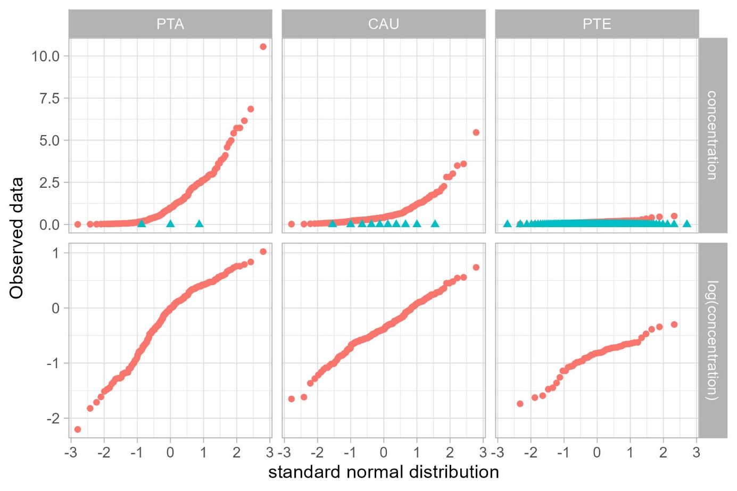
Figure S4. Statistical distribution of observed concentrations (mg/g DW) of PTA, CAU and PTE (in the columns) in the spatial variation study. Top row shows normal quantile plots separated into strictly positive observations (red circles) and zero observations (blue triangles). Lower row shows normal quantile plots for base-10 logarithm of the strictly positive observations. We only see close to straight lines in the lower row, which implies that the strictly positives observations are best modelled on a logarithmic scale.

Hypothesis tests in Dirichlet regression via permutation tests
The distribution among the three illudane glycosides was analysed in a Dirichlet regression using the R package DirichletReg. This package does not allow for random effects, but the experimental design called for a random effect of site in the statistical analysis. In order to take this into account in the hypotheses tests we used the permutation methodology described below.
Consider the spatial variation study using the fixed effect as specified in Table 2. Among these fixed effects site is nested in SW_NE, Country, taxonomic var., sunshine, deciduous, coniferous, light, and dark, while part goes across site. Or phrased differently, if you know the value of site, then you also know the value of SW_NE, …, and dark. In contrast, all values of part appear for all values of site. To do the permutation test for one of the effects in the former case, say the effect of Country, we first fit the Dirichlet regression to the original dataset and retain the likelihood value. After that we 1000 times permute the values of Country in the dataset under the restriction that site remains nested in Country, fit the Dirichlet regression to the permuted dataset and retain the likelihood value. The p-value for the effect of Country can then be found as the proportion of times, where the likelihood value for the permuted datasets is larger than or equal to the likelihood value for original dataset. The permutation test for part is done similarly, but here the permutations are done of the three observations within each of the sites.
Since the Dirichlet regression needs to be refitted for each of the permutations this procedure is computationally demanding. Hence we did not do a best-subset search as done for statistical analysis of content of the individual illudane glycosides. Instead we did a backward model reduction using the permutation tests on a 5 percent significance.

Department of Technology, University College Copenhagen, Sigurdsgade 26, 2200 Copenhagen, Denmark
Department of Plant and Environmental Sciences, University of Copenhagen, Thorvaldsensvej 40, 1871 Frederiksberg, Denmark
Department of Environmental Science, Aarhus University, Frederiksborgvej 399, 4000 Roskilde, Denmark vk@envs.au.dk
Department of Mathematical Sciences, University of Copenhagen, Universitetsparken 5, 2100 Copenhagen, Denmark 5 Present address: Biochemical Assays, Microbe & Culture Research, Novonesis, Bøge Allé 10-12, 2970 Hørsholm, Denmark * Corresponding author vk@envs.au.dk

