10. Appendices
Appendix 1. Composition of parental nutritional solutions
For 100 mL | PEDIAVEN APHP NN1 ® | PEDIAVEN APHP NN 2 ® | Numetah G13%E 3 CP ® | Numetah G13%E 2 CP ® | Numetah G16%E 3CP® | Numetah G16%E 3 CP ® | SNPN1 ®
Producer | Fresenius Kabi | Fresenius Kabi | Baxter | Baxter | Baxter | Baxter
Glucose (g) | 10 | 10 | 13,3 | 16,7 | 15,5 | 20,6 | 15
Carbohydrates (g) | 1,5 | 1,7 | 3,1 | 3,9 | 2,6 | 3,5 | 6
Lipids (g) | 0 | 0 | 2,5 | 0 | 3,1 | 0 | 0
Calories (kcal) | 46 | 79 | 91 | 82 | 93 | 96 | 84
Osmolarity (Osm) | 715 | 790 | 1150 | 1410 | 1230 | 1585 | 1364,5
Sodium (mmol) | 0,45 | 2 | 2,2 | 2,7 | 2,4 | 3,1 | 3
Potassium (mmol) | 0 | 1,7 | 2,1 | 2,6 | 2,28 | 3 | 0
Calcium (mmol) | 0,94 | 0,76 | 1,3 | 1,6 | 0,62 | 0,82 | 0
Magnesium (mmol) | 0,21 | 0,16 | 0,16 | 0,2 | 0,32 | 0,41 | 0,3
Chlorure (mmol) | 0,5 | 2,6 | 3,1 | 3,9 | 2,8 | 3,7
Phosphore (mmol) | 0 | 0,91 | 1,3 | 1,3 | 0,88 | 0,85 | 2
Micronutrient | Yes | Yes | No | No | No | No | Yes
Vitamins | No | No | No | No | No | No | No

Producer | Clinoléic ®  Baxter | SMOF Lipids ®  Fresenius Kabi
TCL soja | 20% | 30%
TCL olive | 80% | 25%
TCM (coconut/palme) |  | 30%
TG à w3 (fish) |  | 15%

Appendix 2. Screenshots of the nutritional information provided by the Metavision prescription software
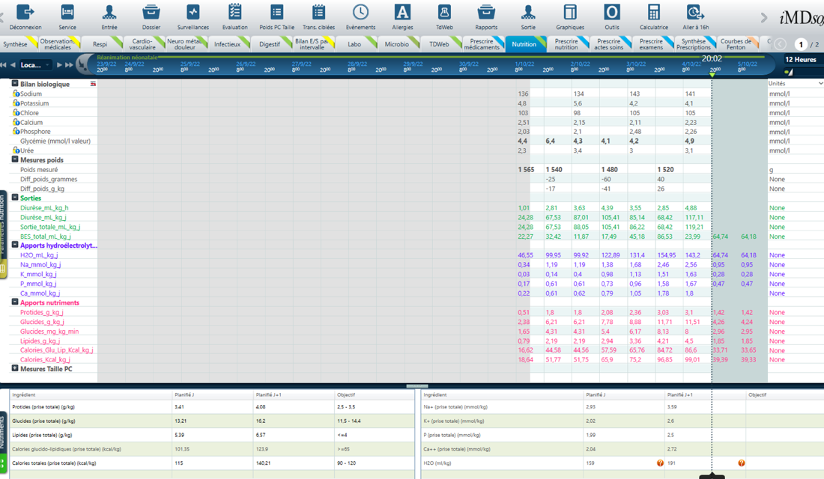
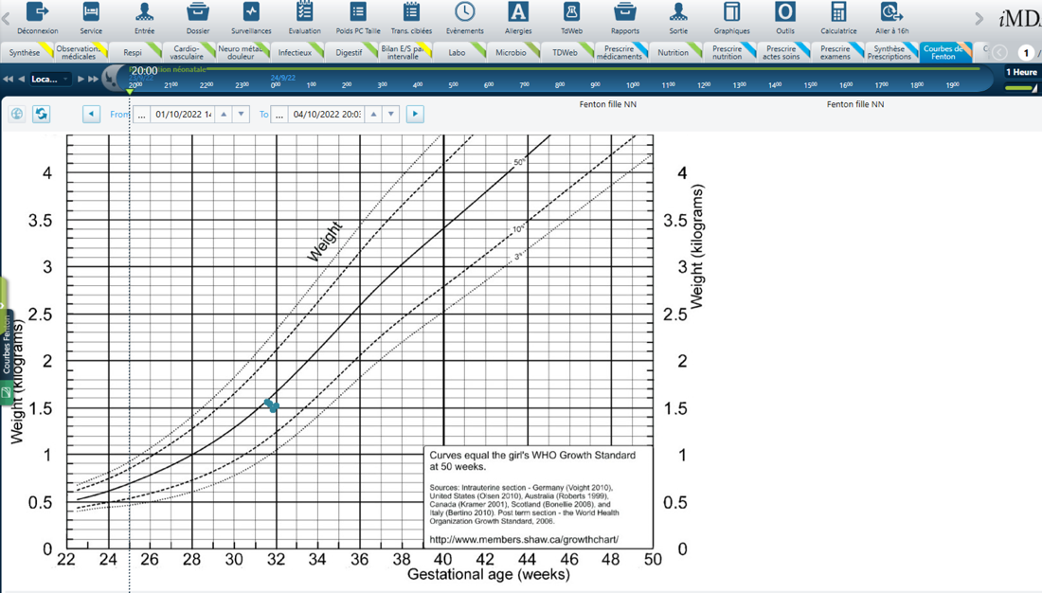

Appendix 3. The quality of weighting and matching was verified by estimation of SMDs, revealing the absence of residual imbalance
The propensity score was estimated using a logistic regression model with caloric and/or protein intake as the dependent variable with respect to the following characteristics: gestational age, sex, BW Z score, antenatal corticosteroid therapy, PROM over 24 hours, preeclampsia, multiparity, chorioamniotitis, mode of birth, 1- and 5-minute APGAR, intubation, and surfactant instillation.

