Supplementary materials 1
The ASIA spinal nerve function score is applied for assessing motor and sensory functions of the cervical nerves at the same times before and after the procedure. The scoring categorizes function into five grades, detailed as follows: Grade A indicates total spinal cord injury without any motor or sensory function in the sacral segments; Grade B signifies incomplete spinal cord injury with sensory but no motor function; Grade C describes incomplete spinal cord injury with both sensory and motor functions, but muscle strength below level 3; Grade D represents incomplete spinal cord injury with sensory and motor functions, where muscle strength is level 3 or above; Grade E indicates normal sensory and motor functions, with muscle strength intact.
Supplementary materials 2
Average Filtering
Mean filtering is a simple, intuitive, and easy-to-implement method for smoothing images, reducing intensity variation between pixels, and often used to reduce noise. It replaces each pixel value with the mean value of its neighbors, eliminating unrepresentative pixel values. Mean filtering is a convolution filter using a kernel to sample the neighborhood when calculating the mean. However, it can be affected by a single unrepresentative pixel and can blur edges if the filter straddles an edge. ¹²
Median Filtering
The median filter reduces noise in an image, often preserving detail better than the mean filter. It replaces the pixel value with the median of neighboring values, making it more robust against unrepresentative pixels. Since the median value is from one of the neighborhood pixels, it does not create unrealistic values when straddling an edge, preserving sharp edges better than the mean filter. ³
Box Filtering
Box Filter is a low-pass filter that smooths images by averaging surrounding pixels, removing details, noise, and edges. It is fast to compute and used to speed up computation-intensive operations in Image Processing and Computer Vision. It filters based on a moving window (or box) . ⁴⁵
Gaussian Filtering
The Gaussian smoothing operator is a 2-D convolution operator that blurs images and removes noise, similar to the mean filter but using a Gaussian-shaped kernel. It supports automatic kernel size calculation or user-provided parameters. Gaussian smoothing provides gentler smoothing and better edge preservation than the mean filter, outputting a weighted average of each pixel's neighborhood. Its frequency response justifies its use as a smoothing filter, effectively removing high spatial frequency components from an image. ⁶⁷
Supplementary materials 3
Category | Original Segment 1 | Original Segment 2 | Average Segment 1 | Average Segment 2 | Box Filter Segment 1 | Box Filter Segment 2 | Gaussian Blur Segment 1 | Gaussian Blur Segment 2 | Median Blur Segment 1 | Median Blur Segment 2
Shape-based features | 14 | 14 | 14 | 14 | 14 | 14 | 14 | 14 | 14 | 14
First-order features | 18 | 18 | 18 | 18 | 18 | 18 | 18 | 18 | 18 | 18
Gray-level dependence matrix (GLDM) features | 14 | 14 | 14 | 14 | 14 | 14 | 14 | 14 | 14 | 14
Gray-level size zone matrix (GLSZM) features | 16 | 16 | 16 | 16 | 16 | 16 | 16 | 16 | 16 | 16
Neighboring gray-tone difference matrix (NGTDM) features | 5 | 5 | 5 | 5 | 5 | 5 | 5 | 5 | 5 | 5
Gray-level run-length matrix (GLRLM) features | 16 | 16 | 16 | 16 | 16 | 16 | 16 | 16 | 16 | 16
Gray-level co-occurrence matrix (GLCM) features | 24 | 24 | 24 | 24 | 24 | 24 | 24 | 24 | 24 | 24
Supplementary materials 4
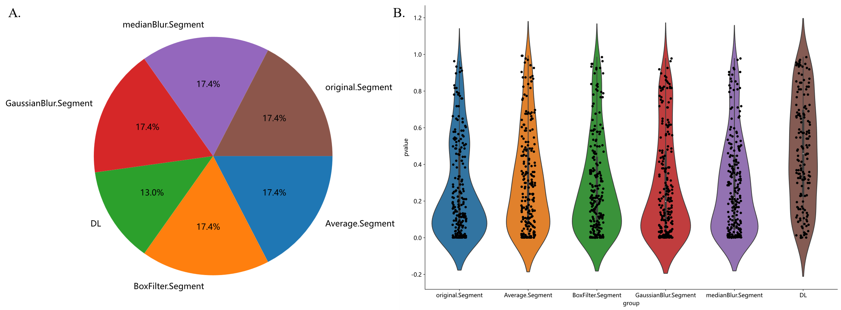
在ResNet50+Radiomics模型中，提取特征分布的扇形图和小提琴图，A：扇形图，表示各种类特征的百分比；B：小提琴图，表示各类特征的显著性大小及分布。

Supplementary materials 5
Because of leak of image data, In order to better carry out the generalization, we carefully set the learning rate. We adapt cosine decay learning rate algorithm in this study. Our learning rate is presented as follow:
$$η_{t}^{task-spec}=η_{min}^{i}+\frac{1}{2}\left(η_{max}^{i}-η_{min}^{i}\right)\left(1+cos\left(\frac{T_{cur}}{T_{i}}π\right)\right) \text{(1)}$$
$η_{min}^{i}=0$, $η_{max}^{i}$ =0.01, $T_{i}=50$ Represents the minimum learning rate, the maximum learning rate, and the number of iteration epochs, respectively. Because the backbone part adopts pre training parameters, in order to ensure the migration effect, On $T_{cur}=\frac{1}{2}T_{i}$Fine tune the parameters of the backbone part. Therefore, the learning rate of backbone part is as follows:
$$η_{t}^{backbone}=\left\{\begin{matrix}0 & \text{ if }T_{cur}≤\frac{1}{2}T_{i} \\ η_{min}^{i}+\frac{1}{2}\left(η_{max}^{i}-η_{min}^{i}\right)\left(1+cos\left(\frac{T_{cur}}{T_{i}}π\right)\right) & \text{ if }T_{cur}>\frac{1}{2}T_{i}\end{matrix}\right. \text{(2)}$$
Other hyperparameter configurations are as follows: optimizer: SGD, loss function: sigmoid cross entropy.
Supplementary materials 6
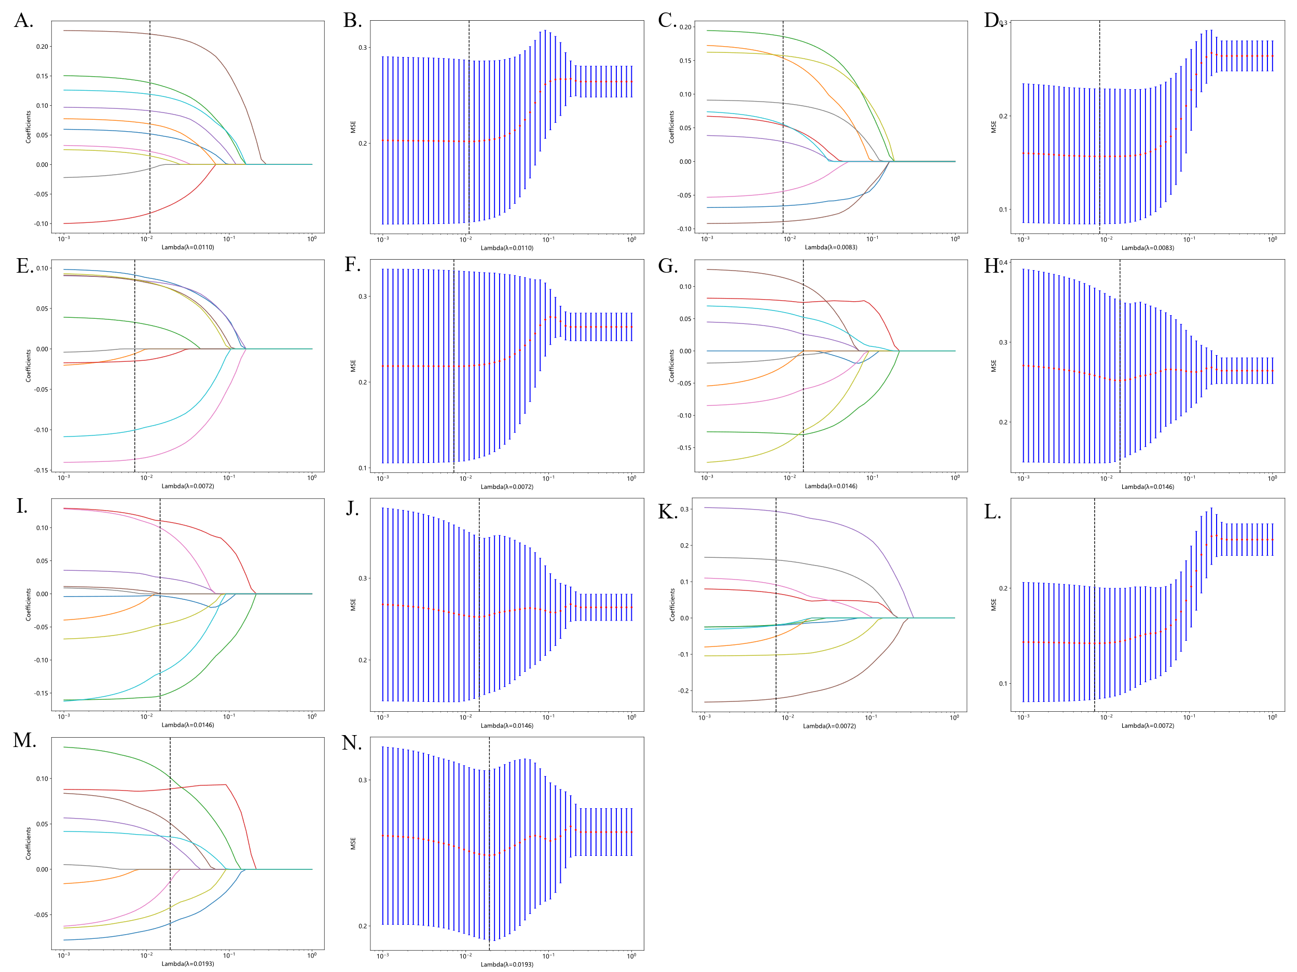
LASSO logistic regression is a binary classification model that automatically selects relevant features and reduces model complexity through L1 regularization. It uses the logistic function for binary outcomes. The partial likelihood deviance (binomial deviance) curve was plotted vs.log(lambda)(left). Dotted vertical lines were drawn at theoptimal values by using the minimum criteria and the 1SE of the minimum criteria the 1-SE crteria)(right).This figure has been established across seven different models.
(A)The ResNet18 model;(B) The ResNet50 model;(C) The ResNet101 model;(D)The radiomics model(E)The radiomics+resnet18 model;(F)The radiomics+resnet50 model;(G)The radiomics+resnet101 model.

Supplementary materials 7
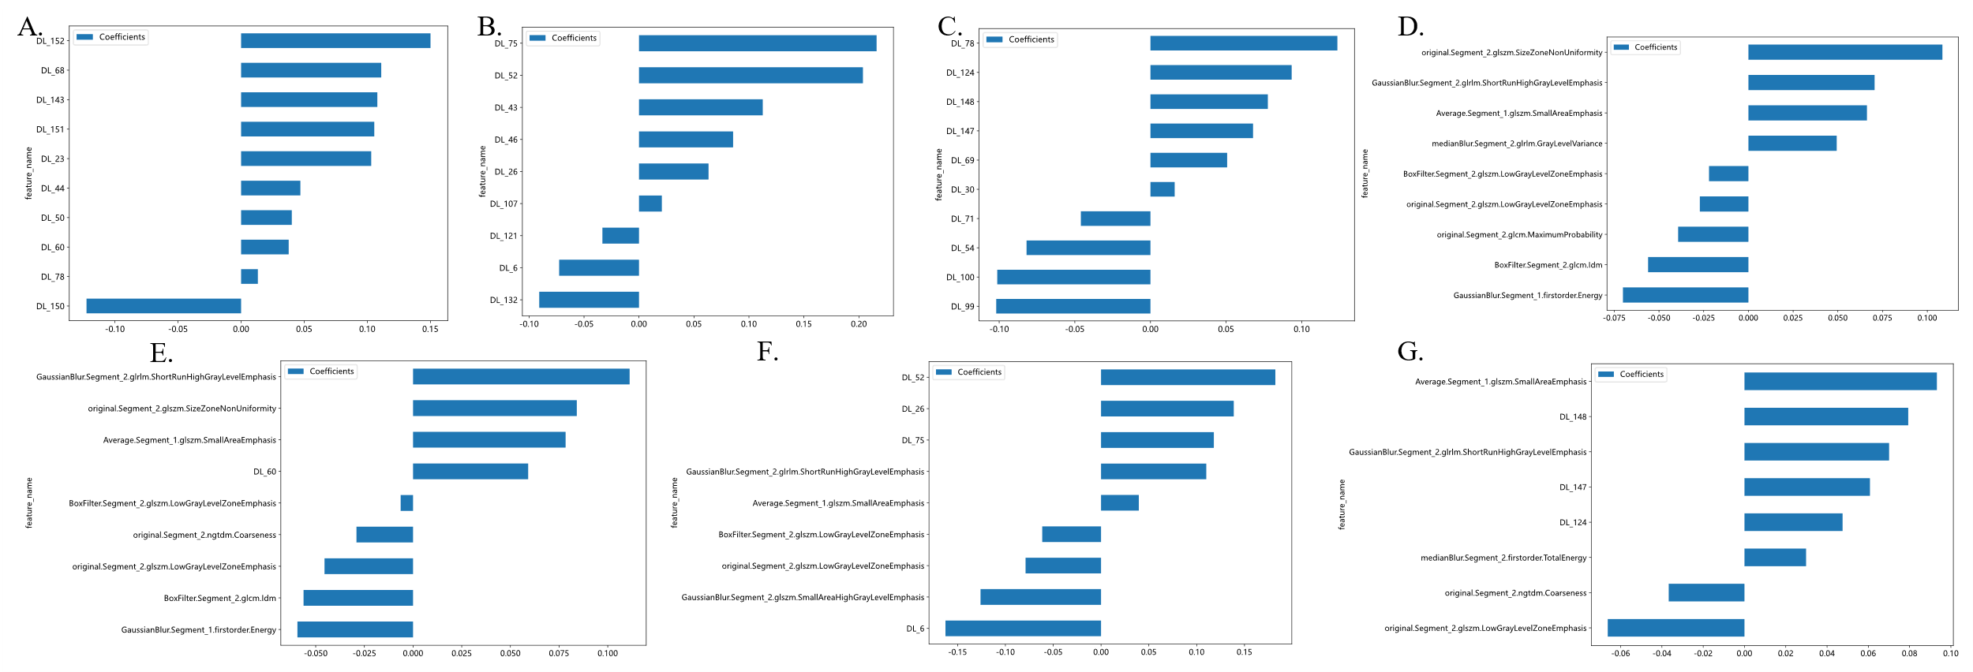
Feature weight of 7 models(A)The ResNet18 model;(B)The ResNet50 model;(C)The ResNet101 model;(D)The radiomics model(E)The radiomics+resnet18 model;(F)The radiomics+resnet50 model;(G)The radiomics+resnet101 model.

