Table 1. Summary of results and clinicopathological characteristics of GI-NEN cases examined in this study.
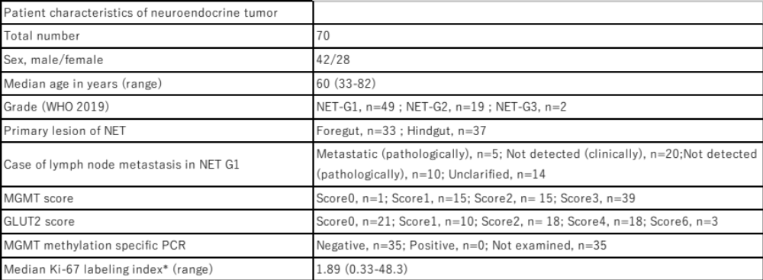
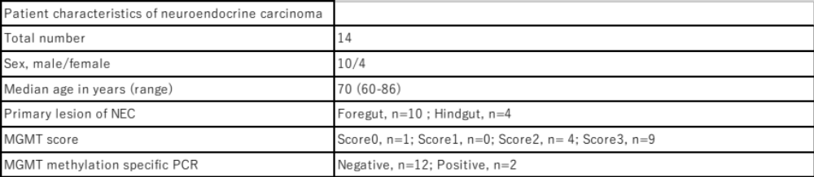
*Round the fourth digit.

Table 2. Summary of immunohistochemistry procedures used in this study.

Table 3. Correlation among MGMT and GLUT2 immunoreactivity.
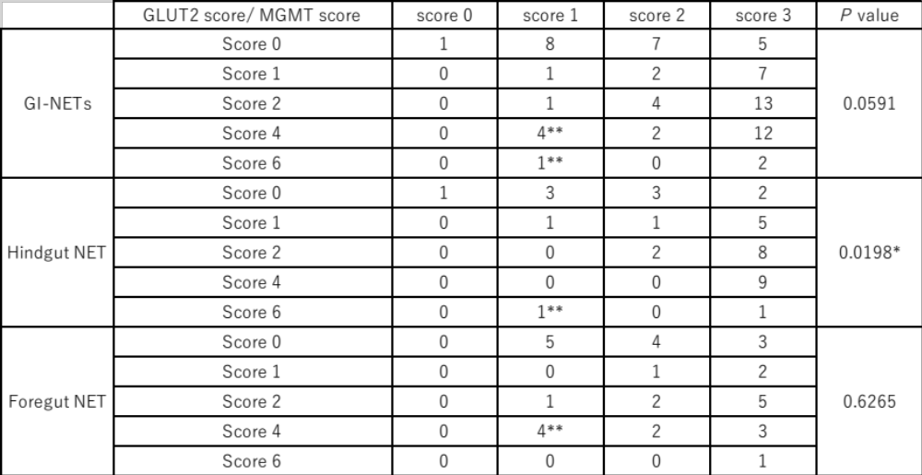
* Statistical significance.
** GI-NET cases which could be potential candidates for STZ therapy.

Table 4. Comparison of MGMT and GLUT2 score in foregut and hindgut NETs according to histological grades.
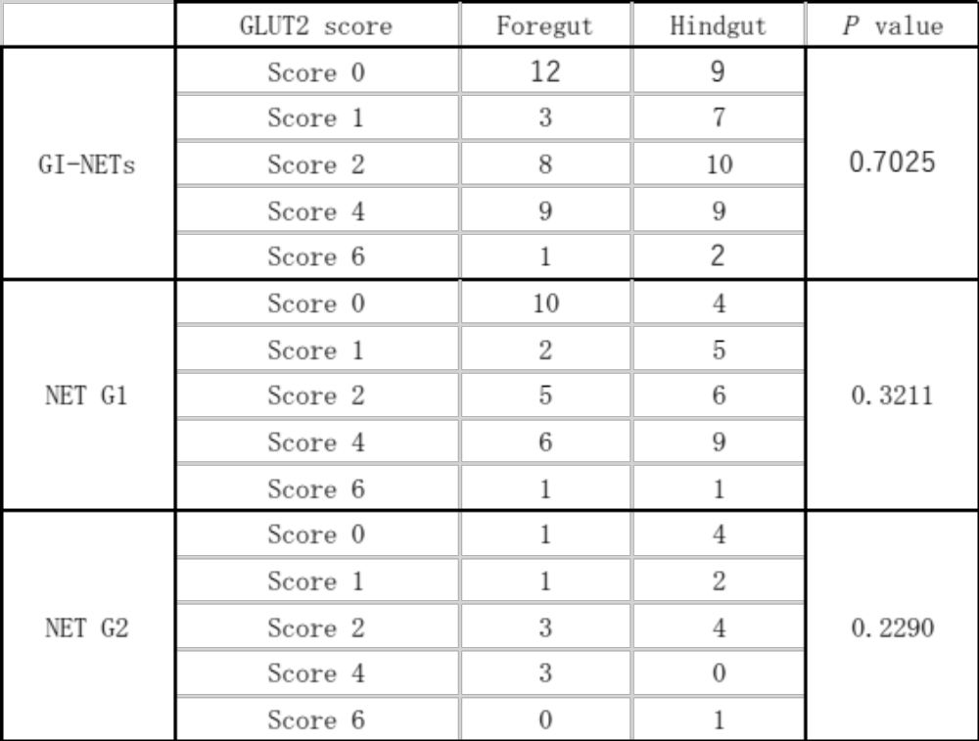
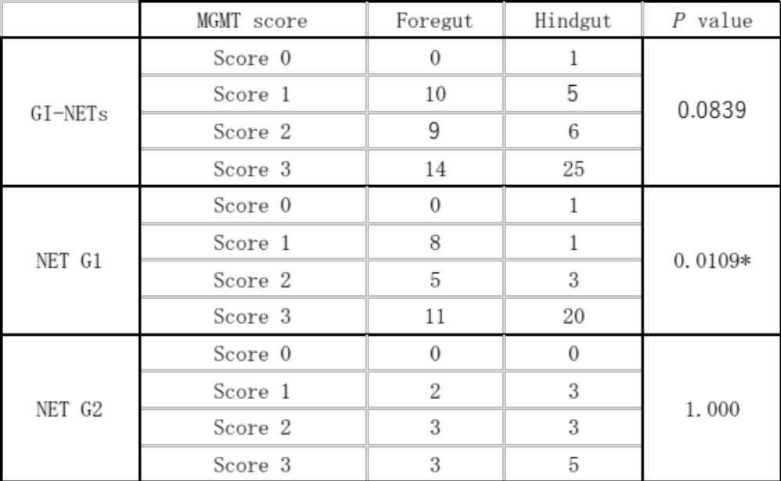
* Statistical significance.
Table 5. Comparison of MGMT and GLUT2 scores of primary tumors with metastatic lesions.
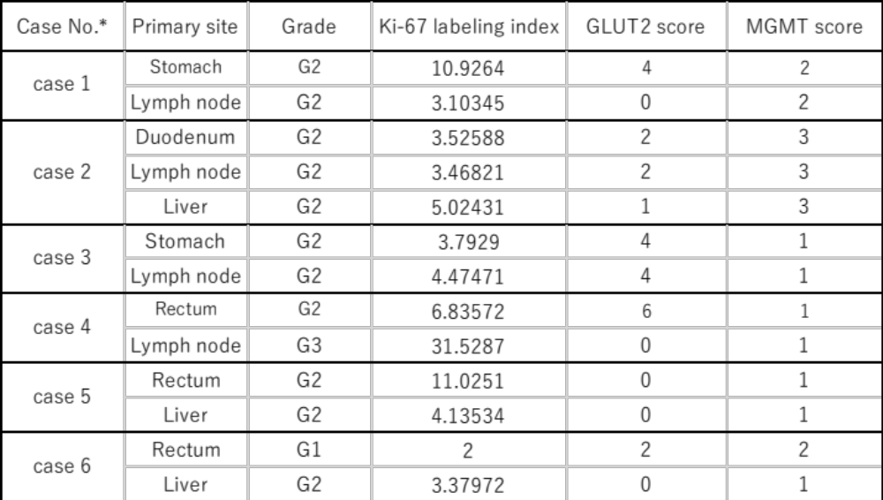
* Patient characteristics of these cases: male, n=3; female, n=3 / Median age in years (range), 65.5 (41-67)

Table 6. Correlation between MGMT or GLUT2 status and lymph node metastases.
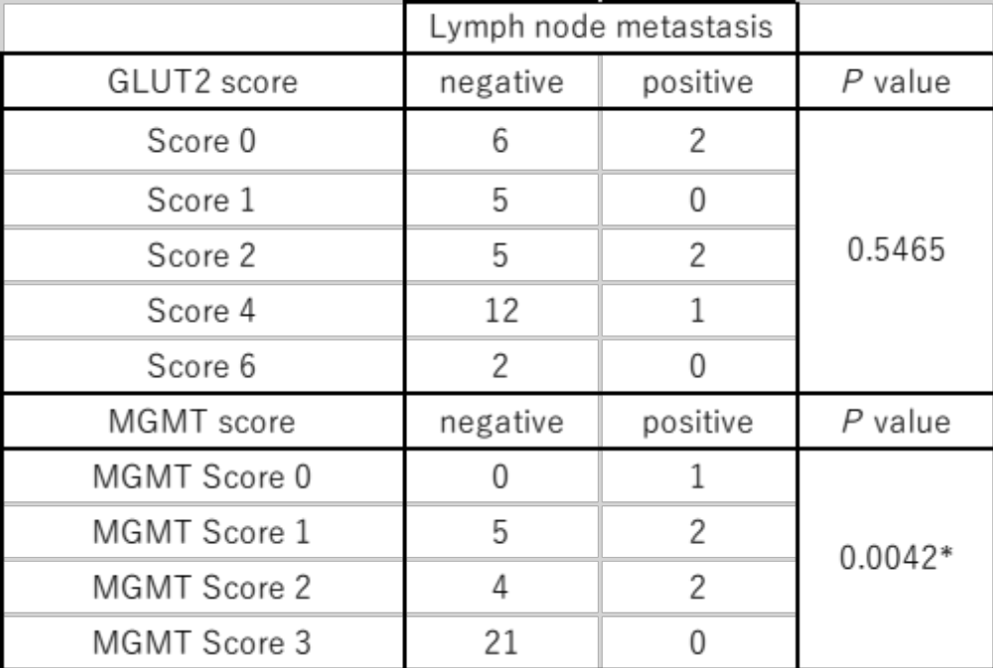
* Statistical significance.

Table 7. Comparison of MGMT immunoreactivity of NETs and NECs.
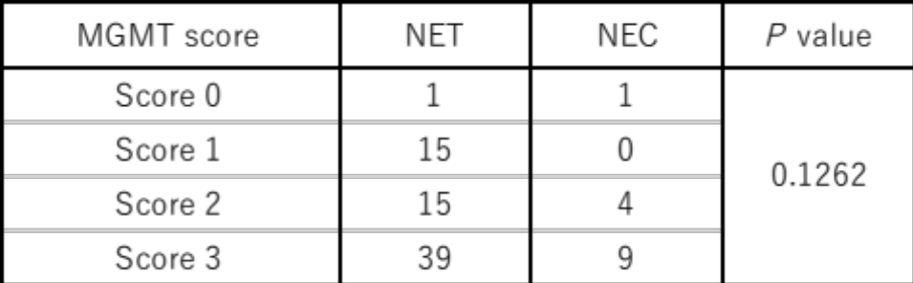

Table 8. Clinicopathological findings of GI-NEN cases in which MGMT promoter methylation status was analyzed using methylation-specific PCR.
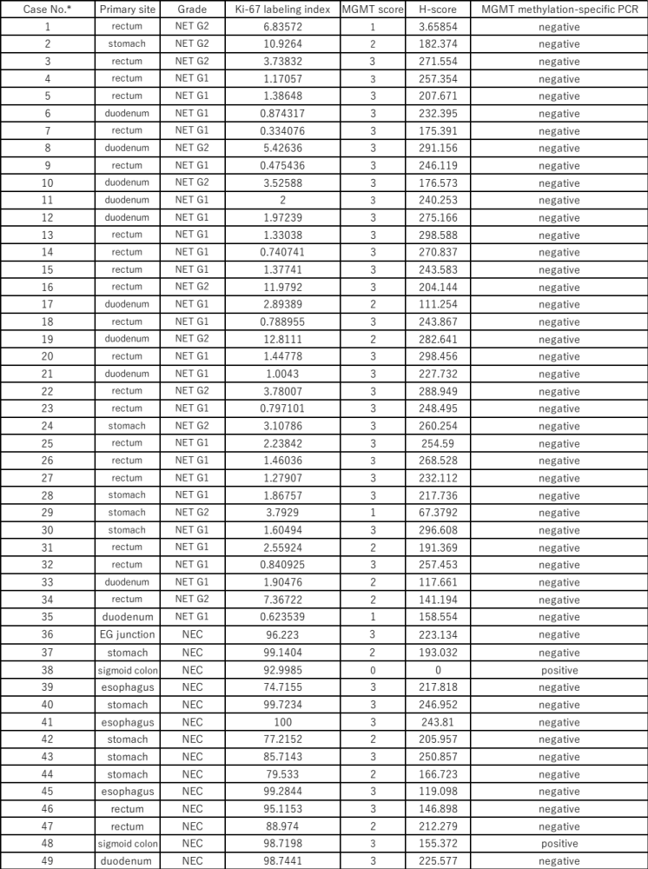
* Patient characteristics of these cases: male, n=32; female, n=17/ Median age in years (range), 66 (39-86)

