Revealing the biodiversity of wild bees (Hymenoptera: Apoidea: Anthophila) in flower strips in Mediterranean floodplains. Which monitoring method fits best?

Oana Catalina Moldoveanu^{1,δ}, Martino Maggioni^{2,3,1,δ}, Daniele Vergari⁴ and Francesca Romana Dani^{1,3,*}.
¹Department of Biology, University of Florence, Italy.
²Terrestrial and Marine Sciences Department, University of Palermo, Italy.
³National Future Biodiversity Centre, Palermo, Italy.
⁴Consorzio di Bonifica Medio Valdarno 3, Florence, Italy.
^{δ}These authors contributed equally to this work.
*Corresponding author.
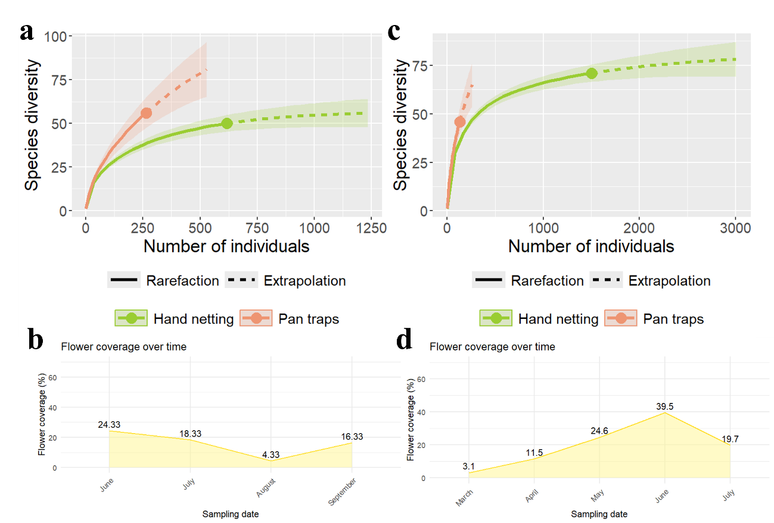
Figure S1. Species (and morphospecies) rarefaction and extrapolation curves of 2022 samplings (a) and 2023 (c). Both rarefaction and extrapolation curves show that pan traps collected a greater number of species than hand netting at the same sample size although the 2023 rarefaction curve showed that pan traps collected fewer species collected by hand netting. Mean flowering coverage over 2022 (b) and 2023 (d) sampling seasons. Pan traps appear to capture more species at lower flowering coverage (2022) than at higher (2023).

