Supporting information to:
Adjustable current-responsive photoswitches based on azobenzene derivatives

Materials
The following reagents and solvents were used as received: sodium chloride (Energy Chemical, 99.9%), methanol (He Hui Chemical, 99%), ethanol (He Hui Chemical, 99%), acetic acid (He Hui Chemical, 99%), acetone (He Hui Chemical, 99%), ethyl ether (He Hui Chemical, 99%), tetrahydrofuran (He Hui Chemical, 99%) , sodium sulphate (Energy Chemical, 99%), ethyl acetate (He Hui Chemical, 99%), hydrochloric acid (He Hui Chemical, 37%), iodomethane (Energy Chemical, 99.5%), sodium nitrite (Energy Chemical, 98%), phenol (Energy Chemical, 99%), sodium hydroxide(Energy Chemical, 97%), manganese dioxide (Energy Chemical, 92%), deuterated chloroform (Cui Ying Chemical, 99.8%), acetonitrile (Energy Chemical, 99.9%), dichloromethane (He Hui Chemical, 99.9%), potassium carbonate (Energy Chemical, 99%), nitrosobenzene (Energy Chemical, 97%), p-toluidine (Energy Chemical, 99%), 4-chloroaniline (Energy Chemical, 99%), 4-fluoroaniline (Energy Chemical, 99%), 4-phenylazophenol (Aladdin, 97%), 4-isopropylaniline (Energy Chemical, 98%), 4-methoxyaniline (Energy Chemical, 99%), azobenzene (Macklin, 97%), 4,4'-diaminoazobenzene (Energy Chemical, 97%), 4,4'-dihydroxyazobenzene (Energy Chemical, 98%), azobenzene-4,4'-dicarboxylic acid (Energy Chemical, 95%), tetrabutylammonium hexafluorophosphate (Energy Chemical, 98%).

Synthetic Procedures
(a) H-AB-Me: nitrosobenzene (0.54 g, 5 mmol, 1.0 eq) was dissolved in a mixed solvent of glacial acetic acid (12 mL) and EtOH (3 mL). p-toluidine (0.54 g, 5 mmol, 1.0 eq) was added to the solution in one portion. The reaction mixture was stirred at 40 °C for 12 h. The resulting solution was poured into ice water and filtered to give the title compound in 86% yield (0.85 g, 4.3 mmol). ¹H-NMR (400 MHz, CDCl₃) δ: 7.90 (d, J=8.2 Hz, 2H), 7.83 (d, J=8.4 Hz, 2H), 7.51 (t, J=7.4 Hz, 2H), 7.46 (t, J=7.2 Hz, 1H), 7.32 (d, J=8.3 Hz, 2H), 2.44 (s, 3H) ppm
(b) H-AB-Cl: nitrosobenzene (0.54 g, 5 mmol, 1.0 eq) was dissolved in a mixed solvent of glacial acetic acid (12 mL) and EtOH (3 mL). 4-chloroaniline (0.56 g, 5 mmol, 1.0 eq) was added to the solution. The reaction mixture was stirred at 40 °C for 12 h. The resulting mixture was poured into ice water and filtered to give the title compound in 42% yield (0.46 g, 2.1 mmol). ¹H-NMR (400 MHz, CDCl₃) δ: 7.89 (dd, J=13.5, 8.3 Hz, 4H), 7.57-7.45 (m, 5H) ppm.
(c) H-AB-F: nitrosobenzene (0.54 g, 5 mmol, 1.0 eq) was dissolved in mixed solvent of glacial acetic acid (12 mL) and EtOH (3 mL). 4-Fluoroaniline (0.64 g, 5 mmol, 1.0 eq) was added to the solution in one portion. The reaction mixture was stirred at 40 °C for 12 h. The resulting mixture was poured into ice water and filtered to give the title compound in 58% yield (0.59 g, 2.9 mmol). ¹H-NMR (400 MHz, CDCl₃) δ: 8.00-7.86 (m, 4H), 7.57-7.43 (m, 3H), 7.20 (d, J=17.2 Hz, 2H) ppm.

(d) H-AB-OMe: 4-hydroxyazobenzene (1.00 g, 5 mmol, 1.0 eq) and K₂CO₃ (0.70 g, 5 mmol, 1.0 eq) were dissolved in acetone (15 mL), to which CH₃I (0.31 mL, 5 mmol, 1.0 eq) was added. The reaction mixture was refluxed at 55 °C for 48 h. The residue was dissolved in water (50 mL) and extracted with ether (3×20 mL). The combined organic phase was washed with saturated NaCl solution (1×20 mL), dried over MgSO₄ and concentrated under reduced pressure. The crude product was purified by column chromatography (PE/EA=10/1, v/v) to give the title compound in 83% yield (0.89 g, 4.2 mmol). ¹H-NMR (400 MHz, CDCl₃) δ: 7.99-7.92 (m, 2H), 7.92-7.86 (m, 2H), 7.51 (dd, J=8.2, 6.6 Hz, 2H), 7.45 (d, J=7.2 Hz, 1H), 7.06-6.98 (m, 2H), 3.90 (s, 3H) ppm.

(e) H-AB-N(Me)₂: nitrosobenzene (0.54 g, 5 mmol, 1.0 eq) was dissolved in a mixed solvent of glacial acetic acid (12 mL) and EtOH (3 mL), to which 4-isopropylaniline (0.68 g, 5mmol, 1.0 eq) was added. The reaction mixture was stirred at 40 °C for 12 h. The resulting mixture was poured into ice water and filtered to give the title compound in 59% yield (0.67 g, 2.97 mmol). ¹H-NMR (400 MHz, CDCl₃) δ: 7.90 (d, J=8.8 Hz, 2H), 7.85 (d, J=7.7 Hz, 2H), 7.47 (t, J=7.8 Hz, 2H), 7.38 (t, J=7.3 Hz, 1H), 6.78 (d, J=9.2 Hz, 2H), 3.10 (s, 6H) ppm.

(f) Me-AB-OH: distilled water (25 mL), p-toluidine (5.36 g, 50 mmol, 1.0 eq) and 37% hydrochloric acid (17.5 mL) were added to a 100 mL round bottom flask. After cooling to 0 °C in an ice-water bath for 30 min, NaNO₂ aqueous solution (2 mM, 25 mL) was added slowly into the mixture and stirred for another 1 h to form the diazo salt. An aqueous solution (45 mL) of phenol (4.71 g, 50 mmol, 1.0 eq) and sodium hydroxide (2.00 g, 50 mmol, 1.0 eq) was added to the round bottom flask dropwise. The resulting mixture was stirred at 0 °C for an additional 4 hrs. The precipitate was washed with water to furnish a yellow, crude product, which was purified by column chromatography (PE/EA=4/1, v/v) to give the title compound in 27% (2.82 g, 13.3 mmol). ¹H-NMR (400 MHz, CDCl₃) δ: 7.86 (d, J=8.9 Hz, 2H), 7.78 (d, J=8.4 Hz, 2H), 7.30 (d, J=8.0 Hz, 2H), 6.94 (d, J=8.9 Hz, 2H), 2.43 (s, 3H) ppm.

(g) Me-AB-OMe: Me-AB-OH (1.00 g, 4.71 mmol) and K₂CO₃ (0.65 g, 4.71 mmol, 1.0 eq) were dissolved in acetone (15 mL), to which CH₃I (0.30 mL, 4.71 mmol, 1.0 eq) was added. The reaction mixture was refluxed at 55 °C for 48 h. The residue was dissolved in water (50 mL) and extracted with ether (3×20 mL). The combined organic phase was washed with saturated NaCl solution (1×20 mL), dried over MgSO₄ and concentrated under reduced pressure. The crude product was purified by column chromatography (PE/EA=10/1, v/v) to give the title compound in 72% yield (0.77 g, 3.4 mmol). ¹H-NMR (400 MHz, CDCl₃) δ: 7.91 (d, J=9.0 Hz, 2H), 7.79 (d, J=8.3 Hz, 2H), 7.30 (d, J=7.9 Hz, 2H), 7.01 (d, J=9.0 Hz, 2H), 3.89 (s, 3H), 2.43 (s, 3H) ppm.

(h) Cl-AB-OH: distilled water (25 mL), 4-chloroaniline (6.38 g, 50 mmol, 1.0 eq) and 37% hydrochloric acid (17.5 mL) were added to a 100 mL round bottom flask. After cooling to 0 °C in an ice-water bath for 30 min, NaNO₂ aqueous solution (2 mM, 25 mL) was added slowly into the mixture and stirred for another 1 h to form the diazo salt. An aqueous solution (45 mL) of phenol (4.71 g, 50 mmol, 1.0 eq), and sodium hydroxide (2.00 g, 50 mmol, 1.0 eq) was added to the reaction mixture dropwise and stirred for an additional 4 hrs at 0 °C. The precipitate was washed with water to furnish a yellow crude product, which was purified by column chromatography (PE/EA= 4/1, v/v) to give the title compound in 27% yield (3.15 g, 13.5 mmol). ¹H-NMR (400 MHz, CDCl₃) δ: 7.87 (d, J=8.8 Hz, 2H), 7.82 (d, J=8.7 Hz, 2H), 7.46 (d, J=8.8 Hz, 2H), 6.95 (d, J=8.9 Hz, 2H) ppm.

(i) Cl-AB-OMe: Cl-AB-OH (1.00 g, 4.30 mmol, 1.0 eq) and K₂CO₃ (0.60 g, 4.30 mmol, 1.0 eq) were dissolved in acetone (15 mL), to which CH₃I (0.27 mL, 4.71 mmol, 1.1 eq) was added. The reaction mixture was refluxed at 55 °C for 48 hrs. The residue was dissolved in water (50 mL) and extracted with ether (3×20 mL). The combined organic phase was washed with saturated NaCl solution (1×20 mL) , dried over MgSO₄ and concentrated under reduced pressure. The crude product was purified by column chromatography (PE/ EA=10/1, v/v) to give the title compound in 48% yield (0.51 g, 2.1 mmol). ¹H NMR (400-MHz, CDCl₃) δ: 7.91 (d, J=8.9 Hz, 2H), 7.83 (d, J=8.7 Hz, 2H), 7.46 (d, J=8.6 Hz, 2H), 7.02 (d, J=9.0 Hz, 2H), 3.90 (s, 3H) ppm.

(j) F-AB-OH: distilled water (25 mL), 4-fluoroaniline (6.38 g, 50 mmol, 1.0 eq) and 37% hydrochloric acid (17.5 mL) were added to a 100 mL round bottom flask. After cooling to 0 °C in an ice-water bath for 30 min, NaNO₂ aqueous solution (2 mM, 25 mL) was added slowly into the mixture and stirred for another 1 h to form the diazo salt. An aqueous solution (45 mL) of phenol (4.71 g, 50 mmol, 1.0 eq) and sodium hydroxide (2.00 g, 50 mmol, 1.0 eq) was added to the round bottom flask dropwise and stirred for an additional 4 hrs at 0 °C. The precipitate was washed with water to furnish a yellow crude product, which was purified by column chromatography (PE/EA=4/1, v/v) to give the title compound in 26% yield (2.76 g, 12.8 mmol). ¹H-NMR (400 MHz, CDCl₃) δ 7.97–7.79 (m, 4H), 7.18 (t, J=8.7 Hz, 2H), 6.94 (d, J=9.0 Hz, 2H) ppm.

(k) F-AB-OMe: F-AB-OH (1.00 g, 4.63 mmol) and K₂CO₃ (0.64 g, 4.63 mmol, 1.0 eq) were dissolved in acetone (15 mL), to which CH₃I (0.29 mL, 4.63 mmol, 1.0 eq) was added. The reaction mixture was refluxed at 55 °C for 48 h. The residue was dissolved in water (50 mL) and extracted with ether (3×20 mL). The combined organic phase was washed with saturated NaCl solution (1×20 mL), dried over MgSO₄ and concentrated under reduced pressure. The crude product was purified by column chromatography (PE/ EA=10/1, v/v) to give the title compound in 84% yield (0.89 g, 3.9 mmol). ¹H-NMR (400 MHz, CDCl₃) δ: 7.94-7.87 (m, 4H), 7.18 (t, J=8.6 Hz, 2H), 7.02 (d, J=9.0 Hz, 2H), 3.89 (s, 3H) ppm.

(l) Cl-AB-Cl: 4-chloroaniline (1.00 g, 7.84 mmol, 1.0 eq) was dissolved in toluene (50 mL), to which MnO₂ (6.81 g, 78.39 mmol, 10.0 eq) was added. The reaction mixture was refluxed at 105 °C for 12 h. The reaction mixture was filtered through a pad of Celite and the filtrate was concentrated under reduced pressure. The crude product was purified by column chromatography (PE/EA=4/1, v/v) to give the title compound in 33% yield (0.65 g, 2.6 mmol). ¹H-NMR (400 MHz, CDCl₃) δ: 7.86 (d, J=8.8 Hz, 4H), 7.49 (d, J=8.7 Hz, 4H) ppm.

(m) F-AB-F: 4-fluoroaniline (1.00 g, 9 mmol, 1.0 eq) was dissolved in toluene (50 mL), to which MnO₂ (7.82 g, 90 mmol, 10.0 eq) was added. The reaction mixture was filtered through a pad of Celite and the filtrate was concentrated under reduced pressure. The crude product was purified by column chromatography (PE/EA=20/1, v/v) to give the title compound in 19% yield (0.37 g, 1.7 mmol). ¹H-NMR (400 MHz, CDCl₃) δ: 7.93 (dd, J=9.0, 5.2 Hz, 4H), 7.20 (t, J=8.6 Hz, 4H) ppm.

(n) Me-AB-Me: p-toluidine (0.50 g, 4.67 mmol, 1.0 eq) was dissolved in toluene (25 mL), to which MnO₂ (4.06 g, 46.66 mmol, 10.0 eq) was added. The reaction mixture was refluxed at 110 °C for 24 h. The reaction mixture was filtered through a pad of Celite and the filtrate was concentrated under reduced pressure. The crude product was purified by column chromatography (PE/EA=4/1, v/v) to give the title compound in 45% yield (0.44 g, 2.1 mmol). ¹H-NMR (400 MHz, CDCl₃) δ: 7.80 (d, J=8.2 Hz, 4H), 7.30 (d, J=8.1 Hz, 4H), 2.42 (s, 6H) ppm.

(o) MeO-AB-OH: distilled water (25 mL), 4-methoxyaniline (6.16 g, 50 mmol, 1.0 eq) and 37% hydrochloric acid (17.5 mL) were charged to a 100 mL round bottom flask. After cooling to 0 °C in an ice-water bath for 30 min, NaNO₂ aqueous solution (2 mM, 25 mL) was added slowly into the mixture and stirred for another 1 h to form the diazo salt. An aqueous solution (45 mL) of phenol (4.71 g, 50 mmol, 1.0 eq) and sodium hydroxide (2.00 g, 50 mmol) was added dropwise and stirred for an additional 4 hrs at 0 °C. The precipitate was washed with water to furnish a yellow crude product, which was purified by column chromatography (PE/EA=4/1, v/v) to give the title compound in 28% yield (3.14 g, 13.8 mmol). ¹H-NMR (400 MHz, CDCl₃) δ: 7.85 (dd, J=16.9, 8.8 Hz, 4H), 7.00 (d, J=8.9 Hz, 2H), 6.93 (d, J=8.8 Hz, 2H), 3.89 (s, 3H) ppm.

(p) MeO-AB-OMe: MeO-AB-OH (1.00 g, 4.38 mmol, 1.0 eq) and K₂CO₃ (0.61 g, 4.38 mmol, 1.0 eq) were dissolved in acetone (15 mL), to which CH₃I (0.27 mL, 4.38 mmol, 1.0 eq) was added. The reaction mixture was refluxed at 55 °C for 48 h. The residue was dissolved in water (50 mL) and extracted with ether (3×20 mL). The combined organic phase was washed with saturated NaCl solution (1×20 mL), dried over MgSO₄. and concentrated under reduced pressure distillation. The crude product was purified by column chromatography (PE/EA=10/1) to give the title compound in 32% yield (0.34 g, 1.4 mmol). ¹H-NMR (400 MHz, CDCl₃) δ: 7.90 (d, J=8.7 Hz, 4H), 7.01 (d, J=8.8 Hz, 4H), 3.89 (s, 6H) ppm.

Structure characterization.
¹H Nuclear Magnetic Resonance (¹H-NMR) Spectroscopy. All NMR spectra were recorded on a Bruker DRX 400 MHz at 25 °C using an external lock (CDCl₃) and referenced to the residual non-deuterated solvent (CHCl₃).
UV-Vis. UV-Vis spectra were obtained using a Shimadzu 2600 UV-Vis spectrophotometer, and identical 4.0 mL quartz cuvettes were used. The sample was prepared using dichloromethane/acetonitrile as the solvent with concentration around 0.05 mM.
Attenuated Total Reflectance Fourier Transform Spectroscopy (ATR−FTIR). ATR-FTIR spectra were obtained using a diamond / ZnSe crystal ATR accessory on a Perkin-Elmer 400 FT-IR Spectrometer. Spectra were recorded between 4000 and 400 cm⁻¹ by acquiring 32 scans. Solids were pressed directly onto the diamond internal reflection element of the ATR without further sample preparation.

Electrochemical characterization
Cyclic Voltammetry (CV). Cyclic voltammetry analyses were performed by a Gamry Interface 5000E potentiostat/galvanostat or CHI 760E potentiostat with a polished glassy carbon electrode as the working electrode, a Pt-wire as the counter electrode, and Ag/AgCl (1M KCl) with salt bridge as a reference electrode. Azobenzene derivative solution (5 mM) in dry ACN with supporting electrolyte tetrabutylammonium hexafluorophosphate (NBu₄PF₆) 0.1 M was prepared for test. The system was then sealed and purged with N₂ for 5 mins. For redox potential characterization, the CV was test in a potential window of -0.5 to -2.0 V at a scan rate of 0.06 V/s. For kinetic characterization, The CV of the azobenzene derivatives were scanned within a potential window from -0.5 to -1.6 V at 0.02, 0.04, 0.06, 0.08, and 0.1 V/s. The charge transfer constant was evaluated from following equation：
$$i_{p}=2.69×{10}^{5}×n^{\frac{3}{2}}×A×D^{\frac{1}{2}}×C×v^{\frac{1}{2}}$$
$$k^{0}=ψ{\left(πD_{app}\frac{nFv}{RT}\right)}^{1/2}$$
n is the number of electrons,
A is the electrode surface area (cm²),
D is the diffusion coefficient (cm²/s),
C is the apparent concentration (mol cm⁻³),
ν is the scan rate of (V/s),
R is the gas constant (8.314 J mol⁻¹·K⁻¹),
T is the absolute temperature (298K),
F is the Faraday constant (96485 C·mol⁻¹),
ψ obtained from reference based on ∆E.
Ultramicroelectrode-Linear Sweep Voltammetry (UME-LSV). UME-LSV test was carried out with a Pt Ultramicroelectrode (Φ=10 µm), Pt-wire, Ag/AgCl (1M KCL) were adopt as counter and reference electrode respectively. E/Z azobenzene (AB, 5mM) and benzo[c]cinnoline (BC, 5mM) in 0.1 M NBu₄PF₆ acetonitrile electrolyte were prepared, followed by LSV from -0.5 to -2.0 V at a scan rate of 10 mV/s with/without UV radiation.
Electrochemical Impedance Spectroscopy (EIS)：AB derivatives (5 mM) in 0.1 M NBu₄PF₆ acetonitrile electrolyte was prepared and purged with N₂. Before EIS test, a CV was scanned first to determine the redox potential of AB derivatives as previous described. Potentiostatic EIS was recorded on Zive SP1 potentiostat with DC voltage set at the E_{1/2} of step 1 and step 2 reduction, AC voltage set as 50 mV and frequencies ranging from 0.05-1000000 Hz. The R_{ct} was simulated with ZMAN softerware and the k⁰ was calculated from equation：
$$R_{ct}=\frac{RT}{n^{2}F^{2}ACk^{0}}$$
R is the gas constant (8.314 J mol⁻¹·K⁻¹),
T is the absolute temperature (298K),
n is the number electrons,
F is the Faraday constant (96485 C mol⁻¹),
A is the electrode surface area (cm²),
C is the concentration of the azobenzene derivatives (mol cm⁻³).

Chronoamperometry (CA). chronoamperometry were performed using a three-electrode system with GC (Φ=3.0 mm) working electrode, Ag/AgNO₃ (10 mM) reference electrode and Pt counter electrode. Sample concentration of AB derivatives was prepared at 20 mM in acetonitrile electrolyte (0.2 M NBu₄PF₆) and purged with N₂. Before CA test, a CV was scanned to determine the redox potential of AB derivatives as previous described. The step potential was set at E_{pc} of step 1 or step 2 and keep the same value for E/Z states.
For steady state (E/Z) CA characterization. CA of E isomers was tested directly after sample preparation. The step potential was set at E_{pc} of step 1 or step 2, and current was recorded for 30 s. For Z isomers, the solution was radiated with UV (365 nm, 1.5 W/cm²) for 60s, then the CA curve was recorded at same voltage under UV irradiation.
For Trans/Cis isomerization kinetic characterization. The kinetic characterization was carried in a shading incubator at 25 ⁰C. The step potential was set at E_{pc} of step 1 and current was recorded for 90 s. When the limiting current (i_{L}) reached after 30 s reduction, the 365nm UV (1.5 W/cm²) irradiation was turned on, the changes of transient current was recorded for another 60 s. The concentration profile over irradiation time of Z isomers was then calculated from Cottrell equation：
$$i(t)={nFAD_{0}^{1/2}C}/{{(π}^{1/2}}t^{1/2})$$
$i\left(t\right)=i_{E}\left(t\right)+i_{Z}\left(t\right)=\frac{aD_{0,E}^{1/2}C_{E}^{*}}{t^{1/2}}+\frac{aD_{0,Z}^{1/2}C_{Z}^{*}}{t^{1/2}}=\frac{aD_{0,E}^{1/2}{(C_{0}^{*}-C}_{Z}^{*})}{t^{1/2}}+\frac{aD_{0,Z}^{1/2}C_{Z}^{*}}{t^{1/2}}$…Eq. S1
$$a=\frac{nFA}{π^{1/2}}$$
$D_{0,E}$ is diffusion coefficients of E isomer obtained from the i_{L} (cm² s⁻¹),
$D_{0,Z}$ is diffusion coefficients of Z isomer obtained from the i_{L} (cm² s⁻¹),
n is the number of electrons,
F is the Faraday constant (96485 C·mol⁻¹),
A is the area of the rotating disk electrode (0.12566 cm²),
C₀* is the initial bulk concentration of AB prepared for the experiment (mol cm⁻³),
C_{E}* and C_{Z}* are bulk concentration of E and Z isomers during the photoisomerization (mol cm⁻³).
For AB-isomerization based electronic switch. The switch test was carried out in daylight environment at 25 ºC. The CA voltage was set as 20 mV over the E_{1/2} of the step 1 reduction and current was recorded for 27000 s. For each cycle, the UV ration was turned on for 120 seconds and off 120 seconds.

DFT computational procedures
Geometry optimizations were performed with the wB97XD functional¹ in combination with the basis set def2TZVPD² theory by using the Gaussian 09 software package³. The atomic partial charges and ESP distribution of E/Z-AB were calculated at B3LYP/6-311+G (d, p) level of theory, the effects of solvent were treated implicitly using the SMD⁴ model, and all the data are analysed by using Multiwfn software⁵
Molecular Dynamics Simulation: Simulation Model
The different initial configurations of azobenzene in acetonitrile (5mM/L) was created by random insertion of azobenzene and acetonitrile molecules into a simulation box (7.3 nm * 7.3 nm * 7.3 nm). Energy minimization was performed to avoid non-physical geometries of the systems and followed by a 3-ns NPT simulation with a reference pressure of 1 atm to remove unwanted bubbles in the simulated box. Finally, an 8-ns NVT simulation was conducted for data analysis. For NVT simulations, the temperature of systems was maintained at 300 K utilizing the Nose-Hoover thermostat⁶. As to NPT ensemble, the pressure was maintained by employing the Parrinello-Rahman barostat⁷. Trajectories of the last 3 ns in the MD simulation are used for data analysis (the MSD of cis-azobenzene and trans- azobenzene in acetonitrile).
All simulations were performed with the GROMACS 5.1.2 package⁸. The Visual Molecular Dynamics (VMD) package was employed for visualization of the simulated trajectories and for analysis of data obtained from the simulation. The generalized AMBER force field (GAFF)⁹ was employed to describe azobenzene and acetonitrile molecules. The van der Waals cross-interactions between dissimilar atoms were calculated employing the Lorentz-Berthelot mixing rule¹⁰, Long-range electrostatic interactions were calculated using the Particle Mesh Ewald (PME) method.

Table S1. EWG/EDG effect on redox potential of AB.
 | Step1 |  |  |  | Step2
ª AB-derivatives | ^{b} E_{pa} (V) | ^{b} E_{pc} (V) | ^{c} E_{1/2} (V) | ^{d} ∆p (V) | ^{b} E_{pa} (V) | ^{b} E_{pc} (V) | ^{c} E_{1/2} (V) | ^{d} ∆p (V)
H-AB-H | -1.744 | -1.856 | -1.800 | 0.112 | -2.075 | -2.439 | -2.257 | 0.364
Cl-AB-Cl | -1.621 | -1.704 | -1.662 | 0.083 | -1.922 | -2.071 | -1.996 | 0.149
Me-AB-Me | -1.847 | -1.947 | -1.897 | 0.100 | -2.238 | -2.459 | -2.348 | 0.221
F-AB-F | -1.752 | -1.857 | -1.804 | 0.105 | -2.051 | -2.380 | -2.215 | 0.329
H-AB-OMe | -1.831 | -1.940 | -1.885 | 0.109 | -2.169 | -2.445 | -2.307 | 0.276
Cl-AB-OMe | -1.752 | -1.859 | -1.805 | 0.107 | -2.083 | -2.360 | -2.221 | 0.277
Me-AB-OMe | -1.896 | -2.016 | -1.956 | 0.120 | -2.317 | -2.569 | -2.443 | 0.252
F-AB-OMe | -1.837 | -1.949 | -1.893 | 0.112 | -2.275 | -2.496 | -2.385 | 0.221
H-AB-H | -1.744 | -1.856 | -1.800 | 0.112 | -2.075 | -2.439 | -2.257 | 0.364
Cl-AB-H | -1.666 | -1.780 | -1.723 | 0.114 | -1.962 | -2.295 | -2.128 | 0.333
Me-AB-H | -1.783 | -1.900 | -1.841 | 0.117 | -2.138 | -2.418 | -2.278 | 0.280
MeO-AB-H | -1.831 | -1.940 | -1.885 | 0.109 | -2.169 | -2.445 | -2.307 | 0.276
F-AB-H | -1.752 | -1.859 | -1.805 | 0.107 | -2.119 | -2.390 | -2.254 | 0.271

ª Experiments were performed using 5 mM solution in MeCN (0.1 M NBu₄PF₆) degassed under N₂. Glassy carbon working electrode, platinum auxiliary electrode and aqueous Ag/AgCl reference electrode with salt bridge. Sweep rate is 60 mV s⁻¹. ^{b} E_{pa} and E_{pc} was calibrated versus Fc/Fc⁺.^{c} E_{1/2} = (E_{pa} + E_{pc})/2. ^{d} ∆p = E_{pa}-E_{pc}.

 | Step 1 |  |  |  |  |  | Step 2
 | E |  | Z |  |  |  | E |  | Z
ª AB-derivatives | ^{b} E_{1/2E}  (V) | ^{c} ∆p_{E}  (V) | ^{b} E_{1/2Z}  (V) | ^{c} ∆p_{Z}  (V) | ^{d} ∆E_{1/2}  (mV) | ^{d} ∆∆p  (mV) | ^{b} E_{1/2E}  (V) | ^{c} ∆p_{E}  (V) | ^{b} E_{1/2Z}  (V) | ^{c} ∆p_{Z}  (V) | ^{d} ∆E_{1/2}  (mV) | ^{d}  ∆p  (mV)
H-AB-H | -1.800 | 0.112 | -1.807 | 0.110 | 7 | 2 | -2.257 | 0.364 | -2.271 | 0.201 | 14.5 | 163
Cl-AB-Cl | -1.662 | 0.083 | -1.671 | 0.085 | 9 | -2 | -1.996 | 0.149 | -2.086 | 0.177 | 90 | -28
Me-AB-Me | -1.897 | 0.100 | -1.898 | 0.099 | 1.5 | 1 | -2.348 | 0.221 | -2.383 | 0.169 | 35 | 52
F-AB-F | -1.804 | 0.105 | -1.804 | 0.103 | 3 | 2 | -2.215 | 0.329 | -2.267 | 0.244 | 51.5 | 85
H-AB-OMe | -1.885 | 0.109 | -1.895 | 0.098 | 9.5 | 11 | -2.307 | 0.276 | -2.357 | 0.196 | 50 | 80
Cl-AB-OMe | -1.805 | 0.107 | -1.811 | 0.105 | 6 | 2 | -2.221 | 0.277 | -2.268 | 0.207 | 47 | 70
Me-AB-OMe | -1.956 | 0.120 | -1.965 | 0.118 | 9 | 2 | -2.443 | 0.252 | -2.477 | 0.221 | 34.5 | 31
F-AB-OMe | -1.893 | 0.112 | -1.909 | 0.111 | 16.5 | 1 | -2.385 | 0.221 | -2.408 | 0.213 | 23 | 8
H-AB-H | -1.800 | 0.112 | -1.807 | 0.110 | 7 | -2 | -2.257 | 0.364 | -2.271 | 0.201 | 14.5 | 163
Cl-AB-H | -1.723 | 0.114 | -1.731 | 0.110 | 8 | 4 | -2.128 | 0.333 | -2.207 | 0.186 | 78.5 | 147
Me-AB-H | -1.841 | 0.117 | -1.865 | 0.118 | 23.5 | -1 | -2.278 | 0.280 | -2.358 | 0.199 | 80.5 | 81
MeO-AB-H | -1.885 | 0.109 | -1.895 | 0.098 | 9.5 | 11 | -2.307 | 0.276 | -2.357 | 0.196 | 50 | 80
F-AB-H | -1.805 | 0.107 | -1.806 | 0.107 | 1 | 0 | -2.254 | 0.271 | -2.251 | 0.265 | -3 | 6
Table S2. Photoisomerization effect on redox potential of AB derivatives.

ª Experiments were performed using 5 mM solution in MeCN (0.1 M NBu₄PF₆) degassed under N₂. Glassy carbon working electrode, platinum auxiliary electrode and aqueous Ag/AgCl reference electrode with salt bridge. Sweep rate is 60 mV s⁻¹. For Z isomer characterization, the sample was irradiated by UV (365 nm) for 60 s before the CV test. ^{b} E_{1/2} = (E_{pa} + E_{pc})/2 and calibrated versus Fc/Fc⁺. ^{c} ∆p = E_{pa}-E_{pc}. ^{d} ∆E_{1/2}= E_{1/2E} - E_{1/2Z} ; ∆∆p=∆p_{E} - ∆p_{Z}.

Table S3. Diffusion coefficient D₀ and charge transfer constant k⁰ of AB derivatives.
 | D₀ (cm² s⁻¹) |  |  | k⁰ (×10⁻³ cm s⁻¹) |  |  |  | k_{iso} (×10⁻³ s⁻¹)
AB-derivatives | ª D₀(E) | ^{b} D₀ (E) | ^{b} D₀(Z) | ^{c} k⁰  (E-S1) | ^{c} k⁰  (Z-S1) | ^{c} k⁰  (E-S2) | ^{c} k⁰  (Z-S2) | ^{d} k_{iso}
H-AB-H | 5.72×10⁻⁶ | 1.01×10⁻⁴ | 2.06×10⁻⁴ | 4.16 | 4.23 | 0.66 | 0.75 | 2.1
Cl-AB-Cl | 8.44×10⁻⁶ | 4.86×10⁻⁵ | 1.09×10⁻⁴ | 4.61 | 4.67 | 0.30 | 0.36 | 2.1
Me-AB-Me | 8.36×10⁻⁶ | 8.53×10⁻⁵ | 2.11×10⁻⁴ | 4.20 | 4.20 | 0.61 | 0.78 | 2.4
F-AB-F | 7.01×10⁻⁶ | 8.56×10⁻⁵ | 1.49×10⁻⁴ | 4.18 | 4.20 | 0.45 | 0.45 | 1.8
H-AB-OMe | 5.75×10⁻⁶ | 1.83×10⁻⁴ | 2.49×10⁻⁴ | 3.82 | 3.90 | 0.57 | 0.74 | 2.0
Cl-AB-OMe | 5.55×10⁻⁶ | 9.80×10⁻⁵ | 1.37×10⁻⁴ | 4.16 | 4.25 | 0.68 | 0.87 | 1.9
Me-AB-OMe | 7.10×10⁻⁶ | 5.54×10⁻⁵ | 1.69×10⁻⁴ | 3.38 | 3.47 | 0.67 | 0.85 | 1.2
F-AB-OMe | 6.79×10⁻⁶ | 1.49×10⁻⁴ | 2.13×10⁻⁴ | 4.08 | 4.01 | 0.51 | 0.78 | 1.9
H-AB-H | 5.72×10⁻⁶ | 1.01×10⁻⁴ | 2.06×10⁻⁴ | 4.16 | 4.23 | 0.66 | 0.75 | 2.1
Cl-AB-H | 6.98×10⁻⁶ | 9.46×10⁻⁵ | 1.56×10⁻⁴ | 4.30 | 4.37 | 0.91 | 0.92 | 1.7
Me-AB-H | 7.48×10⁻⁶ | 6.84×10⁻⁵ | 1.77×10⁻⁴ | 2.75 | 2.78 | 0.48 | 0.56 | 2.3
F-AB-H | 7.67×10⁻⁶ | 6.40×10⁻⁵ | 1.58×10⁻⁴ | 4.07 | 4.03 | 0.62 | 0.61 | 2.2

ª calculated from RDE-LSV results. ^{b} calculated from CA results. ^{c} calculated from EIS results. ^{d} calculated from CA results.
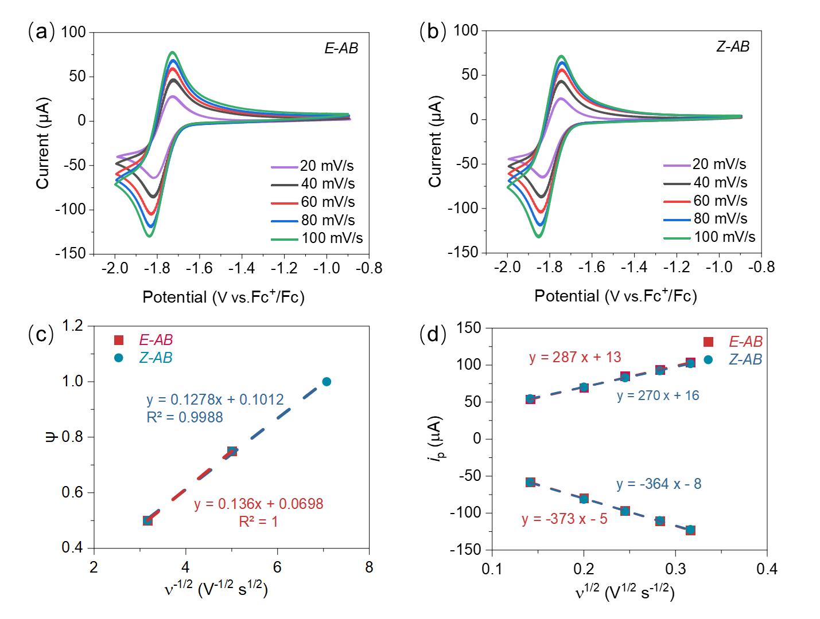
Figure S1. CV curves of 5 mM AB at E (a) and Z (b) states in 0.1 M NBu₄PF₆ in ACN at different scan rates. (c) The Randles-Sevcik plot of $i_{p}-v^{\frac{1}{2}}$ of AB. (d) k⁰ of E/Z-AB calculated by Nicolson method through the $Ψ-v^{-\frac{1}{2}}$ relationship.
Figure S2. Temperature curves of blank acetonitrile electrolyte and AB derivatives solution under UV irradiation (1.5 W/cm²).

Figure S3. UV-Vis detected E-to-Z isomeriztion process under 365 nm wavelength beam (1.5 W/cm²) irradiation.

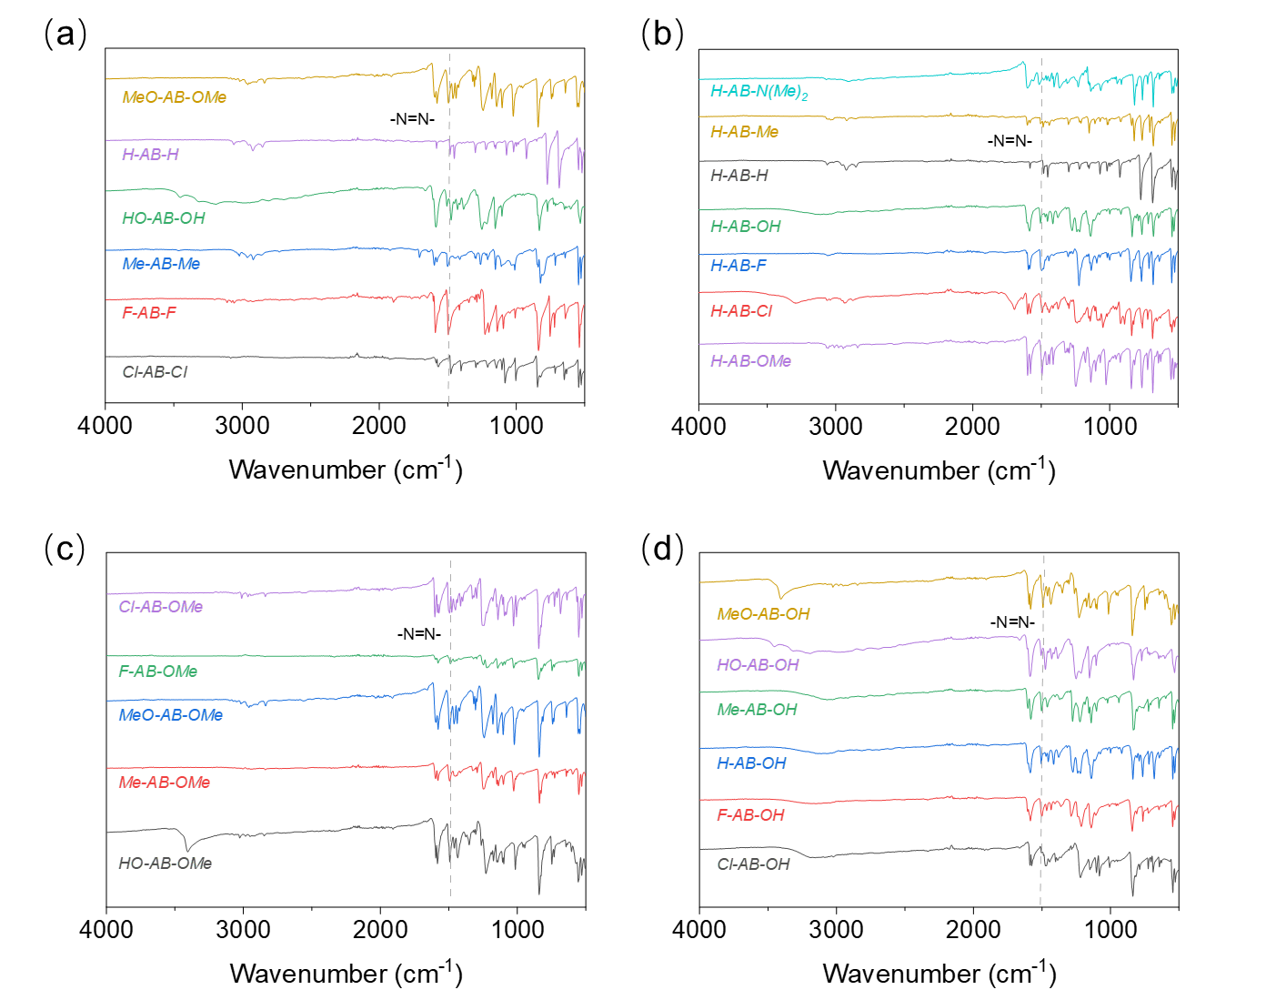
Figure S4. FT-IR spectra of (a) symmetrical para-substituted R-AB-R, (b) para-substituted H-AB-R, (c) para-substituted R-AB-OMe, (d) para-substituted R-AB-OH..

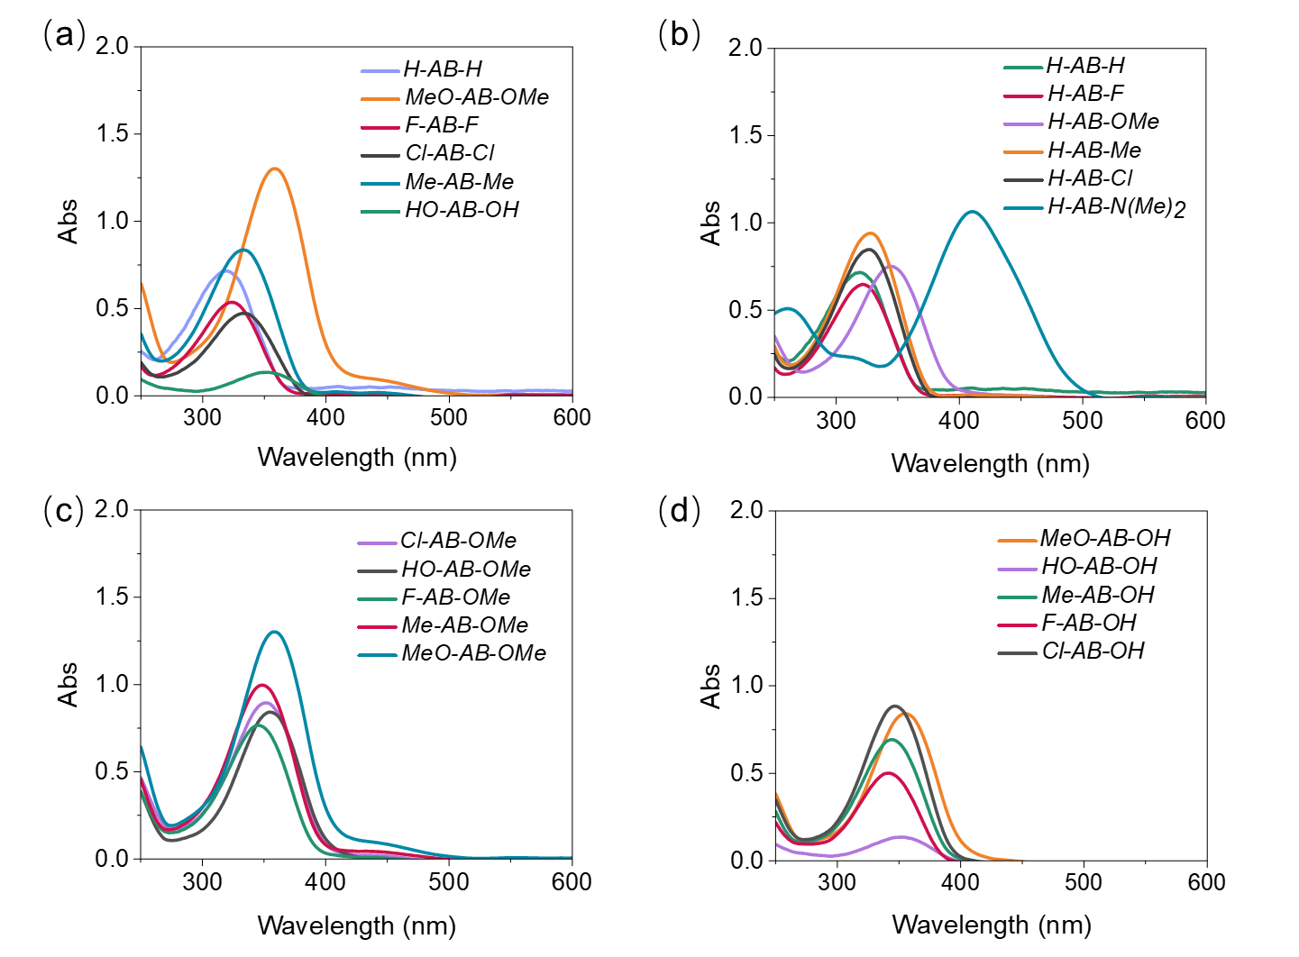
Figure S5. UV-Vis spectra of (a) symmetrical para-substituted R-AB-R, (b) para-substituted H-AB-R, (c) para-substituted R-AB-OMe, (d) para-substituted R-AB-OH.
Figure S6. CV curves of para-substituted R-AB-OH (5mM) in 0.1 M NBu₄PF₆ ecetonitrile electrolyte at scan rate 60 mV s⁻¹.

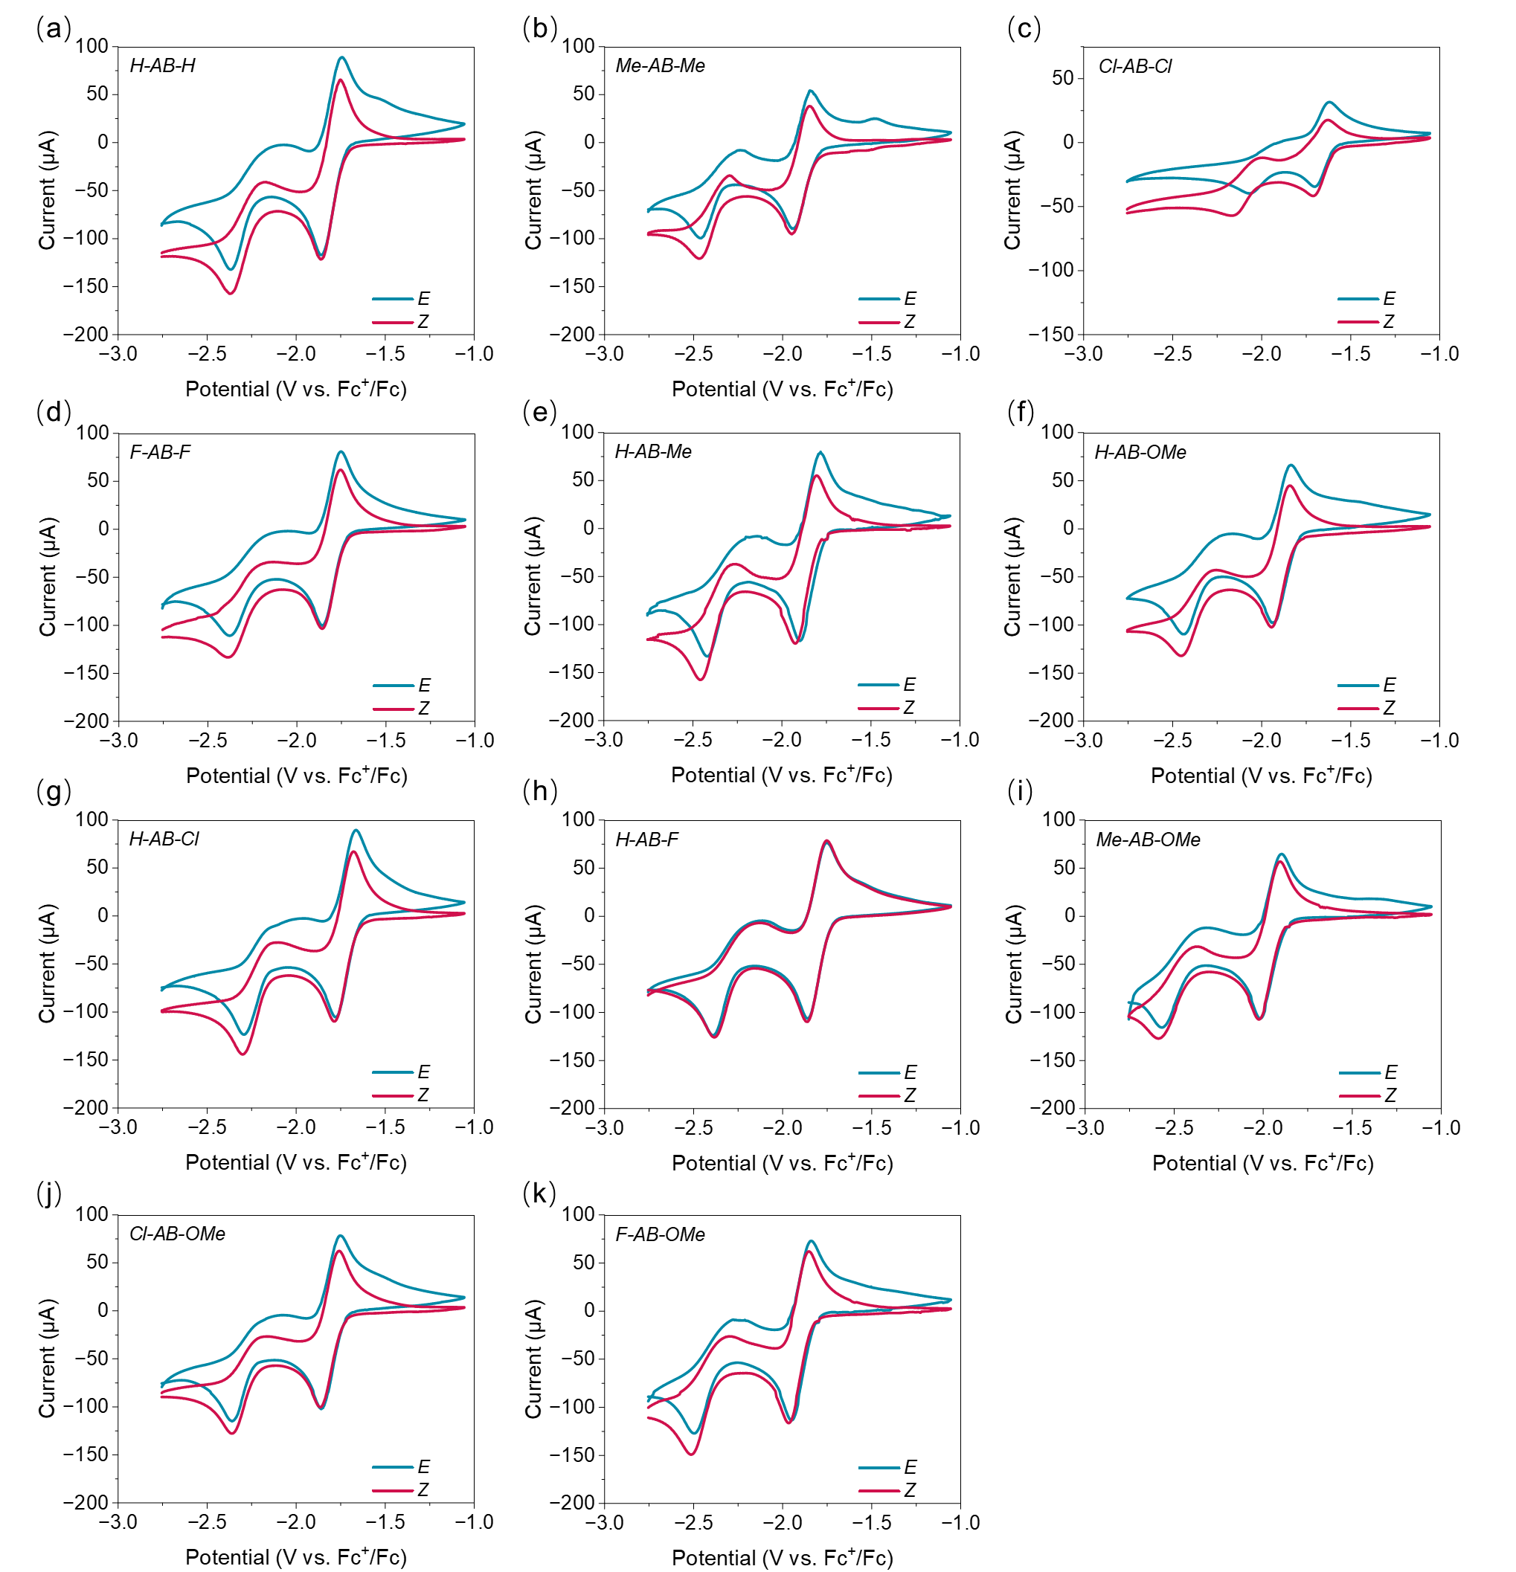
Figure S7. CV curves of E/Z-AB derivatives (5 mM) in acetonitrile electrolyte (0.1 M NBu₄PF₆).

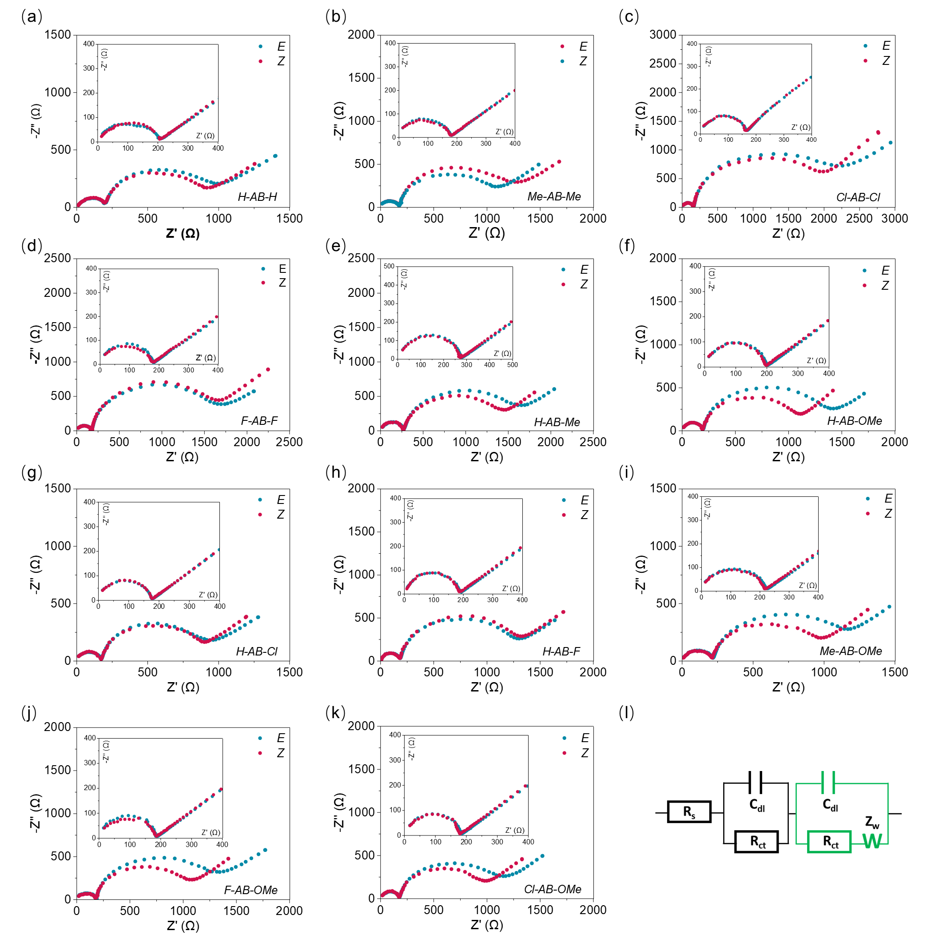
Figure S8. Nyquist plot of E/Z-AB derivatives (5 mM) in acetonitrile electrolyte (0.1 M NBu4PF6) at E_{1/2}, amplitude 10 mV, frequency 0.5-1M Hz.

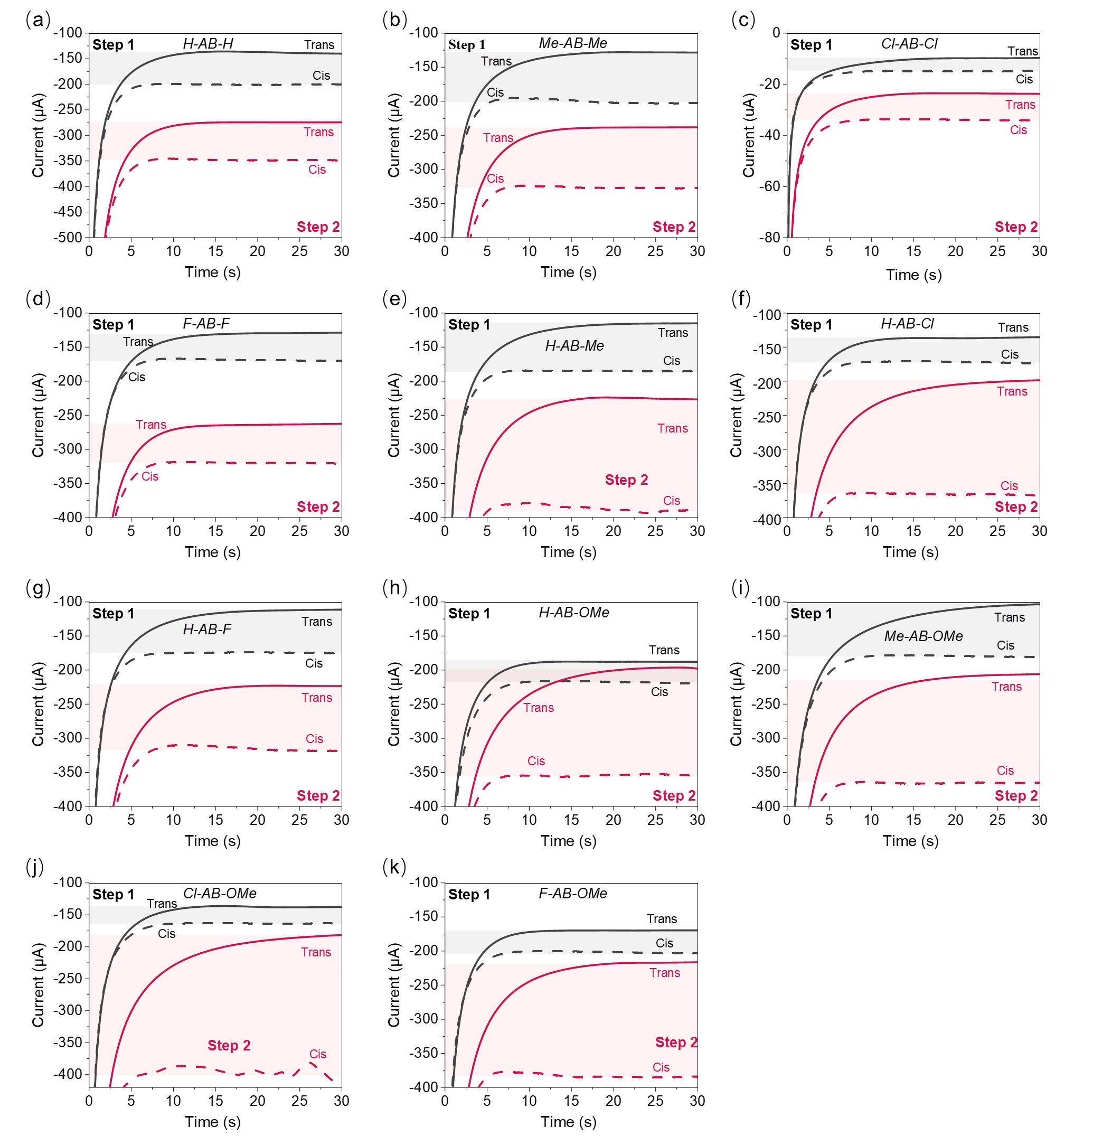

Figure S9. chronoamperometry of E/Z-AB derivatives (5 mM) in acetonitrile electrolyte (0.1 M NBu₄PF₆) with step potential set at E_{pc} of step 1 and step 2 respectively.

.

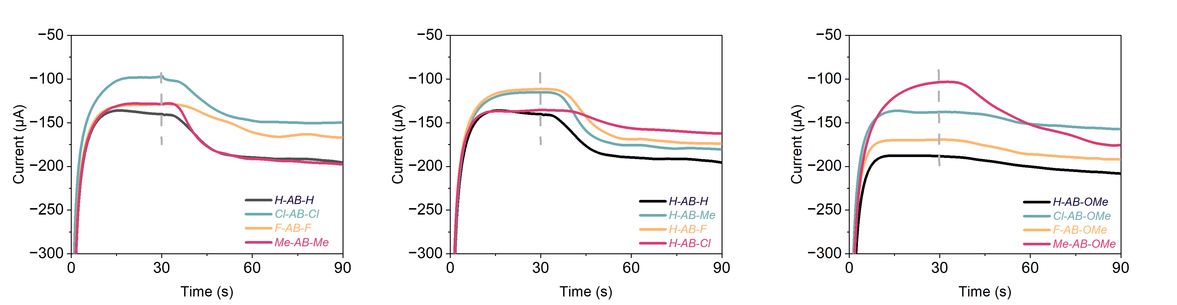Figure S10. The transient current change between Z and E steady states of AB derivatives in CA experiment.
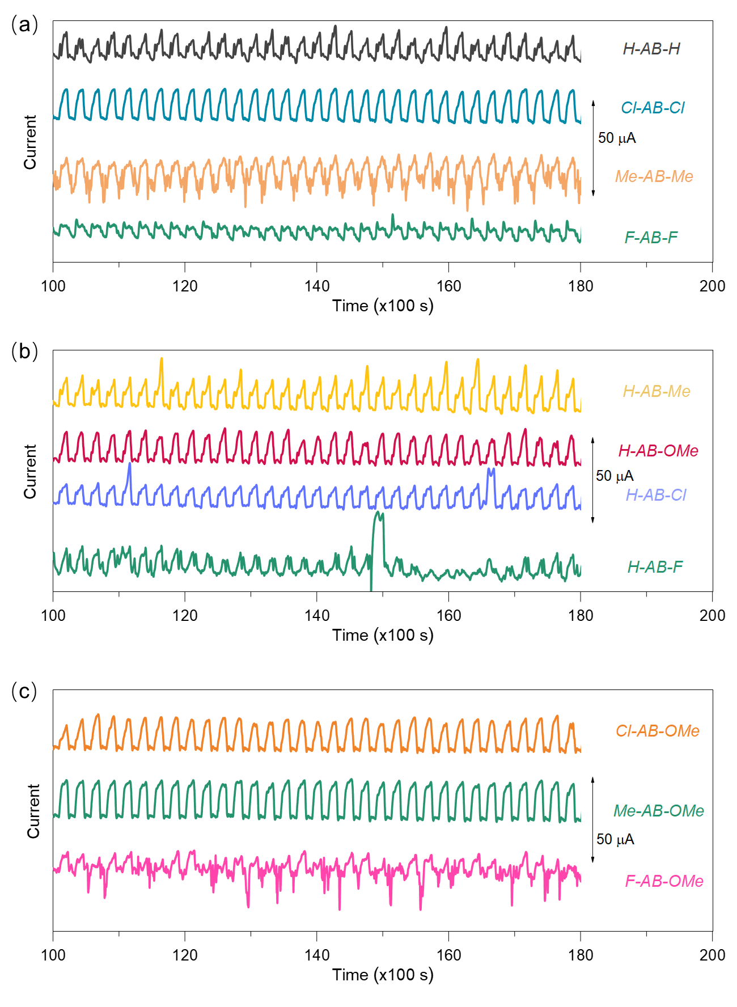
Figure S11. Electrochemical responsive photoswitch based on AB derivatives.

Reference
1 J.-D. Chai and M. Head-Gordon, Phys. Chem. Chem. Phys., 2008, 10, 6615.
2 D. Rappoport and F. Furche, J. Chem. Phys., 2010, 133, 134105.
3 Frisch M J, Trucks G, Schlegel H B, et al. Gaussian 09W, revision A. 02, F, 2009 [C].
4 A. V. Marenich, C. J. Cramer and D. G. Truhlar, J. Phys. Chem. B, 2009, 113, 6378–6396.
5 T. Lu and F. Chen, J. Comput. Chem., 2012, 33, 580-592.
6 D. J. Evans and B. L. Holian, J. Chem. Phys., 1985, 83, 4069-4074.
7 R. Martoňák, A. Laio and M. Parrinello, Phys. Rev. Lett., 2003, 90, 075503.
8 M. J. Abraham, T. Murtola, R. Schulz, et al., SoftwareX, 2015, 1-2, 19-25.
9 J. Wang, R. M. Wolf, J. W. Caldwell, et al., J. Comput. Chem., 2004, 25, 1157-1174.
10 H. A. Lorentz, Ann. Phys., 1881, 248, 127-136.

