Structrual Dynamics of Human deoxyuridine 5'-triphosphate nucleotidohydrolase (dUTPase)
Ravdna Sarreª, Olena Dobrovolska^{b}, Patrik Lundström^{c}, Diana Turcu^{b}, Tatiana Agback^{d}, Øyvind Halskau^{b}, Johan Isaksson^{a,e*}
ªDepartment of Chemistry, UiT the Arctic University of Norway, Box 6050 Langnes, 9037 Tromsø, Norway
^{b}Department of Molecular Biology, University of Bergen, Box 7800, 5020 Bergen, Norway
^{c}Department of Physics, Chemistry and Biology, Linköping University, 581 83 Linköping, Sweden
^{d}Department of Molecular Sciences, Box 7015, SE-750 07 Uppsala, Sweden
^{e}Department of Pharmacy, UiT the Arctic University of Norway, Box 6050 Langnes, 9037 Tromsø, Norway
*To whom correspondence should be addressed. Email, johan.isaksson@uit.no

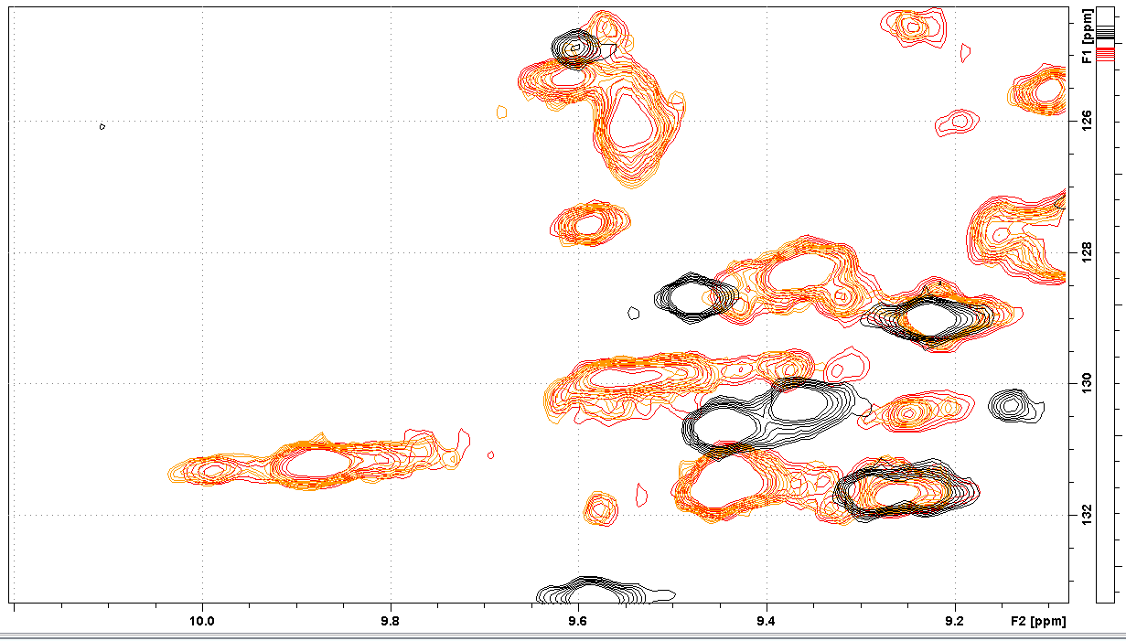
Figure S1. Superimposed NHSQC spectra of dUTPase (black) (apo), dUTPase+dUpNHpp (red) (20ul ligand stock) and dUTPase+dUpNHpp (orange) (40 ul ligand stock), showing that the heterogeneity of the holo form is not dependent on the ligand concentration.

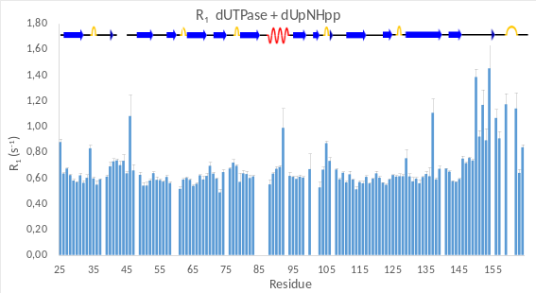 | 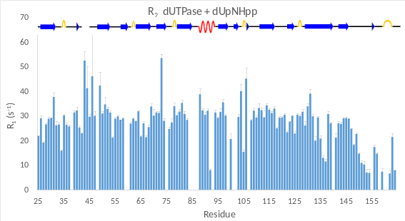
(a) | (b)
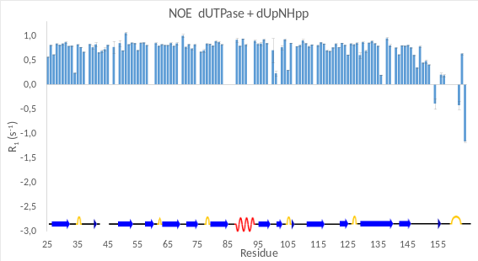 | 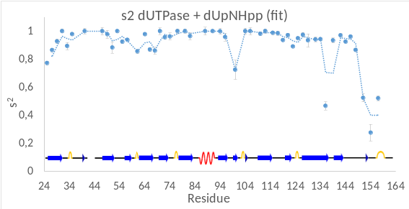
(c) | (d)

Figure S2. Relaxation parameters, (a) R₁, (b) R₂, (c) ¹⁵N-NOE, (d) s² calculated with Modelfree at 600 MHz fitting s² and t_{e}, (model 2 in the Modelfree documentation). All experiments were acquired at 37 ºC.

