Supplementary data
All metadata, intermediate data and full analyses outcomes are provided at https://github.com/vollkorrn/EstuarineFishGillMicrobiota

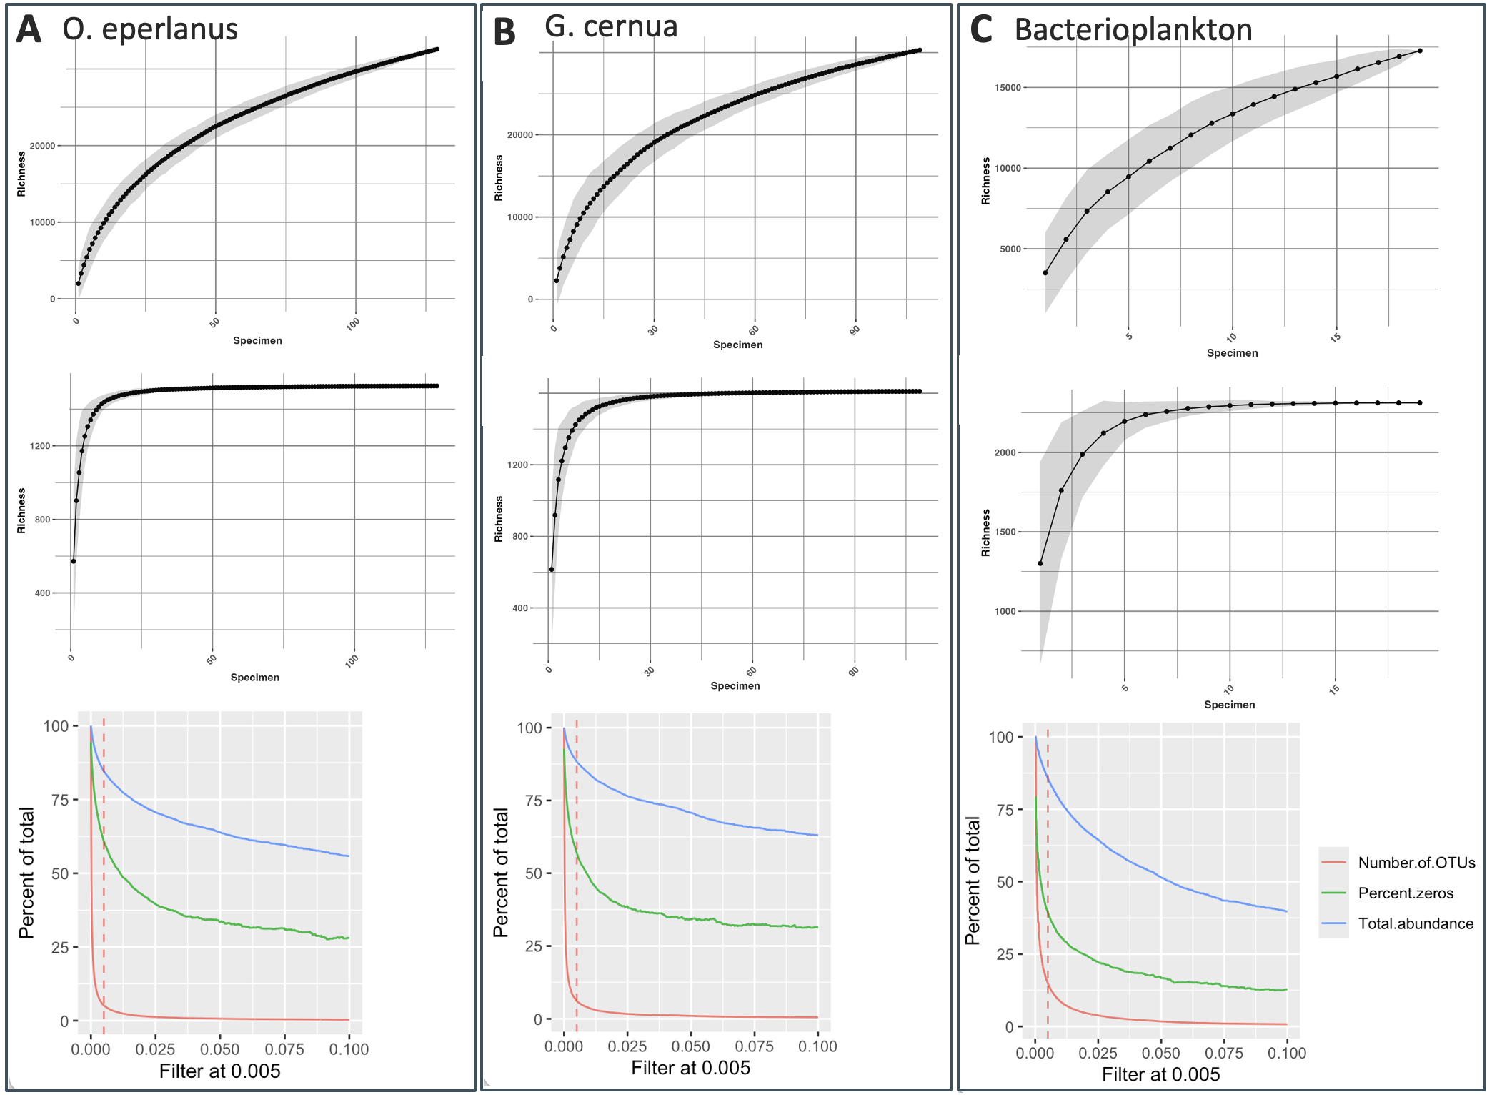
Fig. A. 1 Bacterial ASV accumulation over number of sampled specimen for OE (A), GC (B) and Bacterioplankton (C) for unfiltered data (upper row) and 0.005% overall abundance filtered data (middle row). Bottom row depicts the number of ASVs, percent zeros and total abundance of counts in the individual datasets along different abundance filter levels.

Tab. A. 1 Relative abundance (%) of sequences belonging to phyla in gill microbiome and bacterioplankton (higher 1 % per Sample group).
Phylum | Bakterioplankton | OE | GC
Proteobacteria | 41 ± 5 | 51 ± 10 | 56 ± 13
Bacteroidota | 19 ± 7 | 28 ± 12 | 25 ± 9
Actinobacteriota | 19 ± 9 | 7 ± 5 | 6 ± 6
Verrucomicrobiota | 8 ± 3 | 5 ± 8 | 3 ± 2
Firmicutes |  | 4 ± 7 | 5 ± 13
Deinococcota |  | 2 ± 2 | 2 ± 2
Desulfobacterota | 1.5 ± 1.1
Acidobacteriota | 2.3 ± 1.8
Cyanobacteria | 1.4 ± 1.9
Nitrospirota | 1.9 ± 1.4
Gemmatimonadota | 1.4 ± 0.6
Chloroflexi | 1.2 ± 0.9

Tab. A. 2 Envfit results for ordistep and VIF selected reduced dbRDA models per dataset
Sample Kind | Parameter | R2 | Sig. P
OE gill microbiome | Temperature | 0.682 | 0.001 | ***
 | Salinity | 0.022 | 0.236
 | FillLevel | 0.018 | 0.257
 | GSI | 0.534 | 0.001 | ***
 | NH4 | 0.006 | 0.7
 | NO2 | 0.026 | 0.174
 | NO3 | 0.476 | 0.001 | ***
 | PO4 | 0.12 | 0.001 | ***
 | pH | 0.023 | 0.219
 | TOC | 0.309 | 0.001 | ***
 | SPM | 0.203 | 0.001 | ***
GC gill microbiome | Temperature | 0.179 | 0.002 | **
 | Salinity | 0.11 | 0.012 | **
 | Age | 0.098 | 0.012 | **
 | NO2 | 0.292 | 0.001 | ***
 | NO3 | 0.039 | 0.206
 | PO4 | 0.438 | 0.001 | ***
 | TOC | 0.258 | 0.001 | ***
Bacterioplankton | Temperature | 0,962 | 0,001 | ***
 | Salinity | 0,669 | 0,002 | **
 | PO4 | 0,107 | 0,377
 | pH | 0,874 | 0,001 | ***

Tab. A. 3 Significant association between average Bray-Curtis distance matrices for gill mucus and bacterioplankton communities and Euclidean distances matrices for environmental and physiological measurements estimated via Mantel test.
Sample Kind | Parameter | Mantel | Sig.
OE gill microbiome | Temperature | 0.18 | 0.0001
 | SPM | 0.20 | 0.0001
 | FCF | 0.17 | 0.0004
 | GSI | 0.67 | 0.0001
 | HSI | 0.23 | 0.0001
 | Bacterioplankton | 0.14 | 0.0018
GC gill microbiome | O2 | 0.17 | 0.0001
 | NH4 | 0.17 | 0.0055
 | NO2 | 0.22 | 0.0016
 | Length | 0.10 | 0.0062
Bacterioplankton | Temperature | 0.45 | 0.0003
 | Salinity | 0.55 | 0.0002
 | O2 | 0.33 | 0.0015
 | SPM | 0.19 | 0.0327
 | PO4 | 0.21 | 0.0219
 | NO3 | 0.33 | 0.0022

Tab. A. 4 Indicator species via multipatt with indicator value > 0.7 and P-value < 0.05 after 999 permutations. Shown are taxa with > 1 % relative abundance (> 0.2% for spatial comparisons).
Biomes/Season/  Location | Phylum | Order | Lowest Taxonomic level | Rel. Abundance [%]
Bacterioplankton | Actinobacteriota | Frankiales | Sporichthyaceae  hgcI clade | 3.4  1.1
Bacterioplankton |  | Microtrichales | CL500-29 marine group | 2.3
Bacterioplankton | Bacteroidota | Sphingobacteriales | NS11-12 marine group | 1.3
 |  | Flavobacteriales | Cryomorphaceae | 1.1
Fish gill mucus | Bacteroidota | Flavobacteriales | Elizabethkingia | 16
Fish gill mucus | Proteobacteria | Enterobacterales | Enterobacteriaceae (4 ASVs)  Enterobacter  E. cancerogenus  Citrobacter  Lelliottia | 9.4  2.2  1.1  3.4  1
Fish gill mucus |  | Burkholderiales | Microvirgula | 1.1
Fish gill mucus | Verrucomicrobiota | Verrucomicrobiales | Luteolibacter | 1.6
Fish gill mucus | Actinobacteriota | Micrococcales | Arthrobacter | 1.4
GC | Proteobacteria | Burkholderiales | Verticiella  Polynucleobacter | 1.9  1.3
 |  | Rickettsiales | Candidatus Megaira | 0.6
GC Summer | Firmicutes | Clostridiales | Clostridium sensu stricto 1 | 4.3
GC Summer | Proteobacteria | Pseudomonadales | A. lwoffii  Acinetobacter  A. johnsonii | 2.4  1.2  1
GC Winter | Proteobacteria | Burkholderiales | Polynucleobacter | 3.2
GC Spring | Bacteroidota | Flavobacteriales | Chryseobacterium | 1
GC BB | Verrucomicrobiota | Verrucomicrobiales | Persicirhabdus | 0.2
 | Proteobacteria | Pseudomonadales | Halioglobus | 0.2
GC TF | Firmicutes | Staphylococcales | Macrococcus | 1.5
GC ML | Bacteroidota | Cytophagales | Hymenobacter | 0.2
 | Proteobacteria | Pseudomonadales | Psychrobacter | 0.2
OE Summer | Proteobacteria | Pseudomonadales | Acinetobacter johnsonii | 1.2
OE Winter | Bacteroidota | Flavobacteriales | Chryseobacterium | 1.2
OE Spring | Verrucomicrobiota | Verrucomicrobiales | Luteolibacter | 1.3
 |  |  | Persicirhabdus | 1
 | Bacteroidota | Flavobacteriales | Chryseobacterium | 1
OE TF | Bacteroidota | Flavobacteriales | Elizabethkingia | 1.4
 | Proteobacteria | Enterobacterales | Enterobacter  Citrobacter  Lelliottia  Enterobacteriaceae | 0.6  0.4  0.4  0.2
OE ML | Verrucomicrobiota | Verrucomicrobiales | Luteolibacter | 0.2

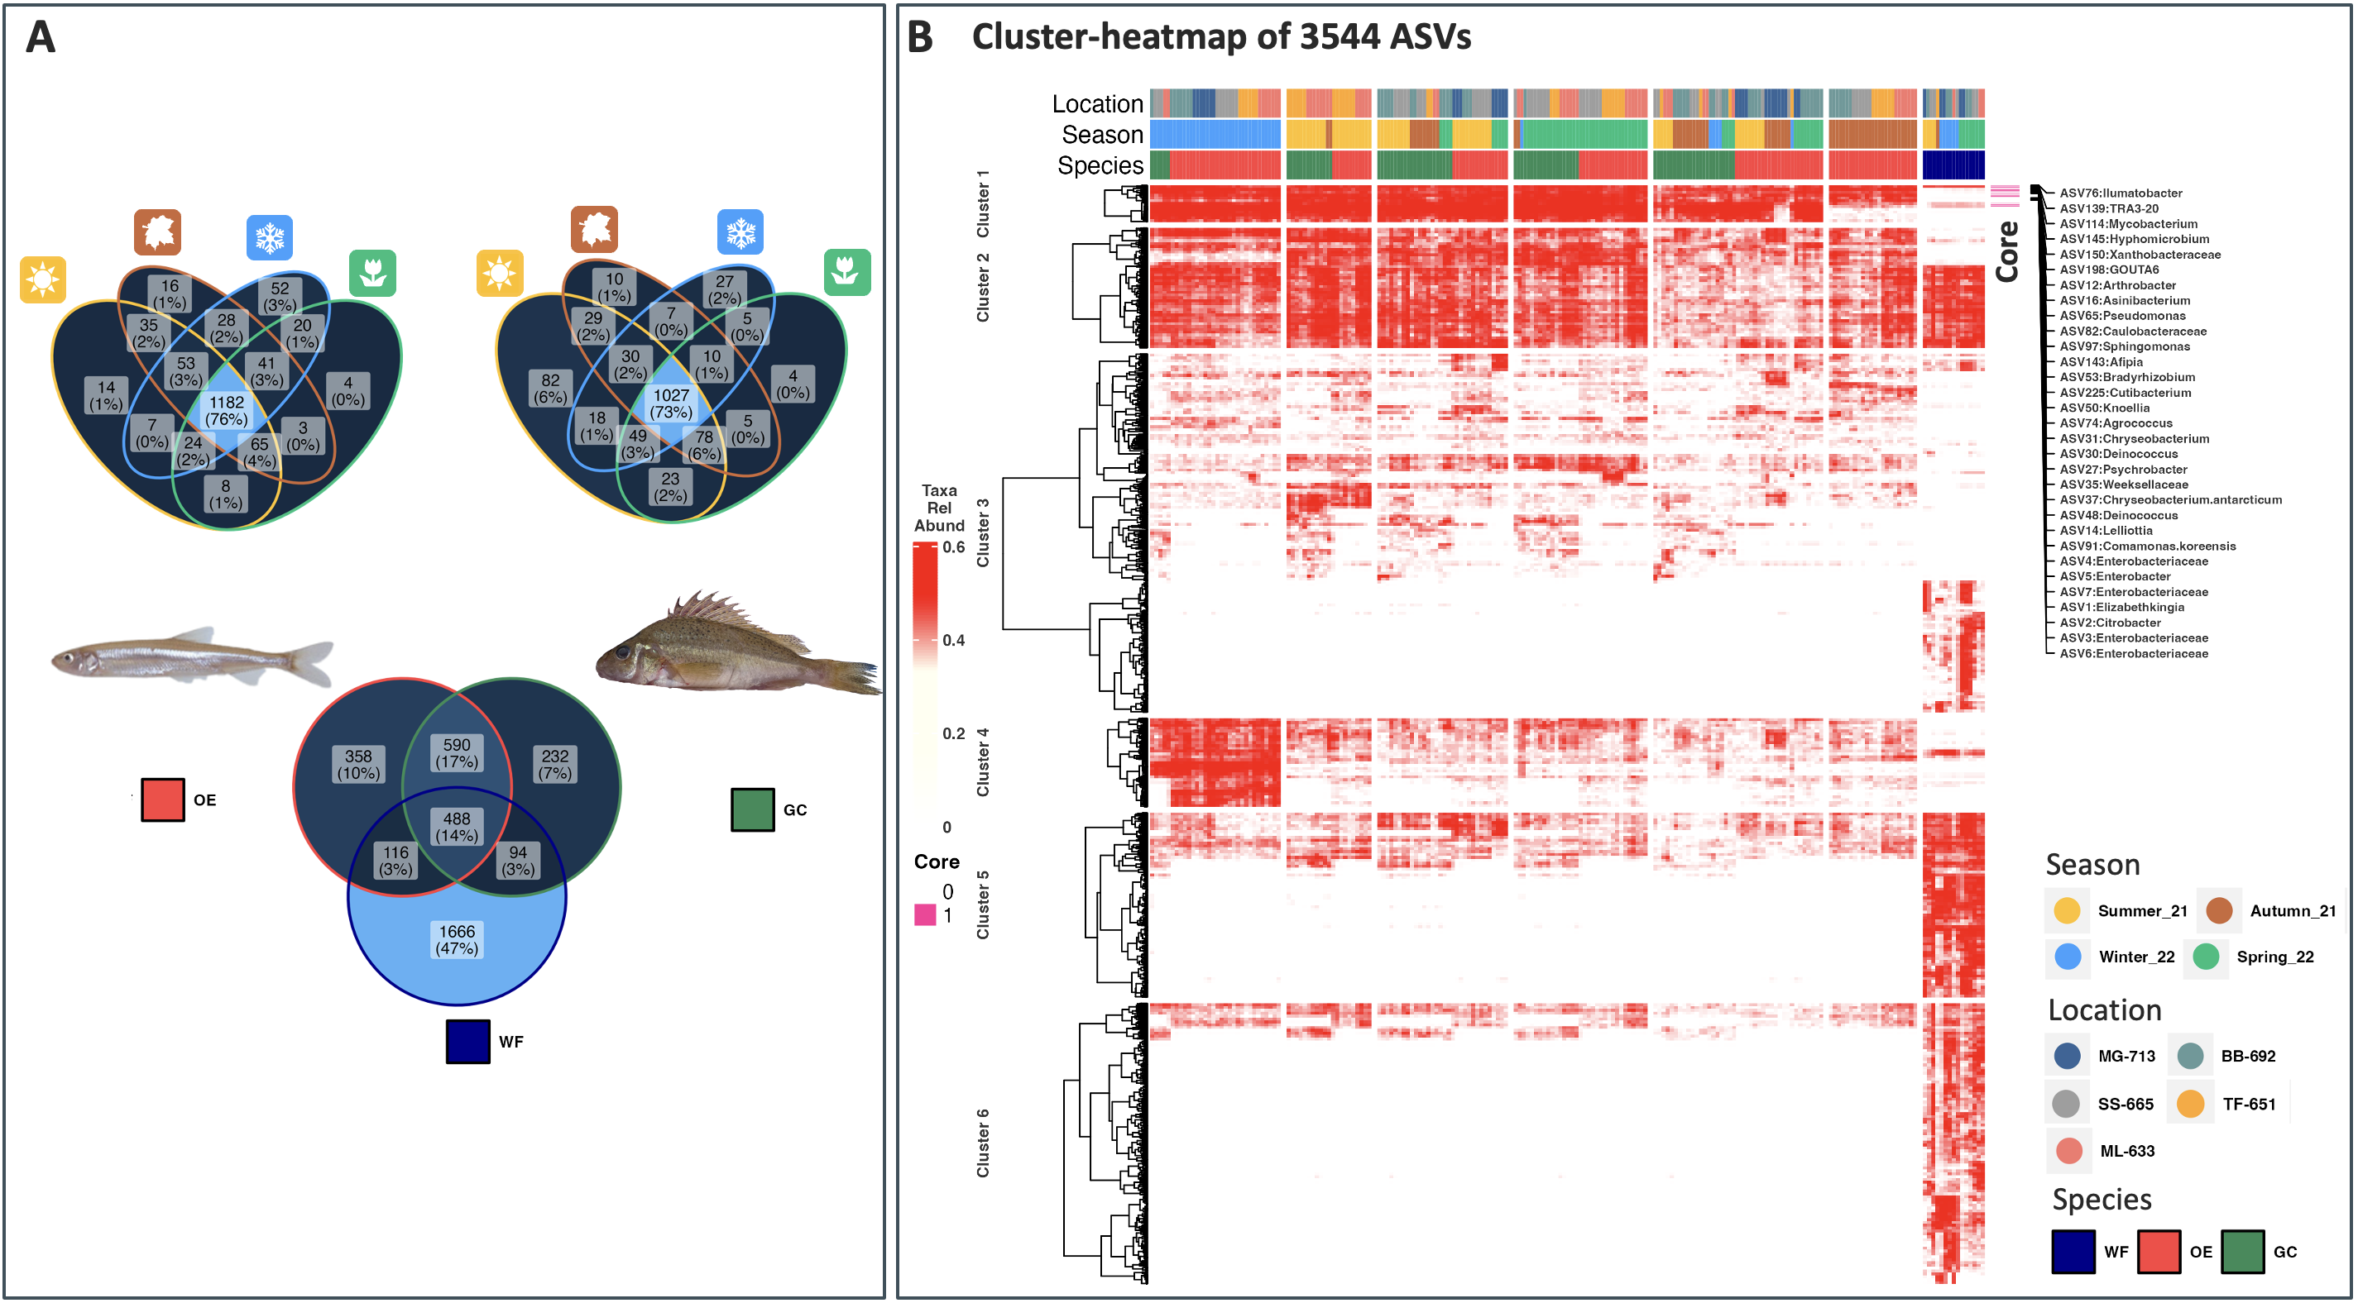
Fig. A. 2 Presence-Absence analysis and abundance visualization of bacterial taxa within the biomes. Venn Diagrams depict presence/absence of bacterial ASVs found in bacterioplankton (WF), smelt (OE) and ruffe (GC) gills and in fish swabs at seasonal samplings (A). Cluster-Heatmap of the relative abundance of the bacterial taxa within all datasets with core taxa in fish gill mucus. While color depicts low abundance, red high abundance. The maximum value of the color code is set at 0.6% to enable meaningful visualization.
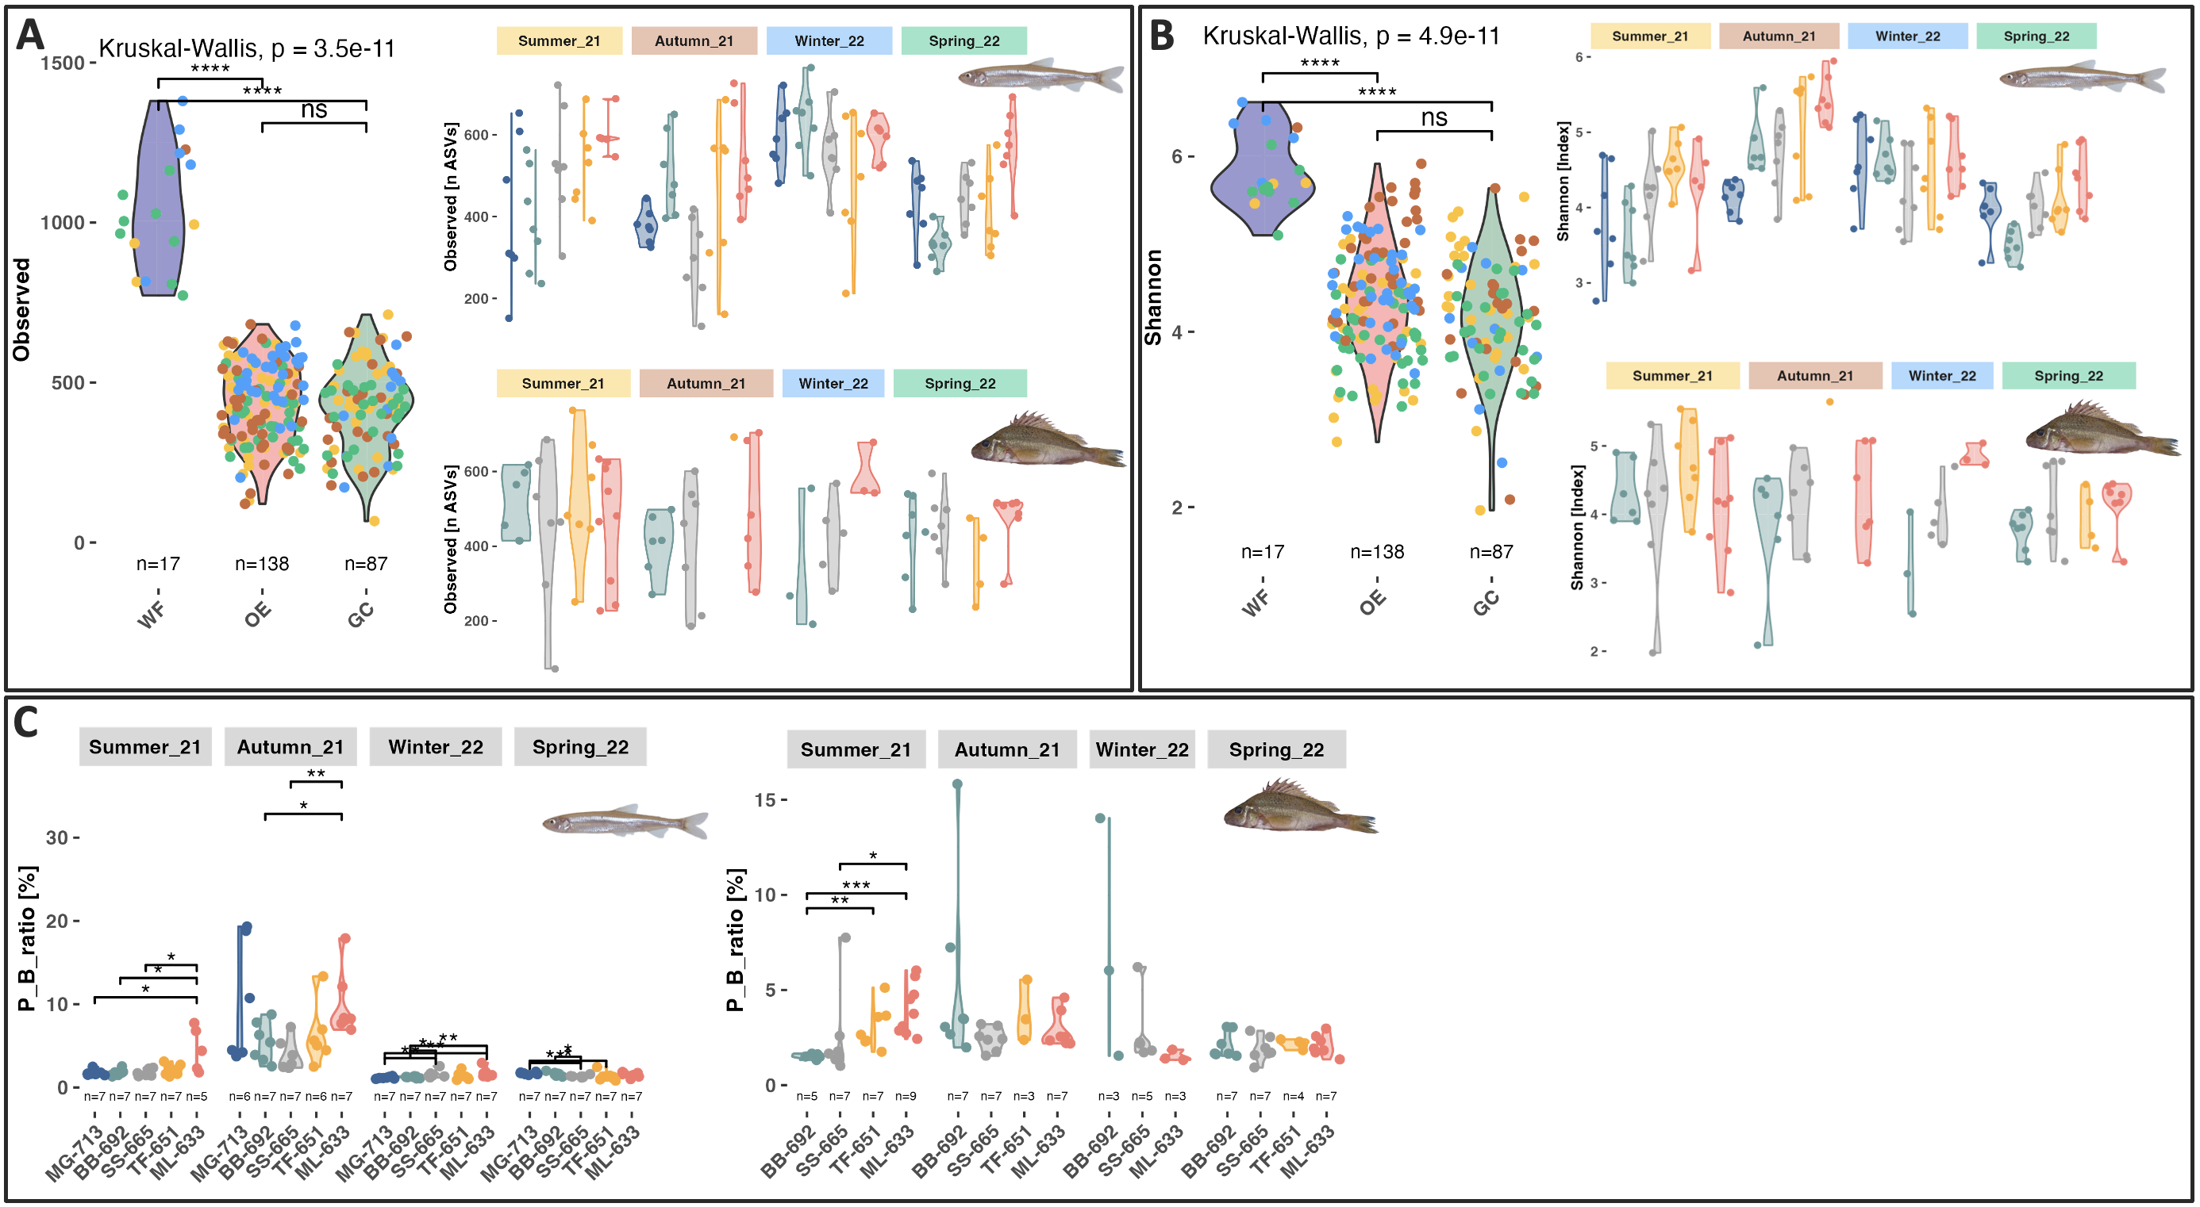
Fig. A. 3 Alpha diversity metrices in bacterioplankton and fill gill mucus. Overall observed richness (A) and Shannon indices (B) are shown for the three biomes (WF = bacterioplankton, OE = smelt, GC = ruffe) and with spatio-temporal resolution for the fish associated bacteria communities. The ratios of Proteobacteria and Bacteroidetes in spatio-temporal resolution are shown for both fish species (C).
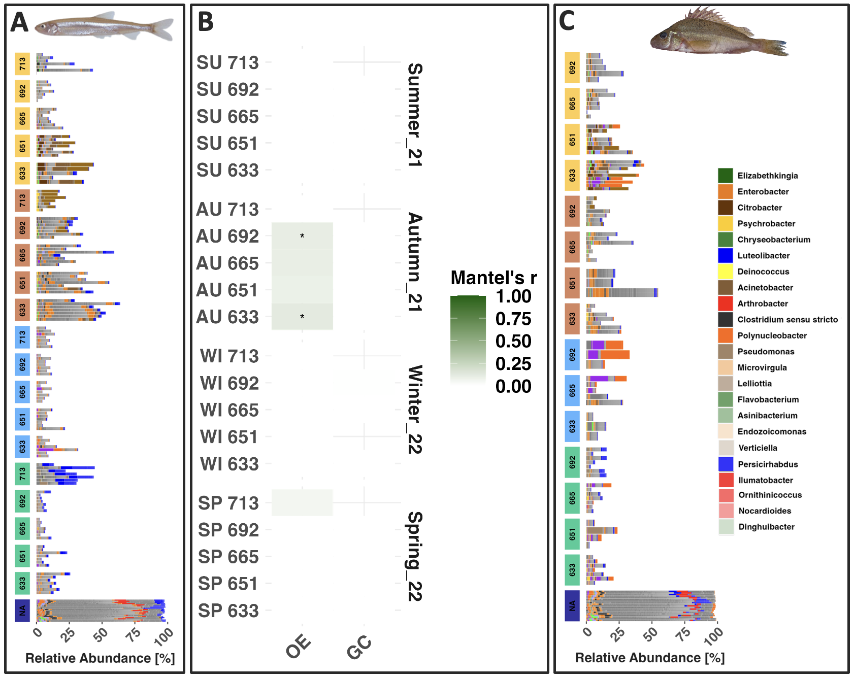
Fig. A. 4 Similarity between bacterioplankton and fish gill communities. Compositional barplot (A & C) show relative abundance of bacterial taxa shared between the bacterioplankton and the fish communities excluding the fish core microbiome. Mantel tests (B) show matrix correlation between overall bacterioplankton communities and spatio-temporal fish gill communities.

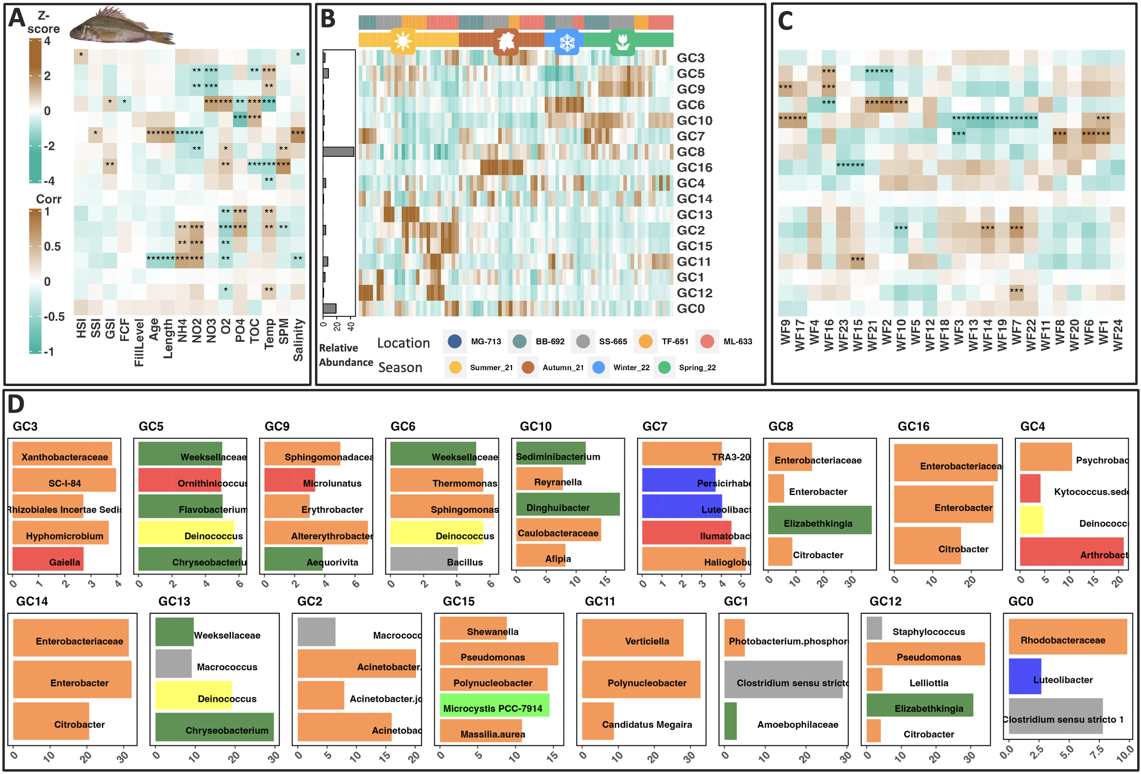
Fig. A. 5 Relationship between bacterial co-occurrence networks, biometric measurements and abiotic conditions for Elbe estuarine ruffe GC. Integrated heatmap of gill bacterial mucus network analysis showing correlation between ASV module eigengenes (B: GC-0-16), physiological traits (A: HSI, SSI, GSI, FCF, FillLevel, Age, Length) and relevant abiotic factors (A: NH₄, NO₂, NO₃, O₂, PO₄, TOC, temperature, SPM, salinity) as well as bacterioplankton module eigenASVs (C WF1-23). B shows Z-score of eigengene values per module as rows for individual fish (n = 89) ordered by season and facets within season by sampling location in upstream direction as columns. Overall relative abundance per module is shown the barplot on the left side. A and C show FDR corrected Pearson correlation strength between eigenASVs and host/external traits, the right panel shows FDR corrected Pearson correlation to WF-SSU eigenASVs (brown representing positive, zero white and green negative correlation) and statistical significance indicated by stars: * P < 0.05, ** P <= 0.01, *** P <= 0.001. Only correlations r > 0.3 are shown. Taxa with highest intra-modular abundance (%) are shown in barplots (D) colored by phylum identity

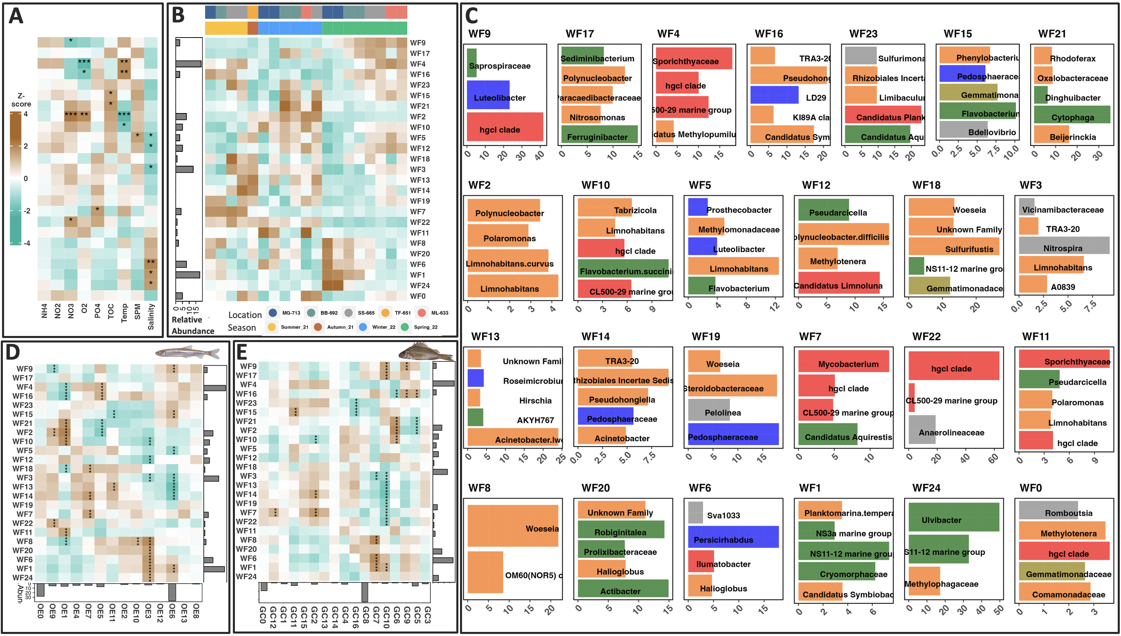
Fig. A. 6 Relationship between bacterial co-occurrence networks and abiotic conditions for free-living bacteria in the Elbe estuary. Integrated heatmap of the bacterioplankton network analysis showing correlation between ASV module eigengenes (B: WF-0-24) and relevant abiotic factors (A: NH₄, NO₂, NO₃, O₂, PO₄, TOC, temperature, SPM, salinity). B shows Z-score of eigengene values per module as rows for individual water samples (n = 19) ordered by season and facets within season by sampling location in upstream direction as columns. Overall relative abundance per module is shown the barplot on the left side. A shows FDR corrected Pearson correlation strength between eigenASVs and external traits (brown representing positive, zero white and green negative correlation) and statistical significance indicated by stars: * P < 0.05, ** P <= 0.01, *** P <= 0.001. Only correlations r > 0.3 are shown. Taxa with highest intra-modular abundance (%) are shown in barplots (C) colored by phylum identity. Module-correlation between biomes and individual relative abundance of module taxa are shown in D and E.

Measures to counter contamination in the workflow:
Strains of Acinetobacter were described as potential contaminants of microbiome studies repeatedly (François-Étienne et al., 2023; Salter et al., 2014; Weyrich et al., 2019). To ensure contamination-free data sets in this wild-sampling study, we added mock community samples randomly at every extraction and sequencing batch indicating no contamination throughout the workflow (Fig. A. 7). Furthermore, we suspect a low risk of contamination between fish samples in abundant bacteria, as the gill is protected by the opercular and we see progressing trends in bacterial composition at stations or sampling events where only one species was caught.
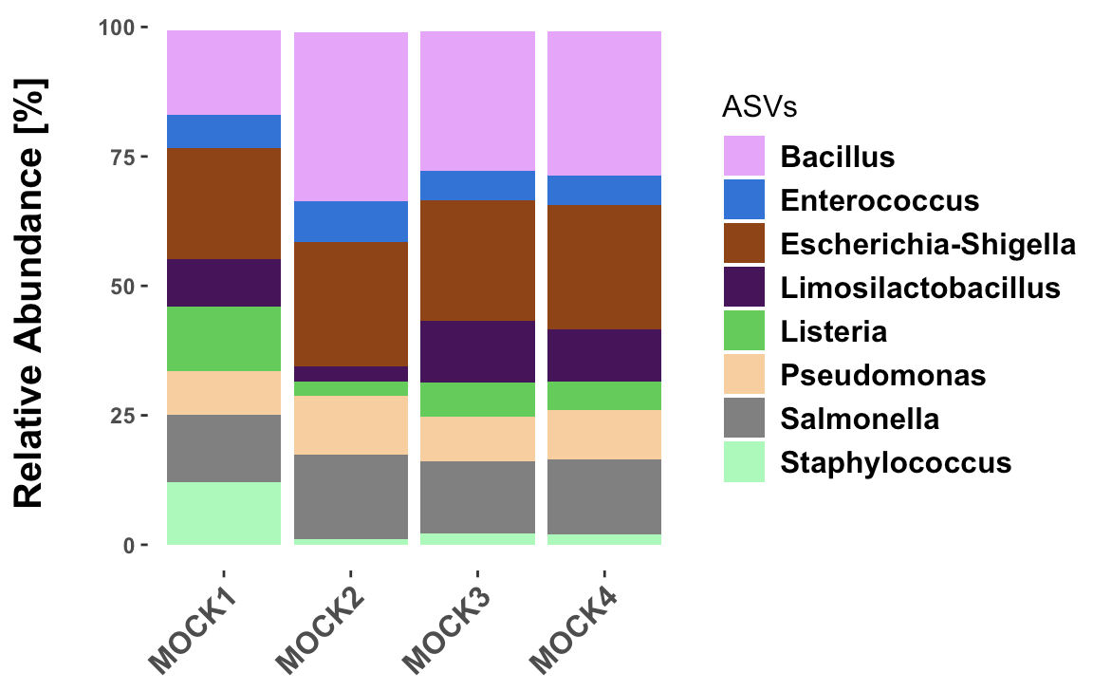
Fig. A. 7 Mock communities. Sterile swabs used for gill mucus recovery were immersed in the MOCK community mix (Zymo) and randomly included during every extraction batch and send for sequencing treated as a normal sample. According to the manufacturer's instructions, the composition should be: Listeria monocytogenes - 12%, Pseudomonas aeruginosa - 12%, Bacillus subtilis - 12%, Escherichia coli - 12%, Salmonella enterica - 12%, Lactobacillus fermentum - 12%, Enterococcus faecalis - 12%, Staphylococcus aureus - 12%, Saccharomyces cerevisiae - 2% and Cryptococcus neoformans - 2%.

