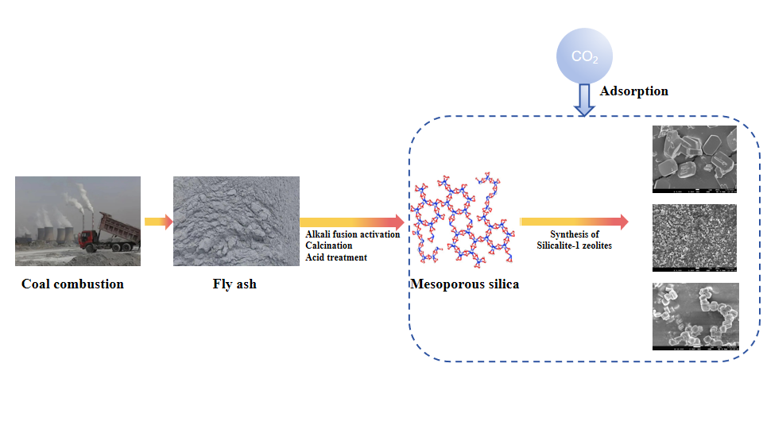
Comparative studies on CO₂ adsorption performance of different morphologies of Silicalite-1 zeolites synthesized from fly ash

