Supplementary Fig. 1 Hypoxia induced sorafenib resistance in hepatoma cells.
a, b Hypoxia induced sorafenib resistance as measured by apoptosis rates (%). c, d Percentage of Huh7 (c) or LM3 (d) cells under hypoxic or normoxic conditions with sorafenib treatment. e qRT-PCR analysis of indicated genes in control, hypoxia treated, sorafenib resistant and hypoxia-induced sorafenib resistant LM3 cells. f Immunoblot showing expression levels of indicated proteins in the above cells. g-i Correlation between HIF1α expression and that of ABCC1 (g), Tomm20 (h) and Tomm70 (i) in HCC patients from TCGA database. Each bar represents the mean ± SEM of three independent experiments. *P<0.05 and ** P<0.01.

Supplementary Fig. 2 ATAD3A plays a vital role in sorafenib sensitivity of hepatoma cells. a Immunoblot showing expression levels of indicated proteins in control and hypoxia-induced sorafenib resistant Huh7 and LM3 cells. b qRT-PCR analysis of ATAD3A expression in LM3-vector and ATAD3A overexpression cells. c Immunoblot showing expression levels of the indicated proteins in ATAD3A overexpressing Huh7 and LM3 cells. d, e Percentage of viable Huh7-vector and Huh7-ATAD3A (d) or LM3-vector and LM3-ATAD3A (e) cells. f DAVID analysis of the top 10 altered pathways using KEGG in shATAD3A LM3 cells compared to control. g The volcano plots showing the differently expressed genes in shATAD3A versus shcontrol cells. Each bar represents the mean ± SEM of three independent experiments. *P<0.05 and ** P<0.01.

Supplementary Fig. 3 ATAD3A plays a vital role in lactate production of hepatoma cells. a, b Lactate levels in the supernatants of Huh7-shControl and Huh7-shATAD3A (a) or LM3- shControl and LM3-shATAD3A (b) cells. c, d Lactate levels in Huh7-Vector and Huh7-ATAD3A (c) or LM3-Vector and LM3-ATAD3A (d) cells with/out 1% O2 exposure for 24h. e, f Lactate levels in Huh7 (e) and LM3 (f) cells with/out miR-210-5P inhibitor transfection and with/out CoCl2 treatment. g, h Lactate levels in control and miR-210-5P mimic-transfected Huh7 (g) and LM3 (h) cells. Each bar represents the mean ± SEM of three independent experiments. *P<0.05 and ** P<0.01.

Supplementary Fig. 4 ATAD3A is down-regulated in hypoxia and a potential target of miR-210-5P.
a Immunofluorescent staining of HIF1α (green) and ATAD3A (red) expression in normoxic and hypoxic LM3 cells (1% O2 treatment for 24h). Scale bar = 200μm. b Immunoblot showing expression levels of indicated proteins in HepG2 and PLC cells with/out 1% O2 or CoCl2 for 24h. c Immunoblot showing expression levels of indicated proteins in Huh7 cells with/out CoCl2 treatment for different durations. d qRT-PCR analysis of ATAD3A expression in LM3 cells with/out CoCl2 treatment for 24h. e Bioinformatics analysis of the hypoxia-responsive miRNAs from digestive cancers. f qRT-PCR analysis showing miR-210-5P levels in Huh7 and LM3 cells treated with DMSO or CoCl2 for 24h. g qRT-PCR analysis showing the expression of ATAD3A in LM3 cells treated with miR-210-5P mimic and inhibitor. Each bar represents the mean ± SEM of three independent experiments. *P<0.05 and ** P<0.01.

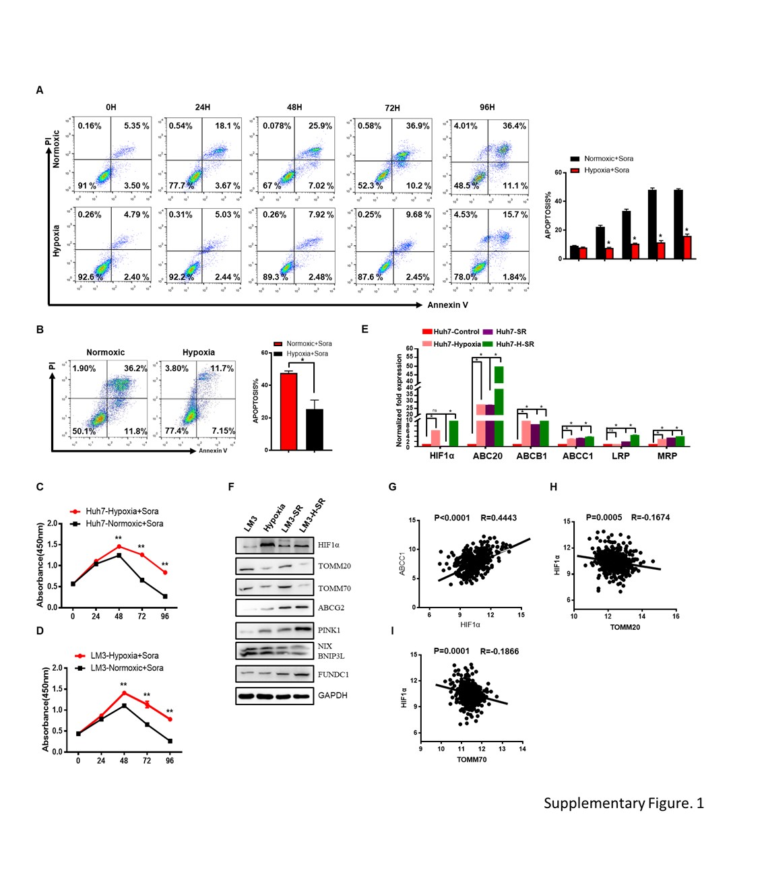

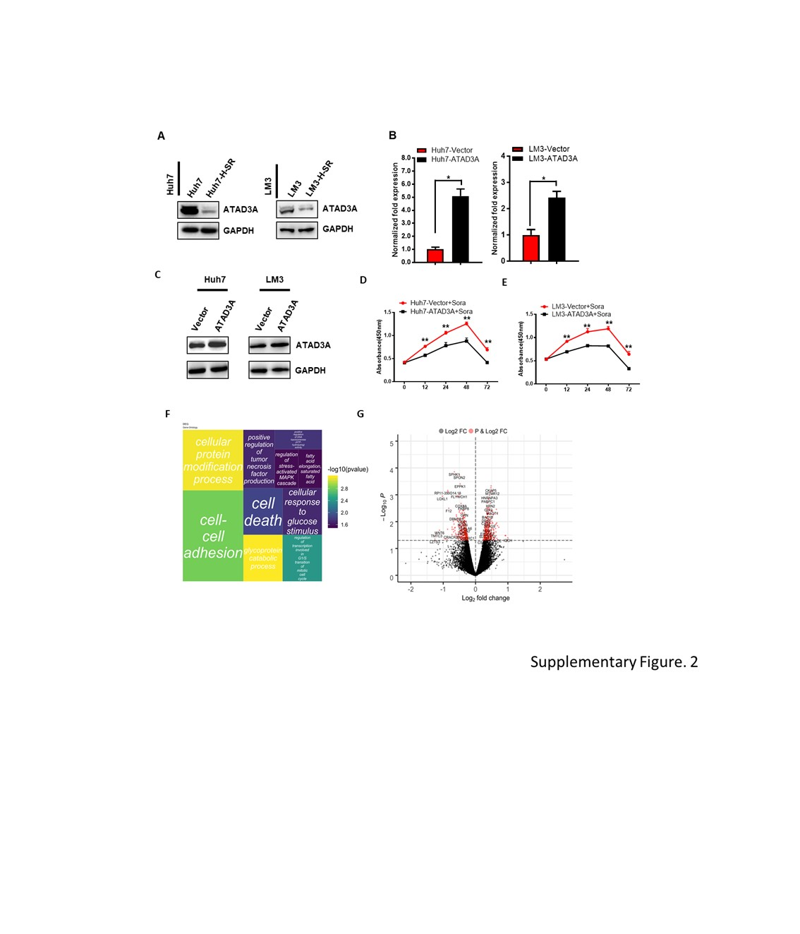

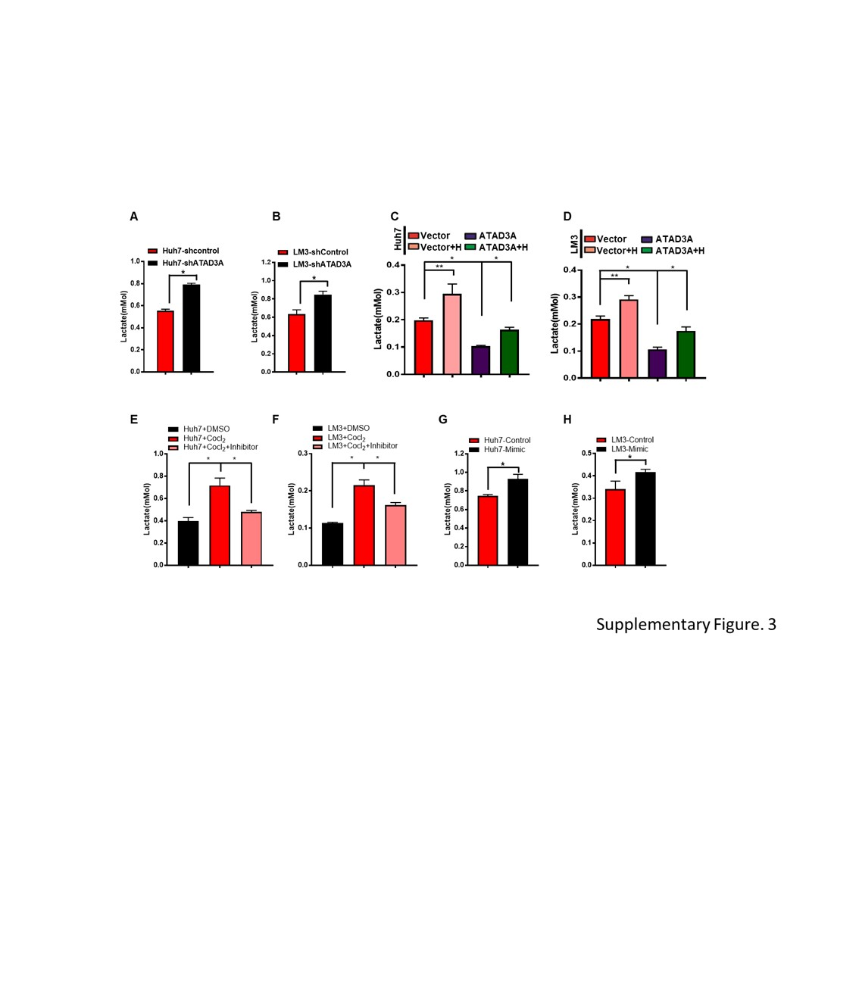

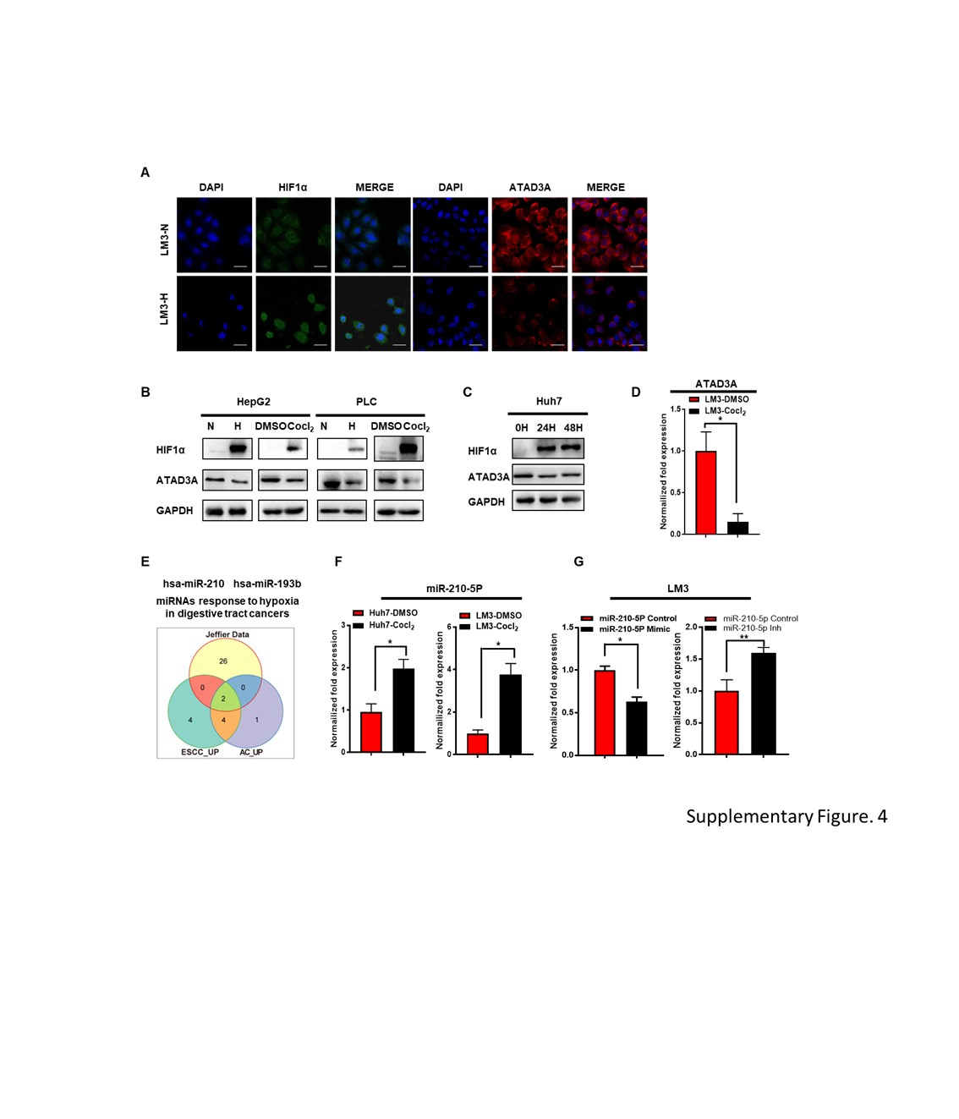

Supplementary table 1. Target sequences and ORF expression clone for PINK1 and ATAD3A.

Gene  (Accession no.) |  | Primer sequence (5’→3’)
PINK1  (NM_65018)  ATAD3A  (NM_001170535 ) | Target sequence | 1- CCAGGCTGGGCCGCAGGACCG  2- CCCCTCACCCCAACATCATCC  3- CGGACGCTGTTCCTCGTTATG
PINK1  (NM_65018)  ATAD3A  (NM_001170535 ) | Target sequence | CCGGCCTGCACATTTAGGATATGCTCTC  GAGAGCATATCCTAAATGTGCAGGTTTTTTG
ATAD3A  (NM_001170535 ) | ORF clone | Forward: 5'CTCCATAGAAGACACCGAC-3'  Reverse: 5-'CATATAGACAAACGCACAC3'

Supplementary table2. Antibodies used for immunostaining analysis.

Antibody  (Accession no.) | Common name | Sources | Corp.
PA5-03671 | ATAD3A | Rabbit | Invitrogen
42406S | TOMM20 | Rabbit | Cell Signaling
sc-390545 | TOMM70 | Mouse | Santa Cruz
4477S | ABCG2 | Rabbit | Cell Signaling
2118 | GAPDH | Rabbit | Cell Signaling
Ab92498 | HIF1α | Rabbit | Abcam
4108S | LC3I/II | Rabbit | Cell Signaling
6946 | PINK1 | Rabbit | Cell Signaling
Ab224722 | FUNDC1 | Rabbit | Abcam
12396 | BNIP3L/NIX | Rabbit | Cell Signaling
9532S | PARP | Rabbit | Cell Signaling
2772 | BAX | Rabbit | Cell Signaling
9662S | Caspase3 | Rabbit | Cell Signaling
2132S | Parkin | Rabbit | Cell Signaling
3933S | ubiquitin | Rabbit | Cell Signaling
4844S | COX IV | Rabbit | Cell Signaling

Supplementary table 3. Sequences of the primers used for qRT-PCR.

Gene  (Accession no.) | Primer sequence (5’→3’) | Amplification  size (bp)
ATAD3A | F: GCGAGCCACCGAGAAGATAAG | 159
(NM_001170536) | R: TGGACCATCTCATTGATGCGG | 159
GAPDH  (NM_002046) | F: CAAGCTCATTTCCTGGTATGAC  R: CAGTGAGGGTCTCTCTCTTCCT | 142
ABC20  (NM_000927) | F: AGGGAAAGTGCTGCTTGA  R: GCTGTTGTCTCCATAGGCA | 139
ABCB1  (NM_000927) | F: CCGCTGTTCGTTTCCTT  R: TCTTTGCTCCTCCATTGC | 134
HIF-1α  (NM_001243084) | F: CCCATTCCTCACCCATC | 127
HIF-1α  (NM_001243084) | R: CTGGCTCATATCCCATCAA | 127
LRP  (NM_002332) | F: GGGGACAAGCTGTGGTG  R: CCAGGGTGGTGCTGTTC | 103
GSTP1 | F: AATACCATCCTGCGTCACC | 150
(NM_000852) | R: CTTGCCCGCCTCATAGTT
EPPK1 | F: AGGGGCGCACGAGCTAT | 100
(NM_031308) | R: GGGAGGGCAGGAGCACT
RITA1 | F: TCCGTGCTCTCTTGTGGA | 112
(NM_001286215) | R: GGCTCTGTCTTGGAGGGA
CSNK2A1 | F: AGTGCCAACCCCTTCAC | 135
(NM_001362770) | R: GCTCAGGCATCAGGAGAC
BTBD3 | F: GCAGATCGAGCCAGACA | 129
(NM_001282550) | R: GAGGAGCACTGAAACTGGA
RAB31 | F: CTCAAAGTGTGCCTTCTCG | 141
(NM_006868) | R: CCCCAGTGTCCTCCATC
NNT | F: TTGACTTTGGTACGATGGG | 113
(NM_001331026) | R: TTTTACTGGGGCACCTTG
SLBP | F: AGTCCCAAGACACCTTCG | 117
(NM_001306074) | R: AAATGCAGAGCCACCTTC
SCCPDH | F: GTAACTGTGGGAGGCATCA | 127
(NM_016002) | R: AGCCAAAGGAGAAGAACCA
EIF2AK2 | F: GGCGCAGTTTGCTCATA | 127
(NM_001135651) | R: GATGGACCTCGATGCCT
PPP3R1 | F: TCCCTTCCCATTTCTGC | 134
(NM_000945) | R: TCAACCTGCCCTTTTCC
UGDH | F: AGAGGGAACAGCCATCAA | 121
(NM_001184700) | R: GGGAACCCAGTGCTCATA
TACC1 | F: TGGCATCAGTAAGTCAGCA | 139
(NM_001122824) | R: AACAGAGTGGCTCCCAAA
SHTN1 | F: CGCTCCCTCTTTCCCTT | 110
(NM_001127211) | R: TTCGCCTATTGCTTGCTC
SERINC5 | F: CCCAACCACGTCTTTACTG | 158
(NM_001174071) | R: CCCACTCTATCTCCCCTTC
CLDN4 | F: TCCTCTGTTCCGGGTAGG | 123
(NM_001305) | R: CCATCCACTCTGCACTTCC
ANXA9 | F: TACAGGCAGCACTTTCCG | 123
(NM_003568) | R: CCACGTCCACAGCAGAAT
MAP3K5 | F: CCTGACGGAAGACCAAGA | 105
(NM_005923) | R: GCAATGAGGGTTGTGATGT
RBPJ | F: AGCAAGCGGATAAAAGTCAT | 104
(NM_001080927) | R: CGATTAAACAGAGCCACCTT
IRAK4 | F: TTTGCCTTCCATTGTGATT | 103
(NM_001114182) | R: TTGTTTTGGCTTACGGTTC
ARID5B | F: CCGGCAACTTTTATCCAG | 117
(NM_001244638) | R: TTCACAATCACCTTTTCGG

