Supplementary Information for
Biocompatible Elastomeric Transistors for Implantable Bioelectronics
Table of Contents Summary

Supplementary Notes ........................................................................................................ 1 - 5
Supplementary Note 1. Characteristics of the FETs .......................................................... 1
Supplementary Note 2. Calculation of surface energies ....................................................... 2
Supplementary Note 3. Mechanism of vulcanization process .......................................... 3-5

Supplementary Figures ................................................................................................... 6 –37
Supplementary Fig. 1 to Fig. 32 ..................................................................................... 6– 37
Reference ......................................................................................................................... 38

Supplementary Notes
Supplementary Note 1. Characteristics of the FETs

The field-effect mobility (μ_{FE}) is calculated in the saturation regime by fitting the plot of the square root of the drain current ($\sqrt{I_{D}}$) versus the gate voltage (V_{G}) in the linear regime. This is done according to equation (S1):
$μ_{FE}=\frac{2L}{WC_{i}}{\left(\frac{∂\sqrt{I_{D}}}{∂V_{G}}\right)}^{2}$ (S1)
Where L is the channel length, W is the channel width. C_{i} is capacitance per unit area of gate dielectric.

Supplementary Note 2. Calculation method for surface energy of the neat DPPT-TT, 3:7 blend film and neat BIIR
The surface free energy was calculated using the Owens-Wendt method¹
$γ_{c}=γ_{c}^{p}+γ_{c}^{d}$ (S2)
$\left(1+\cos{θ_{l}}\right)γ_{l}=2\left(\sqrt{γ_{l}^{d}γ_{c}^{d}}+\sqrt{γ_{l}^{p}γ_{c}^{p}}\right)$ (S3)
where $γ_{c}$, $γ_{c}^{p}$, and $γ_{c}^{d}$are the total surface energy, polar component and dispersive component of surface energy of testing materials, respectively. the contact angle, total surface energy, polar and dispersive component of surface energy of the test liquid, which are water and diiodomethane, are represented by$θ_{l}$, $γ_{l}$, $γ_{l}^{p}$, and $γ_{l}^{d}$.

Supplementary Note 3. Reaction mechanism of BIIR vulcanization process
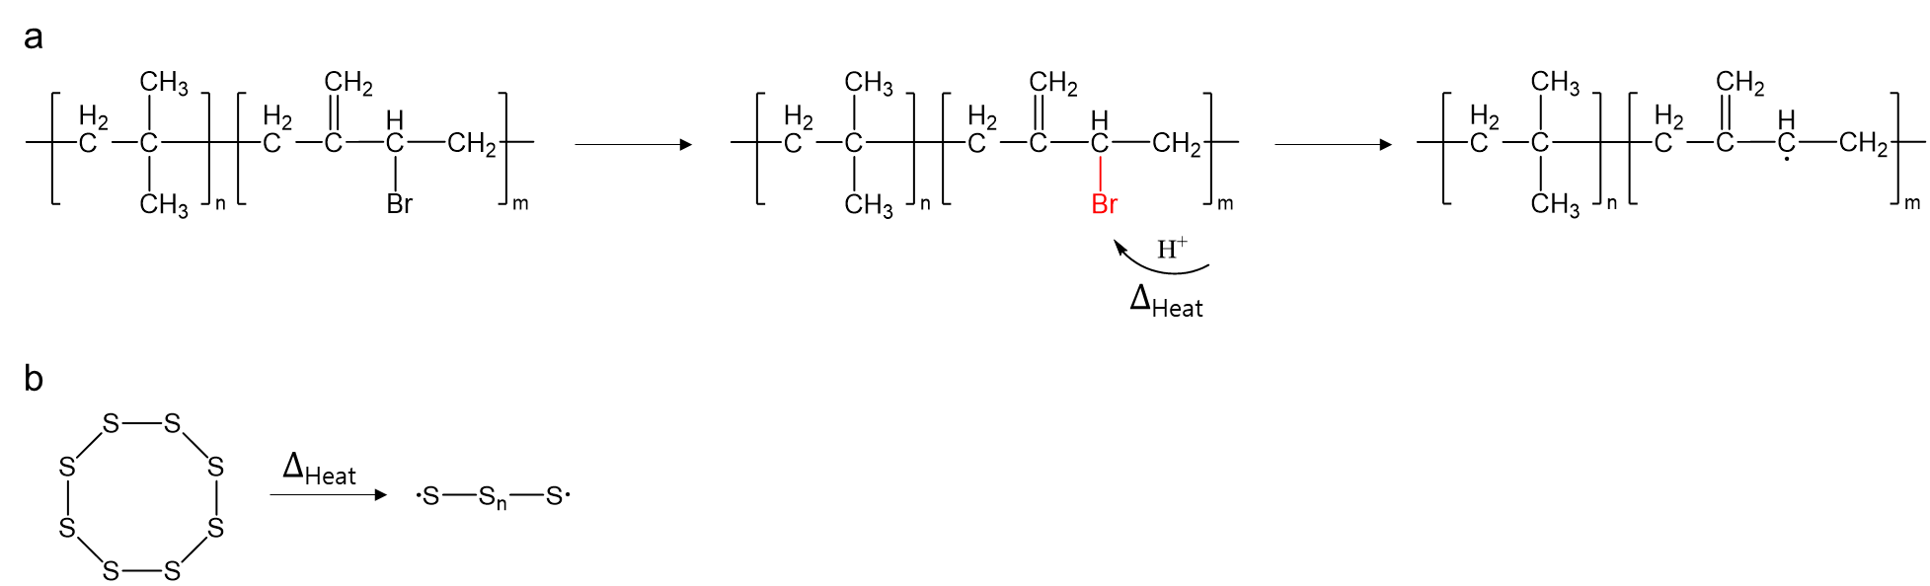

The vulcanization process for crosslinking rubber using sulfur. Bromobutyl Rubber (BIIR) has good crosslinking reactivity due to easily detachable Br (bromine) under heat. The vulcanization mechanism consists of three steps: initiation, propagation, and termination. In the initiation step with heating above 130 ºC, the detachments of bromine involve the creation of radicals on the polymer chain that is assisted by H⁺ ions of stearic acid (supplymentary note 3a). The sulfur molecule S8 is formed to sulfur radicals simultaneously (supplymentary note 3b).

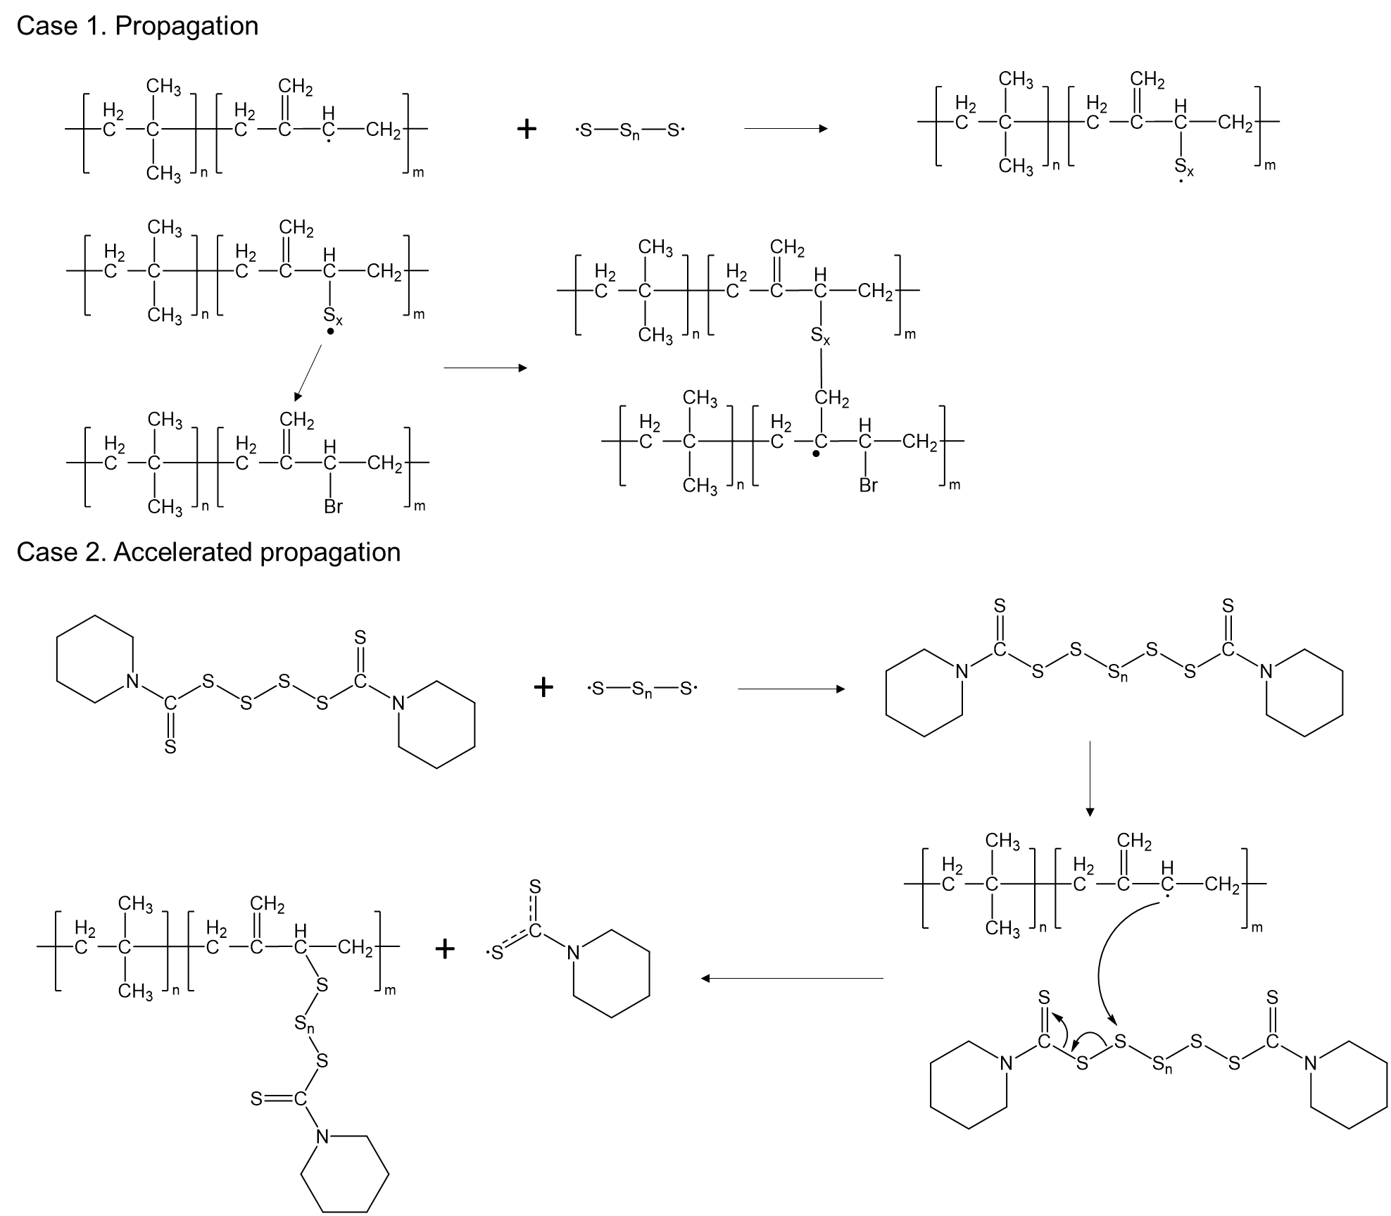
In the propagation step, the sulfur radical reacts with radical of BIIR chain or attack double bond of BIIR chain for forming another reaction site. The main reaction is accelerated-sulfur vulcanization. At first of the propagation, DPTT (dipentamethylenethiuram tetrasulfide) are combined with sulfur radicals and modified to the molecules (DPTT-S_{x}) that have a long sulfur chain between two pentamethylenethiuram group. And the radicals on polymer chain attack to the sulfur atom of DPTT-S_{x} as shown in below^{2,3}.

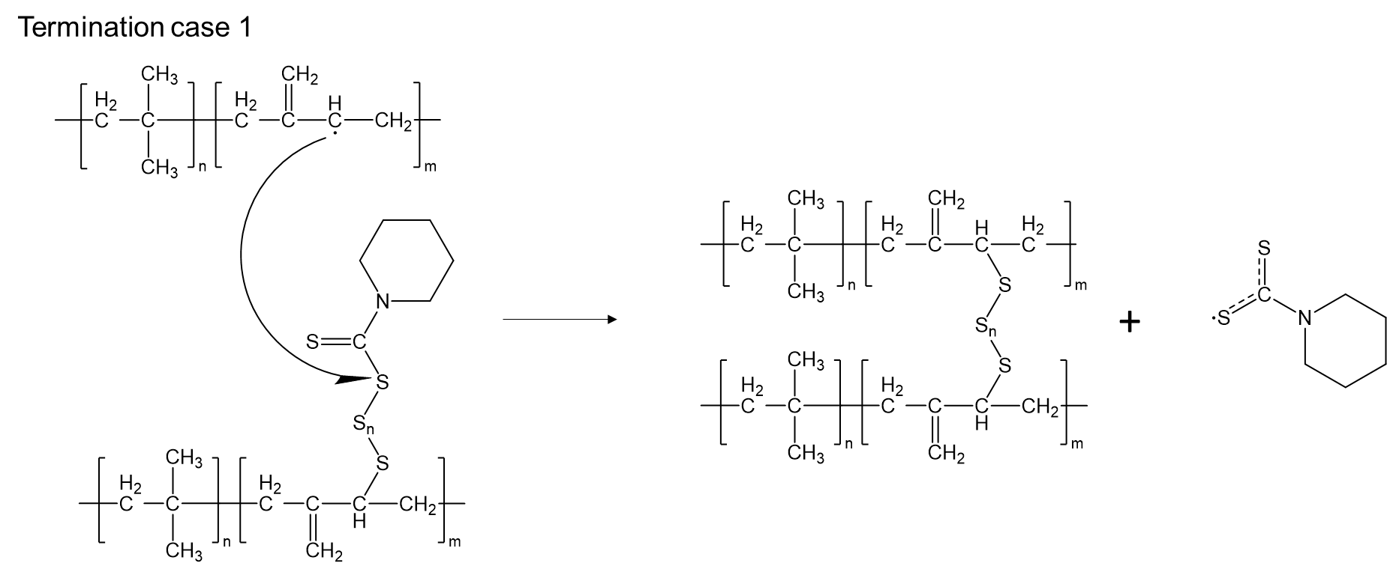

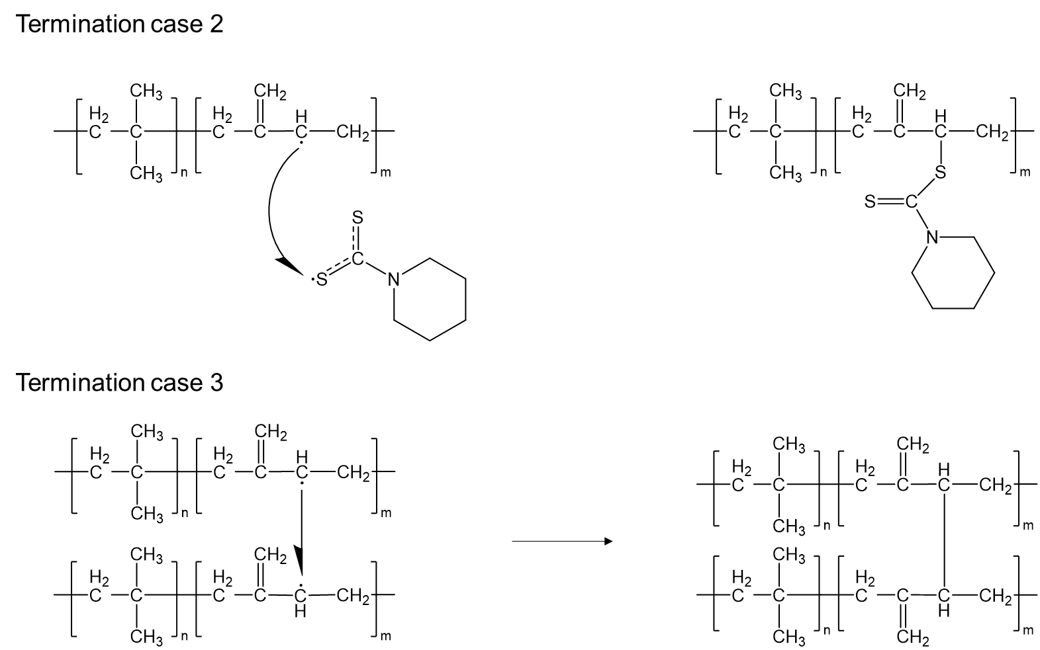
In the termination step, another radical on a neighbor polymer chain attacks to the sulfur atom of DPTT-S_{x} that is already linked with a polymer chain. Unreacted radicals can also linked with another radicals directly or pentamethylenethiuram. Finally, all radicals were reacted and consumed for the crosslinking, and the vulcanization was terminated.
Supplementary Figures
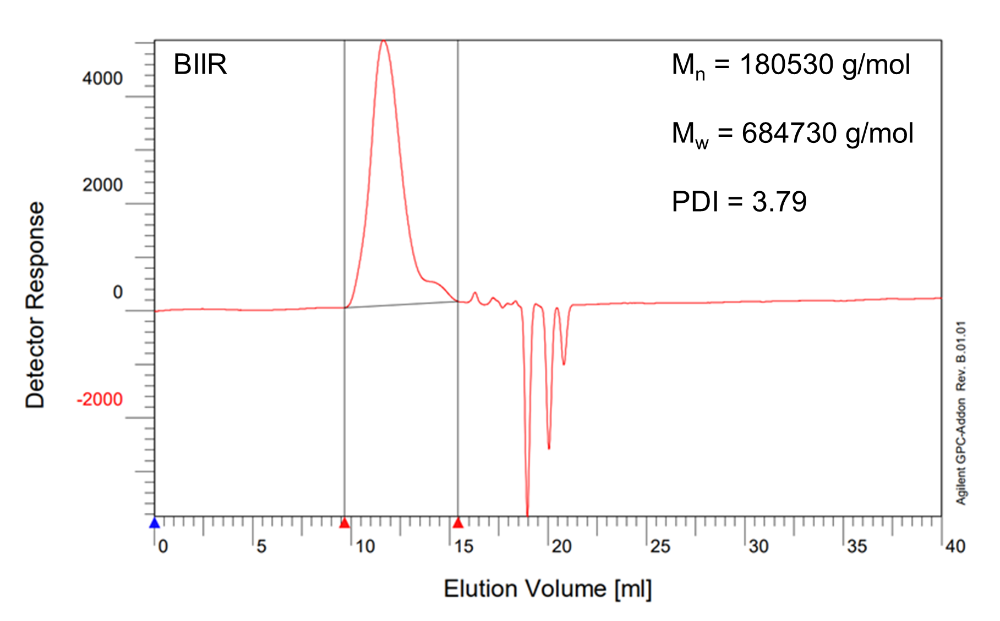
Supplementary Fig. 1. Result of GPC analysis using pure BIIR polymer

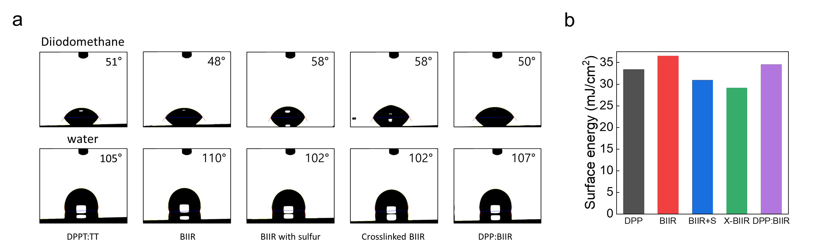
Supplementary Fig. 2. a. Contact angle of DPPT:TT, BIIR, BIIR with crosslinker, BIIR after vulcanization and DPPT-TT:BIIR blend film. b. Surface energy of DPPT:TT, BIIR, BIIR with crosslinker, BIIR after vulcanization, and DPPT-TT:BIIR blend film.

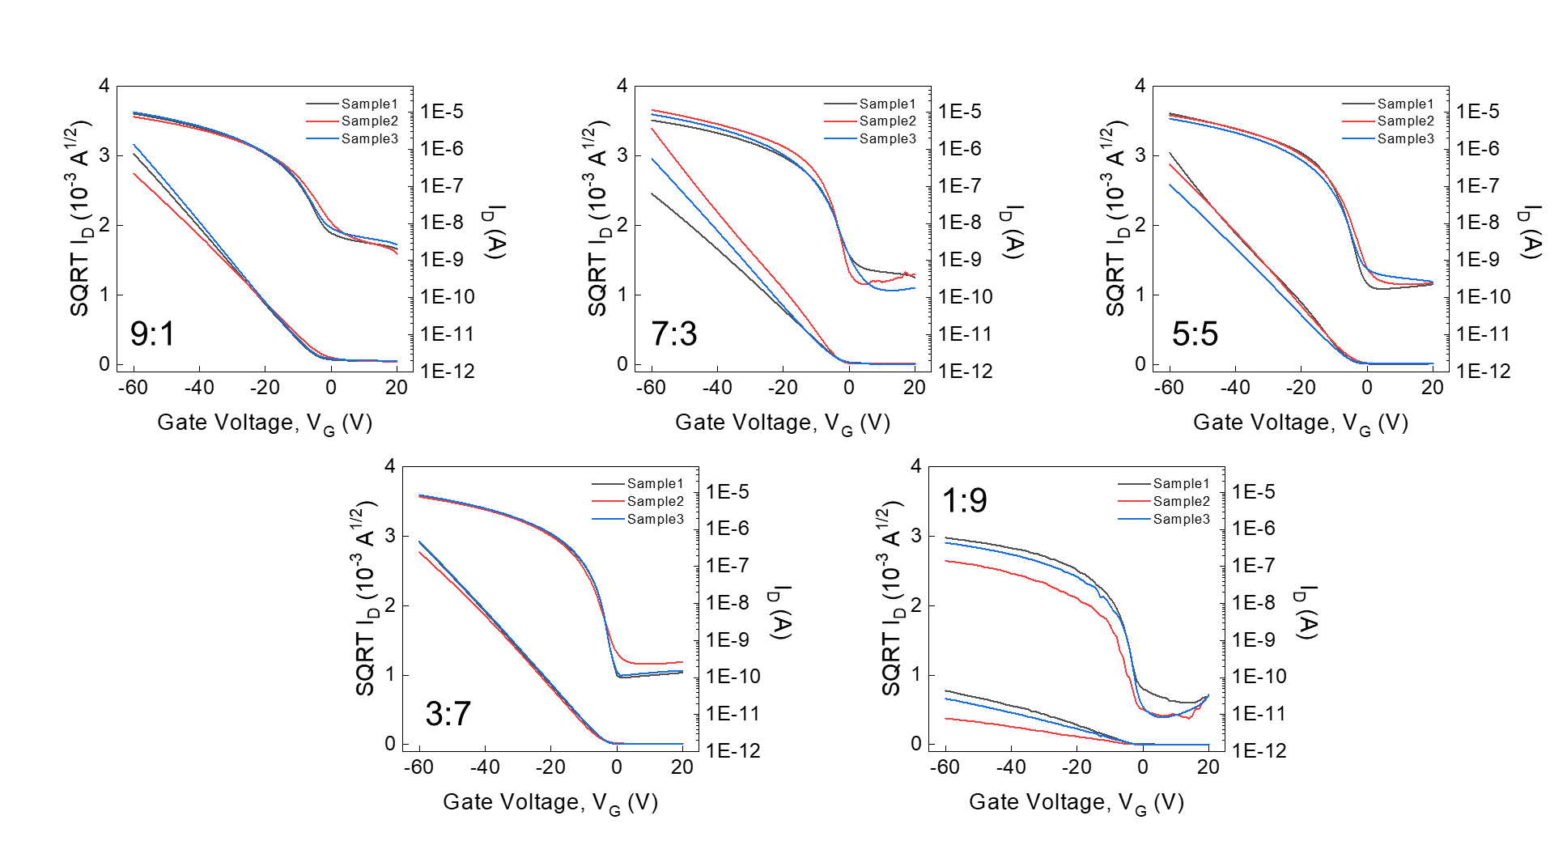
Supplementary Fig. 3. Transfer characteristics (V_{D}= -60 V) with various blending weight ratios (DPPT-TT:BIIR).

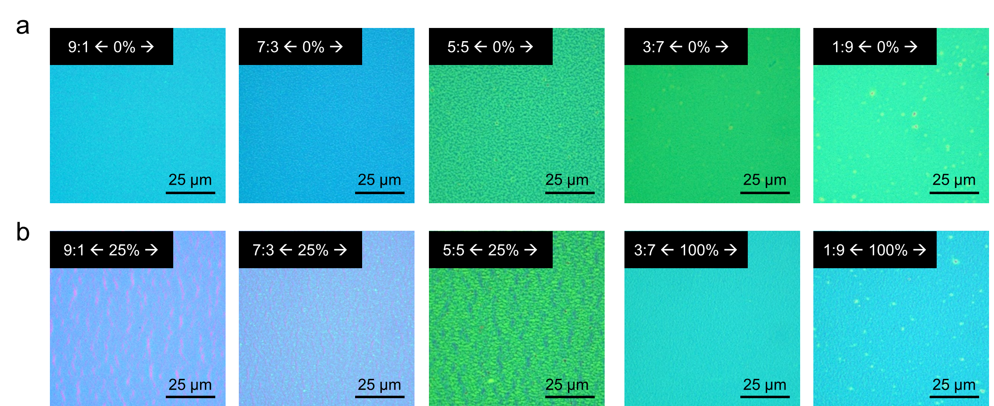
Supplementary Fig. 4. Optical microscopy (OM) images showing semiconducting films at a, 0% and b, 25% strain with 9:1 to 5:5 of blending weight ratio and 100% strain with 3:7 to 1:9 blending weight ratio (DPPT-TT:BIIR).
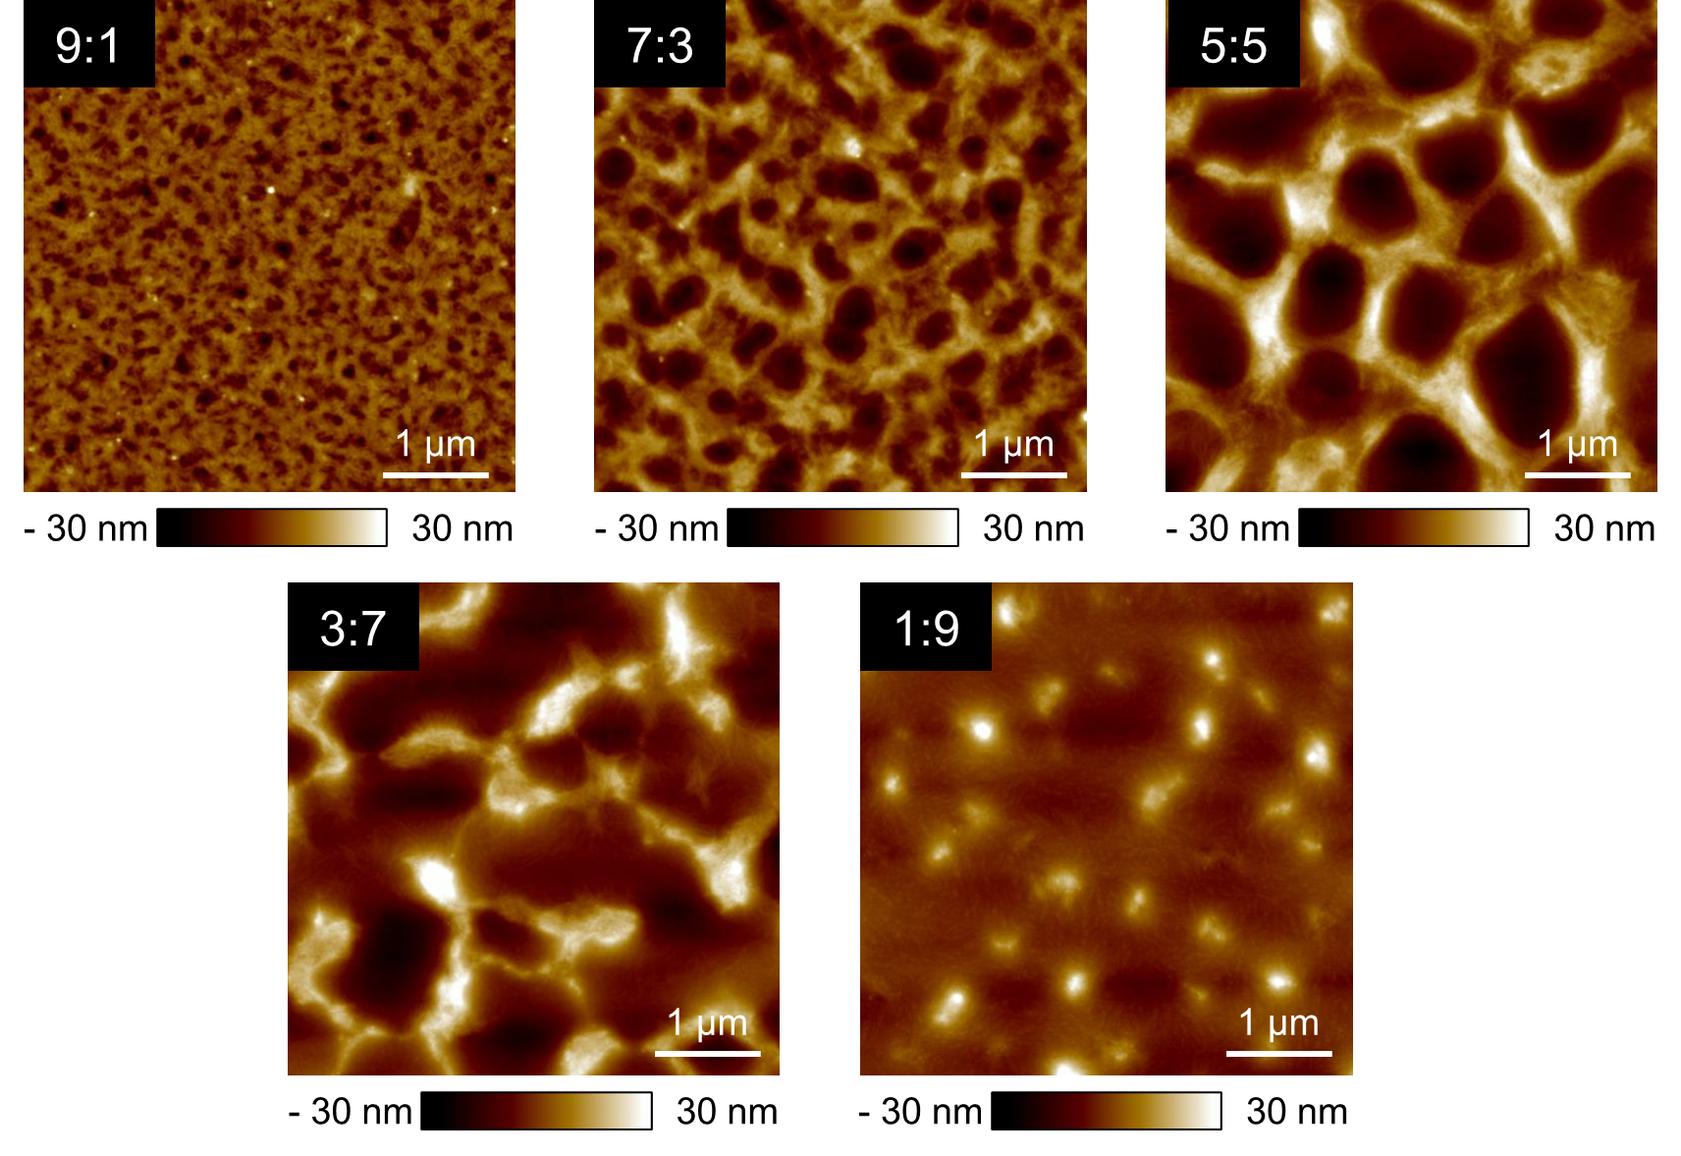
Supplementary Fig. 5. Atomic force microscopy (AFM) height images showing semiconducting film with 9:1 to 1:9 blending weight ratio (DPPT-TT:BIIR).

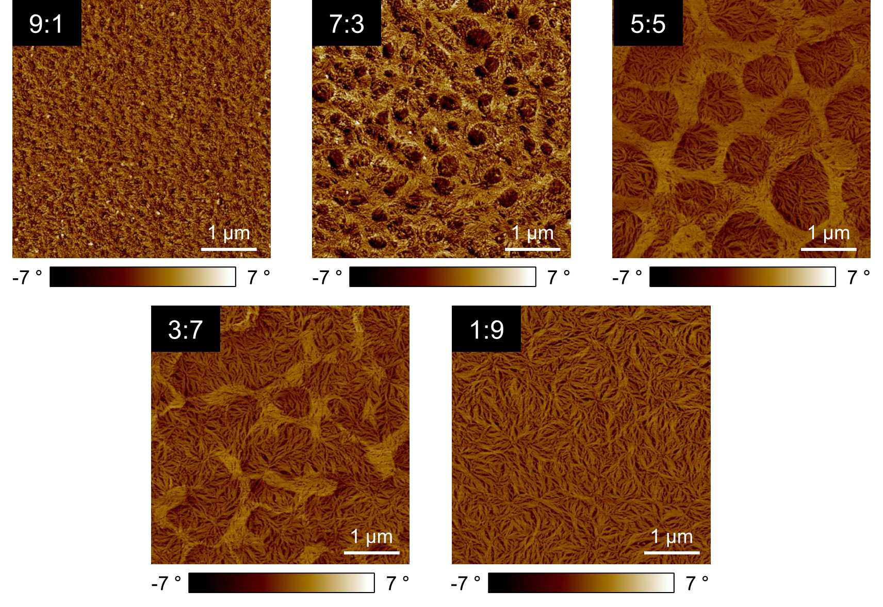
Supplementary Fig. 6. AFM phase images showing semiconducting film with 9:1 to 1:9 blending weight ratio (DPPT-TT:BIIR).

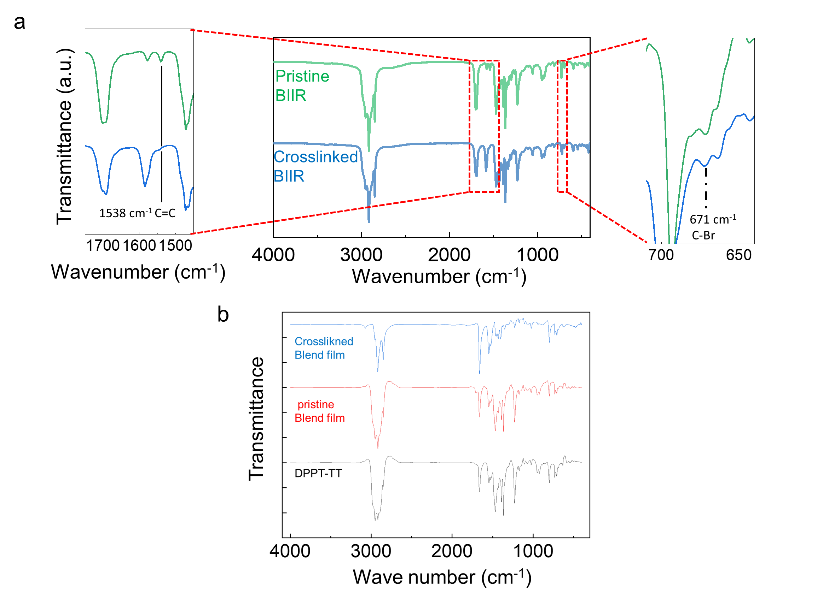
Supplementary Fig. 7. a. FTIR spectra of pristine and crosslinked BIIR films. b. FTIR spectra of neat DPPT-TT, pristine DPPT-TT:BIIR, and crosslinked DPPT-TT:BIIR blend film.

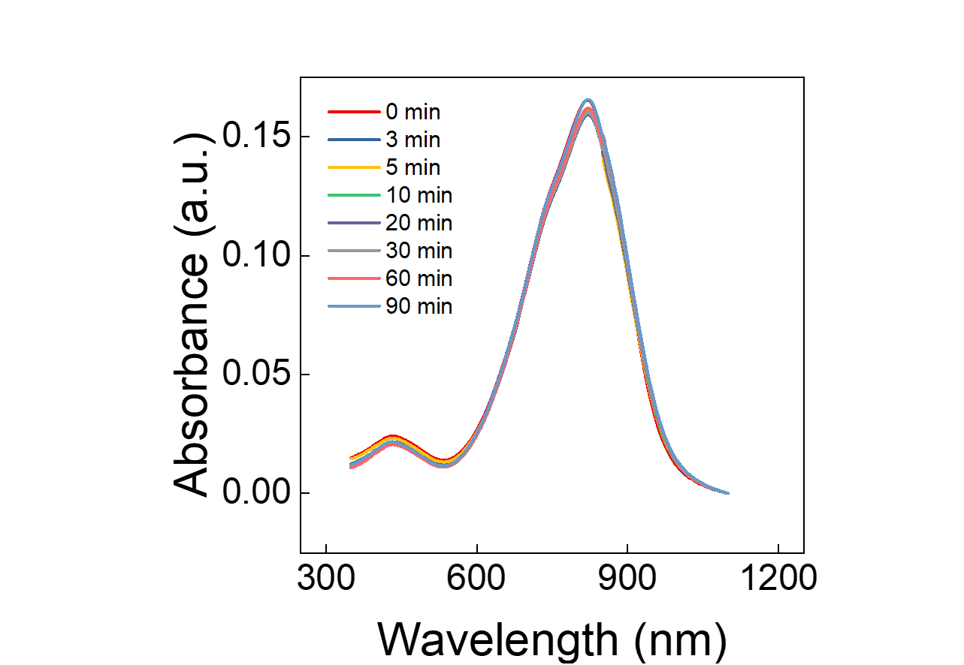

Supplementary Fig. 8. UV-vis-NIR absorbance spectra of semiconducting film under various thermal annealing time.

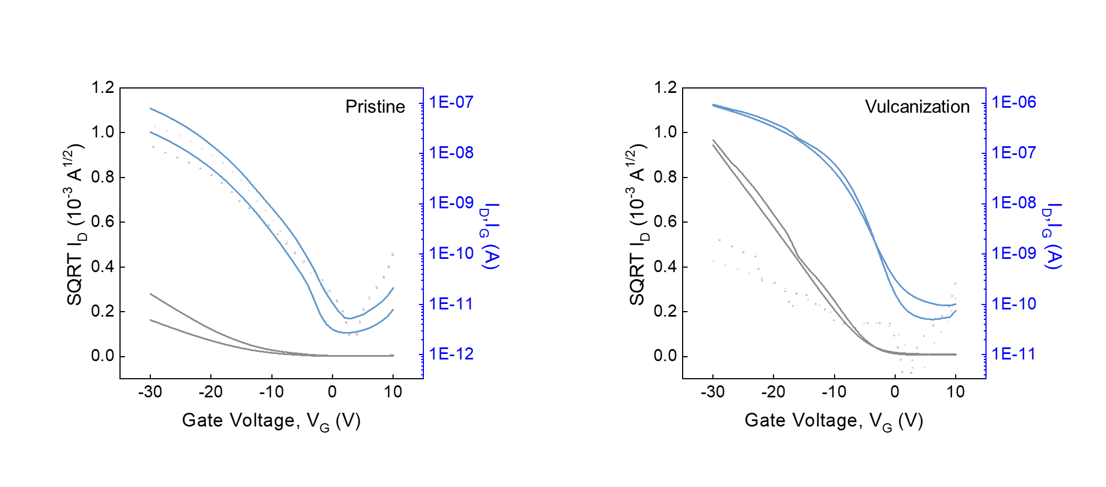
Supplementary Fig. 9. Transfer characteristic of DPPT-TT:BIIR film before and after vulcanization.
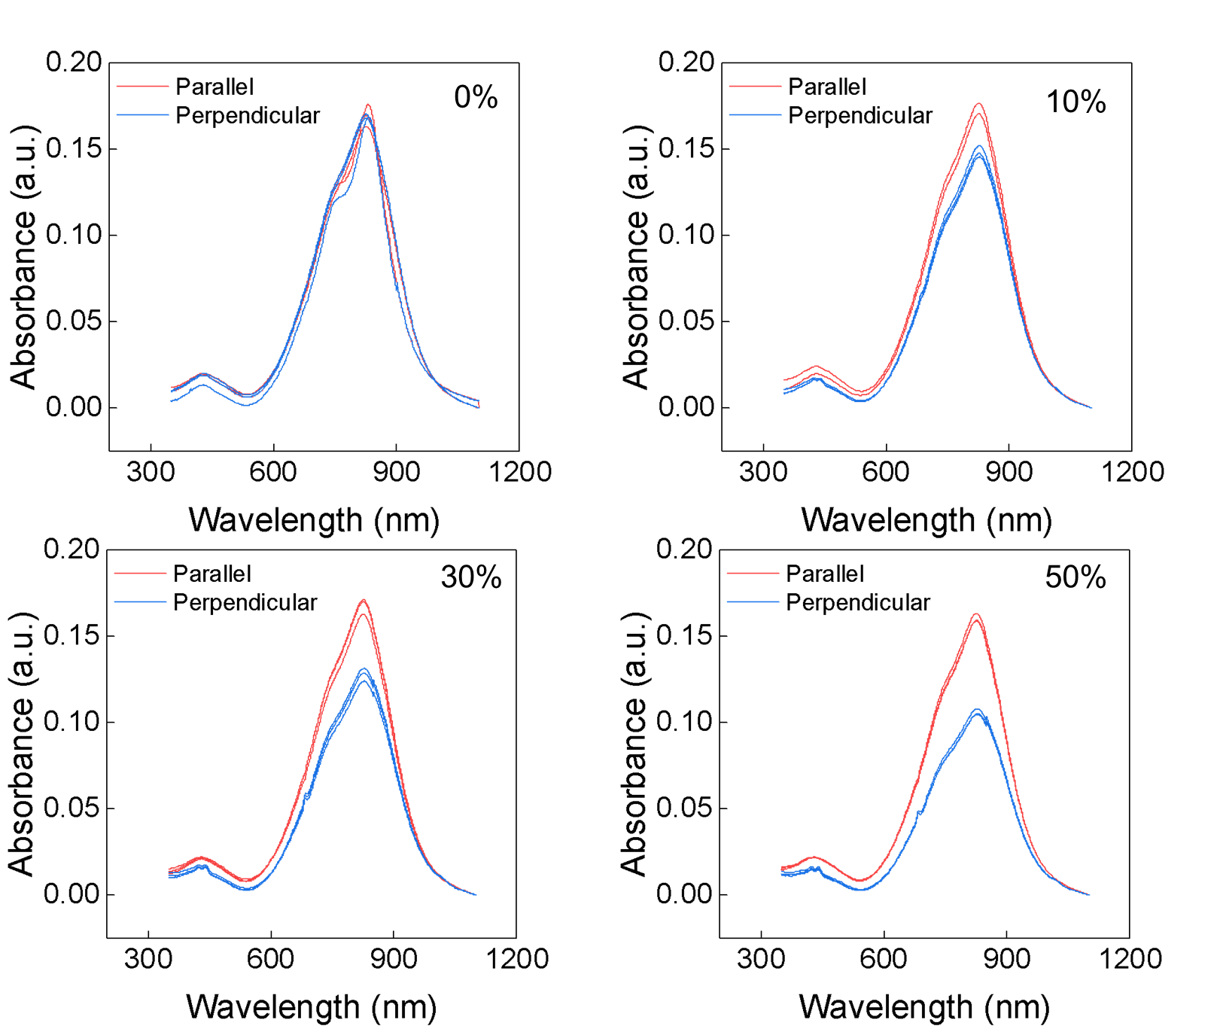
Supplementary Fig. 10. Polarized UV-vis-NIR absorbance spectra of semiconducting film under various strains with parallel and perpendicular stretching directions to the polarized light.

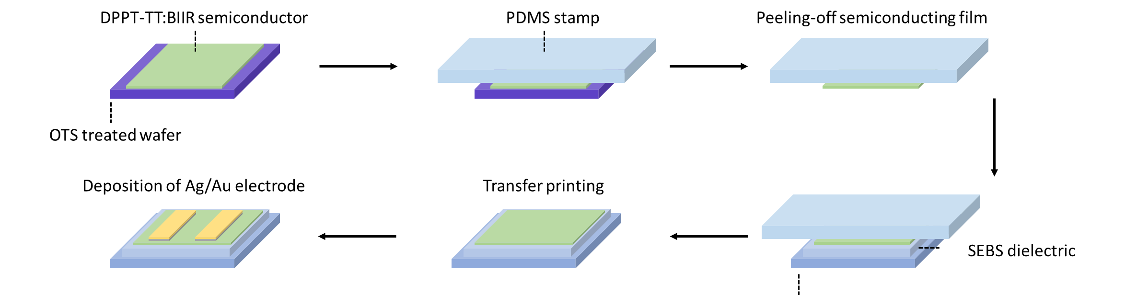
Supplementary Fig. 11. Schematic showing the fabrication method of rigid transistor for electrical measurement.

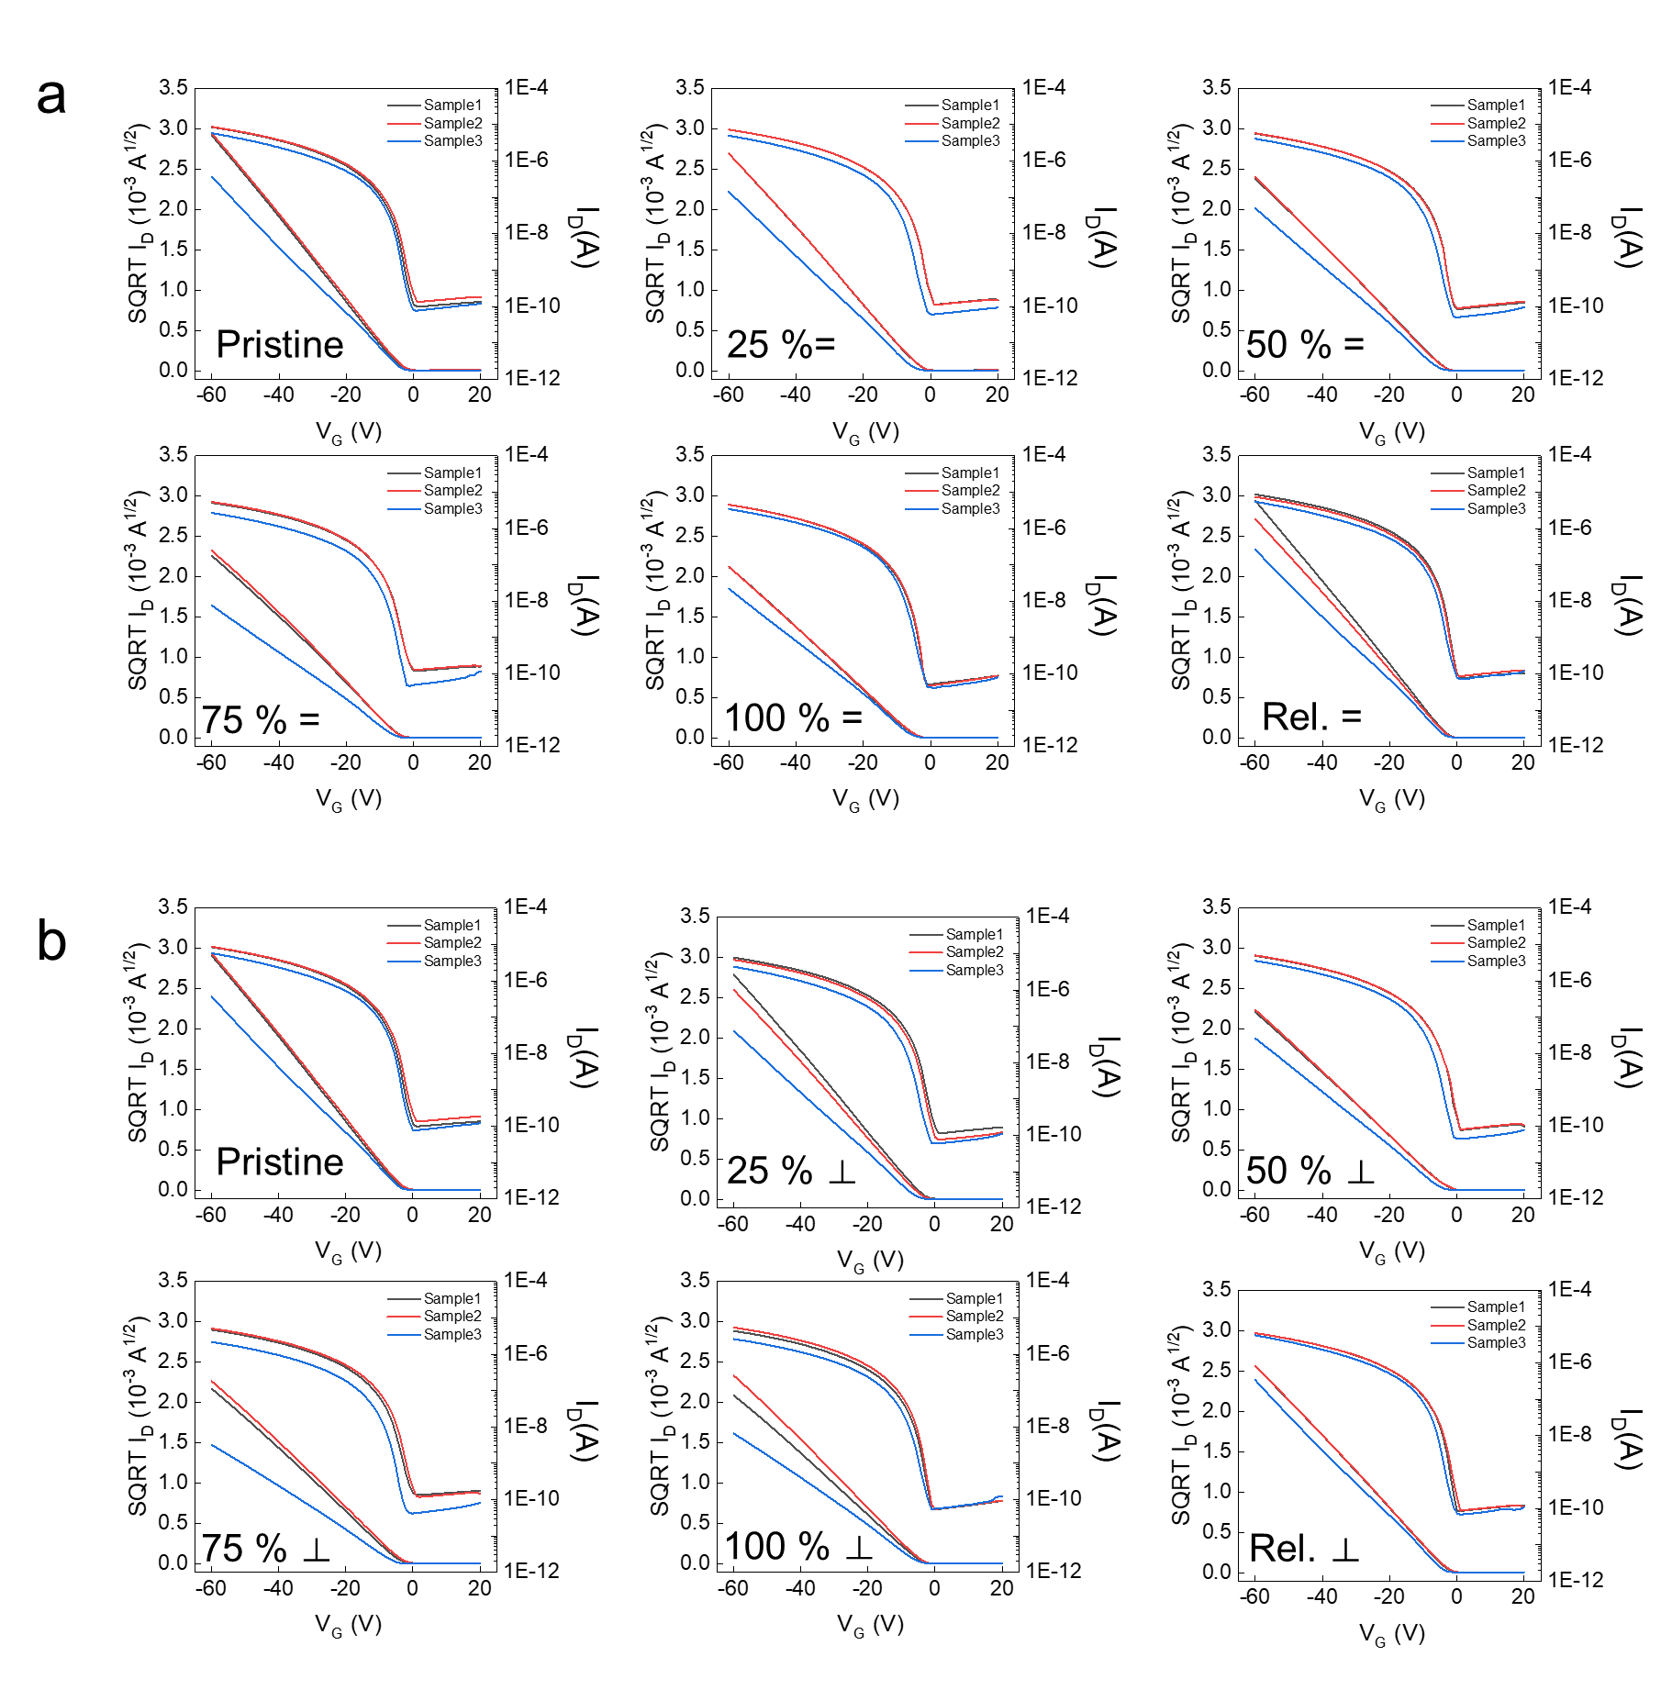
Supplementary Fig. 12. Transfer characteristics (V_{D}= -60 V) using the uniaxially stretched semiconducting films and released state: a, Parallel (=) and b, perpendicular (⊥) stretching direction to the channel.

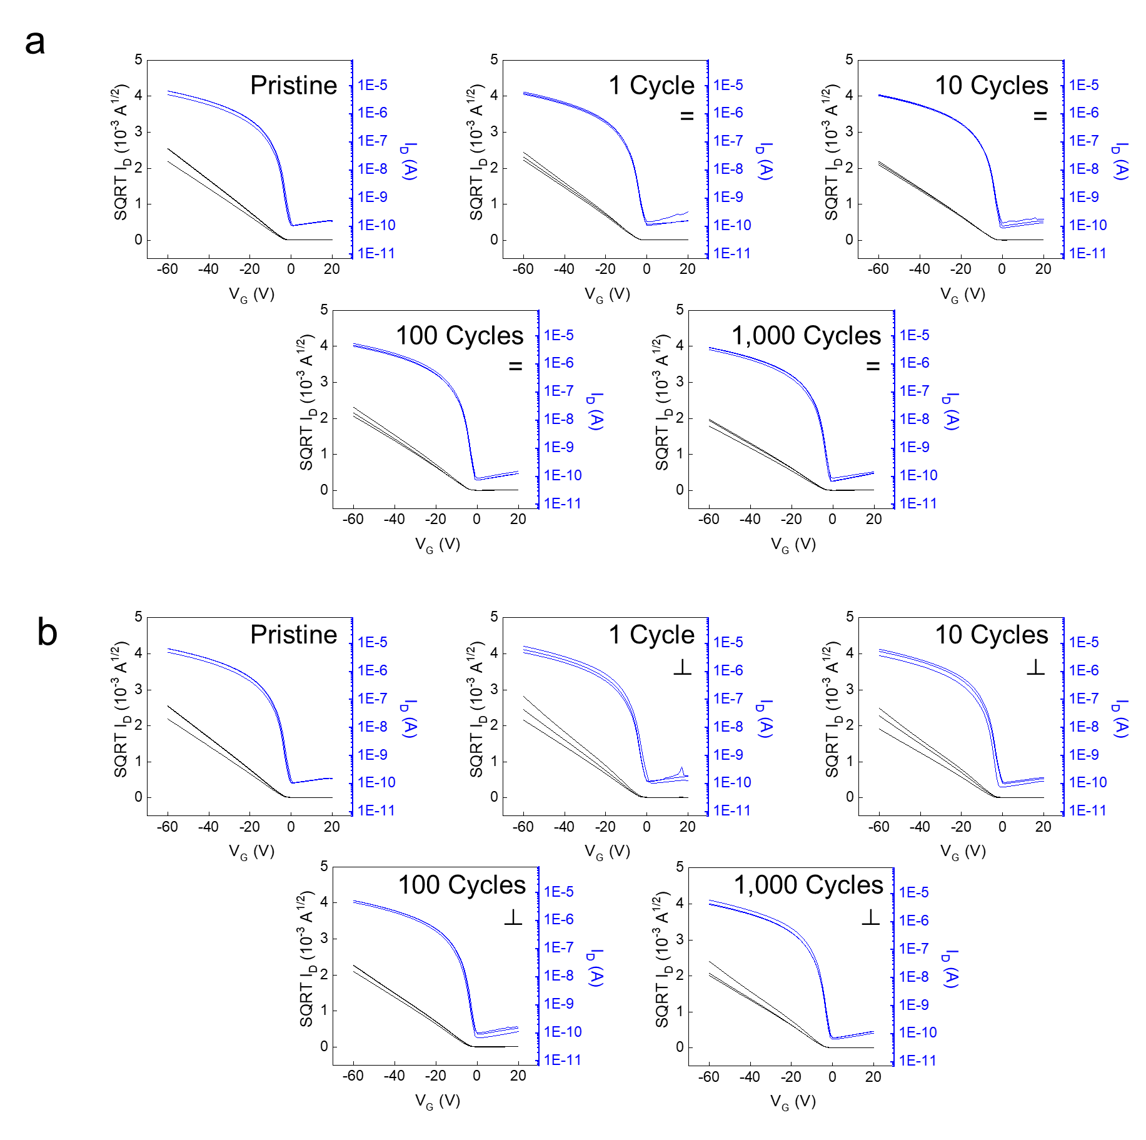
Supplementary Fig. 13. Transfer characteristics (V_{D}= -60 V) under multiple stretching cycles with 100% strain: a, Parallel and b, perpendicular stretching direction to the channel.

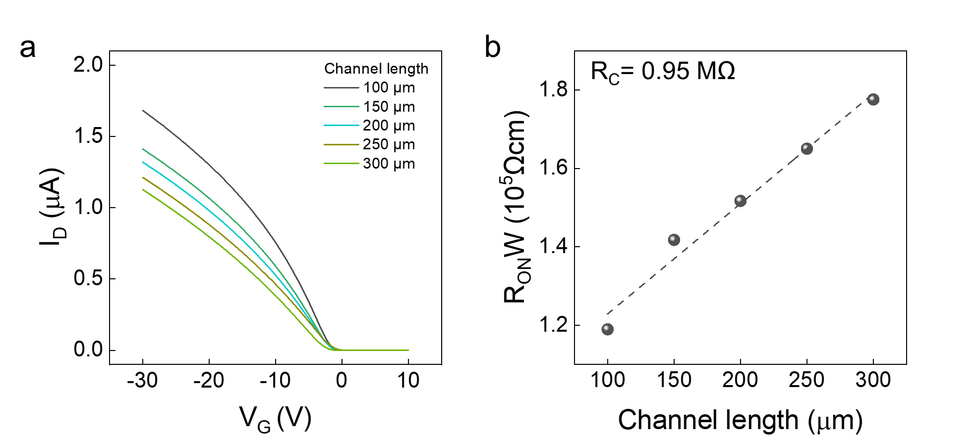
Supplementary Fig. 14. a, Transfer characteristics (V_{D}= -2 V) with various channel length and b, contact resistance calculated by transmission line method (TLM).

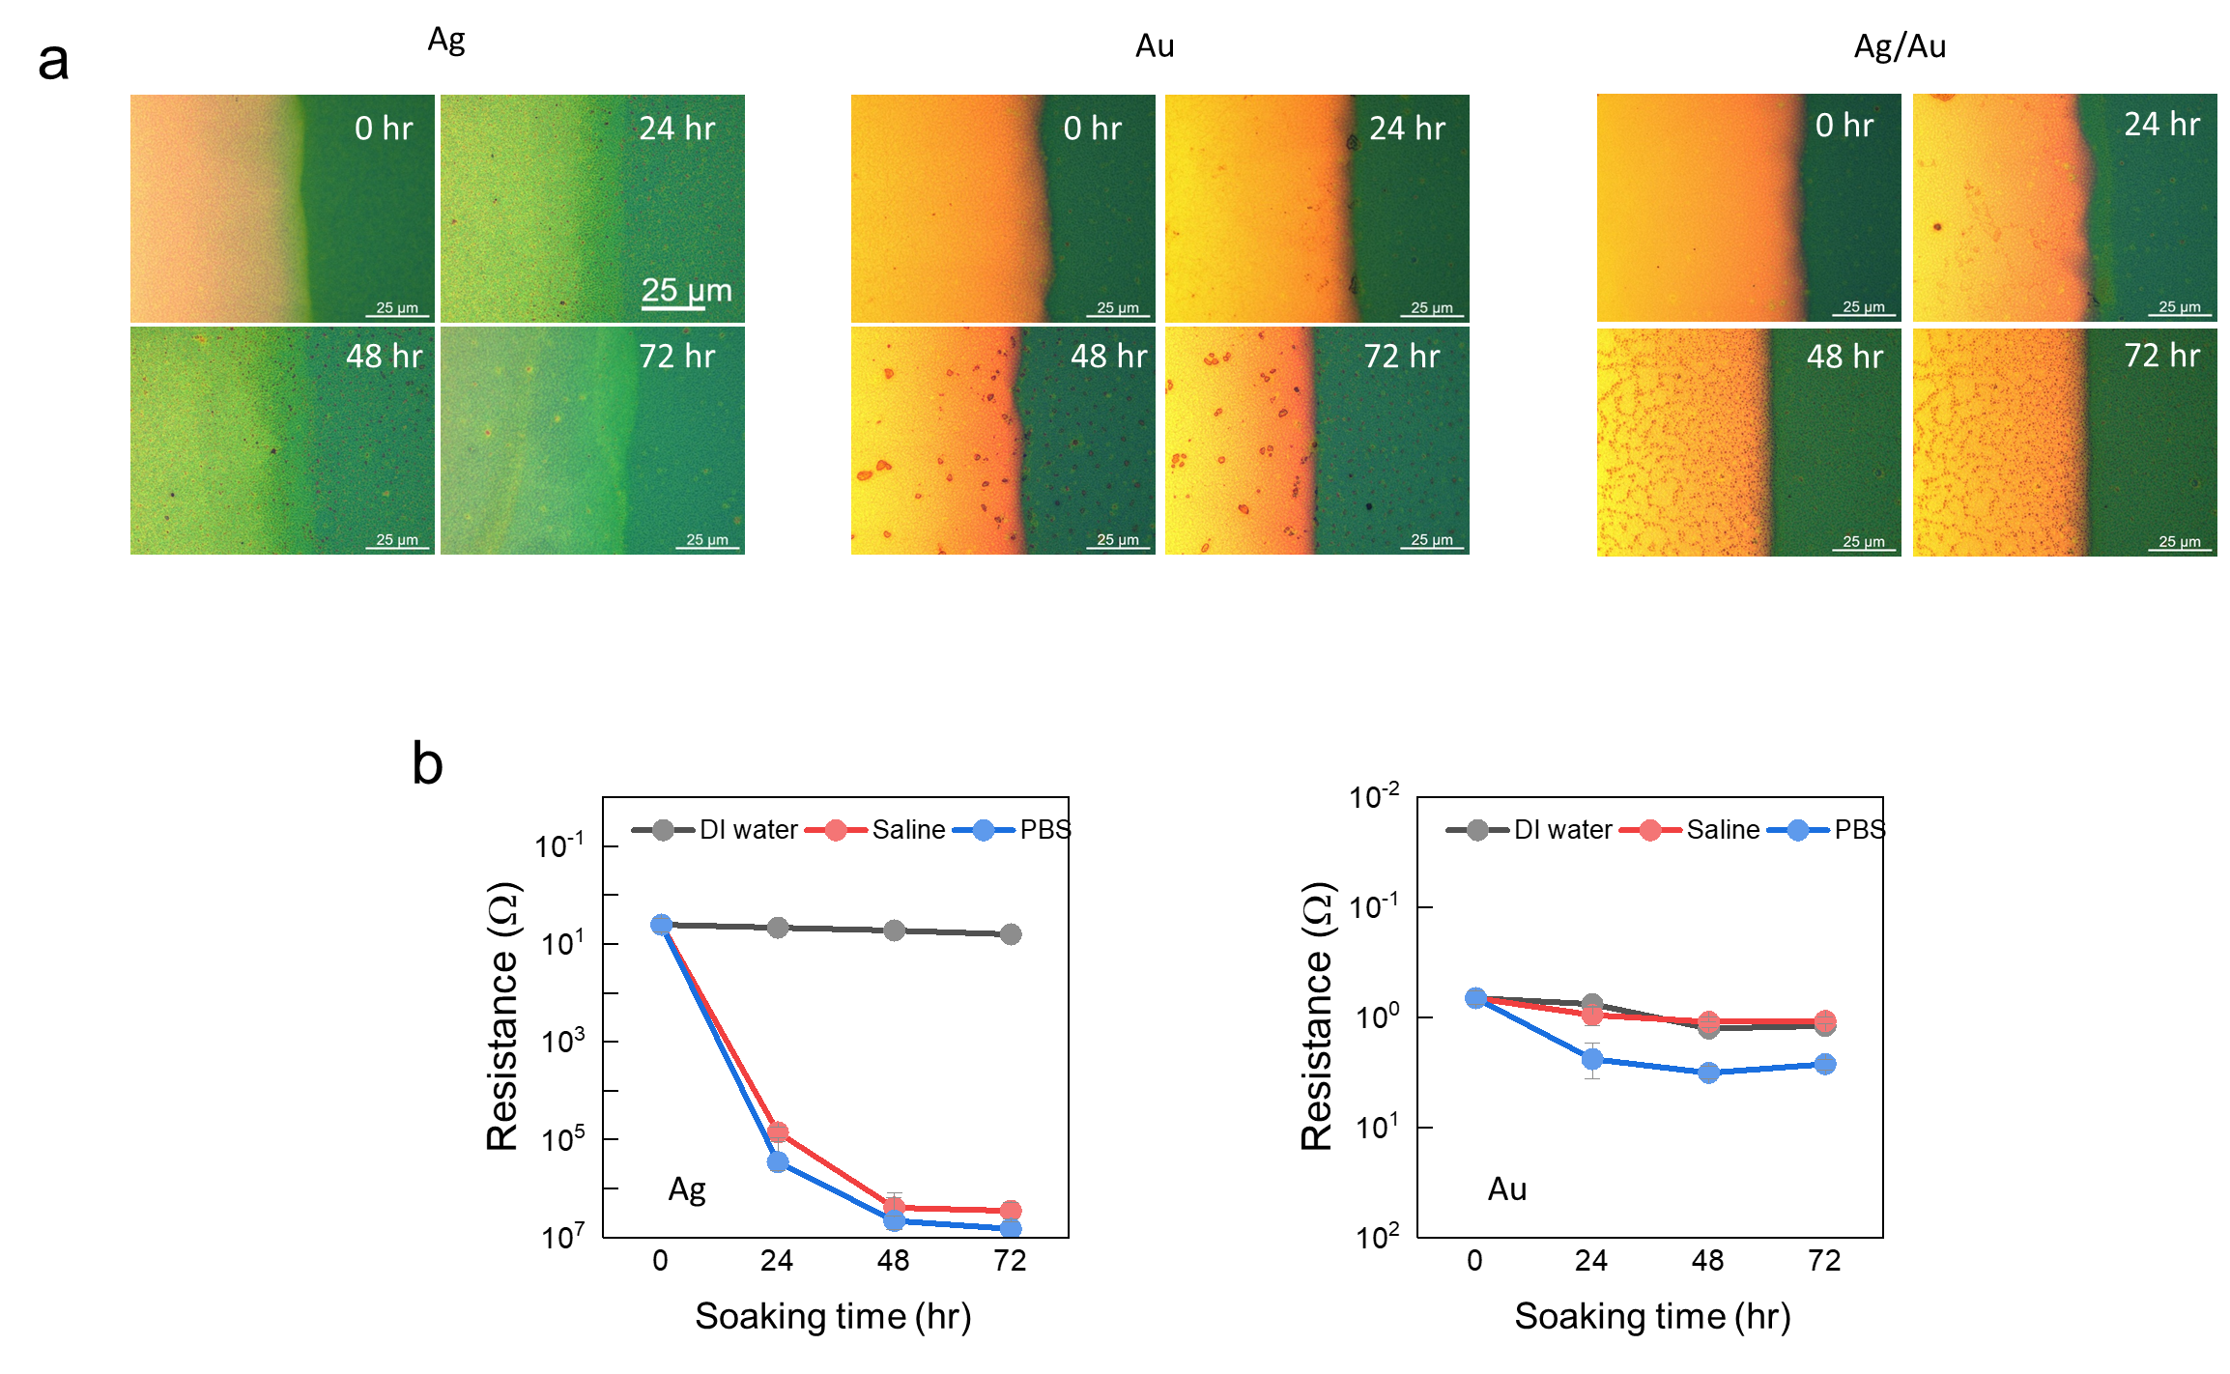
Supplementary Fig. 15. a, OM images of the Ag, Au, Ag/Au S/D electrode on semiconducting film after soaking in artificial sweat. b, Resistance change of Ag and Au electrode on semiconducting film after soaking in DI water, saline solution, and PBS during 72 hr.

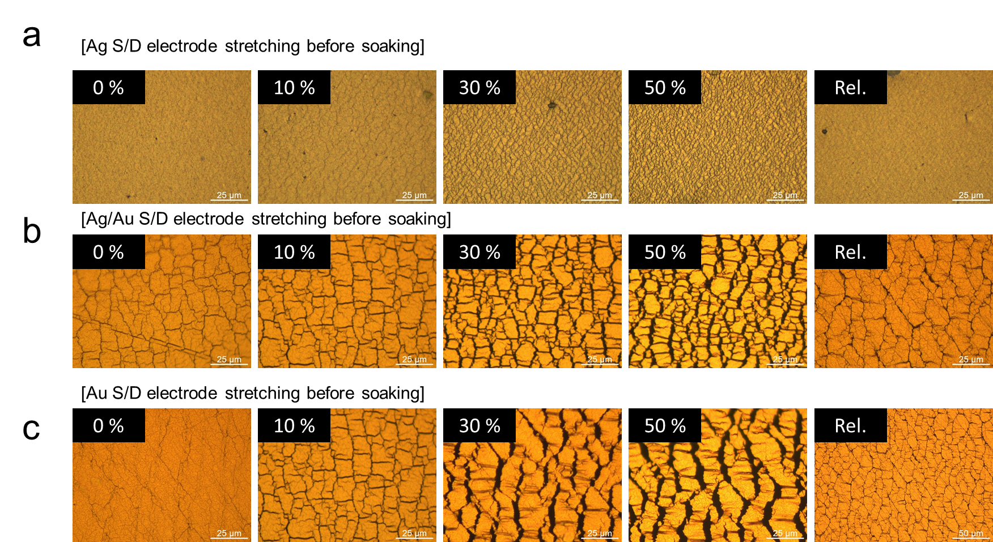
Supplementary Fig. 16. a, OM images of the a, Ag b, Ag/Au c, Au S/D electrode on semiconducting film under stretched and released states.

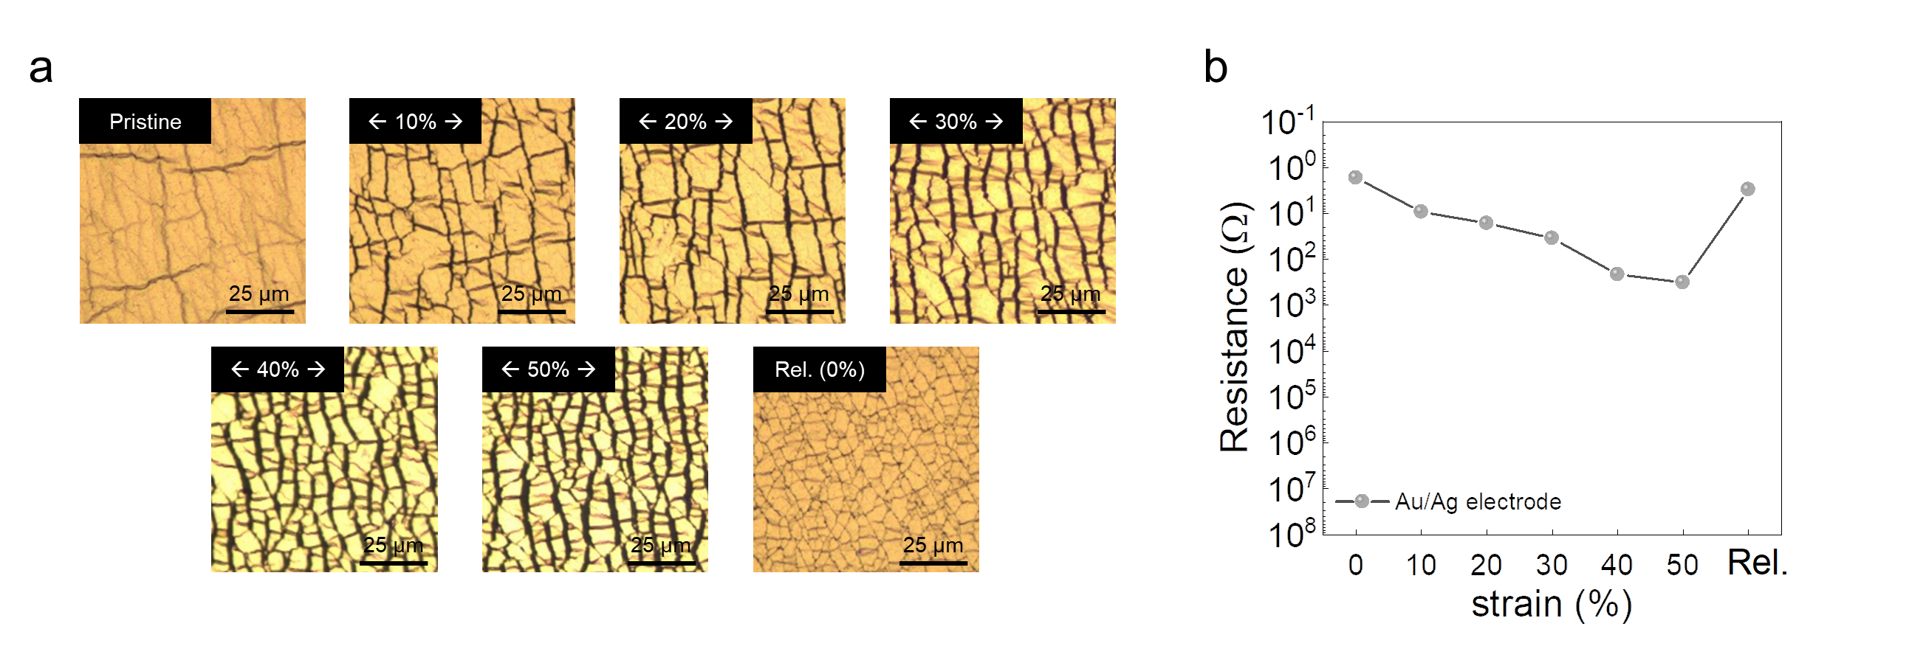
Supplementary Fig. 17. a, OM images of the Au/Ag gate electrode on SEBS substrate under stretched and released states. b, Changes in resistance of the Au/Ag gate electrode ranging from 0 to 50% in stretched and released states (Rel.).

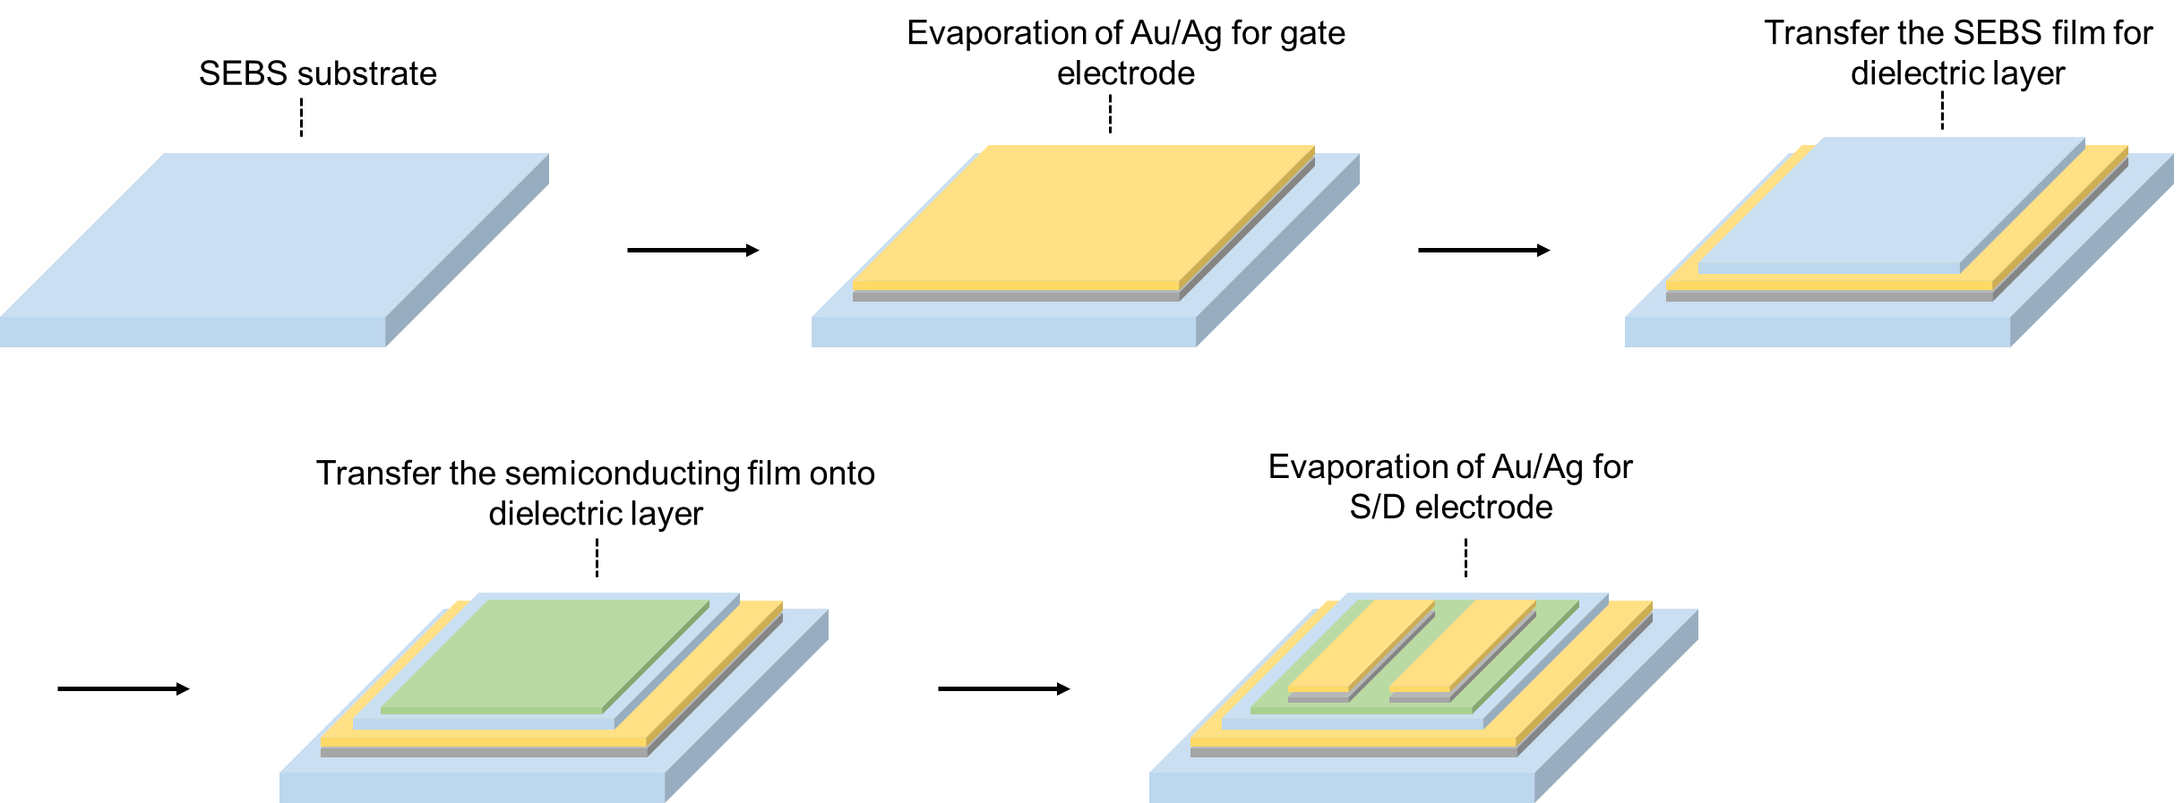
Supplementary Fig. 18. Schematic showing fabrication method for fully stretchable transistor.

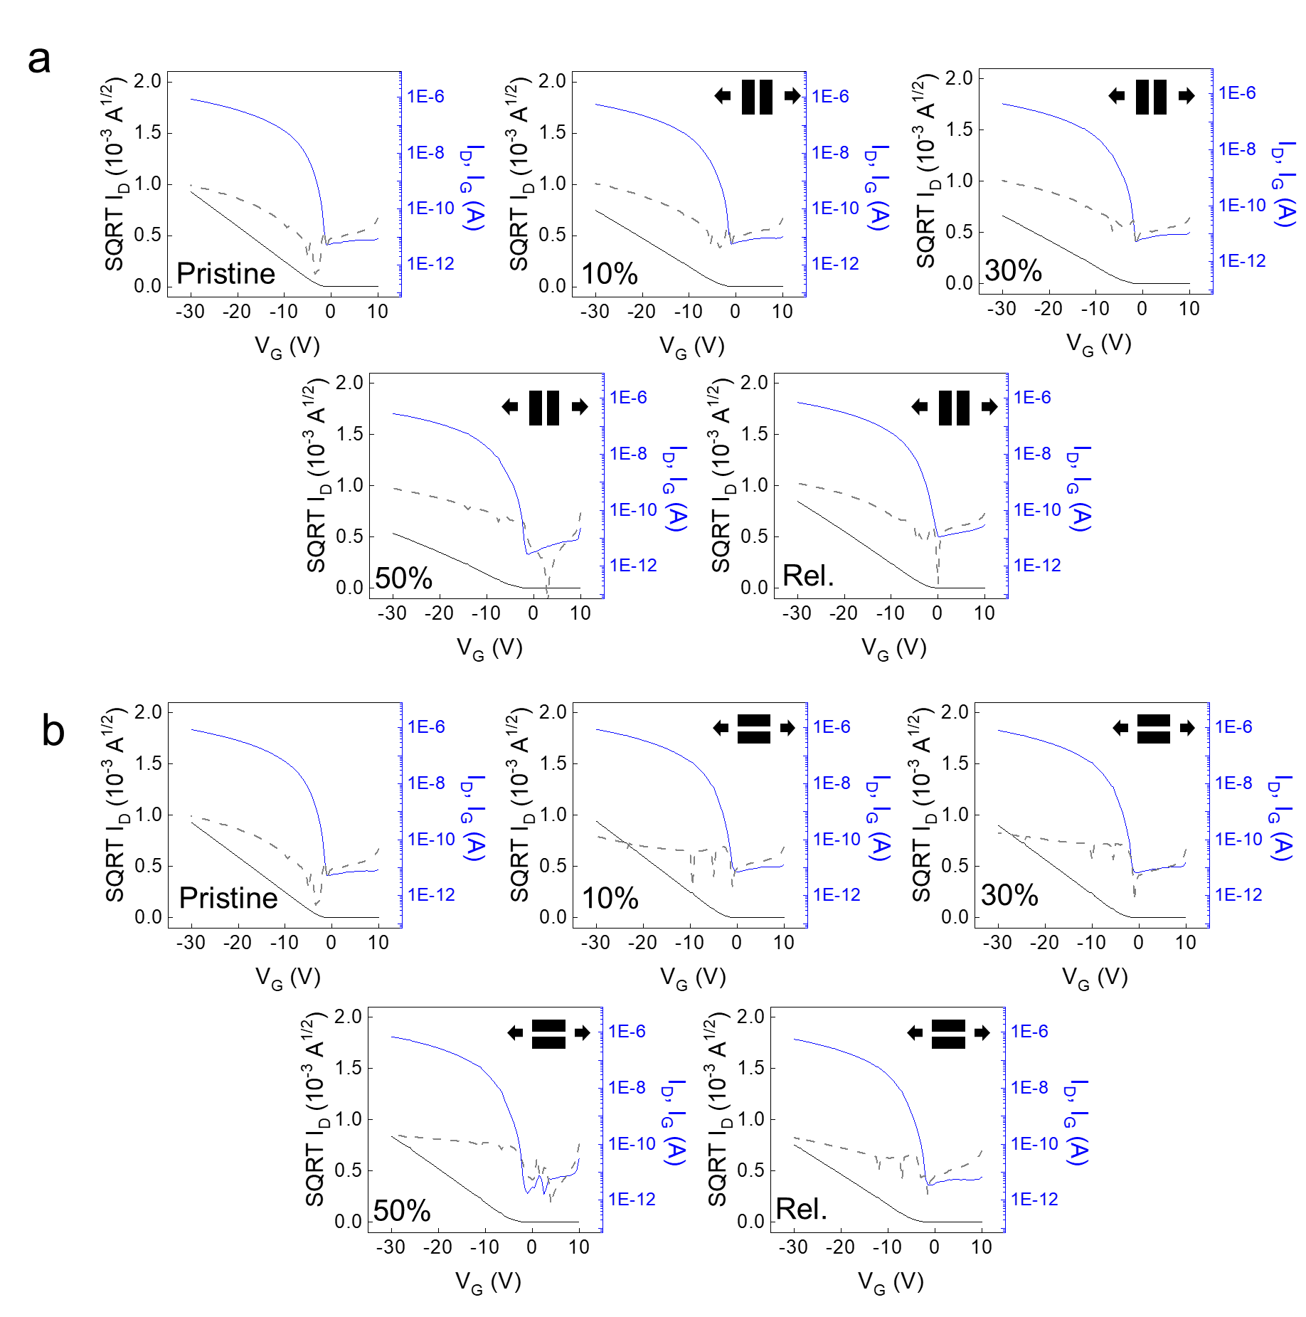
Supplementary Fig. 19. Transfer characteristics (V_{D}= -30 V) of fully stretchable transistor under uniaxially stretched and released state with a, parallel (=) and b, perpendicular (⊥) stretching directions to the channel.

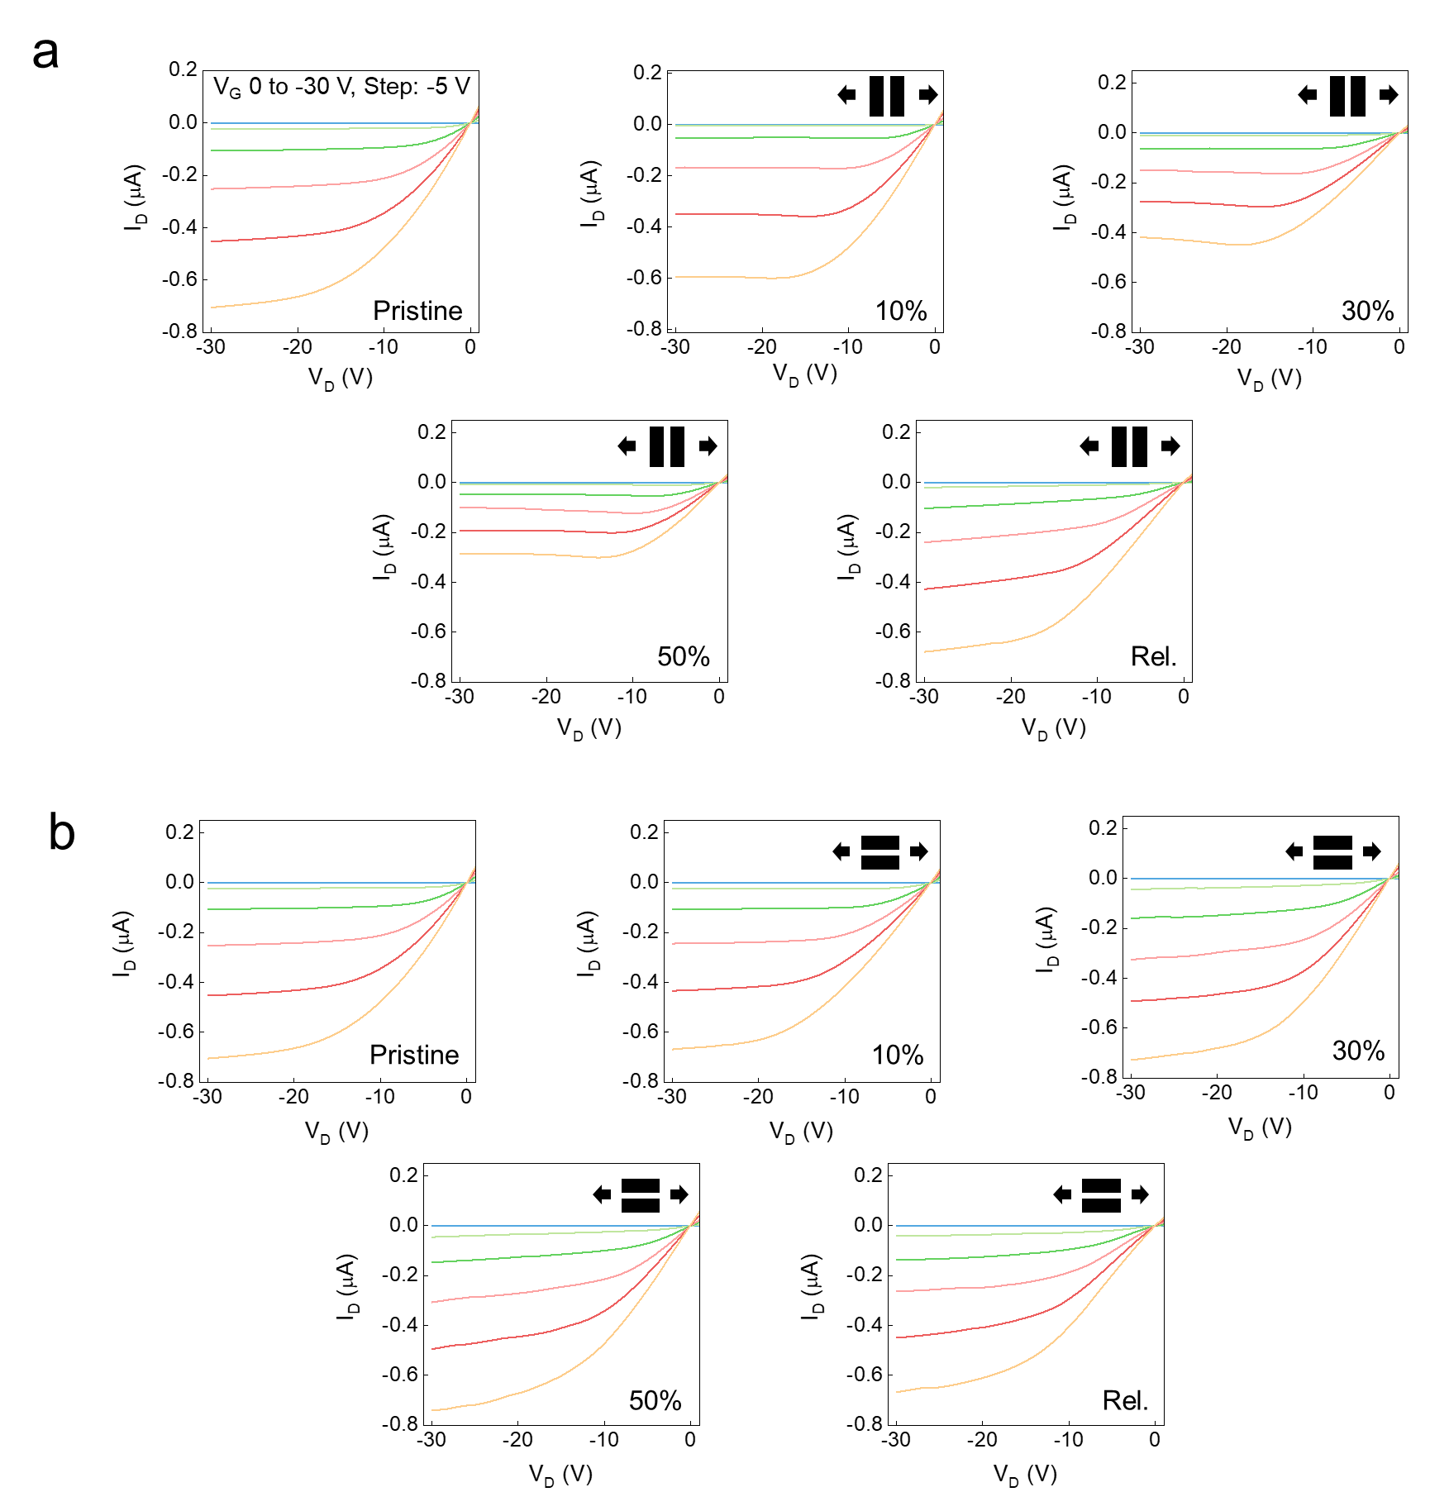
Supplementary Fig. 20. Output characteristics of fully stretchable transistor under uniaxially stretched and released state with a, parallel and b, perpendicular stretching directions to the channel.

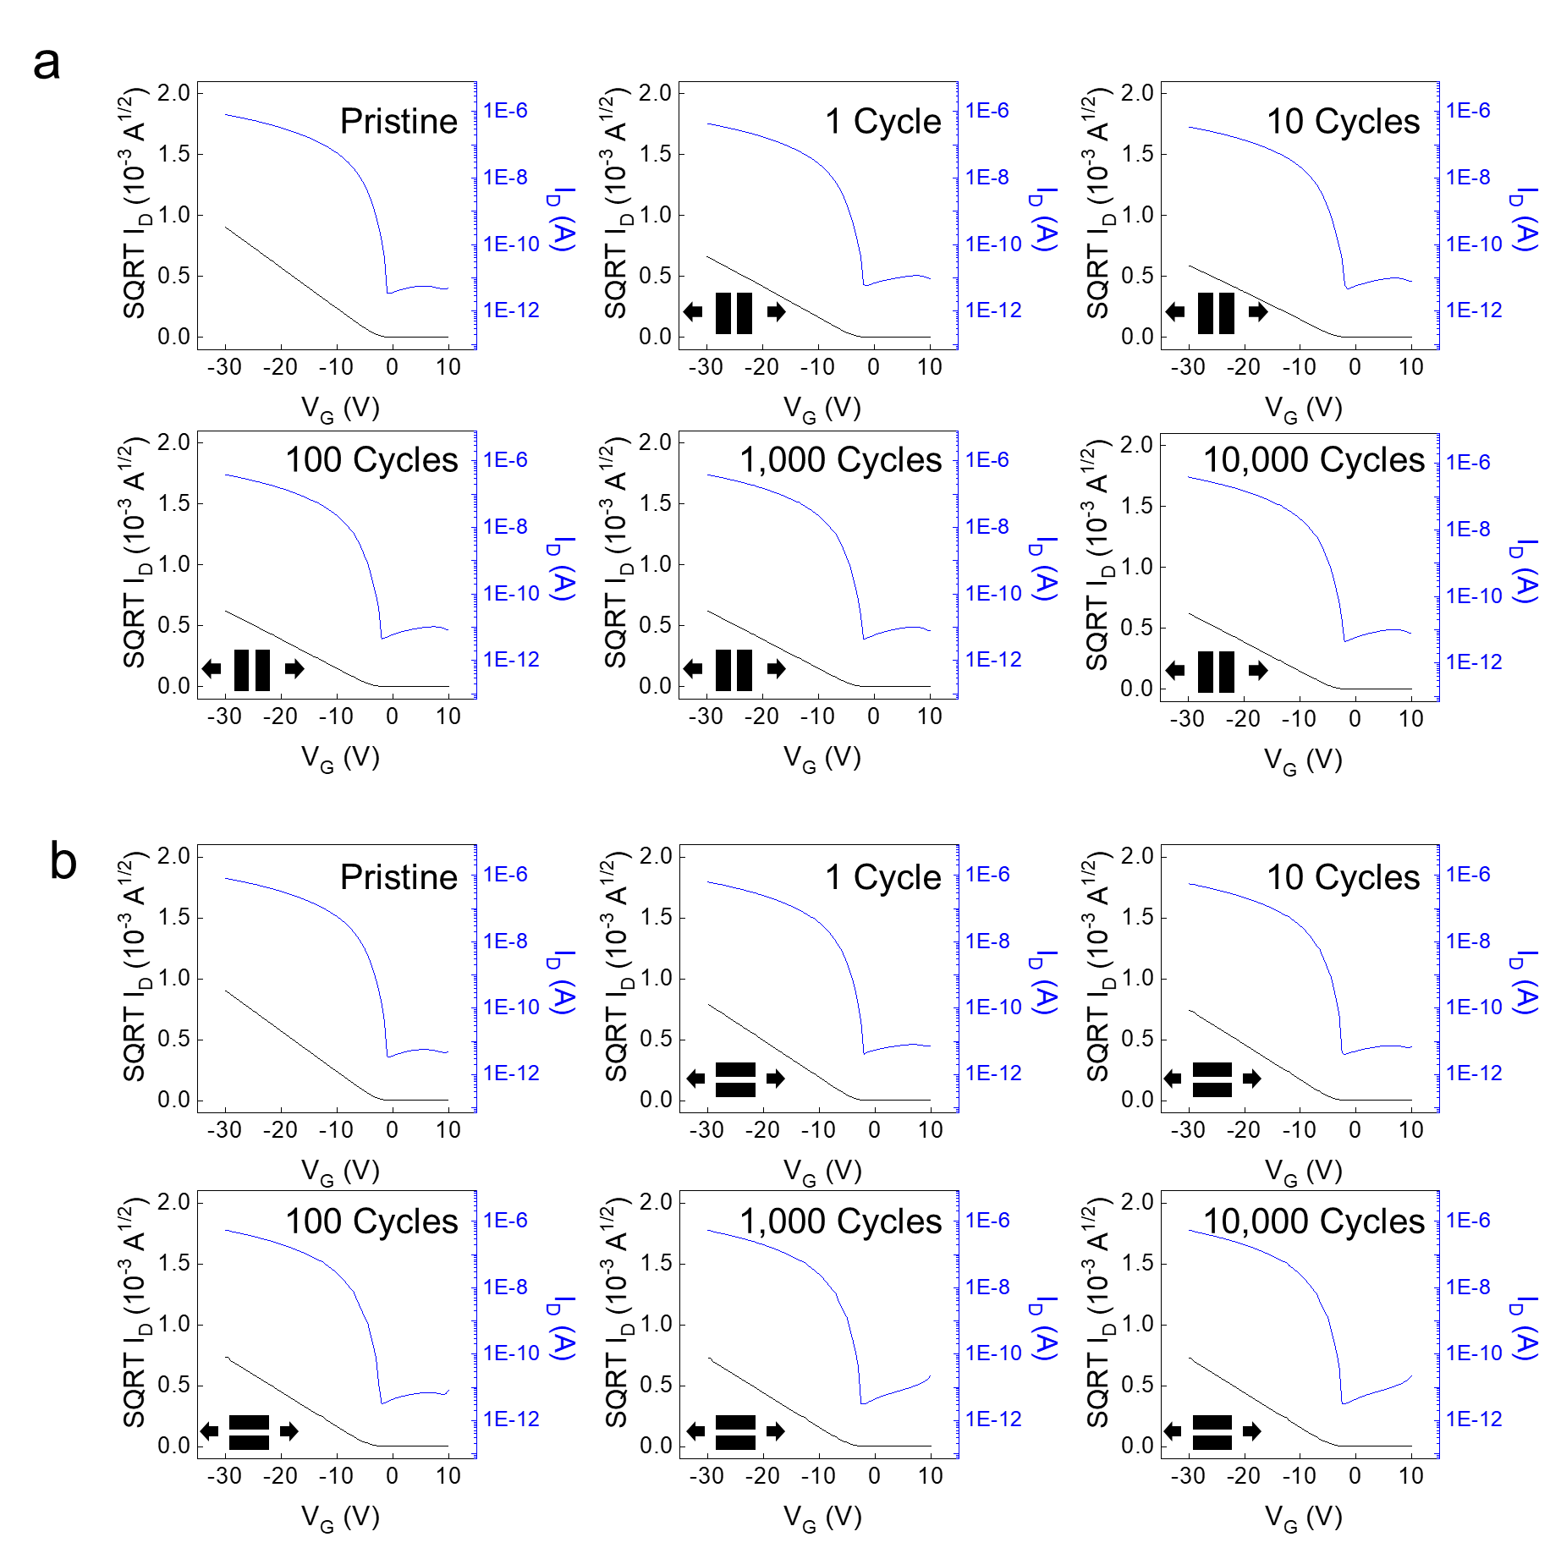
Supplementary Fig. 21. Transfer characteristics (V_{D}= -30 V) of fully stretchable transistor with multiple uniaxial stretching (50%) cycle with a, parallel and b, perpendicular stretching directions to the channel.

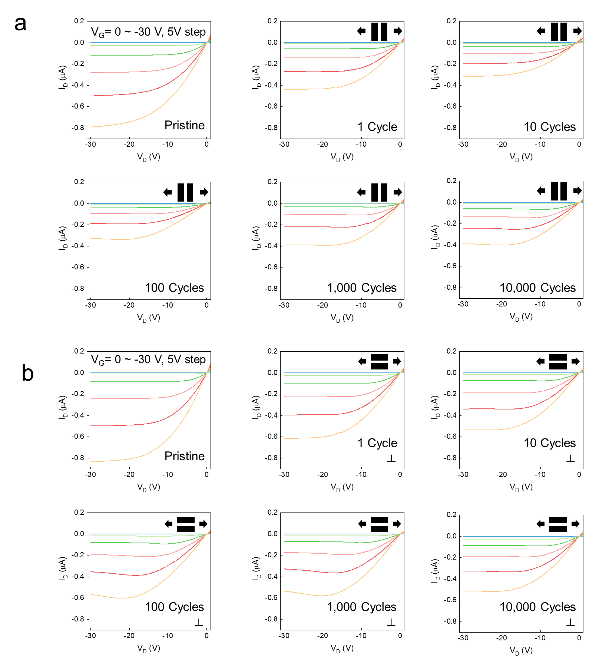
Supplementary Fig. 22. Output characteristics of fully stretchable transistor with multiple uniaxial stretching (50%) cycle with a, parallel and b, perpendicular stretching directions to the channel.

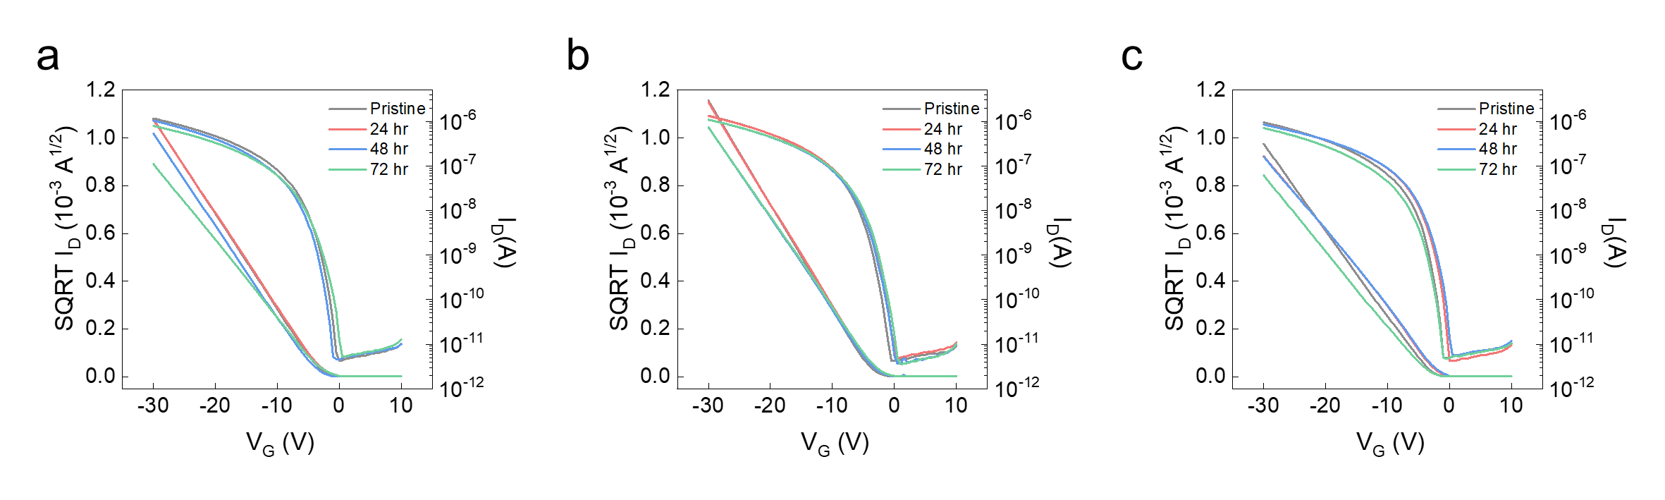
Supplementary Fig. 23. Transfer characteristics (V_{D}= -30 V) after various solution soaking: a, water, b, saline, and c, PBS.

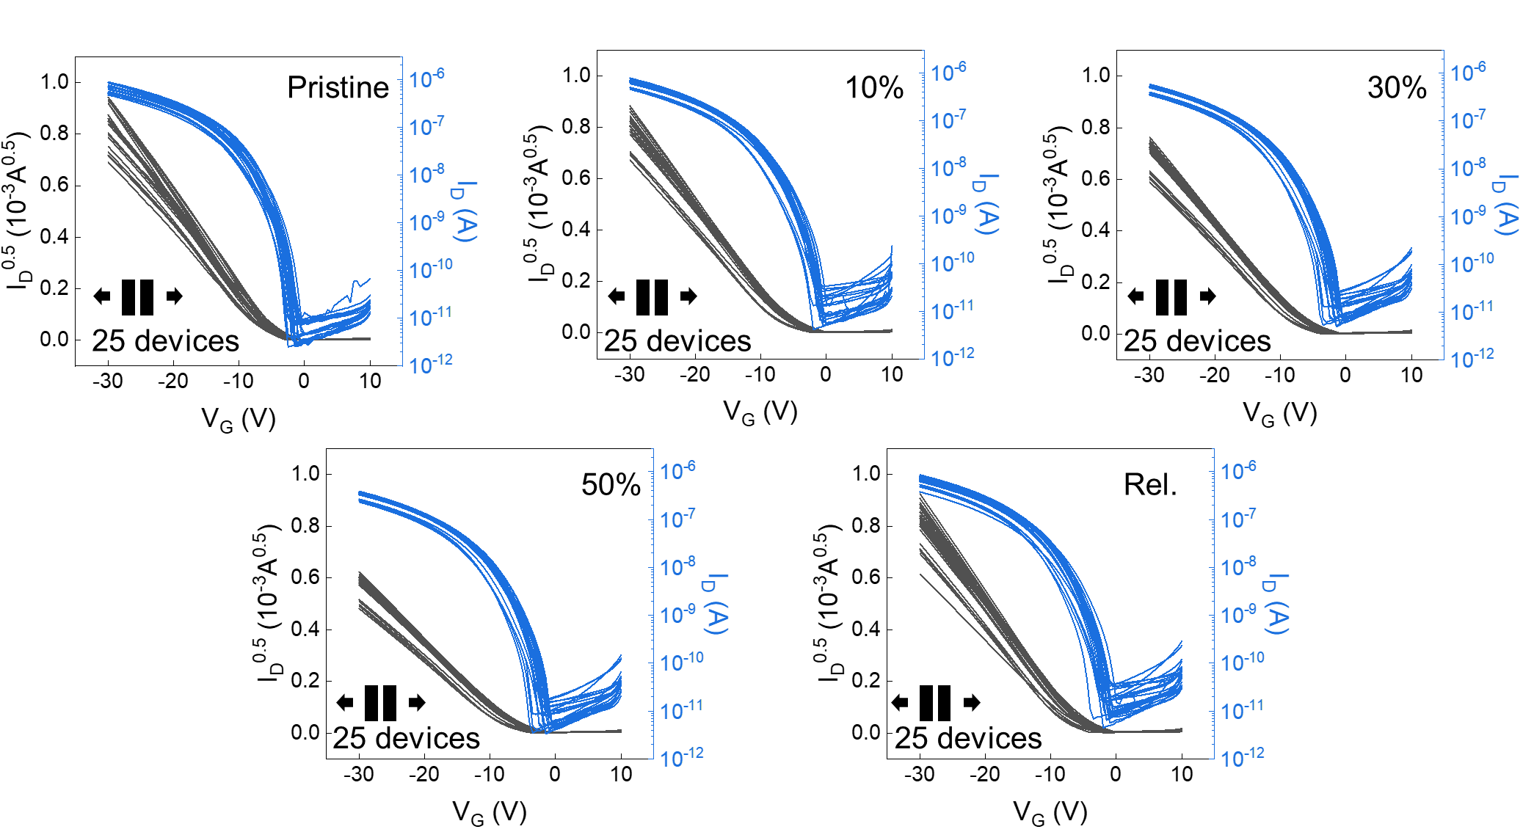
Supplementary Fig. 24. Transfer characteristics (V_{D}= -30 V) of active-matrix array under various stretched state and released state.

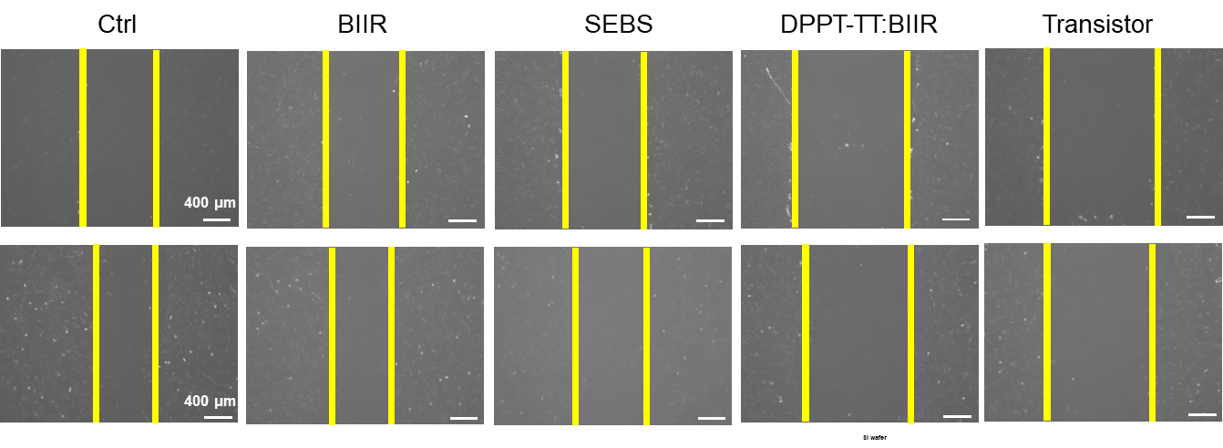
Supplementary Fig. 25. Representative migration image of hDFs after culture with each material.

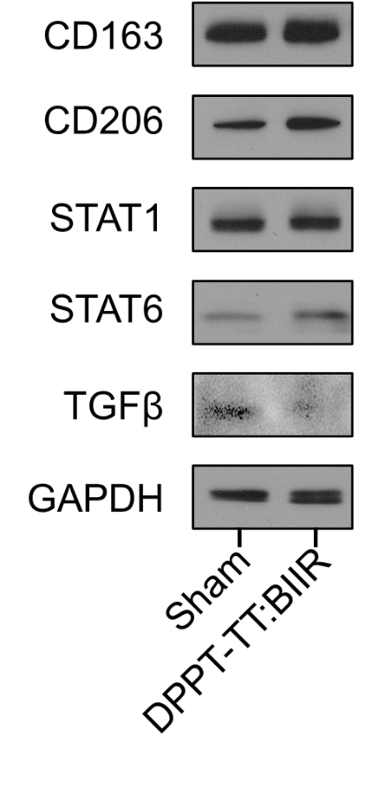
Supplementary Fig. 26. Comparison of M1 and M2 macrophage marker expression between Sham and DPPT-TT:BIIR group as evaluated by Western blot analysis.

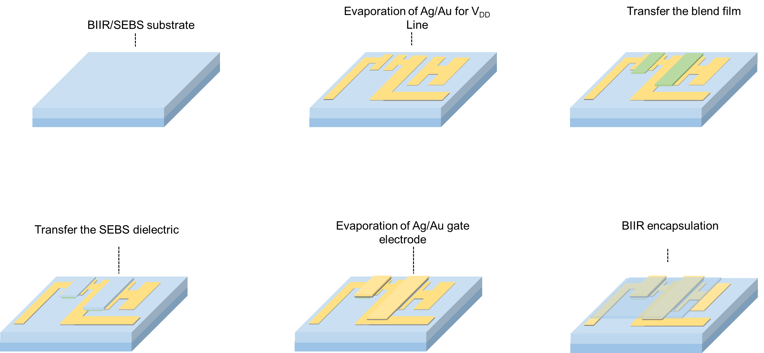
Supplementary Fig. 27. Schematic showing fabrication method for fully stretchable logic gate.

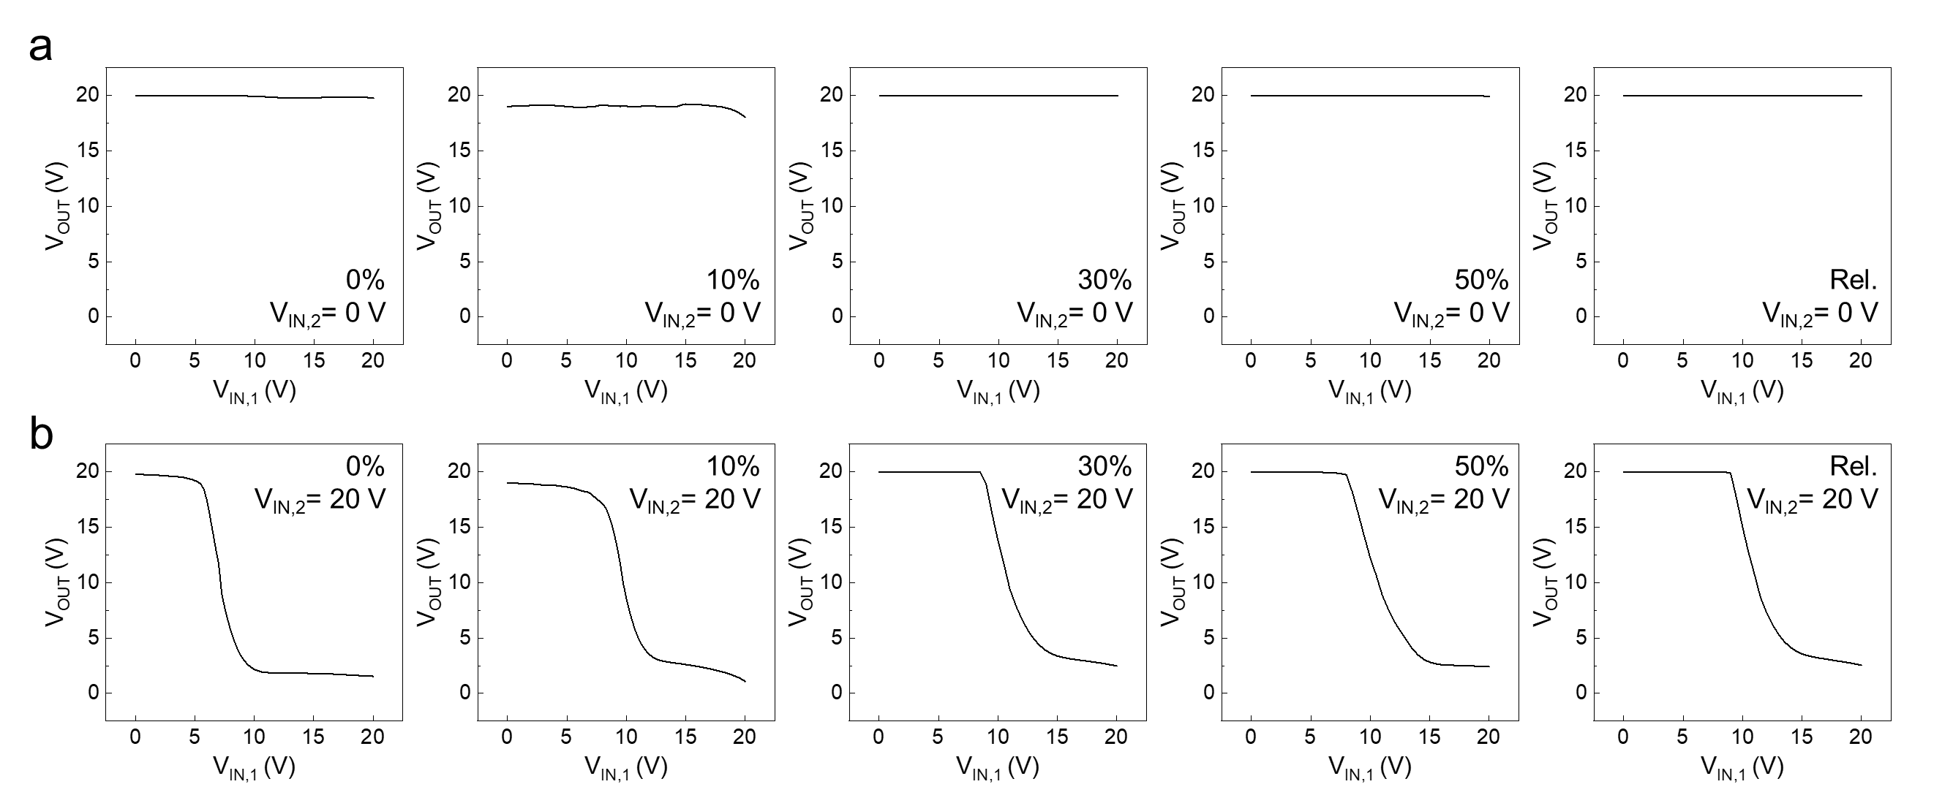
Supplementary Fig. 28. Voltage transfer characteristics (VTCs) of NAND logic device at stretched and released states with a, V_{IN,2}= 0 V and b, V_{IN,2}= 20 V.

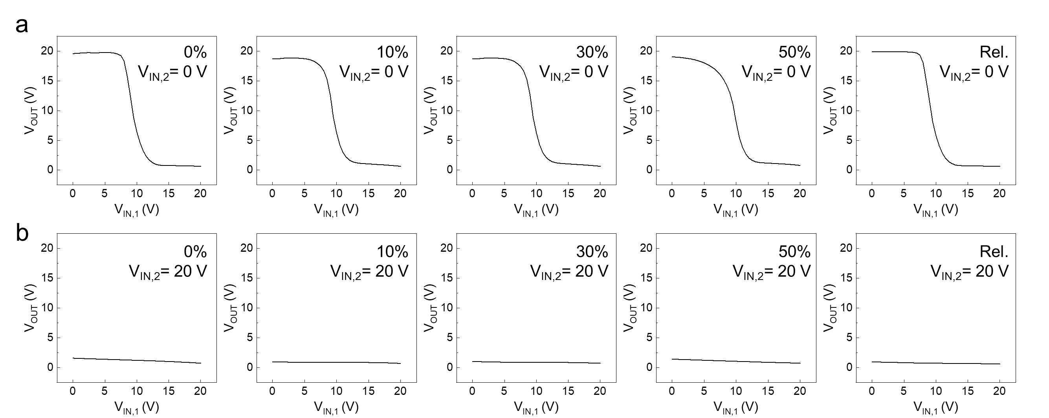
Supplementary Fig. 29. Voltage transfer characteristics (VTCs) of NOR logic device at stretched and released states with a, V_{IN,2}= 0 V and b, V_{IN,2}= 20 V.

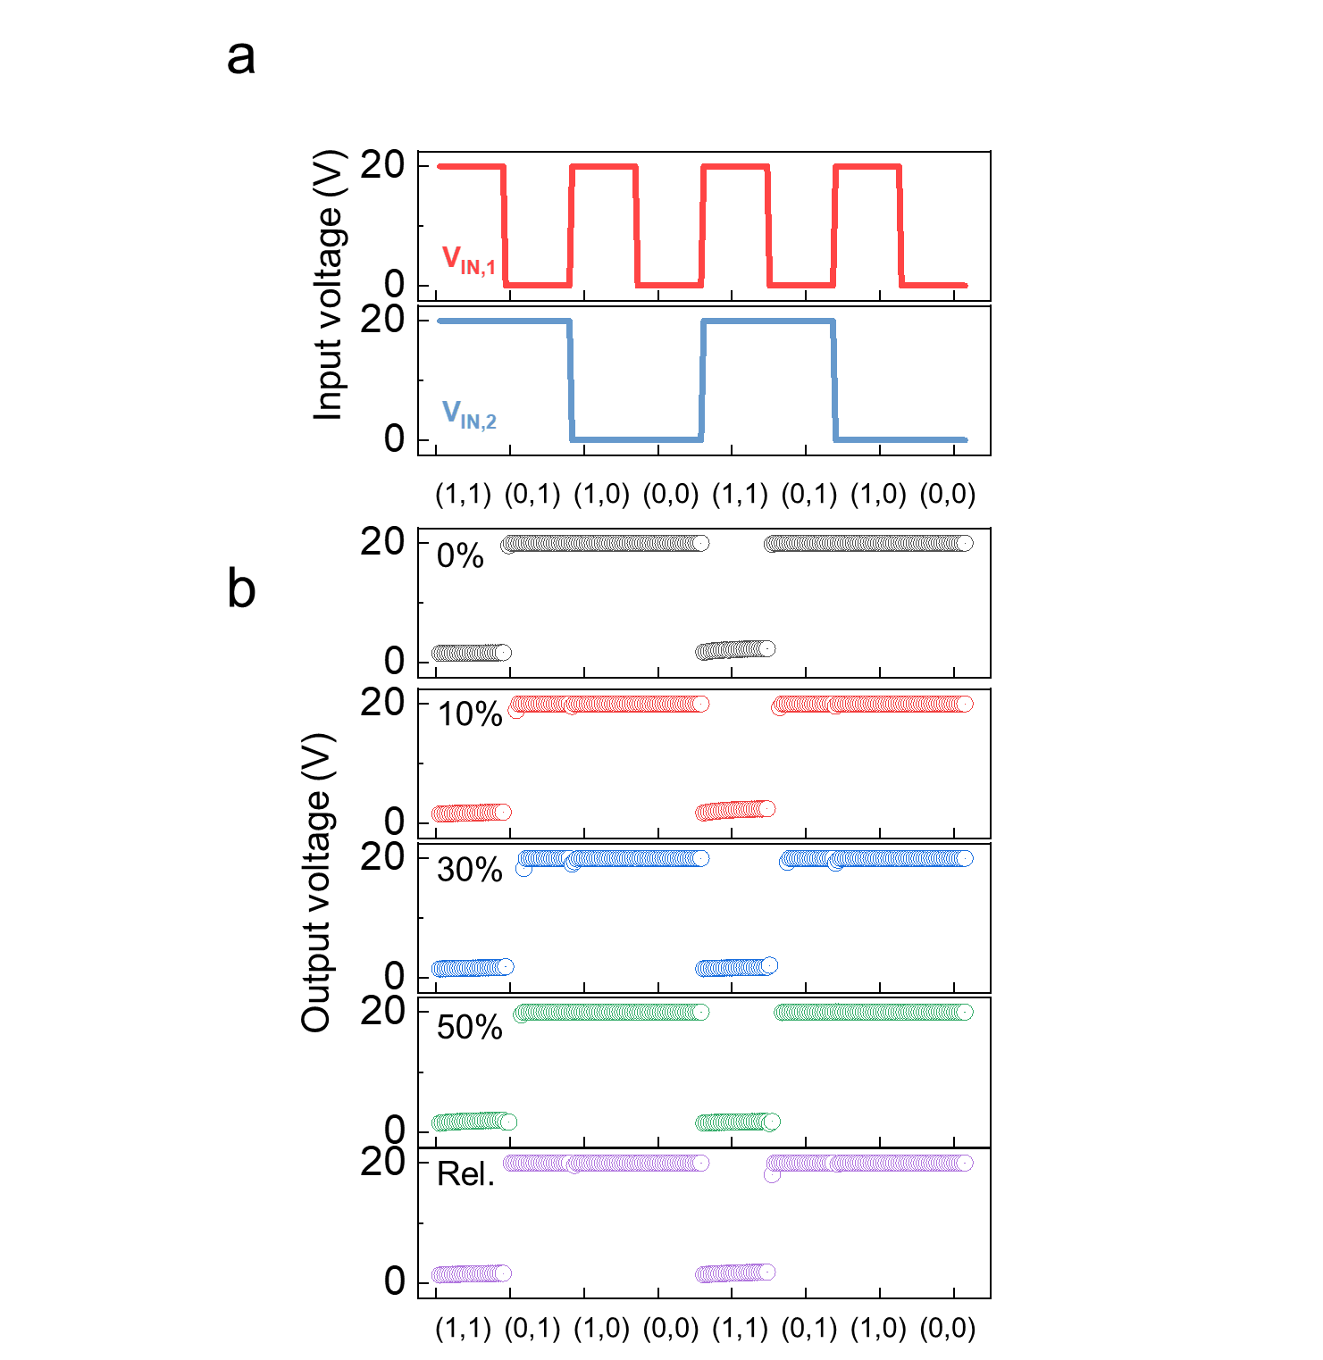Supplementary Fig. 30. a, Input and b, output characteristics of NAND logic device at uniaxially stretched and released states.

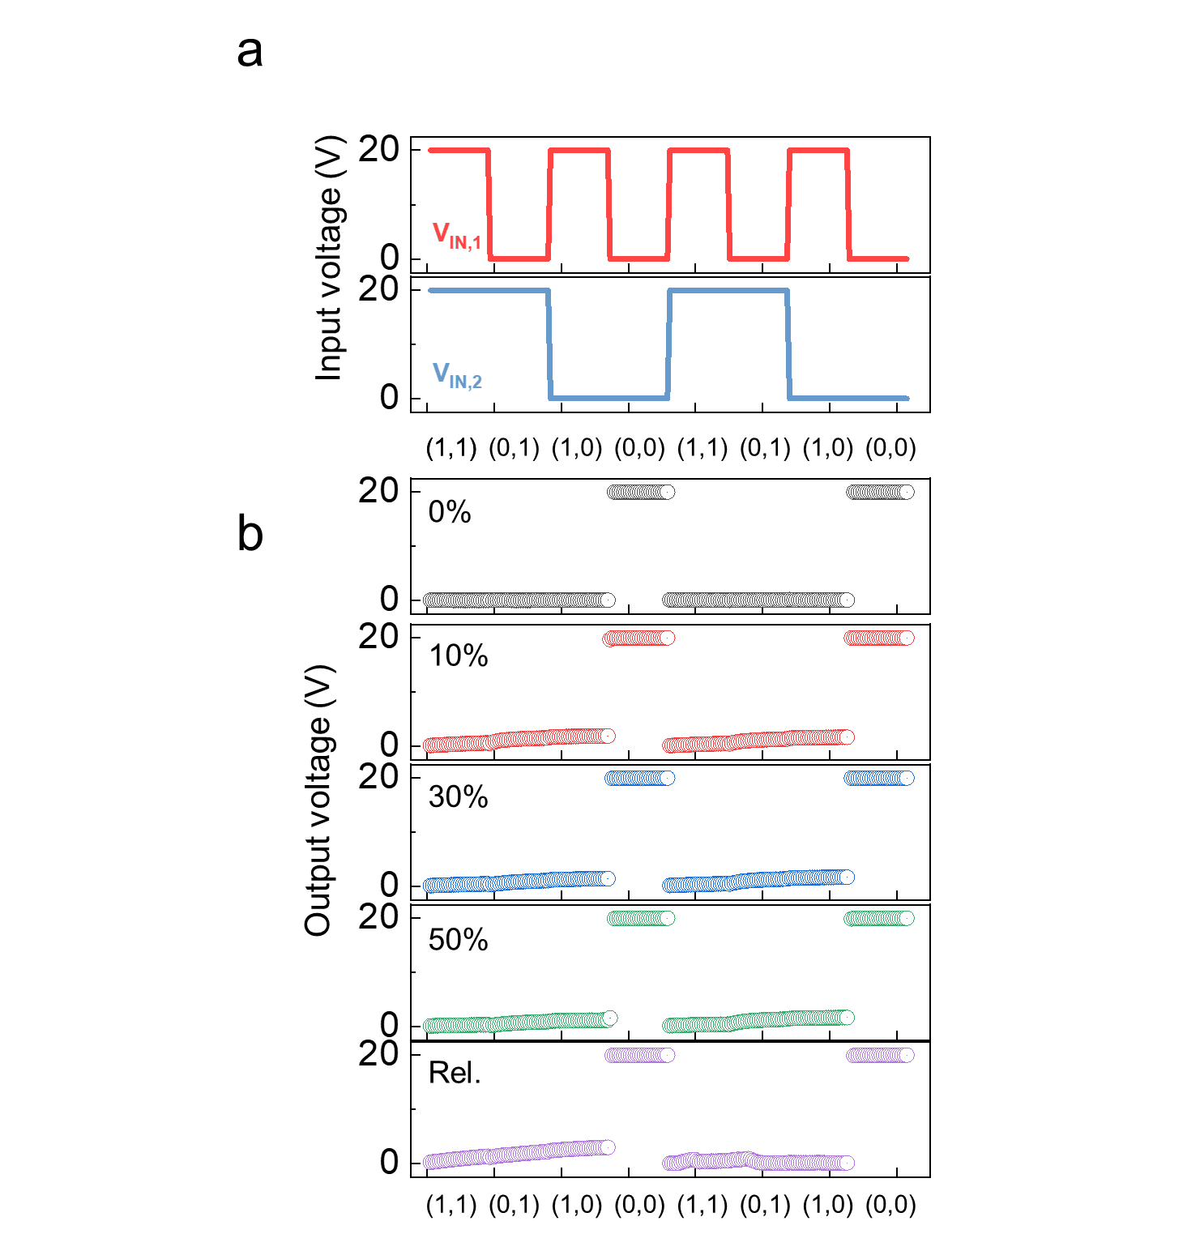Supplementary Fig. 31. a, Input and b, output characteristics of NOR logic devices at uniaxially stretched and released state.

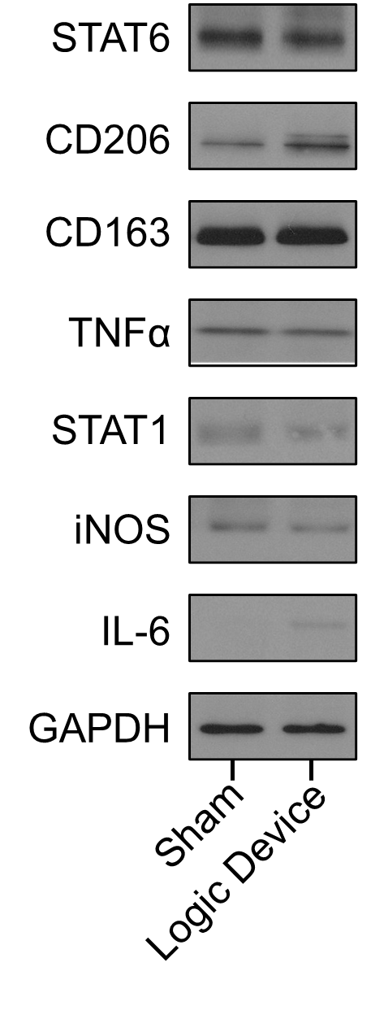
Supplementary Fig. 32. Comparison of M1 and M2 macrophage marker expression between Sham and Logic device group as evaluated by Western blot analysis.

Reference
1. Owens, D. K. & Wendt, R. C. Estimation of the surface free energy of polymers. J Appl Polym Sci 13, 1741–1747 (1969).
2. Choi, Wonmun. The main mechanism and cross-linking structure for accelerated sulfur vulcanization. e-Journal of Soft Materials 2, 47-55 (2006).
3. Nieuwenhuizen, P. J., et al. Thiuram-and dithiocarbamate-accelerated sulfur vulcanization from the chemist's perspective; methods, materials and mechanisms reviewed. Rubber chemistry and technology 70.3, 368-429 (1997).

