Nakamurella leprariae sp. nov., isolated from a lichen sample
De-Feng An¹ • Shao-Juan Yang¹ • Long-Qian Jiang¹ • Xin-Yu Wang² • Xiao-Yu Huang¹ • Lei Lang¹ • Xue-Mei Chen¹ • Ming-Qun Fan¹ • Gui-Ding Li^{1,3} • Ming-Guo Jiang⁴ • Li-Song Wang² • Cheng-Lin Jiang¹ • Yi Jiang^{1,}*
¹Yunnan Institute of Microbiology, Key Laboratory for Conservation and Utilization of Bio-resource, School of Life Sciences, Yunnan University, Kunming, PR China
²Key Lab for Plant Diversity and Biogeography of East Asia, Kunming Institute of Botany, Chinese Academy of Sciences, Kunming 650201, PR China
³Institute of Microbial Pharmaceuticals, Northeastern University, Shenyang 110819, PR China
⁴School of Marine Science and Biotechnology, Guangxi Key Laboratory for Polysaccharide Materials and Modifications, Guangxi University for Nationalities, Nanning 530008, PR China
De-Feng An and Shao-Juan Yang equally contributed to this work
*Author for correspondence
Yi Jiang
Tel & Fax: 86-871-65034073
- mail: jiangyi@ynu.edu.cn

Supplementary Fig. S1. Transmission electron microphotograph of strain YIM 132084^{T} isolated from the lichen of genus Lepraria. Bar, 1µm.
Supplementary Fig. S2. Maximum-likelihood phylogenetic tree based on 16S rRNA gene sequences showing the relationships between strain YIM 132084^{T} and its nearest phylogenetical neighbours. Numbers at nodes refer to bootstrap values (based on 1000 replicates; only values > 50 % are shown). Bar, 0.005 substitutions per nucleotide positon.
Supplementary Fig. S3. Maximum-parsimony phylogenetic based on 16S rRNA gene sequences tree showing the relationships between strain YIM 132084^{T} and its nearest phylogenetical neighbours. Numbers at nodes refer to bootstrap values (based on 1000 replicates; only values > 50 % are shown).
Supplementary Fig. S4. The polar lipids of strain YIM 132084^{T} as revealed by two-dimensional TLC. The plate was sprayed with 10 % (w/v) ethanolic molybdophosphoric acid. Chloroform/methanol/water (65:25:4, v/v/v) was used in the first direction, followed by chloroform/methanol/acetic acid/water (80:12:18:5, v/v/v/v) in the second direction. Abbreviations: DPG, diphosphatidylglycerol; PE, phosphatidylethanolamine; PI, phosphatidylinositol; APL, aminophospholipid; GL, glycolipid; PGL, phosphoglycolipids.

Supplementary Fig. S1.
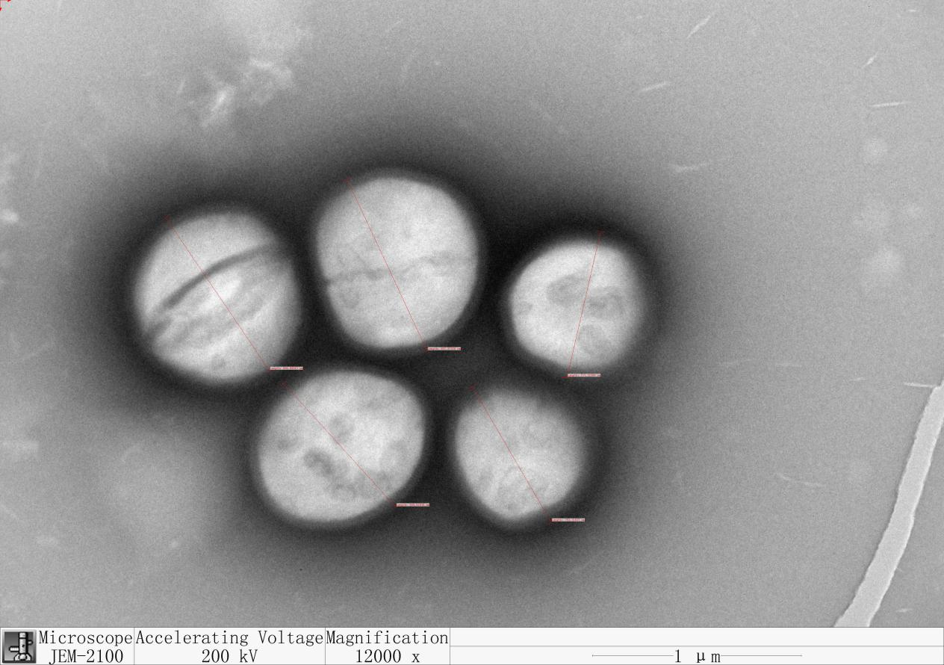

Supplementary Fig. S2.
Nakamurella lactea DSM 19367^{T} (KE384549)

“Nakamurella aerolata” DB0629^{T} (KP326326)

Nakamurella flavida KCTC 19127^{T} (DQ321750)
Nakamurella leprariae YIM 132084^{T} (MZ050064)

Nakamurella flava CGMCC 4.7524^{T} (MK898814)
Nakamurella panacisegetis DSM 26919^{T} (LT629710)

Nakamurella multipartite DSM 44233^{T} (CP001737)

Nakamurella endophytica 2Q3S-4-2^{T} (KT971019)

Nakamurella intestinalis 63MJ-1^{T} (KU379671)
“Nakamurella albus” YIM 132087^{T} (MN317339)
Nakamurella silvestris S20-107^{T} (KP899234)

Nakamurella antarctica S14-144^{T} (CP034170)

Nakamurella deserti 12Sc4-1^{T} (MH244160)

Klenkia marina YIM M13156^{T} (LT746188)

79
99
58
81
63
59
89
0.005

Supplementary Fig. S3.
Nakamurella lactea DSM 19367^{T} (KE384549)

“Nakamurella aerolata” DB0629^{T} (KP326326)

Nakamurella flavida KCTC 19127^{T} (DQ321750)

Nakamurella panacisegetis DSM 26919^{T} (LT629710)

Nakamurella leprariae YIM 132084^{T} (MZ050064)

Nakamurella flava CGMCC 4.7524^{T} (MK898814)

Nakamurella endophytica 2Q3S-4-2^{T} (KT971019)

Nakamurella intestinalis 63MJ-1^{T} (KU379671)

“Nakamurella albus” YIM 132087^{T} (MN317339)

Nakamurella multipartite DSM 44233^{T} (CP001737)

Nakamurella silvestris S20-107^{T} (KP899234)

Nakamurella antarctica S14-144^{T} (CP034170)

Nakamurella deserti 12Sc4-1^{T} (MH244160)

Klenkia marina YIM M13156^{T} (LT746188)

75
99
73
50
85
72

Supplementary Fig. S4.
