Supplementary Material

Figure S1: Extraction algorithm employed within TriNetX to identify eligible patients in the SGLT2i and SGLT2i naïve cohorts.
Figure showing the number of kidney transplant patients before and after PSM was applied for SGLT2i and SGLT2 naïve cohort. ª – Healthcare organisations, ^{b} – Kidney transplant recipient

SGLT2i
Non- SGLT2i
Trinet X
≥ 18 years, Any Gender
111,621,666 patients
115 HCOsª, 16 Countries
6,808
77 HCOs
205,795
77 HCOs
Pre-PSM
4,872
4,872
Post-PSM

 | SGLT2i naïve | SGLT2i
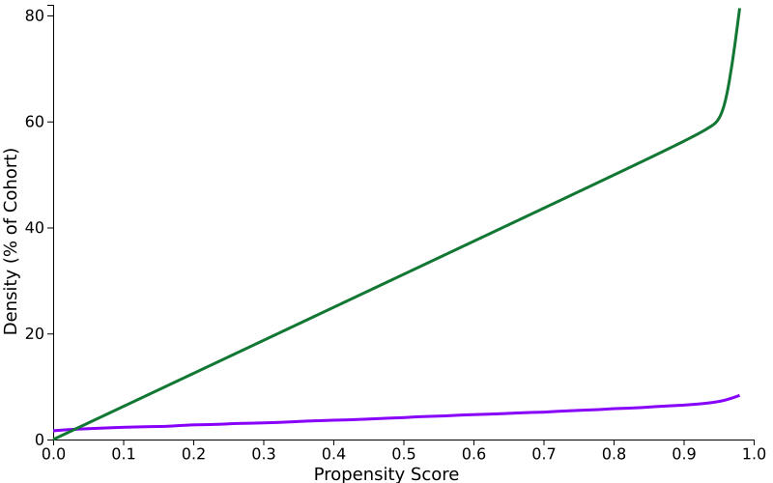 | 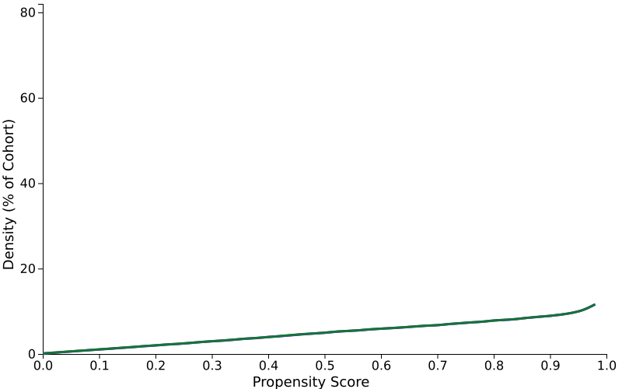
Figure S2: Propensity score density function. Graph of propensity score density function before and after matching for SGLT2i cohorts.

Table S1: ICD-10CM or SNOMED OR LOINC codes used.
Code Type | Code | Code Description
Kidney transplant
SNOMED | 70536003 | Transplant of kidney
SNOMED | 175902000 | Cadaveric renal transplant
SNOMED | 175901007 | Live donor renal transplant
SNOMED | 313030004 | Donor renal transplantation
ICD 10 | Z94.0 | Kidney transplant status
ICD 10 | 0TY00Z1 | Transplantation of Right Kidney, Syngeneic, Open Approach
ICD 10 | 0TY10Z1 | Transplantation of Left Kidney, Syngeneic, Open Approach
ICD 10 | 0TY00Z2 | Transplantation of Right Kidney, Zooplastic, Open Approach
ICD 10 | 0TY10Z2 | Transplantation of Left Kidney, Zooplastic, Open Approach
ICD 10 | 0TY00Z0 | Transplantation of Right Kidney, Allogeneic, Open Approach
ICD 10 | 0TY10Z0 | Transplantation of Left Kidney, Allogeneic, Open Approach
ICD 10 | 0TY0 | Urinary System / Transplantation / Kidney, Right
ICD 10 | 0TY1 | Urinary System / Transplantation / Kidney, Left
Kidney transplant failure
ICD 10 | T86.10 | Unspecified complication of kidney transplant
ICD 10 | T86.12 | Kidney transplant failure
ICD 10 | T86.92 | Unspecified transplanted organ and tissue failure
Kidney transplant rejection
ICD 10 | T86 | Complications of transplanted organs and tissue
ICD 10 | T86.10 | Unspecified complication of kidney transplant
ICD 10 | T86.11 | Kidney transplant rejection
Major adverse cardiovascular event (MACE)
ICD 10 | I20 | Angina pectoris
ICD 10 | I20-I25 | Ischemic heart diseases
ICD 10 | I21 | Acute myocardial infarction
ICD 10 | I48 | Atrial fibrillation and flutter
ICD 10 | I50 | Heart failure
ICD 10 | I63 | Cerebral infarction
Genital and Urinary Tract Infections
ICD 10 | Z87.440 | Personal history of urinary (tract) infections
ICD 10 | N39.0 | Urinary tract infection, site not specified
ICD 10 | A54 | Gonococcal infection
LOINC | 5851-1 | Herpes simplex virus Ag [Presence] in Genital specimen by Immunofluorescence
LOINC | 6467-5 | Microscopic observation [Identifier] in Genital fluid by Gram stain
LOINC | 10352-3 | Bacteria identified in Genital specimen by Aerobe culture
LOINC | 10728-4 | Trichomonas sp identified in Genital specimen by Organism specific culture
LOINC | 12178-0 | Bacteria [Presence] in Genital specimen by Wet preparation
LOINC | 11267-2 | Streptococcus.beta-hemolytic [Presence] in Genital specimen by Organism specific culture
LOINC | 12223-4 | Human papilloma virus 16+18 Ag [Presence] in Genital specimen
LOINC | 12275-4 | Yeast [Presence] in Genital specimen by Wet preparation
LOINC | 14317-2 | Microscopic observation [Identifier] in Genital specimen by Wet preparation
LOINC | 18483-8 | Yeast [Presence] in Genital specimen by Organism specific culture
LOINC | 21284-5 | Gardnerella vaginalis [Presence] in Genital specimen by Organism specific culture
LOINC | 31978-0 | Trichomonas vaginalis Ag [Presence] in Genital specimen
LOINC | 41026-6 | Fungus identified in Genital specimen by Culture
LOINC | 45091-6 | Chlamydia trachomatis Ag [Presence] in Genital specimen
LOINC | 48712-4 | Microscopic observation [Identifier] in Genital specimen by Gram stain
LOINC | 75269-1 | Bacteria identified in Genital specimen by Anaerobe+Aerobe culture
LOINC | 91858-1 | Herpes simplex virus 2 DNA [Presence] in Genital specimen by NAA with probe detection
LOINC | 91859-9 | Herpes simplex virus 1 DNA [Presence] in Genital specimen by NAA with probe detection
Diabetic Ketoacidosis
ICD 10 | E87.2 | Acidosis
ICD 10 | E08.1 | Diabetes mellitus due to underlying condition with ketoacidosis
ICD 10 | E08.10 | Diabetes mellitus due to underlying condition with ketoacidosis without coma
ICD 10 | E08.11 | Diabetes mellitus due to underlying condition with ketoacidosis with coma
ICD 10 | E08.65 | Diabetes mellitus due to underlying condition with hyperglycemia
ICD 10 | E09.11 | Drug or chemical induced diabetes mellitus with ketoacidosis with coma
ICD 10 | E10.1 | Type 1 diabetes mellitus with ketoacidosis
ICD 10 | E10.10 | Type 1 diabetes mellitus with ketoacidosis without coma
ICD 10 | E10.11 | Type 1 diabetes mellitus with ketoacidosis with coma
ICD 10 | E10.65 | Type 1 diabetes mellitus with hyperglycemia
ICD 10 | E11.1 | Type 2 diabetes mellitus with ketoacidosis
ICD 10 | E11.10 | Type 2 diabetes mellitus with ketoacidosis without coma
ICD 10 | E11.11 | Type 2 diabetes mellitus with ketoacidosis with coma
ICD 10 | E11.65 | Type 2 diabetes mellitus with hyperglycemia
ICD 10 | E11.69 | Type 2 diabetes mellitus with other specified complication
ICD 10 | E13.1 | Other specified diabetes mellitus with ketoacidosis
ICD 10 | E13.10 | Other specified diabetes mellitus with ketoacidosis without coma
ICD 10 | E13.11 | Other specified diabetes mellitus with ketoacidosis with coma
Fournier’s Gangrene
ICD 10 | N48.29 | Other inflammatory disorders of penis
ICD 10 | N49 | Inflammatory disorders of male genital organs, not elsewhere classified
ICD 10 | N49.3 | Fournier gangrene
ICD 10 | N50.1 | Vascular disorders of male genital organs
Lower limb amputation
ICD 10 | S78 | Traumatic amputation of hip and thigh
ICD 10 | S88 | Traumatic amputation of lower leg
ICD 10 | Z89 | Acquired absence of limb
ICD 10 | S98 | Traumatic amputation of ankle and foot
Table displaying the International Statistical Classification of Diseases and Related Health Problems 10th Revision, Clinical Modification (ICD-10CM) and Systematized Nomenclature of Medicine Clinical Terms (SNOMED)used to identify cohorts on TriNetX database.

Table S2: Distribution of Sociodemographic characteristics, Co-morbidities, Immunosuppression prescription and Laboratory results, prescription of SGLT2i naïve and SGLT2i cohorts before propensity matching.
 | SGLT2i naïve  N (%) | SGLT2i  N (%) | P-value
Sample size | 205,795 | 6,808 | -
Age  (Mean ± SD) | 52.2  ±15.5 | 59.7  ±11.7 | <0.001
Male | 110,731  (56.6) | 4,337  (63.7) | <0.001
Race
American Indian or Alaska Native | 1,007  (0.5) | 58  (0.9) | <0.001
Native Hawaiian or Other Pacific Islander | 771  (0.4) | 33  (0.5) | 0.243
Not Hispanic or Latino | 116,74  6(59.7) | 4,659  (68.4) | <0.001
Hispanic or Latino | 19,227  (9.8) | 827  (12.1) | <0.001
Unknown Race | 38,094  (19.5) | 1,192  (17.5) | <0.001
Other Race | 9,083  (4.6) | 314  (4.6) | 0.905
Ethnicity
White | 98,107  (50.2) | 2,698  (39.6) | <0.001
Black or African American | 39,273  (20.1) | 1,970  (28.9) | <0.001
Asian | 9,280  (4.7) | 543  (8.0) | <0.001
Unknown Ethnicity | 59,642(30.5) | 1,322  (19.4) | <0.001
Co-Morbidities
Cardiac co-morbidities and diabetes
Acute myocardial infarction | 4,676  (2.4) | 726  (10.7) | <0.001
Subsequent ST elevation (STEMI) and non-ST elevation (NSTEMI) myocardial infarction | 72  (0.0) | 10  (0.1) | <0.001
Old myocardial infarction | 5,014  (2.6) | 877  (12.9) | <0.001
Ischemic cardiomyopathy | 2,053  (1.0) | 396  (5.8) | <0.001
Hypertensive heart disease | 5,204  (2.7) | 1,469  (21.6) | <0.001
Hypertensive heart and chronic kidney disease | 9,790  (5.0) | 1,795  (26.4) | <0.001
Cardiomyopathy | 7,042  (3.6) | 957  (14.1) | <0.001
Cardiomyopathy in diseases classified elsewhere | 689  (0.4) | 119  (1.7) | <0.001
Heart failure | 17,087  (8.7) | 2,250  (33.0) | <0.001
Peripheral vascular disease | 20778 | 2344 | <0.001
Diabetes
Type 1 diabetes mellitus* | 10,727  (5.5) | 781  (11.5) | <0.001
Type 2 Diabetes mellitus* | 41,652  (21.3) | 5,631  (82.7) | <0.001
Other specified diabetes mellitus* | 5,660  (2.9) | 1,363  (20.0) | <0.001
Diabetes mellitus due to underlying condition* | 5,471  (2.8) | 1,079  (15.8) | <0.001
Drug or chemical induced diabetes mellitus* | 4,572  (2.3) | 716  (10.5) | <0.001
Smoking | 14,310  (7.3) | 1,676  (24.6) | <0.001
Immunosuppression
Induction Immunosuppression
Basiliximab | 3,031  (1.5) | 507  (7.4) | <0.001
Alemtuzumab | 581  (0.3) | 51  (0.7) | <0.001
Anti-thymocyte globulin | 2,06  2(1.1) | 1,463  (21.5) | <0.001
Anti-human T-lymphocyte globulin | 1,438  (0.7) | 1,093  (16.1) | <0.001
Rituximab | 948  (0.5) | 153  (2.2) | <0.001
Maintenance immunosuppression
Tacrolimus | 25,853  (13.2) | 5,491  (80.7) | <0.001
Cyclosporine | 4,299  (2.2) | 471  (6.9) | <0.001
Mycophenolate mofetil | 19,662  (10.1) | 4,059  (59.6) | <0.001
Mycophenolic acid | 11,479  (5.9) | 3,058  (44.9) | <0.001
Azathioprine | 3,051  (1.6) | 298  (4.4) | <0.001
Sirolimus | 2,465  (1.3) | 333  (4.9) | <0.001
Belatacept | 214  (0.1) | 269  (4.0) | <0.001
Laboratory results
CKD STAGE*
1 | 13,988  (7.2) | 1,805  (26.5) | <0.001
2 | 27,361  (14.0) | 4,374  (64.2) | <0.001
3 | 38,395  (19.6) | 5,310  (78.0) | <0.001
4 | 40,351  (20.6) | 3,506  (51.5) | <0.001
Proteinuria (Microalbumin)
0 - 30 mg/g | 1,768  (0.9) | 603  (8.9) | <0.001
30 - 300 mg/g | 1,935  (1.0) | 767  (11.3) | <0.001
>300mg/g | 3,001  (1.5) | 518  (7.6) | <0.001
Tacrolimus level ng/mL | 7.8 ± 8.0 | 6.3 ± 2.9 | 0.196
Other cardiovascular risk factors
Body Mass Index (BMI) Mean ± SD | 28.0 ± 5.8 | 30.5 ± 6.0 | <0.001
Systolic Blood Pressure mm[Hg] | 134.1 ± 23.3 | 135.0 ± 20.7 | 0.007
Diastolic Blood Pressure mm[Hg] | 75.5 ± 13.6 | 74.7 ± 12.1 | <0.001
Cholesterol mg/dL | 166.6 ± 51.7 | 157.5 ± 46.4 | <0.001
Hemoglobin A1c/Hemoglobin.total in Blood | 6.2 ± 1.6 | 7.4 ± 1.8 | <0.001
Table displaying the results for SGLT2i cohorts prior to propensity score matching. All statistical analysis was performed using the online TriNetX platform. 1:1 PSM using logistic regression. A P<0.05 was accepted as statistically significant. * The reported numbers exceed the cohort size due to patients being coded using multiple interchangeable codes or duplication of coding within the database.

Table S3: Distribution of co-morbidities (non-cardiac and diabetic), as included in the Charlson co-morbidity index for SGLT2i naïve and SGLT2i cohorts post propensity score matching.
Charlson Co-morbidity Index (CCI)
Components of CCI and associated weights | SGLT2i naïve  N (%) | SGLT2i  N (%) | P-value
Stroke (1) | 1406 | 1040 | < .00001
Dementia (1) | 70 | 88 | 0.15
COPD (1) | 1158 | 789 | <0.001
Connective tissue disease (1) | 444 | 386 | 0.36
Peptic ulcer disease (1) | 407 | 304 | <0.001
Liver disease – Mild (1) | 2043 | 602 | <0.001
Liver disease – Moderate to severe (3) | 3476 | 795 | <0.001
Hemiplegia (2) | 66 | 57 | 0.41
Metastatic solid tumour (6) | 647 | 654 | 0.83
Leukaemia (2) | 127 | 129 | 0.89
Lymphoma (2) | 91 | 123 | 0.03
AIDS (6) | 102 | 92 | 0.47
The table displays the results for SGLT2i cohorts post propensity score matching divided into categories as per the Charlson co-morbidity index. A P<0.05 was accepted as statistically significant. The reported numbers exceed the cohort size due to patients being coded using multiple interchangeable codes or duplication of coding within the database.
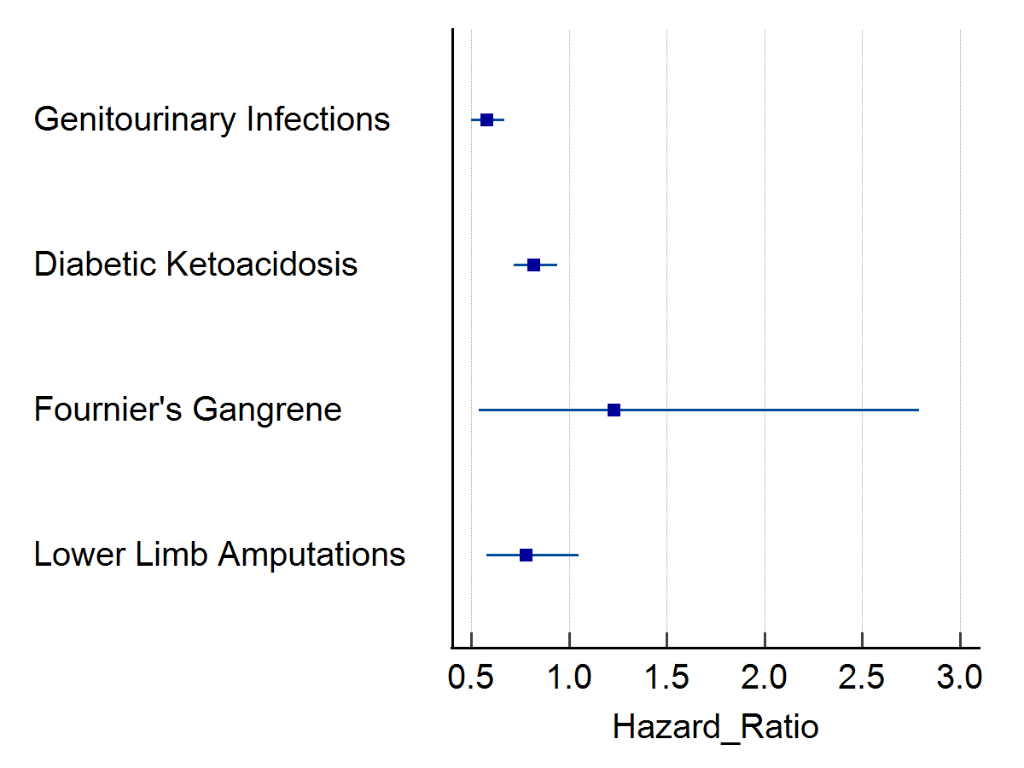
Figure S3: Forrest Plot for secondary outcomes in SGLT2i cohort.
Forrest Plot showing HR and 95 CI for the secondary outcomes, complications of SGLT2i; genitourinary infections, fournier's gangrene, diabetic ketoacidosis (DKA), and lower limb amputations.

Table S4: Cox-regression model of Unadjusted 5-year secondary outcomes (complications)for SGLT2i and SGLT2i naïve cohorts
Outcome | Cohorts | Number with outcome | H.R. | 95% CI | χ² | P-value
Genitourinary infections | SGLT2i naïve | 726 | - | - | - | -
Genitourinary infections | SGLT2i | 240 | 0.576 | (0.50, 0.67) | 40.563 | <0.001
Diabetic Ketoacidosis | SGLT2i naïve | 721 | - | - | - | -
Diabetic Ketoacidosis | SGLT2i | 318 | 0.819 | (0.72, 0.94) | 21.009 | <0.001
Fournier’s Gangrene | SGLT2i naïve | 16 | - | - | - | -
Fournier’s Gangrene | SGLT2i | 10 | 1.232 | (0.54, 2.79) | 0.537 | 0.464
Lower limb amputations | SGLT2i naïve | 144 | - | - | - | -
Lower limb amputations | SGLT2i | 64 | 0.779 | (0.58, 1.05) | 3.706 | 0.054
Number of patients with each secondary outcome, Hazard ratio and 95% confidence interval A P<0.05 was accepted as statistically significant.

