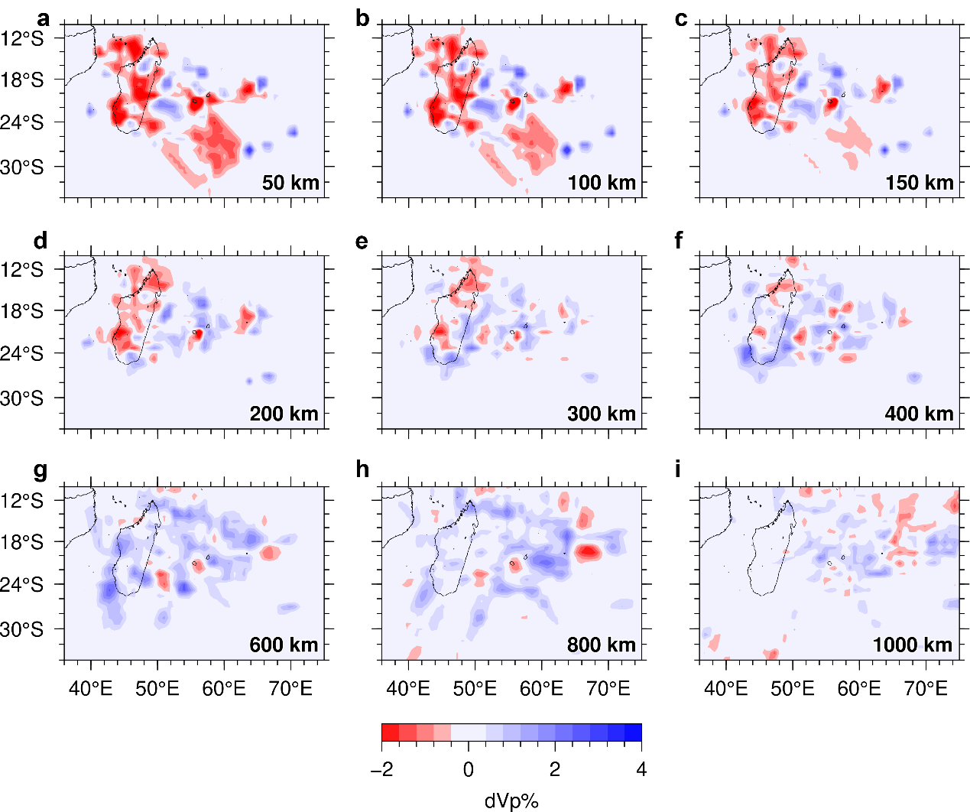
Extended Data Fig. 1: Map views showing the final 3-D Vp model of Reunion Island and its surrounding areas. The slice depth is shown at the lower-right corner of each map.
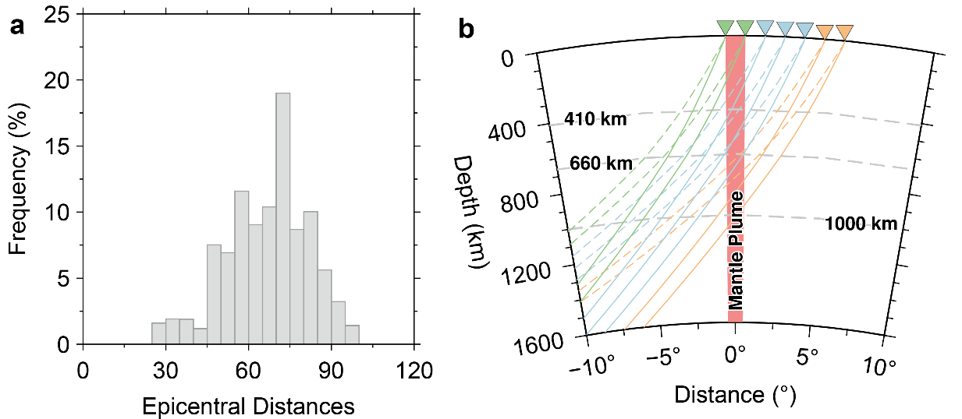
Extended Data Fig. 2: Distance distribution of teleseismic events and sampling power of different ray paths. a, A histogram showing the frequency of the teleseismic events used versus distance to the plume center. b, Ray paths from events with 60° and 80° distances to the plume center, suggesting that the data recorded at stations located far from the plume can sample deeper structures of the plume. Dashed and solid lines denote rays from two events located at 60° and 80°, respectively, away from the plume center.

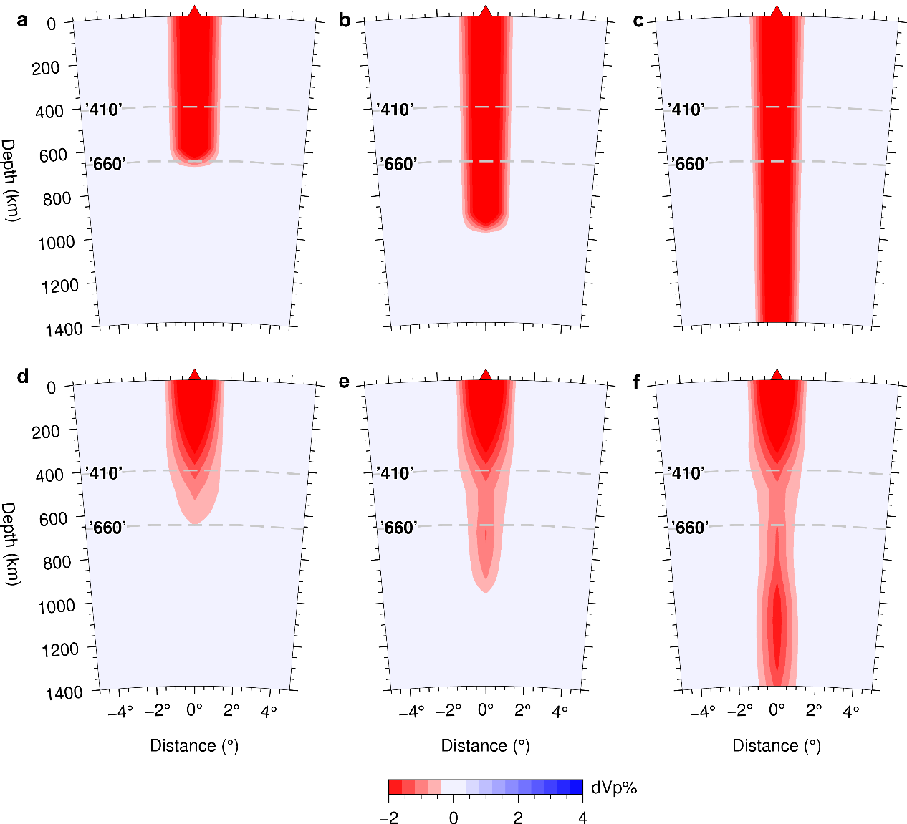
Extended Data Fig. 3: Three synthetic tests for the Reunion plume originating from 660 km, 900 km and 1400 km depths. The plume width is 250 km and its dVp is -4% in the input models (a-c) of the tests. The panels (d-f) show the output models. The triangle above each panel denotes the volcanic Reunion Island. Grey dashed lines denote the 410-km and 660-km discontinuities.

