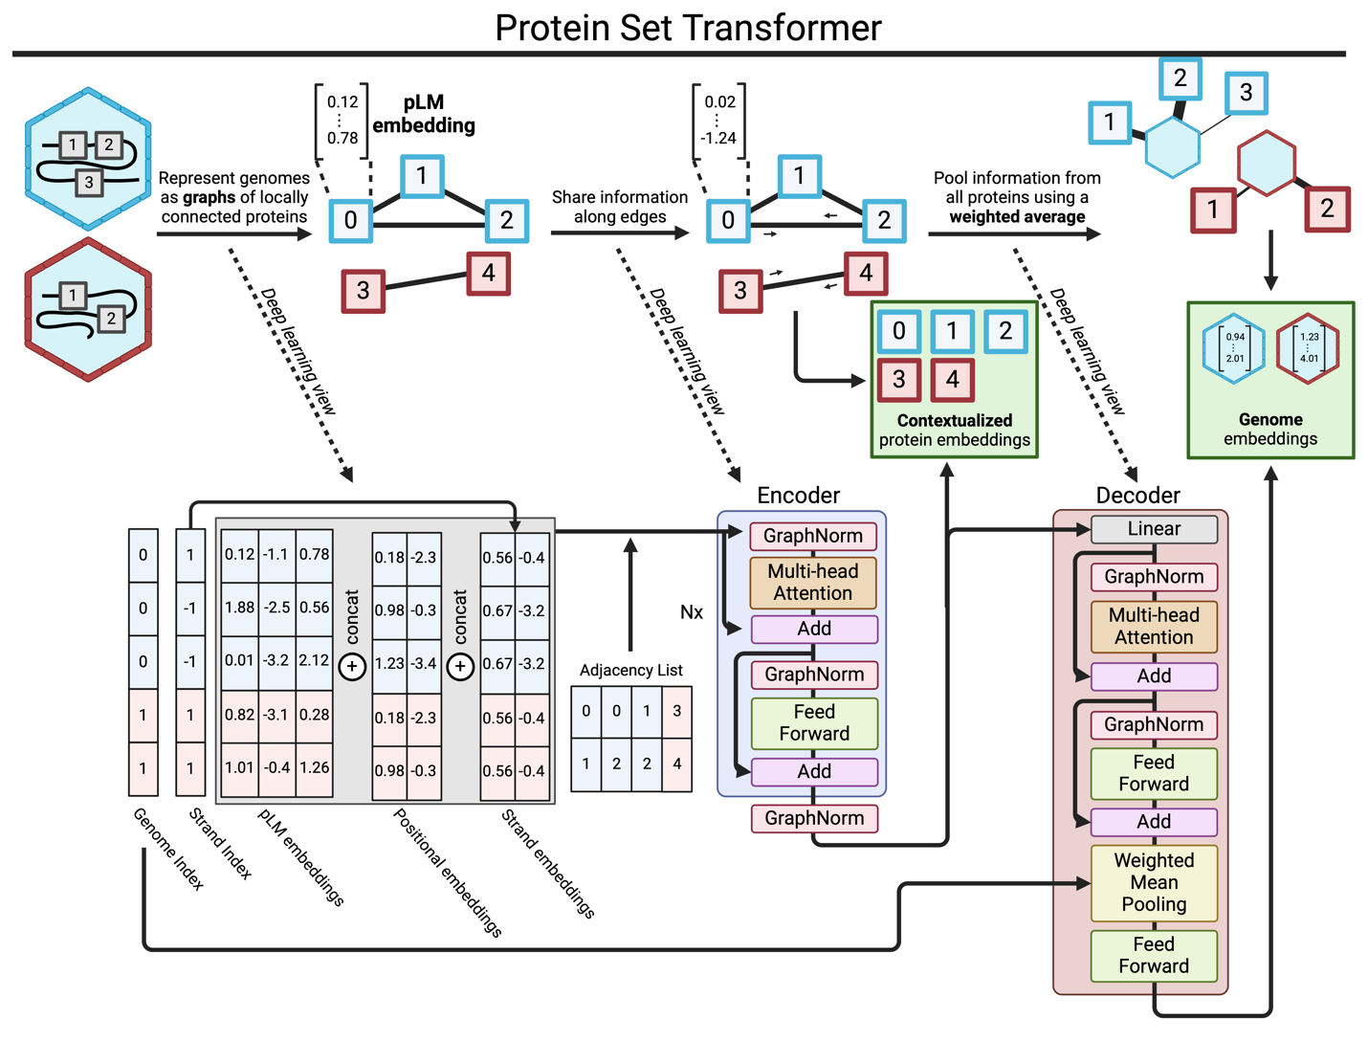
Extended Data Figure 1. A machine-learning-centric view of the Protein Set Transformer (PST) architecture. Each genome is internally represented as a graph, composed of subgraph genome chunks whose size is tunable. A minibatch of genomes is represented in a memory-efficient stacked matrix, where the boundaries for the set of proteins from each genome are tracked using indices and offset pointers for efficient random access. At the beginning of training, the ESM2 protein embeddings are concatenated with learnable positional embeddings based on the relative position in each genome and encoding strand embeddings. This is then input to the PST encoder, which uses multi-head attention for pairs of proteins defined by the initial adjacency matrix. This only allows each protein to attend to its neighbors in the same genome subgraph. The output from the PST encoder are genome-contextualized protein embeddings, which are also the inputs to the PST decoder. The PST decoder uses multi-head attention pooling to project each contextualized protein embedding onto a learnable seed vector. This learns weights for each protein, which are used to pool each protein representation into a final genome representation.
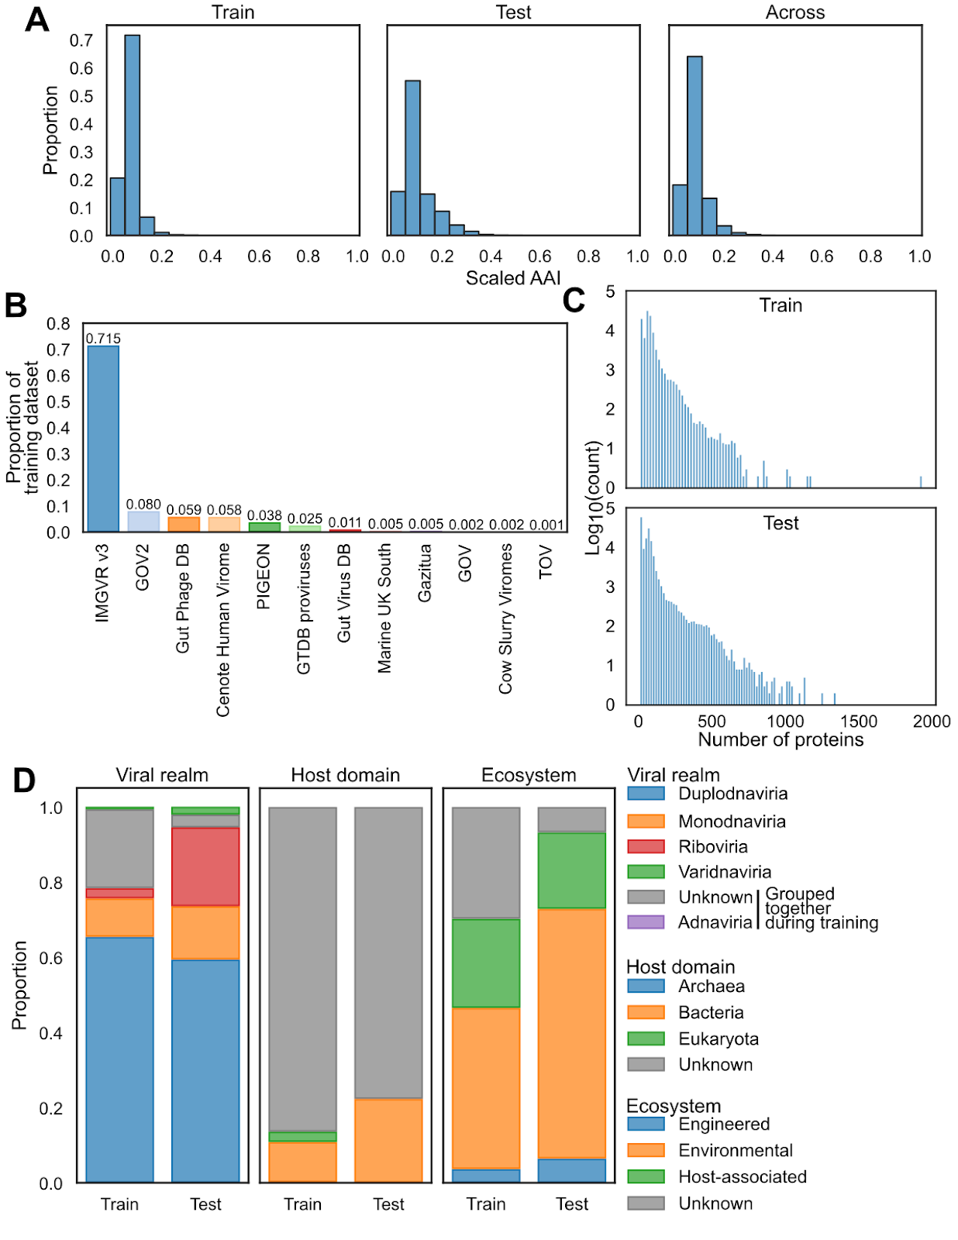
Extended Data Figure 2. The training and test datasets for the vPST. A) Distributions of scaled average amino acid identity (AAI) for viruses only within the training (Train), only within test (Test), and between (Across) datasets. The AAI between pairs of viruses was scaled by multiplying the minimum proportion of proteins from each genome used in computing the AAI. Only the most similar connections are maintained for each virus in each dataset. In the case of across train-test boundaries, the most similar hit for each test virus is reported. B) Proportional source of 103,589 training set viral genomes (see Supplemental Table 1 for the source publication of each virus). C) Genome size distribution of training and test dataset genomes. D) The relative distributions of viral realm, host domain, and broad ecosystem for both the train and test datasets. Viral realm, if not provided by the source database, was predicted by geNomad v1.5.0. Host domains not provided by the source database, excluding predicted proviruses, were considered unknown.
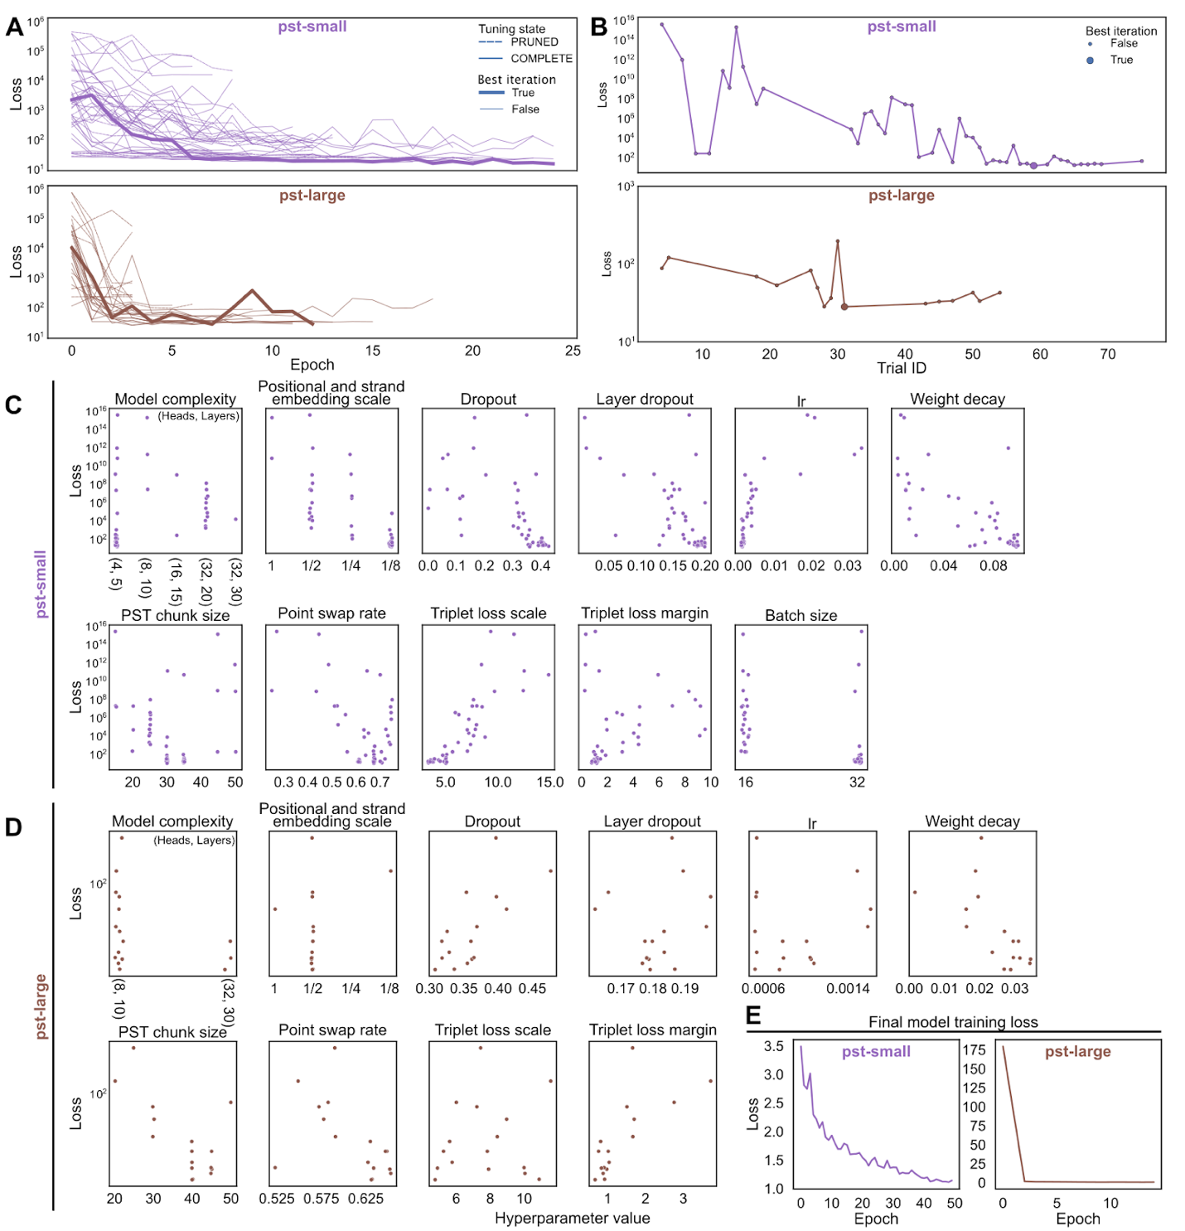
Extended Data Figure 3. Hyperparameter tuning for the vPST. A) Triplet loss curves as a function of training step (epoch) for the small vPST (pst-small, top, purple) and the large vPST (pst-large, bottom, brown). Each line is a different tuning iteration that did not fail. Dashed lines indicate tuning trials that were pruned due to poor performance in early epochs, relative to previous trials. Solid lines indicate trials that completed training. The thicker line highlights the trial that was chosen as the best by cross validation. B) The final triplet loss value for each tuning trial. The larger circle indicates the trial chosen as the best by cross validation. CD) Hyperparameter values tuned with cross validation for the small vPST (C, pst-small, 45 complete trials) and the large vPST (D, pst-large, 16 complete trials). Model complexity refers to the number of attention heads and the number of encoder layers in the PST. Positional and strand embedding scale is the size of each of these concatenated learned embeddings relative to the input ESM2 protein language model embedding for each protein. Lr is learning rate, and weight decay is for the AdamW optimizer. The PST chunk size is the number of proteins per genome chunk. Point swap rate is the proportion of proteins swapped between the anchor and positive genome during point swap samping. Point swap scale is the negative exponential decay scale factor to adjust the weight of the choice of the augmented negative samples in the triplet loss function. Batch size for pst-small is in units of genomes and was constant at 8 genomes for pst-large. E) Training loss curves for the final trained models using the optimal hyperparameters selected for each model.

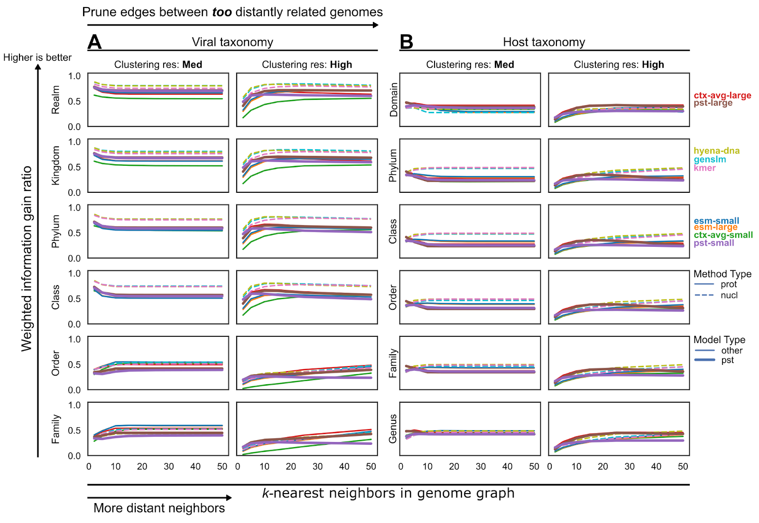
Extended Data Figure 4. Viral and host taxonomic purity of viral genome clusters. Weighted information gain ratio computed as cluster-size-weighted average over all genome clusters, penalized for the proportion of genome singletons, using A) viral taxonomy or B) host taxonomy as the genome labels. Viral taxonomy that was either not provided by source databases or outdated was predicted using geNomad v1.5.0. Unlabeled taxa were excluded during calculation of the relative proportion of taxa comprising a cluster. However, the cluster size used for weighted average included all viruses in the cluster. The Leiden algorithm on a similarity-weighted k-nearest neighbor graph was used to cluster genomes. The edges and edge weights (similarity values) were computed using a similarity-transformed Euclidean distance on the indicated genome embeddings (represented by the color of the lines). All analyses were performed on the vPST test dataset.
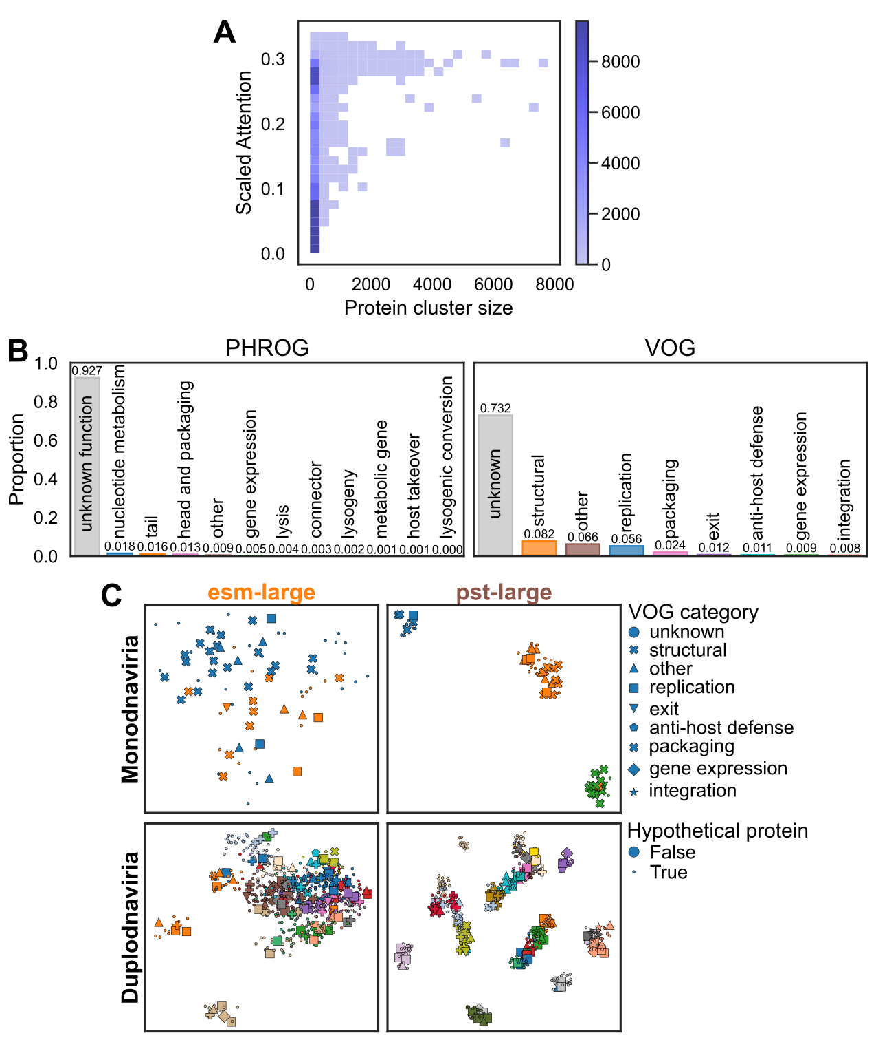
Extended Data Figure 5. Protein function associations detected by vPST. A) Scaled attention for the top 50 sequence identity-based protein clusters (mmseqs2) compared to the number of proteins in the cluster in a 2D histogram. Counts greater than 10,000 were clipped for ease of visualization. B) Distribution of protein functional annotations using curated categories from the PHROG or VOG databases. C) UMAP dimensionality reduction plots for 2 genome clusters primarily composed of (≥85%) Monodnaviria (top) or Duplodnaviria (bottom). Shapes indicate the VOG curated functional category, and colors represent the protein cluster membership using the Leiden algorithm on the kNN graph. These are the same genome clusters as in Fig. 3C. All analyses were done using the proteins from the vPST test dataset.
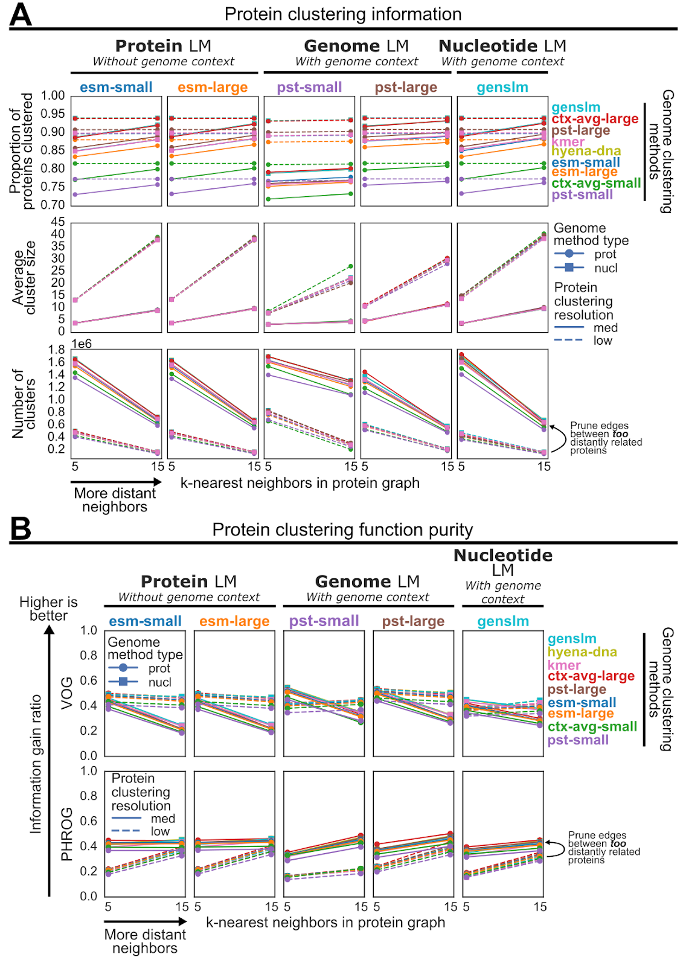
Extended Data Figure 6. Protein clustering information and evaluation. A) Statistics of embedding-based protein clusters detected by the Leiden algorithm on the similarity-weighted k-nearest neighbors graph. The edges and edge weights (similarity values) were computed using cosine similarity after length normalizing the indicated protein embedding (columns). Protein neighbors were only considered if the source genomes belonged to the same genome cluster, which were clustered using the embedding indicated by the color of the line. The genomes were clustered using the parameters that maximized intra-cluster AAI (“High” Leiden resolution, k=15). B) Weighted information gain ratio computed as cluster-size-weighted average over all protein clusters, penalized for the proportion of protein singletons, using curated function categories from VOG and PHROG as protein labels. Unannotated proteins were excluded during calculation of the relative proportion of each function category comprising a cluster. However, the cluster size used for weighted average included all proteins in the cluster. All analyses were done using the proteins from the vPST test dataset.
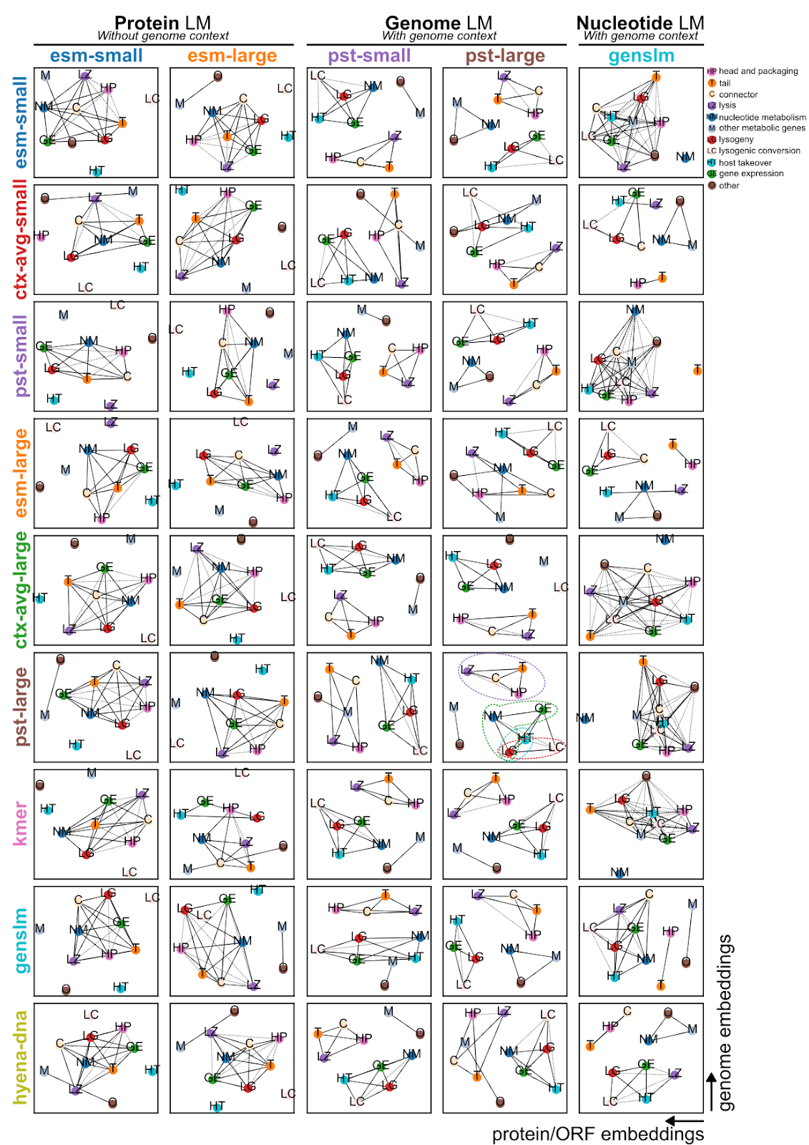
Extended Data Figure 7. Summary of protein function co-clustering. Rows indicate the genome embedding used for genome clustering (k=15, “High” Leiden clustering resolution), and the columns indicate the protein embedding used for protein clustering (k=15, “Med” Leiden clustering resolution). The “pst-large” column refers to the intermediate contextualized protein embeddings, while “ctx-avg-large” row refers to the average of the previous protein embeddings over each genome. The functional categories are curated from the PHROG database. Each connected component was clustered in a co-occurrence graph using the Ledian algorithm with resolution of 1.0. Edges indicate functional categories that were more enriched in the protein clusters compared to the joint occurrence of these categories in the PHROG database. The length of the edges reflects the degree of enrichment. Dotted lines indicate connections that were less enriched than expected. This is a blow up of Fig. 3C. All analyses were done using the proteins from the vPST test dataset.
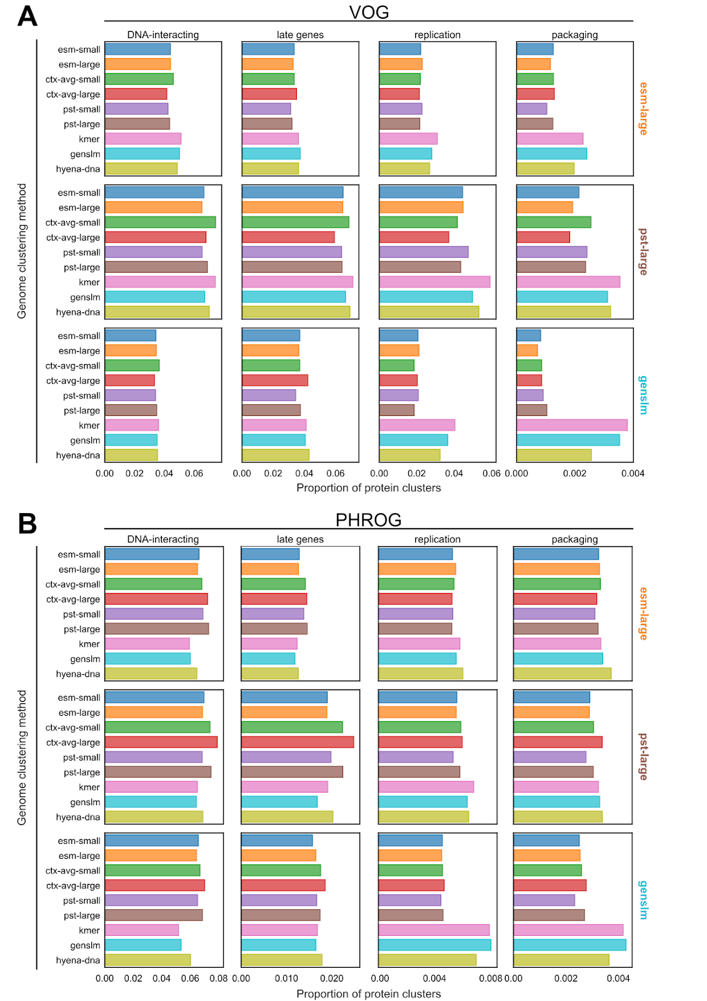
Extended Data Figure 8. The viral Protein Set Transformer (vPST) protein embeddings detects functional modules more frequently than other protein clustering methods. The proportion of protein clusters that correspond to 1 of 4 functional modules (columns) using either A) VOG or B) PHROG annotations. Proteins were clustered within each genome cluster with k=15 and clustering resolution=”med” using the protein embedding indicated by the row. Genomes were clustered with k=15 and clustering resolution=”high” using the genome embedding indicated by the y-axis and color. The data used here were averaged over the genome clustering methods for Fig. 3D. All analyses were done using the proteins from the vPST test dataset.
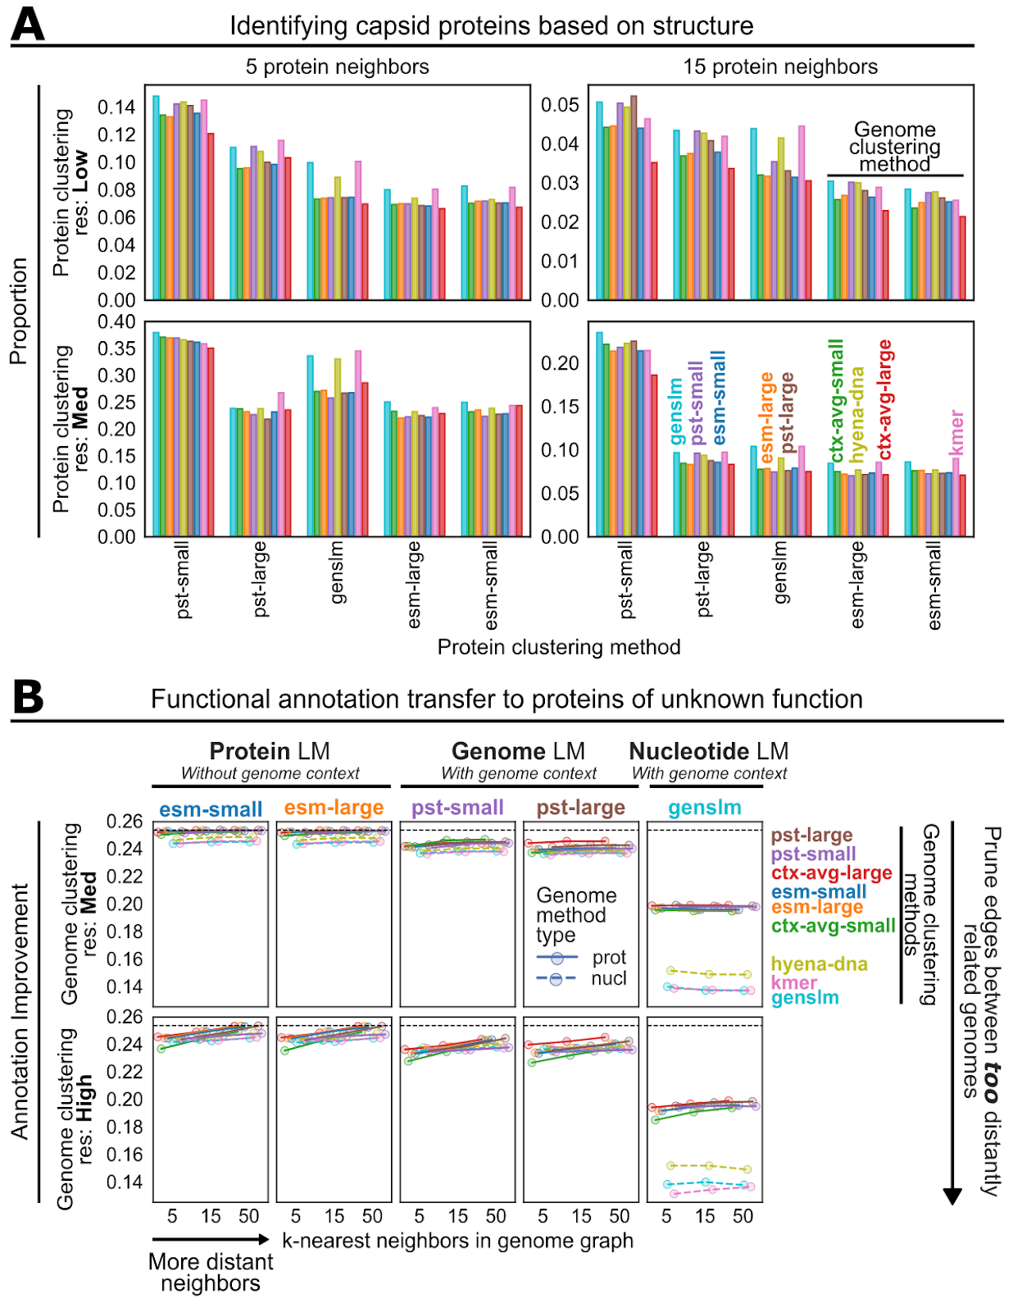
Extended Data Figure 9. Expanding our view of unannotated hypothetical proteins. A) The average proportion of proteins unannotated by VOG clustering with annotated capsid proteins that have structural homology to known capsid folds. Structural homology was detected using foldseek searching against the Protein Data Bank database. Values are only comparable within each subpanel. B) Annotation improvements for proteins unable to be assigned a function by remote homology to the VOG database. Annotation improvement is defined as the fraction of unannotated proteins whose closest neighbor (cosine distance) has an assigned function. For both panels, protein clustering or similarity searching was only allowed for proteins belonging to genomes in the same genome cluster (“High” Leiden resolution, k=15). The color of the bars (A) and lines (B) indicates the embedding used for genome clustering.
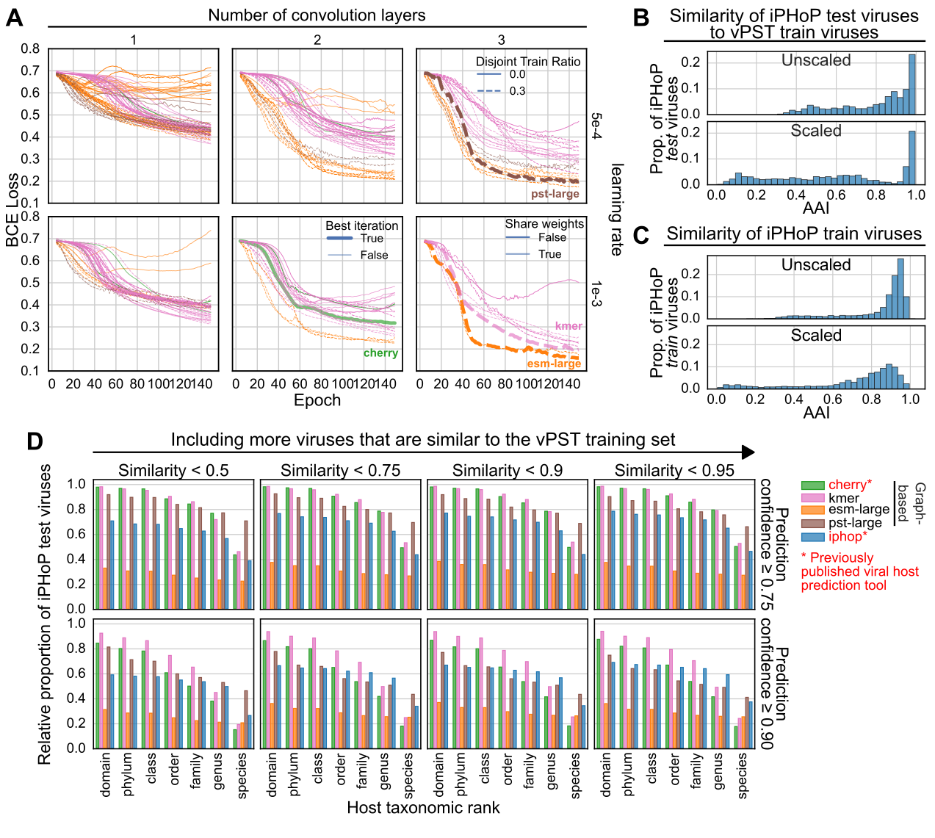
Extended Data Figure 10. Comparing host prediction tools on the iPHoP test dataset. A) Training curves for graph-based host prediction models. Performance of different iterations of host prediction models evaluated using binary cross entropy (BCE) loss on the same validation dataset. Disjoint train ratio refers to the proportion of edges used for inference only, with the remaining edges used only for message passing. In the case of 0.0, all training edges were used for both message passing and inference. The opacity of the lines indicate if the model weights were shared between the virus-host and virus-virus edges during message passing in the same layer. The best iterations for each input node (genome) embedding type are indicated by the thick lines and were chosen as the global minimum loss at the final epoch. The additional lines are for different choices of decoder fully-connected layer hidden dimensions. Each model was trained using the same training dataset of 3,639 viruses as iPHoP. B) The maximum average amino acid identity (AAI) for each iPHoP test virus when searching against the vPST training dataset. “Unscaled” is the raw AAI, while “Scaled” weights the AAI by the minimum proportion of proteins used to compute AAI for each pair of genomes. C) Similar to B, except only computing AAI internally among the iPHoP training dataset. D) The proportion of iPHoP test viruses whose true host taxonomic rank is predicted with confidence ≥ the indicated threshold (rows). Based on B, we excluded viruses from this set if they were more similar based on scaled AAI to the vPST training dataset (columns). The number of test viruses evaluated for each column is 651, 1073, 1167, and 1297, respectively.

