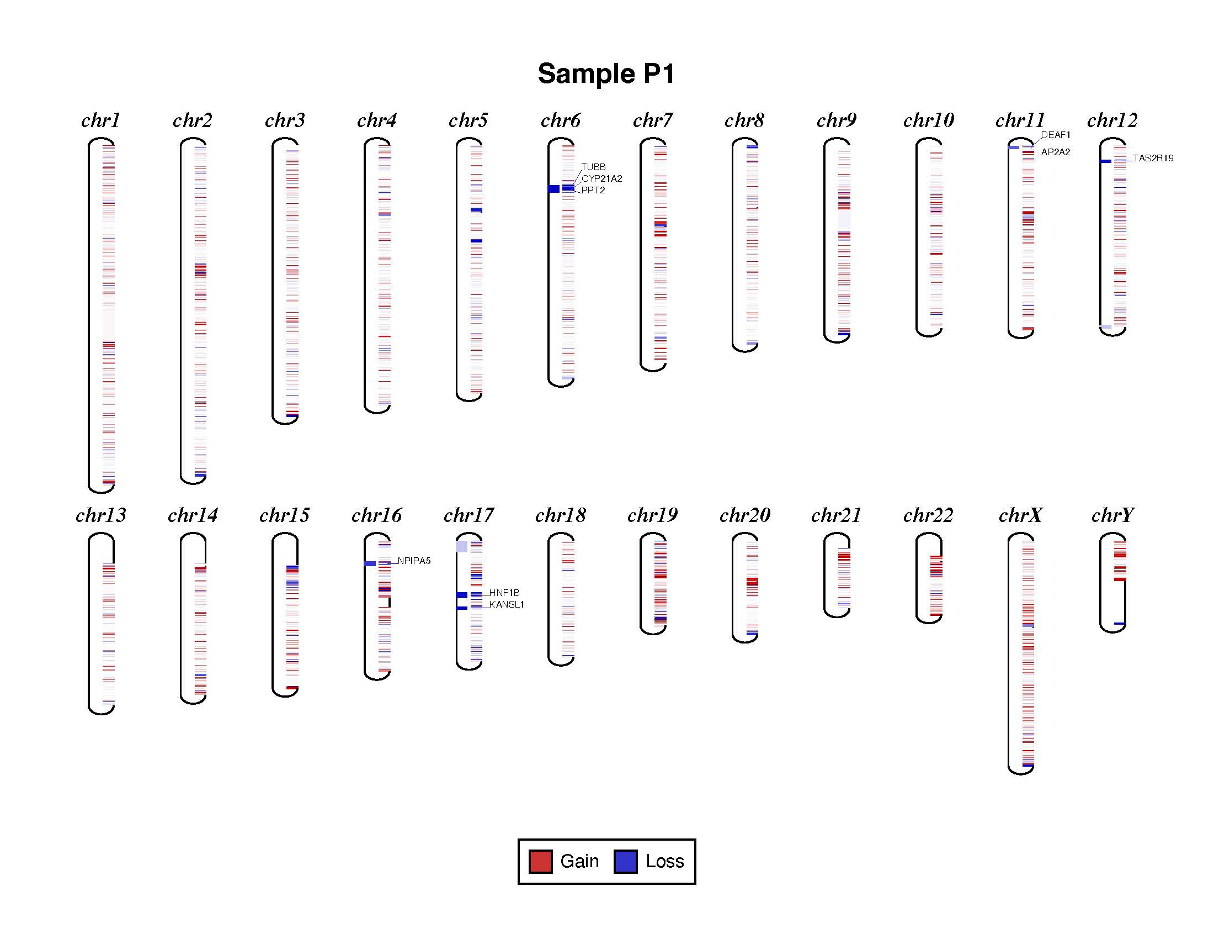

Supplementary Figure 2a: Visualization of CNV distribution across the chromosomes in P1 (phenotype: hypospadias)

