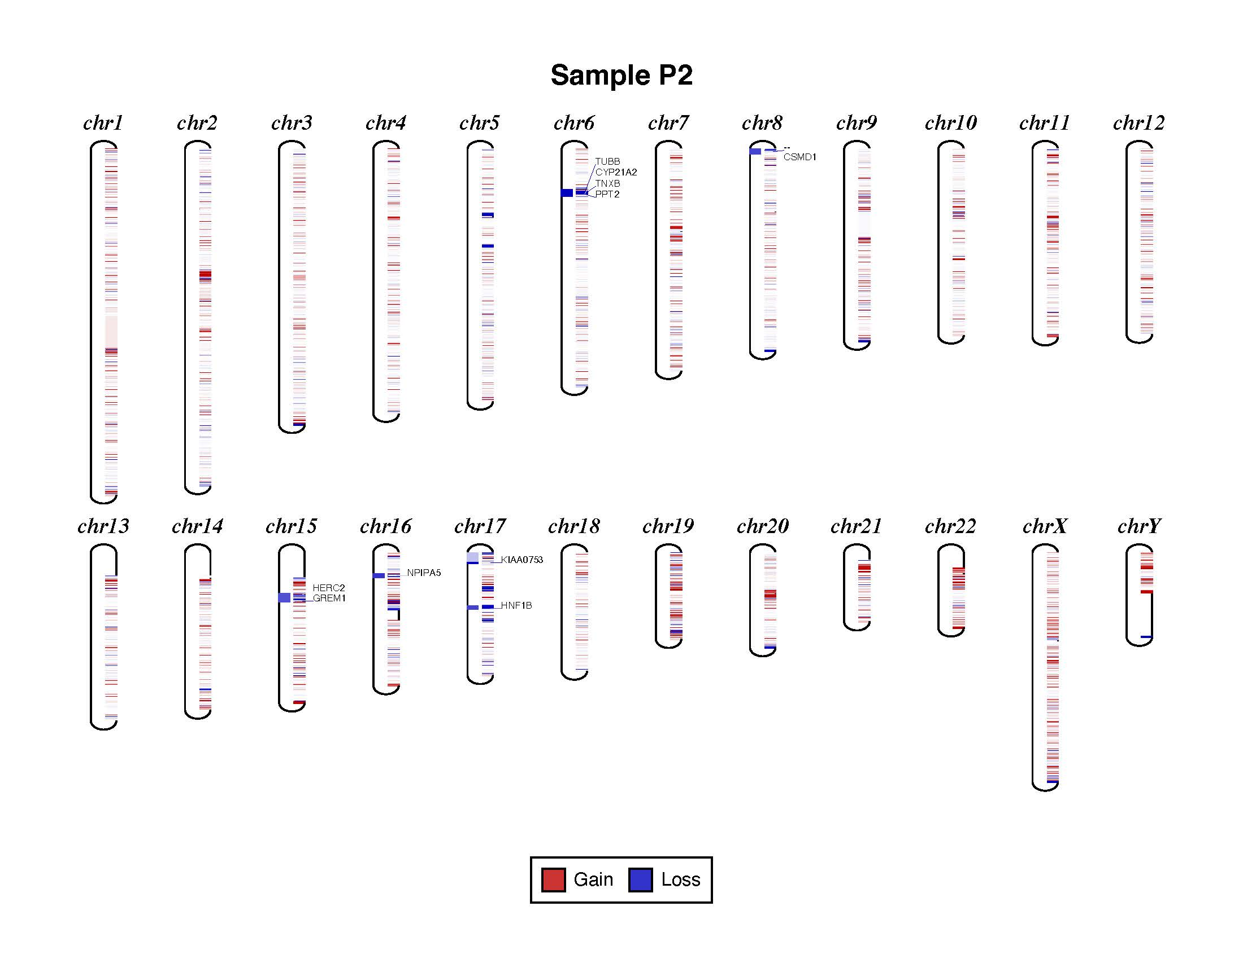
Supplementary Figure 2b: Visualization of CNV distribution across the chromosomes in P2 (phenotype: hypospadias)

