Supplementary Appendix: Prediction of the risk of adverse clinical outcomes with machine learning techniques in patients with chronic no communicable diseases

Alejandro Hernández-Arango MD. MS. ^{1,2} María Isabel Arias ^{3,4} ,Viviana Pérez ², Luis Daniel Chavarría ³ , Fabian Jaimes phD.^{4.}

¹ Professor Department of Internal Medicine, University of Antioquia, School of Medicine Medellin, Colombia
² Hospital Alma Máter de Antioquia, University of Antioquia. Medellin, Colombia.
³ Data Scientist, National University. Medellin, Colombia.
⁴ Full Professor, Department of Internal Medicine, University of Antioquia, Medellín, Colombia

Other results of Statistical tests

The Hartigan immersion test reports possible multimodal distributions for: age, room stay, ICU stay, total value, weight, height, oxygen saturation, thigh circumference, waist circumference, triceps fold, abdomen fold, thigh fold, systolic blood pressure, diastolic blood pressure, resting heart rate, monopodal seconds time, time to diagnosis, glycemia, glycated hemoglobin, how many cigarettes per day, lipoprotein, HDL, total cholesterol, Triglycerides, creatinine 1 consultation, glomerular filtration rate GFR, months difference between GFR, microalbuminuria, TSH.

The normality test reports non-normal distributions for: age, ward stay, ICU stay, ICU stay, total value, weight, height, oxygen saturation, thigh circumference, waist circumference, triceps fold, abdomen fold, thigh fold, systolic blood pressure, diastolic blood pressure, resting heart rate, mets -metabolic index, VO2 - maximum amount of oxygen, monopodal seconds time, time to diagnosis, glycemia, glycated hemoglobin, how many cigarettes per day, lipoprotein, HDL, total cholesterol, triglycerides, creatinine 1 consultation, glomerular filtration rate GFR, months difference between GFR, microalbuminuria, TSH.

Tukey's test indicates distant outliers in: ward stay, ICU stay, total value, weight, height, oxygen saturation, thigh circumference, waist circumference, triceps fold, abdomen fold, systolic blood pressure, diastolic blood pressure, resting heart rate, METS -metabolic index, VO2 - maximum amount of oxygen, glycemia, glycated hemoglobin, how many cigarettes per day, HDL, total cholesterol, triglycerides, creatinine 1 consultation, glomerular filtration rate GFR, months difference between GFR, microalbuminuria, TSH.

Supplementary Table s1. Descriptors of ICD-10 codes included and excluded in each chronic disease category.
ALLERGY
Included ICD-10 codes and labels
J301 | Allergic rhinitis due to pollen
J302 | Other seasonal allergic rhinitis
J303 | Other allergic rhinitis
J304 | Allergic rhinitis, unspecified
J450 | Predominantly allergic asthma
K522 | Allergic and dietetic gastroenteritis and colitis
L20 | Atopic dermatitis
L23 | Allergic contact dermatitis
L500 | Allergic urticaria
Z516 | Desensitization to allergens
ANEMIA
Included ICD-10 codes and labels
D50 | Iron deficiency anaemia
D51 | Vitamin B12 deficiency anaemia
D52 | Folate deficiency anaemia
D53 | Other nutritional anaemias
D55 | Anaemia due to enzyme disorders
D56 | Thalassaemia
D57 | Sickle-cell disorders
D58 | Other hereditary haemolytic anaemias
D59 | Acquired haemolytic anaemia
D60 | Acquired pure red cell aplasia [erythroblastopenia]
D61 | Other aplastic anaemias
D63 | Anaemia in chronic diseases classified elsewhere
D64 | Other anaemias
Excluded ICD-10 codes and labels
D563 | Thalassemia screen
D590 | Drug-induced autoimmune haemolytic anaemia
D592 | Drug-induced nonautoimmune haemolytic anaemia
D593 | Haemolytic-uraemic syndrome
D596 | Haemoglobinuria due to haemolysis from other external causes
D601 | Transient acquired pure red cell aplasia
D611 | Drug-induced aplastic anaemia
D612 | Aplastic anaemia due to other external agents
D642 | Secondary sideroblastic anaemia due to drugs and toxins
ASTHMA
Included ICD-10 codes and labels
J45 | Asthma
ATRIAL FIBRILLATION
Included ICD-10 codes and labels
I48 | Atrial fibrillation and flutter
AUTOIMMUNE DISEASES
Included ICD-10 codes and labels
I731 | Thromboangiitis obliterans [Buerger]
L10 | Pemphigus
L12 | Pemphigoid
L40 | Psoriasis
L41 | Parapsoriasis
L93 | Lupus erythematosus
L94 | Other localized connective tissue disorders
L95 | Vasculitis limited to skin, not elsewhere classified
M30 | Polyarteritis nodosa and related conditions
M31 | Other necrotizing vasculopathies
M32 | Systemic lupus erythematosus
M33 | Dermatopolymyositis
M34 | Systemic sclerosis
M35 | Other systemic involvement of connective tissue
M36 | Systemic disorders of connective tissue in diseases classified elsewhere
Excluded ICD-10 codes and labels
L105 | Drug-induced pemphigus
M320 | Drug-induced systemic lupus erythematosus
M342 | Systemic sclerosis induced by drugs and chemicals
M357 | Hypermobility syndrome
M358 | Other specified systemic involvement of connective tissue
M359 | Systemic involvement of connective tissue, unspecified
M360 | Dermato(poly)myositis in neoplastic disease
M361 | Arthropathy in neoplastic disease
M362 | Haemophilic arthropathy
M363 | Arthropathy in other blood disorders
BLINDNESS, VISUAL IMPAIRMENT
Included ICD-10 codes and labels
H54 | Visual impairment including blindness (binocular or monocular)
Z442 | Fitting and adjustment of artificial eye
Z970 | Presence of artificial eye
Excluded ICD-10 codes and labels
H543 | Mild or no visual impairment, binocular
BLOOD AND BLOOD FORMING ORGAN DISEASES
Included ICD-10 codes and labels
D66 | Hereditary factor VIII deficiency
D67 | Hereditary factor IX deficiency
D68 | Other coagulation defects
D69 | Purpura and other haemorrhagic conditions
D71 | Functional disorders of polymorphonuclear neutrophils
D720 | Genetic anomalies of leukocytes
D730 | Hyposplenism
D731 | Hypersplenism
D732 | Chronic congestive splenomegaly
D74 | Methaemoglobinaemia
D750 | Familial erythrocytosis
D761 | Haemophagocytic lymphohistiocytosis
D763 | Other histiocytosis syndromes
D77 | Other disorders of blood and blood-forming organs in diseases classified elsewhere
D80 | Immunodeficiency with predominantly antibody defects
D81 | Combined immunodeficiencies
D82 | Immunodeficiency associated with other major defects
D83 | Common variable immunodeficiency
D84 | Other immunodeficiencies
D86 | Sarcoidosis
D89 | Other disorders involving the immune mechanism, not elsewhere classified
Excluded ICD-10 codes and labels
D683 | Haemorrhagic disorder due to circulating anticoagulants
D684 | Acquired coagulation factor deficiency
D695 | Secondary thrombocytopenia
D748 | Other methaemoglobinaemias
D807 | Transient hypogammaglobulinaemia of infancy
D891 | Cryoglobulinaemia
D893 | Immune reconstitution syndrome
BRADYCARDIAS AND CONDUCTION DISEASES
Included ICD-10 codes and labels
I441 | Atrioventricular block, second degree
I442 | Atrioventricular block, complete
I443 | Other and unspecified atrioventricular block
I453 | Trifascicular block
I455 | Other specified heart block
Z950 | Presence of cardiac pacemaker
CARDIAC VALVE DISEASES
Included ICD-10 codes and labels
I05 | Rheumatic mitral valve diseases
I06 | Rheumatic aortic valve diseases
I07 | Rheumatic tricuspid valve diseases
I08 | Multiple valve diseases
I091 | Rheumatic diseases of endocardium, valve unspecified
I098 | Other specified rheumatic heart diseases
I34 | Nonrheumatic mitral valve disorders
I35 | Nonrheumatic aortic valve disorders
I36 | Nonrheumatic tricuspid valve disorders
I37 | Pulmonary valve disorders
I38 | Endocarditis, valve unspecified
I390 | Mitral valve disorders in diseases classified elsewhere
I391 | Aortic valve disorders in diseases classified elsewhere
I392 | Tricuspid valve disorders in diseases classified elsewhere
I393 | Pulmonary valve disorders in diseases classified elsewhere
I394 | Multiple valve disorders in diseases classified elsewhere
Q22 | Congenital malformations of pulmonary and tricuspid valves
Q23 | Congenital malformations of aortic and mitral valves
Z952 | Presence of prosthetic heart valve
Z953 | Presence of xenogenic heart valve
Z954 | Presence of other heart-valve replacement
CATARACT AND OTHER LENS DISEASES
Included ICD-10 codes and labels
H25 | Senile cataract
H26 | Other cataract
H27 | Other disorders of lens
H28 | Cataract and other disorders of lens in diseases classified elsewhere
Q12 | Congenital lens malformations
Z961 | Presence of intraocular lens
CEREBROVASCULAR DISEASE
Included ICD-10 codes and labels
G45 | Transient cerebral ischaemic attacks and related syndromes
G46 | Vascular syndromes of brain in cerebrovascular diseases
I60 | Subarchnoid hemorrhage
I61 | Intracerebral haemorrhage
I62 | Other nontraumatic intracranial haemorrhage
I63 | Cerebral infarction
I64 | Stroke, not specified as haemorrhage or infarction
I67 | Other cerebrovascular diseases
I69 | Sequelae of cerebrovascular disease
CHROMOSOMAL ABNORMALITIES
Included ICD-10 codes and labels
Q90 | Down syndrome
Q91 | Edwards syndrome and Patau syndrome
Q92 | Other trisomies and partial trisomies of the autosomes, not elsewhere classified
Q93 | Monosomies and deletions from the autosomes, not elsewhere classified
Q95 | Balanced rearrangements and structural markers, not elsewhere classified
Q96 | Turner syndrome
Q97 | Other sex chromosome abnormalities, female phenotype, not elsewhere classified
Q98 | Other sex chromosome abnormalities, male phenotype, not elsewhere classified
Q99 | Other chromosome abnormalities, not elsewhere classified
CHRONIC INFECTIOUS DISEASES
Included ICD-10 codes and labels
A15 | Respiratory tuberculosis, bacteriologically and histologically confirmed
A16 | Respiratory tuberculosis, not confirmed bacteriologically or histologically
A17 | Tuberculosis of nervous system
A18 | Tuberculosis of other organs
A19 | Miliary tuberculosis
A30 | Leprosy [Hansen disease]
A31 | Infection due to other mycobacteria
A50 | Congenital syphilis
A52 | Late syphilis
A53 | Other and unspecified syphilis
A65 | Nonvenereal syphilis
A66 | Yaws
A67 | Pint [carat]
A692 | Lyme disease
A81 | Atypical virus infections of central nervous system
B20 | Human immunodeficiency virus [HIV] disease resulting in infectious and parasitic diseases
B21 | Human immunodeficiency virus [HIV] disease resulting in malignant neoplasms
B22 | Human immunodeficiency virus [HIV] disease resulting in other specified diseases
B23 | Human immunodeficiency virus [HIV] disease resulting in other conditions
B24 | Unspecified human immunodeficiency virus [HIV] disease
B381 | Chronic pulmonary coccidioidomycosis
B391 | Chronic pulmonary histoplasmosis capsulati
B401 | Chronic pulmonary blastomycosis
B572 | Chagas disease (chronic) with heart involvement
B573 | Chagas disease (chronic) with digestive system involvement
B574 | Chagas disease (chronic) with nervous system involvement
B575 | Chagas disease (chronic) with other organ involvement
B65 | Schistosomiasis [bilharziasis]
B92 | Sequelae or leprosy
B94 | Sequelae of other and unspecified infectious and parasitic diseases
J65 | Pneumoconiosis associated with tuberculosis
M863 | Chronic multifocal osteomyelitis
M864 | Chronic osteomyelitis with draining sinus
M865 | Other chronic haematogenous osteomyelitis
M866 | Other chronic osteomyelitis
CHRONIC KIDNEY DISEASES
Included ICD-10 codes and labels
I120 | Hypertensive renal disease with renal failure
I130 | Hypertensive heart and renal disease with (congestive) heart failure
I131 | Hypertensive heart and renal disease with renal failure
I132 | Hypertensive heart and renal disease with both (congestive) heart failure and renal failure
I139 | Hypertensive heart and renal disease, unspecified
N01 | Rapidly progressive nephritic syndrome
N03 | Chronic nephritic syndrome
N04 | Nephrotic syndrome
N05 | Unspecified nephritic syndrome
N07 | Hereditary nephropathy, not elsewhere classified
N08 | Glomerular disorders in diseases classified elsewhere
N11 | Chronic tubulo-interstitial nephritis
N183 | Chronic kidney disease, stage 3
N184 | Chronic kidney disease, stage 4
N185 | Chronic kidney disease, stage 5
N189 | Chronic kidney disease, unspecified
Q60 | Renal agenesis and other reduction defects of kidney
Q611 | Polycystic kidney, autosomal recessive
Q612 | Polycystic kidney, autosomal dominant
Q613 | Polycystic kidney, unspecified
Q614 | Renal dysplasia
Q615 | Medullary cystic kidney
Q618 | Other cystic kidney diseases
Q619 | Cystic kidney disease, unspecified
Z905 | Acquired absence of kidney
Z940 | Kidney transplant status
CHRONIC LIVER DISEASES
Included ICD-10 codes and labels
B18 | Chronic viral hepatitis
K70 | Alcoholic liver disease
K713 | Toxic liver disease with chronic persistent hepatitis
K714 | Toxic liver disease with chronic lobular hepatitis
K715 | Toxic liver disease with chronic active hepatitis
K717 | Toxic liver disease with fibrosis and cirrhosis of liver
K721 | Chronic hepatic failure
K73 | Chronic hepatitis, not elsewhere classified
K74 | Fibrosis and cirrhosis of liver
K753 | Granulomatous hepatitis, not elsewhere classified
K754 | Autoimmune hepatitis
K758 | Other specified inflammatory liver diseases
K761 | Chronic passive congestion of liver
K766 | Portal hypertension
K767 | Hepatorenal syndrome
K778 | Liver disorders in other diseases classified elsewhere
Q446 | Cystic disease of liver
Z944 | Liver transplant status
Excluded ICD-10 codes and labels
K700 | Alcoholic fatty liver
K701 | Alcoholic hepatitis
CHRONIC PANCREAS, BILIARY TRACT AND GALLBLADDER DISEASES
Included ICD-10 codes and labels
K800 | Calculus of gallbladder with acute cholecystitis
K801 | Calculus of gallbladder with other cholecystitis
K802 | Calculus of gallbladder without cholecystitis
K808 | Other cholelithiasis
K811 | Chronic cholecystitis
K86 | Other diseases of pancreas
Q440 | Agenesis, aplasia and hypoplasia of gallbladder
Q441 | Other congenital malformations of gallbladder
Q442 | Atresia of bile ducts
Q443 | Congenital stenosis and stricture of bile ducts
Q444 | Choledochal cyst
Q445 | Other congenital malformations of bile ducts
Q450 | Agenesis, aplasia and hypoplasia of pancreas
Excluded ICD-10 codes and labels
K862 | Cyst of pancreas
K863 | Pseudocyst of pancreas
K869 | Disease of pancreas, unspecified
CHRONIC ULCER OF THE SKIN
Included ICD-10 codes and labels
I830 | Varicose veins of lower extremities with ulcer
I832 | Varicose veins of lower extremities with both ulcer and inflammation
L89 | Decubitus ulcer and pressure area
L97 | Ulcer of lower limb, not elsewhere classified
L984 | Chronic ulcer of skin, not elsewhere classified
COLITIS AND RELATED DISEASES
Included ICD-10 codes and labels
K520 | Gastroenteritis and colitis due to radiation
K528 | Other specified noninfective gastroenteritis and colitis
K551 | Chronic vascular disorders of intestine
K552 | Angiodysplasia of colon
K572 | Diverticular disease of large intestine with perforation and abscess
K573 | Diverticular disease of large intestine without perforation or abscess
K574 | Diverticular disease of both small and large intestine with perforation and abscess
K575 | Diverticular disease of both small and large intestine without perforation or abscess
K578 | Diverticular disease of intestine, part unspecified, with perforation and abscess
K579 | Diverticular disease of intestine, part unspecified, without perforation or abscess
K58 | Irritable bowel syndrome
K590 | Constipation
K592 | Neurogenic bowel, not elsewhere classified
K62 | Other diseases of anus and rectum
K634 | Enteroptosis
K64 | Haemorrhoids and perianal venous thrombosis
Excluded ICD-10 codes and labels
K620 | Anal polyp
K621 | Rectal polyp
K625 | Haemorrhage of anus and rectum
K626 | Ulcer of anus and rectum
K645 | Perianal venous thrombosis
COPD, EMPHYSEMA, CHRONIC BRONCHITIS
Included ICD-10 codes and labels
J41 | Simple and mucopurulent chronic bronchitis
J42 | Unspecified chronic bronchitis
J43 | Emphysema
J44 | Other chronic obstructive pulmonary disease
J47 | Bronchiectasis
DEAFNESS, HEARING IMPAIRMENT
Included ICD-10 codes and labels
H80 | Otosclerosis
H90 | Conductive and sensorineural hearing loss
H911 | Presbycusis
H913 | Deaf mutism, not elsewhere classified
H919 | Hearing loss, unspecified
Q16 | Congenital malformations of ear causing impairment of hearing
Z453 | Adjustment and management of implanted hearing device
Z461 | Fitting and adjustment of hearing aid
Z962 | Presence of otological and audiological implants
Z974 | Presence of external hearing-aid
DEMENTIA
Included ICD-10 codes and labels
F00 | Dementia in Alzheimer disease
F01 | Vascular dementia
F02 | Dementia in other diseases classified elsewhere
F03 | Unspecified dementia
F051 | Delirium superimposed on dementia
G30 | Alzheimer disease
G31 | Other degenerative diseases of nervous system, not elsewhere classified
DEPRESSION AND MOOD DISEASES
Included ICD-10 codes and labels
F30 | Manic episode
F31 | Bipolar affective disorder
F32 | Depressive episode
F33 | Recurrent depressive disorder
F34 | Persistent mood [affective] disorders
F38 | Other mood [affective] disorders
F39 | Unspecified mood [affective] disorder
F412 | Mixed anxiety and depressive disorder
DIABETES
Included ICD-10 codes and labels
E10 | Insulin-dependent diabetes mellitus
E11 | Non-insulin-dependent diabetes mellitus
E13 | Other specified diabetes mellitus
E14 | Unspecified diabetes mellitus
E891 | Postprocedural hypoinsulinaemia
DORSOPATHIES
Included ICD-10 codes and labels
M40 | Kyphosis and lordosis
M41 | Scoliosis
M42 | Spinal osteochondrosis
M43 | Other deforming dorsopathies
M47 | Spondylosis
M48 | Other spondylopathies
M49 | Spondylopathies in diseases classified elsewhere
M50 | Cervical disc disorders
M51 | Other intervertebral disc disorders
M53 | Other dorsopathies, not elsewhere classified
Q675 | Congenital deformity of spine
Q761 | Klippel-Feil syndrome
Q764 | Other congenital malformations of spine, not associated with scoliosis
DYSLIPIDEMIA
Included ICD-10 codes and labels
E78 | Disorders of lipoprotein metabolism and other lipidaemias
EAR, NOSE, THROAT DISEASES
Included ICD-10 codes and labels
H604 | Cholesteatoma of external ear
H661 | Chronic tubotympanic suppurative otitis media
H662 | Chronic atticoantral suppurative otitis media
H663 | Other chronic suppurative otitis media
H701 | Chronic mastoiditis
H71 | Cholesteatoma of middle ear
H731 | Chronic myringitis
H741 | Adhesive middle ear disease
H810 | The disease
H831 | Labyrinthine fistula
H832 | Labyrinthine dysfunction
H95 | Postprocedural disorders of ear and mastoid process, not elsewhere classified
J300 | Vasomotor rhinitis
J31 | Chronic rhinitis, nasopharyngitis and pharyngitis
J32 | Chronic sinusitis
J33 | Nasal polyp
J341 | Cyst and mucocele of nose and nasal sinus
J342 | Deviated nasal septum
J343 | Hypertrophy of nasal turbinates
J35 | Chronic diseases of tonsils and adenoids
J37 | Chronic laryngitis and laryngotracheitis
J380 | Paralysis of vocal cords and larynx
J386 | Stenosis of larynx
K051 | Chronic gingivitis
K053 | Chronic periodontitis
K07 | Dentofacial anomalies [including malocclusion]
K110 | Atrophy of salivary gland
K117 | Disturbances of salivary secretion
Q30 | Congenital malformations of nose
Q31 | Congenital malformations of larynx
Q32 | Congenital malformations of trachea and bronchus
Q35 | Cleft palate
Q36 | Cleft lip
Q37 | Cleft palate with cleft lip
Q38 | Other congenital malformations of tongue, mouth and pharynx
EPILEPSY
Included ICD-10 codes and labels
G40 | Epilepsy
Excluded ICD-10 codes and labels
G405 | Special epileptic syndromes
ESOPHAGUS, STOMACH AND DUODENUM DISEASES
Included ICD-10 codes and labels
I85 | Osophageal varicoses
I864 | Gastric varices
I982 | Oesophageal varices without bleeding in diseases classified elsewhere
I983 | Oesophageal varices with bleeding in diseases classified elsewhere
K21 | Gastro-oesophageal reflux disease
K220 | Achalasia of cardia
K222 | Oesophageal obstruction
K224 | Dyskinesia of oesophagus
K225 | Diverticulum of oesophagus, acquired
K227 | Barrett oesophagus
K230 | Tuberculous oesophagitis
K231 | Megaoesophagus in Chagas disease
K254 | Gastric ulcer: Chronic or unspecified with haemorrhage
K255 | Gastric ulcer: Chronic or unspecified with perforation
K256 | Gastric ulcer: Chronic or unspecified with both haemorrhage and perforation
K257 | Gastric ulcer: Chronic without haemorrhage or perforation
K264 | Duodenal ulcer: Chronic or unspecified with haemorrhage
K265 | Duodenal ulcer: Chronic or unspecified with perforation
K266 | Duodenal ulcer: Chronic or unspecified with both haemorrhage and perforation
K267 | Duodenal ulcer: Chronic without haemorrhage or perforation
K274 | Peptic ulcer, site unspecified: Chronic or unspecified with haemorrhage
K275 | Peptic ulcer, site unspecified: Chronic or unspecified with perforation
K276 | Peptic ulcer, site unspecified: Chronic or unspecified with both haemorrhage and perforation
K277 | Peptic ulcer, site unspecified: Chronic without haemorrhage or perforation
K284 | Gastrojejunal ulcer: Chronic or unspecified with haemorrhage
K285 | Gastrojejunal ulcer: Chronic or unspecified with perforation
K286 | Gastrojejunal ulcer: Chronic or unspecified with both haemorrhage and perforation
K287 | Gastrojejunal ulcer: Chronic without haemorrhage or perforation
K293 | Chronic superficial gastritis
K294 | Chronic atrophic gastritis
K295 | Chronic gastritis, unspecified
K296 | Other gastritis
K297 | Gastritis, unspecified
K298 | Duodenitis
K299 | Gastroduodenitis, unspecified
K311 | Adult hypertrophic pyloric stenosis
K312 | Hourglass stricture and stenosis of stomach
K313 | Pylorospasm, not elsewhere classified
K314 | Gastric diverticulum
K315 | Abstraction of Duodenuma
Q39 | Congenital malformations of oesophagus
Q40 | Other congenital malformations of upper alimentary tract
Z903 | Acquired absence of part of stomach
GLAUCOMA
Included ICD-10 codes and labels
H401 | Primary open-angle glaucoma
H402 | Primary angle-closure glaucoma
H403 | Glaucoma secondary to eye trauma
H404 | Glaucoma secondary to eye inflammation
H405 | Glaucoma secondary to other eye disorders
H406 | Glaucoma secondary to drugs
H408 | Other glaucoma
H409 | Glaucoma, unspecified
HEART FAILURE
Included ICD-10 codes and labels
I110 | Hypertensive heart disease with (congestive) heart failure
I130 | Hypertensive heart and renal disease with (congestive) heart failure
I132 | Hypertensive heart and renal disease with both (congestive) heart failure and renal failure
I27 | Other pulmonary heart diseases
I280 | Arteriovenous fistula of pulmonary vessels
I42 | Cardiomyopathy
I43 | Cardiomyopathy in diseases classified elsewhere
I50 | Heart failure
I515 | Myocardial degeneration
I517 | Cardiomegaly
I528 | Other heart disorders in other diseases classified elsewhere
Z941 | Heart transplant status
Z943 | Heart and lungs transplant status
HEMATOLOGICAL NEOPLASMS
Included ICD-10 codes and labels
C81 | Hodgkin lymphoma
C82 | Follicular lymphoma
C83 | Non-follicular lymphoma
C84 | Mature T/NK-cell lymphomas
C85 | Other and unspecified types of non-Hodgkin lymphoma
C86 | Other specified types of T/NK-cell lymphoma
C88 | Malignant immunoproliferative diseases
C90 | Multiple myeloma and malignant plasma cell neoplasms
C91 | Lymphoid leukaemia
C92 | Myeloid leukaemia
C93 | Monocytic leukaemia
C94 | Other leukaemias of specified cell type
C95 | Leukaemia of unspecified cell type
C96 | Other and unspecified malignant neoplasms of lymphoid, haematopoietic and related tissue
HYPERTENSION
Included ICD-10 codes and labels
I10 | Essential (primary) hypertension
I11 | Hypertensive heart disease
I12 | Hypertensive renal disease
I13 | Hypertensive heart and renal disease
I15 | Secondary hypertension
INFLAMMATORY ARTHROPATHIES
Included ICD-10 codes and labels
M023 | Reiter disease
M05 | Seropositive rheumatoid arthritis
M06 | Other rheumatoid arthritis
M07 | Psoriatic and enteropathic arthropathies
M08 | Juvenile arthritis
M09 | Juvenile arthritis in diseases classified elsewhere
M10 | Taste
M11 | Other crystal arthropathies
M12 | Other specific arthropathies
M13 | Other arthritis
M14 | Arthropathies in other diseases classified elsewhere
M45 | Ankylosing spondylitis
M460 | Spinal enthesopathy
M461 | Sacroiliitis, not elsewhere classified
M468 | Other specified inflammatory spondylopathies
M469 | Inflammatory spondylopathy, unspecified
INFLAMMATORY BOWEL DISEASES
Included ICD-10 codes and labels
K50 | Crohn disease [regional enteritis]
K51 | Ulcerative colitis
ISCHEMIC HEART DISEASE
Included ICD-10 codes and labels
I20 | Angina pectoris
I21 | Acute myocardial infarction
I22 | Subsequent myocardial infarction
I24 | Other acute ischaemic heart diseases
I25 | Chronic ischaemic heart disease
Z951 | Presence of aortocoronary bypass graft
Z955 | Presence of coronary angioplasty implant and graft
MIGRAINE AND FACIAL PAIN SYNDROMES
Included ICD-10 codes and labels
G43 | Migraine
G440 | Cluster headache syndrome
G441 | Vascular headache, not elsewhere classified
G442 | Tension-type headache
G443 | Chronic post-traumatic headache
G448 | Other specified headache syndromes
G50 | Disorders of trigeminal nerve
MULTIPLE SCLEROSIS
Included ICD-10 codes and labels
G35 | Multiple sclerosis
NEUROTIC, STRESS-RELATED AND SOMATOFORM DISEASES
Included ICD-10 codes and labels
F40 | Phobic anxiety disorders
F41 | Other anxiety disorders
F42 | Obsessive-compulsive disorder
F43 | Reaction to severe stress, and adjustment disorders
F44 | Dissociative [conversion] disorders
F45 | Somatoform disorders
F48 | Other neurotic disorders
Excluded ICD-10 codes and labels
F430 | Acute stress reaction
F432 | Adjustment disorders
OBESITY
Included ICD-10 codes and labels
E66 | Obesity
OSTEOARTHRITIS AND OTHER DEGENERATIVE JOINT DISEASES
Included ICD-10 codes and labels
M15 | Polyarthrosis
M16 | Coxarthrosis [arthrosis of hip]
M17 | Gonarthrosis [arthrosis of knee]
M18 | Arthrosis of first carpometacarpal joint
M19 | Other arthrosis
M362 | Haemophilic arthropathy
M363 | Arthropathy in other blood disorders
OSTEOPOROSIS
Included ICD-10 codes and labels
M80 | Osteoporosis with pathological fracture
M81 | Osteoporosis without pathological fracture
M82 | Osteoporosis in diseases classified elsewhere
OTHER CARDIOVASCULAR DISEASES
Included ICD-10 codes and labels
I09 | Other rheumatic heart diseases
I281 | Aneurysm of pulmonary artery
I310 | Chronic adhesive pericarditis
I311 | Chronic constrictive pericarditis
I456 | Pre-excitation syndrome
I495 | Sick sinus syndrome
I498 | Other specified cardiac arrhythmias
I70 | Atherosclerosis
I71 | Aortic aneurysm and dissection
I72 | Other aneurysm and dissection
I790 | Aneurysm of aorta in diseases classified elsewhere
I791 | Aortitis in diseases classified elsewhere
I950 | Idiopathic hypotension
I951 | Orthostatic hypotension
I958 | Other hypotension
Q20 | Congenital malformations of cardiac chambers and connections
Q21 | Congenital malformations of cardiac septa
Q24 | Other congenital malformations of heart
Q25 | Congenital malformations of great arteries
Q26 | Congenital malformations of great veins
Q27 | Other congenital malformations of peripheral vascular system
Q28 | Other congenital malformations of circulatory system
Z958 | Presence of other cardiac and vascular implants and grafts
Z959 | Presence of cardiac and vascular implant and graft, unspecified
Excluded ICD-10 codes and labels
I091 | Rheumatic diseases of endocardium, valve unspecified
I098 | Other specified rheumatic heart diseases
I702 | Atherosclerosis of arteries of extremities
OTHER DIGESTIVE DISEASES
Included ICD-10 codes and labels
K660 | Peritoneal adhesions
K900 | Coeliac disease
K901 | Tropical sprue
K902 | Blind loop syndrome, not elsewhere classified
K911 | Postgastric surgery syndromes
K93 | Disorders of other digestive organs in diseases classified elsewhere
Q41 | Congenital absence, atresia and stenosis of small intestine
Q42 | Congenital absence, atresia and stenosis of large intestine
Q43 | Other congenital malformations of intestine
R15 | Faecal incontinence
Z904 | Acquired absence of other parts of digestive tract
Z980 | Intestinal bypass and anastomosis status
OTHER EYE DISEASES
Included ICD-10 codes and labels
H022 | Lagophthalmos
H023 | Blepharochalasis
H024 | Ptosis of eyelid
H025 | Other disorders affecting eyelid function
H04 | Disorders of lacrimal system
H05 | Disorders of orbit
H104 | Chronic conjunctivitis
H17 | Corneal scars and opacities
H184 | Corneal degeneration
H185 | Hereditary corneal dystrophies
H186 | Keratoconus
H187 | Other corneal deformities
H188 | Other specified disorders of cornea
H189 | Disorder of cornea, unspecified
H193 | Keratitis and keratoconjunctivitis in other diseases classified elsewhere
H198 | Other disorders of sclera and cornea in diseases classified elsewhere
H201 | Chronic iridocyclitis
H21 | Other disorders of iris and ciliary body
H310 | Chorioretinal scars
H311 | Charydal Degeneration
H312 | Hereditary choroidal dystrophy
H318 | Other specified disorders of choroid
H319 | Disorder of choroid, unspecified
H33 | Retinal detachments and breaks
H352 | Other proliferative retinopathy
H353 | Degeneration of macula and posterior pole
H354 | Peripheral retinal degeneration
H355 | Hereditary retinal dystrophy
H357 | Separation of retinal layers
H358 | Other specified retinal disorders
H359 | Retinal disorder, unspecified
H36 | Retinal disorders in diseases classified elsewhere
H47 | Other disorders of optic [2nd] nerve and visual pathways
H48 | Disorders of optic [2nd] nerve and visual pathways in diseases classified elsewhere
H49 | Paralytic strabismus
H51 | Other disorders of binocular movement
Q10 | Congenital malformations of eyelid, lacrimal apparatus and orbit
Q11 | Anophthalmos, microphthalmos and macrophthalmos
Q13 | Congenital malformations of anterior segment of eye
Q14 | Congenital malformations of posterior segment of eye
Q15 | Other congenital malformations of eye
Z947 | Corneal transplant status
Excluded ICD-10 codes and labels
H043 | Acute and unspecified inflammation of lacrimal passages
H050 | Acute inflammation of orbit
H470 | Disorders of optic nerve, not elsewhere classified
H471 | Papilloedema, unspecified
H481 | Retrobulbar neuritis in diseases classified elsewhere
OTHER GENITOURINARY DISEASES
Included ICD-10 codes and labels
B901 | Sequelae of genitourinary tuberculosis
N200 | Calculus of kidney
N202 | Calculus of kidney with calculus of ureter
N209 | Urinary calculus, unspecified
N210 | Calculus in bladder
N218 | Other lower urinary tract calculus
N219 | Calculus of lower urinary tract, unspecified
N22 | Calculus of urinary tract in diseases classified elsewhere
N301 | Interstitial cystitis (chronic)
N302 | Other chronic cystitis
N303 | Trigonitis
N304 | Irradiation cystitis
N31 | Neuromuscular dysfunction of bladder, not elsewhere classified
N320 | Bladder-neck obstruction
N323 | Diverticulum of bladder
N328 | Other specified disorders of bladder
N329 | Bladder disorder, unspecified
N33 | Bladder disorders in diseases classified elsewhere
N35 | Urethral stricture
N393 | Stress incontinence
N394 | Other specified urinary incontinence
N480 | Leukoplakia or penis
N484 | Impotence of organic origin
N489 | Disorder of penis, unspecified
N701 | Chronic salpingitis and oophoritis
N711 | Chronic inflammatory disease of uterus
N731 | Chronic parametritis and pelvic cellulitis
N734 | Female chronic pelvic peritonitis
N736 | Female pelvic peritoneal adhesions
N761 | Subacute and chronic vaginitis
N763 | Subacute and chronic vulvitis
N81 | Female genital prolapse
N88 | Other noninflammatory disorders of cervix uteri
N895 | Stricture and atresia of vagina
N905 | Atrophy of vulva
N952 | Postmenopausal atrophic vaginitis
Q54 | Hypospadias
Q620 | Congenital hydronephrosis
Q621 | Atresia and stenosis of ureter
Q622 | Congenital megaloureter
Q623 | Other obstructive defects of renal pelvis and ureter
Q624 | Agenesis of ureter
Q627 | Congenital vesico-uretero-renal reflux
Q628 | Other congenital malformations of ureter
Q638 | Other specified congenital malformations of kidney
Q639 | Congenital malformation of kidney, unspecified
Q640 | Eepispadias
Q641 | Exstrophy of urinary bladder
Q643 | Other atresia and stenosis of urethra and bladder neck
Q644 | Malformation of urachus
Q645 | Congenital absence of bladder and urethra
Q646 | Congenital diverticulum of bladder
Q647 | Other congenital malformations of bladder and urethra
Q648 | Other specified congenital malformations of urinary system
Q649 | Congenital malformation of urinary system, unspecified
Z906 | Acquired absence of other organs of urinary tract
Z907 | Acquired absence of genital organ(s)
Z960 | Presence of urogenital implants
OTHER METABOLIC DISEASES
Included ICD-10 codes and labels
E20 | Hypoparathyroidism
E21 | Hyperparathyroidism and other disorders of parathyroid gland
E22 | Hyperfunction of pituitary gland
E23 | Hypofunction and other disorders of pituitary gland
E24 | Cushing syndrome
E25 | Adrenogenital disorders
E26 | Hyperaldosteronism
E27 | Other disorders of adrenal gland
E28 | Ovarian dysfunction
E29 | Testicular dysfunction
E31 | Polyglandular dysfunction
E34 | Other endocrine disorders
E35 | Disorders of endocrine glands in diseases classified elsewhere
E40 | Kwashiorkor
E41 | Nutritional marasmus
E42 | Marasmic kwashiorkor
E43 | Unspecified severe protein-energy malnutrition
E44 | Protein-energy malnutrition of moderate and mild degree
E45 | Retarded development following protein-energy malnutrition
E46 | Unspecified protein-energy malnutrition
E64 | Sequelae of malnutrition and other nutritional deficiencies
E70 | Disorders of aromatic amino-acid metabolism
E71 | Disorders of branched-chain amino-acid metabolism and fatty-acid metabolism
E72 | Other disorders of amino-acid metabolism
E74 | Other disorders of carbohydrate metabolism
E75 | Disorders of sphingolipid metabolism and other lipid storage disorders
E76 | Disorders of glycosaminoglycan metabolism
E77 | Disorders of glycoprotein metabolism
E79 | Disorders of purine and pyrimidine metabolism
E80 | Disorders of porphyrin and bilirubin metabolism
E83 | Disorders of mineral metabolism
E84 | Cystic fibrosis
E85 | Amyloidosis
E88 | Other metabolic disorders
E89 | Postprocedural endocrine and metabolic disorders, not elsewhere classified
K903 | Pancreatic steatorrhoea
K904 | Malabsorption due to intolerance, not elsewhere classified
K908 | Other intestinal malabsorption
K909 | Intestinal malabsorption, unspecified
K912 | Postsurgical malabsorption, not elsewhere classified
M83 | Adult osteomalacia
M88 | Paget disease of bone [osteitis deformans]
N25 | Disorders resulting from impaired renal tubular function
Excluded ICD-10 codes and labels
E231 | Drug-induced hypopituitarism
E242 | Drug-induced Cushing syndrome
E244 | Alcohol-induced pseudo-Cushing syndrome
E273 | Drug-induced adrenocortical insufficiency
E343 | Short stature, not elsewhere classified
E344 | Constitutional tall stature
E350 | Disorders of thyroid gland in diseases classified elsewhere
E441 | Mild protein-energy malnutrition
E790 | Hyperuricaemia without signs of inflammatory arthritis and tophaceous disease
E804 | Gilbert syndrome
E883 | Tumour lysis syndrome
E890 | Postprocedural hypothyroidism
E892 | Postprocedural hypoparathyroidism
OTHER MUSCULOSKELETAL AND JOINT DISEASES
Included ICD-10 codes and labels
B902 | Sequelae of tuberculosis of bones and joints
M212 | Flexion deformity
M213 | Wrist or foot drop (acquired)
M214 | Flat foot [pes planus] (acquired)
M215 | Acquired clawhand, clubhand, clawfoot and clubfoot
M216 | Other acquired deformities of ankle and foot
M217 | Unequal limb length (acquired)
M218 | Other specified acquired deformities of limbs
M219 | Acquired deformity of limb, unspecified
M22 | Disorders of patella
M23 | Internal derangement of knee
M24 | Other specific joint derangements
M252 | Flail joint
M253 | Other instability of joint
M357 | Hypermobility syndrome
M61 | Calcification and ossification of muscle
M652 | Calcific tendinitis
M653 | Trigger finger
M654 | Radial styloid tenosynovitis [de Quervain]
M700 | Chronic crepitant synovitis of hand and wrist
M720 | Palmar fascial fibromatosis [Dupuytren]
M722 | Plantar fascial fibromatosis
M724 | Pseudosarcomatous fibromatosis
M750 | Adhesive capsulitis of shoulder
M751 | Rotator cuff syndrome
M753 | Calcific tendinitis of shoulder
M754 | Impingement syndrome of shoulder
M797 | Fibromyalgia
M841 | Nonunion of fracture [pseudarthrosis]
M89 | Other disorders of bone
M91 | Juvenile osteochondrosis of hip and pelvis
M93 | Other osteochondropathies
M94 | Other disorders of cartilage
M96 | Postprocedural musculoskeletal disorders, not elsewhere classified
M99 | Biomechanical lesions, not elsewhere classified
Q65 | Congenital deformities of hip
Q66 | Congenital deformities of feet
Q68 | Other congenital musculoskeletal deformities
Q71 | Reduction defects of upper limb
Q72 | Reduction defects of lower limb
Q73 | Reduction defects of unspecified limb
Q74 | Other congenital malformations of limb(s)
Q77 | Osteochondrodysplasia with defects of growth of tubular bones and spine
Q78 | Other osteochondrodysplasias
Q796 | Ehlers-Danlos syndrome
Q798 | Other congenital malformations of musculoskeletal system
Q87 | Other specified congenital malformation syndromes affecting multiple systems
S382 | Traumatic amputation of external genital organs
S48 | Traumatic amputation of shoulder and upper arm
S58 | Traumatic amputation of forearm
S68 | Traumatic amputation of wrist and hand
S78 | Traumatic amputation of hip and thigh
S88 | Traumatic amputation of lower leg
S98 | Traumatic amputation of ankle and foot
T05 | Traumatic amputations involving multiple body regions
T096 | Traumatic amputation of trunk, level unspecified
T116 | Traumatic amputation of upper limb, level unspecified
T136 | Traumatic amputation of lower limb, level unspecified
T147 | Crushing injury and traumatic amputation of unspecified body region
T90 | Sequelae of injuries of head
T91 | Sequelae of injuries of neck and trunk
T92 | Sequelae of injuries of upper limb
T93 | Sequelae of injuries of lower limb
T94 | Sequelae of injuries involving multiple and unspecified body regions
T95 | Sequelae of burns, corrosions and frostbite
T96 | Sequelae of poisoning by drugs, medicaments and biological substances
T97 | Sequelae of toxic effects of substances chiefly nonmedicinal as to source
T98 | Sequelae of other and unspecified effects of external causes
Z440 | Fitting and adjustment of artificial arm (complete)(partial)
Z441 | Fitting and adjustment of artificial leg (complete)(partial)
Z891 | Acquired absence of hand and wrist
Z892 | Acquired absence of upper limb above wrist
Z893 | Acquired absence of both upper limbs [any level]
Z894 | Acquired absence of foot and ankle
Z895 | Acquired absence of leg at or below knee
Z896 | Acquired absence of leg above knee
Z897 | Acquired absence of both lower limbs [any level, except toes alone]
Z898 | Acquired absence of upper and lower limbs [any level]
Z899 | Acquired absence of limb, unspecified
Z946 | Bone transplant status
Z966 | Presence of orthopaedic joint implants
Z971 | Presence of artificial limb (complete)(partial)
OTHER NEUROLOGICAL DISEASES
Included ICD-10 codes and labels
B900 | Sequelae of central nervous system tuberculosis
D482 | Neoplasm of uncertain or unknown behaviour: Peripheral nerves and autonomic nervous system
G041 | Tropical spastic paraplegia
G09 | Sequelae of inflammatory diseases of central nervous system
G10 | Huntington disease
G11 | Hereditary ataxia
G12 | Spinal muscular atrophy and related syndromes
G13 | Systemic atrophies primarily affecting central nervous system in diseases classified elsewhere
G24 | Dystonia
G25 | Other extrapyramidal and movement disorders
G26 | Extrapyramidal and movement disorders in diseases classified elsewhere
G32 | Other degenerative disorders of nervous system in diseases classified elsewhere
G37 | Other demyelinating diseases of central nervous system
G51 | Facial nerve disorders
G52 | Disorders of other cranial nerves
G53 | Cranial nerve disorders in diseases classified elsewhere
G70 | Myasthenia gravis and other myoneural disorders
G71 | Primary disorders of muscles
G723 | Periodic paralysis
G724 | Inflammatory myopathy, not elsewhere classified
G728 | Other specified myopathies
G729 | Myopathy, unspecified
G73 | Disorders of myoneural junction and muscle in diseases classified elsewhere
G80 | Cerebral palsy
G81 | Hemiplegia
G82 | Paraplegia and tetraplegia
G83 | Other paralytic syndromes
G90 | Disorders of autonomic nervous system
G91 | Hydrocephalus
G938 | Other specified disorders of brain
G939 | Disorder of brain, unspecified
G95 | Other diseases of spinal cord
G99 | Other disorders of nervous system in diseases classified elsewhere
M471 | Other spondylosis with myelopathy
Q00 | Anencephaly and similar malformations
Q01 | Encephalocele
Q02 | Microcephaly
Q03 | Congenital hydrocephalus
Q04 | Other congenital malformations of brain
Q05 | Spina bifida
Q06 | Other congenital malformations of spinal cord
Q07 | Other congenital malformations of nervous system
Q760 | Spina bifida occulta
Excluded ICD-10 codes and labels
G130 | Paraneoplastic neuromyopathy and neuropathy
G131 | Other systemic atrophy primarily affecting central nervous system in neoplastic disease
G251 | Drug-induced tremor
G254 | Drug-induced chorea
G256 | Drug-induced tics and other tics of organic origin
G510 | Bell palsy
G732 | Other myasthenic syndromes in neoplastic disease
G733 | Myasthenic syndromes in other diseases classified elsewhere
G734 | Myopathy in infectious and parasitic diseases classified elsewhere
G838 | Other specified paralytic syndromes
OTHER PSYCHIATRIC AND BEHAVIORAL DISEASES
Included ICD-10 codes and labels
F04 | Organic amnesic syndrome, not induced by alcohol and other psychoactive substances
F06 | Other mental disorders due to brain damage and dysfunction and to physical disease
F07 | Personality and behavioural disorders due to brain disease, damage and dysfunction
F09 | Unspecified organic or symptomatic mental disorder
F102 | Mental and behavioural disorders due to use of alcohol: Dependence syndrome
F106 | Mental and behavioural disorders due to use of alcohol: Amnesic syndrome
F107 | Mental and behavioural disorders due to use of alcohol: Residual and late-onset psychotic disorder
F112 | Mental and behavioural disorders due to use of opioids: Dependence syndrome
F116 | Mental and behavioural disorders due to use of opioids: Amnesic syndrome
F117 | Mental and behavioural disorders due to use of opioids: Residual and late-onset psychotic disorder
F122 | Mental and behavioural disorders due to use of cannabinoids: Dependence syndrome
F126 | Mental and behavioural disorders due to use of cannabinoids: Amnesic syndrome
F127 | Mental and behavioural disorders due to use of cannabinoids: Residual and late-onset psychotic disorder
F132 | Mental and behavioural disorders due to use of sedatives or hypnotics: Dependence syndrome
F136 | Mental and behavioural disorders due to use of sedatives or hypnotics: Amnesic syndrome
F137 | Mental and behavioural disorders due to use of sedatives or hypnotics: Residual and late-onset psychotic disorder
F142 | Mental and behavioural disorders due to use of cocaine: Dependence syndrome
F146 | Mental and behavioural disorders due to use of cocaine: Amnesic syndrome
F147 | Mental and behavioural disorders due to use of cocaine: Residual and late-onset psychotic disorder
F152 | Mental and behavioural disorders due to use of other stimulants, including caffeine: Dependence syndrome
F156 | Mental and behavioural disorders due to use of other stimulants, including caffeine: Amnesic syndrome
F157 | Mental and behavioural disorders due to use of other stimulants, including caffeine: Residual and late-onset psychotic disorder
F162 | Mental and behavioural disorders due to use of hallucinogens: Dependence syndrome
F166 | Mental and behavioural disorders due to use of hallucinogens: Amnesic syndrome
F167 | Mental and behavioural disorders due to use of hallucinogens: Residual and late-onset psychotic disorder
F172 | Mental and behavioural disorders due to use of tobacco: Dependence syndrome
F176 | Mental and behavioural disorders due to use of tobacco: Amnesic syndrome
F177 | Mental and behavioural disorders due to use of tobacco: Residual and late-onset psychotic disorder
F182 | Mental and behavioural disorders due to use of volatile solvents: Dependence syndrome
F186 | Mental and behavioural disorders due to use of volatile solvents: Amnesic syndrome
F187 | Mental and behavioural disorders due to use of volatile solvents: Residual and late-onset psychotic disorder
F192 | Mental and behavioural disorders due to multiple drug use and use of other psychoactive substances: Dependence syndrome
F196 | Mental and behavioural disorders due to multiple drug use and use of other psychoactive substances: Amnesic syndrome
F197 | Mental and behavioural disorders due to multiple drug use and use of other psychoactive substances: Residual and late-onset psychotic disorder
F50 | Eating disorders
F52 | Sexual dysfunction, not caused by organic disorder or disease
F60 | Specific personality disorders
F61 | Mixed and other personality disorders
F62 | Enduring personality changes, not attributable to brain damage and disease
F63 | Habit and impulse disorders
F68 | Other disorders of adult personality and behaviour
F70 | Mild mental retardation
F71 | Moderate mental retardation
F72 | Severe mental retardation
F73 | Profound mental retardation
F78 | Other mental retardation
F79 | Unspecified mental retardation
F80 | Specific developmental disorders of speech and language
F81 | Specific developmental disorders of scholastic skills
F82 | Specific developmental disorder of motor function
F83 | Mixed specific developmental disorders
F84 | Pervasive developmental disorders
F88 | Other disorders of psychological development
F89 | Unspecified disorder of psychological development
F95 | Tic disorders
F99 | Mental disorder, not otherwise specified
OTHER RESPIRATORY DISEASES
Included ICD-10 codes and labels
B909 | Sequelae of respiratory and unspecified tuberculosis
E662 | Extreme obesity with alveolar hypoventilation
J60 | Coalworker pneumoconiosis
J61 | Pneumoconiosis due to asbestos and other mineral fibres
J62 | Pneumoconiosis due to dust containing silica
J63 | Pneumoconiosis due to other inorganic dusts
J64 | Unspecified pneumoconiosis
J65 | Pneumoconiosis associated with tuberculosis
J66 | Airway disease due to specific organic dust
J67 | Hypersensitivity pneumonitis due to organic dust
J684 | Chronic respiratory conditions due to chemicals, gases, fumes and vapours
J701 | Chronic and other pulmonary manifestations due to radiation
J703 | Chronic drug-induced interstitial lung disorders
J704 | Drug-induced interstitial lung disorders, unspecified
J84 | Other interstitial pulmonary diseases
J92 | Pleural plaque
J941 | Fibrothorax
J953 | Chronic pulmonary insufficiency following surgery
J955 | Postprocedural subglottic stenosis
J961 | Chronic respiratory failure
J98 | Other respiratory disorders
Q33 | Congenital malformations of lung
Q34 | Other congenital malformations of respiratory system
Z902 | Acquired absence of lung [part of]
Z942 | Lung transplant status
Z943 | Heart and lungs transplant status
Z963 | Presence of artificial larynx
Excluded ICD-10 codes and labels
J981 | Pulmonary collapse
OTHER SKIN DISEASES
Included ICD-10 codes and labels
L13 | Other bullous disorders
L28 | Lichen simplex chronicus and prurigo
L301 | Dyshidrosis [pompholyx]
L43 | Lichen planus
L508 | Other urticaria
L581 | Chronic radiodermatitis
L85 | Other epidermal thickening
Q80 | Congenital ichthyosis
Q81 | Epidermolysis bullosa
Q821 | Xeroderma pigmentosum
Q822 | Mastocytosis
Q829 | Congenital malformation of skin, unspecified
Excluded ICD-10 codes and labels
L432 | Lichenoid drug reaction
PARKINSON AND PARKINSONISM
Included ICD-10 codes and labels
G20 | Parkinson disease
G21 | Secondary parkinsonism
G22 | Parkinsonism in diseases classified elsewhere
G23 | Other degenerative diseases of basal ganglia
Excluded ICD-10 codes and labels
G210 | Malignant neuroleptic syndrome
PERIPHERAL NEUROPATHY
Included ICD-10 codes and labels
B91 | Sequelae of poliomyelitis
G14 | Postpolio syndrome
G54 | Nerve root and plexus disorders
G55 | Nerve root and plexus compressions in diseases classified elsewhere
G56 | Mononeuropathies of upper limb
G57 | Mononeuropathies of lower limb
G58 | Other mononeuropathies
G59 | Mononeuropathy in diseases classified elsewhere
G60 | Hereditary and idiopathic neuropathy
G628 | Other specified polyneuropathies
G629 | Polyneuropathy, unspecified
G63 | Polyneuropathy in diseases classified elsewhere
M472 | Other spondylosis with radiculopathy
M531 | Cervicobrachial syndrome
M541 | Radiculopathy
Excluded ICD-10 codes and labels
G631 | Polyneuropathy in neoplastic disease
PERIPHERAL VASCULAR DISEASE
Included ICD-10 codes and labels
I702 | Atherosclerosis of arteries of extremities
I73 | Other peripheral vascular diseases
I792 | Peripheral angiopathy in diseases classified elsewhere
I798 | Other disorders of arteries, arterioles and capillaries in diseases classified elsewhere
Excluded ICD-10 codes and labels
I731 | Thromboangiitis obliterans [Buerger]
I738 | Other specified peripheral vascular diseases
PROSTATE DISEASES
Included ICD-10 codes and labels
N40 | Hyperplasia of prostate
N411 | Chronic prostatitis
N418 | Other inflammatory diseases of prostate
SCHIZOPHRENIA AND DELUSIONAL DISEASES
Included ICD-10 codes and labels
F20 | Schizophrenia
F22 | Persistent delusional disorders
F24 | Induced delusional disorder
F25 | Schizoaffective disorders
F28 | Other nonorganic psychotic disorders
SLEEP DISORDERS
Included ICD-10 codes and labels
F510 | Nonorganic insomnia
F511 | Nonorganic hypersomnia
F512 | Nonorganic disorder of the sleep-wake schedule
F513 | Sleepwalking [somnambulism]
G47 | Sleep disorders
SOLID NEOPLASMS
Included ICD-10 codes and labels
C | Malignant neoplasms
D00 | Carcinoma in situ of oral cavity, oesophagus and stomach
D01 | Carcinoma in situ of other and unspecified digestive organs
D02 | Carcinoma in situ of middle ear and respiratory system
D03 | Melanoma in situ
D04 | Carcinoma in situ of skin
D05 | Carcinoma in situ of breast
D06 | Carcinoma in situ of cervix uteri
D07 | Carcinoma in situ of other and unspecified genital organs
D09 | Carcinoma in situ of other and unspecified sites
D320 | Benign neoplasm: Cerebral meninges
D321 | Benign neoplasm: Spinal meninges
D329 | Benign neoplasm: Meninges, unspecified
D330 | Benign neoplasm: Brain, supratentorial
D331 | Benign neoplasm: Brain, infratentorial
D332 | Benign neoplasm: Brain, unspecified
D333 | Benign neoplasm: Cranial nerves
D334 | Benign neoplasm: Spinal cord
Q85 | Phakomatoses, not elsewhere classified
Excluded ICD-10 codes and labels
C81 | Hodgkin lymphoma
C82 | Follicular lymphoma
C83 | Non-follicular lymphoma
C84 | Mature T/NK-cell lymphomas
C85 | Other and unspecified types of non-Hodgkin lymphoma
C86 | Other specified types of T/NK-cell lymphoma
C88 | Malignant immunoproliferative diseases
C90 | Multiple myeloma and malignant plasma cell neoplasms
C91 | Lymphoid leukaemia
C92 | Myeloid leukaemia
C93 | Monocytic leukaemia
C94 | Other leukaemias of specified cell type
C95 | Leukaemia of unspecified cell type
C96 | Other and unspecified malignant neoplasms of lymphoid, haematopoietic and related tissue
THYROID DISEASES
Included ICD-10 codes and labels
E00 | Congenital iodine-deficiency syndrome
E01 | Iodine-deficiency-related thyroid disorders and allied conditions
E02 | Subclinical iodine-deficiency hypothyroidism
E03 | Other hypothyroidism
E05 | Thyrotoxicosis [hyperthyroidism]
E062 | Chronic thyroiditis with transient thyrotoxicosis
E063 | Autoimmune thyroiditis
E065 | Other chronic thyroiditis
E07 | Other disorders of thyroid
E350 | Disorders of thyroid gland in diseases classified elsewhere
E890 | Postprocedural hypothyroidism
Excluded ICD-10 codes and labels
E035 | Myxoedema coma
VENOUS AND LYMPHATIC DISEASES
Included ICD-10 codes and labels
I780 | Hereditary haemorrhagic telangiectasia
I83 | Varicose veins of lower extremities
I87 | Other disorders of veins
I89 | Other noninfective disorders of lymphatic vessels and lymph nodes
I972 | Postmastectomy lymphoedema syndrome
Q820 | Hereditary lymphoedema
NOTE: When all sub-codes within a given ICD-10 code were classified as chronic, the highest possible level of aggregation of the hierarchy was included in the list (e.g. three-digit code for asthma (J45), one-digit code for malignant neoplasms (C), etc.).

Supplementary Table 2. Description of all variables in the model

Name (Spanish) | Name (English) | Explanation
edad | age | Patient age
n urg | number of emergencies | Number of emergency admissions
n hosp | number of hospitalizations | Number of hospitalizations
n cx | number of surgeries | Number of surgeries
n ce med general | number of outpatient consultations per general practitioner | Number of medical consultations in general medicine
n ce med especializada | number of outpatient consultations per specialist doctor | Number of medical consultations in specialized medicine
estancia sala | general hospitalization room stay | Length of stay in the hospital ward
estancia uce | stay in special care | Length of stay in the emergency intensive care unit
estancia uci | ICU stay | Length of stay in the intensive care unit
pancreatobiliar | pancreatobiliary | Diagnosis of pancreatic or biliary disease
glaucoma | glaucoma | Glaucoma diagnosis
hipertensión | hypertension | Diagnosis of hypertension
cerebro vascular | vascular brain | Diagnosis of cerebrovascular disease
vertigo y alteraciones auditivas | vertigo and hearing disturbances | Diagnosis of vertigo or hearing disorders
bradicardias y enfermedades de la conduccion | bradycardias and conduction diseases | Diagnosis of bradycardia or conduction disease
otras genitourinarias | other genitourinary | Diagnosis of other genitourinary diseases
depresion y alteraciones del animo | depression and mood disorders | Diagnosis of depression or mood disorders
EPOC | COPD | Diagnosis of chronic obstructive pulmonary disease
enfermedad renal cronica | chronic kidney disease | Diagnosis of chronic kidney disease
enfermedades de la tiroides | thyroid diseases | Diagnosis of thyroid diseases.
otras enfermedades digestivas | other digestive diseases | Diagnosis of other digestive diseases
hematologicas | hematological | Diagnosis of blood-related diseases.
alteraciones otorrinolaringologicas | otorhinolaryngological disorders | Diagnosis of diseases related to the ears, nose and throat
obesidad | obesity | Diagnosis of obesity
enfermedades de la prostata | prostate diseases | Diagnosis of prostate diseases.
esquizofrenia | schizophrenia | Diagnosis of schizophrenia
vascular periferica | peripheral vascular | Diagnosis of peripheral vascular disease
alteraciones de la agudeza visual | alterations in visual acuity | Diagnosis of visual acuity alterations
cromosómicas | chromosomal | Diagnosis of chromosomal abnormalities
osteoporosis | osteoporosis | Diagnosis of osteoporosis
infecciones cronicas | chronic infections | Diagnosis of chronic infections
anemia | anemia | Diagnosis of anemia
somatomorfos | somatomorphs | Diagnosis of somatoform disorders
otras enfermedades oculares | other eye diseases | Diagnosis of other eye diseases.
colitis y gastrointestinales inferiores | colitis and lower gastrointestinal | Diagnosis of colitis or other lower gastrointestinal diseases
artrosis | osteoarthritis | Diagnosis of osteoarthritis
enfermedad isquemica cardiaca | ischemic heart disease | Diagnosis of ischemic heart disease
otras respiratorias | other respiratory | Diagnosis of other respiratory diseases
cataratas | waterfalls | Cataract diagnosis
hepatopatia cronica | chronic liver disease | Diagnosis of chronic liver disease
otras neurologicas | other neurological | Diagnosis of other neurological diseases
otras psiquiatricas | other psychiatric | Diagnosis of other psychiatric illnesses
valvulares | valves | Diagnosis of valvular heart disease
otras dermatologicas | other dermatological | Other dermatological conditions
autoinmunes | autoimmune | Autoimmune conditions
trastornos del sueño | sleep disorders | Sleep disorders
enfermedad venosa y linfatica | venous and lymphatic disease | Venous and lymphatic disease
migraña y síndromes faciales dolorosos | migraine and facial pain syndromes | Migraine and facial pain syndromes
dislipidemia | dyslipidemia | Dyslipidemia (abnormal levels of lipids in the blood)
esclerosis multiple | multiple sclerosis | Multiple sclerosis
demencias | dementias | Dementia
alergia | allergy | Allergy
asma | asthma | Asthma
úlceras | ulcers | Ulcers
enfermedad inflamatoria intestinal | inflammatory bowel disease | inflammatory bowel disease
neuropatias perifericas | peripheral neuropathies | Peripheral neuropathy
epilepsia | epilepsy | Epilepsy
artropatías inflamatorias | inflammatory arthropathies | Inflammatory joint diseases
lumbalgia cronica | chronic low back pain | Chronic low back pain
otras enfermedades cardiovasculares | other cardiovascular diseases | Other cardiovascular diseases
parkinson | parkinson | Parkinson's disease
cáncer | cancer | Cancer
fibrilacion auricular | atrial fibrillation | atrial fibrillation
diabetes | diabetes | Diabetes
falla cardiaca | heart failure | Heart failure
gastrointestinales superiores | upper gastrointestinal | Upper gastrointestinal disorders
hechos otros | other facts | Other factors
fact estancias | fact stays | Hospital stays
fact ayudas dx | fact aid dx | Diagnostic aids
fact interconsultas | fact interconsultations | Interconsultations
fact medicamentos insumos | fact medicines supplies | Medications and supplies
fact otros conceptos | fact other concepts | Other concepts
fact procedimientos paquetes qx | fact procedures qx packages | Procedures and surgery packages
hecho rondas | done rounds | medical rounds
fact banco sangre | fact blood bank | blood bank
fact planta oxigeno | fact plant oxygen | Oxygen supply
fact consulta externa | fact external consultation | External consultations
fact salud oral | fact oral health | Oral health
hecho total | complete fact | Total cost of health care
peso | weight | Weight
talla | size | Height
saturacion oxigeno | oxygen saturation | Oxygen saturation
perímetro muslo | thigh perimeter | thigh circumference
perímetro cintura | waist circumference | Waist circumference
pliegue tríceps | triceps fold | Triceps skin fold thickness
pliegue abdomen | abdomen fold | Abdominal skinfold thickness
pliegue muslo | thigh fold | Thigh skinfold thickness
presión arterial sistólica | systolic blood pressure | Systolic blood pressure
presión arterial diastólica | diastolic blood pressure | Diastolic blood pressure
frecuencia cardíaca en reposo | resting heart rate | Resting heart rate
auto-calificacion nivel de ejercicio | exercise level self-rating | Self-assessed exercise level
constantes | constants | Vital signs (for example, temperature, heart rate, respiratory rate, blood pressure)
mets -índice metabólico | mets -metabolic index | Metabolic equivalent of task (a measure of physical activity)
vo2 - máxima cantidad de oxígeno | vo2 - maximum amount of oxygen | Maximum oxygen consumption during exercise
índice de fragilidad groningen | groningen fragility index | Groningen Frailty Index (a measure of frailty in older adults)
tiempo segundos monopodal | time seconds single leg | Single-leg balance time (a measure of balance ability)
tiempo segundos 5metros | time seconds 5 meters | Time to walk 5 meters
tiempo con el diagnóstico | time with diagnosis | Time since diagnosis
glicemia | glycemia | blood glucose level
hemoglobina glicada | glycated hemoglobin | Glycosylated hemoglobin level (a measure of long-term blood sugar control)
tiempo con el diagnóstico2 | time with diagnosis2 | Time since diagnosis (alternative measure)
cuantos cigarrillos dia | how many cigarettes a day | Number of cigarettes smoked per day.
años de consumo | years of consumption | Years of smoking history
lipoproteina hdl | hdl lipoprotein | HDL cholesterol
colesterol total | total cholesterol | Total blood cholesterol level
triglicéridos | triglycerides | Blood triglyceride level
creatinina 1 consulta | creatinine 1 consultation | Blood creatinine level during the first medical consultation
tasa de filtración glomerular tfg | glomerular filtration rate tfg | Glomerular filtration rate, a measure of kidney function
microalbuminuria | microalbuminuria | A condition in which small amounts of the protein albumin are found in the urine, which may be a sign of kidney damage.
tsh | tsh | Thyroid-stimulating hormone level in the blood
creatinina 2 consulta | creatinine 2 consultation | Blood creatinine level during the second medical consultation
tasa de filtración glomerular tfg3 | glomerular filtration rate tfg3 | Glomerular filtration rate measured during the third medical visit
cambio de tfg | change of tfg | Change in glomerular filtration rate between the first and third medical visit
estado vital | vital status | Vital status, whether the patient is alive or deceased
sexo M | sex M | Patient's gender, with "M" indicating male
calificacion indicefragilidad Normal | Normal indicefragility rating | Frailty assessment, with "Normal" indicating no significant frailty
calificación indicefragilidad Frágil | Fragile indicefragility rating | Frailty assessment, with “Fragile” indicating significant frailty
calificación apoyo monopodal Aceptable | single-leg support rating Acceptable | Balance rating, with "Acceptable" indicating good balance
calificacion apoyo monopodal Malo...Fragil | single leg support rating Bad Fragile | Balance assessment, with "Poor... Fragile" indicating poor and fragile balance
calificacion apoyo monopodal Bueno | single-leg support rating Good | Balance rating, with "Good" indicating excellent balance
calificación velocidad Deficiente | Poor speed rating | Assessment of walking speed, with "Poor" indicating slow walking speed
calificación velocidad Malo...Frágil | rating speed Bad Fragile | Assessment of gait speed, with "Poor...Fragile" indicating poor and fragile gait speed
calificación velocidad Aceptable | Acceptable speed rating | Gait speed assessment, with "Acceptable" indicating good gait speed
calificación velocidad Bueno | speed rating Good | Gait speed assessment, with "Good" indicating excellent gait speed
indice tobillo brazo X0.91...1.30.Normal | ankle arm index X0 91 1 30 Normal | Ankle-brachial index, a measure of peripheral arterial disease, where "Normal" indicates no significant disease
indice tobillo brazo X0.41...0.90.Enfermedad.arterial.periférica.leve.a.moderada | ankle arm index X0 41 0 90 Mild to moderate peripheral arterial disease | Ankle-brachial index, with "Mild to moderate peripheral arterial disease" indicating mild to moderate peripheral arterial disease
indice tobillo brazo X.0.4.EAP.Grave | index ankle arm X 0 4 PAD Severe | Ankle-brachial index, with "PAD.Severe" indicating severe peripheral arterial disease
diabetes mellitus Si | diabetes mellitus Yes | If the patient has diabetes mellitus, with "Yes" indicating that the patient has the condition
tipo diabetes mellitus II | type II diabetes mellitus | Type of diabetes mellitus, where "II" indicates type 2 diabetes
tipo diabetes mellitus I | type I diabetes mellitus | Type of diabetes mellitus, where "I" indicates type 1 diabetes
es insulinarequisito Si | is insulin required Yes | If the patient requires insulin for diabetes control, with "Yes" indicating that the patient requires insulin
control diabetes controlada | controlled diabetes control | If the patient's diabetes is controlled, with "Controlled" indicating that the condition is under control
control diabetes No.controlada | control diabetes Uncontrolled | If the patient's diabetes is not controlled, with "Not controlled" indicating that the condition is not under control
tiene hta si | has hta yes | Indicates whether the patient has hypertension or not
control hta Controlada | Controlled tool control | Indicates whether the patient's hypertension is controlled or not
control hta No.controlada | tool control Not controlled | Indicates whether the patient's hypertension is uncontrolled or not
epoc bodex Leve | mild bodex epoc | Indicates whether the patient has chronic obstructive pulmonary disease (COPD) of mild severity
epoc bodex Moderada | bodex epoc Moderate | Indicates whether the patient has chronic obstructive pulmonary disease (COPD) of moderate severity
epoc bodex Grave | epoc bodex Grave | Indicates if the patient has chronic obstructive pulmonary disease (COPD) of severe severity
enfermedad coronaria IAM | coronary heart disease AMI | Indicates whether the patient has had a myocardial infarction (heart attack)
enfermedad coronaria Angina.inestable | coronary heart disease unstable angina | Tells if the patient has unstable angina (chest pain or discomfort) caused by reduced blood flow to the heart
enfermedad coronaria Angina.estable | coronary heart disease stable angina | Indicates whether the patient has stable angina (chest pain or discomfort) caused by physical activity or emotional stress
insuficiencia cardiaca Controlada | Controlled heart failure | Indicates whether the patient's heart failure is controlled or not
insuficiencia cardiaca No.controlada | Uncontrolled heart failure | Indicates whether the patient's heart failure is uncontrolled or not.
valvulopatía Si | valve disease Yes | Indicates if the patient has a heart valve disorder
arritmia o paciente con dispositivo Si | arrhythmia or patient with device Yes | Indicates whether the patient has an arrhythmia (irregular heartbeat) or a device to monitor heart rhythm
sufre de alguna enfermedad cardiovascular Si | suffer from some cardiovascular disease Yes | Indicates if the patient suffers from any cardiovascular disease
tabaquismo Si | smoking Yes | Indicates if the patient is currently a smoker
tabaquismo Ex.fumador | smoking Ex-smoker | Indicates if the patient is an ex-smoker
clasificación de framinghan Bajo.riesgo | framinghan classification Low risk | Indicates whether the patient is at low risk of developing cardiovascular disease according to the Framingham score
clasificación de framinghan Alto.riesgo | framinghan classification High risk | Indicates whether the patient is at high risk of developing cardiovascular disease according to the Framingham score
estadio de la enfermedad renal Estadio.2 | stage of kidney disease Stage 2 | Indicates the stage of the patient's kidney disease (stage 2)
estadio de la enfermedad renal Estadio.3A | stage of kidney disease Stage 3A | Indicates the stage of the patient's kidney disease (stage 3a)
estadio de la enfermedad renal Estadio.1 | stage of kidney disease Stage 1 | Indicates the stage of the patient's kidney disease (stage 1)
estadio de la enfermedad renal Estadio.3B | stage of kidney disease Stage 3B | Indicates the stage of the patient's kidney disease (stage 3b)
estadio de la enfermedad renal Estadio.4 | stage of kidney disease Stage 4 | Indicates the stage of the patient's kidney disease (stage 4)
estadio de la enfermedad renal Estadio.5 | stage of kidney disease Stage 5 | Indicates the stage of the patient's kidney disease (stage 5)
clase funcional Clase.funcional.2B | functional class Functional class 2B | Indicates the functional class of the patient with heart failure (
clase funcional Clase.funcional.2B | functional class Functional class 2B | Class IIb functional capacity of the heart
clase funcional Clase.funcional.4 | functional class Functional class 4 | Class IV functional capacity of the heart
clase funcional Clase.funcional.2A | functional class Functional class 2A | Class IIa functional capacity of the heart
clase funcional Clase.funcional.3 | functional class Functional class 3 | Class III functional capacity of the heart
clase funcional Clase.funcional.1 | functional class Functional class 1 | Class I functional capacity of the heart
úlcera de pie diabético Si | diabetic foot ulcer Yes | If the patient has a foot ulcer related to diabetes mellitus.

Supplementary table 3. Prevalence of Chronic Disease Categories Distribution

Pancreato-biliary disease, n (%) | 5 (0.1)
Glaucoma, N (%) | 59 (1.2)
Hypertension, n (%) | 3267 (67.4)
cerebrovascular, n (%) | 472 (9.7)
Vertigo and hearing disturbances, n (%) | 286 (5.9)
Bradycardias and conduction diseases, n (%) | 36 (0.7)
Other genitourinary, n (%) | 282 (5.8)
Depression and mood disturbances, n (%) | 990 (20.4)
COPD, N (%) | 940 (19.4)
Chronic kidney disease, n (%) | 660 (13.6)
Thyroid diseases, n (%) | 808 (16.7)
Other digestive diseases, n (%) | 23 (0.5)
Hematological, n (%) | 24 (0.5)
Otorhinolaryngological disorders, n (%) | 97 (2.0)
Obesity, n (%) | 566 (11.7)
Prostate diseases, n (%) | 222 (4.6)
Schizophrenia, n (%) | 95 (2.0)
Peripheral vascular, n (%) | 38 (0.8)
Alterations in visual acuity, n (%) | 17 (0.4)
Chromosomal, n (%) | 5 (0.1)
Osteoporosis, n (%) | 424 (8.8)
Chronic infections, n (%) | 45 (0.9)
Anemia, n (%) | 136 (2.8)
Somatoform, n (%) | 808 (16.7)
Other ophthalmological diseases, n (%) | 31 (0.6)
Colitis and lower gastrointestinal, n (%) | 248 (5.1)
osteoarthritis, n (%) | 798 (16.5)
Ischemic heart disease, n (%) | 789 (16.3)
Other respiratory, n (%) | 26 (0.5)
Cataracts, n (%) | 16 (0.3)
Other neurological, n (%) | 220 (4.5)
other psychiatric, n (%) | 317 (6.5)
Other dermatological, n (%) | 76 (1.6)
Autoimmune, n (%) | 186 (3.8)
Sleep disorders, n (%) | 345 (7.1)
Venous and lymphatic disease, n (%) | 282 (5.8)
Migraine and painful facial syndromes, n (%) | 251 (5.2)
Dyslipidemia, n (%) | 2057 (42.5)
Multiple Sclerosis, n (%) | 5 (0.1)
Dementias, n (%) | 443 (9.1)
Allergy, n (%) | 141 (2.9)
Asthma, n (%) | 87 (1.8)
Chronic Ulcers, n (%) | 59 (1.2)
Inflammatory Bowel Disease, n (%) | 16 (0.3)
Peripheral Neuropathies, n (%) | 271 (5.6)
Epilepsy, n (%) | 213 (4.4)
Inflammatory Arthropathies, n (%) | 157 (3.2)
Chronic Lumbago, n (%) | 152 (3.1)
Other Cardiovascular Diseases, n (%) | 120 (2.5)
Parkinson, N (%) | 104 (2.1)
Cancer, n (%) | 185 (3.8)
Atrial fibrillation, n (%) | 350 (7.2)
Diabetes, n (%) | 2123 (43.8)
Other Cardiac Diseases, n (%) | 545 (11.2)
Upper gastrointestinal, n (%) | 268 (5.5)

Supplementary Figure 1. Importance of Variables in the Mortality Prediction Model with Elastic-Net Regression

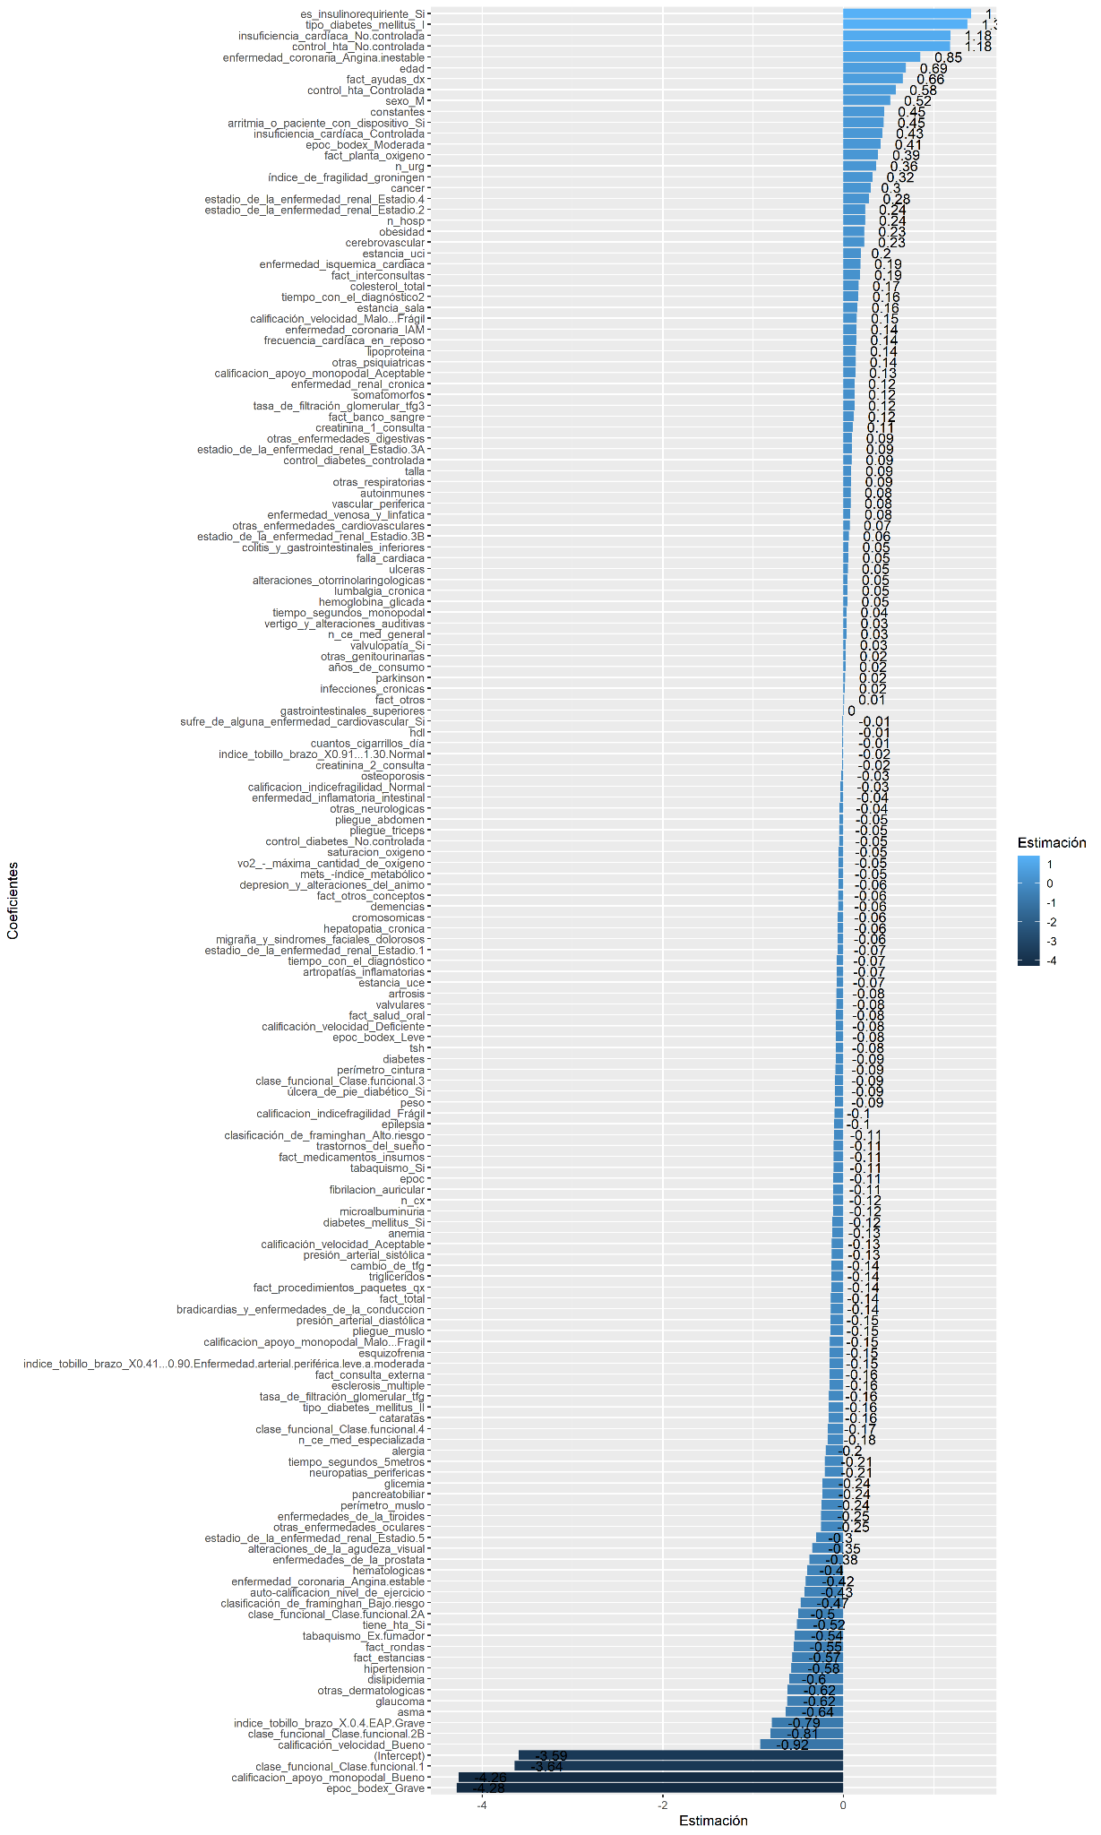

Supplementary Figure 2. Importance of Mortality Prediction Model Variables with XGBoost

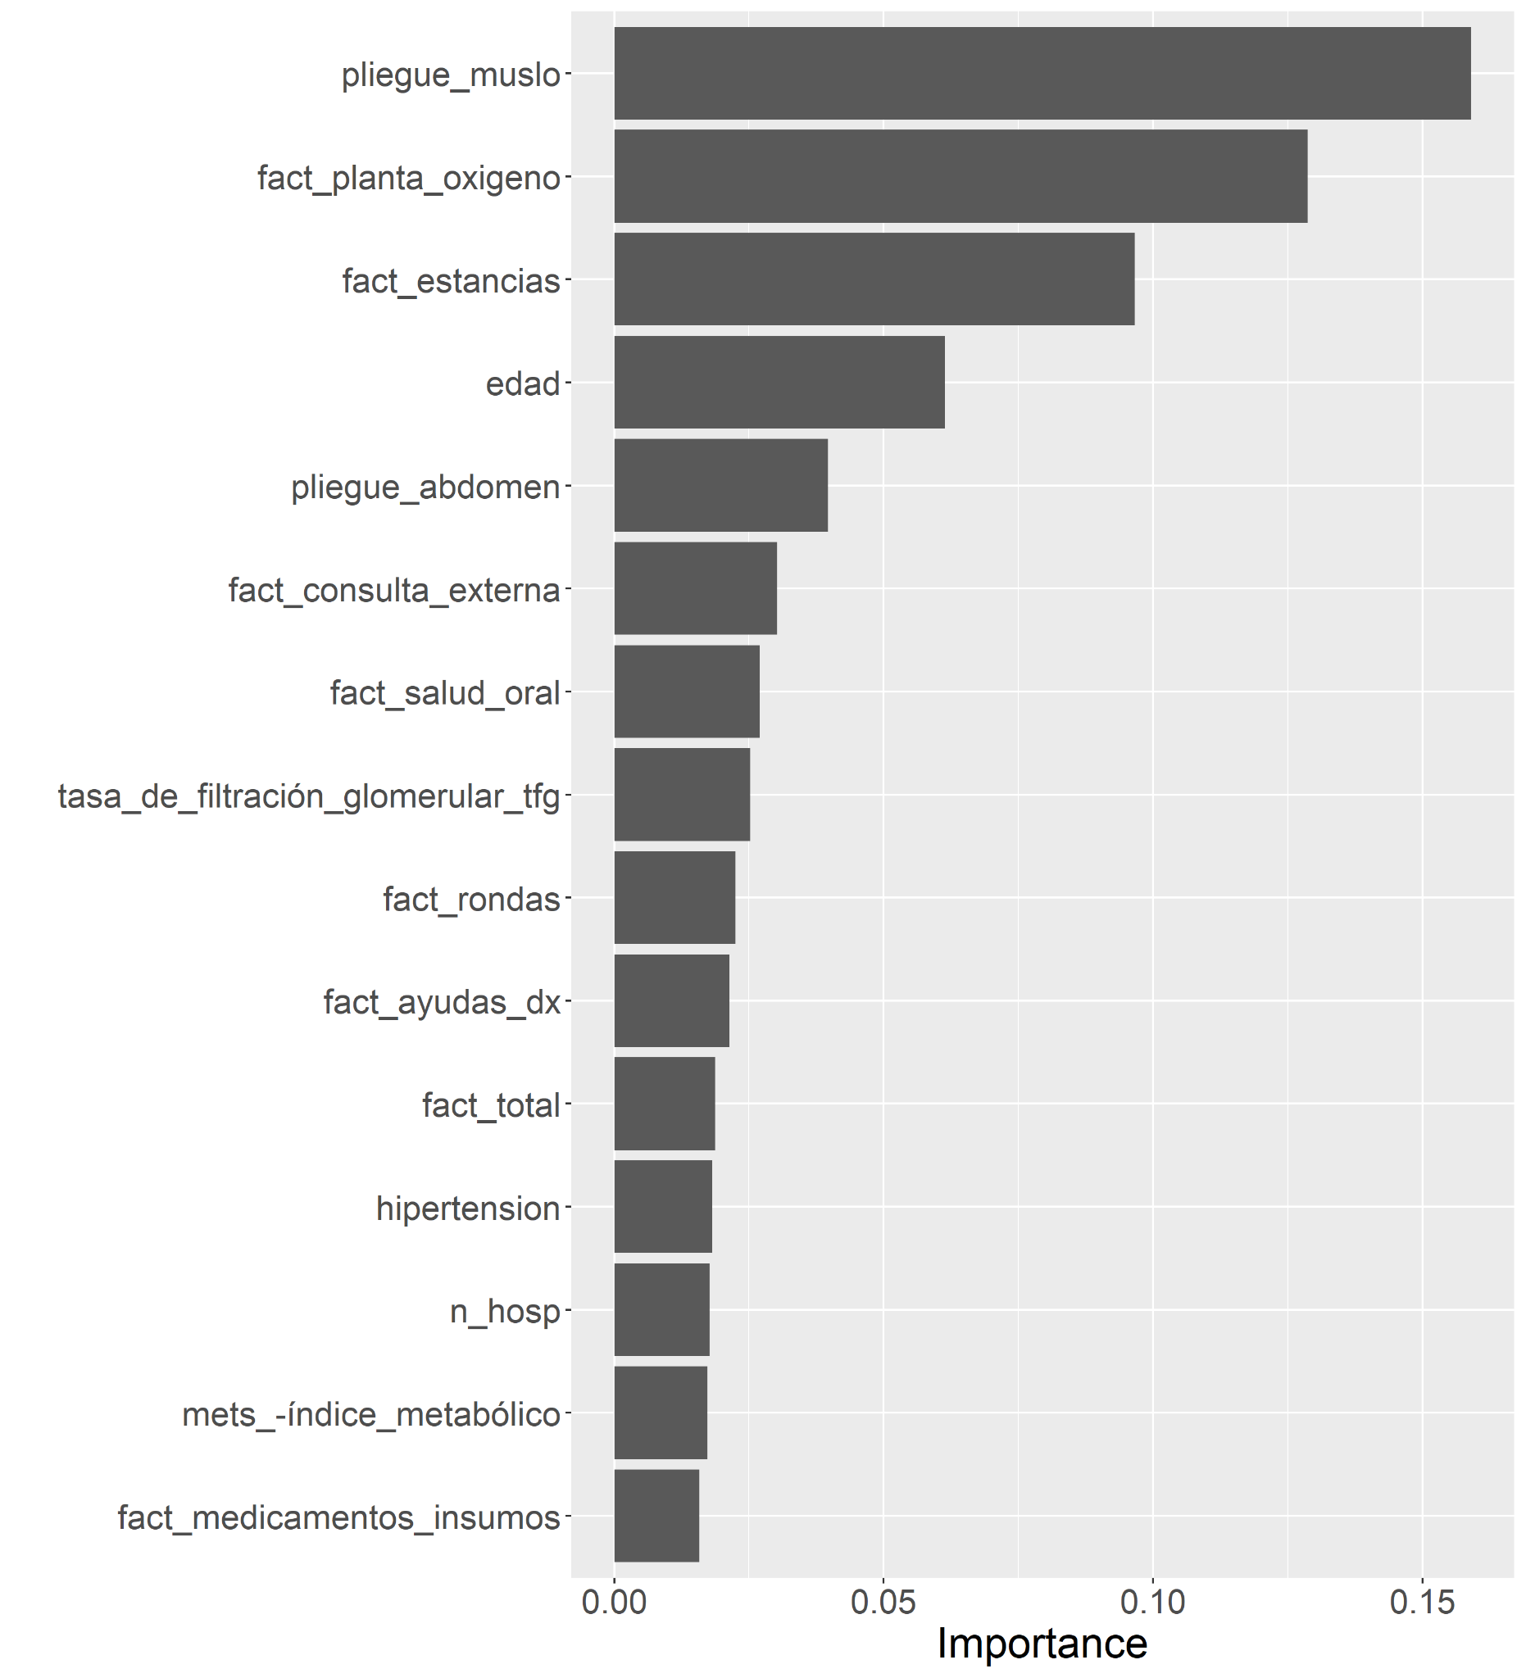

Figure 9. Importance of Variables in the Hospitalization Prediction Model with Elastic-net

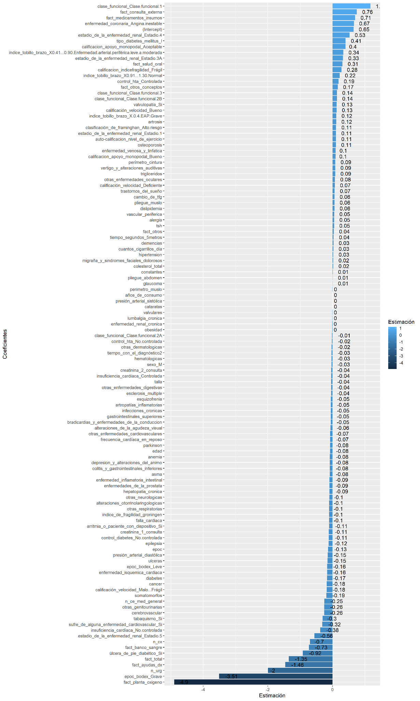
Supplementary Figure 3. Importance of the variables of the hospitalization prediction model with XGBoost

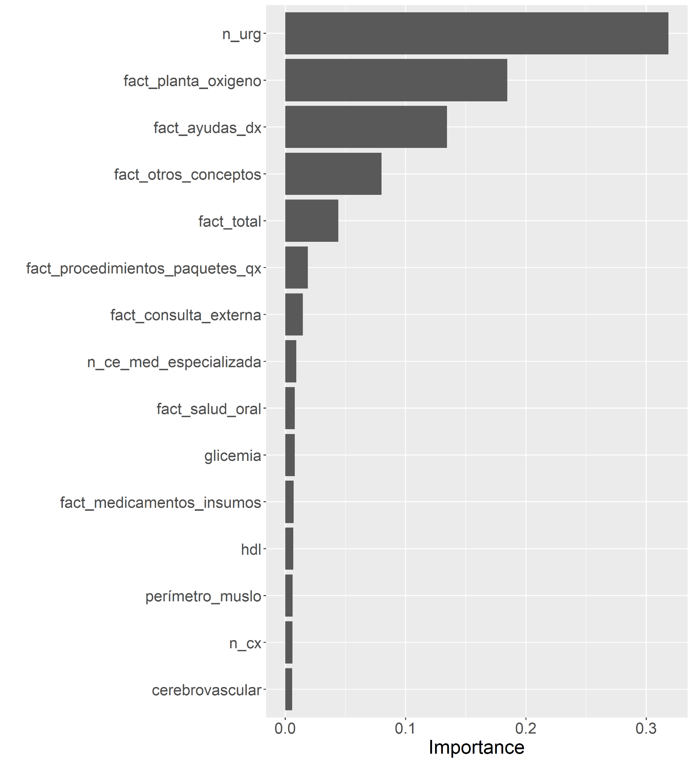

Supplementary Figure 4. Importance of the variables of the prediction model for emergency consultations with Elastic-net.
Supplementary Figure 5. Importance of the variables of the prediction model for emergency room visits with XGBoost.

Supplementary Figure 6. Calibration plots of Elastic Net and XGBoost models for Hospitalization, Mortality and Emergency Room Consultation outcomes.

- Hospitalization Elastic net and XGBoost

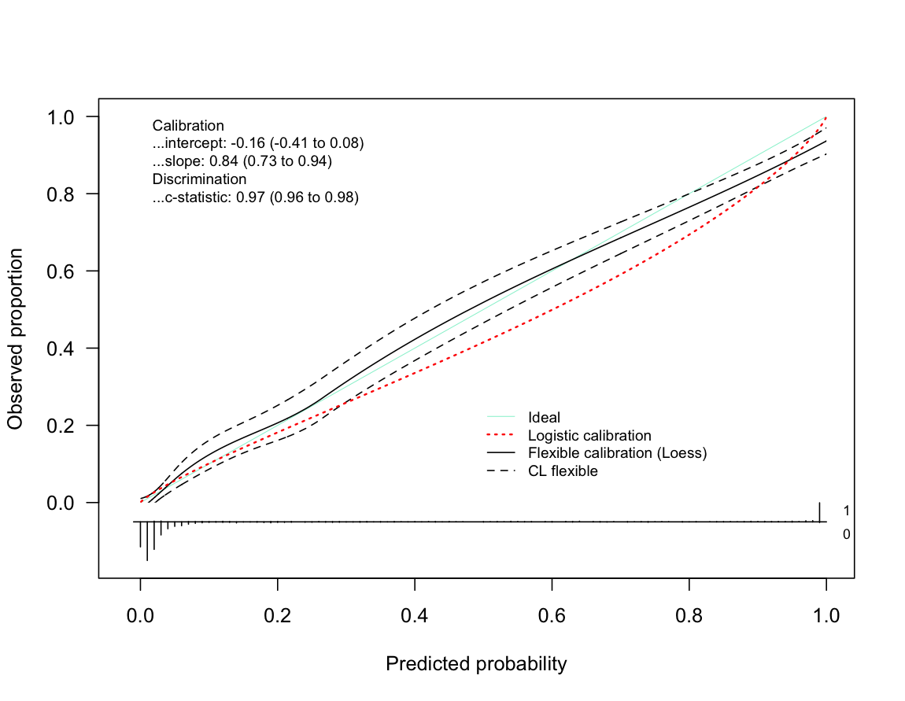

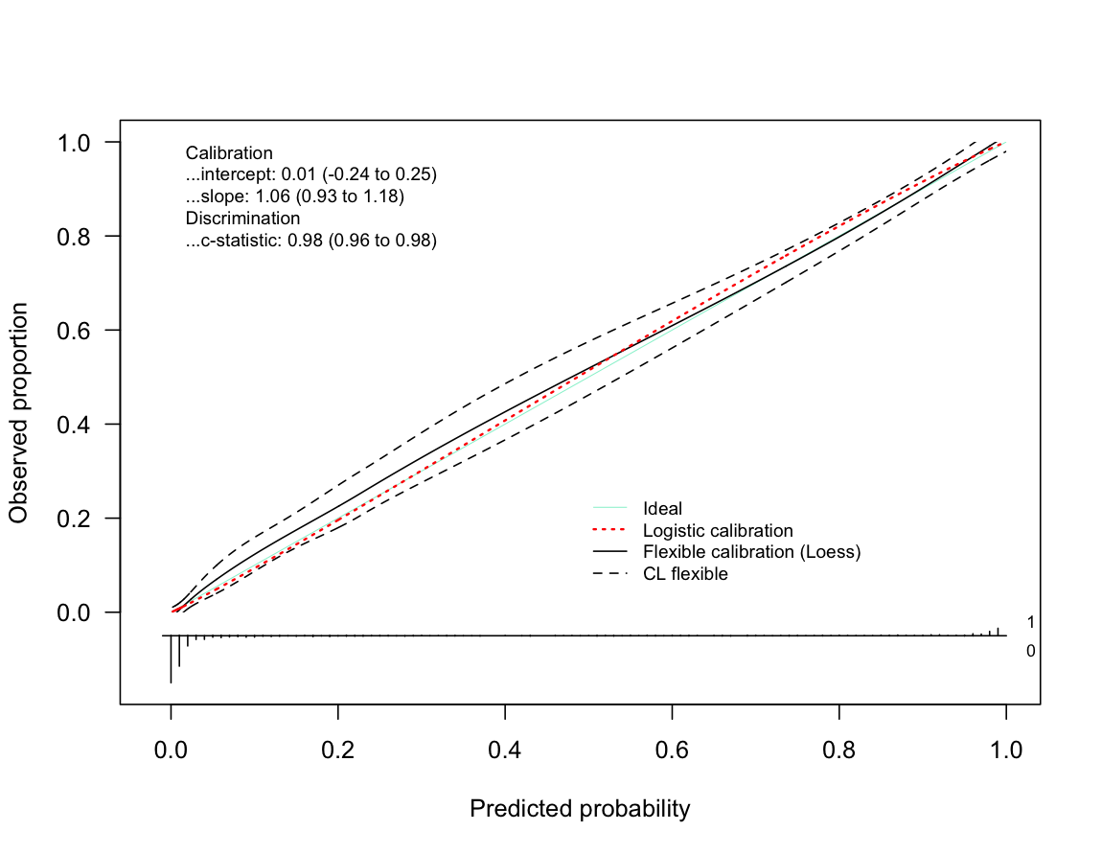

- Mortality Elastic net and XGBoost
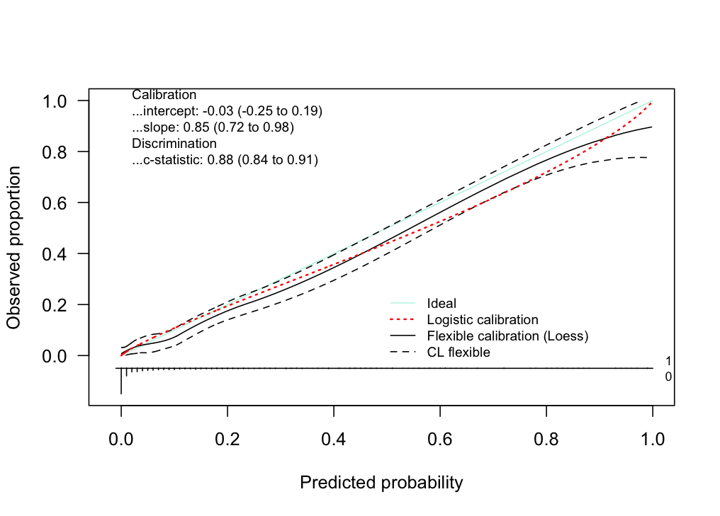

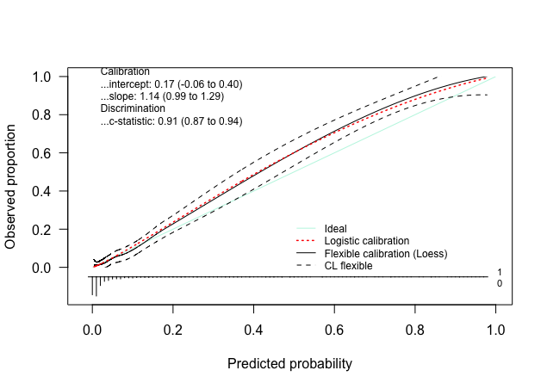

- Emeregency room Elastic net and XGBoost
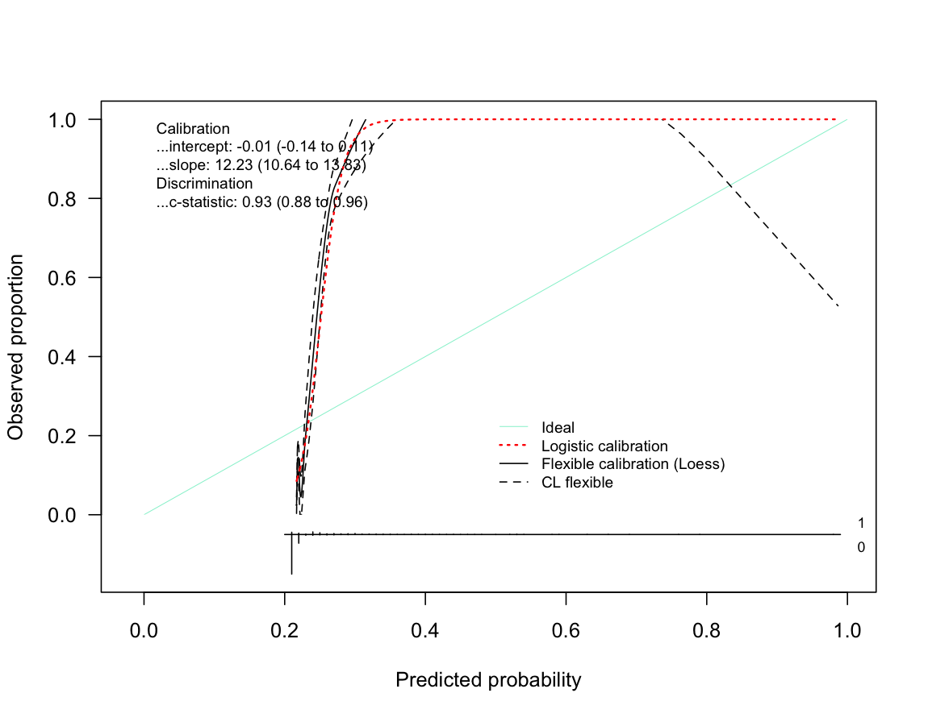

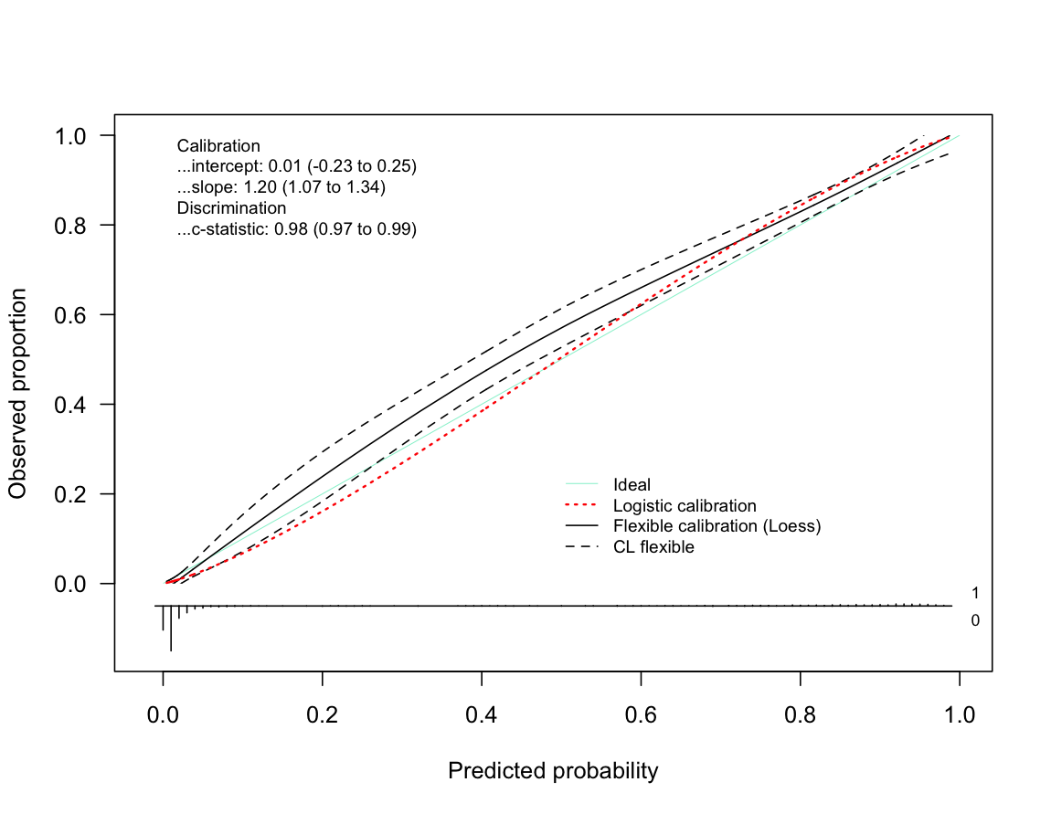

The calibration curves of the Elastic Net and XGBoost models are shown for the outcomes of (A) Hospitalization, (B) Mortality and (C) Emergency Room Consultation with 95% CI for intercept and slope. The graph also shows the values from C to statistic for the Elastic Net (1, 3, and 5) and XGBoost (2, 4, and 6) models along with their respective 95% confidence intervals.

