Annexures:
Annexure 1: The 2010 American College of Rheumatology/European League Against Rheumatism Classification Criteria for Rheumatoid Arthritis

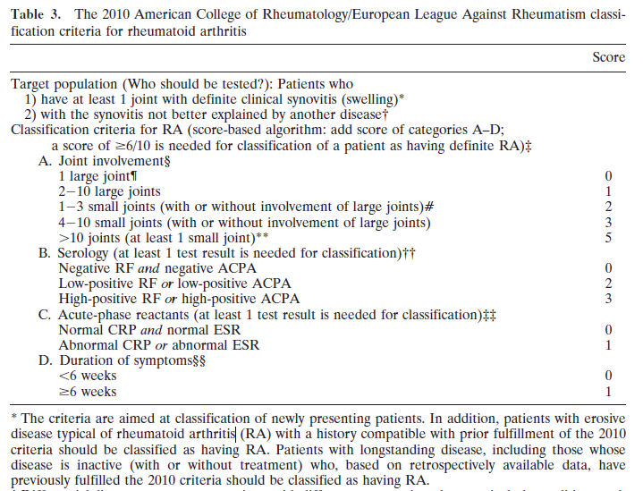

Annexure 2: Visual Analogue Scale for Assessment of Pain

No pain______________________________________________________________Very severe pain
How severe is your pain today? Place a vertical mark on the line above to indicate how bad you feel is your pain today.
The patient places a mark on the line to indicate his/her level of pain. The VAS score is determined by measuring in millimetres from the left hand end of the line to the point marked by the patient.

Annexure 3: Mannequin for Recording Tender and Swollen Joints

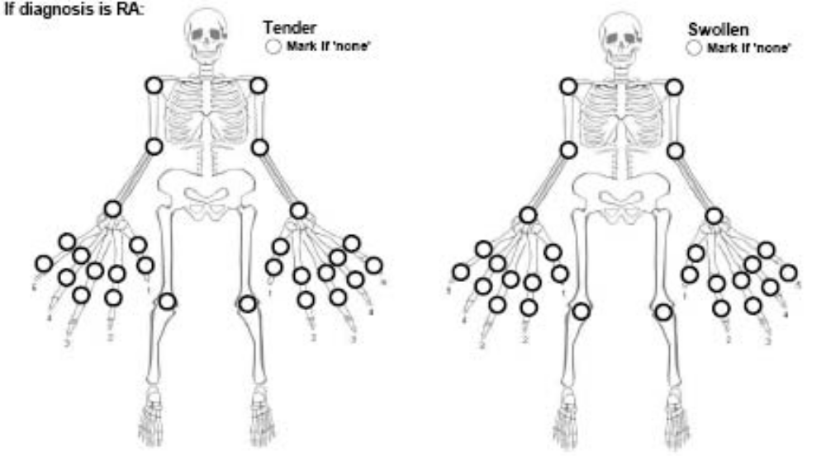

Annexure 4: Disease Activity Score in 28 Joints (DAS 28)

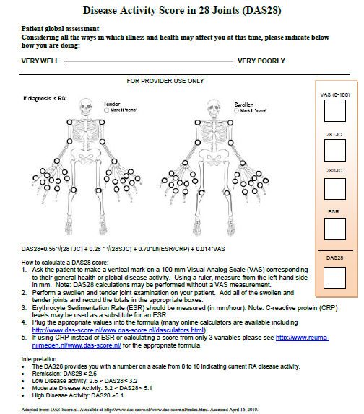

Annexure 5: Radiological Score

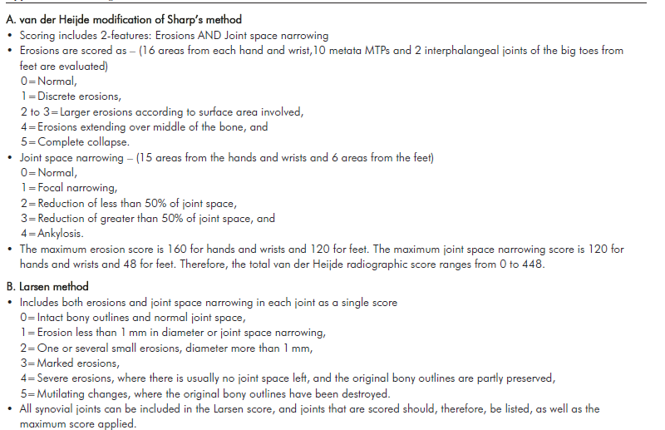

Annexure 6: The Indian HAQ

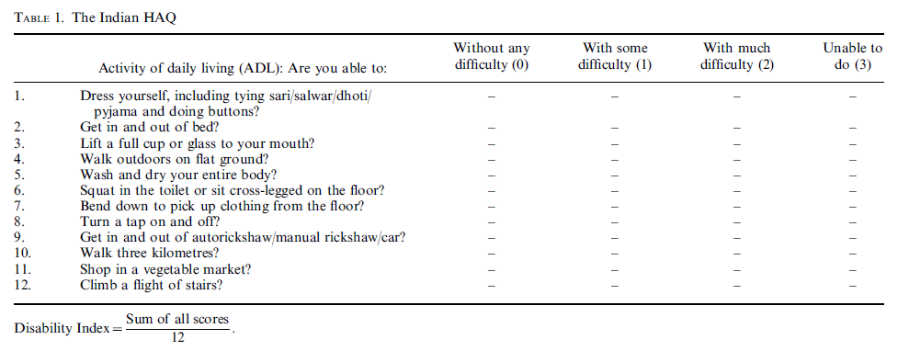

Annexure 7: EULAR Criteria for Improvement in Disease Activity

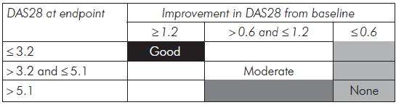

Annexure 8: Proforma
DEPARTMENT OF GERIATRIC MEDICINE
ALL INDIA INSTITUTE OF MEDICAL SCIENCES, NEW DELHI

Patient details
Date- CR NO- UHID.NO Mobile no-
Name :
Age: Sex:
Address:

Income:
Education status: 1.Illiterate 2.Primary 3.Undergraduate4. Graduate5. Post graduate
Marital status: 1.Married 2. Single 3. Divorced4.Widowed
Living arrangement:
Height weight BMI
CLINICAL EVALUATION :
Chief complaints-

Other complaints- Loss of weight, Fever, Myalgia, Fatigue, Lymphadenopathy, Neuropathy, Rheumatoid nodules, Splenomegaly, PMR-like symptoms

PERSONAL HISTORY:
Alcohol:
Smoking:no. Of cigrattes /day duration pack years
Tobacco:

Reproductive and breastfeeding history-
Oral contraceptives (OC)-
Hormone replacementtherapy (HRT)-
Live birth history-
Breastfeeding-
Menstrual history

PAST HISTORY-

OTHERCOMORBIDITIES AND JOINT DEFORMITIES-secondarySjogren’s syndrome, Interstitial lung disease, pericarditis, cardiomyopathies, CAD, valvular disease, pulmonary nodule, anemia, felty syndrome, vasculitis, osteoporosis, oral, ocular, renal, skin, endocrine, Malignancy, Swan-neck, Ulnar deviation, Boutonniere,etc

Family history:

COMPREHENSIVE GERIATRIC ASSESSMENT(CGA):
HMSE-

Medication history-
GENERAL PHYSICAL EXAMINATION:
Pulse: raterhythmbrachiofemoral delay
Blood pressure:
Resp rate:
Temperature:
Pallor/icterus/cyanosis/clubbing/pedal oedema/jvp

SYSTEMIC EXAMINATION:

MUSCULOSKELETAL SYSTEM:

TYPES OF JOINT INVOLVEMENT/DEFORMITY:

No. JOINT INVOLVEMENT-

TENDER JOINT COUNT (TJC)-

SWOLLEN JOINT COUNT (SJC)-

VISUAL ANALOG SCALE (VAS) –

DISEASE ACTIVITY SCORE (DAS 28)-
SUBCUTANEOUS NODULE-
HEALTH ASSESSMENT QUESTIONNAIRE DISABILITY INDEX (HAQ DI)-
CARDIOVASCULAR SYSTEM:

RESPIRATORY SYSTEM:

PER ABDOMEN:
CNS:
INVESTIGATIONS:
Haemoglobin
ESR/CRP:
RF
ACCP
Plain radiographs of joints involved and both hands (AP view)-
Serum 14-3-3η
RFT
LFT
PFT
2DECHO

Annexure 9: Patient Information Sheet

STUDY TITLE : STUDYOF RHEUMATOID ARTHRITIS IN OLDER PATIENTS
Investigator:

- Ramesh kumar sah, MD, Department of Geriatric Medicine, AIIMS
- Dr. A B Dey, Professor and Head Dept. of Geriatric Medicine.
- Dr. S. N. Dwivedi, Professor, Department of Biostatistics, AIIMS
- Dr. Uma Kumar, Professor, Department of Medicine, AIIMS
- Dr. C J Das, Associate Professor, Department of Radiology, AIIMS
- Dr. Prashun Chatterjee, Assistant Professor, Department of Geriatric Medicine,
- Dr. Avinash Chakrawarty, Assistant Professor, Department of Geriatric Medicine

Purpose and aim of study: To study the spectrum of Rheumatoid Arthritis in older patients with special emphasis on clinical, radiological, immunological profile, disease severity and disability and to study the diagnostic utility of a serum 14-3-3ηas a marker in RA compared to standard clinical and serological measures.
Method of study:
If you are willing to participate in the study, we will take detailed history, clinical evaluation, followed by Investigations with Disease activity score calculation and disability evaluation.
Duration of Study: Single time study
Benefits by participating in the study
All elderly patients with polyarthritis of both gender, by participating in the study, will be benefited by getting screened and diagnosed for Rheumatoid Arthritis, a chronic destructive inflammatory arthritis causing progressive disability, among all other type of polyarthritis, using various clinical, radiological and immunological profile.
Further, among all diagnosed case of Rheumatoid Arthritis, its activity, severity and disability parameters will also be studied. So that appropriate treatment will be established to reduce progression and improve physical functions and quality of life.
Potential risks/harm of participating in the study:
There is no harm or risk involved to the patients participating in the study.
Right to participate or withdraw from the study:
You are free to participate and withdraw from the research at any time. There will be no penalties or any loss in the benefits to which you would be otherwise entitled once you withdraw.
Confidentiality:
All the information that you provide during the study will be kept confidential and will be utilized only for study purposes.
The Tests:
You will be subjected to routine hematological, biochemical and imaging procedure which will help in the diagnosis of RA.
Cost: Free
The translation that has been made to Hindi is accurate.

Contacts:

Investigator:
Dr. A B Dey, Professor,
Department ofGeriatric Medicine,
AIIMS, New Delhi-29
Phone- 09868397241

Annexure 10: Participant / LAR Informed Consent Form (PICF)

Participant identification number for this trial: _______________________
Title of project: STUDY OF RHEUMATOID ARTHRITIS IN OLDER PATIENTS

Name of Principal Investigator:
Dr. A B Dey, Professor,
Department ofGeriatric Medicine,AIIMS, New Delhi-29
Phone- 09868397241

The contents of the information sheet dated ……………….. that was provided have been read carefully by me / explained in detail to me, in a language that I comprehend, and I have fully understood the contents. I confirm that I have had the opportunity to ask questions.
The nature and purpose of the study and its potential risks / benefits and expected duration of the study, and other relevant details of the study have been explained to me in detail.I understand that my participation is voluntary and that I am free to withdraw at any time, without giving any reason, without my medical care or legal right being affected.
I understand that the information collected about my ward from his/her participation in this research and sections of any of his medical notes may be looked at by responsible individuals from AIIMS.I, on behalf of my ward, give permission for these individuals to have access to his/her records.

I, on behalf of my ward, agree to take part in the above study.
--------------------------------------------- Date:
(Signatures / Left Thumb Impression) of the LAR Place:

Name of the Participant: ____________________________________
Son / Daughter / Spouse of:__________________________________
Complete postal address: _____________________________________

Name of the LAR:
Relation with the participant:

This is to certify that the above consent has been obtained in my presence.
------------------------------
Signatures of the Principal Investigator
Date:
Place:

1)Witness – 1 2) Witness – 2

Signatures Signatures
Name: Name:
Address: Address:

Annexure 11: Indo-US Cross National Dementia Epidemiology Study

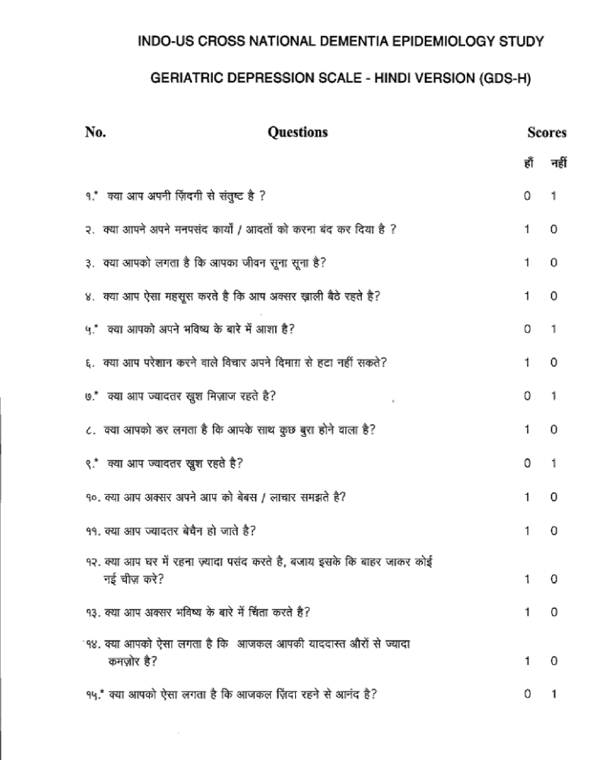

Annexure 12: ADL (Barthel)

Total score: ____/20
 | 0 | 1 | 2 | 3
Bowels | Incontinent | Occasional leaks (1/week) | Continent
Bladder | Incontinent/ catheterized | Occasional leaks (1/week) | Continent
Grooming | Needs help | Independent
Toilet use | Dependent | Needs help | Independent
Feeding | Dependent | Needs help | Independent
Dressing | Dependent | Needs help | Independent
Transfer (bed-chair-bed) | Unable | Major help by 1-2 people | Minor help verbal or physical | Independent
Mobility | Immobile | Wheel chair-independent | Walks with help of a person | Independent (may use aid)
Stairs | Unable | Needs help | Independent
Bathing | Unable | Independent

Annexure 13: Instrumental ADL (IADL)

Total score: ____/8
Can you use the telephone? | Yes | No
Can you prepare meals? | Yes | No
Can you go to the market and do shopping? | Yes | No
Can you clean your home? | Yes | No
Can you wash your clothes? | Yes | No
Can you take your medicines? | Yes | No
Can you keep accounts and manage your money? | Yes | No
Can you use public transport? | Yes | No

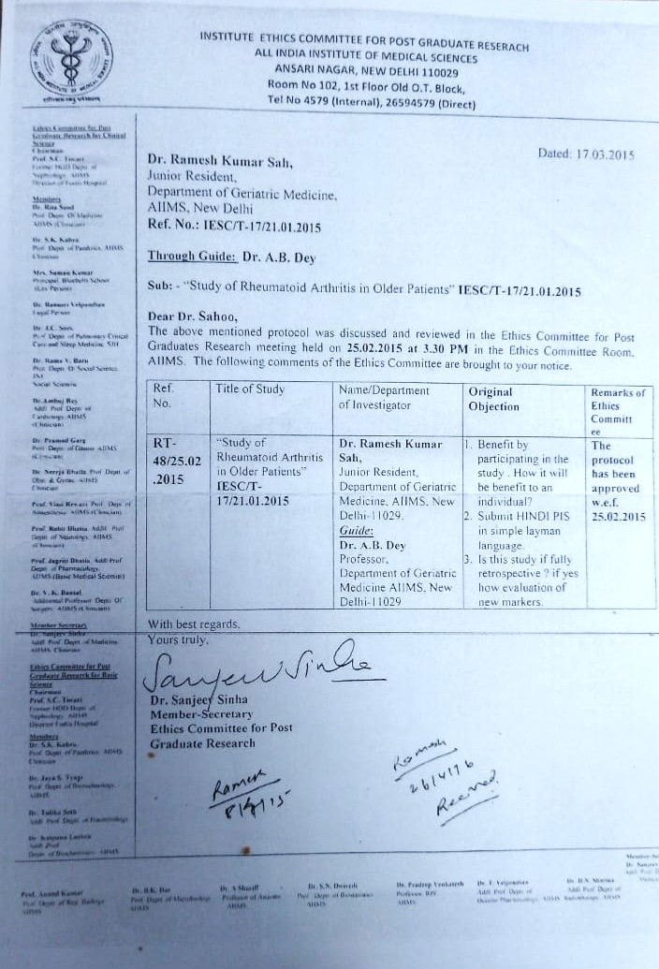

ABBREVIATIONS

RA Rheumatoid Arthritis
EORA ElderlyOnset Rheumatoid Arthritis
LORA Late Onset Rheumatoid Arthritis
YORA Younger Onset Rheumatoid Arthritis
IRA Indian Rheumatology Association
ACR American College of Rheumatology
EULAR European League Against Rheumatism
HRQOL Health-Related Quality of Life
PMR Polymyalgia Rheumatica
RF Rheumatoid Factor
ACPA Anti-Citrullinated Protein Antibody
ACCP Anti-Cyclic Citrullinated Peptide
TJC Tender Joint Count
SJC Swollen Joint Count
DAS Disease Activity Score
HAQ DI Health Assessment Questionnaire Disability Index
MAPK Mitogen-Activated Protein Kinase
SHS Sharp–van der Heijde scoring
SENS Simplified Erosion Narrowing Score
JSN Joint Space Narrowing
CGA Comprehensive Geriatric Assessment

*****

