Les Mills THRIVE


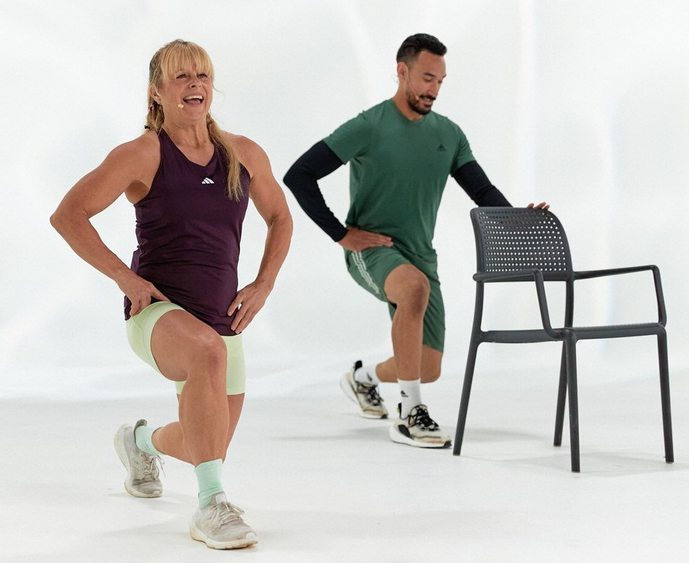
The exercise group in this study will attend a group exercise session at least twice weekly led by a Les Mills trained instructor for a 12-week period. The exercise sessions will consist of flexibility, strength and coordination exercises based on an adaptation of the NEMEX program for a group exercise environment (Skou & Roos, 2017). This program has been demonstrated to be safe and effective and has been shown to generate significant improvements in self-reported outcomes and functional tests in individuals with hip joint OA (Villadsen et al., 2014). These individuals will also be provided with a digital version of the class so they can complete additional exercise sessions at home and will be encouraged to do so once a week in addition to the live classes, or as a substitute if they are unable to attend a scheduled workout.

The classes will be run in group fitness studios in the participating YMCA in the USA and the University of the Fraser Valley (Chilliwack campus, Chilliwack, BC, Canada). In each class, the instructor will provide options to either increase or decrease the intensity, as well as cues that will help participants gauge whether they should be increasing or decreasing the intensity of each exercise.

WORKOUT STRUCTURE
Tracks | Exercises | Duration | Progression
 |  |  | Low | Intermediate | High
Warm Up | Squats | 5 minutes | Chair Support | Body weight
 | Marches / Treading
 | Lunges
 | Side stepping
Squats | Squats (Mid Stance) | 5 minutes | Chair support | Body weight | weight plate
 | Wide Squats
 | Cal Raises
Integrated Core | Side lunges | 5 minutes | Chair Support | Body weight | Weight Plates or Resistance band
 | Woodchops
 | Waiters bow
 | Weighted rows
Standing Hip | Hip abduction | 5 minutes | Chair Support | Body weight | Weight Plate or Resistance Band
 | Hip extension
 | Single Leg deadlift
 | Single Leg Balance
Lunge | Stationary Lunges | 5 minutes | Chair Support | Body weight | Weight Plate
 | Back Stepping Lunges
Lying Hip | Bridges | 5 minutes | Standing Chair Option | Short Lever | Long Lever
 | Hip abductions
 | Clams
Lying Core | Crunches | 5 minutes | Standing Chair Option | Short Lever | Long Lever
 | Lower Abdominal Hip and Knee Extension
 | Hovers
 | Planks
Flexibility | Glute | 5 minutes | Standing Chair Option
 | Hamstring
 | Hip flexors
 | Quads
 | Calf

References
Skou, S. T., & Roos, E. M. (2017). Good Life with osteoArthritis in Denmark (GLA:D): evidence-based education and supervised neuromuscular exercise delivered by certified physiotherapists nationwide. BMC Musculoskelet Disord, 18(1), 72. https://doi.org/10.1186/s12891-017-1439-y
Villadsen, A., Overgaard, S., Holsgaard-Larsen, A., Christensen, R., & Roos, E. M. (2014). Immediate efficacy of neuromuscular exercise in patients with severe osteoarthritis of the hip or knee: a secondary analysis from a randomized controlled trial. J Rheumatol, 41(7), 1385-1394. doi:10.3899/jrheum.130642

