SUPPLEMENTARY APPENDIX
Supplement to Antonio Ceriello et al. Management of Subjects with Type 2 Diabetes Hospitalized in Internal Medicine Units: A Cluster-Randomized, Multicenter Study Before & After an Educational Program

Figure S1. Flow chart of the study.

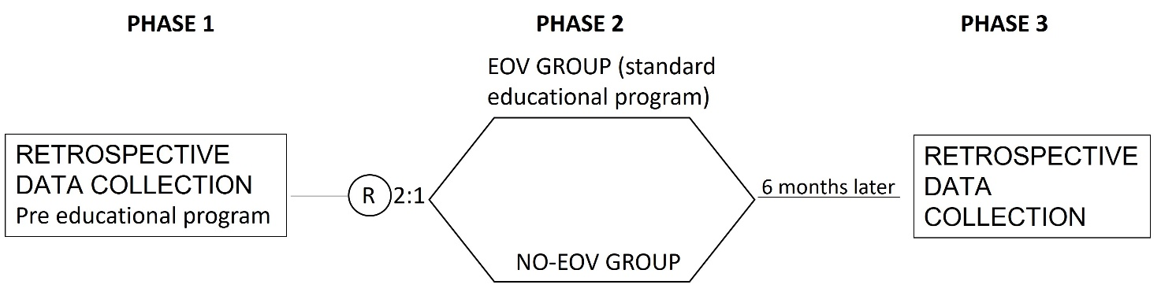

Figure S2. Results of the satisfaction questionnaire regarding the educational intervention completed by the participants.
