Table 2. Correlations between histopathologic findings, GDF15+ vs. GDF15-, and strong HSP60 vs. weak HSP60 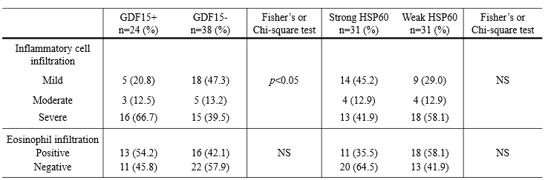
n: number of patients; HSP60: Heat shock protein 60; GDF15: growth differentiation factor 15; NS: not significant

