Table 1. Correlations between selected data and fibrosis, GDF15+ vs. GDF15-, and strong HSP60 vs. weak HSP60
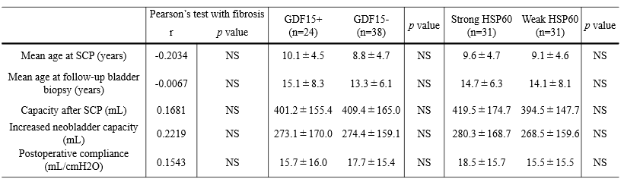
n: number of patients; r: correlation coefficient; HSP60: heat shock protein 60; SCP: sigmoidocolocystoplasty; GDF15: growth differentiation factor 15; NS: not significant

