SUPPLEMENTAL FIGURES

Figure S1. E9.5 embryo scRNA-seq data quality control. The merged dataset from the two technical replicates was analysed. Graphical illustration of the relationship between the number of features (genes) and the counts (expression levels) in individual cells before (a) and after (b) setting up a 7,500 gene-per-cell cutoff. Red lines mark the threshold used in each case. After setting up distinct cutoffs, graphs illustrate the number of genes, reads, and the percentage of mitochondrial and ribosomal gene expression in each case.

Figure S2. ScRNA-seq analysis of the E9.5 posterior cardiac inflow region. (a) UMAP plot of all cells that passed quality controls (n=13,479) computed by highly variable genes. Cells with similar transcriptional profiles were clustered into 13 groups, as indicated by the colour code. (b) Dot plot showing the expression of well-characterised marker genes. Proepicardial classical genes are enclosed in the black rectangle. STMI and PE clusters appears in bold. Abbreviations: CM, cardiomyocytes; EGT, endodermal gut tube; EC, endothelial cell; HB, hematoblasts; HEP, hepatoblasts; HEPM; hepatomesenchymal cells; JCF, juxta cardiac field; PE, proepicardial cells; SHF, second heart field; LPM, lateral plate mesodermal cells; STM, septum transversum mesenchymal cell.

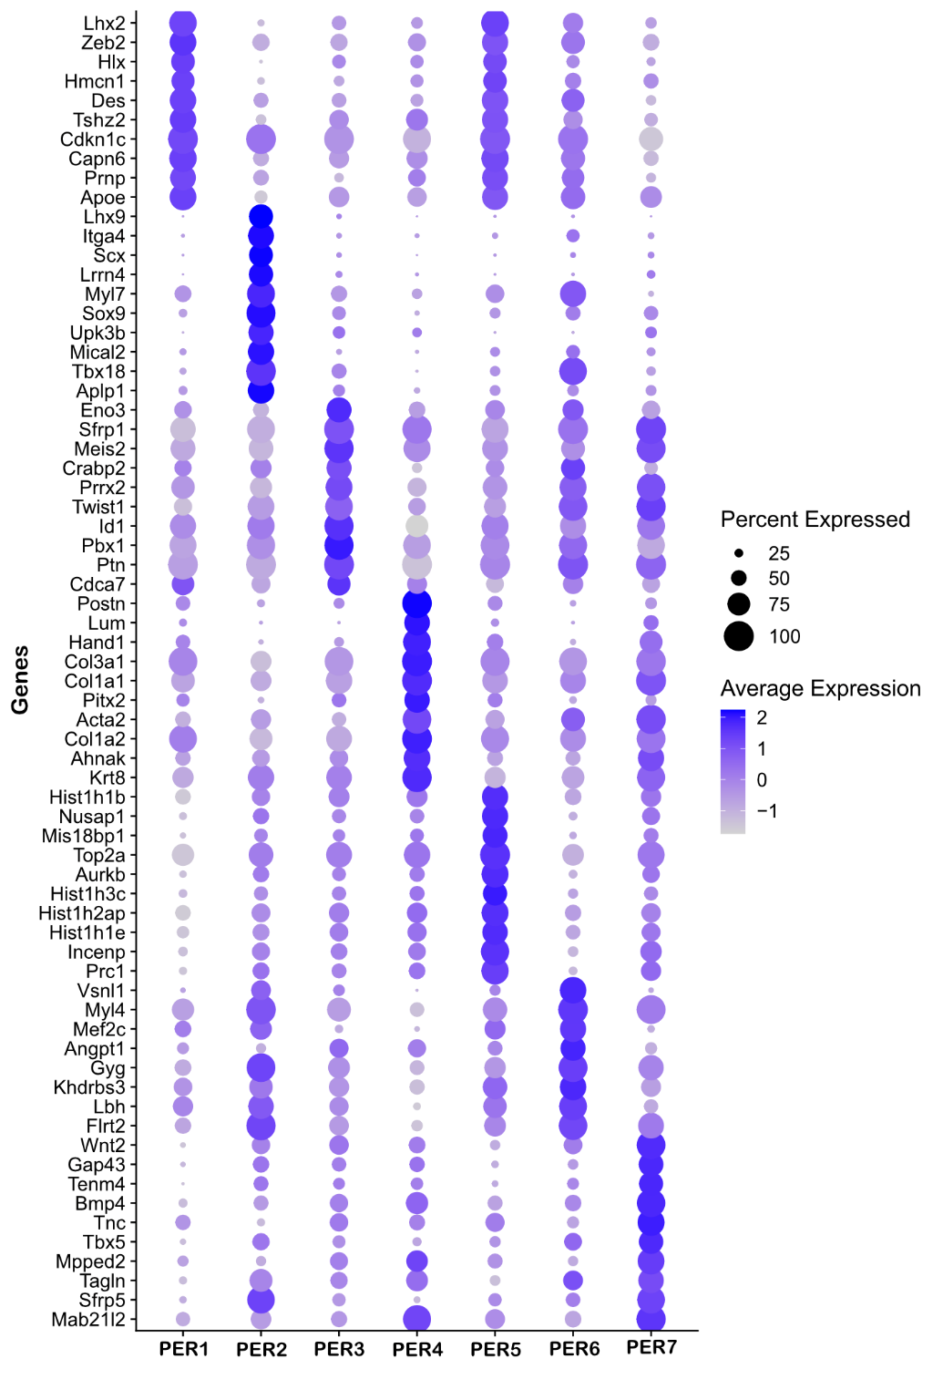
Figure S3. Gene expression analysis in PER clusters. The dot plot displays the top 5 differentially expressed genes in the PER clusters.

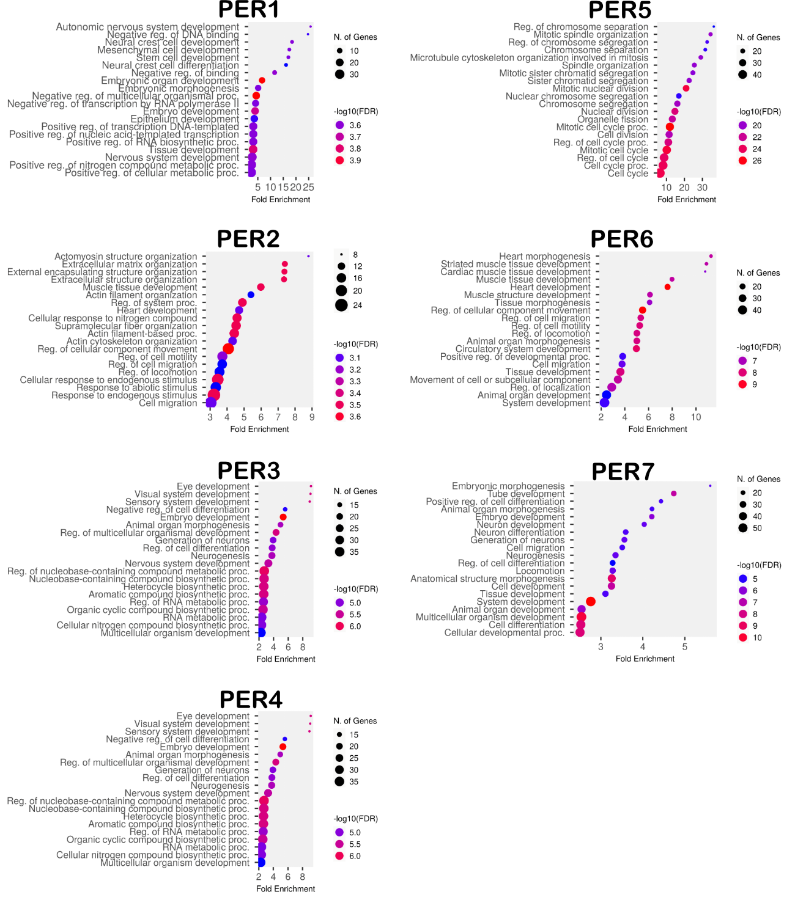
Figure S4. GO term analysis of the PER clusters. Top GO biological process terms for each PER cluster.

Figure S5. Tissue characterisation of E9.5 PER clusters. Expression of Wt1/Tcf21 (mRNA; a-a’’), SOX9 (protein; b-b’’), TBX5 (protein; c-c’’) and Postn (mRNA; d-d’’). Dapi (blue) was used to counterstain cell nuclei. Scale bars: 100 µm (a-d) and 25 µm (a’-a’’, b’-b’’, c’-c’’, d’-d’’).

Figure S6. Characterisation of PE-like cells in cardiac gastruloids. (a) Summary of the protocol for cardiac gastruloids formation: 400 R1 embryonic stem cells are aggregated in embryoid bodies in medium containing N2B27. After 2 days, gastrulation is induced by adding CHIR99021 and, after 4 days, cardiogenic differentiation is induced by adding a cocktail of FGF2, VEGF, and ascorbic acid (N2B27⁺⁺⁺). Cardiac gastruloids were cultured in 3 independent experiments. (b) Quantification of the number of gastruloids with beating domains (each dot represents an independent experiment and more than 20 gastruloids were counted in each of them). (c) qPCR Expression of Mesp1, Tnnt2, Wt1 by qPCR (graphs represent each of 3 independent experiments). Relative gene expression (N0) was normalised with Tbp as the reference gene. Representative images of cardiac gastruloids (i) (arrows mark beating tissues). (e-g) Wt1/Itga4 mRNA expression in gastruloids after 10 days of culture. Immunohistochemistry and RNA ISH were performed in at least 3 embryos from 3 different litters for each developmental stage. Three independent cardiac gastruloid culture experiments were run in 3 independent experiments. Scale bars: 250 µm (i), 50 µm (j), 25 µm (f-f’’) and 10 µm (g).

Figure S7. Characterisation of primitive epicardial epithelial and mesenchymal epicardial-derived cells. (a-a’’) Wt1/Itga4 RNA ISH in E12.5 heart tissue sections. Arrows mark an intramyocardial Wt1⁺ cell and arrowheads mark an intramyocardial Wt1⁺/Itga4⁺ cell. Scale bars: 15 µm.

Figure S8. Setting up a 4-hydroxytamoxifen (4OHT) induction protocol. Pregnant Wt1-Cre^{ERT2};R26R-EYFP females were subject to a single intraperitoneal administration of 4OHT. YFP⁺ cell clusters were examined in E15.5 hearts following the administration at E8.75 stage of either vehicle (a), 250 µg (b) or 1 mg (c) of 4OHT per mouse. Three independent experiments were performed per experimental condition. (d) Quantification of YFP⁺ cells in E9.5 and E12.5 embryos. n represents independent embryos (n= 7 for E9.5 and E12.5). Scale bars: 500 µm.

Figure S9. scRNA-seq analysis of E12.5 Wt1-lineage cells. (a) UMAP representation of 3,405 Wt1-Cre^{ERT2};TdTomato cells (E12.5 embryos). Recombination was induced at E9.5 and E10.5 (75 mg/kg 4OHT via oral gavage). The published scRNA-seq dataset²⁵ can be found in the Gene Expression Omnibus database under accession code “GSE154715”. (b) Gene expression of different epicardial (Wt1, Itga4), epithelial (Krt18, Krt19), EMT/mesenchymal-related (Pdpn, Snai2, Twist1) gene markers.

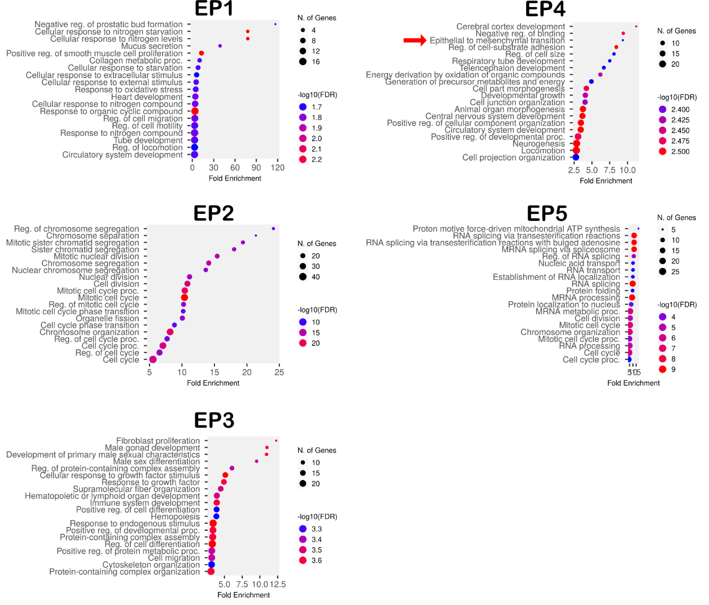
Figure S10. E12.5 EP cluster GO term analysis. Top GO biological process terms for each EP cluster.

Figure S11. Integration of E9.5-E12.5 PE/Epicardial/EPDC scRNA-seq datasets. (a) The PER2 cluster (true PE cells) from our scRNA-seq dataset and EP clusters from a published scRNA-seq dataset²⁵ were integrated using Harmony. (b) UMAP plot of the cells after integration shows 5 clusters. The proportion of PER2 cells in the clusters after integration is represented in c. (d) Expression of Wt1, Itga4, Krt19, Krt18 and Pdpn in the clusters after integration.

Fig. S12. Cell proliferation study through the proepicardium-epicardium-EPDCs developmental continuum. WT1 and EdU co-staining identifies proliferating PE (E9.5, a) and primitive epicardial cells (E10.5 in b, and E12.5 in c). TNNI staining was used to counterstain the myocardial layer. EdU was administered to pregnant females over a 2 h period. Additional WGA staining at E12.5 stage allows for the accurate distinction of the epicardial layer from the subepicardial mesenchyme. Dapi (blue) was used to counterstain cell nuclei. Quantification of proliferating PE/epicardial cells, subepicardial cells and intramyocardial WT1⁺ cells (WT1⁺/EdU⁺) from E9.5 to E18.5 (d). Standard deviations are represented as vertical bars. Embryos from at least 3 different litters were analysed: 11 embryos at E9.5, 7 embryos at E10.5 (around 200 counted cells/embryo), 9 embryos at E12.5 (around 200, 135 and 40 epicardial/subepicardial/myo-WT1⁺counted cells per embryo, 8 embryos at E15.5 (around 70, 75 and 300 epicardial/subepicardial/myo-WT1⁺counted cells per embryo), and 7 embryos at E18.5 (around 75, 30 and 500 counted epicardial/subepicardial/myo-WT1⁺ counted cells per embryo). Statistical significance was calculated using a T-test. Scale bars: 100 µm (a) and 25 µm (b, c).

Figure S13. Cell cycle arrest analysis. (a) EPIC were cultured under different nocodazole doses. (b) FACS analysis of propidium iodide (PI)-stained cells. (c) The minimal nocodazole concentration needed to arrest cells in G2/M was identified. (d) The reversibility of cell cycle arrest (nocodazole at 500 ng/mL) was checked. (e, f) Cell cycle arrest was evaluated in E11.5 hearts cultured ex vivo (24h) using PHH3 tissue immunostainings and PI flow cytometry (g). Dapi (blue) was used to counterstain cell nuclei. Graphs in b, c and f represent 3 independent experiments. Representative images of WT1 staining in E11.5 heart sections (h) and 24h-treated vehicle and nocodazole hearts (i, j, respectively). Statistical significance was calculated using a T-test. Scale bars: 25 µm (e, f) and 15 µm (h-j).

Figure S14. Differential analysis of signalling pathways in the PE and myocardium. (a) Dashed lines enclose the micro dissected tissues used for RNA-seq, (PE and cardiac ventricle). (b) Volcano plot representation of differentially expressed genes between the PE and heart (myocardial) samples. (c) KEGG pathway analysis. (d) Heatmap of Wnt related genes identified in our dataset. (e) Jun expression in 3 biological replicates of PE and heart samples. Statistical significance was calculated using a T-test (****p < 0.0001). Scale bars: 250 µm (a).

Figure S15. Characterisation of non-canonical Wnt signals in E10.5 hearts. (a) Expression of C-JUN (immunohistochemistry) and (b) and C-JUN⁺ cell quantification. (c, c’) Wt1 and Wnt5a expressing epicardial cells. (d, d’) Tcf21 and Ror2 expression in E10.5 heart sections. (e) Itga4⁺/Ror2⁺ cell quantification. Dapi (blue) was used to counterstain cell nuclei. n represents independent embryos (in b and e, n = 3). Scale bars: 25 µm.

Supplementary Table S1: qPCR primers
Gene | Forward | Reverse | Amplicon length
Wt1 | AAGGATACAGCACGGTCACT | TGAAGGAATGGTTGGGGAACT | 90
Tnnt2 | AGTTCAAGCAGCAGAAATACGA | TTCCCACGAGTTTTGGAGACTT | 82
Mesp1 | GTCTGCAGCGGGGTGTCGTG | CGGCGGCGTCCAGGTTTCTA | 189
Tbp | CCCCACAACTCTTCCATTCT | GCAGGAGTGATAGGGGTCAT | 103

