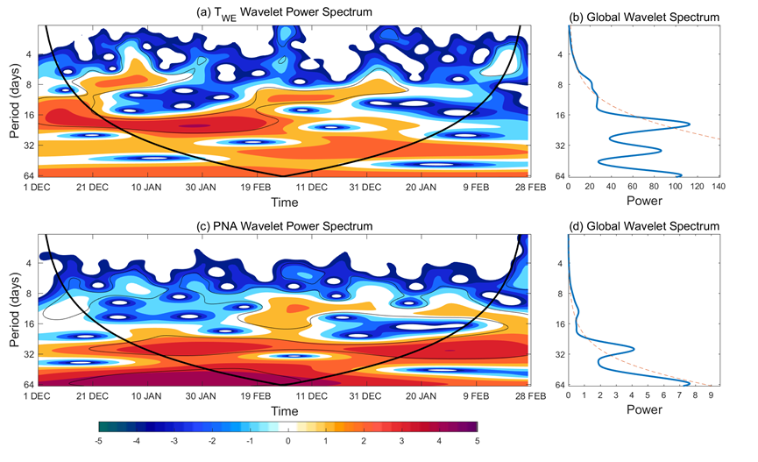
Figure S1. The local and global wavelet power spectrum of daily (a-b) T_{WE} and (c-d) PNA index from December 2013/February 2014 to December 2014/February 2015. The 90% confidence level against red noise for the global wavelet power spectrum is indicated by the dashed line.

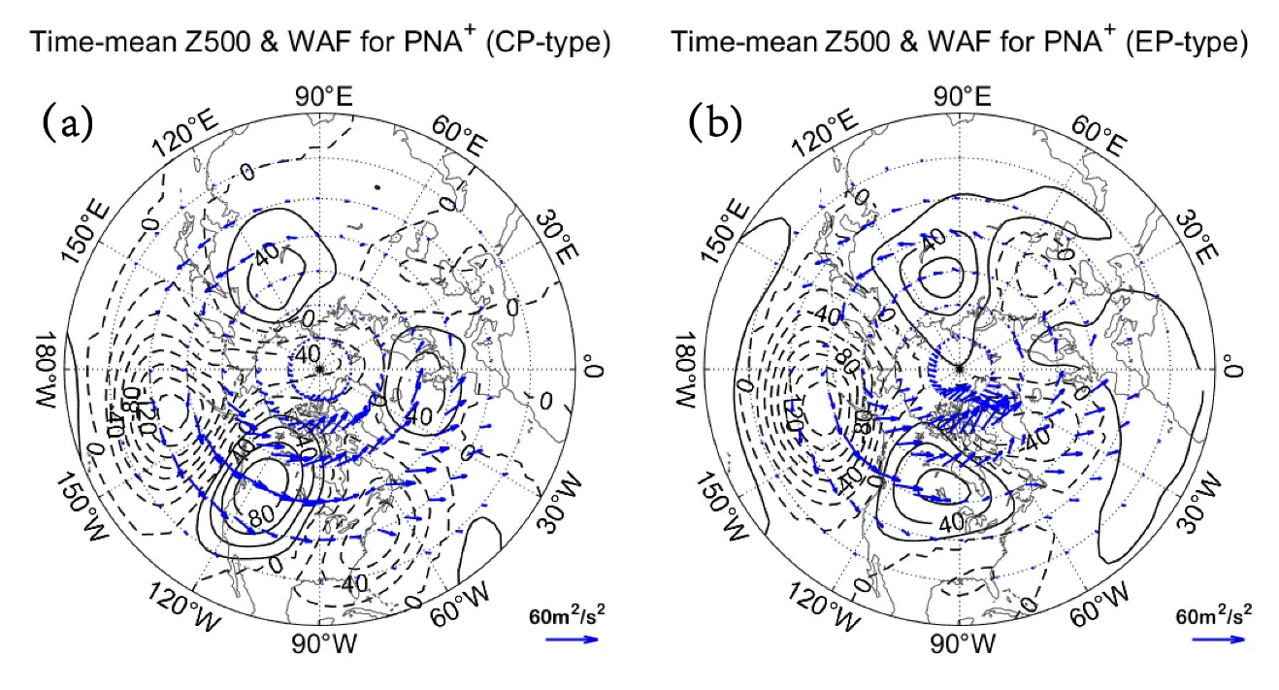
Figure S2. Time-mean fields of composite daily Z500 anomalies (contours, CI=20gpm) and horizontal wave activity flux (WAF) vector (arrows; units: m2/s2) based on Takaya and Nakamura (2001) averaged from lag-5 to 5 days of PNA⁺ events for (a) CP- and (b) EP-type El Niño winters.

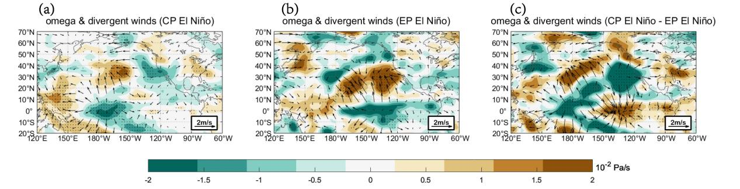
Figure S3. (a, b, c) Horizontal fields of composite DJF-mean 500hPa vertical velocity denoted by omega (color shading) superimposed by 200hPa divergent wind anomalies (arrows) for PNA events excluded (the days of the PNA event from lag -10 to 10 days are removed) during (a) CP-type, (b) EP-type El Niño winters and (c) the CP-type minus EP-type difference. The dot represents the region above the 95% confidence level based on a two-sided Student’s t-test.

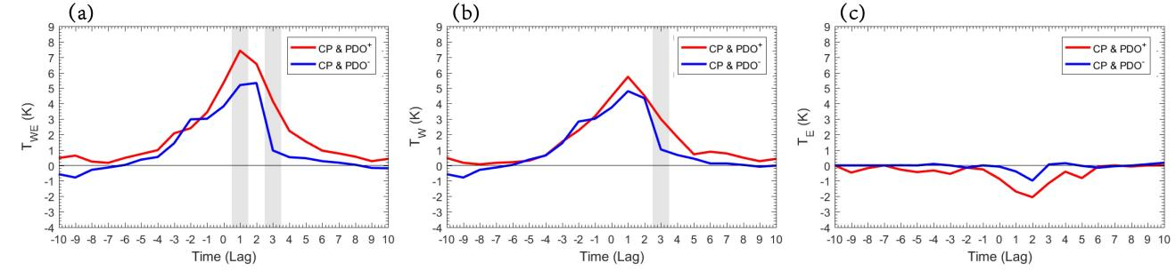
Figure S4. (a, b, c) Temporal variations of composite daily (a) T_{WE}=T_{W}-T_{E} (b) T_{W} (40°N-70°N, 130°W-100°W) (c) T_{E} (25°N-50°N, 95°W-65°W) from lag-10 to 10 days of PNA⁺ events for PDO⁺ and CP-type El Niño combination (red line) and PDO⁻ and CP-type El Niño combination (blue line). The gray shading denotes the difference between the two curves being significant above the 90% confidence level based on 5000 Monte Carlo simulations.

