Supplementary data
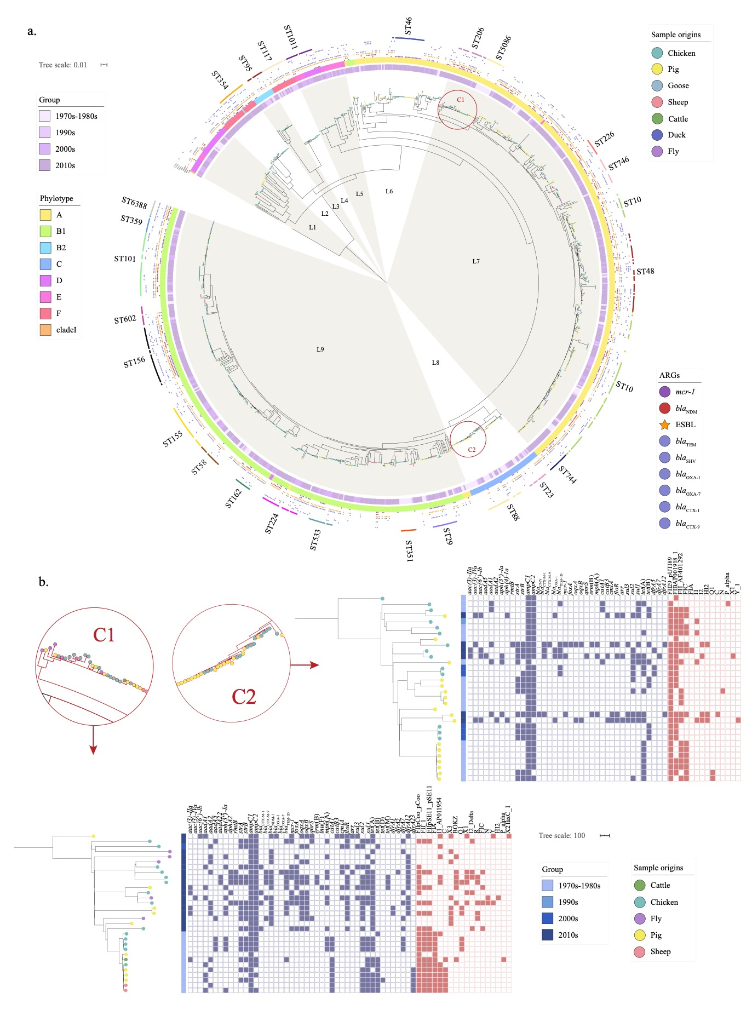
Fig. S1 a. Phylogenetic tree of 982 E. coli isolates from food-animal in China. The midpoint-rooted tree was constructed using n=50672 core-genome SNPs, and the tree along with all these metadata have been uploaded to microreact (https://microreact.org/project/9ozGFW62hE7LmgkVZ9Uouh/449bbe4b). b. Phylogenetic tree of the two clades C1 and C2 highlighted in Fig. 1a and annotated by host, time group and gene content. The tips are colored by the host. Columns are as follows: sampling time, and presence or absence of ARGs (blue) and plasmid replicons (red).
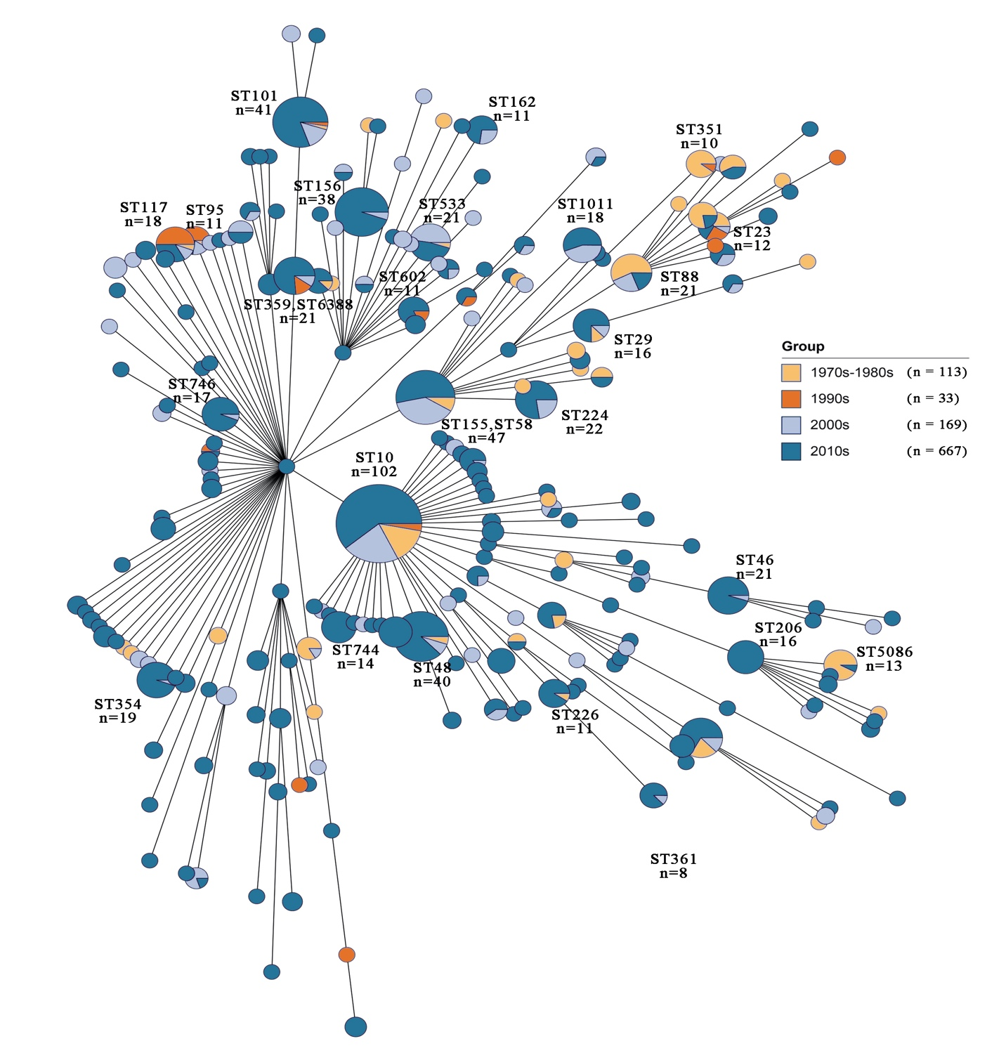
Fig. S2 Minimum spanning tree of the whole data set by multi-locus sequence typing. The time group of all isolates is indicated by different colors.
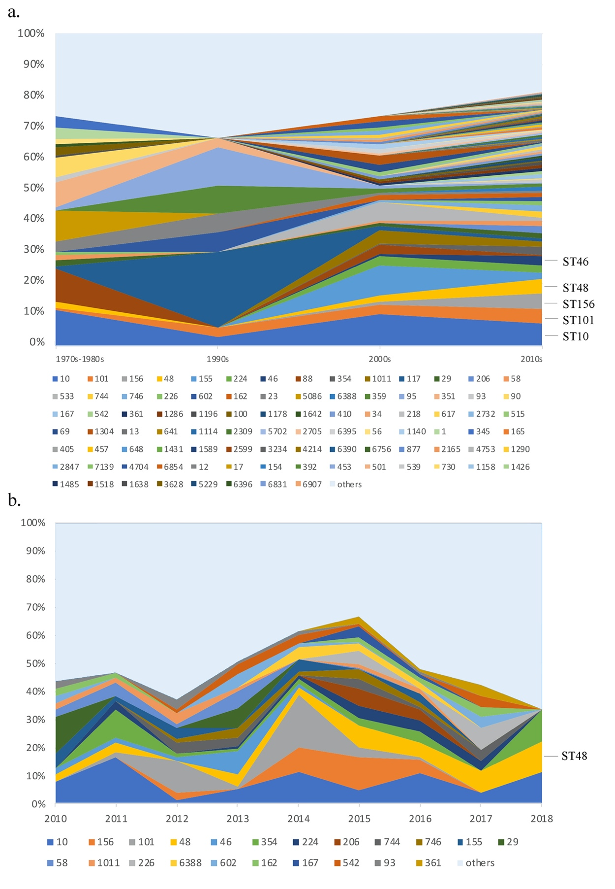
Fig. S3 a. The prevalence of different E. coli sequence types in different time groups. b. The prevalence of different E. coli sequence types in the 2010s.
Fig. S4 (a) Prevalence of some specific STs with a rising (red) or declining (blue) trend over time and (b) the ARG containing numbers in these STs. The average numbers were noted by “x”, and discrete numbers were showed as dots. For some groups like ST46, most of the isolates (n = 17) contain same n umber of ARGs (n = 9, including colistin resistance gene mcr-1), which were overlapped on the “x”.

Fig. S5 Number of genes in a. pangenome, b. chromosome pan-genome, and c. plasmid pan-genome.

Fig. S6 The distribution of the number of plasmid replicon genes and virulence genes per isolate in different time group. The mean ARG count for each group is noted above. The “*” on the right represent p-values. *: p < 0.05; **: p < 0.01; ***: p < 0.001.

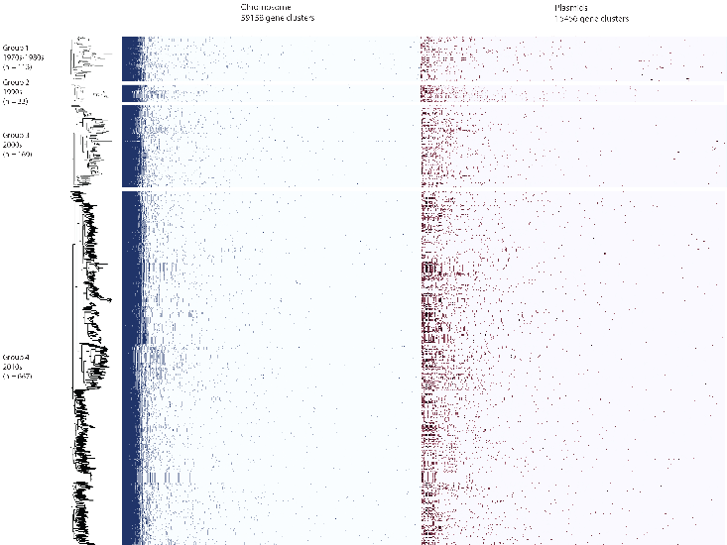
Fig. S7 Gene content matrix clustered within each time groups and separated by the gene location (chromosome and plasmids).
Fig. S8 a. The prevalence of plasmid replicon genes grouped by time and host. b. The P-values of pairwise comparisons of prevalence of time-groups.

Fig. S9 a. The prevalence of virulence genes grouped by time and host. The virulence genes were clustered by function and the name of classes were annotated on the left. b. The P-values of pairwise comparisons of prevalence of time-groups.

Fig. S10 The P-value of all possible pairwise comparisons of ARG prevalence of time-groups.
Fig. S11 The value of antimicrobial production with phenotype and genotype changes over the time. a. The dark grey histogram shows the mean value of production of norfloxacin per year in different time groups. The light grey histogram shows the mean value of production of other quinolones used in animals (ciprofloxacin, ofloxacin, levofloxacin, lomefloxacin, pefloxacin and pipemidic acid) per year, and data were only available from 2000s. The black line represents the prevalence of norfloxacin resistance and the orange lines represent the prevalence of quinolone-resistant genes. b. The histogram shows the mean value of production of colistin in different time groups. The black line represents the prevalence of colistin resistance and the green line represent the prevalence of colistin-resistant gene mcr-1. Production data before 2000 were unavailable.

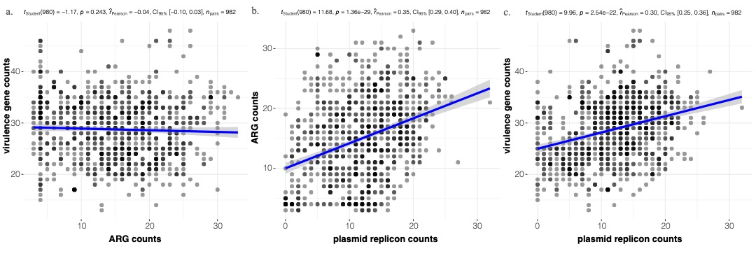
Fig. S12 The correlation of mean counts of ARGs, plasmid replicons, and virulence genes detected from genomes. a. The correlation between ARG and virulence genes counts. b. The correlation between plasmid replicon and ARG counts. c. The correlation between plasmid replicons and virulence gene counts.
Fig. S13 The co-occurrence of ARGs and plasmid replicons in different time groups. The first two of the groups (1970s-80s and 1990s) were merged as “before 2000”, due to the smaller quantities of isolates. We define the false discovery rate (FDR) threshold as 0.05 in this algorithm; significant pairwise values from 1 (blue) to -1 (red) (i.e. co-occurrence and mutual exclusivity) are shown. The blue box labelled “ARG-ARG” shows the pairwise co-occurrence and mutual exclusivity of ARGs, and the red box labelled “plasmid-plasmid” shows the pairwise co-occurrence and mutual exclusivity of plasmid replicons. The gold boxes labelled with numbers indicate the co-occurrence and mutual exclusivity between ARGs and plasmid replicons, and these are annotated on the bottom left.
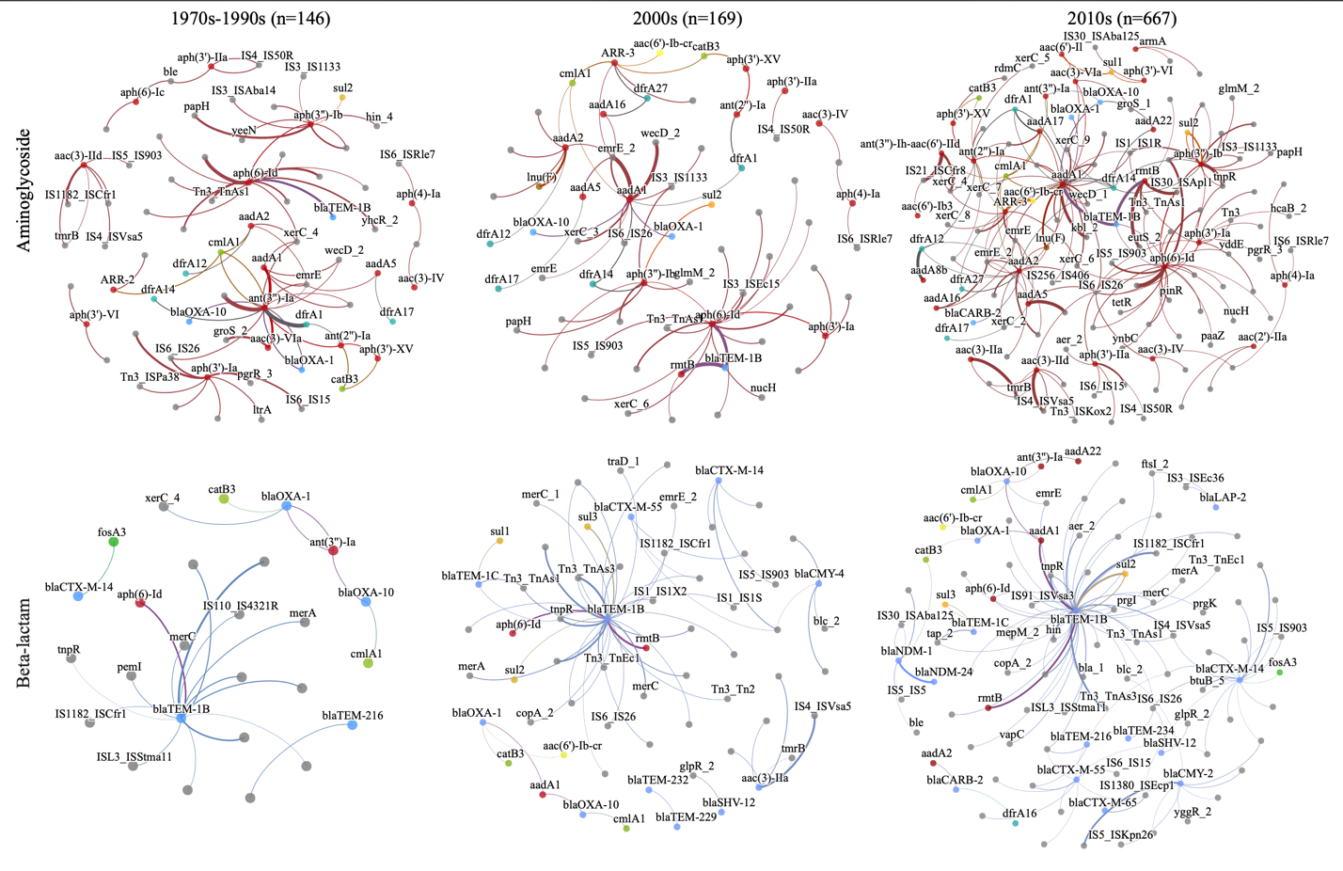
Fig. S14 ARG co-occurrence networks of aminoglycoside and beta-lactam resistance genes among isolates grouped by sampling time: 1970s-1990s (n=146), 2000s (n=169) and 2010s (n=667). Nodes represent genes and are colored to represent the antimicrobial class for ARGs; aminoglycoside: red; β-lactam: blue; trimethoprim: cyan; phenicol: green; rifampin: pink; fluroquinolones: yellow; poymyxins: orange; grey: non-ARG. Unlabelled nodes were annotated as hypothetical protein. Edges are coloured according to the nodes the connect. Edge widths represent connection weight calculated by Roary.

Supplementary Tables
The following tables are showed in this file:
Table S2. The prevalence of resistant of 16 antimicrobials in four time-groups.
Table S4. The antimicrobial usage on animals in China in the last five decades.
Table S5. The gross output value of veterinary medicine in different time.
Table S6. Information of 532 isolates downloaded from NCBI.
The following tables are available in xlsx file:
Table S1. Details of 982 isolates of E. coli, including metadata with addition of gene screening and pan-genome statistical results.
Table S3. Gene screening results of plasmid replicons, ARGs and virulence genes.

Table S2. The prevalence of resistant of 16 antimicrobials in four time-groups.
 | Time | 1970-1980s | 1990s | 2000s | 2010s
 | Gentamicin | 3.66% | 28.57% | 27.66% | 48.24%
 | Apramycin | 1.22% | 0.00% | 2.13% | 17.09%
 | Tetracycline | 65.85% | 82.14% | 86.52% | 80.40%
 | Tigecycline | 1.22% | 0.00% | 10.64% | 0.00%
 | Norfloxacin | 0.00% | 3.57% | 33.33% | 38.69%
 | Florfenicol | 0.00% | 14.29% | 30.50% | 53.77%
 | Chloramphenicol | 45.12% | 60.71% | 43.26% | 52.26%
 | Colistin | 0.00% | 0.00% | 13.48% | 43.22%
 | Ampicillin | 24.39% | 67.86% | 77.30% | 72.86%
 | Amoxicillin/Clavulanic acid | 13.41% | 71.43% | 59.57% | 53.77%
 | Meropenem | 0.00% | 0.00% | 0.00% | 1.01%
 | Cefazolin | 1.22% | 25.00% | 22.70% | 49.25%
 | Cefoxitin | 0.00% | 0.00% | 4.96% | 18.09%
 | Ceftiofur | 0.00% | 0.00% | 8.51% | 38.69%
 | Aztreonam | 1.22% | 0.00% | 5.67% | 34.17%
 | Trimethoprim/Sulfamethoxazole | 74.39% | 67.86% | 77.30% | 74.37%

Table S4. The antimicrobial usage on animals in China.
Time | In use¹ | Ceased using
1960s | Penicillin, tetracyclines, streptomycin, sulfonamides, and chloramphenicol (in the late 1960s)
1970s | All above, plus ampicillin, kanamycin, and gentamicin (in the late 1970s)
1980s | All above plus FQs (in the late 1980s)
1990s | All above, the use of FQs were increasing. Florfenicol and ceftiofur were used in the late 1990s. | The use of penicillin, streptomycin, and chloramphenicol was decreasing.
2000s | All above except for the banned ones. | In 2002, MOA have banned the usage of chloramphenicol in agriculture², followed by vancomycin in 2005³
2010s | All above except for the banned ones. | Norfloxacin, pefloxacin, lomefloxacin and ofloxacin were banded for use in food-producing animals by 2016⁴. Colistin was banned from animal feeds by April 2017⁵.

Table S5. The gross output value of veterinary medicine in different time.
Time (Time period) | Gross output value of veterinary medicine  (billion RMB)
1987(1970s-80s) | 0.212⁶
1995(1990s) | 4.073⁶
2007(2000-2007) | 19.597⁶
2011(2008-2011) | 37⁷
2015(2012-2015) | 46.231⁸
2017(2016-2017) | 52.245⁹

Table S6. Information of 532 isolates downloaded from NCBI.
BioProject | No. | Host/n | Collection time | Preference of isolating
PRJNA230969¹⁰ | 9 | Pig | 2000/10/10 | US FDA surveillance project for the rapid detection of foodborne contamination events
PRJNA357722¹¹ | 3 | Pig | 2000 | US FDA surveillance effort for the rapid traceback of foodborne pathogens
PRJNA547507 | 1 | Cow | 2018/5/1 | WGS data for E. coli
PRJNA531750 | 3 | Pig | 2018/1 | WGS data for E. coli
PRJNA534136 | 1 | Pig | 2018/12/1 | WGS data for E. coli
PRJNA564204 | 1 | Pig | 2014 | WGS data for E. coli
PRJNA565670 | 1 | Chicken | 2017/1/1 | WGS data for E. coli
PRJNA526123 | 2 | Pig | 2017/7 | WGS data for E. coli
PRJNA528364 | 1 | Pig | 2017/8/16 | WGS data for E. coli
PRJNA588380 | 1 | Pig | 2019/7/1 | WGS data for E. coli
PRJNA588383 | 1 | Pig | 2019/7/1 | WGS data for E. coli
PRJNA588384 | 1 | Pig | 2019/7/1 | WGS data for E. coli
PRJNA588386 | 1 | Pig | 2019/7/1 | WGS data for E. coli
PRJNA450836 | 19 | Bovine/4  Chicken/10  Pig/5 | 2014 | investigate the genetic diversity and relationship of E. coli clinical strains
PRJNA380692¹² | 1 | Chicken | 2015/6/23 | domestic chicken gut microbiota
PRJNA307142 | 142 | Bovine/16  Sheep/57  Pig/69 | 1976-2014 | Evolution study
PRJNA514245¹³ | 52 | Broiler/39  Pig/13 | 2013-2016 | Not found
PRJNA421631 | 1 |  | 2007 | Not found
  Duck
PRJNA480178 | 2 | Chicken/1  Pig/1 | 2012, 2016 | Not found
PRJNA308786¹⁴ | 1 | Pig | 2006 | Extraintestinal pathogenic E. coli (ExPEC)
PRJNA557097 | 1 | Pig | 2013/11/30 | ExPEC
PRJNA294139 | 1 | Pig | 2014 | ExPEC causing fatal pneumonia in pig farm.
PRJNA246132¹⁵ | 1 | Pig | 2011 | ETEC
PRJNA557100 | 1 | Cow | 2018/8/17 | a virulent strain isolated from the dairy cow with acute mastitis
PRJNA433057 | 17 | Cow | 2017/8 | ESBL-producing E. coli
PRJNA349231¹⁶ | 131 | Chicken/99  Fly/32 | 2014-2015 | NDM positive E. coli
PRJNA507915¹⁷ | 66 | Bovine/1  Chicken/11  Fly/12  Pig/42 | 2015/7 | Carbapenem-resistant Enterobacteriaceae (CRE)
PRJNA565896 | 1 | Chicken | 2018/11/1 | CRE
PRJNA565902 | 1 | Duck | 2018/11/1 | CRE
PRJNA420050 | 1 | Chicken | 2015/1/12 | E. coli co-producing MCR-1 and NDM-1
PRJNA534154 | 1 | Pig | 2018/12/1 | colistin resistance
PRJNA515800 | 1 | Pig | 2017/10 | mcr-1 positive
PRJNA434044 | 54 | Chicken | 2016 | mcr-1 positive
PRJNA362688 | 1 | Pig | 2016/7/1 | MCR-1-producing E. coli strain isolated from diarrheic piglet
PRJNA587053 | 1 | Chicken | 2014/10/20 | fosfomycin resistance Gene fosA3
PRJNA383767 | 1 | Chicken | 2017/4/21 | avian multoyage resistant E. coli
PRJNA490022 | 1 | Chicken | 2017/8/1 | Multiple drug-resistant E. coli strain
PRJNA490024 | 1 | Chicken | 2017/8/1 | Multiple drug-resistant E. coli strain
PRJNA506117 | 1 | Chicken | 2017/3/1 | The multigrug resistant E. coli isolated from diseased chicken
PRJNA280577 | 1 | Pig | 1998/7/1 | An E. coli that could be induced phage
PRJNA280589 | 1 |  | 2007/6/16 | An E. coli that a induced phage could infect
  Duck
PRJNA288351 | 1 |  | 2007/3/1 | containing a phage similar to pro147
  Duck
PRJNA543425 | 1 | Chicken | 2009/5 | the host strain of bacteriophage Bp7
PRJNA543427 | 1 | Chicken | 2009/5/25 | resistant to phage Bp7

References

1 Li, S. et al. Investigation of integrons/cassettes in antimicrobial-resistant Escherichia coli isolated from food animals in China. Science China 53, 613-619 (2010).
2 MOA. Announcement of the Ministry of Agriculture and Rural People's Republic of China No. 193. China Ministry of Agriculture and Rural Affairs of the People’s Republic of China (2002).
3 MOA. Announcement of the Ministry of Agriculture and Rural People's Republic of China No. 560. http://www.moa.gov.cn/gk/zcfg/nybgz/200806/t20080606_1057240.htm (2005).
4 MOA. Announcement of the Ministry of Agriculture and Rural People's Republic of China No. 2292. China Ministry of Agriculture and Rural Affairs of the People’s Republic of China (2015).
5 MOA. Announcement of the Ministry of Agriculture and Rural People's Republic of China No. 2428. China Ministry of Agriculture and Rural Affairs of the People’s Republic of China (2016).
6 Wang, Y. M. The development trend of Chinese pharmaceutical industry. (Second Military Medical University Press, 2002).
7 Statistics, N. B. o. China Animal Husbandry and Veterinary Yearbook. 59-59 (2012).
8 Li, M. Current situation and development trend of veterinary drug industry in China. BeiFangMuYe (2016).
9 Liu, X. R., Zhang, Y. J. & Zang, H. Y. Analysis of current situation and development trend of veterinary medicine industry in China. Contemporary livestock and poultry farming No.427, 46-47 (2018).
10 Patel, I. R., Gangiredla, J., Mammel, M. K., Lampel, K. A. & Lacher, D. W. Draft Genome Sequences of the Escherichia coli Reference (ECOR) Collection. Microbiology Resource Announcements 7 (2018).
11 Lacher, D. W., Mammel, M. K., Gangiredla, J., Gebru, S. T. & Dudley, E. G. Draft Genome Sequences of Isolates of Diverse Host Origin from the E. coli Reference Center at Penn State University. Microbiology Resource Announcements 9 (2020).
12 Rongqin et al. Identification and genomic analysis of antifungal property of a tomato root endophyte Pseudomonas sp. p21. Antonie van Leeuwenhoek (2016).
13 Souvorov, A., Agarwala, R. & Lipman, D. J. SKESA: Strategic k-mer extension for scrupulous assemblies. Genome biology 19 (2018).
14 Bo, H., Meng, X. R., Zhang, L. Y., Tan, C. & Li, S. W. TolC Promotes ExPEC Biofilm Formation and Curli Production in Response to Medium Osmolarity. Journal of Biomedicine and Biotechnology 2014, 574274 (2014).
15 Ren, W. et al. Draft Genome Sequence of Enterotoxigenic Escherichia coli Strain W25K. Genome Announcements 2, 675 (2014).
16 Shen, Y. et al. Anthropogenic and environmental factors associated with high incidence of mcr-1 carriage in humans across China. Nature Microbiology 3, 1 (2018).
17 Li, J. et al. Inter-Host Transmission of Carbapenemase-Producing Escherichia coli among Humans and Backyard Animals. Environmental Health Perspectives 127 (2019).

