Extended Data Figures
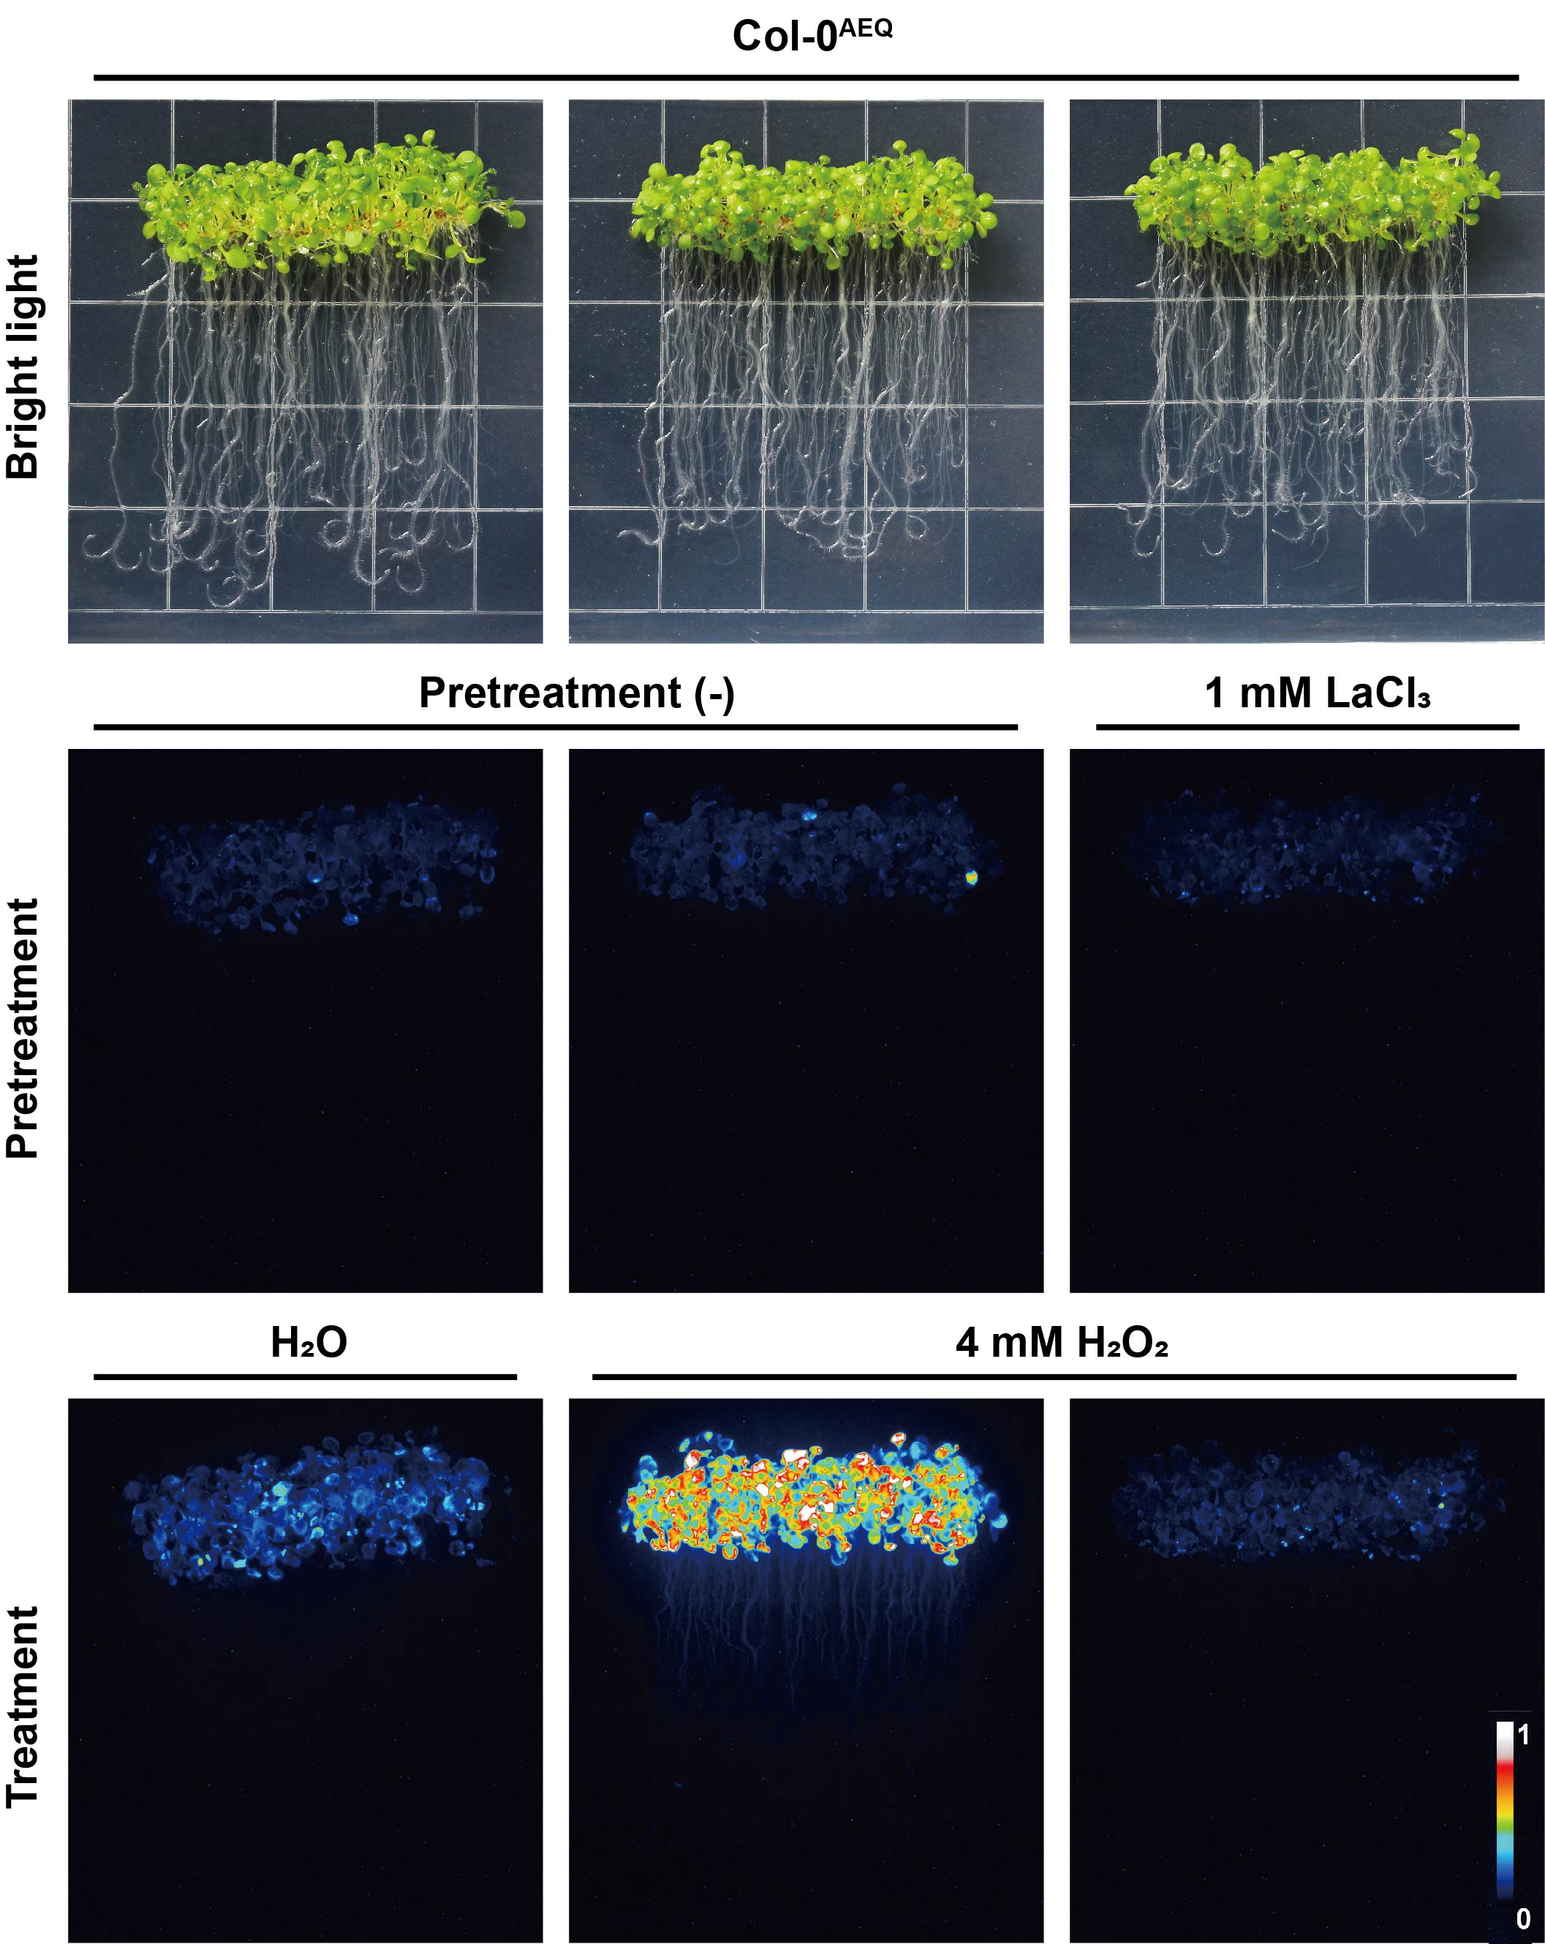

Extended Data Fig. 1 | H₂O₂ triggers the specific cytosolic [Ca²⁺]_{cyt} increase in Col-0^{AEQ}.
Images of H₂O₂-induced Ca²⁺ increases scaled by a pseudo-colour bar in aequorin-expressing wild-type (WT) Col-0. Treatment with LaCl₃ as a inhibitor of calcium channels resulted in a significant decrease in fluorescence values.

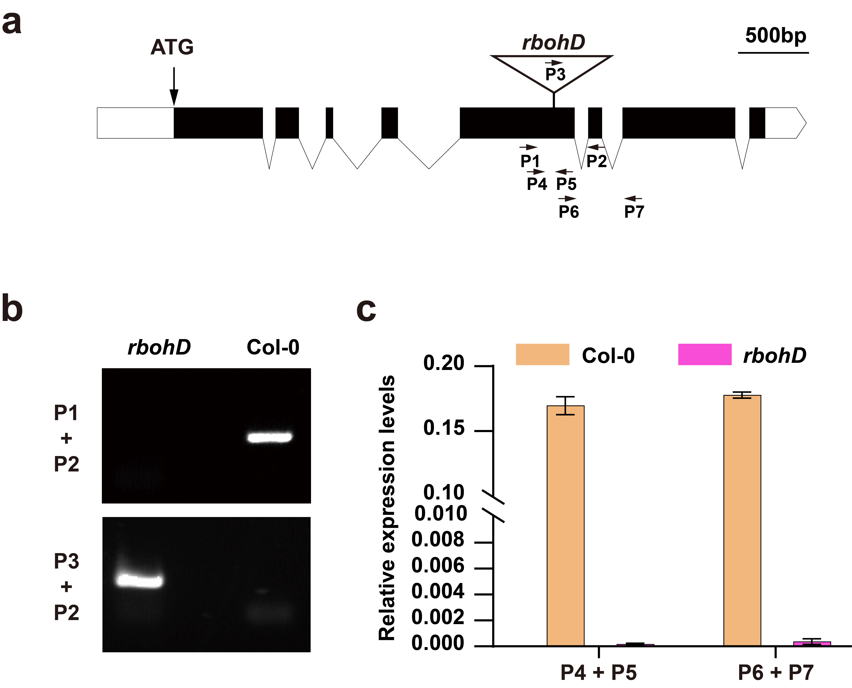
Extended Data Fig. 2 | Genotyping of Arabidopsis rbohD mutant.
a. Schematic representation of the exon-intron structure of the RBOHD gene and the transposon insertion site, with the transposon in the fifth exon, the PCR primers and the real-time quantitative polymerase chain reaction (qRT-PCR) primers binding to the gene are shown in the figure. b, PCR identification of mutant rbohD with primers P1/P2 and P2/P3. c, Detection of RBOHD mRNA expression by primers pairs of P4/P5 and P6/P7 in Col-0 and rbohD mutant based on qRT-PCR.
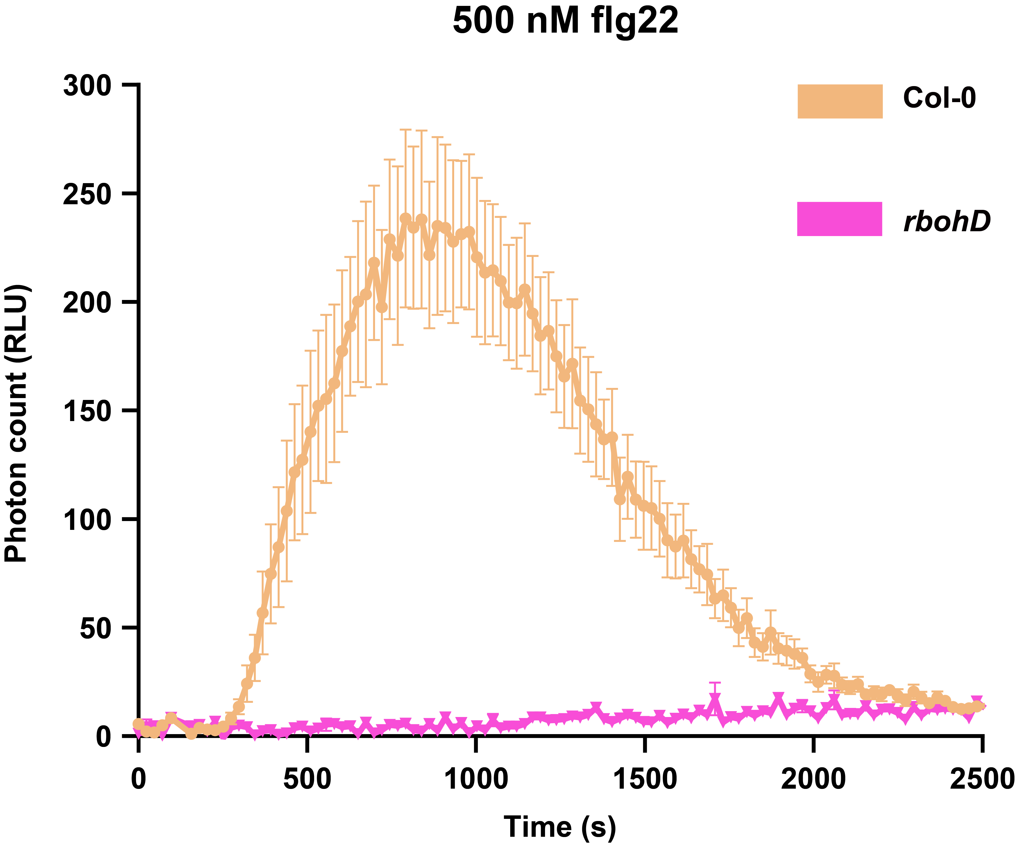
Extended Data Fig. 3 | flg22-induced ROS burst was impaired in rbohD.
Analysis of ROS level detection in Col-0 and rbohD mutant induced by 500 nM flg22. Data are mean ± s.e.m., n=8.
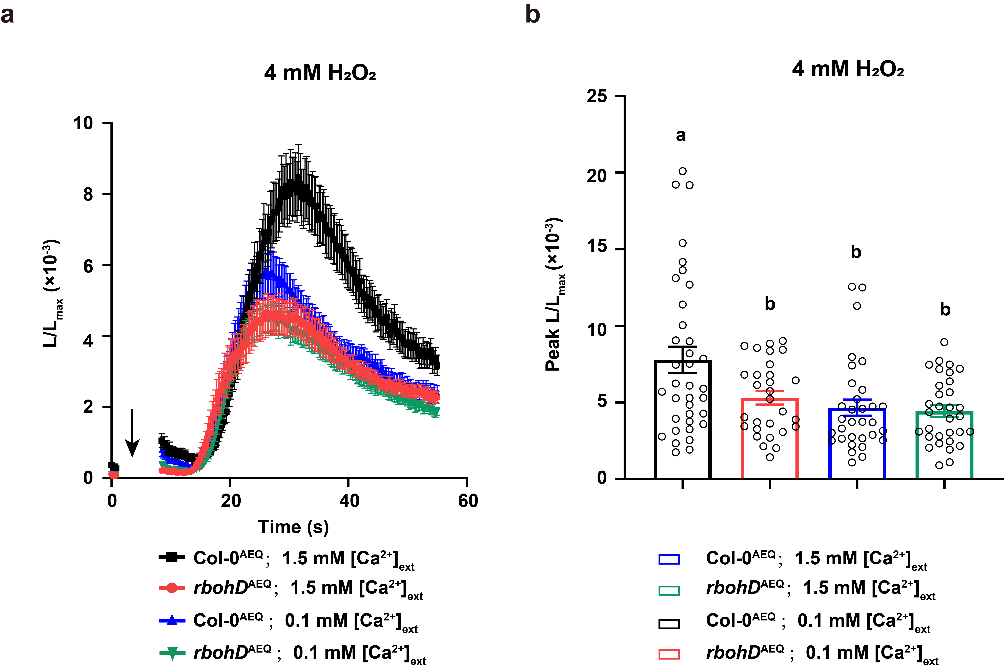
Extended Data Fig. 4 | H₂O₂-induced cytosolic [Ca²⁺]_{cyt} increase in Col-0^{AEQ} and rbohD^{AEQ} under different extra Ca²⁺ conditions.
a-b, Time course (a) and quantification (b) of [Ca²⁺]_{cyt} in Col-0^{AEQ} and rbohD^{AEQ} seedlings induced by 4 mM H₂O₂. Data are presented as mean ± s.e.m. and n≥29 biologically independent seedlings.

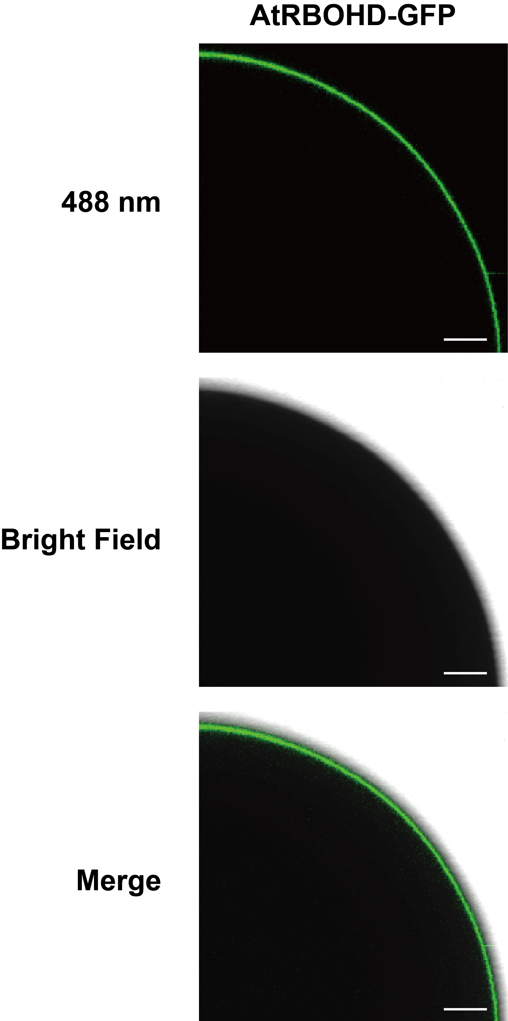

Extended Data Fig. 5 | Localization of RBOHD-GFP on plasma membrane.
Two days after the cRNA of RBOHD-GFP was injected into Xenopus oocytes for expression, the fluorescent signals were observed under a fluorescent confocal Lecia SP8 microscope. Scale bar=200 μm.

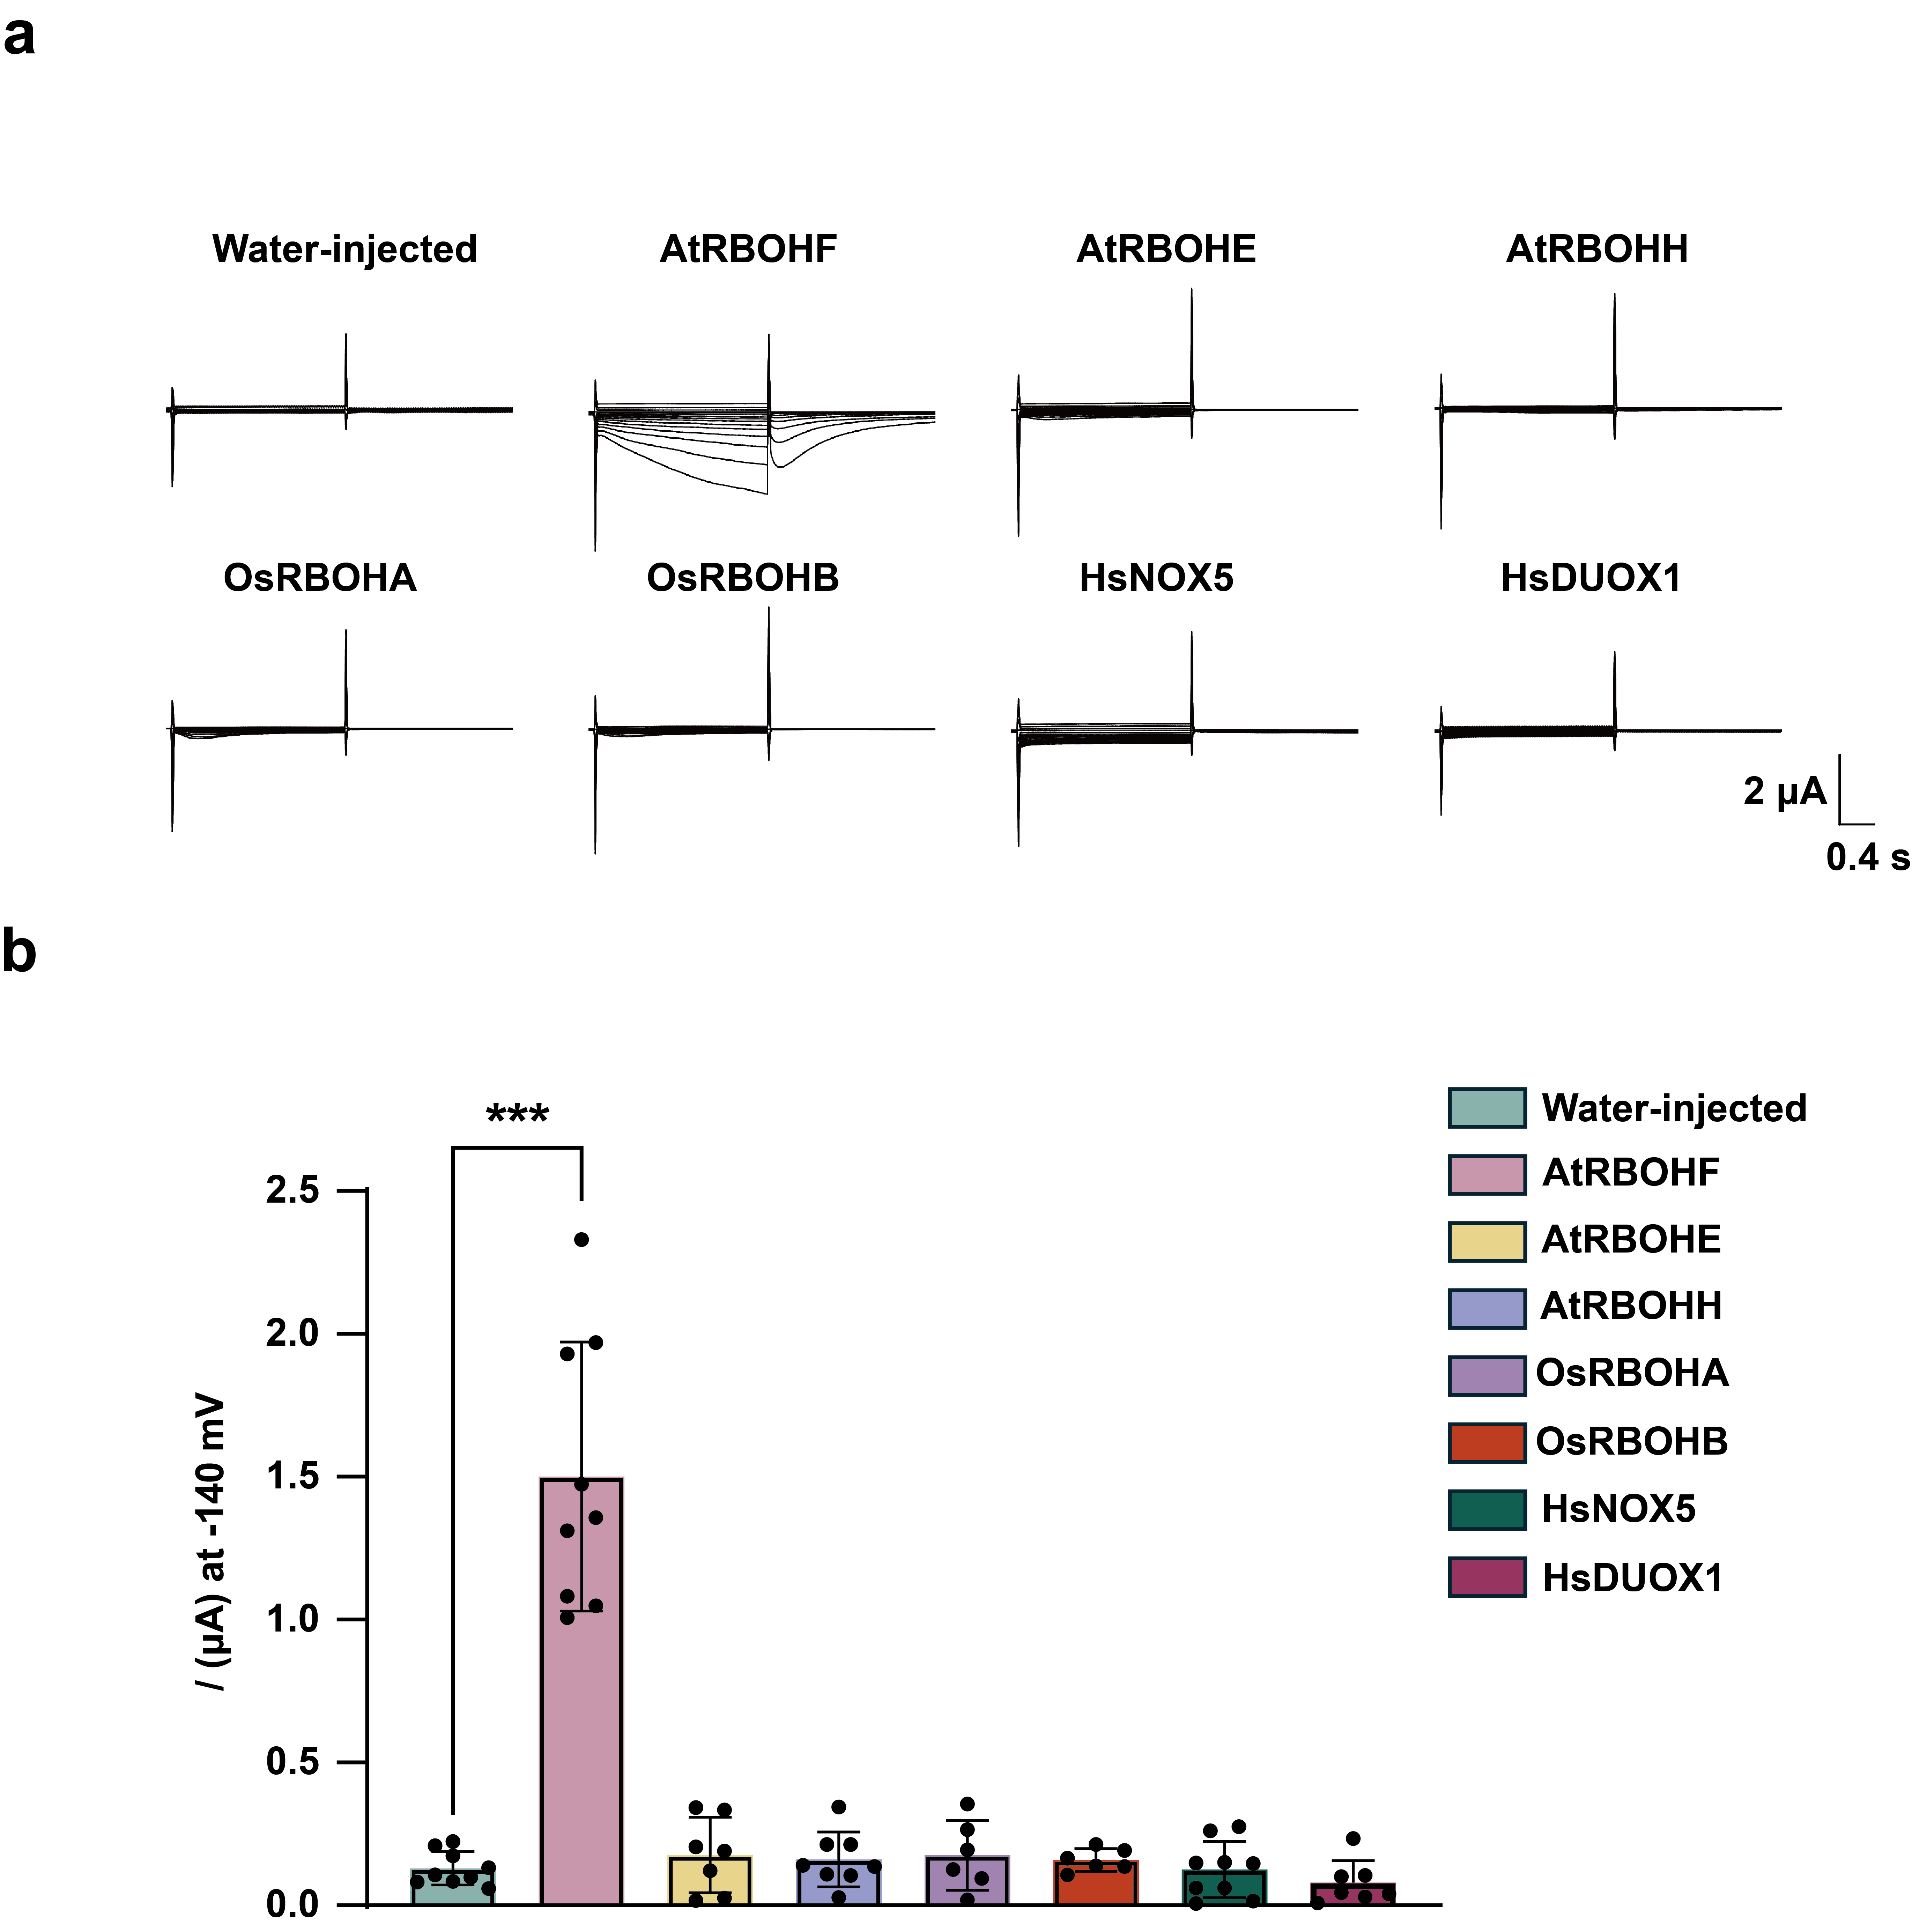

Extended Data Fig. 6 | Analysis of calcium channel activity of plant and human NOXs in TEVC assay.
a-b, The cRNAs of homologous genes of NOXs/RBOHs from different species were injected into Xenopus oocytes, and the current values were recorded by TEVC assay under 30 mM CaCl₂ perfusate (a). The chart shows the currents of different samples at -140 mV (b). P values are calculated from two-sided Student's t-tests. Data are presented as mean ± s.d., and n≥6 biologically independent oocytes.

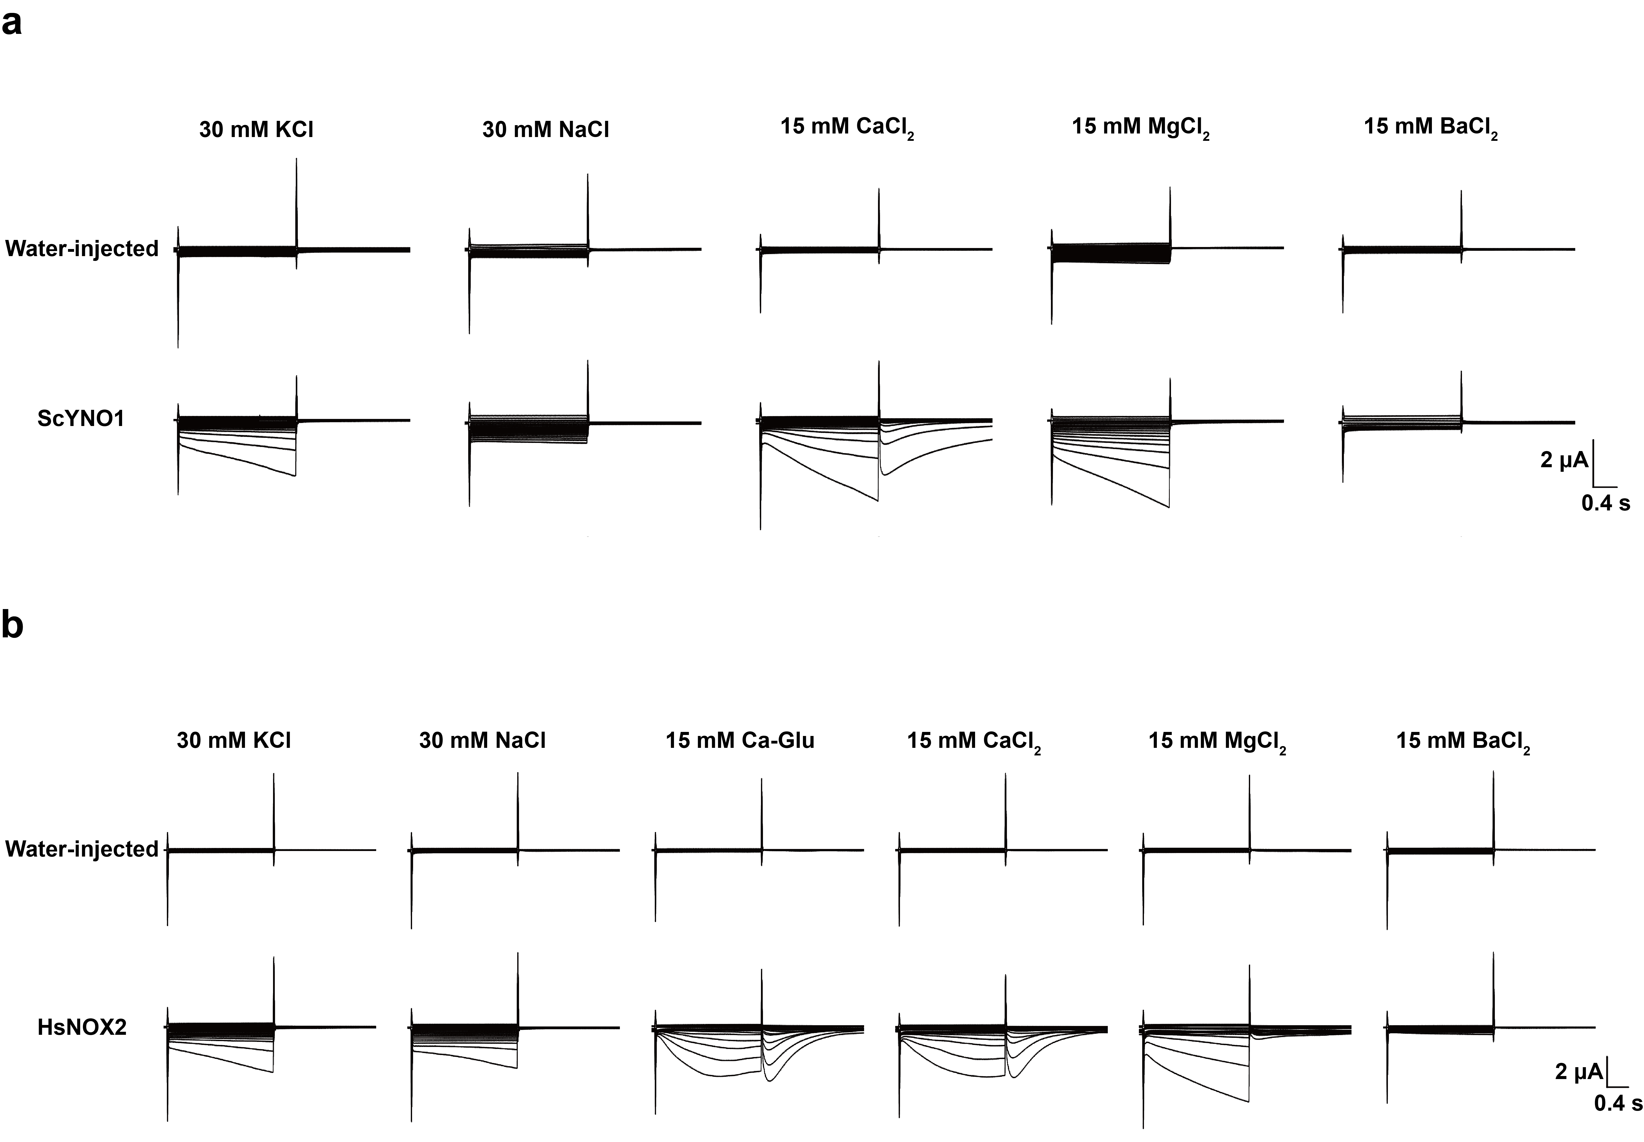

Extended Data Fig. 7 | Ion selectivity of ScYNO1 and HsNOX2.
a, The currents of Xenopus oocytes expressing ScYNO1 cRNA were recorded in perfusion buffer containing 30 mM KCl, 30 mM NaCl, 15 mM CaCl₂, 15 mM MgCl₂ and 15 mM BaCl₂ by TEVC assay. b, The currents of Xenopus oocytes expressing HsNOX2 cRNA were recorded in perfusion buffer containing 30 mM KCl, 30 mM NaCl, 15 mM CaCl₂, 15 mM MgCl₂ and 15 mM BaCl₂ by TEVC assay.

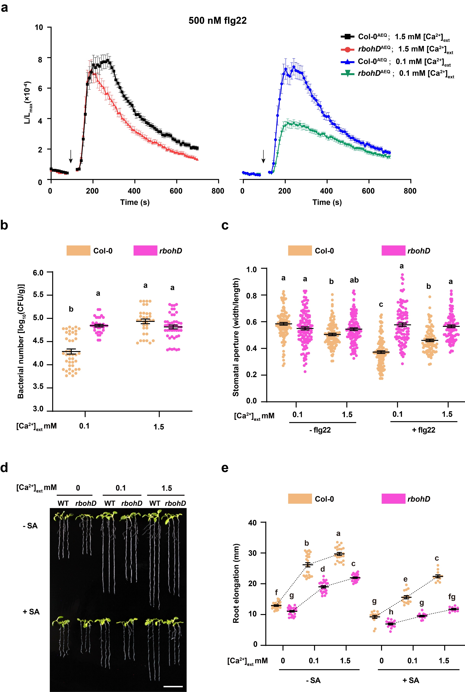
Extended Data Fig. 8 | Physiological function of RBOHD in response to abiotic stimuli is dependent of extra Ca²⁺ concentrations.
a, The changes of [Ca²⁺]_{cyt} in Col-0^{AEQ} and rbohD^{AEQ} seedlings induced by 500 nM flg22. Data are presented as mean ± s.e.m. and n≥50 biologically independent seedlings. b, Measurement of bacterial growth on seedlings of WT and rbohD under 0.1 and 1.5 mM CaCl₂ treatment. c, The stomatal opening measurement of 4-week-old plants grown under 0.1 and 1.5 mM CaCl₂ with or without 1 μM flg22 treatment. d, e, Root phenotypes (d) and root elongation measurement (e) of WT and rbohD under 0, 0.1 and 1.5 mM CaCl₂ with or without 20 μM SA treatment. Data are presented as mean ± s.e.m. (b, c, e) and statistical significance was determined using two-way (b) or three-way (c, e) analysis of variance (ANOVA) and multiple comparison by the Tukey's method.

