Supplementary Materials for

Characterization of natural killer (NK) cells in lung adenocarcinoma and construction of an NK risk signature based on single-cell and macromolecular RNA-seg data
Chuanxi Tian^{1,2 #}, Yikun Guo^{2,3#}, Tianyi Lv^{2#}, Daowen Yang⁴*, Min Li¹*

¹Guang’anmen Hospital, China Academy of Chinese Medical Sciences, Beijing 100053, China;
²Beijing University of Chinese Medicine, Beijing 100029, China;
³Dongzhimen Hospital, Beijing University of Chinese Medicine, Beijing 100700, China;
⁴China-Japan Friendship Hospital, Beijing 100029, China.
#These authors contributed equally to this work.

* Correspondence:
Daowen Yang, 13910331107@139.com, China-Japan Friendship Hospital, Beijing 100029, China.
Min Li, limin-72114@163.com, Guang'anmen Hospital, China Academy of Traditional Chinese Medical Sciences, Beijing 100053, China.

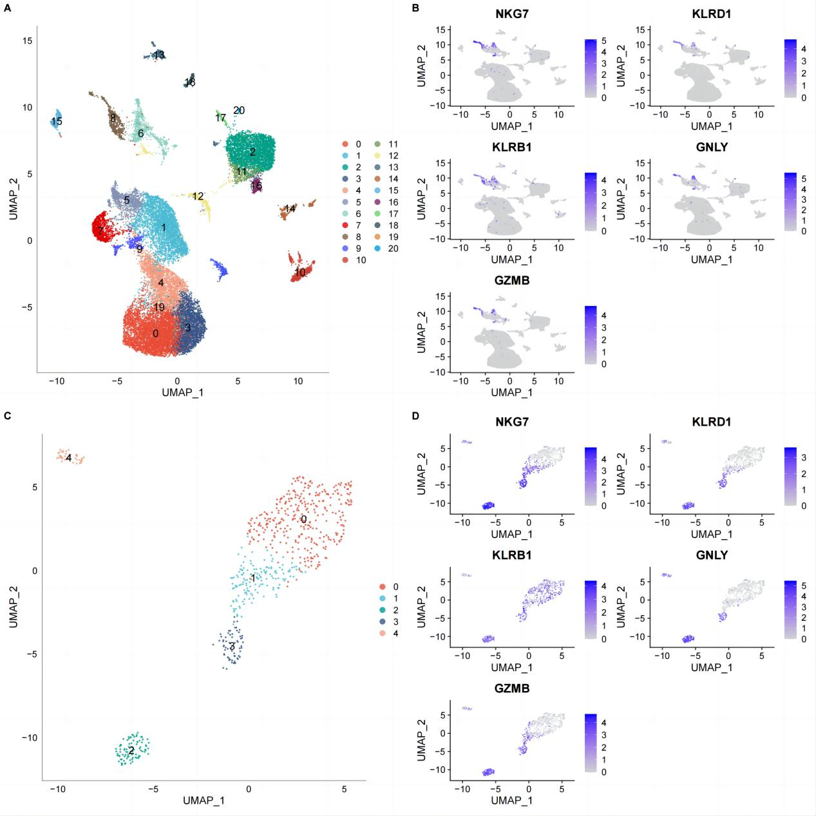
Figure S1 The clustering of NK populations and dimensionality reduction. (A) Distribution of subpopulations after clustering of all cells; (B) TSNE map of NK cells marker gene expression; (C) Distribution of subpopulations after re-clustering of NK cells; (D) TSNE diagram of marker expression in five NK clusters.

