Transcriptomics-guided optimization of vitamins to enhance erythromycin yield in saccharopolyspora erythraea
Xiang Ke¹, Xing Jiang¹, Shuohan Wang¹, Xiwei Tian^{1, 2}* and Ju Chu¹*

¹ State Key Laboratory of Bioreactor Engineering, East China University of Science and Technology, Shanghai 200237, China
² Qingdao Innovation Institute of East China University of Science and Technology, 596-1 East Jiushui Road, Qingdao, 266102, China
*Correspondence:
Xiwei Tian: xiweitian@ecust.edu.cn; Tel. (+86) 021-64257019; 130 Meilong Road, Shanghai 200237, China.
Ju Chu: juchu@ecust.edu.cn; Tel. (+86) 021-64253021; 130 Meilong Road, Shanghai 200237, China.
Supplemental materials

Table S1 Concentration levels of vitamins used in the Plackett-Burman experimental design
 | Factors | High level (mg/L) | Low level (mg/L)
F1 | TPP | 0.75 | 0.25
F2 | VB2 | 0.5625 | 0.1875
F3 | VB6 | 0.45 | 0.15
F4 | VB7 | 7.5 | 2.5
F5 | VB12 | 0.15 | 0.45
F6 | Hemin | 2 | 6

Table S2 The design of Plackett-Burman experiment
RUN | F1 | F2 | F3 | F4 | F5 | F6
1 | -1 | -1 | -1 | 1 | -1 | 1
2 | 1 | 1 | 1 | -1 | -1 | -1
3 | -1 | -1 | 1 | 1 | 1 | 1
4 | 1 | -1 | 1 | 1 | 1 | -1
5 | -1 | 1 | 1 | 1 | -1 | -1
6 | -1 | -1 | -1 | 1 | -1 | -1
7 | 1 | -1 | 1 | 1 | -1 | 1
8 | 1 | 1 | -1 | 1 | -1 | 1
9 | 1 | 1 | -1 | 1 | 1 | 1
10 | -1 | 1 | -1 | 1 | 1 | -1
11 | 1 | -1 | 1 | 1 | 1 | -1
12 | 0 | 0 | 0 | 0 | 0 | 0
13 | -1 | 1 | 1 | 1 | 1 | 1

Table S3 The central carbon metabolic network model
No. | Reaction
r1 | Glc+ATP → G6P
r2 | G6P → F6P
r3 | G6P → R5P+2·NADPH+CO₂
r4 | 3·R5P → 2·F6P+GAP
r5 | F6P+ATP→2·GAP
r6 | GAP→Pyr+2·ATP+NADH
r7 | Pyr →AcCoA + NADH + CO₂
r8 | AcCoA+OAC → Icit
r9 | Cit → α-KG+NADH+CO₂
r10 | α-KG → SucCoA+NADH +CO₂
r11 | SucCoA → OAC+NADH+FADH₂+ATP
r12 | Suc → Mal + FADH₂
r13 | Mal → OAC + NADH
r14 | OAC → Pyr + ATP + CO₂
r15 | Cit + AcCoA→ Mal + Suc
r16 | Mal → Pyr + CO2 + NADH
r17 | SucCoA → MetCoA
r18 | MetCoA → ProCoA + ATP + CO₂
r19 | ProCoA + 6·MetCoA + 2·Glc + 9·NADPH→ Ery + 2·NADH + 6·CO₂
r20 | NADH + 0.5 ·O₂ → 2.5 ·ATP
r21 | FADH₂ + 0.5·O₂ → 1.5 ·ATP
r22 | Cit → Cit.ex
r23 | Pyr → Pyr.ex
r24 | CO₂ → CO₂.ex
r25 | O₂.ex → O₂
r26 | Ery → Ery.ex
r27 | Glc.ex → Glc

Table S4 The specific rate and carbon recovery rate of E3 fermentation between 84-96 h
 | E3 | E3 with vitamins
q_{ery}(mmol/gDCW/h) | 0.00168 | 0.00293
q_{CO2}(mmol/gDCW/h) | 1.046 | 1.0732
q_{O2}(mmol/gDCW/h) | 0.933 | 0.994
q_{glu}(mmol/gDCW/h) | 0.196 | 0.207
*Carbon recovery rate（%） | 93.9% | 95.0%
*Carbon recovery rate（%）=（q_{ery}×37+q_{co2}×1）/（q_{glucose}×6）

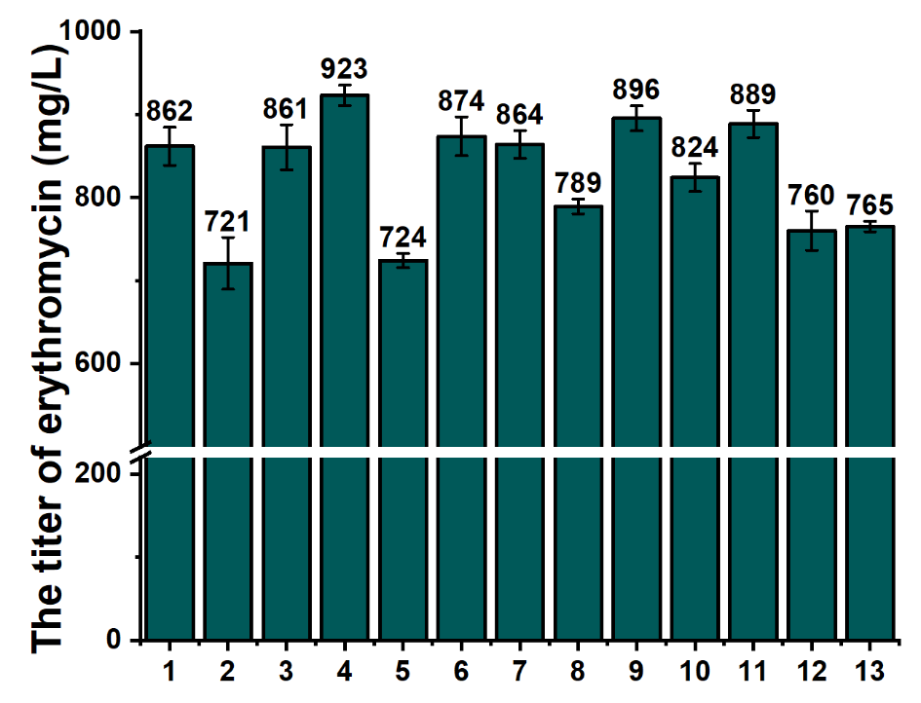
Fig. S1 The response values of Plackett-Burman experimental
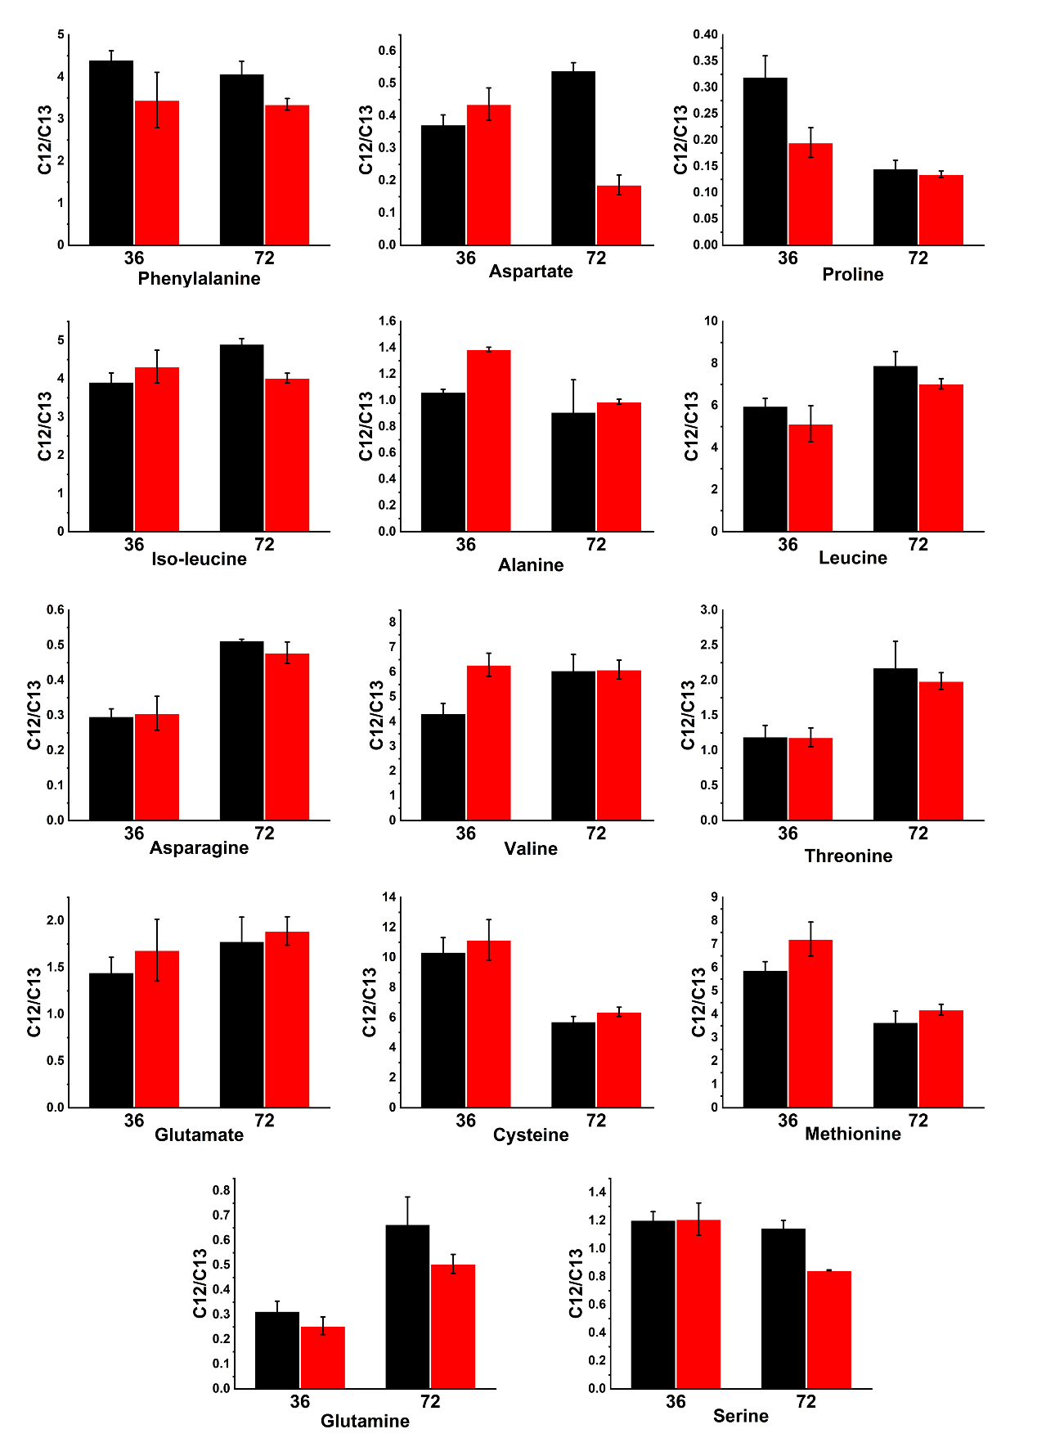
Fig.S2 The effects of vitamins supplementation on the relative intracellular concentrations of amino acids in E3 at 36 h and 72 h. The relative concentration of intracellular organic acids is represented by the ratio of 12C intracellular metabolites to 13C internal standards

