Algorithms

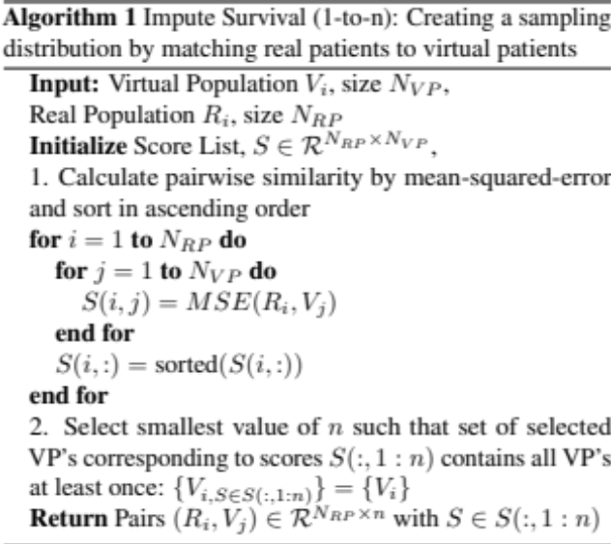
Algorithm 1. 1-to-n matching algorithm for matching n virtual patients to each real patient

