Spatially variable response of Antarctica’s ice sheets to Pliocene orbital forcing during the Pliocene: Supplementary Material

IODP Site U1524 Lithostratigraphy and Sedimentological Interpretations
Site U1524A is characterised by three lithostratigraphic units (LSUs) that are primarily based on gradual changes in diatom content³² (Fig. 1 and 2). The dominate lithofacies characterizing these sediments include diatom-rich mud, diatom ooze and mud. LSU I encompasses cores 1H to 23H with depths from 0 to 200.55 m CSF-A and temporally ranges from Pliocene to Pleistocene in age based on chronostratigraphy³². This unit is subdivided into three units (i.e., LSU IA, LSU IB, and LSU IC; youngest to oldest) based on changes in diatom content. Diatom content increases downhole with the top of a diatom ooze interval at 200.56 CSF-A defining the base of LSU I³². This transition is highlighted by a baseline decrease in physical property data sets of NGR and an increase in colour reflectance b* values (lower values = blue; higher values=yellow) (Supplementary Fig.1). The sampled interval for this study extends from U1524A LSU IB to LSU II from 99 to 270 CSF-B.
Subunit IB extends from cores 9H to 17H with depths from 78.03-155.58 m CSF-A for a thickness of 77.55 m. LSU IB consists of unconsolidated massive bioturbated to laminated olive gray diatom-rich mud to muddy diatom ooze interbedded at the decimeter to meter scale with greenish gray diatom-rich sandy mud with dispersed clasts. Contacts are sharp to gradational and are associated with color changes. Clasts, mud clasts, and sand lenses and pods are observed throughout Subunit IB; fine grained silt laminations consists discontinuous to contorted in some intervals and suggest soft sediment deformation and bioturbation. An increase in the thickness of sandy mud beds with clasts indicates the base of Subunit IB. Grain size data and the IBRD-MAR record highlights the overall increase in sand content and cyclical nature of the diatom-rich sandy mud beds (Supplementary Fig.1). An overall decrease in NGR and MS values highlight the boundary between LSU IB and IC.
Subunit IC extends from cores 17H to 23H with depths from 155.58- 200.55m CSF-A for a thickness of 44.97 m. LSU IC is similar to that of LSU IB but consists of fewer and overall thinner diatom-rich sandy mud beds with dispersed clasts (Supplementary Fig. 1 & Supplementary Fig.2). An increase in muddy diatom ooze beds indicates the base of LSU IC and is highlighted by the overall decrease in NGR and increase in b* values. LSU II is Pliocene in age and consists of massive bioturbated to mud laminated olive gray diatom ooze interbedded at the decimeter to meter scale with massive greenish gray muddy diatom ooze with dispersed clasts and diatom-rich sandy mud that are thinner than those in LSU1 (Supplementary Fig.2). The diatom ooze has pyrite staining, and sand lenses and pods occur throughout. A disconformity representing >1.0 M.y. is interpreted to be located within LSU II between 273.01-282.94 CSF-A in Hole A. Chronostratigraphy indicates the sediments above the disconformity are < ~3.3 Ma in age, corresponding to the timing of Marine Isotope Stage (MIS) M2³², a known period of changing glacial dynamics in the Ross Sea Embayment^{7,9}.
The depositional setting at site U1524 reflects sedimentary sequences deposited by a continuum of processes relating to pelagic and downslope low density turbidity currents in an ice-distal glaciomarine setting. Diatom oozes and diatom-rich muds commonly contain fine silt laminae that also comprise of rich-biogenic content of fragmented diatoms that are most abundant in Pliocene age sediment of LSU II. The fine-grained silt laminae account for <2% of the core section and are structurally consistent with established models of non-erosive low density turbidites during overbank deposition onto a channel levee setting (e.g., ^{15,71,72}), rather than from thicker sandy turbidite beds that also occur in Antarctic continental rise settings^{73,74}. Bathymetric reconstructions of the continental shelf, based on seismic reflection profiles suggest overdeepening and a transition to a landward-dipping continental shelf occurred during the Early Pliocene (<3.3 Ma)⁷⁵, with the development of a trough-mouth fan on the upper slope and a sediment-starved continental rise coinciding with this overdeepening^{76–78}. Thus, given that the occurrence of these event beds within Pliocene age sediment that are <3.3 Ma years in age, and the shelf geometry during deposition, downslope turbidity currents most likely represent a constant pulsing of sediment delivery due to the outflow of dense bottom waters formed on the shelf, rather than slope failures from sediment overloading during periods of glacial advance (e.g., ^{15,72}). This is also consistent with both the adjacent continental shelf AND-1B record⁹ and paleoceanographric records^{79,80} indicating bottom water production and delivery to the Pacific Ocean sector of the Southern Ocean is considered to have been a persistent feature during the mid to Late Pliocene. Furthermore, the overall decrease in IBRD content within LSU II when laminae are most abundant, relative to the well punctuated events in LSU I, as the number of laminae decrease (Supplementary Fig.1), highlights the lack of influence low-density turbidites have on the IBRD MAR record. The decrease in biogenic opal and diatom content (Supplementary Fig. 1 & Fig. 2) upsection demonstrates a decrease in biological productivity along this margin during Southern Ocean Late Pliocene cooling^{9,81,82} and an increase in hemipelagic deposition.

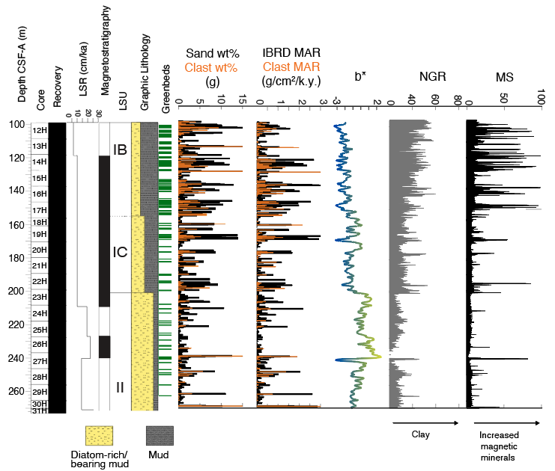

Supplementary Figure 1. Lithostratigraphy, grain size and physical property data sets of the Plio-Pleistocene record of U1524. The downcore distribution of greenish grey diatom-rich sandy mud beds coincide with an increase in coarse sand (250 m to 2 mm) and clast (>2 mm) content. Colour reflectance (b*) and physical property (NGR and MS) data highlight overall changes in lithological variability across LSUs.

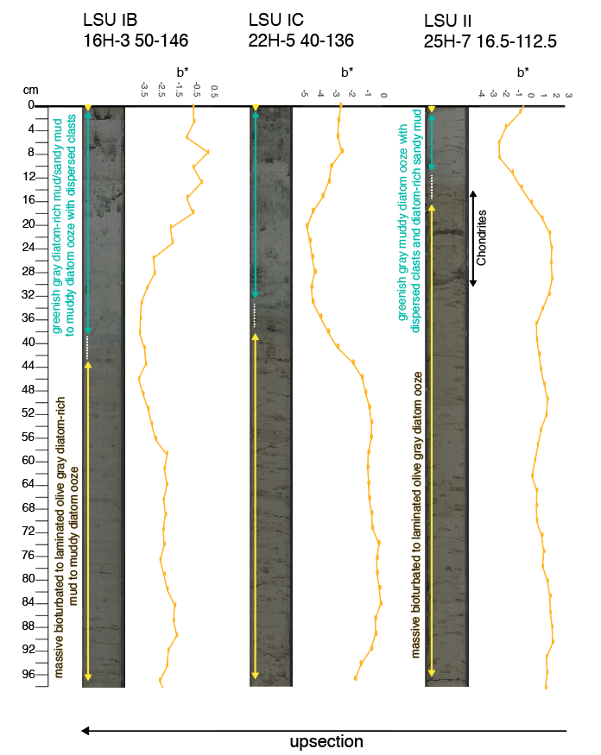
Supplementary Figure 2. Representative sequences of typical sedimentary packages. Bed thickness of diatom-rich sandy muds increase upcore and is highlighted by color reflectance b* data (low values = yellow; high values = blue).

IBRD as a proxy for ice dynamics
Methodologies vary in the determination of ice-rafted material as iceberg rafted debris (IBRD) and all have uncertainties, despite the utility of such records providing some of the most fundamental insights on both the onset and behavior of marine-terminating polar ice sheets and or glaciers in both the Northern and Southern Hemisphere. However, a recent review of methodologies commonly used in Antarctic margin records⁸³ examined the consistency between these methods which includes: (1) counting IRD particles in the 150 µm to 2 mm size fraction using a laser particle size analyzer, (2) calculating the weight percent of the 250 µm - 2 mm size fraction from sieving, and (3) visually counting particles > 2 mm from x-radiographs of sediment cores. The later of the two methods (in terms of consistency and reproducibility) provide the most robust method for quantifying the flux of ice rafted material to the sea, as the upper sand size fraction has been demonstrated to be less biased towards possible winnowing by bottom currents and turbidites in Antarctic margin settings analgous to U1524⁸³. The downcore distribution of IBRD MAR and Clast MAR correspond to each other in terms of abundance (Supplementary Fig. 1), which is consistent with previous studies^{15,83–87} that demonstrate the close relationship between the coarse sand fraction (250µm-2mm) and clasts (>2mm) content in marine sediment cores and their utility as a proxy for IRD or IBRD^{88,89}.
Currently, the Antarctic ice sheet loses 50-80% of its mass from iceberg calving events with the rest is due to basal melting³⁵. Newly formed icebergs can become entrained in the westward flowing Antarctic coastal current/ASC. In some regions, these bergs can undergo transport by local gyres whereby they become under the influence of the eastward flowing Antarctic circumpolar current (ACC) and migrate northward⁹⁰ (Fig.1). The flux of terrigenous material transported by these icebergs to a deep sea setting has commonly been used as a proxy to understand the flux of icebergs calving off the margin, thus reflecting mass balance changes of ice sheets and glaciers in both the Northern and Southern Hemispheres^{e.g., 15,91,92}. For example, large amplitude pulsing events of ice rafted debris within a sedimentary record most likely represents deposition to the sea floor during rapid disintegration of an ice shelf. Whereas, along margins that consists of fast-moving ice tongues and ice cliffs, ice rafting events maybe characterized by persistent low amplitude pulsing events throughout a sedimentary record³⁷. Glacial regimes changes may fluctuate between these two types of marine terminating glaciers and provide a mix signal in the geological record, but also maybe identifiable and allude to the presence or absence of an ice shelf³⁷. Millennial-scale pulses of ice rafted debris to the Scotia Sea and ice sheet modeling studies addressing Antarctic sea level contribution spanning the last deglaciation (20-9 kyr) demonstrate the utility of this proxy as an indicator of dynamic ice sheet discharge in the geological past^{62,86}.

IODP Site Meltwater proxies

Palynology

Protoperidinioid (P) dinocysts are mostly represented by the genera Brigantedinium, Lejeunecysta, Selenopemphix. P dinocysts are likely produced by heterotrophic dinoflagellates (Supplementary Data)⁹³ and, at present, dominate the assemblages in Antarctic sediments in areas with high nutrients and/or (year-round) sea-ice cover. At present, samples in quasi perennial sea-ice covered areas are dominated by Selenopemphix antarctica, with abundant Brigantedinium spp. and rare occurrence of other species^{94–97}. Gonyaulacoid dinocysts, mostly produced by autotrophic dinoflagellates (Supplementary Data)⁹³, are mostly absent and when present, they are represented by few specimens of Impagidinium pallidum and small Batiacasphaera. Total dinocysts concentrations (Supplementary Data) were calculated to identify productivity trends. Gonyaulacoid cysts are generally produced by phototrophic, autotrophic dinoflagellates. At present, they are rarely found in samples close to the Antarctic margin and mostly represented by Impagidinium pallidum, a species with polar distribution, and affinities for high nutrients, sea-ice, and reduced water salinity seasonally⁹⁶.
Of the 26 palynological samples analyzed between 223.2 and 253.1 mbsf, the sample at 240.7 m and all the samples below 247.4 mbsf were barren. In general, dinocysts were scarce in all samples (Supplementary Data), except for the samples at 227.5 m and 236.8 m where more than 100 dinocysts could be counted in 2 slides. The acritarch Leiosphaeridia was by far the dominant palynomorph in all samples (Supplementary Data It is usually interpreted as sea-ice indicator⁹⁵. Most of the samples contained few to abundant (227.5 m) brackish water algae Cymatiosphaera spp., which is taken to indicate brackish, stratified surface waters⁶ caused by ice melting^{32,95,98}.
The record of U1524 shows a general dominance of cysts produced by heterotrophic dinoflagellates and acritarch Leiosphaeridia, indicating a high productivity, sea-ice dominated environment, not dissimilar to that of present-day^{94–96}. Two peaks in total dinocyst concentrations at 227.5 and 237.8 m could be related to episodes of increased productivity. Interestingly, the peak at 227.5 mbsf coincides with a sudden increase in the presence and concentration of Cymatiosphaera (FIG) suggesting that a meltwater pulse event (and consequent release of nutrients) was the main cause of the increased productivity.
The percentages of autotrophic dinocysts (Supplementary Figure 3), mostly Impagidinium pallidum, are somewhat higher between 225.6 and ~229.8 mbsf which may indicate that during this interval a relatively longer period of open waters occurred. However, such data must be taken with caution, due to the generally low dinocyst counts.

Organic geochemical proxies
Short-chain n-fatty acids such as n-C₁₈ fatty acid originate from a wide variety of organisms, including terrestrial plants, phytoplankton, zooplankton and bacteria. However, ref. ^{99,100} examined sources of n-C₁₈ fatty acid in Antarctic coastal sediments and argued that its primary sources are likely pelagic phytoplankton, especially a Phaeocystis antarctica of the Prymnesiophytes, particularly so in the highly productive region. Phaeocystis antarctica is a major phytoplankton species, dominating spring phytoplankton blooms in the Ross Sea^{101,102}, which is one of the most productive areas in the Antarctic Ocean, supporting that n-C₁₈ fatty acid in U1524 predominantly originates from Phaeocystis. d¹³C of n-C₁₈ fatty acid also supports this interpretation. Average values of n-C₁₈ fatty acid d¹³C (-29.5 ‰ ± 1.2, n = 110) in U1524 is close to that of n-C₁₆ fatty acids (-30.7 ± 0.8 ‰) derived from Arctic pelagic phytoplankton¹⁰³.
dD of phytoplankton biomarkers has been proposed as a hydroclimate proxy, reflecting a combination of isotopic composition, temperature and salinity in surface water^{99,104,105}. In the coastal region where there is isotopically depleted freshwater discharge from land, dD of phytoplankton derived fatty acids in sediments primarily reflect the freshwater input^{104,106}. Ref. ⁹⁹ examined what the n-C₁₈ fatty acid dD record in a marine sediment core taken from off East Antarctica reflects and concluded that it mainly derived from discharge of isotopically depleted glacier meltwater from Antarctica in the Holocene. As shown in Fig. S3, a comparison of n-C₁₈ fatty acid dD and freshwater species in U1524 during the MPWP shows that the decreases in n-C₁₈ fatty acid dD coincide with periods of high abundance of freshwater species, supporting that the dD of n-C₁₈ fatty acids in U1524 records glacial meltwater events.

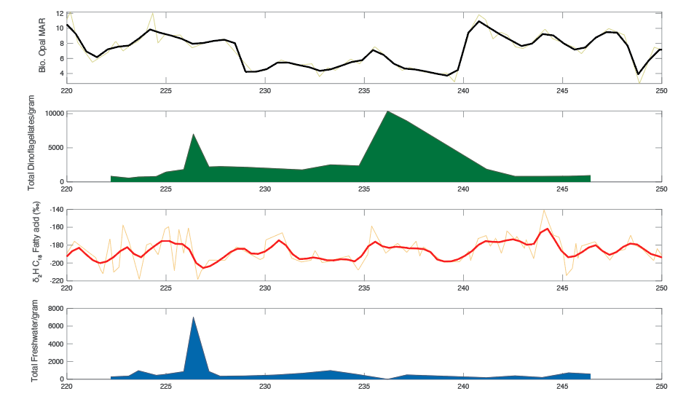
Supplementary Figure 3. Comparisons of mid-Pliocene productivity and meltwater proxies in U1524 plotted against Depth CSF-B(m).

Time Series Results and Analysis Examining the Effects of Variable Sedimentation and Red-Noise

Orbital interpretations are based on frequencies identified in the E-T-P solution⁴⁵ from 2345 to 3317 ka, where E1=411.86-kyr, E2=93.91-kyr, O1=40.57-kyr, P1=23.61-kyr, P2=22.35-kyr, and P3=18.8-kyr periodicities.

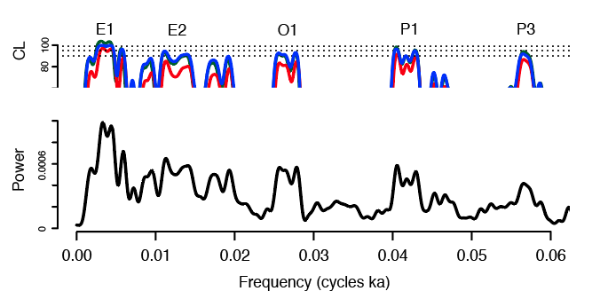
Supplementary Figure 4. Power spectral estimates for the untuned U1524 IBRD-MAR record. Significant orbital frequencies are identified using three red noise confidence level (CL) estimates (red line⁵⁷; blue line⁴⁶; green line⁵⁸).

Supplementary Table 1. Power spectral estimates results and orbital interpretations for the untuned U1524 IBRD-MAR record. Estimates above a 90% harmonic confidence level limit are listed.
Frequency | Period (k.y.) | Harmonic CL | Red Noise CL | Orbital Interpretation
LOWSPEC
0.003 | 368.821 | 98.235 | 92.550 | E1
0.013 | 78.037 | 98.452 | 82.259 | E2
0.027 | 37.308 | 97.438 | 84.196 | O1
0.042 | 24.069 | 98.347 | 85.129 | P1
0.058 | 17.933 | 92.783 | 63.734 | P3
mtmML96
0.003 | 368.182 | 98.207 | 96.376 | E1
0.010 | 98.580 | 97.141 | 65.665 | E2
0.013 | 78.072 | 98.278 | 88.115 | E2
0.027 | 37.313 | 97.523 | 89.990 | O1
0.042 | 24.071 | 98.369 | 89.656 | P1
0.058 | 17.934 | 92.601 | 68.243 | P3
mtm
0.003 | 369.182 | 98.252 | 84.249 | E1
0.013 | 78.072 | 97.895 | 72.270 | E2
0.027 | 37.313 | 97.523 | 80.124 | O1
0.042 | 24.071 | 98.369 | 81.644 | P1

Supplementary Table 2. Power spectral estimates results and orbital interpretations for the untuned U1524 Biogenic Opal MAR record (3319-3034 kyr). Estimates above a 90% harmonic confidence level limit are listed.
Frequency | Period (k.y.) | Harmonic CL | Red Noise CL | Orbital Interpretation
LOWSPEC
0.045 | 22.446 | 99.096 | 69.229 | P2
0.053 | 19.050 | 93.146 | 77.959 | P3
mtmML96
0.045 | 22.429 | 99.209 | 74.882 | P2
0.052 | 19.065 | 93.038 | 83.592 | P3
mtm
0.045 | 22.429 | 99.209 | 67.505 | P2
0.052 | 19.065 | 93.038 | 76.851 | P3

Supplementary Table 3. Power spectral estimates results and orbital interpretations for the untuned U1524 TEX₈₆ SST estimates (3319-3034 kyr). Estimates above a 90% harmonic confidence level limit are listed.
Frequency | Period (k.y.) | Harmonic CL | Red Noise CL | Orbital Interpretation
LOWSPEC
0.044 | 22.866 | 96.245 | 72.916 | P2
mtmML96
0.044 | 22.863 | 94.829 | 83.649 | P2
0.052 | 19.365 | 97.591 | 71.116 | P3
mtm
0.044 | 22.863 | 94.829 | 76.7429 | P2
0.052 | 19.365 | 97.591 | 60.417 | P3

Supplementary Table 4. Power spectral estimates results and orbital interpretations for the untuned U1524 ₂H C₁₈ fatty acid meltwater proxy estimates (3319-3034 kyr). Estimates above a 90% harmonic confidence level limit are listed.
Frequency | Period (k.y.) | Harmonic CL | Red Noise CL | Orbital Interpretation
LOWSPEC
0.026 | 38.730 | 99.272 | 93.594 | O1
mtmML96
0.026 | 38.780 | 99.241 | 93.956 | O1
mtm
0.026 | 38.780 | 99.241 | 90.977 | O1

Effect of Variable sedimentation
To account for distortions related to variable sedimentation, we applied the U1524 sedimentation rates and IBRD sampling interval to the mid- to late-Pliocene ETP solution spanning the time-period as the U1524 IBRD record. We compare this solution to that of the undistorted ETP solution⁴⁵ (Supplementary Figure 5). Note that the difference in MTM power estimates is nearly identical between the two, showing minimal loss of power due to distortion. In this instance, U1524 sedimentation does not appear to significantly distort the frequency spectrum of the ETP solution; at the sampling resolution utilized within this study (0.24m median sample interval), it seems likely that the IBRD record from U1524 is robust for time-series analysis with respect to distortion from sedimentation.

Effects of added “red” noise for ETP, U1524, and U1361
In addition to distortion of records by variable sedimentation, another challenge in time-series analysis is contamination by means of stochastic noise. Noise can fall on a spectrum between non-autocorrelated “white” noise and autocorrelated “red” noise. “Red” noise frequently leads to false positives at lower frequencies, making true positives within the eccentricity range hard to detect. The ‘Robust’ AR1 Multi-Taper Method⁴⁶ and LOWSPEC⁵⁸ functions employed within this study are generally very effective at enhancing spectral peak detection and minimizing false positives, especially within lower frequency Eccentricity bands, that result from noise contamination. It is important to note that we utilize an improved Robust AR1 methodology, originally introduced in Ref ¹⁵, which overcomes a low frequency bias in the original method Ref. ⁴⁶. Here, we further quantify the effect of adding noise to time-series records by testing the noise limits at which various spectral peaks become undetectable (Supplemental Figure 6).

As a first pass for testing the sensitivity of LOWESPEC to the contamination, noise was added to the mid- to late-Pliocene pure ETP solution⁴⁹ at variable degrees of autocorrelation from ρ=0.0 (“white”) to ρ=1.0 (“red”). In all cases, the variance of the noise was equal to that of the ETP solution itself; additionally, all of the astronomical terms (E1, E2, O1, P1, P2, and P3) are present and identifiable with LOWSPEC in the original solution. As we can see in Supplemental Figure 6, the addition of noise of any degree of autocorrelation does not seem to affect the detection of O1, P1, and P2 peaks. P3 appears to be readily detectable with moderately “red” noise, although the power appears to be weaker than for other P terms. E1 and E2 are most affected by the addition of noise; E1 becomes less detectable with highly “red” noise (ρ>0.6), whereas E2 becomes less detectable with moderately “red” noise (ρ>0.3). This is likely a reflection of the noise modeling inherent to LOWSPEC analysis; LOWSPEC greatly reduces the likelihood of falsely identifying peaks in the low-frequency domain that could easily be attributed to noise (Meyers, 2012). Conversely, when low-frequency peaks are identified as significant via LOWSPEC, there is a higher likelihood that they represent true positives and were not produced by noise alone.

As a next step at quantifying the effect of added noise to ETP as well as IBRD records from sites U1524 and U1361, 10,000 MC simulations were performed on each record for each of four noise coefficients (ρ = 0.0, 0.3, 0.6, 0.9) to further examine the effect of added noise (Supplemental Figure 7). Again, the variance of the noise added in these simulations was equal to that of the original record. Frequencies identified as significant at 85% confidence via LOWSPEC were compiled for each record/noise coefficient; kernel density was estimated for each record/noise coefficient so as to semi-quantitatively examine how noise affects the spectra.

For the ETP solution, the effects are similar to those observed in Supplemental Figure 6: the addition of noise at any degree of “redness” does not seem to have a major effect on terms O1, P1, P2, and P3, whereas moderately- to highly- “red” noise affect the detection of E2 and E1 terms, respectively. On the other hand, the addition of “red” noise to the IBRD records from sites U1524 and U1361 appears to have a noticeable though less dramatic effect on terms E1 and E2. This suggests that perhaps the eccentricity-band signal present within these two records is strong enough that it was unlikely to have been a product of noise alone. For site 1524, the effect of added noise on O1 and P1-P3 peaks appears to be minimal at low- to moderate-“red” noise.

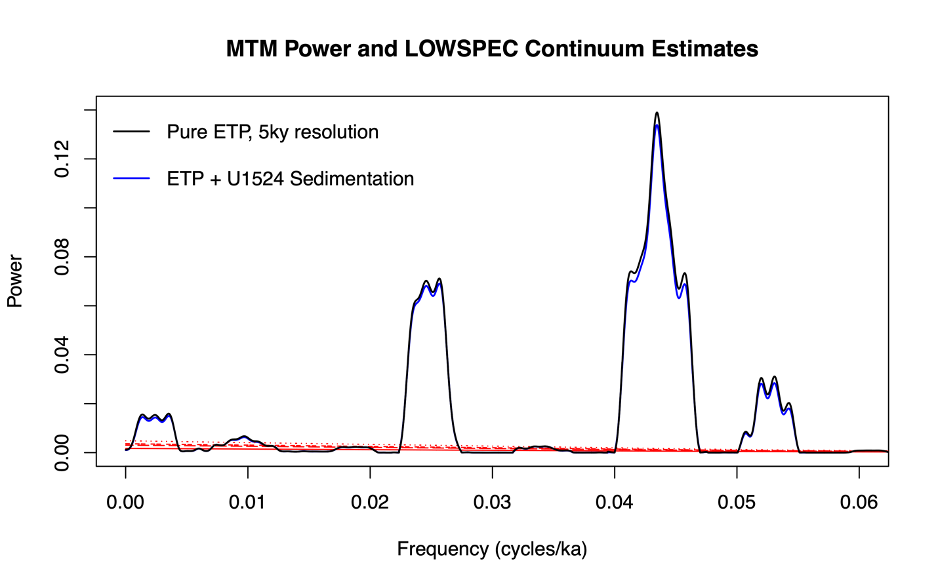
Supplementary Figure 5. LOWSPEC comparison between Pure ETP record at 5ky resolution vs ETP record with 1524 sedimentation rate/IBRD sampling interval applied. Power spectra of ETP solution for the Mid- to Late-Pliocene interval spanning U1524 IBRD record (3300-2300 ka) at 5kyr sample resolution (black) and ETP solution with U1524 sedimentation rates and sampling interval applied (blue) are plotted against LOWSPEC background (solid red) and LOWESPEC 90-95-99 Confidence Levels (dashed red) curves.

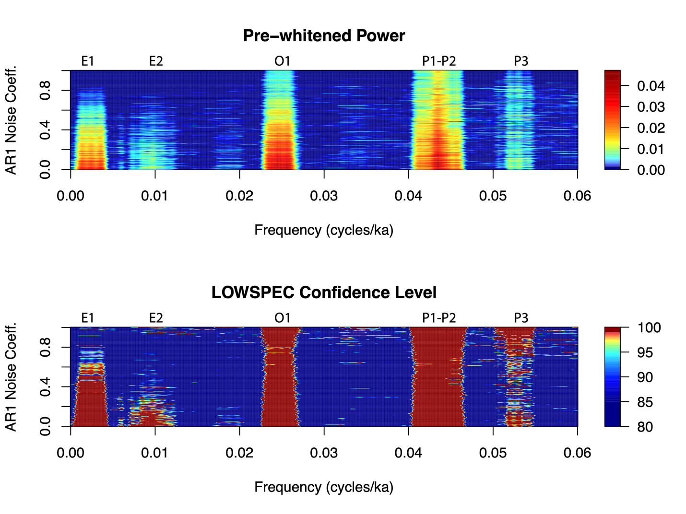
Supplementary Figure 6. Power/Confidence heatmap plot for E-T-P solution + Noise. Pre-whitened power and confidence level (e.g., the confidence with which we can reject the null hypothesis that a spectral peak is produced by noise alone) identified via LOWSPEC analysis (Meyers, 2012). AR1 noise coefficient (ρ) is a measure of how correlated (or “red”) added noise is. O1 and P1-P2 frequency bands are readily identified with high confidence regardless of how “red” the added noise is. E1 and P3 bands are identifiable with moderately “red” noise. E2 is most affected by the addition of highly “red” noise, but it is still identifiable up to ρ=0.2-0.3. ρ=0.0 means non-autocorrelated “white” noise; ρ=1.0 means purely autocorrelated “red” noise.

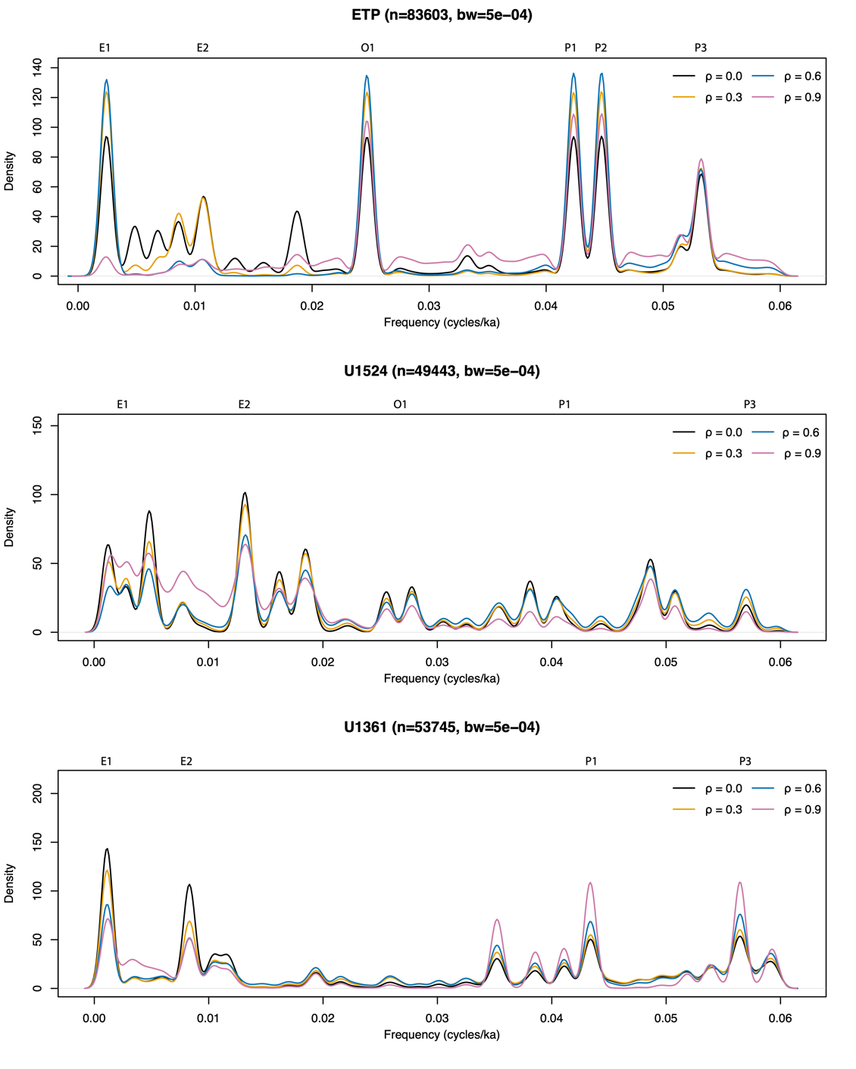

Supplementary Figure 7. Spectral Frequency Kernel Density plots for pure E-T-P solution, as well as U1524 and U1361 IBRD records. Frequencies are identified from LOWSPEC analysis (Meyers, 2012) of the given record plus added noise; they are significant at 85% confidence level (CL). 10000 iterations per AR1 noise coefficient (ρ) are run for each record to test the sensitivity of spectral peaks to the addition of variable “red” noise. Kernel density of frequencies identified as significant is estimated using bandwidth of 5e-4 (cycles/ka) from compiled results all iterations at a specified noise coefficient.

Ice Sheet Modeling Experiments
Our model ensemble consists of five air and ocean temperature scenarios over 20,000 year-long model runs (Supplementary Figures 8) using the methods of Ref. ³⁰. These climate scenarios allow us to investigate the ice sheet response to varying levels of ocean and atmospheric forcing. From the simulations we extract either area-integrated or area-averaged values for four key metrics for the two West Antarctic Ice Sheet catchments (Amundsen Sea and Siple Coast) most likely to affect core site U1524, and the two East Antarctic Ice Sheet catchments (Transantarctic Mountains -TAM- and Wilkes subglacial basin -SB-) catchments most likely to affect core site U1361^{30,107}. Supplementary Figures 8 lustrates the time-evolving changes taking place in each of these four sectors under each of the temperature scenarios considered. The four rows present (a) the percent change of the volume of grounded ice, (b) percent change in the area of floating ice, (c) average ice temperature at the bed, and (d) percent change in the average velocity at the base of the ice.

A clear difference exists between the responses of the West (brown lines) and East (blue lines) Antarctic catchments. In all temperature scenarios, West Antarctic catchments lose grounded ice more rapidly than their East Antarctic counterparts. As grounded ice declines, floating area tends to initially increase (reflecting flotation of previously grounded ice), but then decreases as ocean-forced melt leads to calving line retreat. The mean basal temperatures of West Antarctic catchments tends to decline as ice is lost, reflecting thinning and greater escape of geothermal heat, as well as reductions in velocity that lower the amount of frictional and strain heating taking place. East Antarctic catchments, by contrast, mostly warm slightly as the simulations proceed, reflecting greater strain and frictional heating arising from steeper ice margins and faster overall flow.

The rate at which these changes take place and the characteristics of the response depend on both the magnitude of the forcing (i.e., air temp. and ocean temp. scenarios) and catchment. Under all forcing scenarios, the WAIS Siple Coast and Amundsen catchments experience the fastest and greatest amount of volume loss of grounded ice as basal velocities increase within the first 5-kyr of the simulations. The dramatic loss of floating ice following 5-kyr would most likely transpire as rapid disintegration events of floating ice and input of iceberg armada events into the adjacent Southern Ocean^{37.} The slower and smaller magnitude of response for the TAM and Wilkes SB may reflect the slower waxing and waning of ice retreat with more of a constant discharge of icebergs that occurs along those adjacent EAIS margins³⁷.

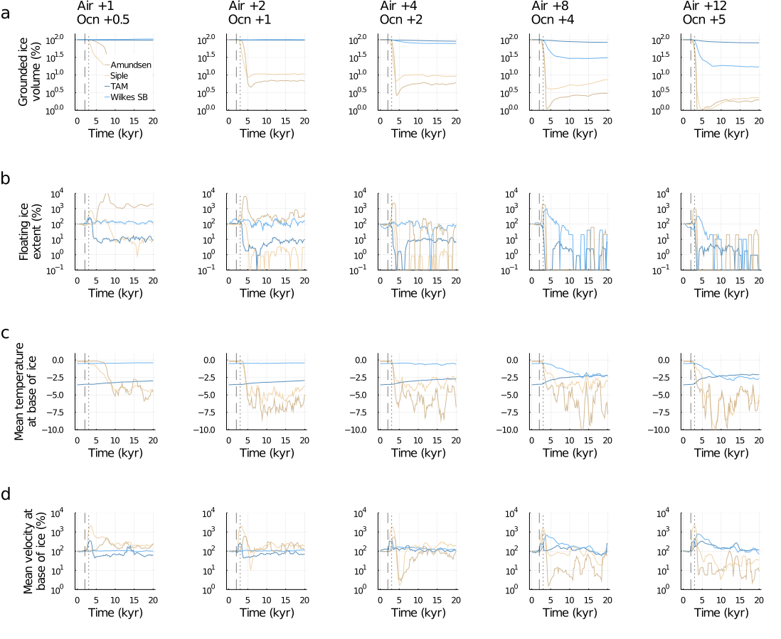
Supplementary Figure 8. Relative sensitivity of WAIS and EAIS catchments to air and ocean temperature increases. a) percent change of the volume of grounded ice, (b) percent change in the area of floating ice, (c) average ice temperature at the bed, and (d) percent change in the average velocity at the base of the ice. All percentage values are relatively to the initial modelled state (100%) for each catchment. Brown lines denote West Antarctic catchments, blue lines show East Antarctic catchments. Vertical dashed and dotted lines at 2000 and 3000 years show respectively the start and end times of the ramped thermal forcing imposed. Totals (a, b) and averages (c, d) are calculated from all cells with non-zero ice thickness in each catchment.

Supplementary Material References
71. Deep-water fine-grained sediments: facies models | Geological Society, London, Special Publications. https://www.lyellcollection.org/doi/abs/10.1144/GSL.SP.1984.015.01.38.
72. Lucchi, R. G. et al. Mid-late Pleistocene glacimarine sedimentary processes of a high-latitude, deep-sea sediment drift (Antarctic Peninsula Pacific margin). Mar. Geol. 189, 343–370 (2002).
73. Threshold behavior of a marine‐based sector of the East Antarctic Ice Sheet in response to early Pliocene ocean warming - Hansen - 2015 - Paleoceanography - Wiley Online Library. https://agupubs.onlinelibrary.wiley.com/doi/full/10.1002/2014PA002704.
74. Passchier, S., Hansen, M. A. & Rosenberg, J. Quartz grain microtextures illuminate Pliocene periglacial sand fluxes on the Antarctic continental margin. Depositional Rec. 7, 564–581 (2021).
75. De Santis, L., Prato, S., Brancolini, G., Lovo, M. & Torelli, L. The Eastern Ross Sea continental shelf during the Cenozoic: implications for the West Antarctic ice sheet development. Glob. Planet. Change 23, 173–196 (1999).
76. Rebesco, M., Camerlenghi, A., Geletti, R. & Canals, M. Margin architecture reveals the transition to the modern Antarctic ice sheet ca. 3 Ma. Geology 34, 301–304 (2006).
77. Bart, P. J. & Desantis, L. Glacial Intensification During the Neogene: A Review of Seismic Stratigraphic Evidence from the Ross Sea, Antarctica, Continental Shelf. Oceanography 25, 166–183 (2012).
78. Bart, P. J. & Iwai, M. The overdeepening hypothesis: How erosional modification of the marine-scape during the early Pliocene altered glacial dynamics on the Antarctic Peninsula’s Pacific margin. Palaeogeogr. Palaeoclimatol. Palaeoecol. 335–336, 42–51 (2012).
79. Antarctic role in Northern Hemisphere glaciation | Science. https://www.science.org/doi/full/10.1126/science.1255586?casa_token=yS6f_I44J3UAAAAA%3AV3j1POfdEF2JYbRiGx2SPxqBCv8umAxL4yGSZhu2P8lQuD_wzqKFFBG1hC8izObSZmKRJlx6F_D1XsOi.
80. Patterson, M. O., et al. A Southwest Pacific perspective on long‐term global trends in Pliocene‐Pleistocene stable isotope records. Paleoceanography and Paleoclimatology 33.7, 825-839 (2018).
81. Whitehead, J. M. & Bohaty, S. M. Pliocene summer sea surface temperature reconstruction using silicoflagellates from Southern Ocean ODP Site 1165. Paleoceanography 18, (2003).
82. Escutia, C. et al. Circum-Antarctic warming events between 4 and 3.5 Ma recorded in marine sediments from the Prydz Bay (ODP Leg 188) and the Antarctic Peninsula (ODP Leg 178) margins. Glob. Planet. Change 69, 170–184 (2009).
83. McKay, R. et al. A Comparison of Methods for Identifying and Quantifying Ice Rafted Debris on the Antarctic Margin. Paleoceanogr. Paleoclimatology 37, e2021PA004404 (2022).
84. Clark, P. U. & Pisias, N. G. Interpreting Iceberg Deposits in the Deep Sea. Science 290, 51–52 (2000).
85. Proceedings of the Ocean Drilling Program, 145 Scientific Results. vol. 145 (Ocean Drilling Program, 1995).
86. Weber, M. E. et al. Millennial-scale variability in Antarctic ice-sheet discharge during the last deglaciation. Nature 510, 134–138 (2014).
87. Grobe, H. A simple method for the determination of ice-rafted debris in sediment cores. Polarforschung 57, 123–126 (1987).
88. Evans, J. et al. Late Quaternary sedimentation in Kejser Franz Joseph Fjord and the continental margin of East Greenland. Geol. Soc. Lond. Spec. Publ. 203, 149–179 (2002).
89. Anderson, J. B. Antarctic Marine Geology. (Cambridge University Press, 1999).
90. Stuart, K. M. & Long, D. G. Tracking large tabular icebergs using the SeaWinds Ku-band microwave scatterometer. Deep Sea Res. Part II Top. Stud. Oceanogr. 58, 1285–1300 (2011).
91. Kanfoush, S. L. Millennial -scale variability in late Pleistocene ice-rafting to the South Atlantic Ocean. (University of Florida, United States -- Florida).
92. Jansen, E., Fronval, T., Rack, F. & Channell, J. E. T. Pliocene-Pleistocene ice rafting history and cyclicity in the Nordic Seas during the last 3.5 Myr. Paleoceanography 15, 709–721 (2000).
93. Harland, R. & Pudsey, C. J. Dinoflagellate cysts from sediment traps deployed in the Bellingshausen, Weddell and Scotia seas, Antarctica. Mar. Micropaleontol. 37, 77–99 (1999).
94. Prebble, J. G. et al. An expanded modern dinoflagellate cyst dataset for the Southwest Pacific and Southern Hemisphere with environmental associations. Mar. Micropaleontol. 101, 33–48 (2013).
95. Hartman, J. D., Bijl, P. K. & Sangiorgi, F. A review of the ecological affinities of marine organic microfossils from a Holocene record offshore of Adélie Land (East Antarctica). J. Micropalaeontology 37, 445–497 (2018).
96. Zonneveld, K. A. F. et al. Atlas of modern dinoflagellate cyst distribution based on 2405 data points. Rev. Palaeobot. Palynol. 191, 1–197 (2013).
97. Thöle, L. M. et al. An expanded database of Southern Hemisphere surface sediment dinoflagellate cyst assemblages and their oceanographic affinities. J. Micropalaeontology 42, 35–56 (2023).
98. Hannah, M. J. The palynology of ODP site 1165, Prydz Bay, East Antarctica: A record of Miocene glacial advance and retreat. Palaeogeogr. Palaeoclimatol. Palaeoecol. 231, 120–133 (2006).
99. Ashley, K. E. et al. Mid-Holocene Antarctic sea-ice increase driven by marine ice sheet retreat. Clim. Past 17, 1–19 (2021).
100. Ashley, K. E. et al. Exploring the use of compound-specific carbon isotopes as a palaeoproductivity proxy off the coast of Adélie Land, East Antarctica. Biogeosciences 18, 5555–5571 (2021).
101. DiTullio, G. R. et al. Rapid and early export of Phaeocystis antarctica blooms in the Ross Sea, Antarctica. Nature 404, 595–598 (2000).
102. Schoemann, V., Becquevort, S., Stefels, J., Rousseau, V. & Lancelot, C. Phaeocystis blooms in the global ocean and their controlling mechanisms: a review. J. Sea Res. 53, 43–66 (2005).
103. Budge, S. M. et al. Tracing carbon flow in an arctic marine food web using fatty acid-stable isotope analysis. Oecologia 157, 117–129 (2008).
104. Sachs, J. P. et al. An Arctic Ocean paleosalinity proxy from δ2H of palmitic acid provides evidence for deglacial Mackenzie River flood events. Quat. Sci. Rev. 198, 76–90 (2018).
105. Assessment of hydrogen isotopic compositions of n‐fatty acids as paleoclimate proxies in Lake Biwa sediments - Seki - 2012 - Journal of Quaternary Science - Wiley Online Library. https://onlinelibrary.wiley.com/doi/full/10.1002/jqs.2577.
106. Häggi, C., Chiessi, C. M. & Schefuß, E. Testing the D / H ratio of alkenones and palmitic acid as salinity proxies in the Amazon Plume. Biogeosciences 12, 7239–7249 (2015).
107. Zwally, H. J., Robbins, J. W., Luthcke, S. B., Loomis, B. D. & Rémy, F. Mass balance of the Antarctic ice sheet 1992–2016: reconciling results from GRACE gravimetry with ICESat, ERS1/2 and Envisat altimetry. J. Glaciol. 67, 533–559 (2021).

