II-Supplementary Figures
A549 HepG2
- Melittin
- Cetuximab
- Bevacizumab
- Cetuximab/Melittin combination
- Bevacizumab/Melittin combination
Supplementary Figure 1.

A. | A549 cancer cells | HepG2 cancer cells
 | 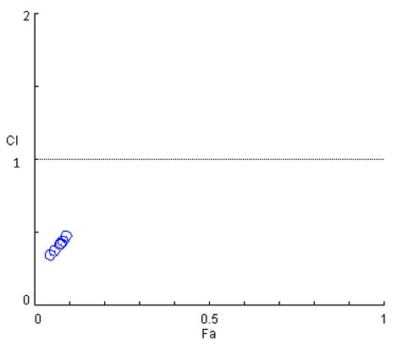 | 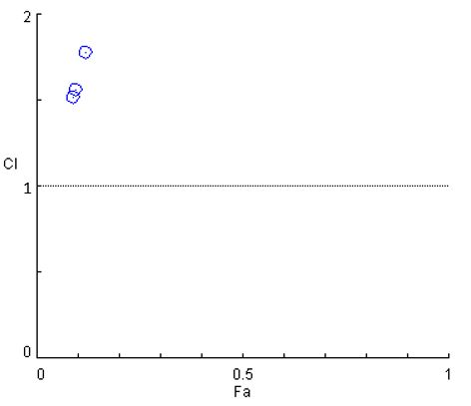
B. | 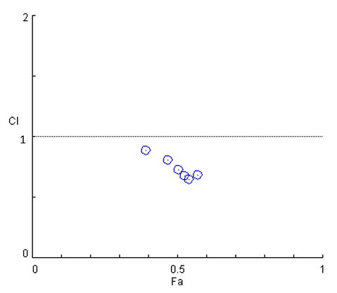 | 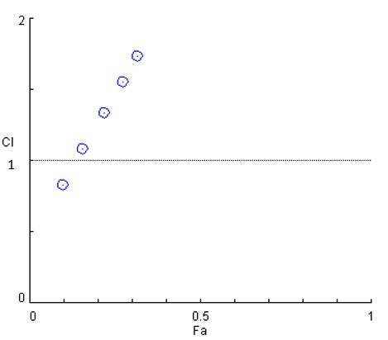
C. | 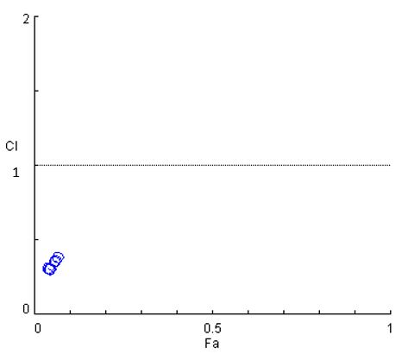 | 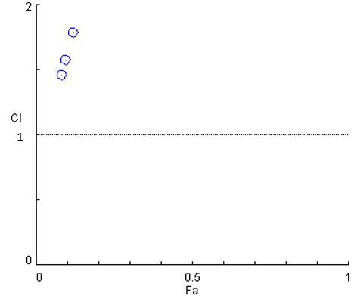
D. | 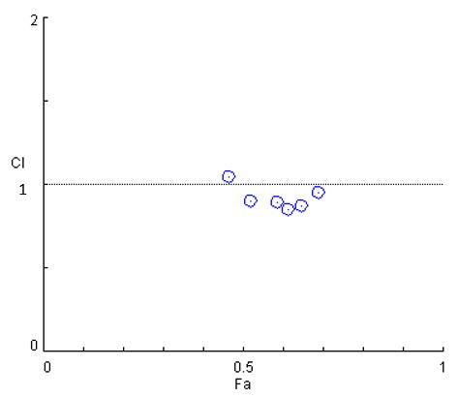 | 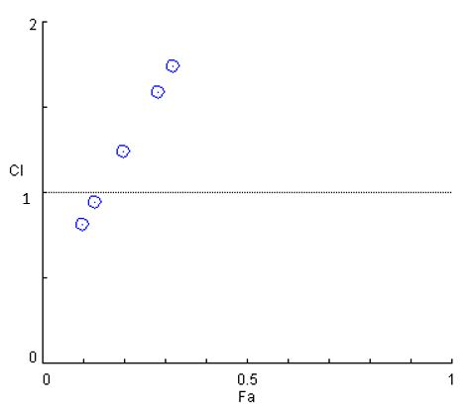
Supplementary Figure 2.

A549 Cell Apoptosis
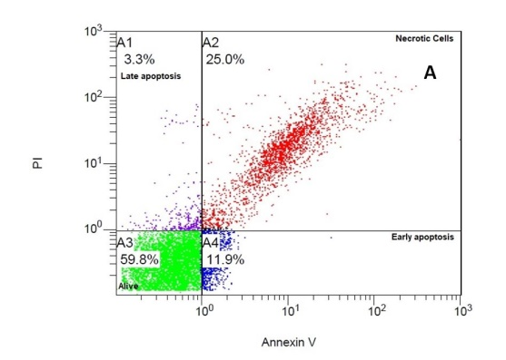 | 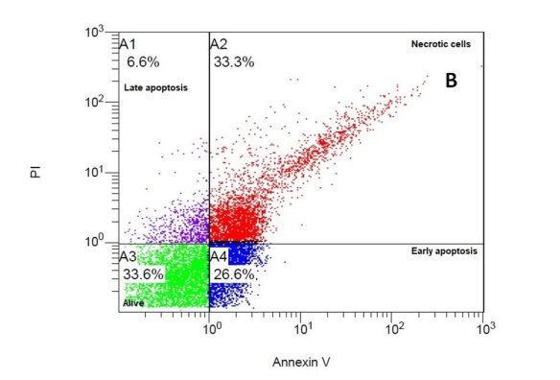
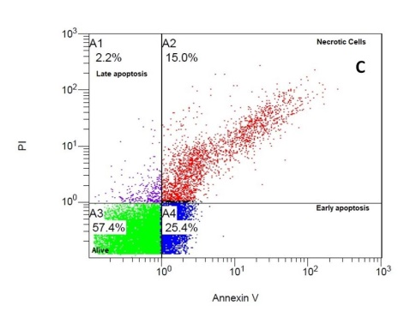 | 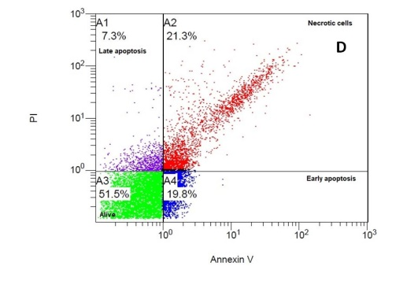
Supplementary Figure 3.

HepG2 Apoptosis
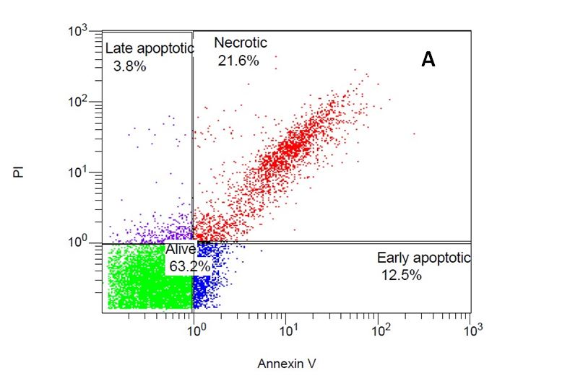 | 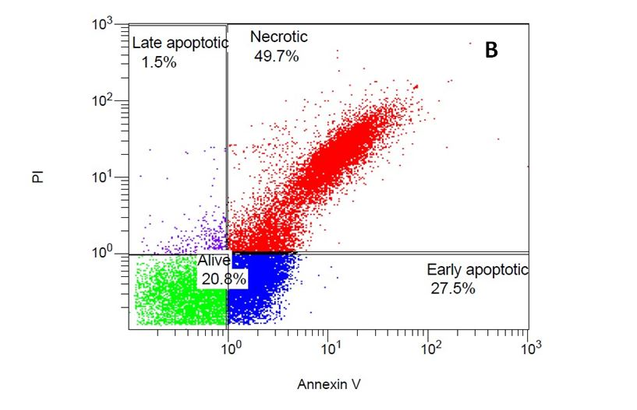
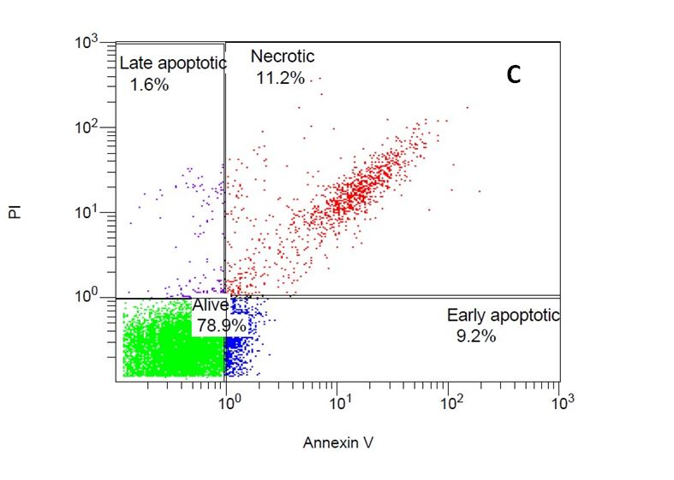 | 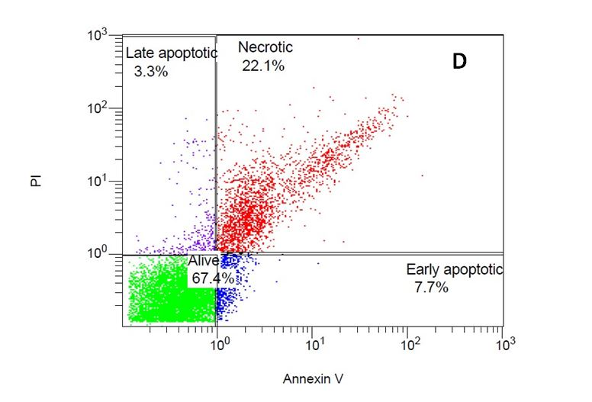
Supplementary Figure 4.

A549 Cell Cycle
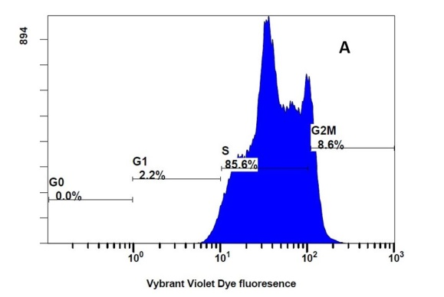 | 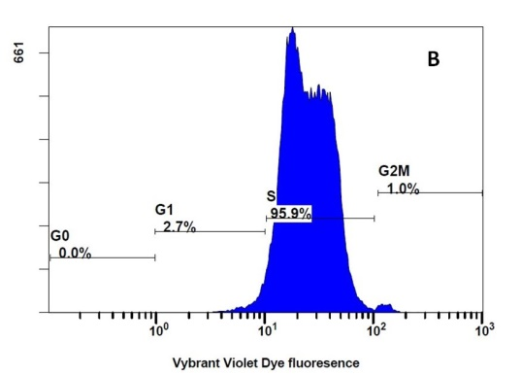
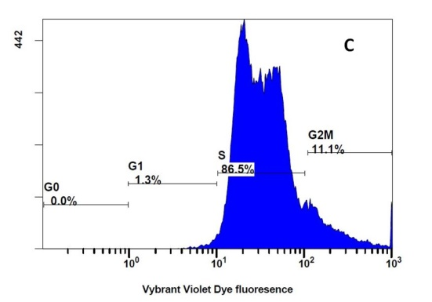 | 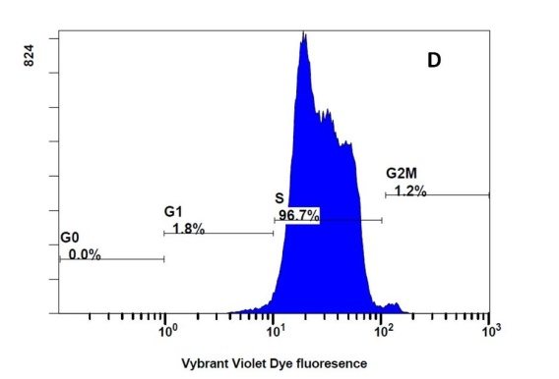
Supplementary Figure 5.

HepG2 Cell Cycle
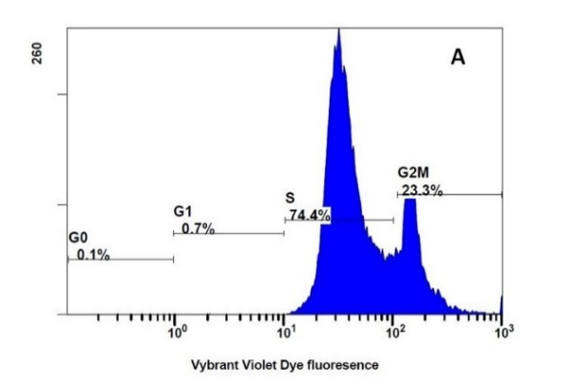 | 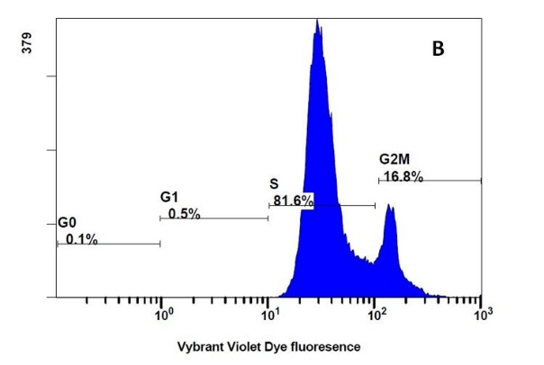
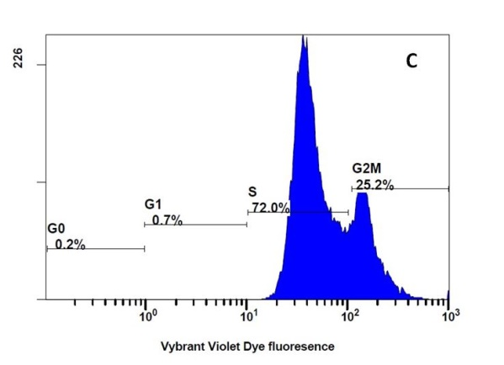 | 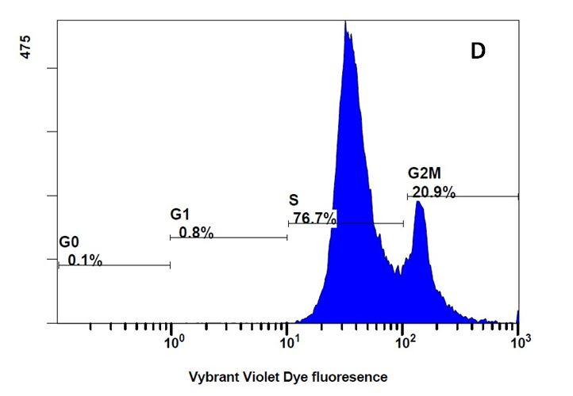

Supplementary Figure 6.

Supplementary Figure Legends
Supplementary Figure 1. MTT assays were used to determine the effects of various drug concentrations on the viability of A549 (A) and HepG2 (B) cancer cells after 24 and 48 hours of treatment. (A) Effects of various melittin concentrations. (B) Effects of various cetuximab concentrations. (C) Effects of various bevacizumab concentrations. (D) Effects of the combination of cetuximab and melittin. (E) Effects of the combination of bevacizumab and melittin. **** represents a P value < 0.0001, *** represents P < 0.001, ** represents a P value <0.01, and * represents a P value <0.05. The results from three independent experiments are shown. Each value represents a reading from one of the triplicate wells in each experiment. IC₅₀ denotes the half-maximal inhibitory concentration of each drug.
Supplementary Figure 2. Combination index plots of the effects of mAbs combined with different concentrations of melittin on A549 and HepG2 cancer cells are shown in the left and right panels, respectively. The nonconstant ratio interactions between mAbs and melittin are expressed in terms of cell viability. mAbs were used at different concentrations with twofold dilutions ranging from 1000 µg/mL to 31.25 µg/mL, and melittin was used at different concentrations (50, 25, and 12.5 µg/mL) in A549 and HepG2 cell lines after a 48-hour treatment period as follows: (A) Cetuximab was combined with 50 µg/mL melittin. (B) Left, cetuximab combined with 12.5 µg/mL melittin. Right, cetuximab combined with 25 µg/mL melittin. (C) Bevacizumab combined with 50 µg/mL melittin. (D) Left, bevacizumab combined with 12.5 µg/mL melittin. Right, bevacizumab combined with 25 µg/mL melittin. (Fa) is the fraction affected, and (CI) is the combination index as the result of the combination represented in the graph. All dots >1 indicate antagonism, those <1 indicate synergism, and those =1 indicate an additive effect.
Supplementary Figure 3. Flow cytometry analysis of apoptosis and necrosis in A549 cancer cells after single and combined mixture treatments. All panels show representative flow cytometry dot plots for propidium iodide (PI)/Annexin V staining of cancer cell lines (A) Cetuximab IC₅₀ (208 µg/mL) single treatment, (B) Cetuximab IC₅₀/25 µg/mL Melittin combined mixture treatment, (C) Bevacizumab IC₅₀ (206.5 µg/mL) single treatment, (D) Bevacizumab IC₅₀/25 µg/mL Melittin combined mixture treatment.
Supplementary Figure 4. Flow cytometry analysis of apoptosis and necrosis in HepG2 cancer cells after single and combined mixture treatments. All panels show representative flow cytometry dot plots for propidium iodide (PI)/Annexin V staining of cancer cell lines (A) Cetuximab IC₅₀ (265 µg/mL) single treatment, (B) Cetuximab IC₅₀/12.5 µg/mL Melittin combined mixture treatment, (C) Bevacizumab IC₅₀ (708.84 µg/mL) single treatment, (D) Bevacizumab IC₅₀/12.5 µg/mL Melittin combined mixture treatment.
Supplementary Figure 5. Cell cycle pattern analysis of A549 cancer cells after single and combined mixture treatments. All panels show representative flow cytometry histograms for cell cycle staining with Vybrant DyeCycle Violet stain (A) Cetuximab IC₅₀ (208 µg/mL) single treatment, (B) Cetuximab IC₅₀/25 µg/mL Melittin combined mixture treatment, (C) Bevacizumab IC₅₀ (206.5 µg/mL) single treatment, (D) Bevacizumab IC₅₀/25 µg/mL Melittin combined mixture treatment.
Supplementary Figure 6. Cell cycle pattern analysis of HepG2 cancer cells after single and combined mixture treatments. All panels show representative flow cytometry histograms for cell cycle staining with Vybrant DyeCycle Violet stain (A) Cetuximab IC₅₀ (265 µg/mL) single treatment, (B) Cetuximab IC₅₀/12.5 µg/mL Melittin combined mixture treatment, (C) Bevacizumab IC₅₀ (708.84 µg/mL) single treatment, (D) Bevacizumab IC₅₀/12.5 µg/mL Melittin combined mixture treatment.

