Supplementary Materials for

Remote Detection of Human Brain Reaction to Speech by AI Speckle Pattern Analysis

N. Segal¹†*, Ya. Beiderman¹, Z. Kalyuzhner¹, S. Agdarov¹, Ye. Beiderman², Z. Zalevsky¹‡

Corresponding author: Natalya Segal. Email: Natalya.Segal@gmail.com

The PDF file includes:

Figs. S1 to S9
Tables S1 to S2

Supplementary text, figures, and tables.

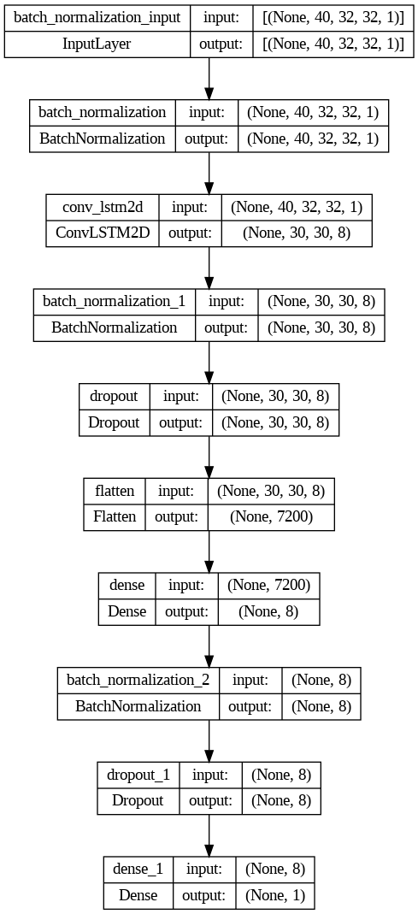
Fig. S1. DNN layers and input/output tensor shapes per layer.
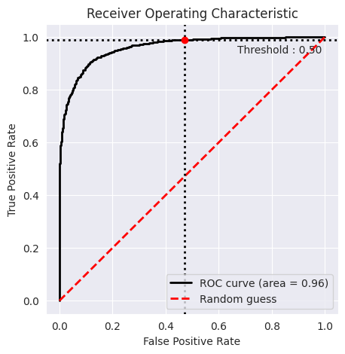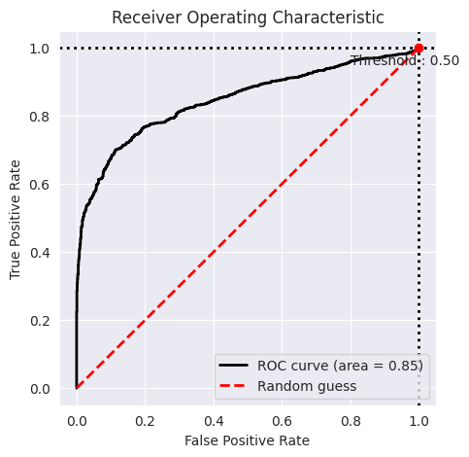
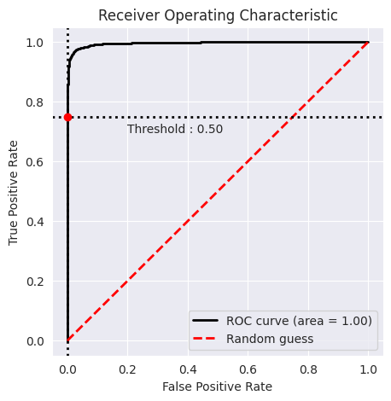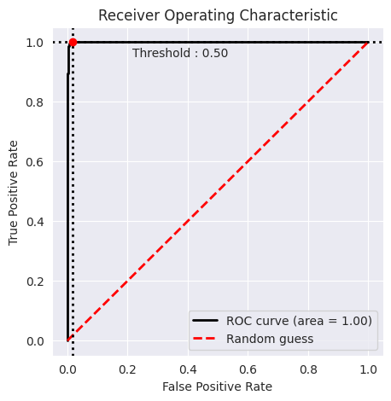
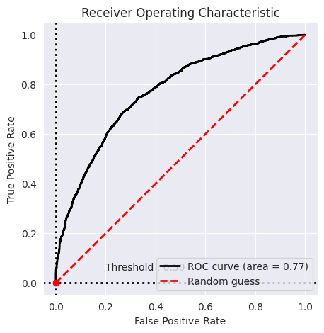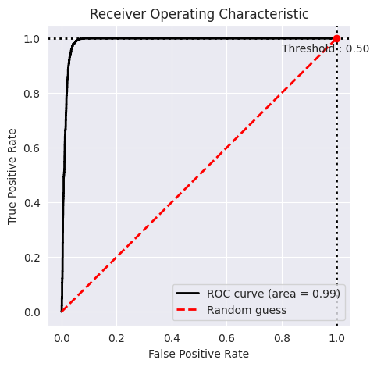
Fig. S2.
AUC-ROC curve per subjects 1 to 6 (numbers run from left to right). The AUC average 0.93. The lowest AUC was for the subject with the highest age.
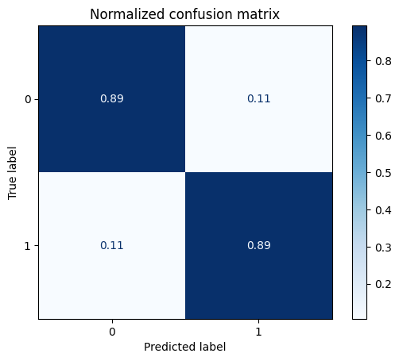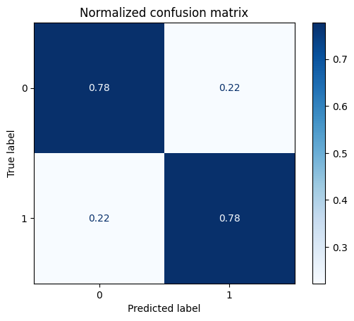
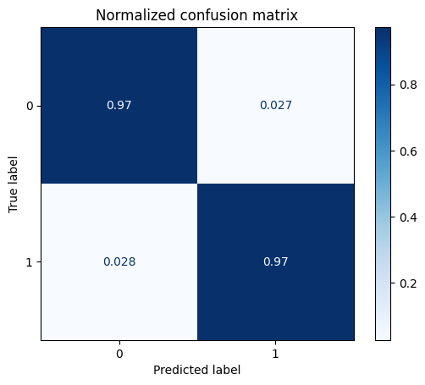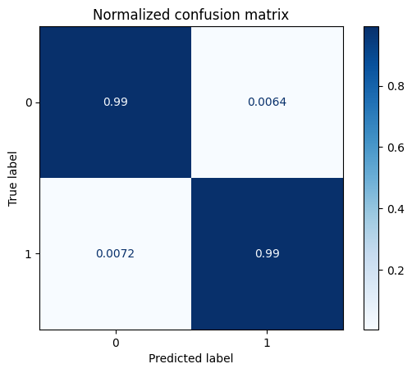
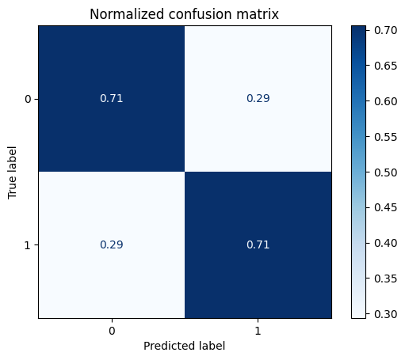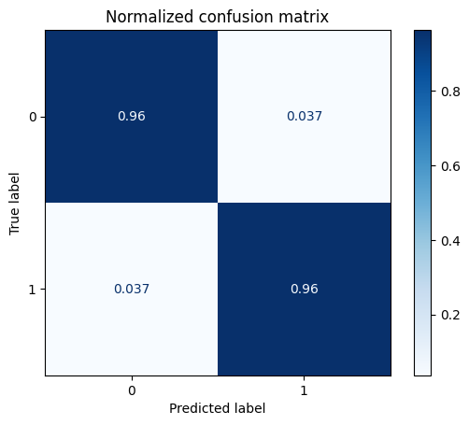
Fig. S3.
Normalized confusion matrices for subjects 1-6.

  - 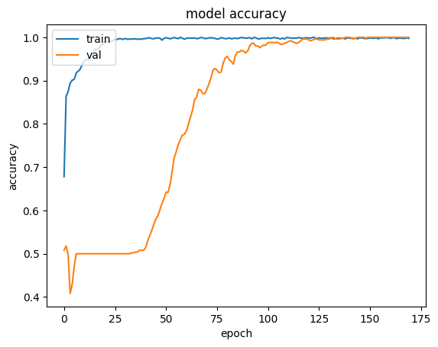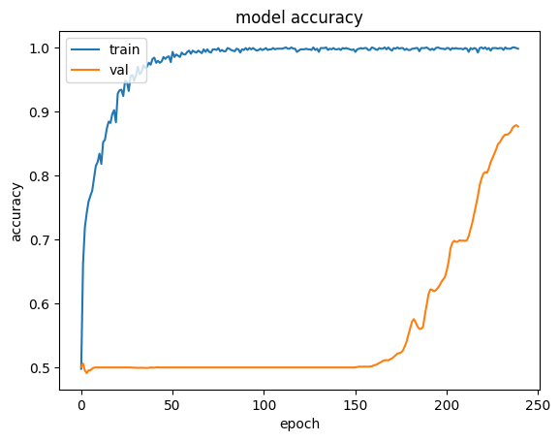
  - 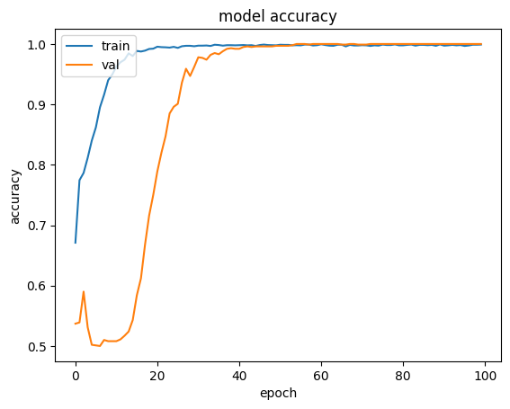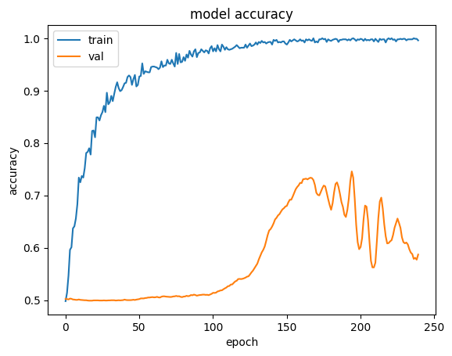
  - 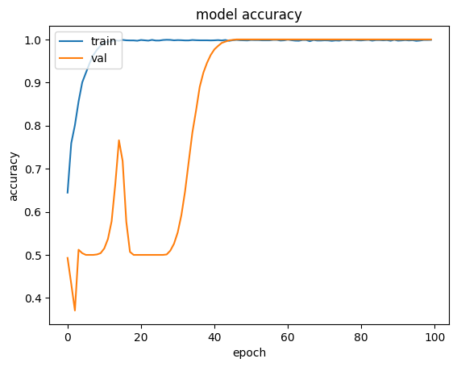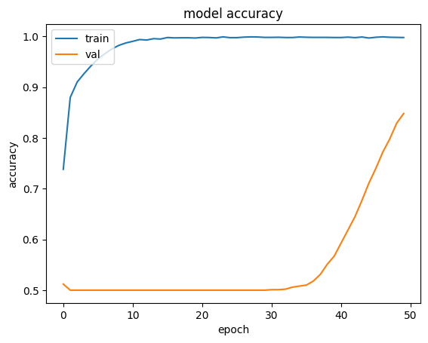
Fig. S4.
Accuracy (validation in orange, train in blue) graph over epochs per subject from subject 1 to 6.

  - 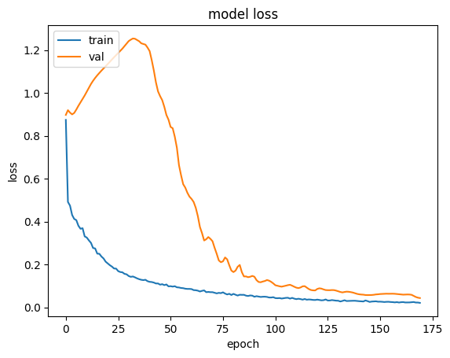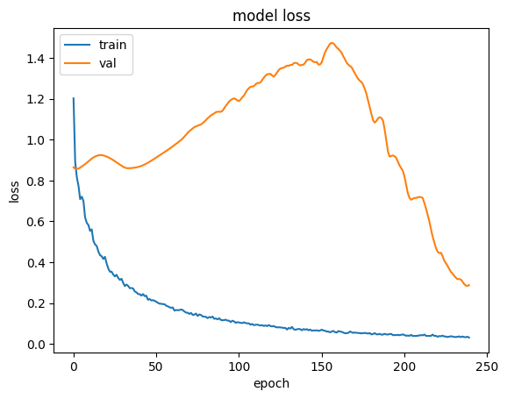
  - 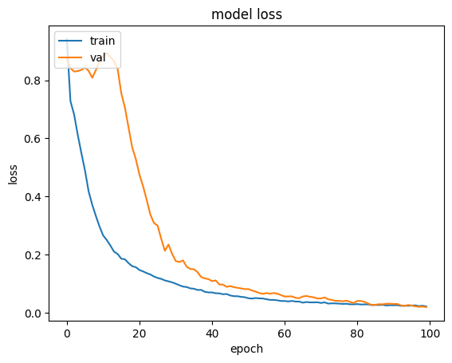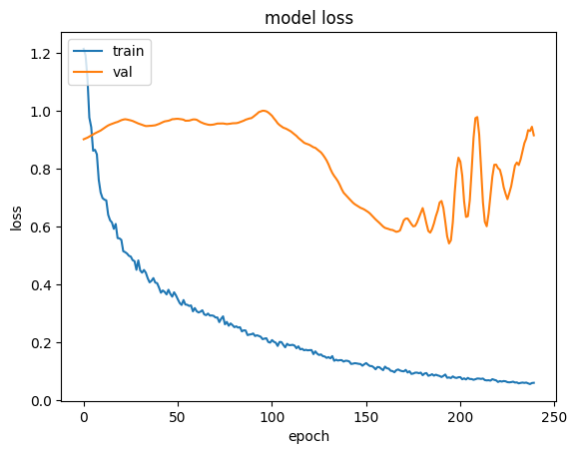
  - 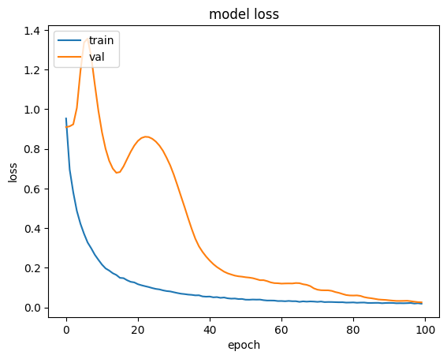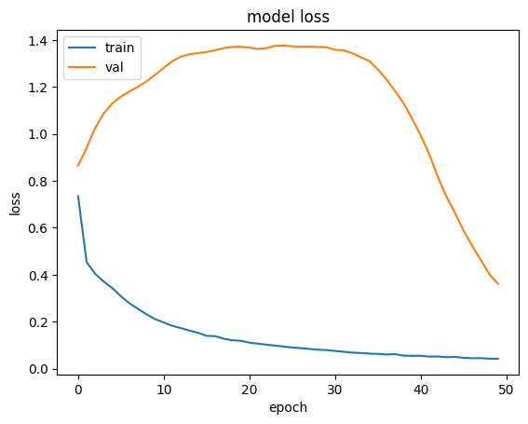

Fig. S5.
Loss (validation in orange, train in blue) changes over epochs per subject from subject 1 to subject 6.

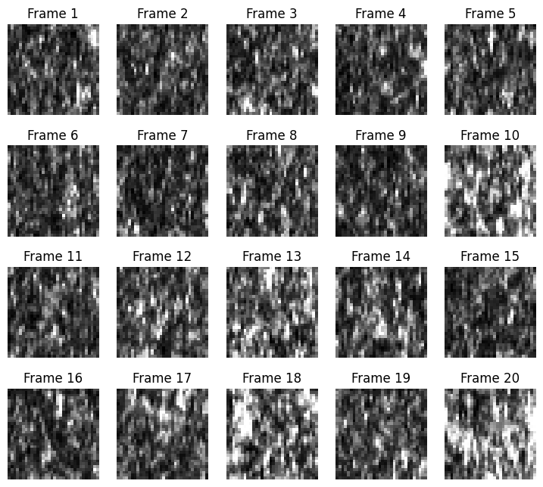
Fig. S6.
Sample frames from speckles video.

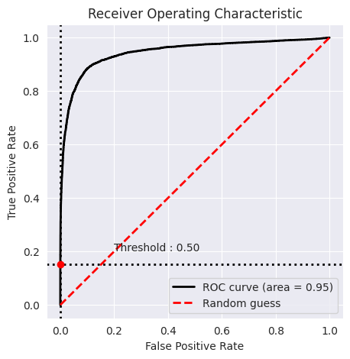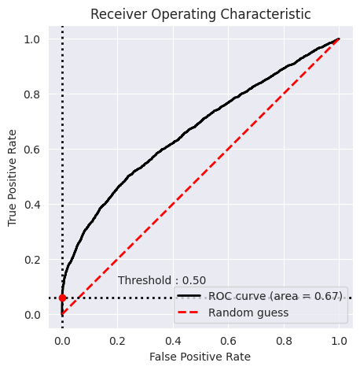
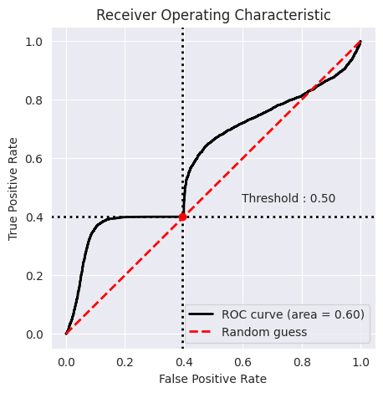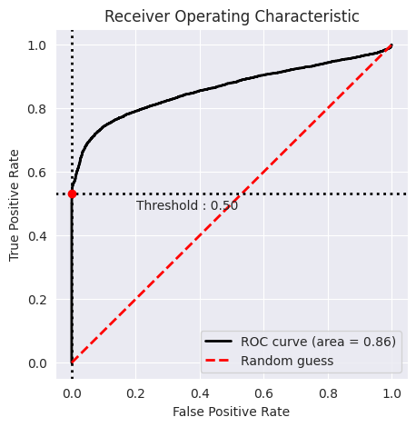

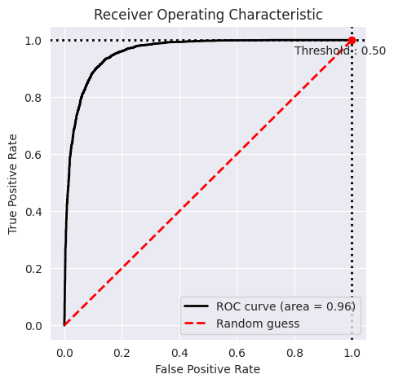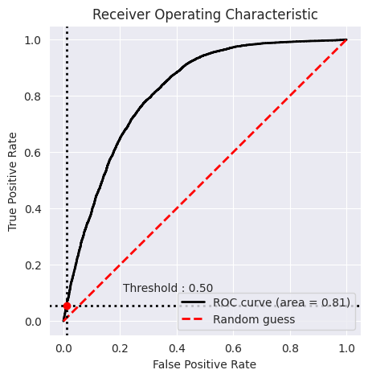
Fig. S7.
AUC-ROC curve per generalization splits 1 to 6 (numbers run from left to right). The AUC average 0.81. The lowest AUC was for the subject with the highest age.

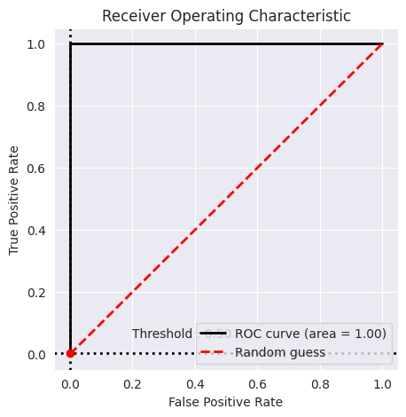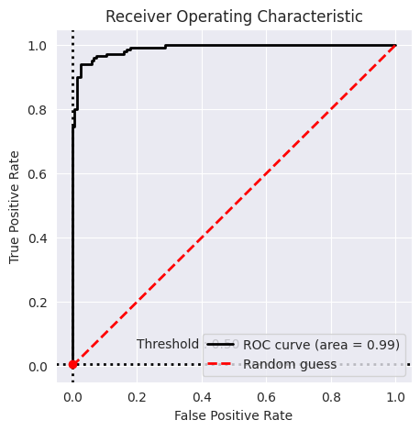
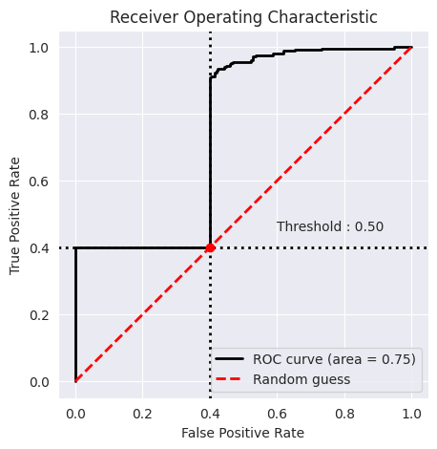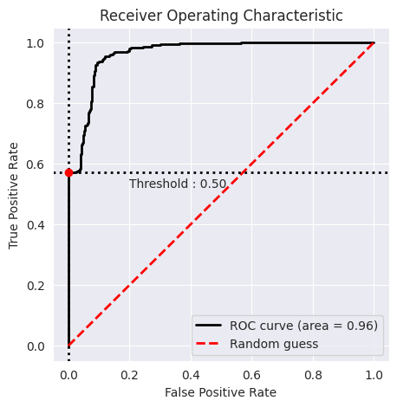
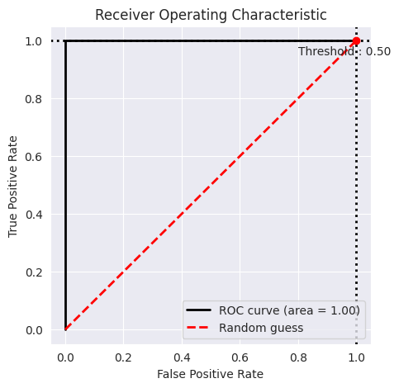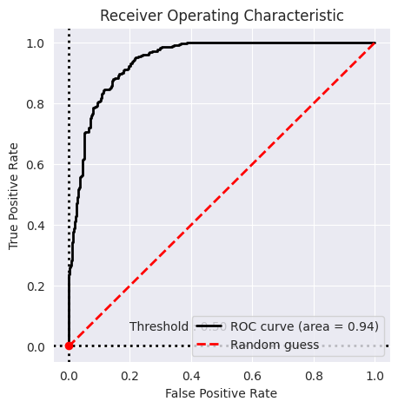
Fig. S8.
AUC-ROC curve per generalization splits 1 to 6 with 1 sec aggregation (numbers run from left to right). The AUC average 0.94. The lowest AUC was for the subject with the highest age.
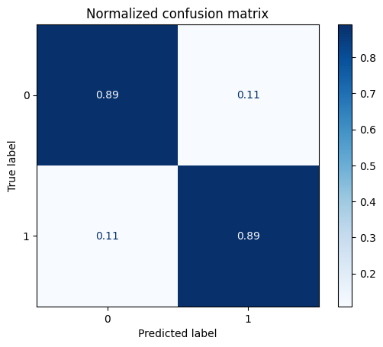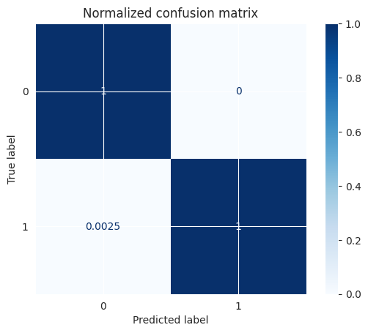

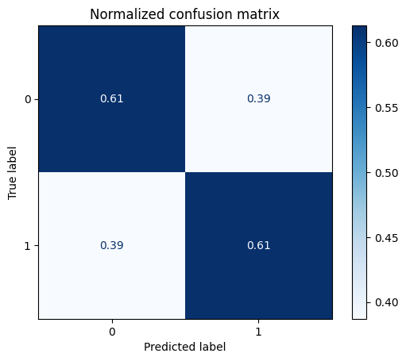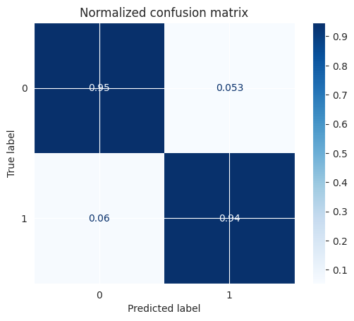

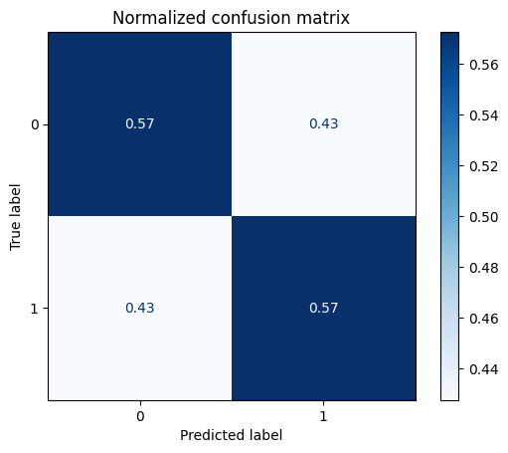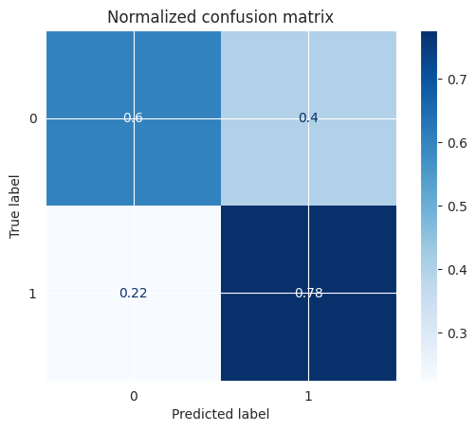
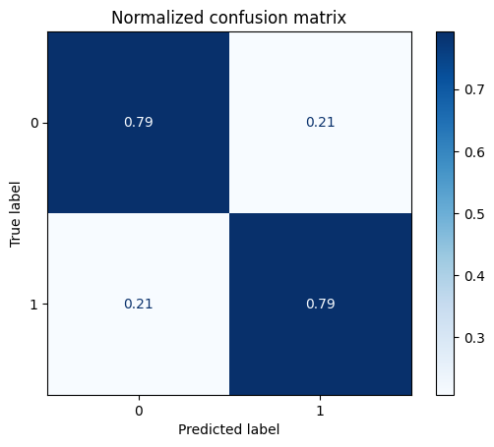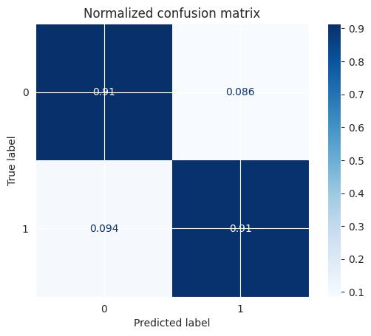
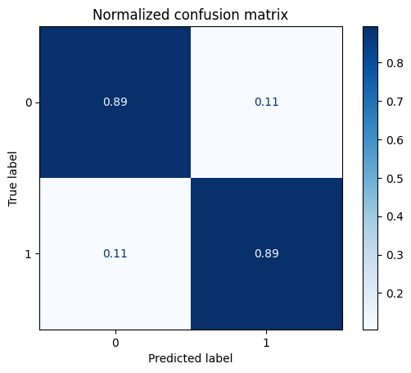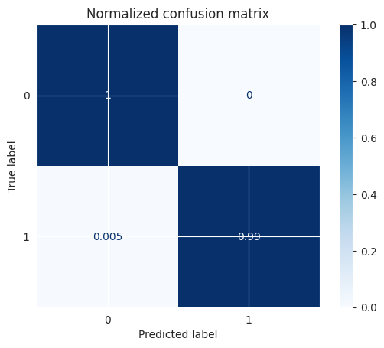
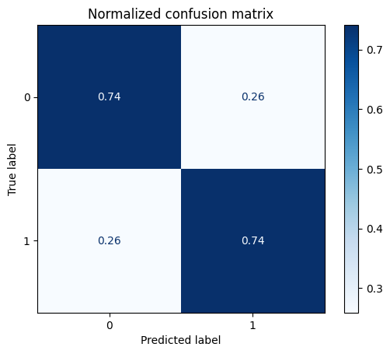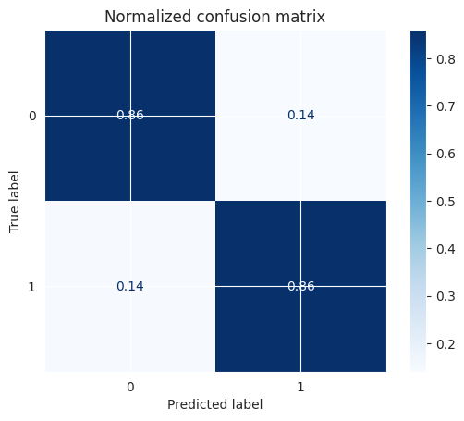
Fig. S9.
Normalized confusion matrices for splits 1-6 without (left) and with (right) aggregation.
Table S1. Detailed information in the DNN layers
# | Layer type | Output shape | Number of parameters
1 | Batch normalization | (None, 40, 32, 32, 1) | 4
2 | ConvLSTM2D layer with  8 filters (9 filters in generalization experiment),  kernel size (3, 3),  regularization using kernel_constraint=max_norm(2.) | (None, 30, 30, 8) | 2624
3 | Batch normalization | (None, 30, 30, 8) | 32
4 | Dropout layer with rate 0.5 | (None, 30, 30, 8) | 0
5 | Flatten | (None, 7200) | 0
6 | Dense layer with:  kernel_constraint=max_norm(2.),  kernel_regularizer='l2',  activation="relu" | (None, 8) | 57608
7 | Batch normalization | (None, 8) | 32
8 | Dropout layer with rate 0.5 | (None, 8) | 0
9 | Dense layer with:  kernel_constraint=max_norm(2.), activation="sigmoid" | (None, 1) | 9

Table S2. Generalization on six different splits of 2 subjects in the train, 2 in validation, and 2 in test set. Results are given for the test sets. Aggregated results are for over an aggregation of 1 sec, 25 chunks of 40 frames.
Subjects in Split |  |  | AUC per chunk | AUC aggregated | Accuracy | Accuracy aggregated | Kappa | Kappa aggregated | split #
test | validation | train
3, 6 | 1, 4 | 2, 5 | 0.95 | 1 | 89.1% | 99.9% | 0.78 | 1 | 1
4,5 | 2, 3 | 1, 6 | 0.67 | 0.99 | 61% | 94% | 0.23 | 0.89 | 2
1, 2 | 5, 6 | 3, 4 | 0.6 | 0.75 | 57.2% | 68.8% | 0.15 | 0.38 | 3
2, 3 | 4, 5 | 1, 6 | 0.86 | 0.96 | 79.3% | 91% | 0.59 | 0.82 | 4
5, 6 | 3, 4 | 1, 2 | 0.96 | 1 | 89.4% | 99.8% | 0.79 | 1 | 5
3, 4 | 5, 6 | 1, 2 | 0.81 | 0.94 | 74.1% | 85.9% | 0.48 | 0.72 | 6

