Additional file 2
Description of probes generated for the Northen blot.
The RNA probes were transcribed and labeled using the digoxigenin-11-UTP reagent. To generate the probe, 4 µl of the previously developed RT-PCR product with the Adenylate cyclase gene was used. The labeling efficiency of the probe for the detection of dsRNA-FocAdcy molecules was estimated through dilution, as described in Figure 1 and Table 1.

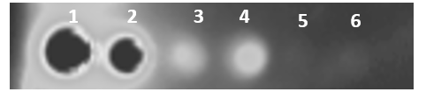
Figure 1. Determination of RNA probe efficiency, corresponding to probe generation with FocAdcy RT-PCR product. Numbers indicate the detection capacity by digoxigenin-11-UTP according to the RNA dilution.

Table 1. Estimation of RNA concentration by probe dilution.

Point | Dilution | Conc. (ng/µl)
1 | 1 | 2140
2 | 1:10 | 214
3 | 1:100 | 2.14
4 | 1:3.3 | 0.65 ≡ 650 pg/µl
5 | 1:10 | 0.065 ≡ 65 pg/µl
6 | 1:10 | 0.0065 ≡ 6.5 pg/µl

