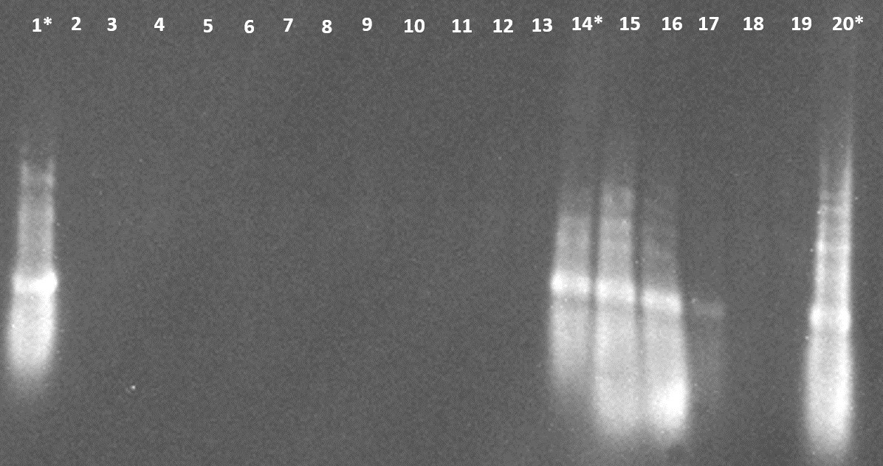
Additional file 8. Raw results of Northern blots
Figure 1. First part of the Northern blot result. Samples from 1 to 20. Sample details are shown in table 1. *Corresponds to a positive control of dsRNA.

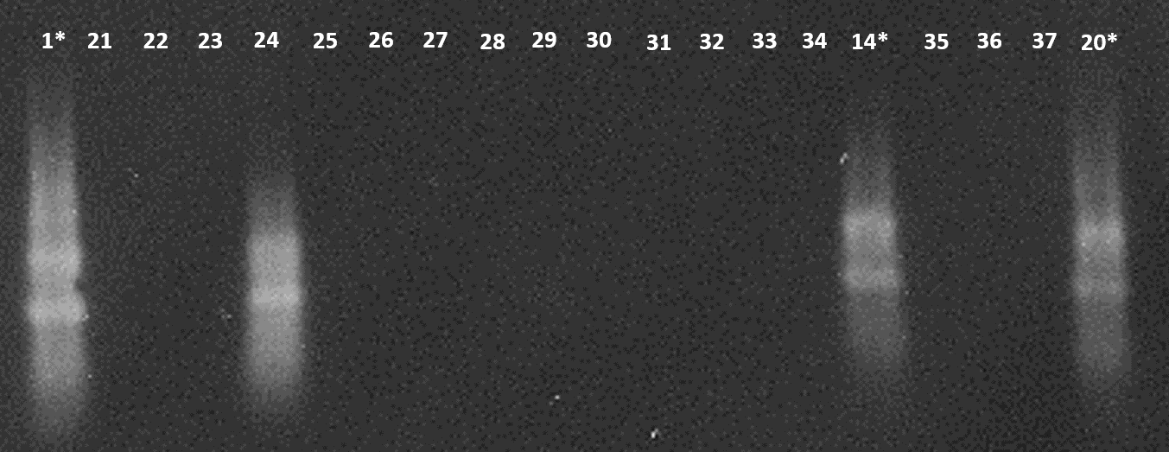
Figure 2. second part of the Northern blot result. Samples from 21 to 37. Sample details are shown in table 1. *Corresponds to a positive control of dsRNA.

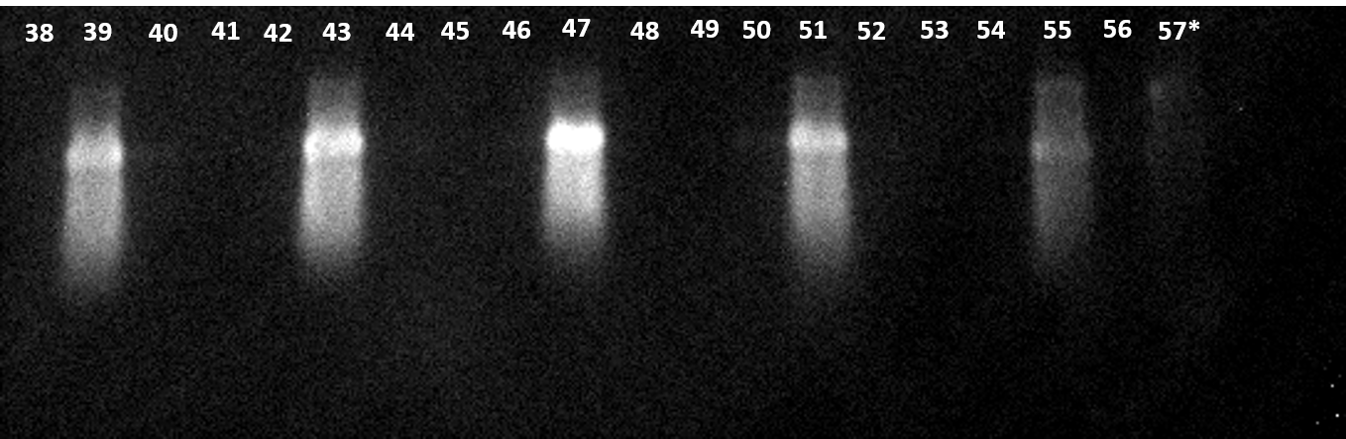
Figure 3. Third part of the Northern Blot result. Samples from 38 to 57. Sample details are shown in table 1. *Corresponds to a positive control of dsRNA.

Table 1. Sample details in Northern blot results
Sample Code | Treatment | Plant # | Tissue | hours post-application (hpa) | Replica #
1 | dsRNA (10-fold dilution)-1 | - | - | - | -
2 | solution of dsRNA+Triton X+DMSO | 4 | Root | 1 hpa | R2
3 | solution of dsRNA+Triton X+DMSO | 4 | corm | 1 hpa | R2
4 | solution of dsRNA+Triton X+DMSO | 4 | pseudostem | 1 hpa | R2
5 | solution of dsRNA+Triton X+DMSO | 3 | Root | 1 hpa | R1
6 | solution of dsRNA+Triton X+DMSO | 3 | corm | 1 hpa | R1
7 | solution of dsRNA+Triton X+DMSO | 3 | pseudostem | 1 hpa | R1
8 | control solution of water+Triton X+DMSO | 2 | Root | 1 hpa | R2
9 | control solution of water+Triton X+DMSO | 2 | corm | 1 hpa | R2
10 | control solution of water+Triton X+DMSO | 2 | pseudostem | 1 hpa | R2
11 | control solution of water+Triton X+DMSO | 1 | Root | 1 hpa | R1
12 | control solution of water+Triton X+DMSO | 1 | corm | 1 hpa | R1
13 | control solution of water+Triton X+DMSO | 1 | pseudostem | 1 hpa | R1
14 | solution of dsRNA+Triton X+DMSO (100 fold-dilution) | - | - | - | -
15 | solution of dsRNA+Triton X+DMSO | 4 | leaf # 3 | 1 hpa | R2
16 | solution of dsRNA+Triton X+DMSO | 3 | leaf # 3 | 1 hpa | R1
17 | solution of dsRNA+Triton X+DMSO | 3 | leaf # 2 | 1 hpa | R1
18 | control solution of water+Triton X+DMSO | 2 | leaf # 3 | 1 hpa | R1
19 | control solution of water+Triton X+DMSO | 1 | leaf # 3 | 1 hpa | R2
20 | solution of dsRNA+Triton X+DMSO (10 fold-dilution) | - | - | - | -
21 | solution of dsRNA+Triton X+DMSO | 7 | Root | 12 hpa | R1
22 | solution of dsRNA+Triton X+DMSO | 7 | pseudostem | 12 hpa | R1
23 | solution of dsRNA+Triton X+DMSO | 7 | leaf # 4 | 12 hpa | R1
24 | solution of dsRNA+Triton X+DMSO | 7 | leaf # 3 | 12 hpa | R1
25 | solution of dsRNA+Triton X+DMSO | 7 | leaf # 2 | 12 hpa | R1
26 | control solution of water+Triton X+DMSO | 6 | Root | 12 hpa | R2
27 | control solution of water+Triton X+DMSO | 6 | corm | 12 hpa | R2
28 | control solution of water+Triton X+DMSO | 6 | pseudostem | 12 hpa | R2
29 | control solution of water+Triton X+DMSO | 6 | leaf # 4 | 12 hpa | R2
30 | control solution of water+Triton X+DMSO | 6 | leaf # 3 | 12 hpa | R2
31 | control solution of water+Triton X+DMSO | 6 | leaf # 2 | 12 hpa | R2
32 | control solution of water+Triton X+DMSO | 5 | Root | 12 hpa | R1
33 | control solution of water+Triton X+DMSO | 5 | corm | 12 hpa | R1
34 | control solution of water+Triton X+DMSO | 5 | pseudostem | 12 hpa | R1
35 | control solution of water+Triton X+DMSO | 5 | leaf # 4 | 12 hpa | R1
36 | control solution of water+Triton X+DMSO | 5 | leaf # 3 | 12 hpa | R1
37 | control solution of water+Triton X+DMSO | 5 | leaf # 2 | 12 hpa | R1
38 | solution of dsRNA+Triton X+DMSO | 8 | leaf # 4 | 12 hpa | R2
39 | solution of dsRNA+Triton X+DMSO | 8 | leaf # 3 | 12 hpa | R2
40 | solution of dsRNA+Triton X+DMSO | 8 | leaf # 2 | 12 hpa | R2
41 | solution of dsRNA+Triton X+DMSO | 7 | corm | 12 hpa | R1
42 | solution of dsRNA+Triton X+DMSO | 16 | leaf # 4 | 48 hpa | R2
43 | solution of dsRNA+Triton X+DMSO | 16 | leaf # 3 | 48 hpa | R2
44 | solution of dsRNA+Triton X+DMSO | 16 | leaf # 2 | 48 hpa | R2
45 | solution of dsRNA+Triton X+DMSO | 15 | corm | 48 hpa | R1
46 | solution of dsRNA+Triton X+DMSO | 15 | leaf # 4 | 48 hpa | R1
47 | solution of dsRNA+Triton X+DMSO | 15 | leaf # 3 | 48 hpa | R1
48 | solution of dsRNA+Triton X+DMSO | 15 | leaf # 2 | 48 hpa | R1
49 | solution of dsRNA+Triton X+DMSO | 12 | Corm | 24 hpa | R2
50 | solution of dsRNA+Triton X+DMSO | 12 | leaf # 4 | 24 hpa | R2
51 | solution of dsRNA+Triton X+DMSO | 12 | leaf # 3 | 24 hpa | R2
52 | solution of dsRNA+Triton X+DMSO | 12 | leaf # 2 | 24 hpa | R2
53 | solution of dsRNA+Triton X+DMSO | 11 | Corm | 24 hpa | R1
54 | solution of dsRNA+Triton X+DMSO | 11 | leaf # 4 | 24 hpa | R1
55 | solution of dsRNA+Triton X+DMSO | 11 | leaf # 3 | 24 hpa | R1
56 | solution of dsRNA+Triton X+DMSO | 11 | leaf # 2 | 24 hpa | R1
57 | dsRNA (10-fold dilution)-2 | - | - | - | -

Result Analysis.
The samples in which dsRNA was detected were: 15, 16 (corresponding to leaf # 3 of 1 hpa of replicates 2 and 1 respectively); 24, 39 (corresponding to leaf # 3 of 12 hpa of replicates 1 and 2 respectively); 43, 47 (corresponding to leaf # 3 of 48 hpa of replicates 2 and 1 respectively) and 51, 55 (corresponding to leaf # 3 of 24 hpa of replicates 2 and 1 respectively). In sample 17 we observed a weak band of dsRNA. We believe this corresponds to cross-spray onto leaf # 2 during the application on leaf # 3, as there is no evidence of translocation in other tissues where the dsRNA was not applied.

