Supplementary information for

Unequal roles of cities in the inter-urban healthcare system

Juan Li¹, Pengjun Zhao^{2, 1,*}, Mengzhu Zhang^{1,*}
- School of Urban Planning and Design, Peking University Shenzhen Graduate School
- College of Urban and Environmental Sciences, Peking University
* Corresponding authors:
Pengjun Zhao: pengjun.zhao@pku.edu.cn
Mengzhu Zhang: mengzhu.zhang@pku.edu.cn

List of Supplementary Figures
- Frequency distribution of the trans-city healthcare utilization
- Three types of patient mobility
- Characteristics of five types of cities regarding inter-urban healthcare provision
- Characteristics of pseudo-patient mobility to Type C and Type D cities
- Spatial scale of the served non-local patients of the four types of cities regarding inter-urban healthcare provision
- Characteristics of four types of cities regarding inter-urban healthcare demand
- Composition of the three types of patient mobility of Type 1 and Type 2 cities
- Spatial scale of the outflowing non-local patients of the four types of cities regarding inter-urban healthcare demand
- Examples of the four types of cities regarding inter-urban healthcare provision
- Examples of the four types of cities regarding inter-urban healthcare demand
- Dual roles of cities regarding the provision/demand functions in the IHS
- Spatial distributions of the nine compound modes
- Analytical framework for identifying trans-city healthcare utilization
- Analytical framework for identifying three types of patient mobility
- Capacity of Tertiary-A hospitals of each city
- The elbow index (sum of squared errors) and the Silhouette Coefficient of clustering analysis
List of Supplementary Tables
- Variables for clustering destination cities
- Variables for clustering origin cities

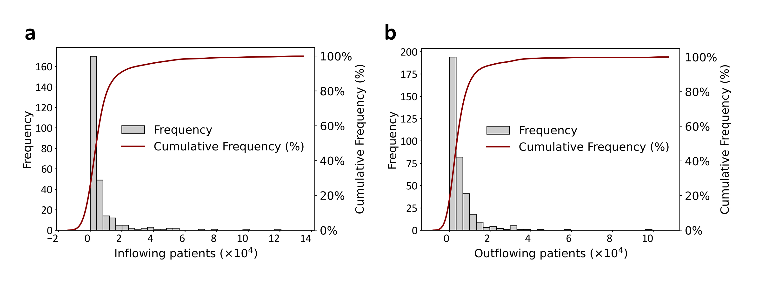
Supplementary Figure 1. Frequency distribution of the trans-city healthcare utilization. a. Number of inflowing patients. b. Number of outflowing patients.

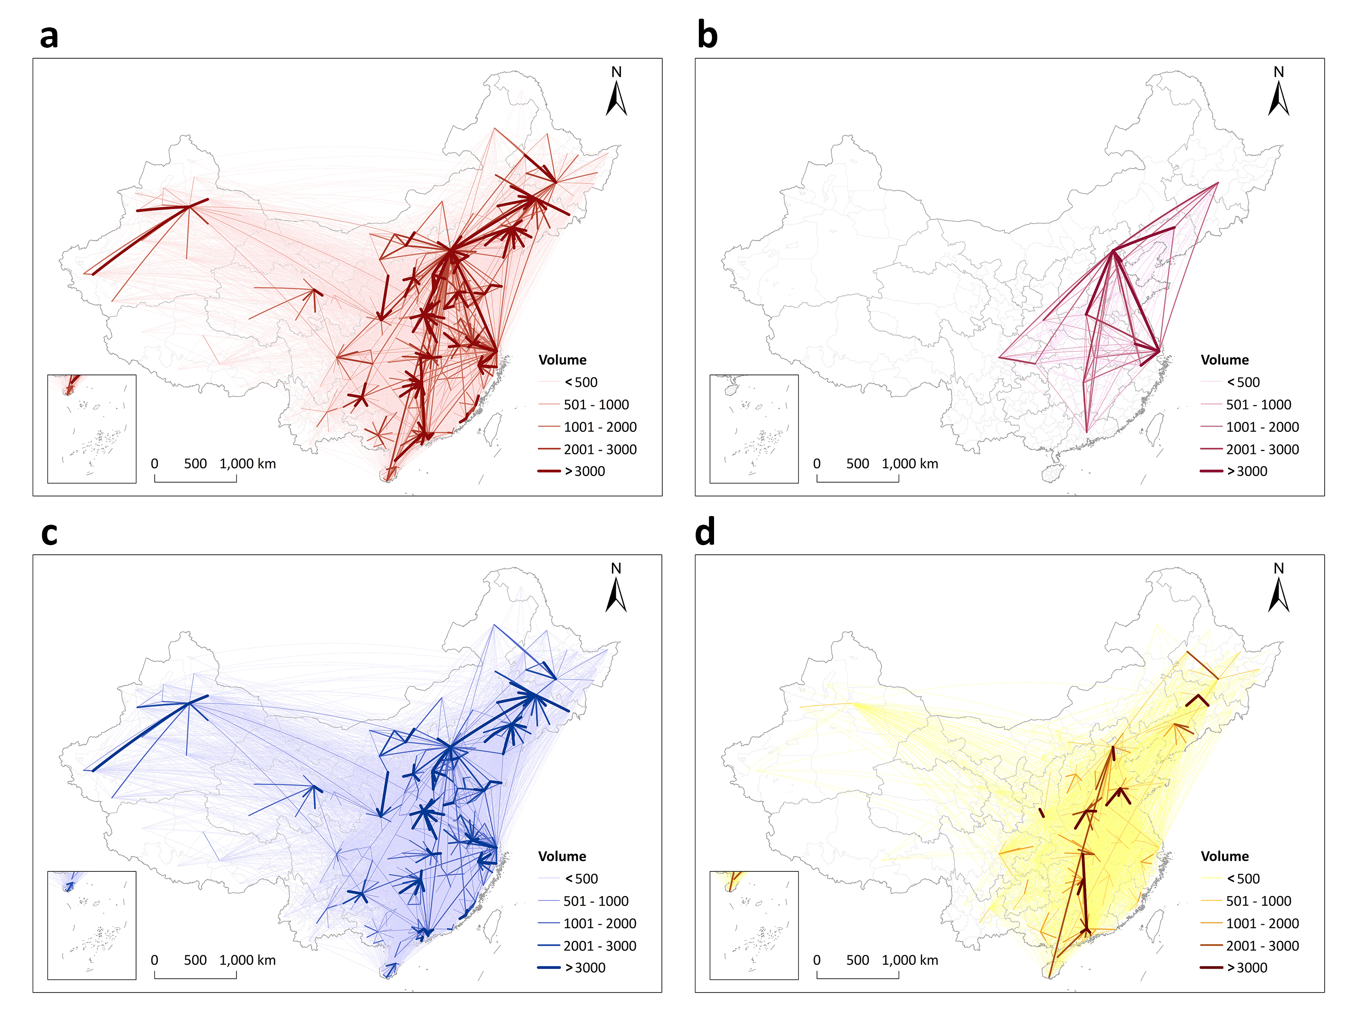
Supplementary Figure 2. Three types of patient mobility. a. All trans-city healthcare utilization. b. Mobility for the best treatment/diagnosis. c. Mobility for better treatment/diagnosis. d. Pseudo-patient mobility.

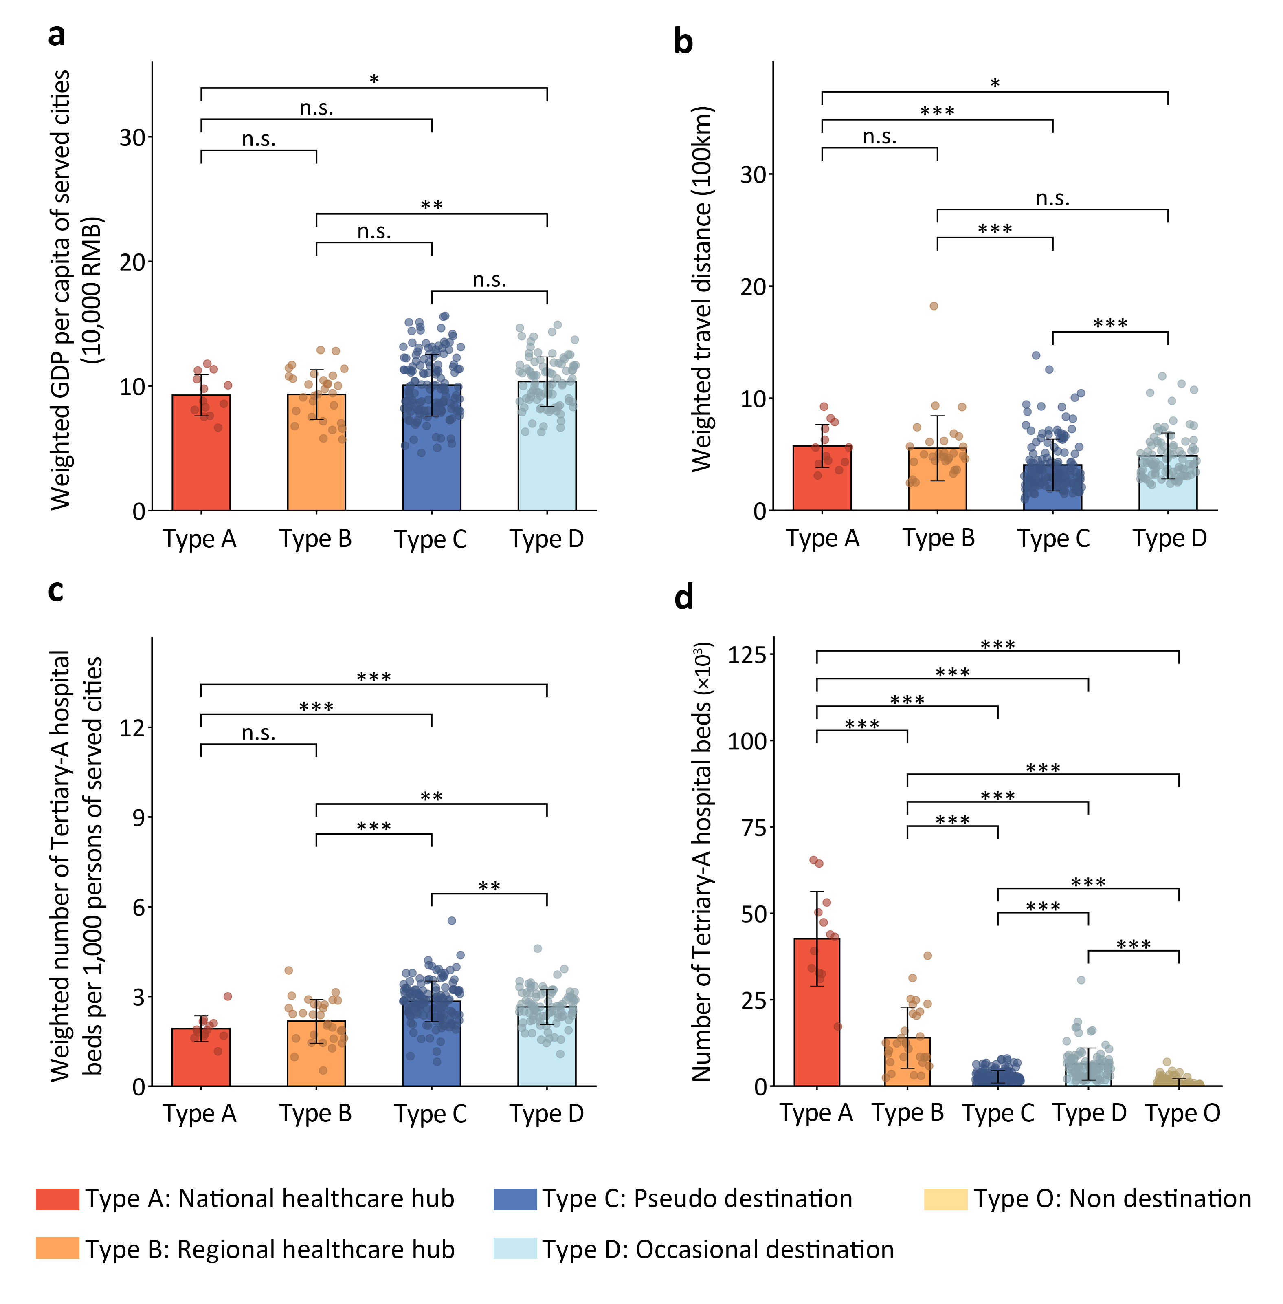
Supplementary Figure 3. Characteristics of five types of cities regarding inter-urban healthcare provision. a. Economic level of the served cities measured by weighted GDP per capita of served cities. b. Geographical depth of catchment area measured by weighted travel distance of inflowing patients. c. Healthcare deprivation of the served cities measured by weighted number of Tertiary-A hospital beds per 1,000 persons of the served cities. d. Local healthcare capacity of the provision cities measured by the number of Tertiary-A hospital beds.

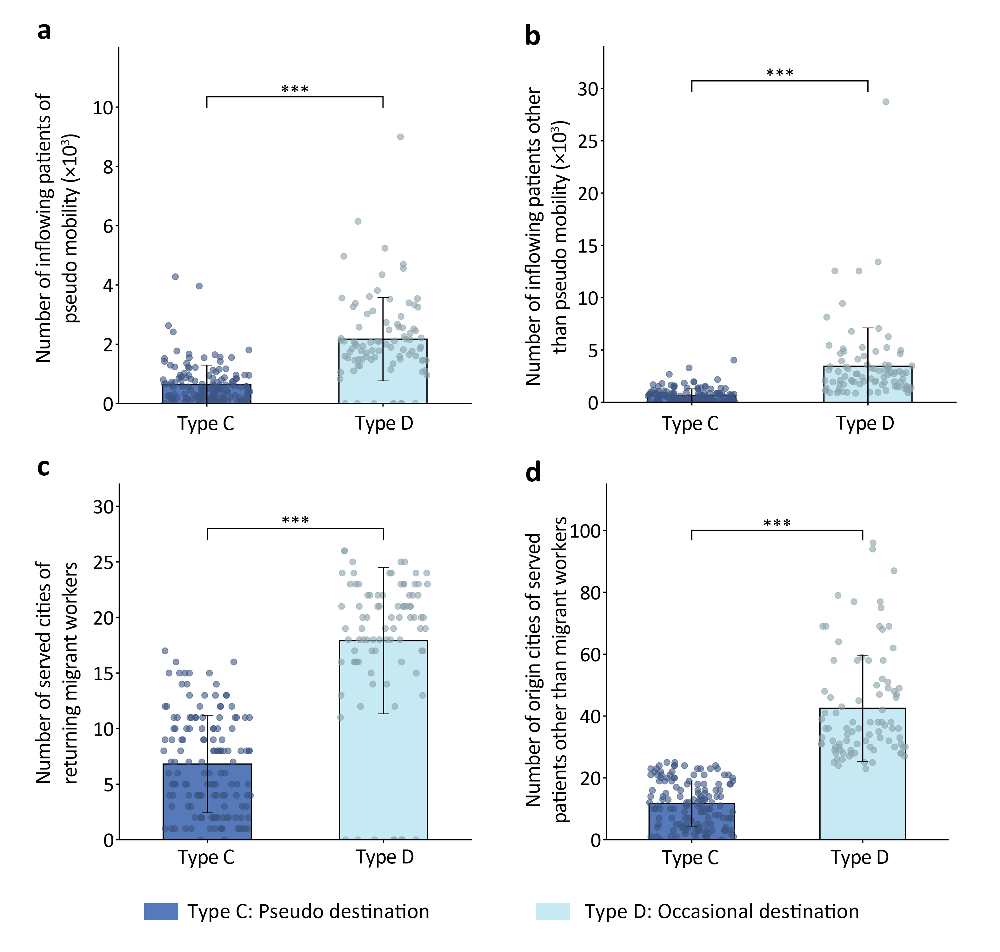
Supplementary Figure 4. Characteristics of pseudo-patient mobility to Type C and Type D cities. a. Number of inflowing patients who are returning migrant workers belonging to the pseudo-patient mobility. b. Number of inflowing patients other than pseudo-patient mobility. c. Number of the served cities where the returning migrant workers come from. d. Number of cities where the served non-local patients who are not returning migrant workers come from.

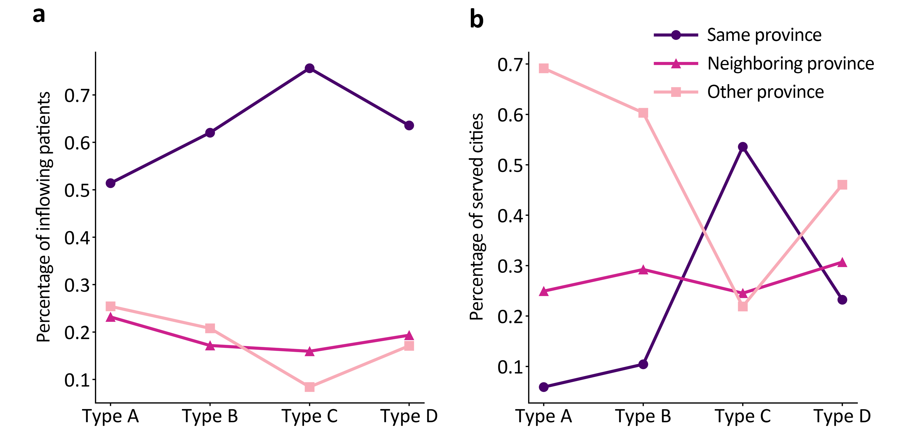
Supplementary Figure 5. Spatial scale of the served non-local patients of the four types of cities regarding inter-urban healthcare provision. a. Mean ratio of the inflowing patients from the same province, neighboring provinces, and other provinces, respectively. b. Mean ratio of the served cities from the same province, neighboring provinces, and other provinces, respectively. Type A: national healthcare hub, Type B: regional healthcare hub, Type C: pseudo destination, Type D: Occasional destination.

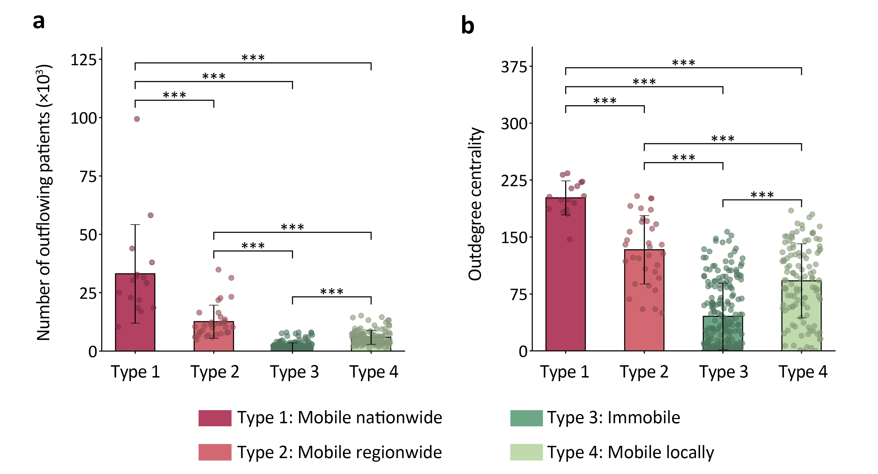
Supplementary Figure 6. Characteristics of four types of cities regarding inter-urban healthcare demand. a. Number of outflowing patients. b. Transport accessibility measured by the outdegree centrality in the national railway network.

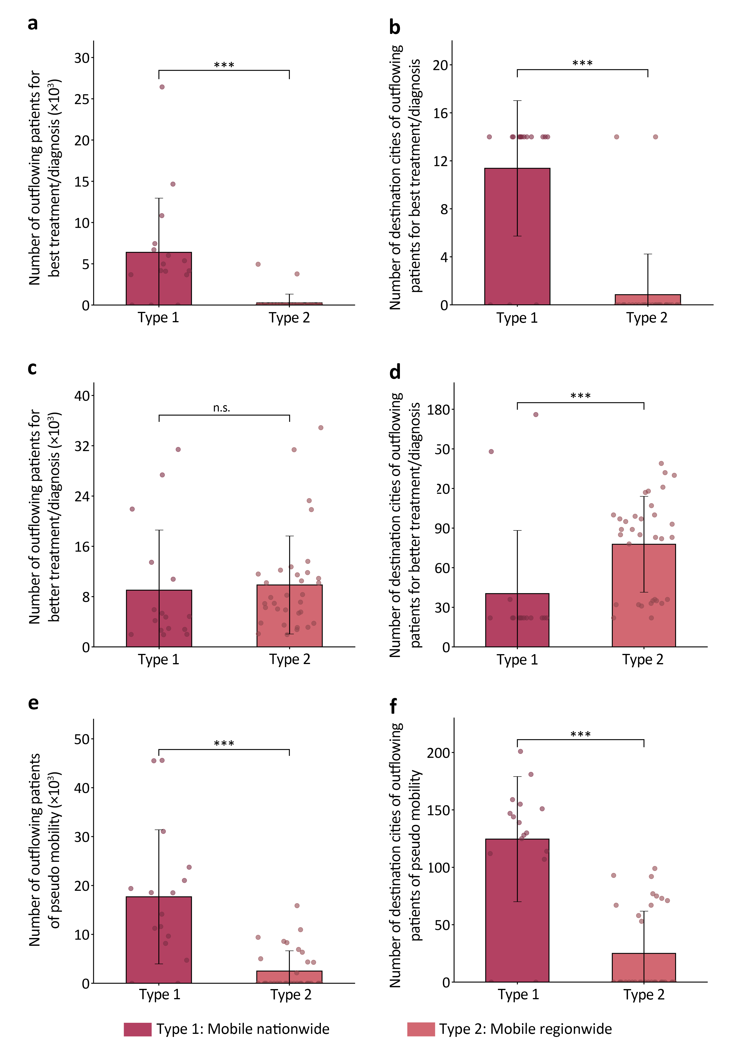
Supplementary Figure 7. Composition of the three types of patient mobility of Type 1 and Type 2 cities. a. Number of outflowing patients who pursue the best treatment/diagnosis. b. Number of destination cities which the outflowing patients visit to obtain the best treatment/diagnosis. c. Number of outflowing patients who pursue better treatment/diagnosis. d. Number of destination cities which the outflowing patients visit to obtain better treatment/diagnosis. e. Number of outflowing patients who are migrant workers. f. Number of destination cities of the returning migrant workers.
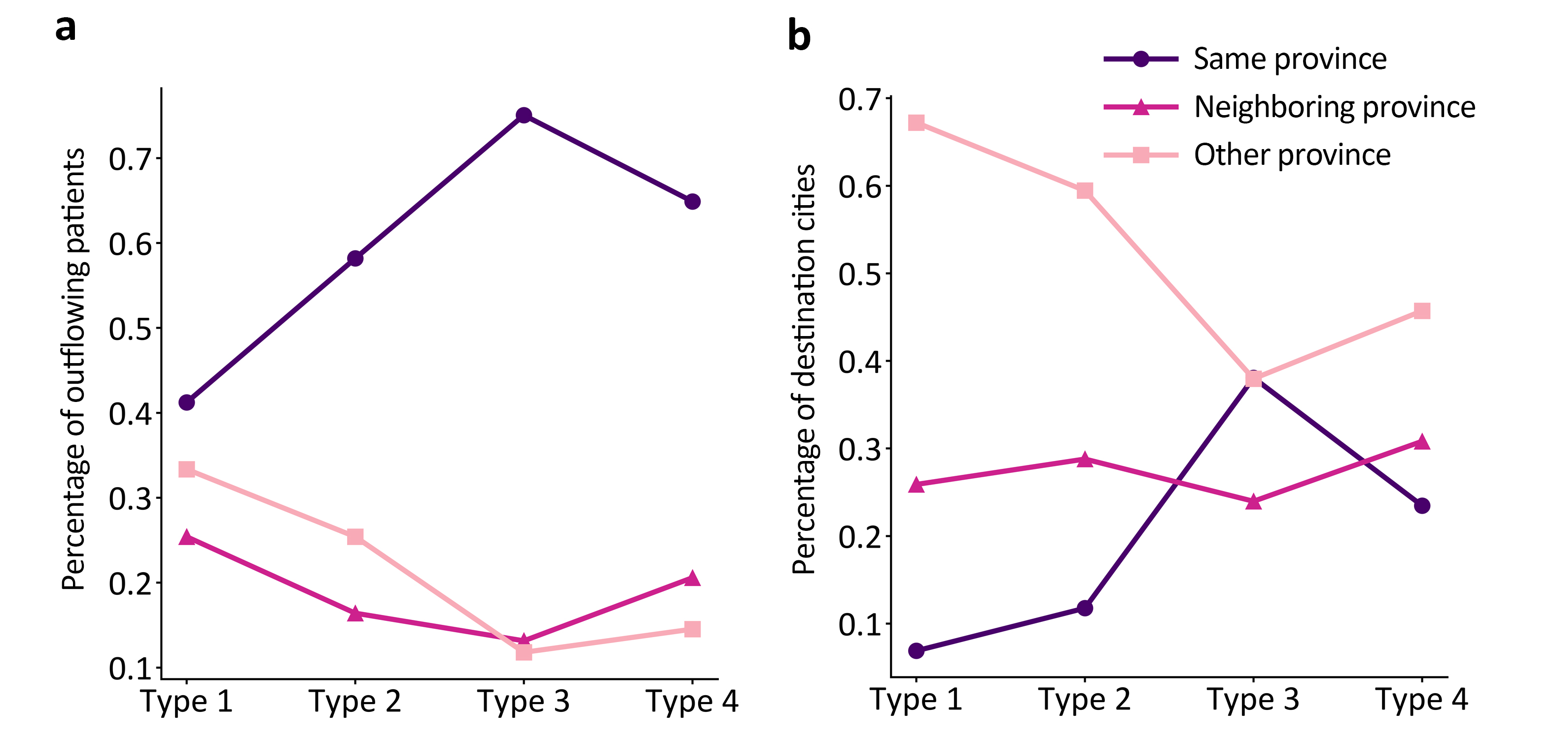

Supplementary Figure 8. Spatial scale of the outflowing non-local patients of the four types of cities regarding inter-urban healthcare demand. a. Mean ratio of the outflowing patients visiting the same province, neighboring provinces, and other provinces, respectively. b. Mean ratio of the destination cities of the same province, neighboring provinces, and other provinces, respectively.
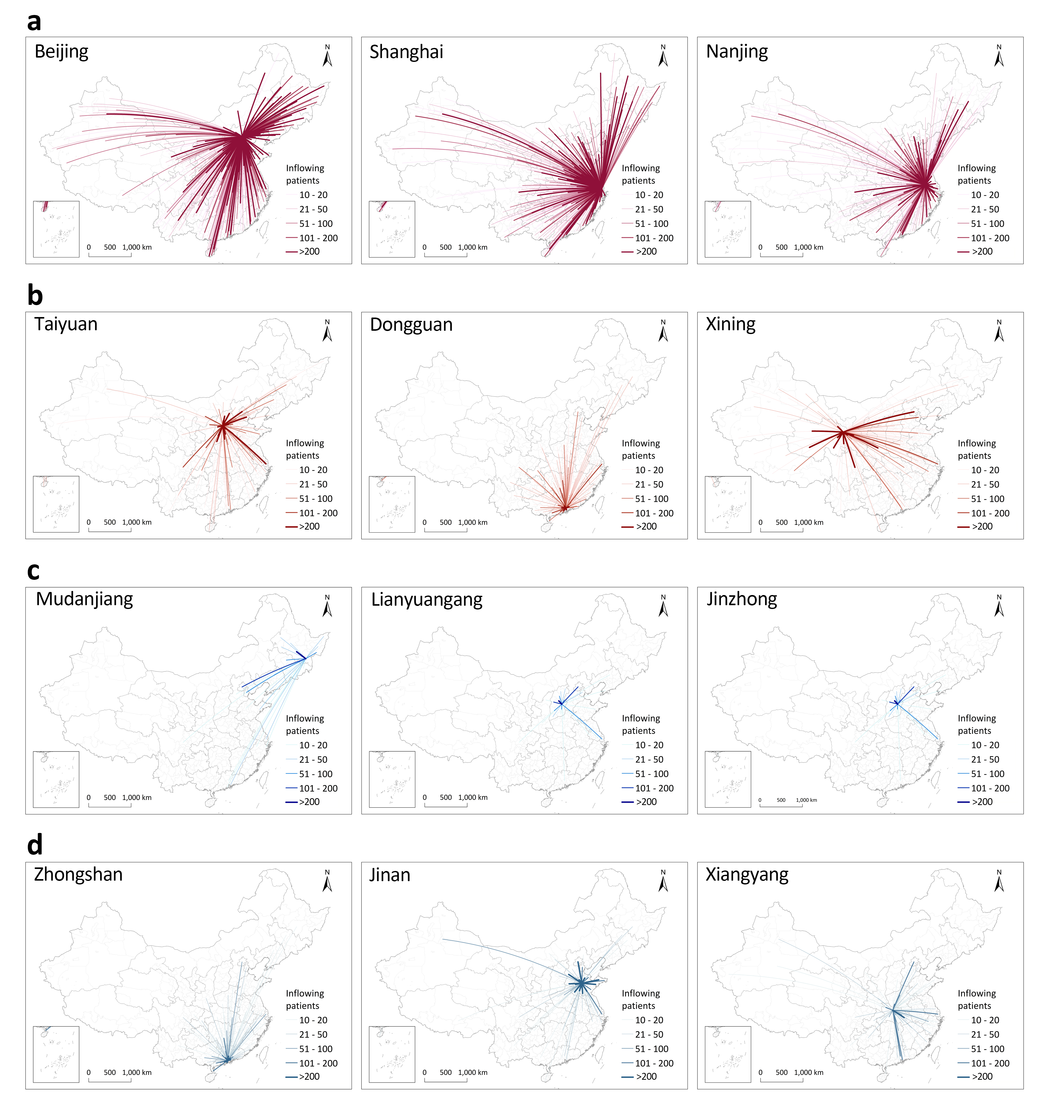
Supplementary Figure 9. Examples of the four types of cities regarding inter-urban healthcare provision. a. Type A cities: national healthcare hub. b. Type B cities: regional healthcare hub. c. Type C cities: pseudo destination. d. Type D cities: occasional destination.
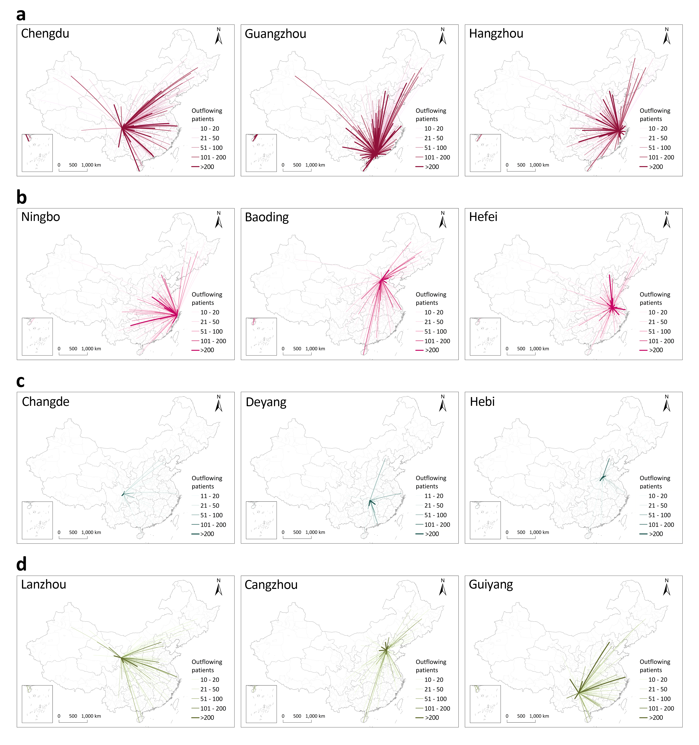
Supplementary Figure 10. Examples of the four types of cities regarding inter-urban healthcare demand. a. Type 1 cities: mobile nationwide. b. Type 2 cities: mobile regionwide. c. Type 3 cities: immobile. d. Type 4 cities: mobile locally.
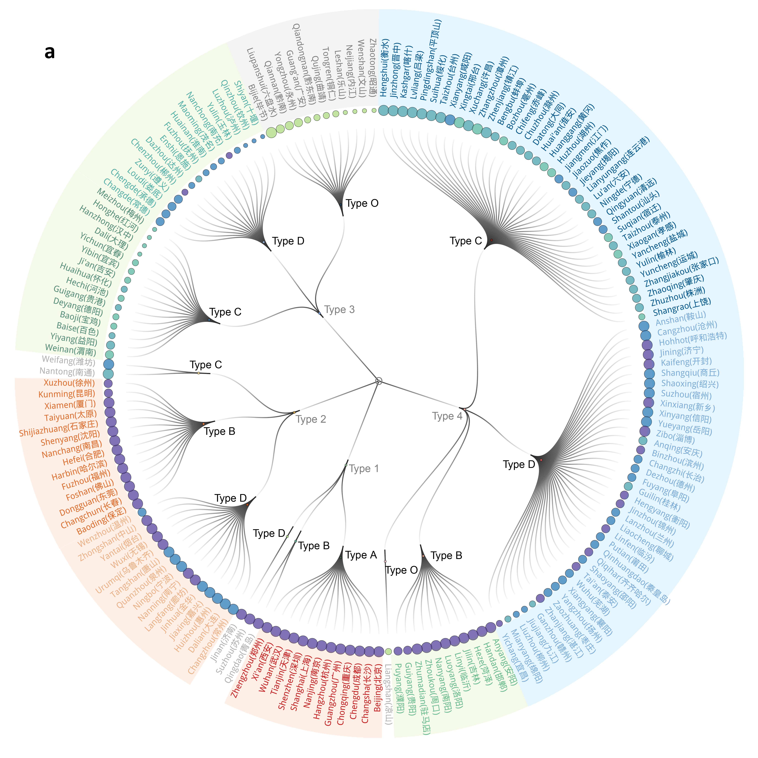
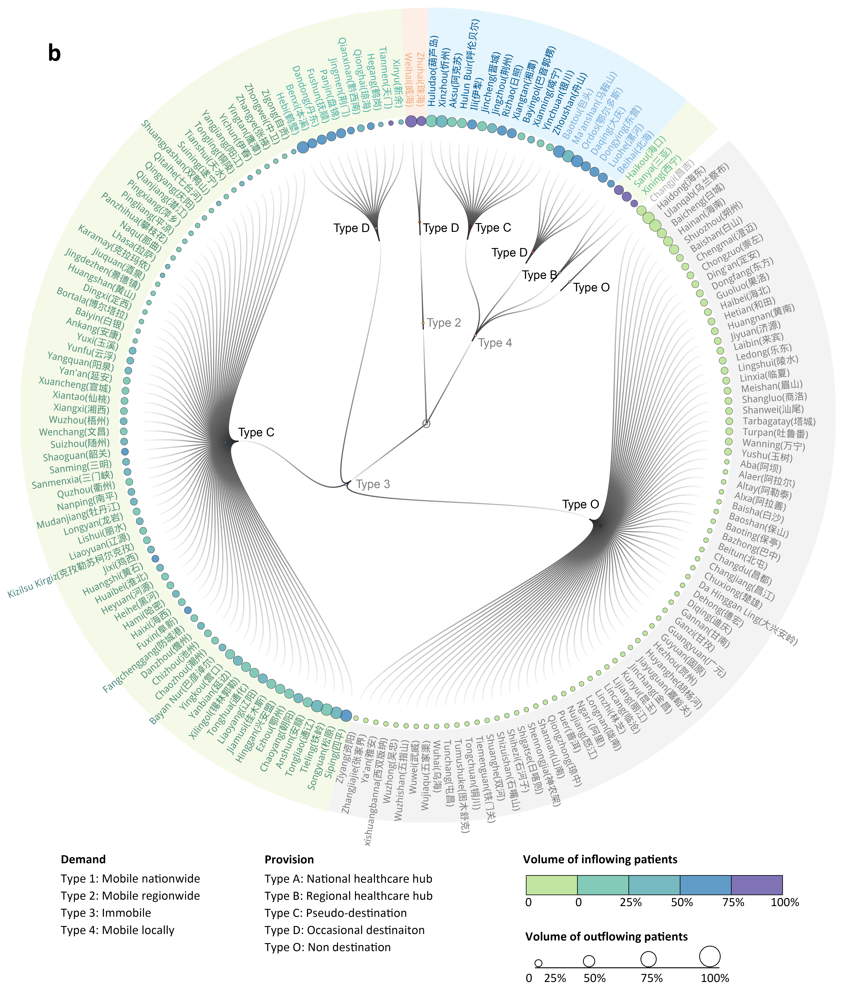
Supplementary Figure 11. Dual roles of cities regarding the provision/demand functions in the IHS. a. Cities with a population of over 3 million; b. Cities with a population below 3 million. Each line connecting a type of origin city and a type of destination city is further divided into multiple lines which are connected to a group of cities, indicating the role of the group of cities in the inter-urban healthcare system.
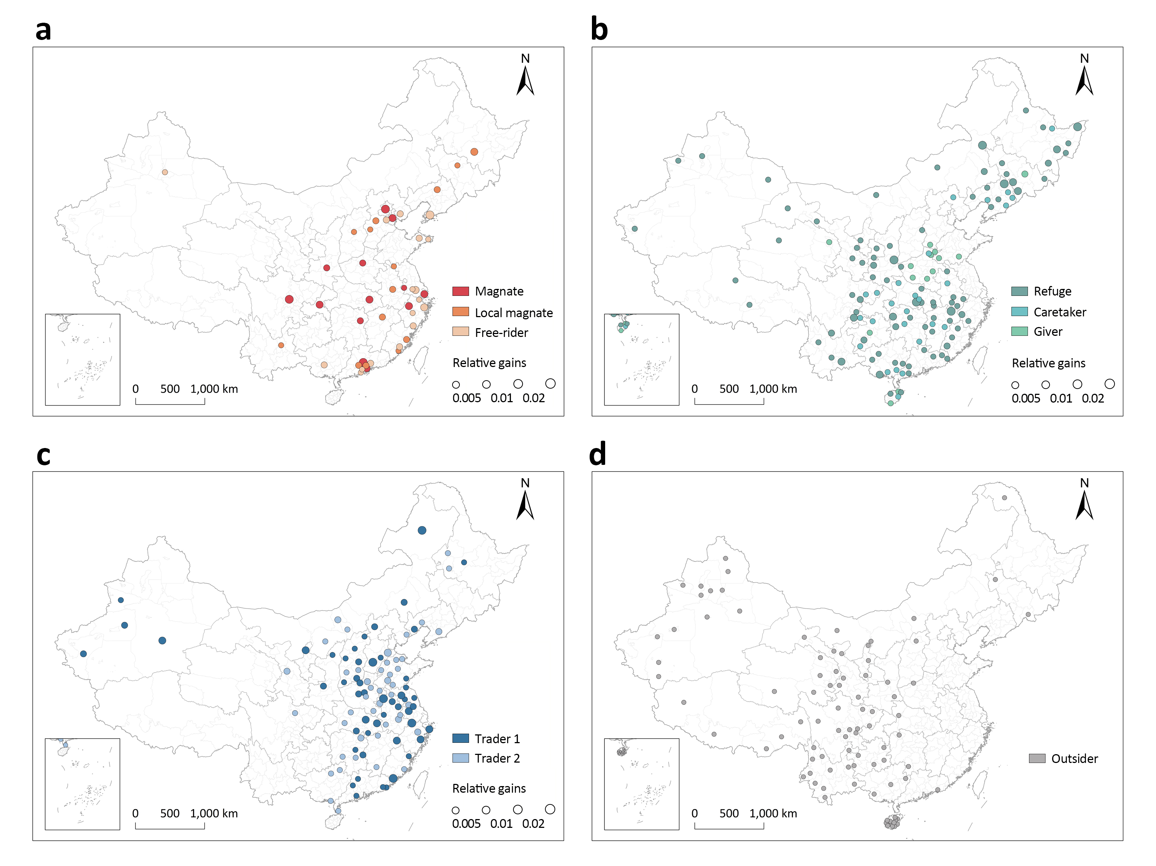
Supplementary Figure 12. Spatial distributions of the nine compound modes. a. The three modes which benefit from the IHS, including magnate, local magnate, and free-rider. b. The three modes which scarcely benefit from the IHS, including refuges, caretaker and giver. c. The two trader modes. d. The outsider mode.
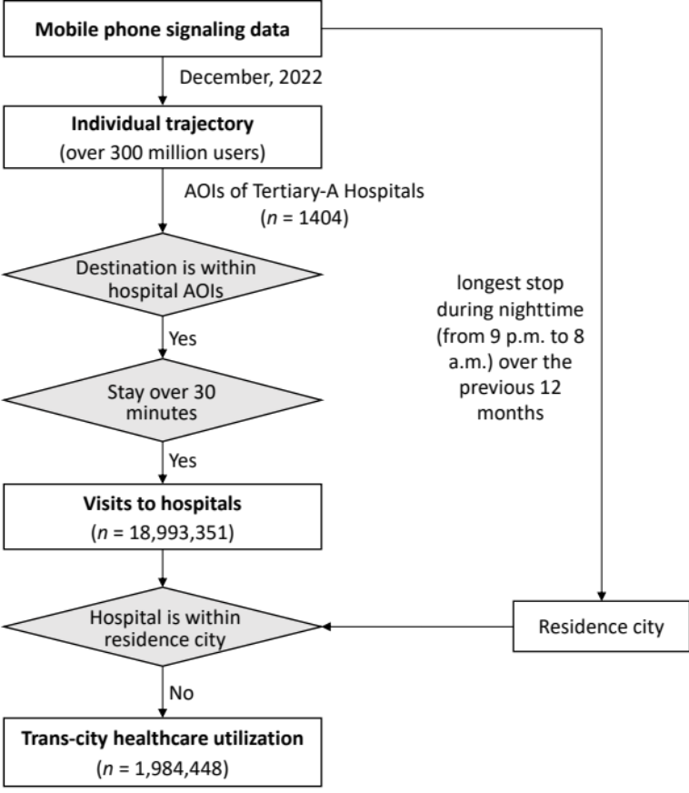
Supplementary Figure 13. Analytical framework for identifying trans-city healthcare utilization.
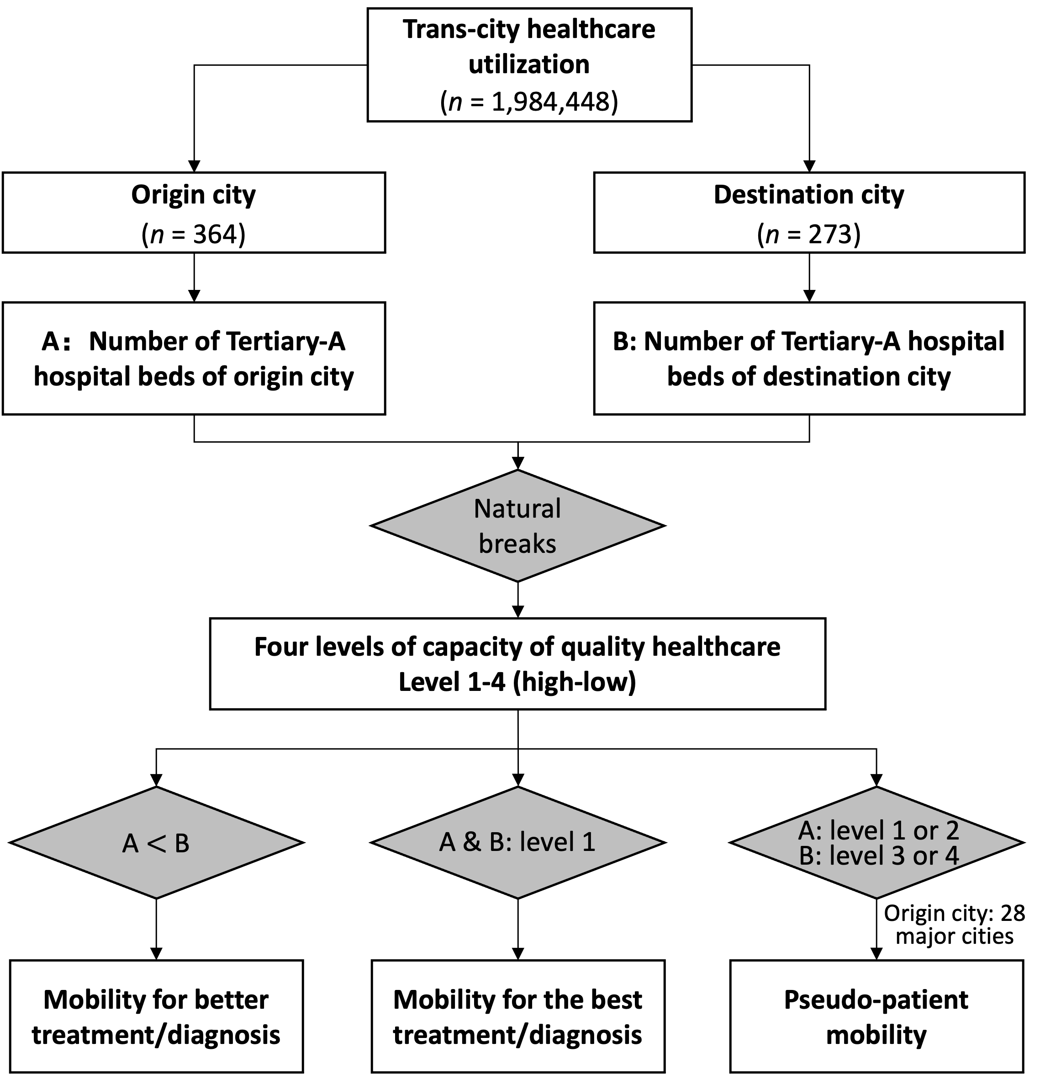
Supplementary Figure 14. Analytical framework for identifying three types of patient mobility.

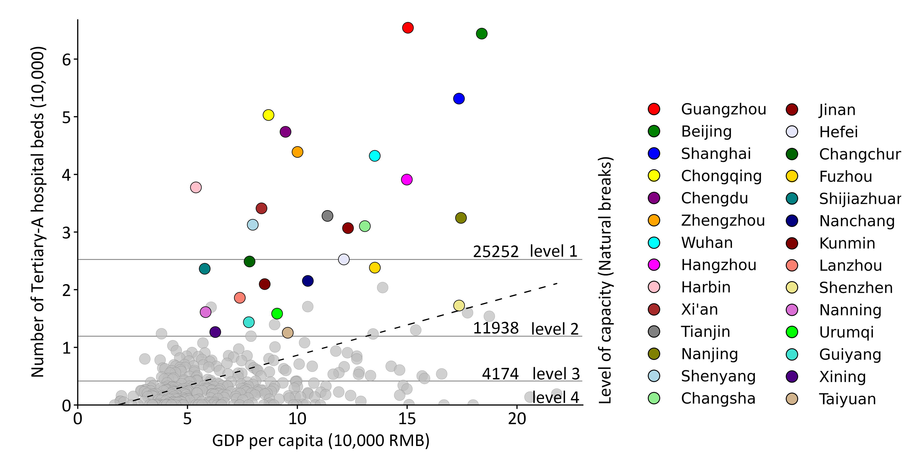
Supplementary Figure 15. Capacity of Tertiary-A hospitals of each city.
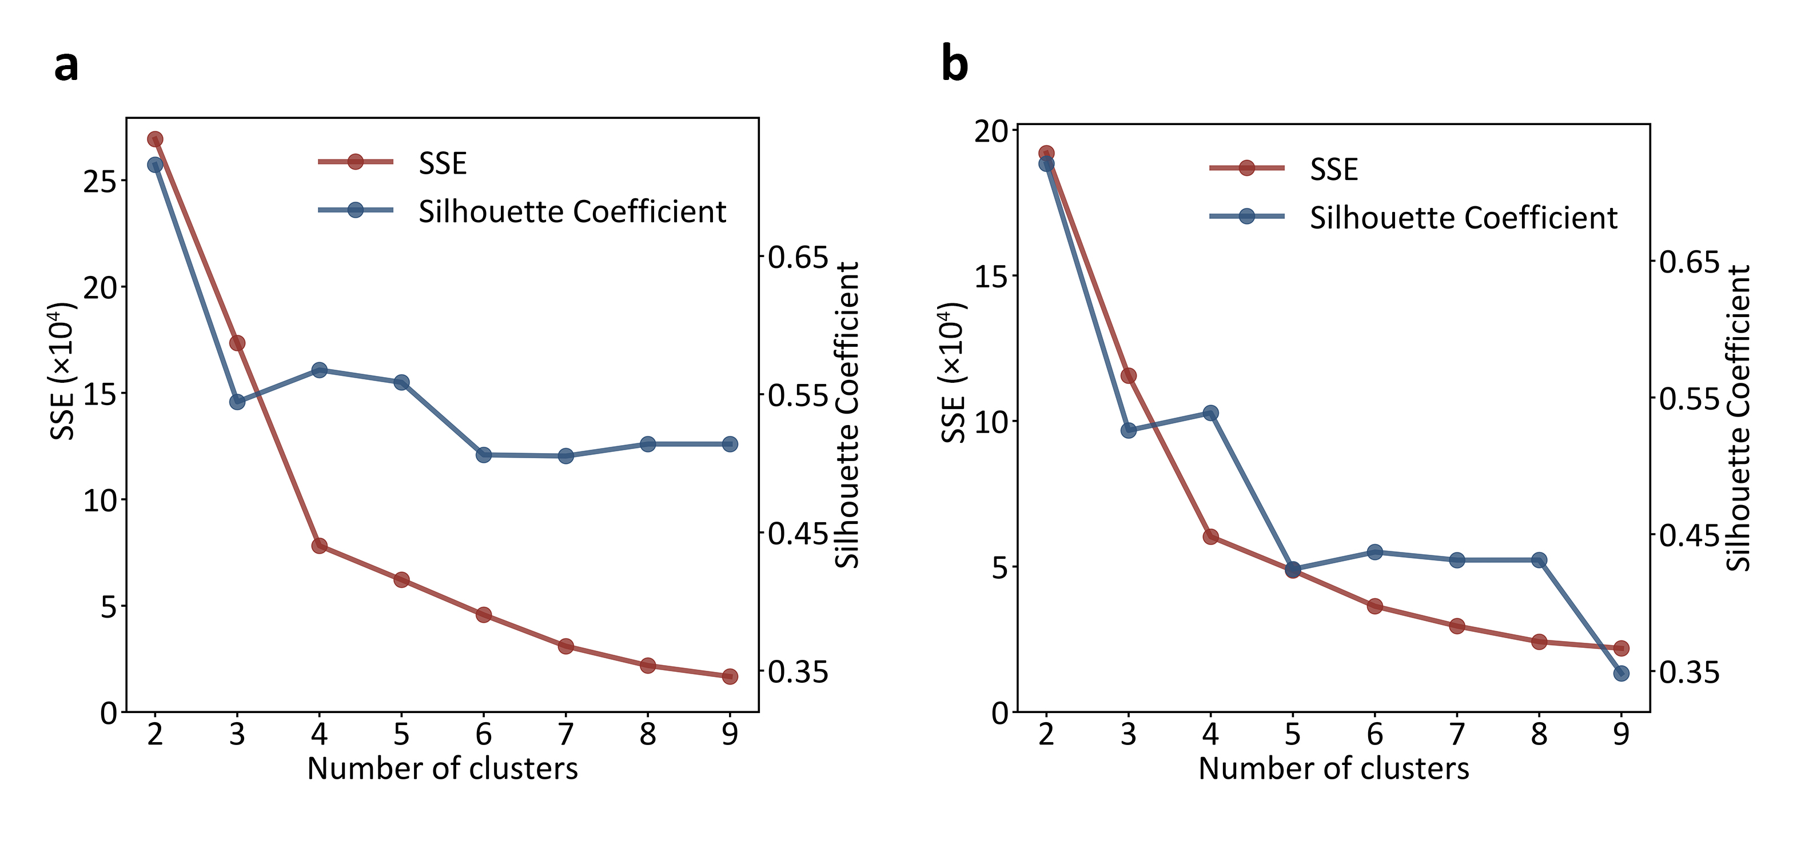
Supplementary Figure 16. The elbow index (sum of squared errors) and the Silhouette Coefficient of clustering analysis. a. Clustering results of the origin cities. b. Clustering results of the destination cities.

Supplementary Table 1. Variables for clustering destination cities.
Dimension | Attributes | Measure | Data source
Scope of services | Horizontal scope: Diversity of the served cities | Number of origin cities | Mobile phone signaling data
Scope of services | Vertical scope: Geographical depth of catchment area | ${WDist}_{i}= \frac{\sum_{ }^{ }{{inF}_{ij}* D_{ij}}}{\sum{{inF}_{ij}}}$ | Mobile phone signaling data
Necessity of services | Healthcare deprivation of the served cities | ${WBed}_{i}= \frac{\sum_{ }^{ }{{inF}_{ij}* {Bed}_{j}}}{\sum{{inF}_{ij}}}$ | Official website of each hospital
Necessity of services | Economic level of the served cities | ${WGdp}_{i}= \frac{\sum_{ }^{ }{{inF}_{ij}* {GDP}_{j}}}{\sum{{inF}_{ij}}}$ | China city statistical yearbook
Type of mobility | Percentage of mobility for the best treatment/diagnosis | $${P_Best}_{i}= \frac{\sum{inF_{ig}}}{\sum{{inF}_{ij}}}$$ | Mobile phone signaling data
Type of mobility | Percentage of mobility for better treatment/diagnosis | $${P_Better}_{i}= \frac{\sum{inF_{ih}}}{\sum{{inF}_{ij}}}$$ | Mobile phone signaling data
Type of mobility | Percentage of pseudo-patient mobility | $${P_Peso}_{i}= \frac{\sum{inF_{ik}}}{\sum{{inF}_{ij}}}$$ | Mobile phone signaling data

The variables used in the bisecting K-Means algorithm are shown in Supplementary Tables 1 and 2. In Supplementary Table 1, for a destination city i, inF_{ij} is the inflow of non-local patients to city i from origin city j, inF_{ig} and inF_{ih} are the inflow of patients pursuing the best and better diagnosis/treatment from origin city g and h, respectively, and inF_{ik} is the inflow of returning migrant workers from origin city k to city i ($g, h, k ∈j$). The sum of ${P_Best}_{i}$, ${P_Better}_{i}$, and ${P_Peso}_{i}$ equals 1. D_{ij} is the distance between city j and city i, Bed_{j} is the number of Tertiary-A hospital beds per 1,000 persons of city j, and GDP_{j} is the GDP per capita in 2022 of city j.

Supplementary Table 2. Variables for clustering origin cities.
Dimension | Attributes | Measure | Data source
Scope of mobility | Vertical scope: geographical depth of mobility | ${WDist}_{m}= \frac{\sum_{ }^{ }{{outF}_{mn}* D_{mn}}}{\sum{{outF}_{mn}}}$ | Mobile phone signaling data
Scope of mobility | Horizontal scope: Diversity of destinations | Number of destination cities | Mobile phone signaling data
Motivation to move | Local healthcare deprivation | Number of Tertiary-A hospital beds per 1,000 persons | Official website of each hospital
Economic ability to move | Local economic level | GDP per capita | China city statistical yearbook
Type of mobility | Percentage of mobility for the best treatment/diagnosis | $${P_Best}_{m}= \frac{\sum{outF_{mg}}}{\sum{{outF}_{mn}}}$$ | Mobile phone signaling data
Type of mobility | Percentage of mobility for better treatment/diagnosis | $${P_Better}_{m}= \frac{\sum{outF_{mh}}}{\sum{{outF}_{mn}}}$$ | Mobile phone signaling data
Type of mobility | Percentage of pseudo-patient mobility | $${P_Peso}_{m}= \frac{\sum{outF_{mk}}}{\sum{{outF}_{mn}}}$$ | Mobile phone signaling data

In Supplementary Table 2, for an origin city m, outF_{mn} is the outflow of non-local patients from city m to destination city n, outF_{mg} and outF_{mh} are the outflow of patients pursuing the best and better diagnosis/treatment in destination city g and h, respectively, and outF_{mk} is the outflow of migrant workers from city m to destination city k ($g, h, k ∈n$). The sum of ${P_Best}_{m}$, ${P_Better}_{m}$, and ${P_Peso}_{m}$ equals 1. D_{mn} is the distance between city m and city n.

