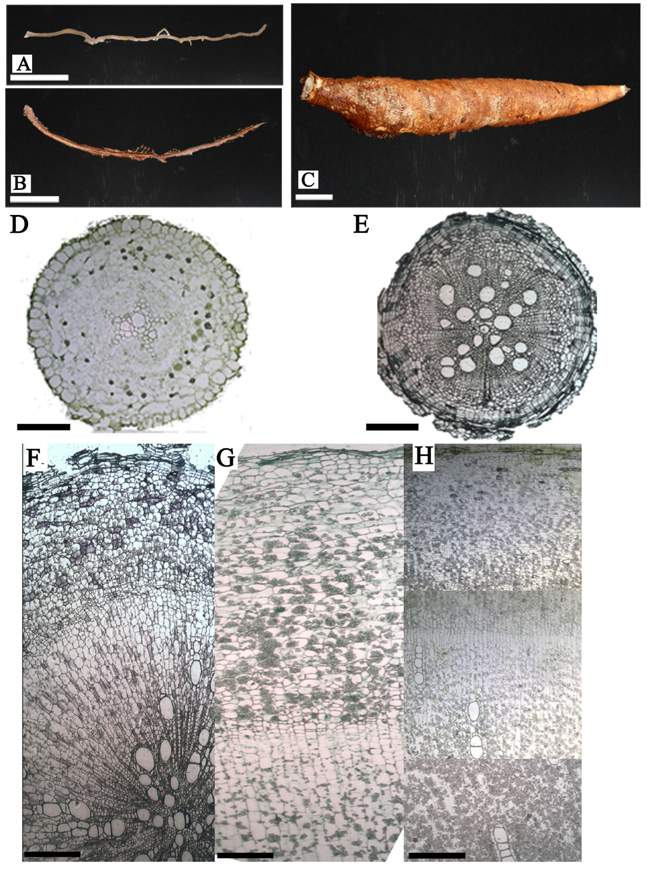
Supplementary data 1 Morphological and anatomical characters of the three kinds of root in cassava
A, primary fibrous root; B, secondary fibrous root; C, storage root; D, transverse section of a primary fibrous root; E, tranverse section of a secondary fibrous root; F-H, transverse section of storage root on early, middle and late stages respectively. Bars: A-C, 1cm; D, 2mm; E-H, 5mm.

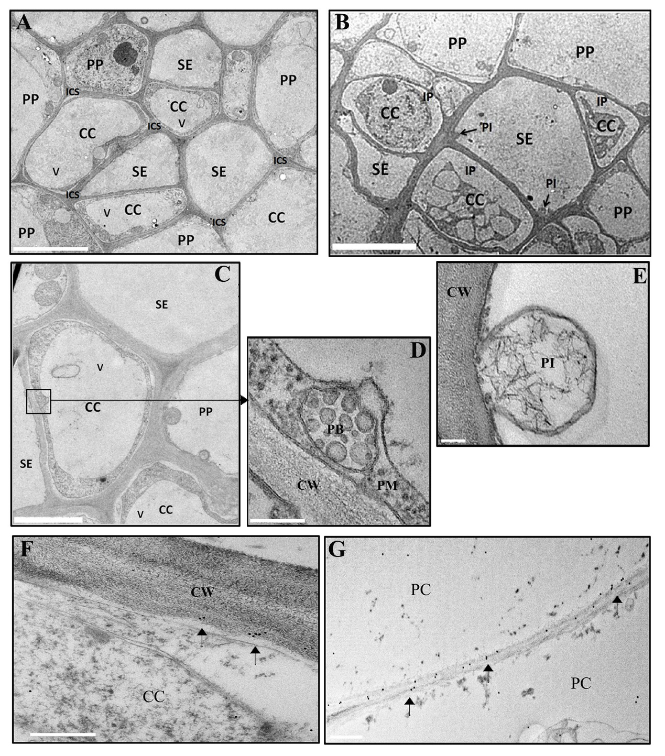
Supplementary data 2 Structure of the primary fibrous root and Sub-cellular localisation of SUTs in the developing cassava root using immunogold particle labelling
A-E, Transverse section of a cassava fibrous root. A, SE–CC complex and its surrounding PCs; increased intercellular space was observed. B, Plasmolysis of the CCs of a PFR, some of which exhibited plasmalemma invagination. C, Suspected paramural bodies were observed in some CCs. D, Amplification of the suspected paramural body. E, Amplification of the invagination shown in B. F, G, SUTs visualised with immunogold particles were localised to the plasma membranes of CCs and PCs. Bar = 5 μm in A, B; 2 μm in C; 200 nm in D, E; and 0.5 μm in F, G.

