SUPPLEMENTARY INFORMATION

FIGURE S1. Correlation diagram of symbiodiniaceae cell density after 480 h and Zn concentration in biomass for the different Zn treatments. All normalizations refer to the respective controls. Dots are connected as a means to highlight the correlations.
Symbiodinium microadriaticum
Zn_{total} = 0.09 mg/L | Zn_{total} = 50 mg/L
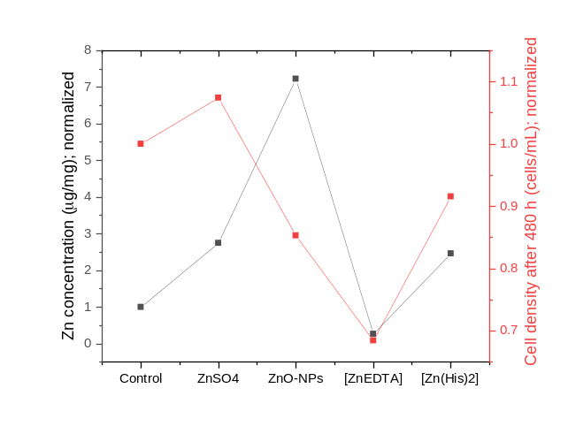 | 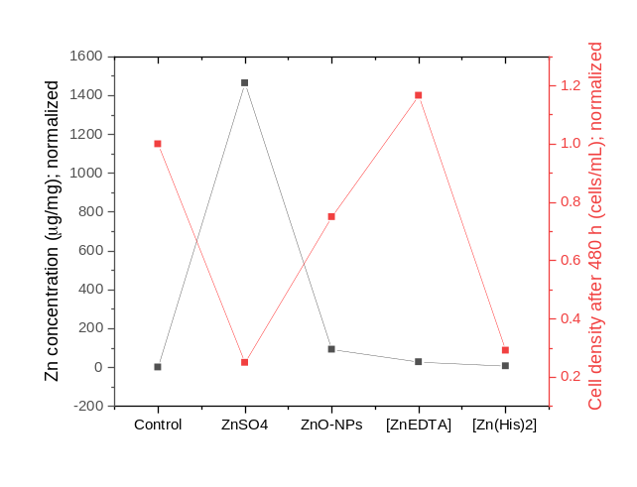
Breviolum minutum
Zn_{total} = 0.09 mg/L | Zn_{total} = 50 mg/L
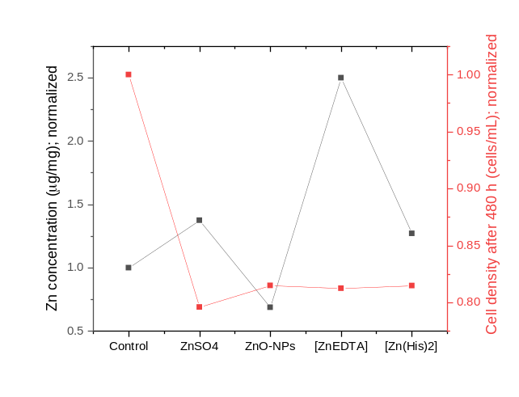 | 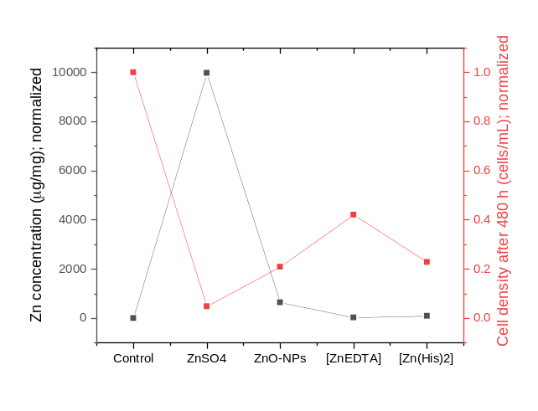

FIGURE S1 (continued)
Effrenium voratum
Zn_{total} = 0.09 mg/L | Zn_{total} = 50 mg/L
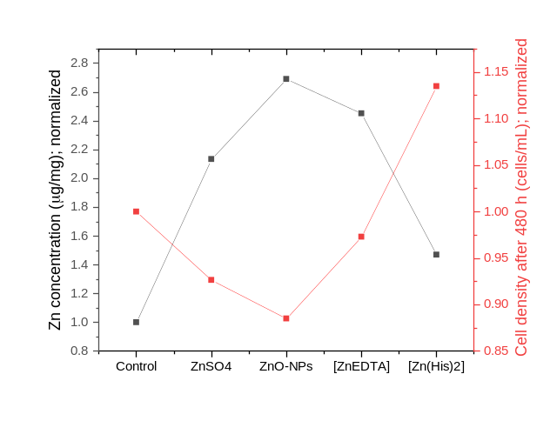 | 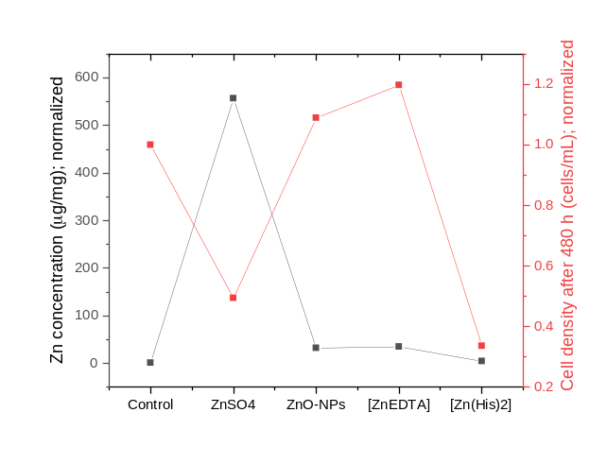

FIGURE S2: Dose-response curves for (a) free Zn(II) and (b) ZnO-NPs inhibition of the trypsin-like activity of Millepora alcicornis extracts.

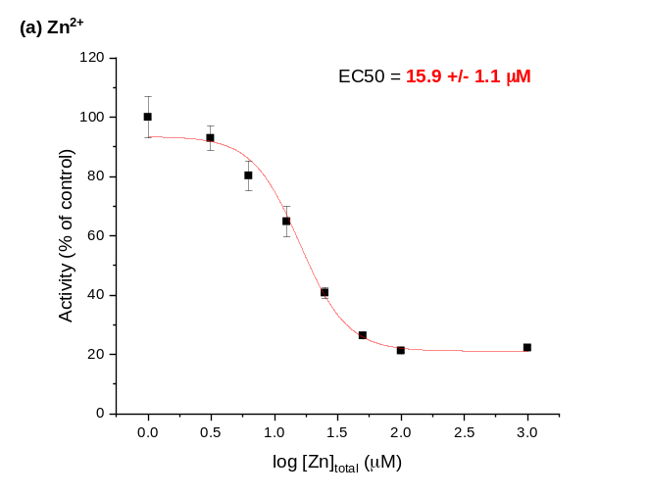 | 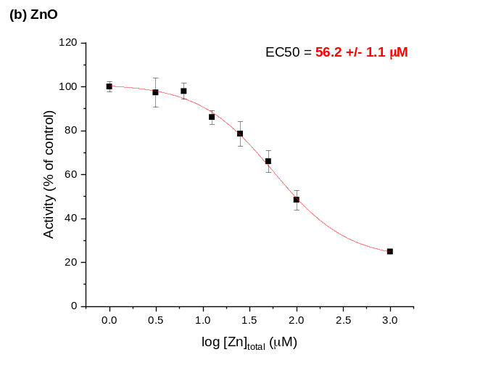

FIGURE S3. Trypsin-like activity of Millepora alcicornis extracts under treatments with zinc citrate and zinc glycinate. * p< 0.05 in relation to the activity of the control.
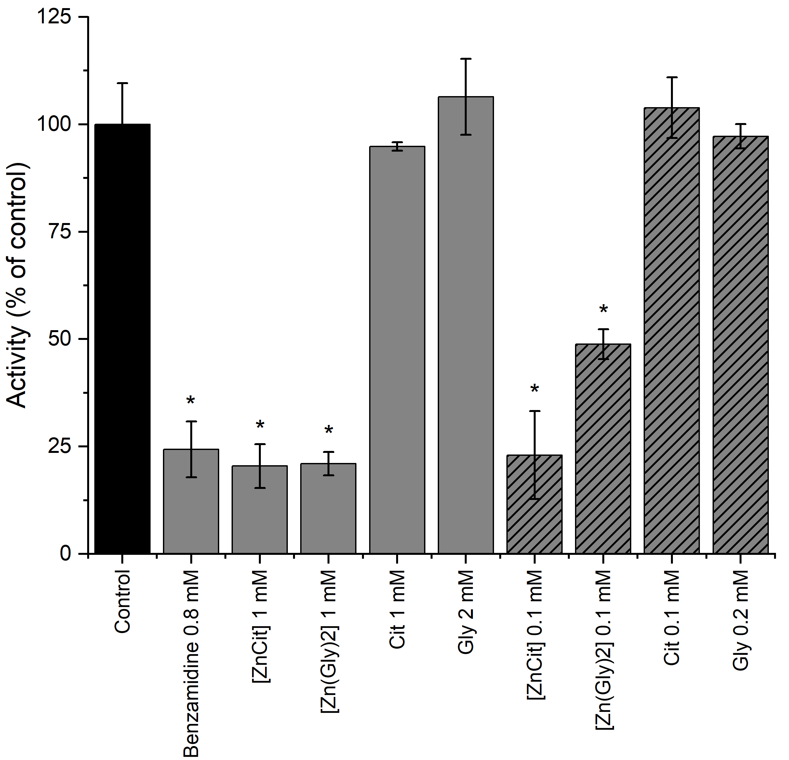

Table S1. Analysis of Variance of the cell densities at each sampling time for each treatment, compared to the controls.
Species | Zn source | Zn concentration (mg L⁻¹) | Sampling time (h) | p value | Statistically difference with control at the same sampling time (yes or no)
S. microadriaticum | ZnSO₄ | 0.09 | 24 | 0.20647852 | N
S. microadriaticum | ZnSO₄ | 0.09 | 48 | 0.01721773 | Y
S. microadriaticum | ZnSO₄ | 0.09 | 120 | 0.00050969 | Y
S. microadriaticum | ZnSO₄ | 0.09 | 216 | 0.002334 | Y
S. microadriaticum | ZnSO₄ | 0.09 | 360 | 0.798273 | N
S. microadriaticum | ZnSO₄ | 0.09 | 480 | 0.360558 | N
S. microadriaticum | ZnO-NPs | 0.09 | 24 | 0.20242283 | N
S. microadriaticum | ZnO-NPs | 0.09 | 48 | 0.0184143 | Y
S. microadriaticum | ZnO-NPs | 0.09 | 120 | 0.00090078 | Y
S. microadriaticum | ZnO-NPs | 0.09 | 216 | 0.005643 | Y
S. microadriaticum | ZnO-NPs | 0.09 | 360 | 0.846928 | N
S. microadriaticum | ZnO-NPs | 0.09 | 480 | 0.048508 | Y
S. microadriaticum | [ZnEDTA] | 0.09 | 24 | 0.67080497 | N
S. microadriaticum | [ZnEDTA] | 0.09 | 48 | 0.01070586 | Y
S. microadriaticum | [ZnEDTA] | 0.09 | 120 | 0.00054939 | Y
S. microadriaticum | [ZnEDTA] | 0.09 | 216 | 0.004663 | Y
S. microadriaticum | [ZnEDTA] | 0.09 | 360 | 0.675931 | N
S. microadriaticum | [ZnEDTA] | 0.09 | 480 | 0.048241 | Y
S. microadriaticum | [Zn(His)₂] | 0.09 | 24 | 0.21572359 | N
S. microadriaticum | [Zn(His)₂] | 0.09 | 48 | 0.02983003 | Y
S. microadriaticum | [Zn(His)₂] | 0.09 | 120 | 0.00557538 | Y
S. microadriaticum | [Zn(His)₂] | 0.09 | 216 | 0.096351 | N
S. microadriaticum | [Zn(His)₂] | 0.09 | 360 | 0.108693 | N
S. microadriaticum | [Zn(His)₂] | 0.09 | 480 | 0.247343 | N
S. microadriaticum | ZnSO₄ | 50 | 24 | 0.30624 | N
S. microadriaticum | ZnSO₄ | 50 | 48 | 0.008867 | Y
S. microadriaticum | ZnSO₄ | 50 | 120 | 4.07E-05 | Y
S. microadriaticum | ZnSO₄ | 50 | 216 | 0.002311 | Y
S. microadriaticum | ZnSO₄ | 50 | 360 | 0.033138 | Y
S. microadriaticum | ZnSO₄ | 50 | 480 | 0.000951 | Y
S. microadriaticum | ZnO-NPs | 50 | 24 | 0.481468 | N
S. microadriaticum | ZnO-NPs | 50 | 48 | 0.018824 | Y
S. microadriaticum | ZnO-NPs | 50 | 120 | 0.000843 | Y
S. microadriaticum | ZnO-NPs | 50 | 216 | 0.00079 | Y
S. microadriaticum | ZnO-NPs | 50 | 360 | 0.13111 | N
S. microadriaticum | ZnO-NPs | 50 | 480 | 0.158025 | N
S. microadriaticum | [ZnEDTA] | 50 | 24 | 0.014597 | Y
S. microadriaticum | [ZnEDTA] | 50 | 48 | 0.063788 | N
S. microadriaticum | [ZnEDTA] | 50 | 120 | 0.604474 | N
S. microadriaticum | [ZnEDTA] | 50 | 216 | 0.915568 | N
S. microadriaticum | [ZnEDTA] | 50 | 360 | 0.021105 | Y
S. microadriaticum | [ZnEDTA] | 50 | 480 | 0.077211 | N
S. microadriaticum | [Zn(His)₂] | 50 | 24 | 0.797654 | N
S. microadriaticum | [Zn(His)₂] | 50 | 48 | 0.762078 | N
S. microadriaticum | [Zn(His)₂] | 50 | 120 | 0.052493 | N
S. microadriaticum | [Zn(His)₂] | 50 | 216 | 0.00313 | Y
S. microadriaticum | [Zn(His)₂] | 50 | 360 | 0.002131 | Y
S. microadriaticum | [Zn(His)₂] | 50 | 480 | 0.00297 | Y
Species | Zn source | Zn concentration (mg L⁻¹) | Sampling time (h) | p value | Statistically difference with control at the same sampling time (yes or no)
E. voratum | ZnSO₄ | 0.09 | 24 | 0.14265707 | N
E. voratum | ZnSO₄ | 0.09 | 48 | 0.00052792 | Y
E. voratum | ZnSO₄ | 0.09 | 120 | 0.02924639 | Y
E. voratum | ZnSO₄ | 0.09 | 216 | 0.002192 | Y
E. voratum | ZnSO₄ | 0.09 | 360 | 0.118461 | N
E. voratum | ZnSO₄ | 0.09 | 480 | 0.468888 | N
E. voratum | ZnO-NPs | 0.09 | 24 | 0.04312593 | Y
E. voratum | ZnO-NPs | 0.09 | 48 | 0.00166339 | Y
E. voratum | ZnO-NPs | 0.09 | 120 | 0.00497598 | Y
E. voratum | ZnO-NPs | 0.09 | 216 | 0.00117 | Y
E. voratum | ZnO-NPs | 0.09 | 360 | 0.137002 | N
E. voratum | ZnO-NPs | 0.09 | 480 | 0.164903 | N
E. voratum | [ZnEDTA] | 0.09 | 24 | 0.02988401 | Y
E. voratum | [ZnEDTA] | 0.09 | 48 | 0.01813673 | Y
E. voratum | [ZnEDTA] | 0.09 | 120 | 0.00022945 | Y
E. voratum | [ZnEDTA] | 0.09 | 216 | 0.001282 | Y
E. voratum | [ZnEDTA] | 0.09 | 360 | 0.095919 | N
E. voratum | [ZnEDTA] | 0.09 | 480 | 0.752033 | N
E. voratum | [Zn(His)₂] | 0.09 | 24 | 0.05223712 | N
E. voratum | [Zn(His)₂] | 0.09 | 48 | 0.00348498 | Y
E. voratum | [Zn(His)₂] | 0.09 | 120 | 0.0054306 | Y
E. voratum | [Zn(His)₂] | 0.09 | 216 | 0.028288 | Y
E. voratum | [Zn(His)₂] | 0.09 | 360 | 0.130761 | N
E. voratum | [Zn(His)₂] | 0.09 | 480 | 0.236711 | N
E. voratum | ZnSO₄ | 50 | 24 | 0.011295 | Y
E. voratum | ZnSO₄ | 50 | 48 | 0.002059 | Y
E. voratum | ZnSO₄ | 50 | 120 | 0.002924 | Y
E. voratum | ZnSO₄ | 50 | 216 | 0.000684 | Y
E. voratum | ZnSO₄ | 50 | 360 | 0.003768 | Y
E. voratum | ZnSO₄ | 50 | 480 | 0.002195 | Y
E. voratum | ZnO-NPs | 50 | 24 | 0.007415 | Y
E. voratum | ZnO-NPs | 50 | 48 | 0.005316 | Y
E. voratum | ZnO-NPs | 50 | 120 | 9.46E-05 | Y
E. voratum | ZnO-NPs | 50 | 216 | 0.000539 | Y
E. voratum | ZnO-NPs | 50 | 360 | 0.170662 | N
E. voratum | ZnO-NPs | 50 | 480 | 0.304519 | N
E. voratum | [ZnEDTA] | 50 | 24 | 0.614517 | N
E. voratum | [ZnEDTA] | 50 | 48 | 0.251677 | N
E. voratum | [ZnEDTA] | 50 | 120 | 0.045489033 | Y
E. voratum | [ZnEDTA] | 50 | 216 | 0.001515 | Y
E. voratum | [ZnEDTA] | 50 | 360 | 0.229533 | N
E. voratum | [ZnEDTA] | 50 | 480 | 0.105586 | N
E. voratum | [Zn(His)₂] | 50 | 24 | 0.189368 | N
E. voratum | [Zn(His)₂] | 50 | 48 | 0.00044 | Y
E. voratum | [Zn(His)₂] | 50 | 120 | 0.00339043 | Y
E. voratum | [Zn(His)₂] | 50 | 216 | 0.002359 | Y
E. voratum | [Zn(His)₂] | 50 | 360 | 0.008164 | Y
E. voratum | [Zn(His)₂] | 50 | 480 | 0.010381 | Y

Species | Zn source | Zn concentration (mg L⁻¹) | Sampling time (h) | p value | Statistically difference with control at the same sampling time (yes or no)
B. minutum | ZnSO₄ | 0.09 | 24 | 0.96817879 | N
B. minutum | ZnSO₄ | 0.09 | 48 | 0.14042053 | N
B. minutum | ZnSO₄ | 0.09 | 120 | 0.00177686 | Y
B. minutum | ZnSO₄ | 0.09 | 216 | 0.550914 | N
B. minutum | ZnSO₄ | 0.09 | 360 | 0.031533 | Y
B. minutum | ZnSO₄ | 0.09 | 480 | 0.098244 | N
B. minutum | ZnO-NPs | 0.09 | 24 | 0.01466187 | Y
B. minutum | ZnO-NPs | 0.09 | 48 | 0.01939925 | Y
B. minutum | ZnO-NPs | 0.09 | 120 | 0.00935711 | Y
B. minutum | ZnO-NPs | 0.09 | 216 | 0.000326 | Y
B. minutum | ZnO-NPs | 0.09 | 360 | 0.052457 | N
B. minutum | ZnO-NPs | 0.09 | 480 | 0.072873 | N
B. minutum | [ZnEDTA] | 0.09 | 24 | 0.15629665 | N
B. minutum | [ZnEDTA] | 0.09 | 48 | 0.98753666 | N
B. minutum | [ZnEDTA] | 0.09 | 120 | 0.00688184 | Y
B. minutum | [ZnEDTA] | 0.09 | 216 | 0.014666 | Y
B. minutum | [ZnEDTA] | 0.09 | 360 | 0.040771 | Y
B. minutum | [ZnEDTA] | 0.09 | 480 | 0.020753 | Y
B. minutum | [Zn(His)₂] | 0.09 | 24 | 0.20543479 | N
B. minutum | [Zn(His)₂] | 0.09 | 48 | 0.07107095 | N
B. minutum | [Zn(His)₂] | 0.09 | 120 | 4.3547E-05 | Y
B. minutum | [Zn(His)₂] | 0.09 | 216 | 0.002041 | Y
B. minutum | [Zn(His)₂] | 0.09 | 360 | 0.296053 | N
B. minutum | [Zn(His)₂] | 0.09 | 480 | 0.031051 | Y
B. minutum | ZnSO₄ | 50 | 24 | 0.660745 | N
B. minutum | ZnSO₄ | 50 | 48 | 0.000773 | Y
B. minutum | ZnSO₄ | 50 | 120 | 5.07E-06 | Y
B. minutum | ZnSO₄ | 50 | 216 | 1.25E-05 | Y
B. minutum | ZnSO₄ | 50 | 360 | 0.000777956 | Y
B. minutum | ZnSO₄ | 50 | 480 | 0.000150574 | Y
B. minutum | ZnO-NPs | 50 | 24 | 0.000125 | Y
B. minutum | ZnO-NPs | 50 | 48 | 0.000444 | Y
B. minutum | ZnO-NPs | 50 | 120 | 2.75E-06 | Y
B. minutum | ZnO-NPs | 50 | 216 | 1.63716E-05 | Y
B. minutum | ZnO-NPs | 50 | 360 | 0.001438043 | Y
B. minutum | ZnO-NPs | 50 | 480 | 0.000446264 | Y
B. minutum | [ZnEDTA] | 50 | 24 | 0.06977 | N
B. minutum | [ZnEDTA] | 50 | 48 | 0.006941 | Y
B. minutum | [ZnEDTA] | 50 | 120 | 3.92E-05 | Y
B. minutum | [ZnEDTA] | 50 | 216 | 0.006977102 | Y
B. minutum | [ZnEDTA] | 50 | 360 | 0.027276464 | Y
B. minutum | [ZnEDTA] | 50 | 480 | 0.000686521 | Y
B. minutum | [Zn(His)₂] | 50 | 24 | 0.685664 | N
B. minutum | [Zn(His)₂] | 50 | 48 | 0.680273 | N
B. minutum | [Zn(His)₂] | 50 | 120 | 0.012773279 | Y
B. minutum | [Zn(His)₂] | 50 | 216 | 0.024780373 | Y
B. minutum | [Zn(His)₂] | 50 | 360 | 0.004741751 | Y
B. minutum | [Zn(His)₂] | 50 | 480 | 0.000322206 | Y

