Table 1 Genotypes, codes, populations, locations, GPS, and herbarium vouchers for the Iris aucheri genotypes used in this study.
Accessions | Accessions code | Populations | Locations | Coordinates | Herbarium voucher | Iris plants
Genotype 1 | G1 | Pop 1 | Haibat Sultan | 36.10300, 44.67082 | SUFA:HOMS#_06a | 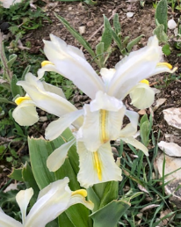 | 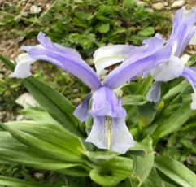
Genotype 2 | G2 | Pop 1 | Haibat Sultan | 36.10300, 44.67082 | SUFA:HOMS#_06b
Genotype 3 | G3 | Pop 1 | Haibat Sultan | 36.10300, 44.67082 | SUFA:HOMS#_06c
Genotype 4 | G4 | Pop 1 | Haibat Sultan | 36.10300, 44.67082 | SUFA:HOMS#_06d
Genotype 5 | G5 | Pop 1 | Haibat Sultan | 36.10300, 44.67082 | SUFA:HOMS#_06e
Genotype 6 | G6 | Pop 1 | Haibat Sultan | 36.10300, 44.67082 | SUFA:HOMS#_06f
Genotype 7 | G7 | Pop 1 | Haibat Sultan | 36.10300, 44.67082 | SUFA:HOMS#_06g
Genotype 8 | G8 | Pop 2 | Tawella | 35.19956, 46.18531 | SUFA:HOMS#_07a | 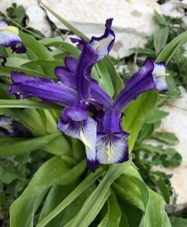 |  | 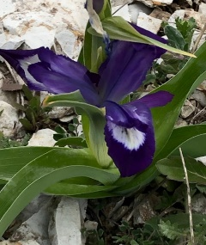
Genotype 9 | G9 | Pop 2 | Tawella | 35.19956, 46.18531 | SUFA:HOMS#_07b
Genotype 10 | G10 | Pop 2 | Tawella | 35.19956, 46.18531 | SUFA:HOMS#_07c
Genotype 11 | G11 | Pop 2 | Tawella | 35.19956, 46.18531 | SUFA:HOMS#_07d
Genotype 12 | G12 | Pop 2 | Tawella | 35.19956, 46.18531 | SUFA:HOMS#_07e
Genotype 13 | G13 | Pop 2 | Tawella | 35.19956, 46.18531 | SUFA:HOMS#_07f
Genotype 14 | G14 | Pop 2 | Tawella | 35.19956, 46.18531 | SUFA:HOMS#_07g
Genotype 15 | G15 | Pop 2 | Tawella | 35.19956, 46.18531 | SUFA:HOMS#_07h
Genotype 16 | G16 | Pop 3 | Bestana | 36.136289, 44.684711 | SUFA:HOMS#_08a | 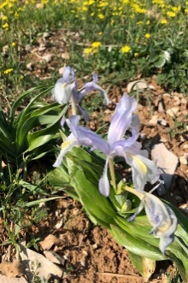 |  | 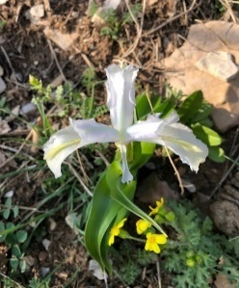
Genotype 17 | G17 | Pop 3 | Bestana | 36.136289, 44.684711 | SUFA:HOMS#_08b
Genotype 18 | G18 | Pop 3 | Bestana | 36.136289, 44.684711 | SUFA:HOMS#_08c
Genotype 19 | G19 | Pop 3 | Bestana | 36.136289, 44.684711 | SUFA:HOMS#_08d
Genotype 20 | G20 | Pop 3 | Bestana | 36.136289, 44.684711 | SUFA:HOMS#_08e
Genotype 21 | G21 | Pop 3 | Bestana | 36.136289, 44.684711 | SUFA:HOMS#_08f
Genotype 22 | G22 | Pop 3 | Bestana | 36.136289, 44.684711 | SUFA:HOMS#_08g
Genotype 23 | G23 | Pop 3 | Bestana | 36.136289, 44.684711 | SUFA:HOMS#_08h
Genotype 24 | G24 | Pop 3 | Bestana | 36.136289, 44.684711 | SUFA:HOMS#_08i
Genotype 25 | G25 | Pop 4 | Qaradakh | 35.286439, 45.379442 | SUFA:HOMS#_09a | 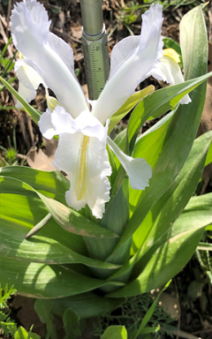 |  | 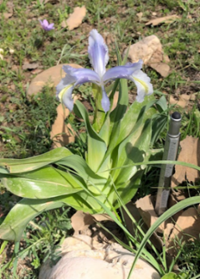
Genotype 26 | G26 | Pop 4 | Qaradakh | 35.286439, 45.379442 | SUFA:HOMS#_09b
Genotype 27 | G27 | Pop 4 | Qaradakh | 35.286439, 45.379442 | SUFA:HOMS#_09c
Genotype 28 | G28 | Pop 4 | Qaradakh | 35.286439, 45.379442 | SUFA:HOMS#_09d
Genotype 29 | G29 | Pop 4 | Qaradakh | 35.286439, 45.379442 | SUFA:HOMS#_09e
Genotype 30 | G30 | Pop 4 | Qaradakh | 35.286439, 45.379442 | SUFA:HOMS#_09f
Genotype 31 | G31 | Pop 4 | Qaradakh | 35.286439, 45.379442 | SUFA:HOMS#_09g
Genotype 32 | G32 | Pop 4 | Qaradakh | 35.286439, 45.379442 | SUFA:HOMS#_09h
Genotype 33 | G33 | Pop 4 | Qaradakh | 35.286439, 45.379442 | SUFA:HOMS#_09i
Genotype 34 | G34 | Pop 4 | Qaradakh | 35.286439, 45.379442 | SUFA:HOMS#_09j
Genotype 35 | G35 | Pop 4 | Qaradakh | 35.286439, 45.379442 | SUFA:HOMS#_09k
Genotype 36 | G36 | Pop 4 | Qaradakh | 35.286439, 45.379442 | SUFA:HOMS#_09l
Genotype 37 | G37 | Pop 5 | Warte | 36.443594, 44.755489 | SUFA:HOMS#_10a | 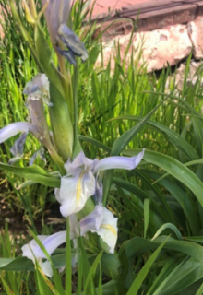 |  | 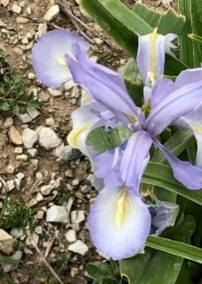
Genotype 38 | G38 | Pop 5 | Warte | 36.443594, 44.755489 | SUFA:HOMS#_10b
Genotype 39 | G39 | Pop 5 | Warte | 36.443594, 44.755489 | SUFA:HOMS#_10c
Genotype 40 | G40 | Pop 5 | Warte | 36.443594, 44.755489 | SUFA:HOMS#_10d
Genotype 41 | G41 | Pop 5 | Warte | 36.443594, 44.755489 | SUFA:HOMS#_10e
Genotype 42 | G42 | Pop 5 | Warte | 36.443594, 44.755489 | SUFA:HOMS#_10f
Genotype 43 | G43 | Pop 5 | Warte | 36.443594, 44.755489 | SUFA:HOMS#_10g
Genotype 44 | G44 | Pop 5 | Warte | 36.443594, 44.755489 | SUFA:HOMS#_10h
Genotype 45 | G45 | Pop 5 | Warte | 36.443594, 44.755489 | SUFA:HOMS#_10i
Genotype 46 | G46 | Pop 5 | Warte | 36.443594, 44.755489 | SUFA:HOMS#_10j
Genotype 47 | G47 | Pop 5 | Warte | 36.443594, 44.755489 | SUFA:HOMS#_10k
Genotype 48 | G48 | Pop 5 | Warte | 36.443594, 44.755489 | SUFA:HOMS#_10l

Table 2 ISSR and CDDP primers, primer sequences and annealing temperatures (ATs)
ISSR Primers | Sequence of primer (5′ – 3′) | AT (°C)
UBC-811 | GAGAGAGAGAGAGAGAC | 50.00
UBC-812 | GAGAGAGAGAGAGAGAA | 50.40
UBC-813 | CTCTCTCTCTCTCTCTT | 50.00
UBC-815 | CTCTCTCTCTCTCTCTG | 50.00
UBC-823 | TCTCTCTCTCTCTCTCC | 50.00
UBC-825 | ACACAC ACACACACACT | 50.00
UBC-834 | AGAGAGAGAGAGAGAGGT | 50.00
UBC-841 | GAGAGAGAGAGAGAGACTC | 50.00
UBC-847 | CACACACACACACACAGC | 50.00
UBC-849 | GTGTGTGTGTGTGTGTGA | 50.00
CDDP Primers
ABP1-1 | ACSCCSATCCACCGC | 50.00
ERF1 | CACTACCCCGGSCTSCG | 50.00
Knox2 | CACTGGTGGGAGCTSCAC | 50.00
KNOX3 | AAGCGSCACTGGAAGCC | 50.00
MADS-1 | ATGGGCCGSGGCAAGGTGC | 50.00
Myb1 | GGCAAGGGCTGCCGC | 50.00
Myb2 | GGCAAGGGCTGCCGG | 50.00
WRKY-R2 | GCCCTCGTASGTSGT | 50.00
WRKY-R2B | GCCCTCGTASGTSGT | 50.00
WRKY-R3B | GCCCTCGTASGTSGT | 50.00

Table 3 Total number of polymorphic bands (TPB), number of observed alleles (Na), effective number of alleles (Ne), Shannon’s information index (I), expected heterozygosity or gene diversity (He), unbiased expected heterozygosity (uHe), and polymorphic information content (PIC) values based on ISSR and CDDP primers.
ISSR markers | TPB | Na | Ne | I | He | uHe | PIC | CDDP Markers | TPB | Na | Ne | I | He | uHe | PIC
UBC-811 | 15.00 | 1.76 | 1.48 | 0.43 | 0.28 | 0.30 | 0.36 | ABP1-1 | 21.00 | 1.43 | 1.36 | 0.32 | 0.21 | 0.23 | 0.24
UBC-812 | 9.00 | 1.58 | 1.30 | 0.32 | 0.20 | 0.21 | 0.32 | ERF1 | 7.00 | 1.51 | 1.41 | 0.34 | 0.23 | 0.24 | 0.26
UBC-813 | 7.00 | 1.80 | 1.43 | 0.39 | 0.26 | 0.27 | 0.34 | Knox2 | 16.00 | 1.63 | 1.38 | 0.34 | 0.22 | 0.24 | 0.24
UBC-815 | 14.00 | 1.79 | 1.41 | 0.39 | 0.25 | 0.27 | 0.35 | KNOX3 | 15.00 | 1.64 | 1.37 | 0.36 | 0.23 | 0.24 | 0.37
UBC-823 | 10.00 | 1.78 | 1.57 | 0.47 | 0.32 | 0.34 | 0.40 | MADS-1 | 11.00 | 1.47 | 1.26 | 0.28 | 0.17 | 0.18 | 0.25
UBC-825 | 13.00 | 1.75 | 1.41 | 0.39 | 0.25 | 0.27 | 0.30 | Myb1 | 10.00 | 1.54 | 1.36 | 0.32 | 0.21 | 0.22 | 0.21
UBC-834 | 13.00 | 1.49 | 1.40 | 0.36 | 0.24 | 0.25 | 0.22 | Myb2 | 8.00 | 1.68 | 1.47 | 0.41 | 0.28 | 0.29 | 0.28
UBC-841 | 13.00 | 1.78 | 1.46 | 0.41 | 0.27 | 0.29 | 0.34 | WRKY-R2 | 20.00 | 1.42 | 1.31 | 0.30 | 0.19 | 0.20 | 0.23
UBC-847 | 7.00 | 1.80 | 1.37 | 0.37 | 0.24 | 0.25 | 0.31 | WRKY-R2B | 11.00 | 1.44 | 1.34 | 0.32 | 0.21 | 0.22 | 0.26
UBC-849 | 7.00 | 1.57 | 1.45 | 0.36 | 0.25 | 0.26 | 0.23 | WRKY-R3B | 15.00 | 1.59 | 1.46 | 0.40 | 0.27 | 0.28 | 0.30
Mean | 10.80 | 1.71 | 1.43 | 0.39 | 0.26 | 0.27 | 0.32 | Mean | 13.40 | 1.53 | 1.37 | 0.34 | 0.22 | 0.23 | 0.26
Total | 108.00 |  |  |  |  |  |  | Total | 134.00

Table 4 Molecular variance analysis of Iris aucheri populations using ISSR, CDDP, and their combined data.
Source | Df | SS | MS | Est. Var. | Var (%)
ISSR markers
Among Pops | 4.00 | 136.71 | 34.18 | 1.88 | 10.41
Within Pops | 43.00 | 695.40 | 16.17 | 16.17 | 89.59
Total | 47.00 | 832.10 |  | 18.05 | 100.00
PhiPT | 0.10**
p value | 0.001
CDDP markers
Among Pops | 4.00 | 145.14 | 36.29 | 1.88 | 9.36
Within Pops | 43.00 | 784.53 | 18.24 | 18.24 | 90.64
Total | 47.00 | 929.67 |  | 20.13 | 100.00
PhiPT | 0.09**
p Value | 0.001
ISSR+CDDP markers
Among Pops | 4.00 | 285.61 | 71.40 | 3.78 | 9.69
Within Pops | 43.00 | 1514.64 | 35.22 | 35.22 | 90.31
Total | 47.00 | 1800.25 |  | 39.00 | 100.00
PhiPT | 0.10**
p Value | 0.001
Df, degrees of freedom; SS, sum of squares; MS, mean of squares; Est. Var. estimated variance, Var variance, PhiPT proportion of the total genetic variance between the individuals within a population, p value probability value; ** statistically significant at the 0.01 level.

Table 5 Diversity indices of populations determined via ISSR, CDDP, and their combined markers
 | ISSR markers
Pop | Na | Ne | I | He | uHe | PPL (%) | NPB
Pop 1 | 1.78 | 1.44 | 0.40 | 0.26 | 0.28 | 85.19 | 1.00
Pop 2 | 1.80 | 1.47 | 0.42 | 0.28 | 0.29 | 86.11 | 1.00
Pop 3 | 1.76 | 1.46 | 0.41 | 0.27 | 0.29 | 85.19 | 0.00
Pop 4 | 1.42 | 1.36 | 0.33 | 0.22 | 0.23 | 64.81 | 0.00
Pop 5 | 1.81 | 1.44 | 0.40 | 0.26 | 0.28 | 88.89 | 0.00
Mean | 1.71 | 1.43 | 0.39 | 0.26 | 0.27 | 82.00 | 0.40
 | CDDP markers
Pop 1 | 1.53 | 1.35 | 0.32 | 0.21 | 0.22 | 70.15 | 2.00
Pop 2 | 1.57 | 1.44 | 0.39 | 0.26 | 0.28 | 74.63 | 2.00
Pop 3 | 1.69 | 1.41 | 0.37 | 0.24 | 0.26 | 80.60 | 2.00
Pop 4 | 1.25 | 1.29 | 0.26 | 0.17 | 0.18 | 55.22 | 5.00
Pop 5 | 1.58 | 1.35 | 0.33 | 0.21 | 0.22 | 74.63 | 0.00
Mean | 1.52 | 1.37 | 0.34 | 0.22 | 0.23 | 71.05 | 2.20
 | ISSR+CDDP markers
Pop 1 | 1.64 | 1.39 | 0.35 | 0.23 | 0.25 | 76.76 | 3.00
Pop 2 | 1.67 | 1.45 | 0.41 | 0.27 | 0.28 | 79.67 | 3.00
Pop 3 | 1.72 | 1.43 | 0.39 | 0.26 | 0.27 | 82.57 | 2.00
Pop 4 | 1.32 | 1.32 | 0.29 | 0.19 | 0.20 | 59.34 | 5.00
Pop 5 | 1.69 | 1.39 | 0.36 | 0.24 | 0.25 | 81.33 | 0.00
Mean | 1.61 | 1.39 | 0.36 | 0.24 | 0.25 | 75.93 | 2.60
Pop population, Na number of observed alleles, Ne effective number of alleles, I Shannon’s information index, He expected heterozygosity or gene diversity, uHe unbiased expected heterozygosity, NPB number of private bands, PPL percentage of polymorphic loci.

