Supplementary Materials
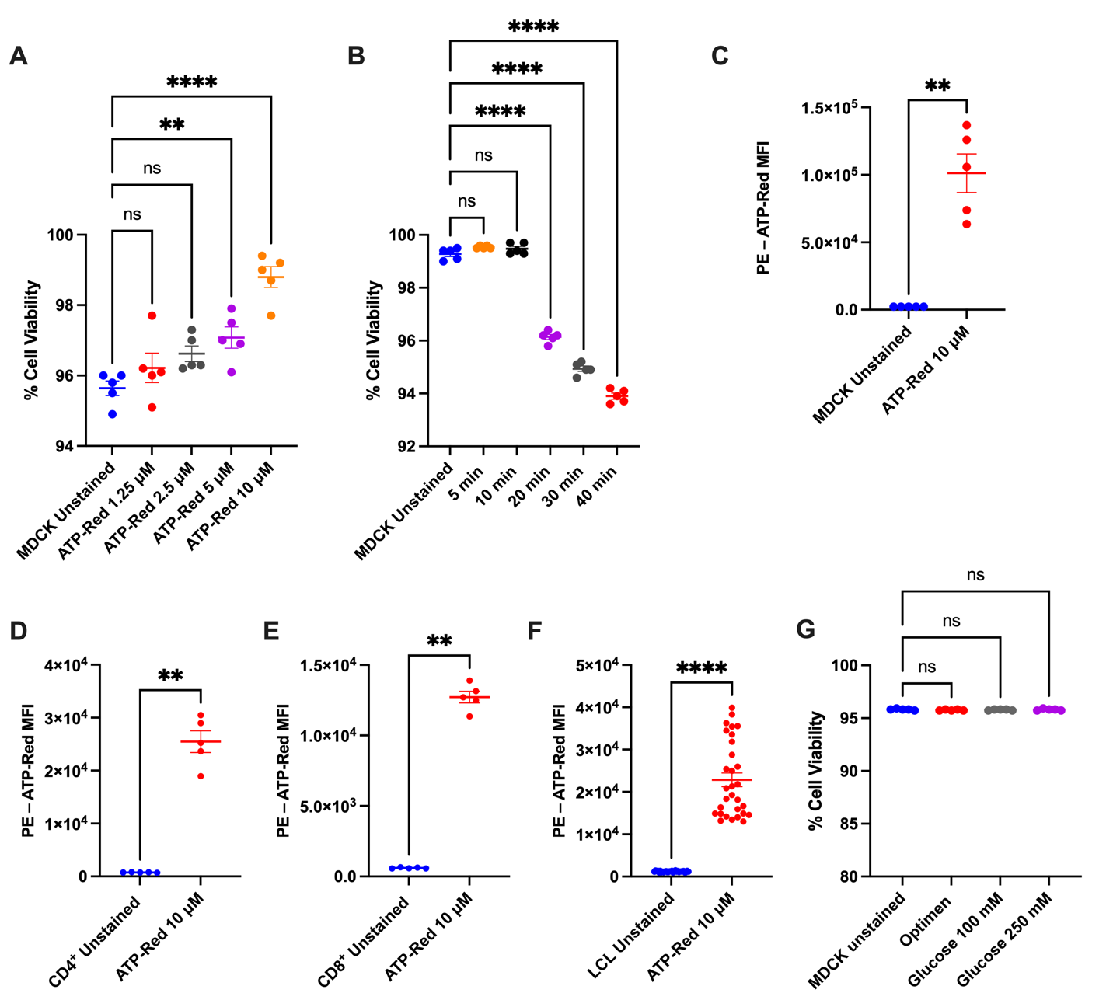
Supplementary Figure 1. A: Percentage of cell viability of MDCK cells treated with different concentrations of ATP-Red for 20 minutes at 37° C and 5% CO₂. B: Percent cell viability of MDCK cells treated in time kinetics with 10 μM ATP-Red for 20 minutes at 37° C and 5% CO₂. C: MDCK cells ATP-Red shift vs unstained cells. D-E: Murine CD4+ and CD8+ cells ATP-Red shift vs unstained cells. F: Human LCL cells ATP-Red shift vs unstained cells. G: Percentage of cell viability of MDCK cells treated with different concentrations of glucose using 10 μM ATP-Red for 20 minutes at 37° C and 5% CO₂. A-B, G: Ordinary one-way ANOVA by Multiple Comparison Test; **** p < 0.0001, *p < 0.05. C-F: Mann-Whitney test **p < 0.05; **** p < 0.0001

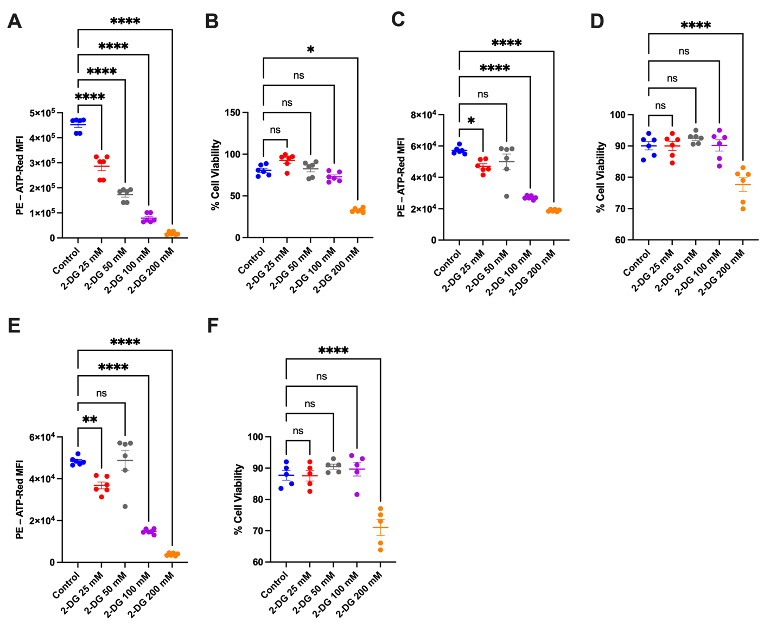

Supplementary Figure 2. A: Fluorescence intensity of MDCK cells treated with different concentrations of 2-DG. B: Percentage of cell viability of MDCK cells treated with different concentrations of 2-DG using 10 μM ATP-Red for 20 minutes at 37° C and 5% CO₂. C: Fluorescence intensity of LCL cells treated with different concentrations of 2-DG. D: Percentage of cell viability of LCL cells treated with different concentrations of 2-DG using 10 μM ATP-Red for 20 minutes at 37° C and 5% CO₂. E: Fluorescence intensity of Jurkat cells treated with different concentrations of 2-DG. F: Percentage of cell viability of Jurkat cells treated with different concentrations of 2-DG using 10 μM ATP-Red for 20 minutes at 37° C and 5% CO₂. A-F: Ordinary one-way ANOVA by Multiple Comparison Test; **** p < 0.0001, *p < 0.05.

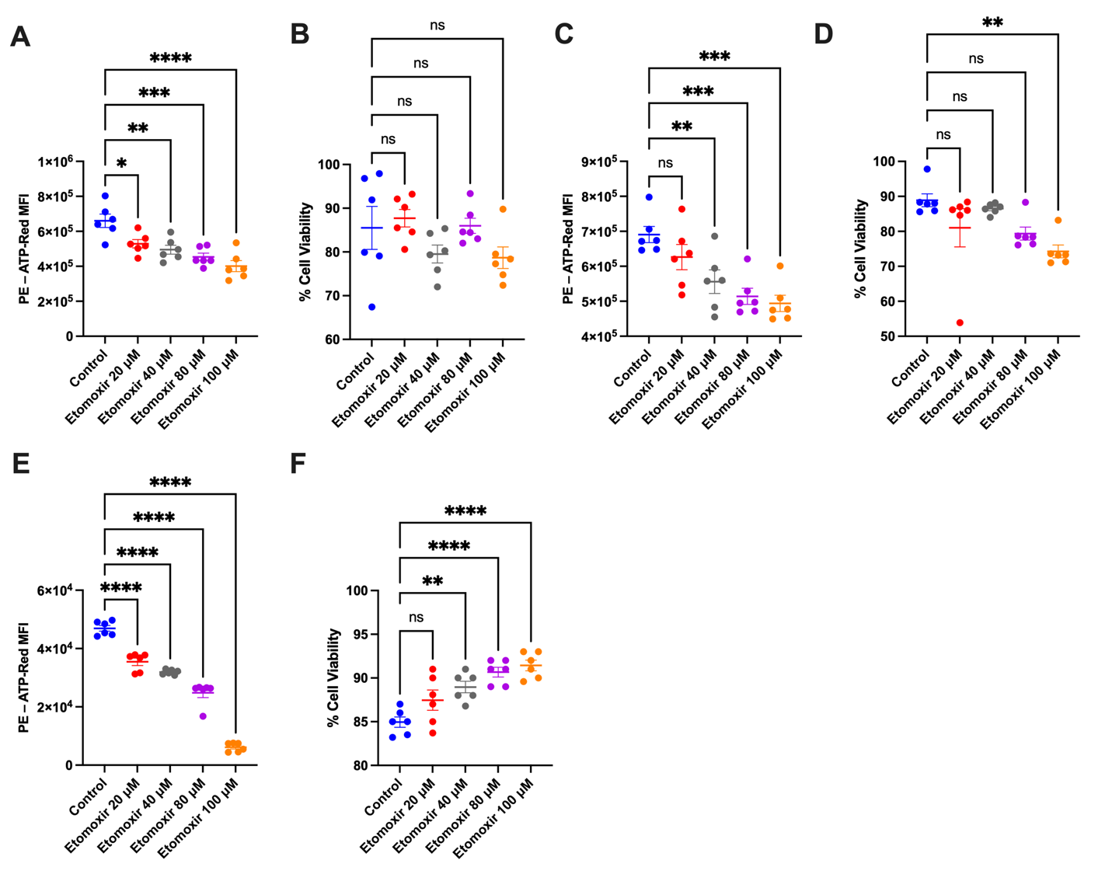

Supplementary Figure 3. A: Fluorescence intensity of MDCK cells treated with different concentrations of etomoxir. B: Percentage of cell viability of MDCK cells treated with different concentrations of etomoxir using 10 μM ATP-Red for 20 minutes at 37° C and 5% CO₂. C: Fluorescence intensity of LCL cells treated with different concentrations of etomoxir. D: Percentage of cell viability of LCL cells treated with different concentrations of etomoxir using 10 μM ATP-Red for 20 minutes at 37° C and 5% CO₂. E: Fluorescence intensity of Jurkat cells treated with different concentrations of etomoxir. F: Percentage of cell viability of Jurkat cells treated with different concentrations of etomoxir using 10 μM ATP-Red for 20 minutes at 37° C and 5% CO₂. A-F: Ordinary one-way ANOVA by Multiple Comparison Test; **** p < 0.0001, *p < 0.05.

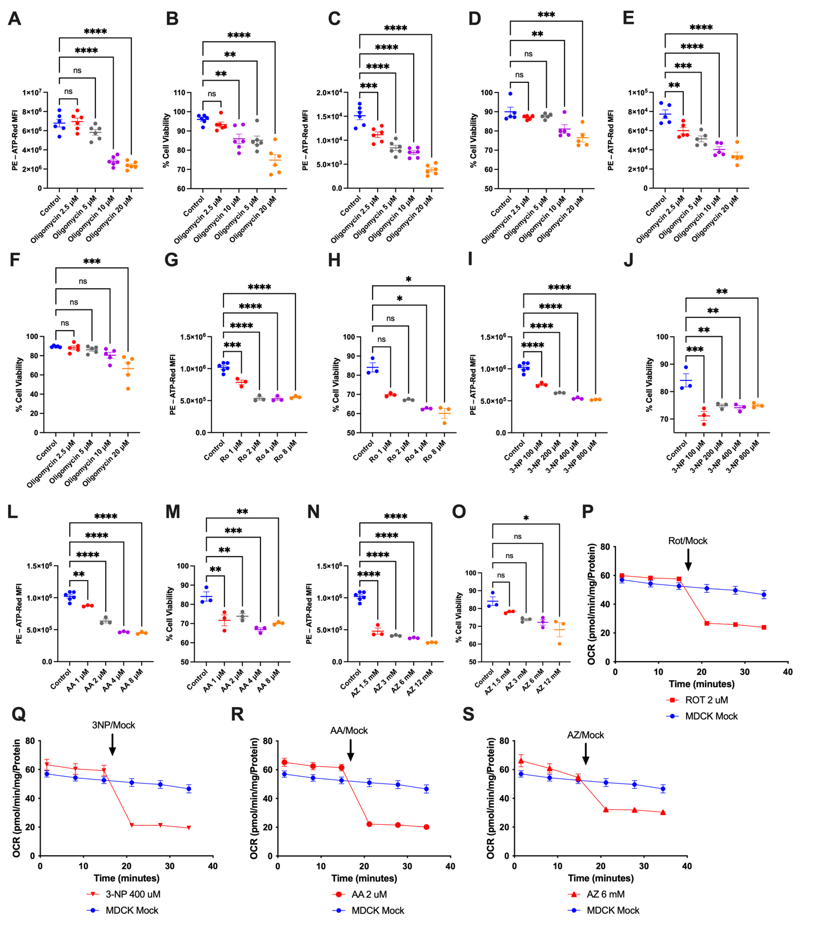

Supplementary Figure 4. A: Fluorescence intensity of MDCK cells treated with different concentrations of oligomycin and 10 μM ATP-Red for 20 minutes at 37° C and 5% CO₂. B: Percentage of cell viability of MDCK cells treated with different concentrations of oligomycin. C: Fluorescence intensity of LCL cells treated with different concentrations of oligomycin and 10 μM ATP-Red for 20 minutes at 37° C and 5% CO₂. D: Percentage of cell viability of LCL cells treated with different concentrations of oligomycin. E: Fluorescence intensity of Jurkat cells treated with different concentrations of oligomycin and 10 μM ATP-Red for 20 minutes at 37° C and 5% CO₂. F: Percentage of cell viability of Jurkat cells treated with different concentrations of oligomycin. G, I, L, N: Fluorescence intensity of MDCK cells treated with different concentrations of rotenone (RO), 3-NP (3-NP), antimycin A (AA) and sodium azide (AZ). H, J, M, O: Percentage of cell viability of MDCK cells treated with different concentrations of rotenone (RO), 3-NP (3-NP), antimycin A (AA) and sodium azide (AZ). P-S: Complete sequence of the experiment is shown for obtain the oxygen consumption values in different drugs treatment using rotenone (RO), 3-NP (3-NP), antimycin A (AA) and sodium azide (AZ) in MDCK WT vs SURF1 KO cells, analyzed with the Seahorse extracellular flux analyzer. A-O: Ordinary one-way ANOVA by Multiple Comparison Test; **** p < 0.0001, *p < 0.05.

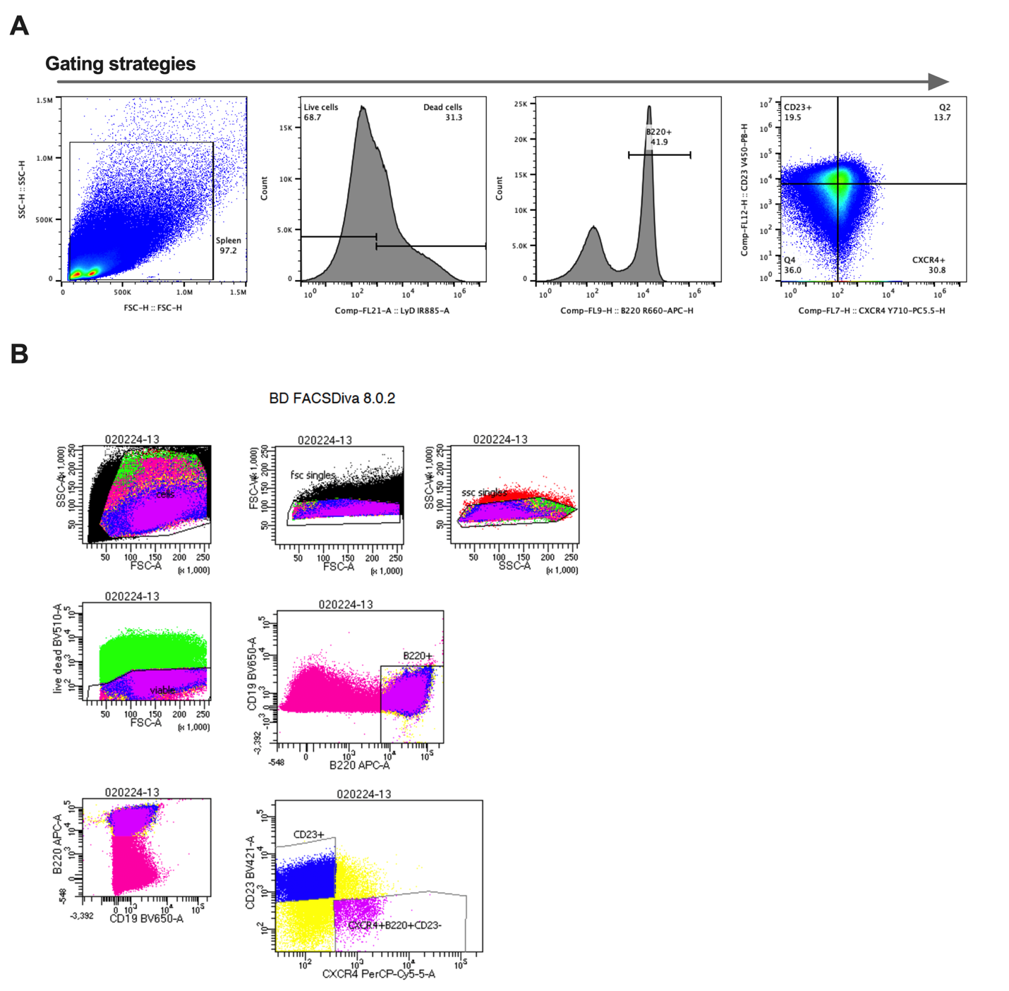

Supplementary Figure 5. A: Cells were selected using the gating strategy where we select the cells from the spleen for their complexity and cellular granularity, where we subsequently select live cells and identify the B220 markers for B cells and the (LZ CD23⁺) and (DZ CXCR4⁺). B: sorting strategy for cells where we subsequently select live cells and identify the B220 markers for B cells and the (LZ CD23⁺) and (DZ CXCR4⁺).

