Supplementary material
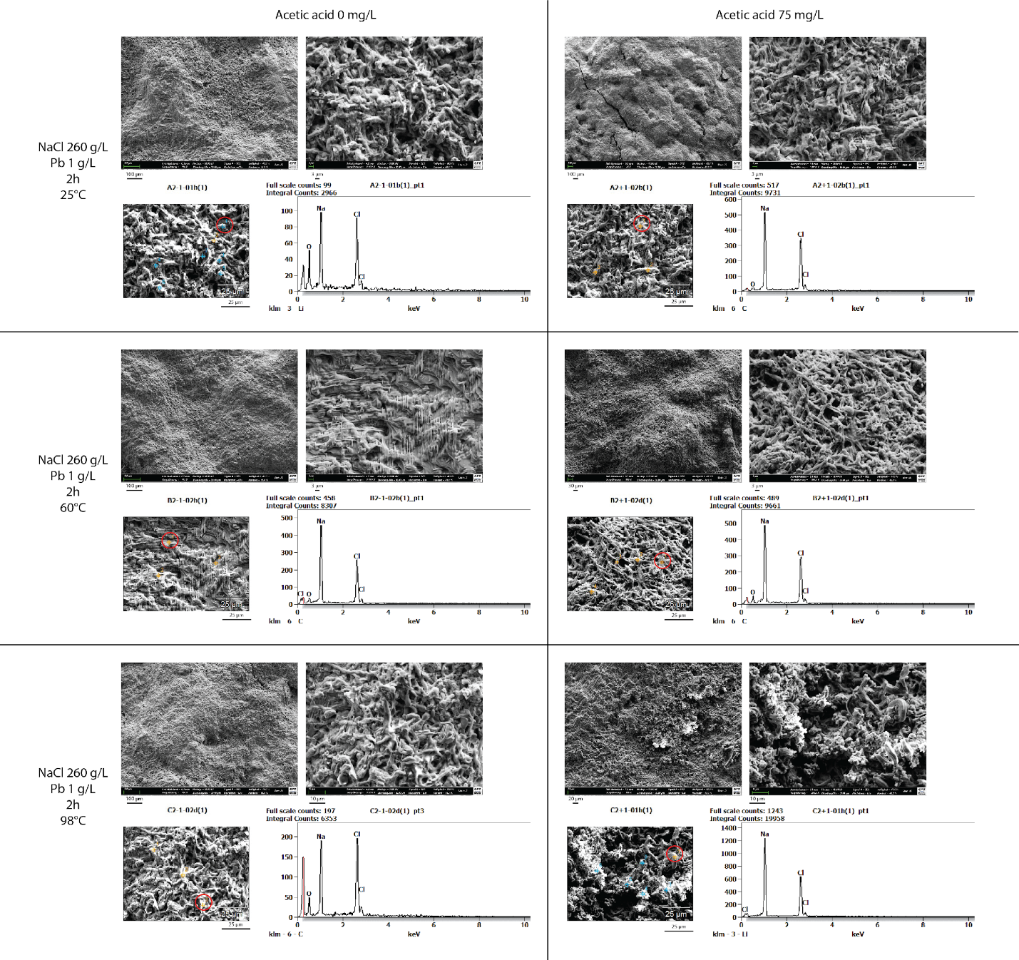
Supplementary Figure 1: SEM microscopy images of biomass exposed to different conditions and corresponding EDX analysis. Common variables for all treatments: NaCl [260 g/L], Pb²⁺ [1 g/L], Contact time: 2 h. Variations between the treatments: temperature (25 °C, 60 °C, 98 °C), presence [60 mg/L] or absence [0 mg/L] of acetic acid. Scale: present on each image. One EDX measure point is shown for each condition (red circle).

Supplementary Table 1. Summary of the different treatments tested and the number of replicates per treatment. Additional condition common to all treatments: 8 bar of pressure. Treatments without NaCl are highlighted in grey.
Pb2+ | NaCl | Acetic acid | Temperature | Contact time | Number of replicates
1 g/L | 265 g/L | 0 mg/L | 25°C | 1 h | 3
1 g/L | 265 g/L | 60 mg/L | 25°C | 1 h | 3
1 g/L | 265 g/L | 0 mg/L | 60°C | 1 h | 3
1 g/L | 265 g/L | 60 mg/L | 60°C | 1 h | 3
1 g/L | 265 g/L | 0 mg/L | 98°C | 1 h | 3
1 g/L | 265 g/L | 60 mg/L | 98°C | 1 h | 3
1 g/L | 0 g/L | 0 mg/L | 25°C | 2 h | 2
1 g/L | 0 g/L | 60 mg/L | 25°C | 2 h | 2
1 g/L | 265 g/L | 0 mg/L | 25°C | 2 h | 3
1 g/L | 265 g/L | 60 mg/L | 25°C | 2 h | 3
1 g/L | 265 g/L | 0 mg/L | 60°C | 2 h | 3
1 g/L | 265 g/L | 60 mg/L | 60°C | 2 h | 3
1 g/L | 265 g/L | 0 mg/L | 98°C | 2 h | 3
1 g/L | 265 g/L | 60 mg/L | 98°C | 2 h | 3
1 g/L | 265 g/L | 0 mg/L | 25°C | 3 h | 3
1 g/L | 265 g/L | 60 mg/L | 25°C | 3 h | 3
1 g/L | 265 g/L | 0 mg/L | 60°C | 3 h | 3
1 g/L | 265 g/L | 60 mg/L | 60°C | 3 h | 3
1 g/L | 265 g/L | 0 mg/L | 98°C | 3 h | 3
1 g/L | 265 g/L | 60 mg/L | 98°C | 3 h | 3

Supplementary Table 2. p-values and p-adjusted values for the ANOVA model testing the impact of temperature, acetic acid and time of exposure on the amount of lead present in the fungal biomass.
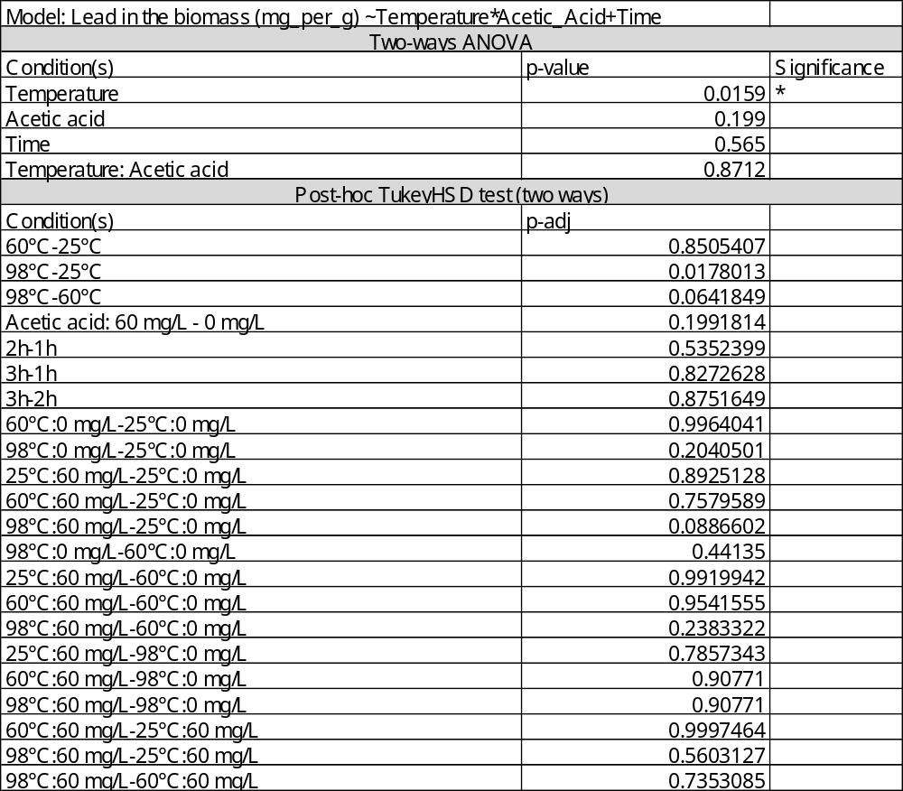

Supplementary Table 3. p-values (ANOVA) and p-adjusted values (TukeyHSD test) for the model testing the impact of the presence or absence of salt and acetic acid on the amount of lead present in the fungal biomass.
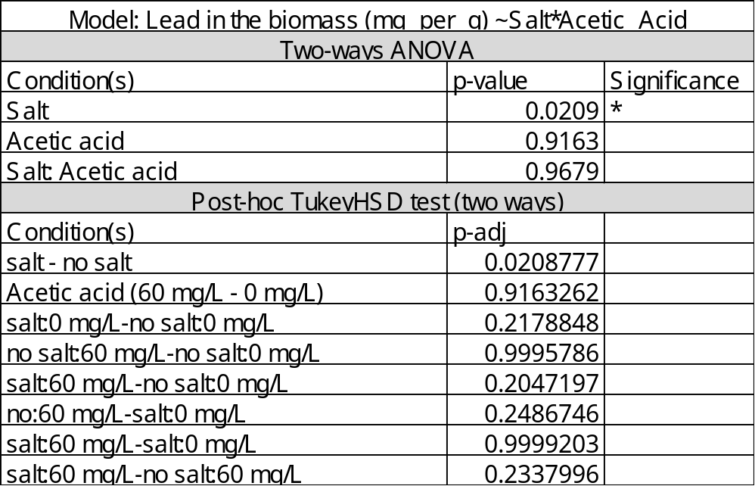

Supplementary Table 4. p-values (ANOVA) and p-adjusted values (TukeyHSD test) for the model testing the impact of the presence or absence acetic acid and the time of exposure on the amount of lead present in the fungal biomass at 25 °C.
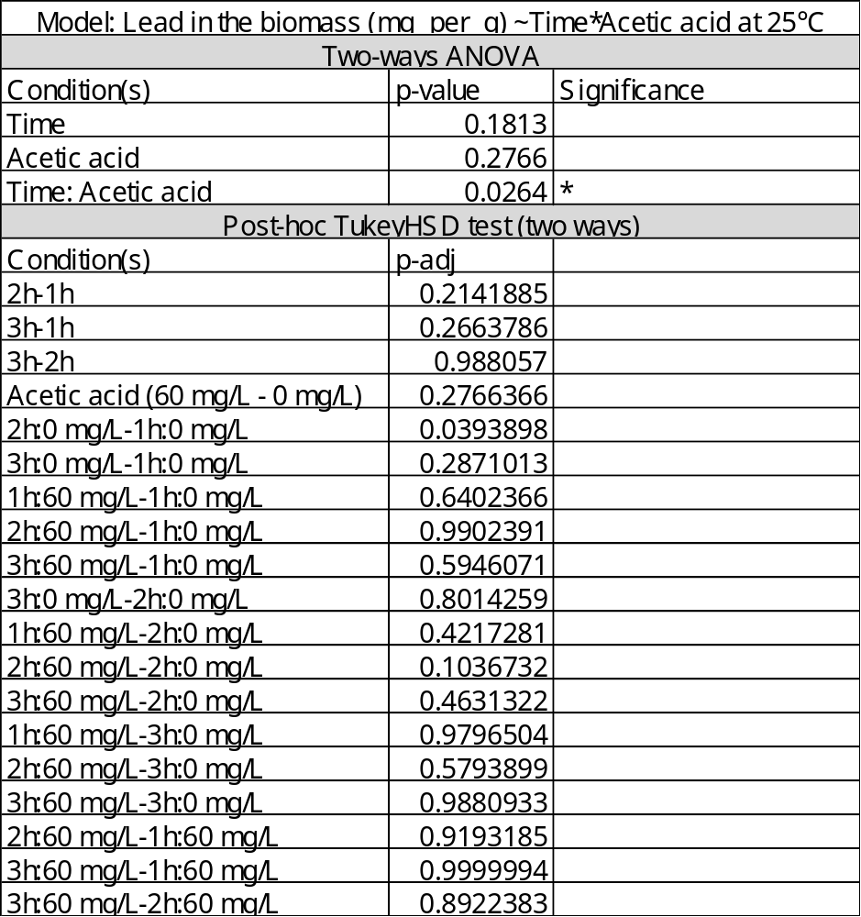

Supplementary Table 5. p-values (ANOVA) and p-adjusted values (TukeyHSD test) for the model testing the impact of the presence or absence acetic acid and the time of exposure on the amount of lead present in the fungal biomass at 60 °C.
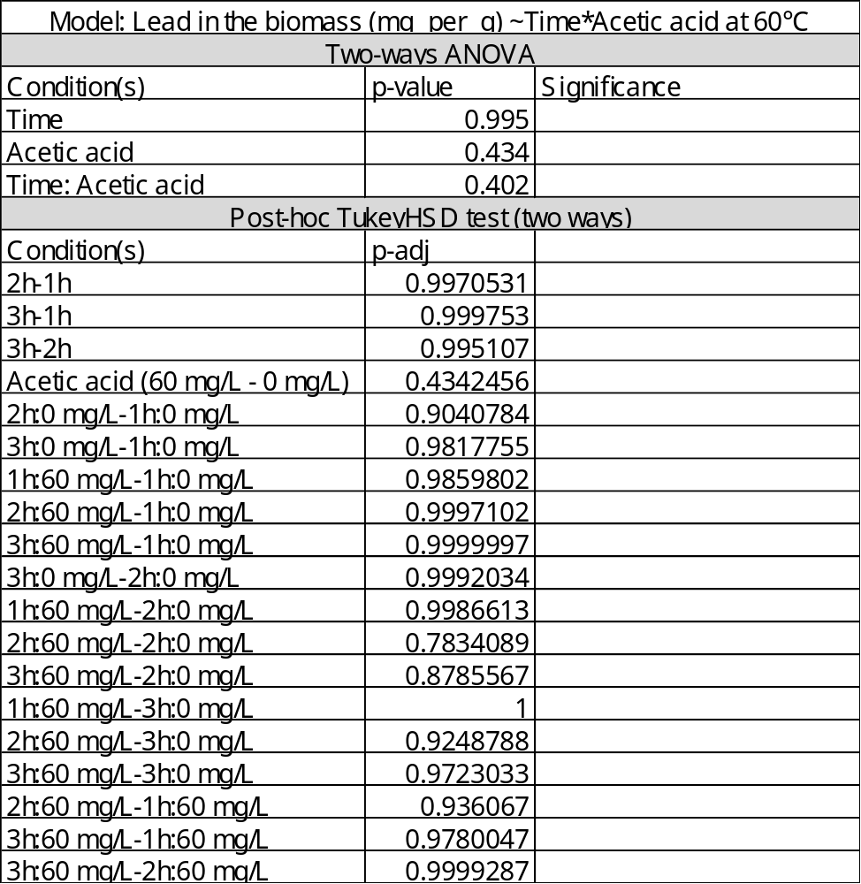

Supplementary Table 6. p-values (ANOVA) and p-adjusted values (TukeyHSD test) for the model testing the impact of the presence or absence acetic acid and the time of exposure on the amount of lead present in the fungal biomass at 98 °C.
