Supplementary Material
Model informed approach to estimate treatment effect in placebo-controlled clinical trials using an artificial intelligence based propensity weighting methodology to account for non-specific responses to treatment
R. Gomeni¹, F. Bressolle-Gomeni¹
¹Pharmacometrica, Longcol, La Fouillade, France

Corresponding author:

Roberto Gomeni
Pharmacometrica, Lieu-dit Longcol, 12270, La Fouillade, France
E-mail: roberto.gomeni@pharmacometrica.com
Phone number: +33 760451976

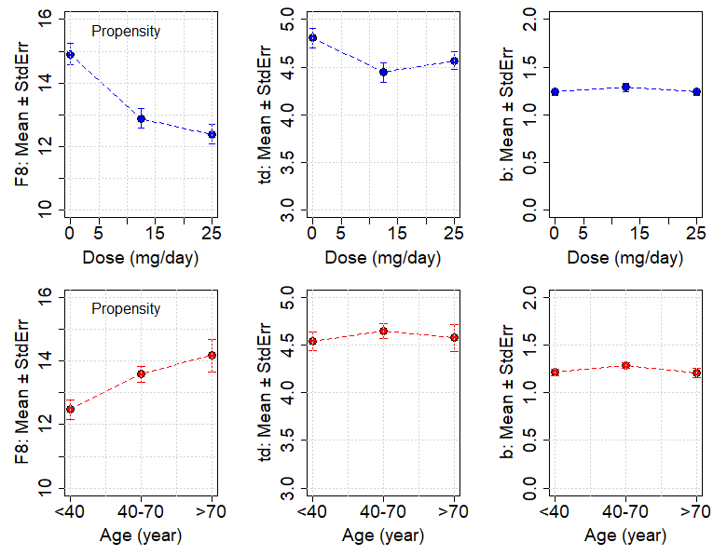
Fig. S1. Propensity analysis. Plots of then mean (± Standard Error) of the individual Bayesian parameter estimates as a function of the dose (dose=0 for placebo) and of the class of age
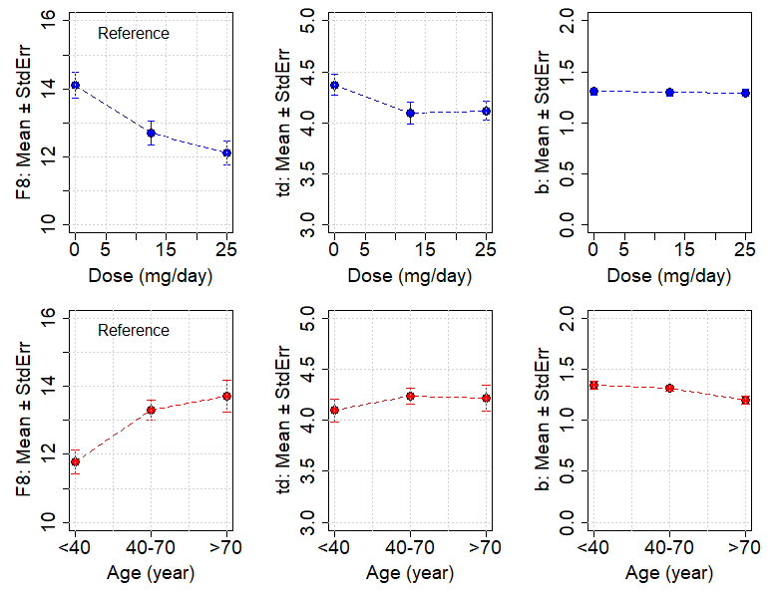
Fig. S2. Reference analysis. Plots of then mean (± Standard Error) of the individual Bayesian parameter estimates as a function of the dose (dose=0 for placebo) and of the class of age

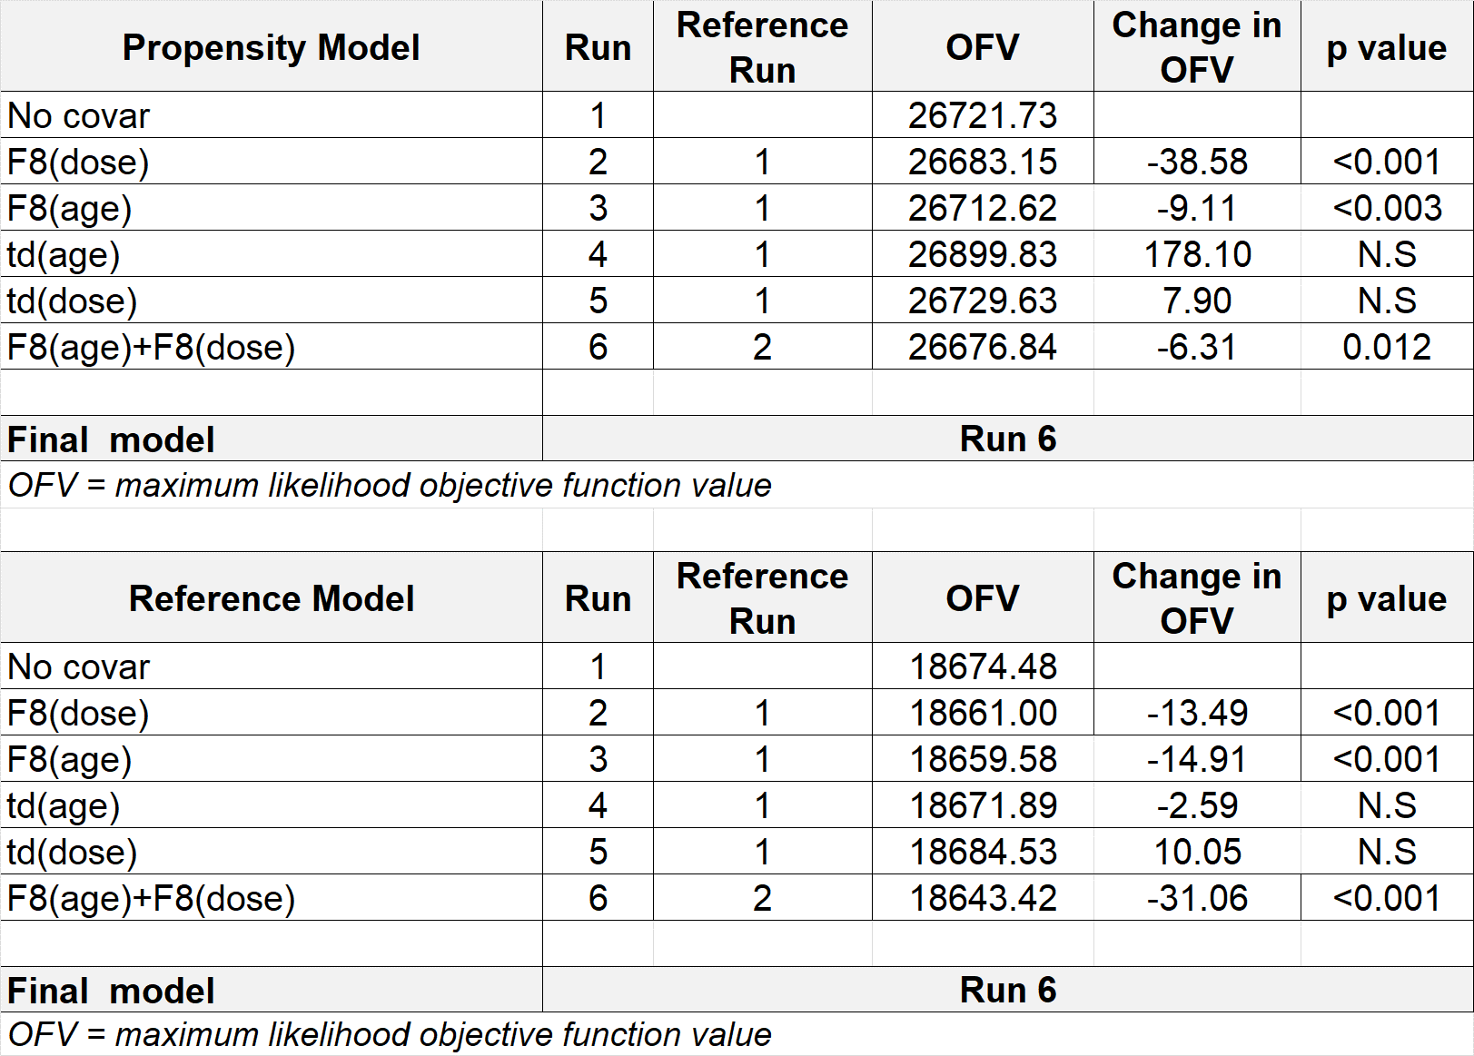
Table S1. Stepwise covariate model building procedure for the ‘propensity’ and ‘reference’ models. The first column lists each model tested. The second column lists the reference run to which the test run was compared. The third and fourth columns list the OFV for each test run and the change in OFV from the reference run (test – reference), respectively. The fifth column reports the p value associated to the chi-squared statistics.
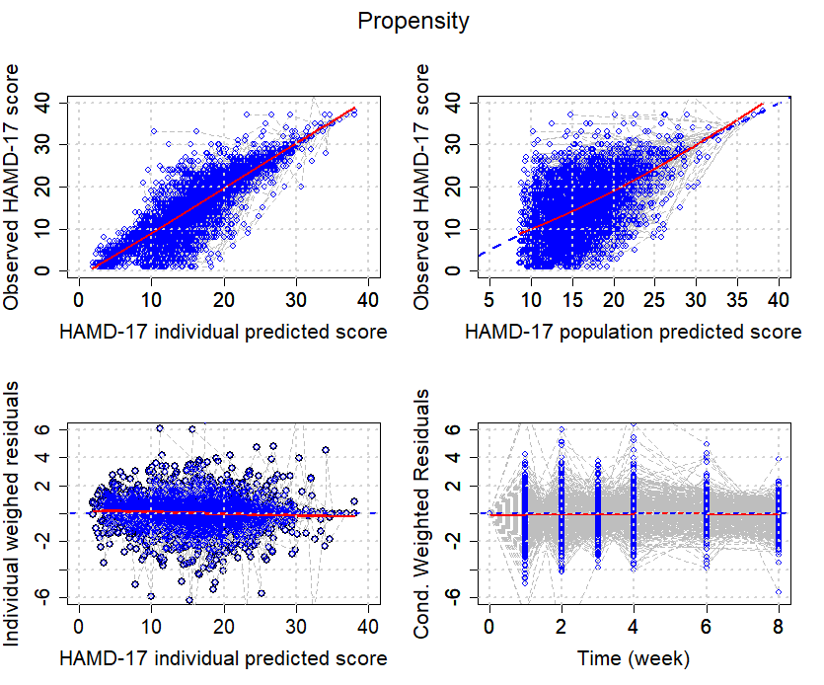
Fig S3. Propensity model. Goodness-of-fit plots. The blue dotted lines represent the reference identity line (in the observed versus individual and population model predicted concentration values plots) and the reference zero intercept horizontal lines (in the IWRES and Conditional Weighted residual plots). The red lines represent the smoothing function lines. The gray lines joint the individual observation (circles).

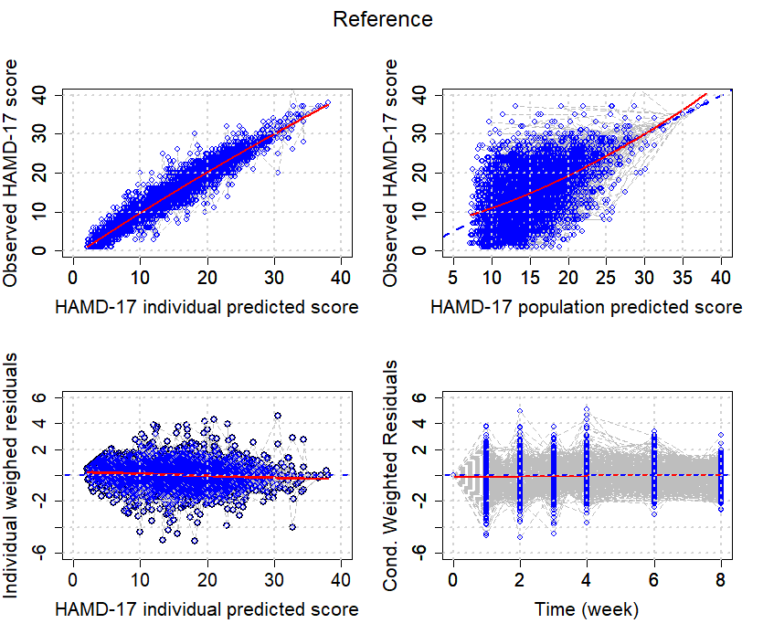
Fig S4. Reference model. Goodness-of-fit plots. The blue dotted lines represent the reference identity line (in the observed versus individual and population model predicted concentration values plots) and the reference zero intercept horizontal lines (in the IWRES and Conditional Weighted residual plots). The red lines represent the smoothing function lines. The gray lines joint the individual observation (circles).

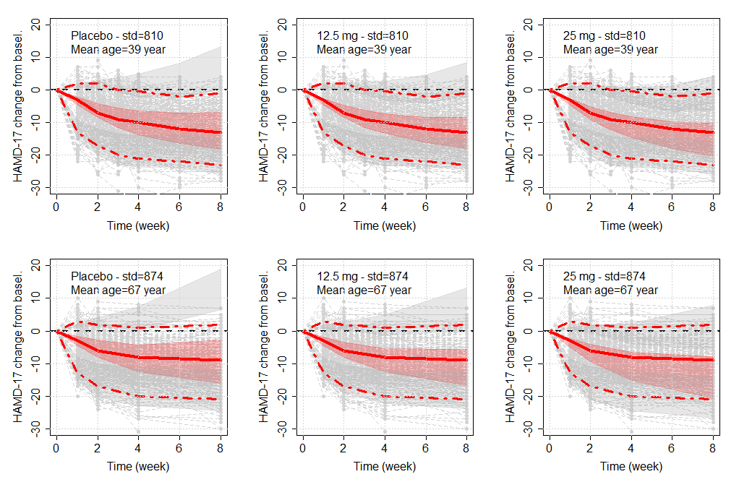
Figure S5. Propensity model. Prediction-corrected visual predictive checks stratified by dose and median split of age of the longitudinal HAMD-17 total score versus time computed using the final ‘Propensity’ and ‘Reference’ model outcomes. Points are observed HAMD-17 scores, solid red lines represents the median observed values, and dashed lines represent 5th percentiles and 95th percentiles of the observed values. The upper and lower shaded areas represent the 90% confidence interval spread of the 5th–95th percentile predicted values, and middle shaded areas represent the 90% confidence interval spread of predicted values.

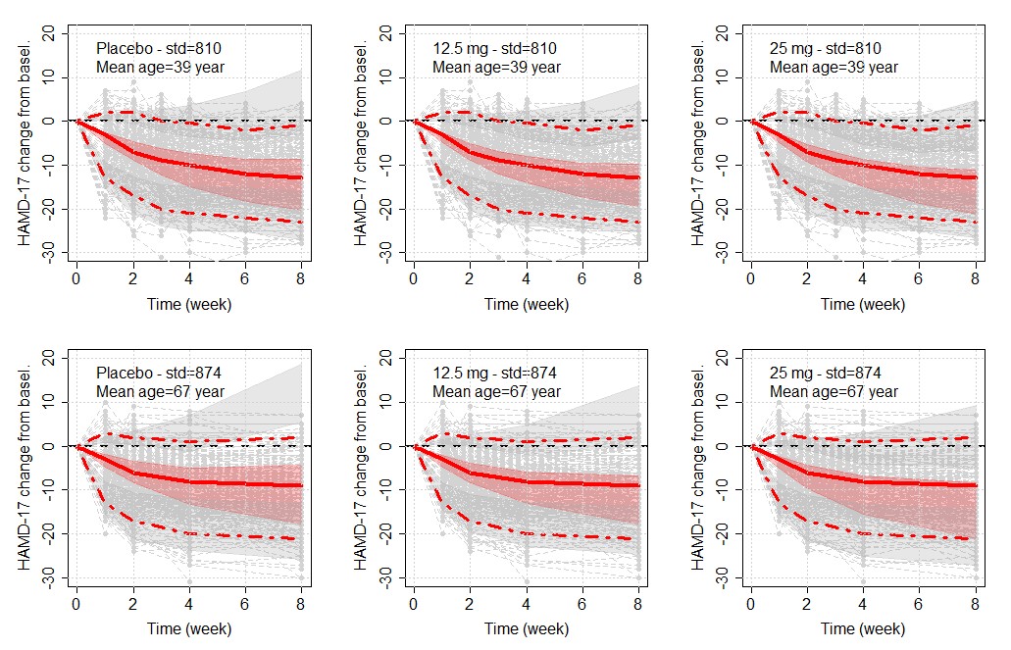
Figure S6. Reference model. Prediction-corrected visual predictive checks stratified by dose and median split of age of the longitudinal HAMD-17 total score versus time computed using the final ‘Propensity’ and ‘Reference’ model outcomes. Points are observed HAMD-17 scores, solid red lines represents the median observed values, and dashed lines represent 5th percentiles and 95th percentiles of the observed values. The upper and lower shaded areas represent the 90% confidence interval spread of the 5th–95th percentile predicted values, and middle shaded areas represent the 90% confidence interval spread of predicted values.

