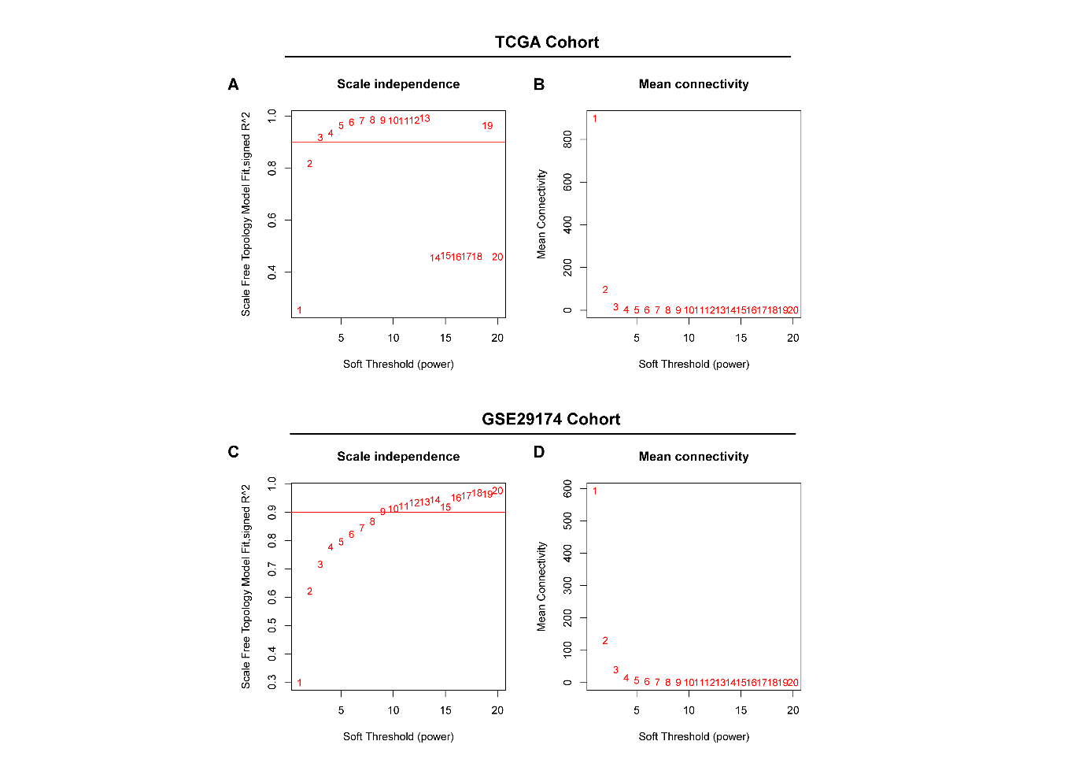

Supplementary Figure 1 Determination of soft-threshold power of the TCGA cohort and GSE29174 cohort
(Korbecki, #18) The scale-free fit index and mean connectivity of WGCNA of TCGA BRCA cohort.
(C-D) The scale-free fit index and mean connectivity of WGCNA of the GSE29174 cohort.

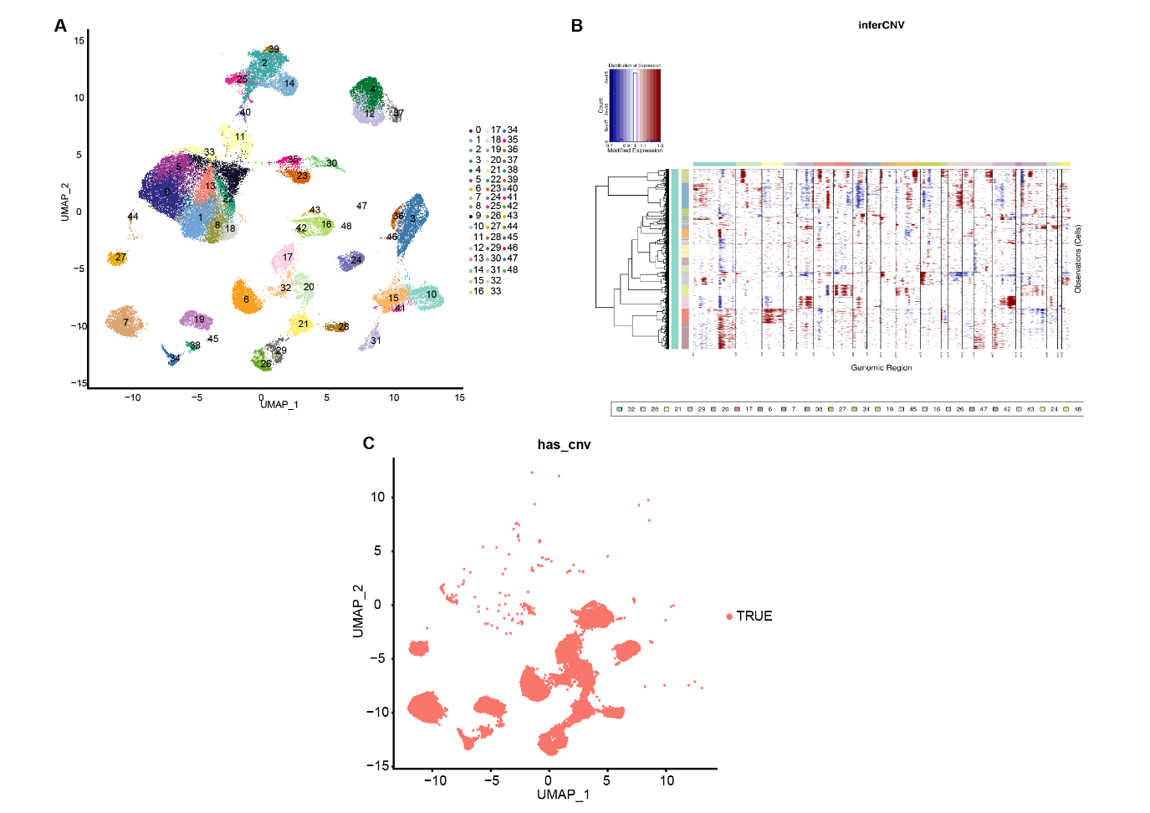

Supplementary Figure 2 Infer copy number variation of all epithelial cells
(A) The UMAP plot shows the raw cell clusters of 26 breast cancer patients.
(B) InferCNV heatmaps of all epithelial cells grouped by cell clusters.
(C) CNV of all epithelial cells shown by UMAP plot.
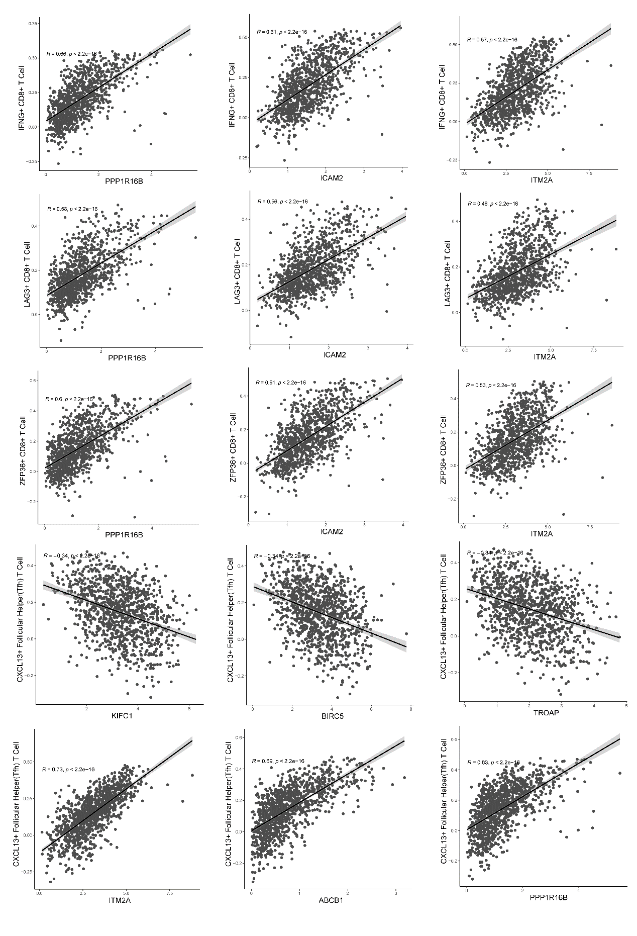
Supplementary Figure 3 Detailed results of correlation between key genes and immune cells Scatter plots showed the strongest positive or negatively correlated genes among the key genes associated with IFNG⁺CD8⁺ T cells, LAG3⁺CD8⁺ T cells, ZFP36⁺CD8⁺T cells, and CXCL13⁺ follicular helper T cells.

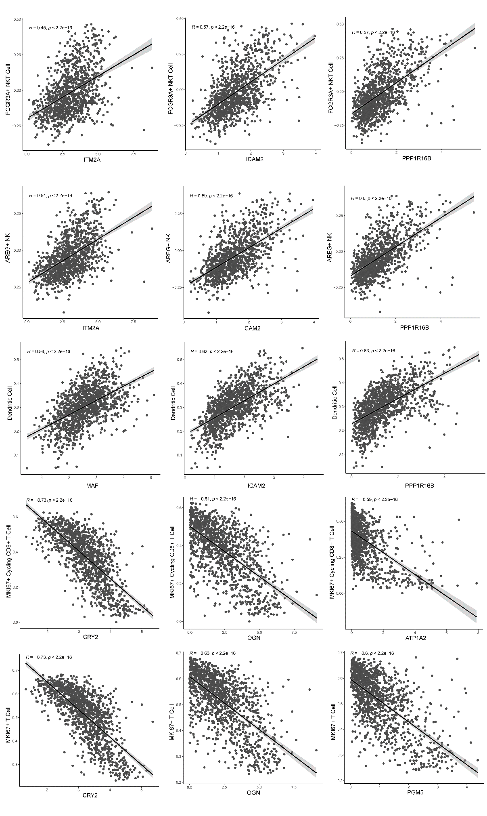
Supplementary Figure 4 Detailed results of correlation between key genes and immune cells Scatter plots showed the strongest positive or negative correlation among the key genes associated with FCGR3A⁺ NKT cells, AREG⁺ NK cells, dendritic cells, MKI67⁺ circulating CD8⁺ T cells, and MKI67⁺ T cells

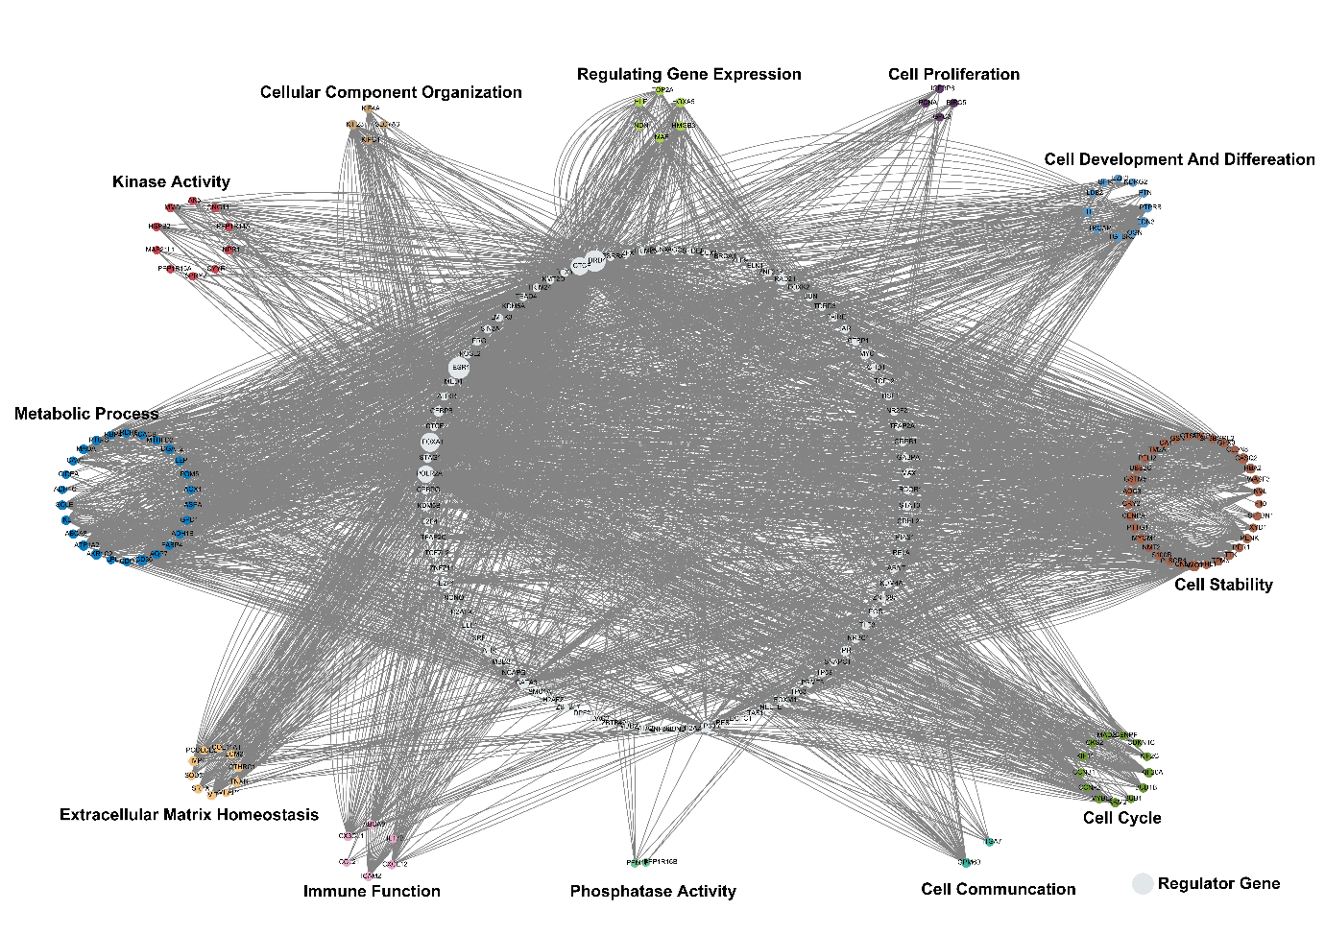
Supplementary Figure 5 Whole regulation network of hub genes
Integrating 2504 Chip-seq datasets to construct a gene regulation network, the hub genes were annotated into twelve clusters based on their major function, and the larger circle of regulatory genes represent more genes were regulated.

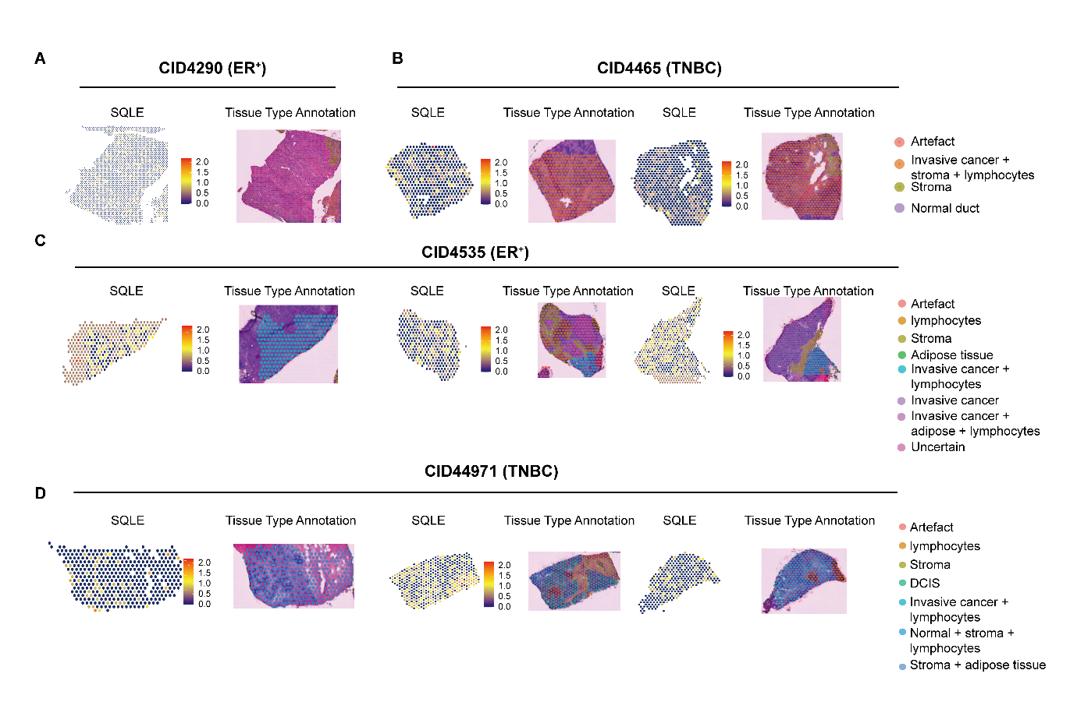
Supplementary Figure 6 Spatial transcriptomics (ST) of BRCA and mapping of cell types
(A-D) The ST slide of patients, region clustering of patients, standardized expression levels of SQLE in BRCA patients ST, and annotated BRCA patient’s tumor cryosection on the ST slide.

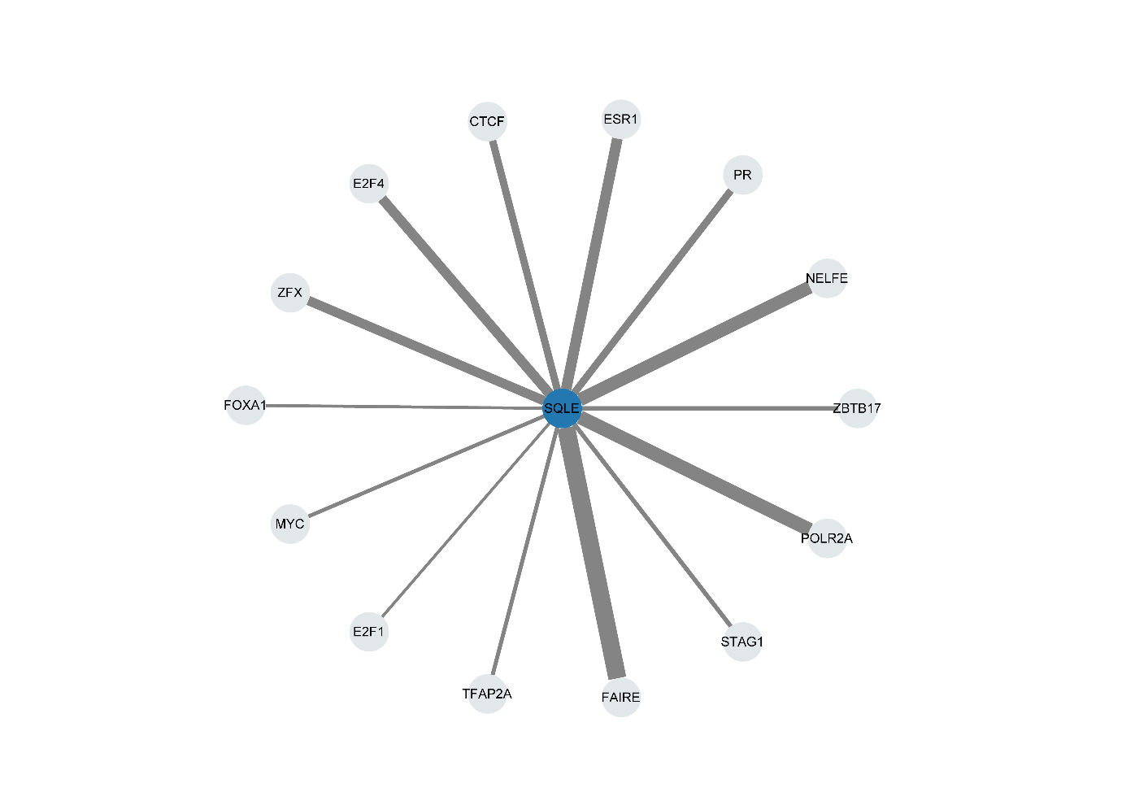
Supplementary Figure 7 The TF regulation of SQLE
The transcription factors that possibly regulate the expression of SQLE, the more width of the line, the stronger the regulation strength.

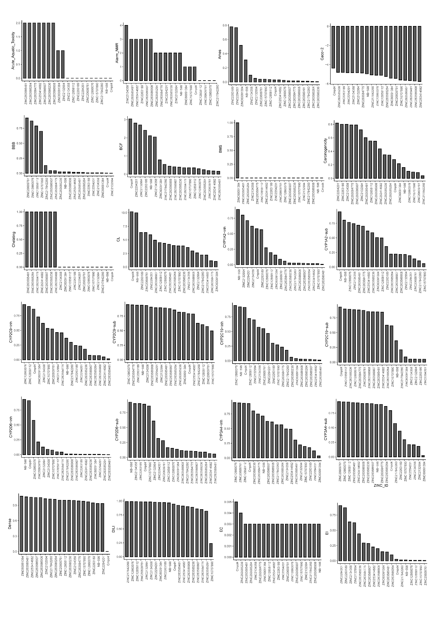
Supplementary Figure 8 The prediction of ADMET properties (part 1)
The ADMET properties of leading compounds were predicted by ADMETlab2.0. The explanation and full name of each property can be referenced in the “Explanation” part of the ADMETlab2.0 website (https://admetmesh.scbdd.com/explanation/index).

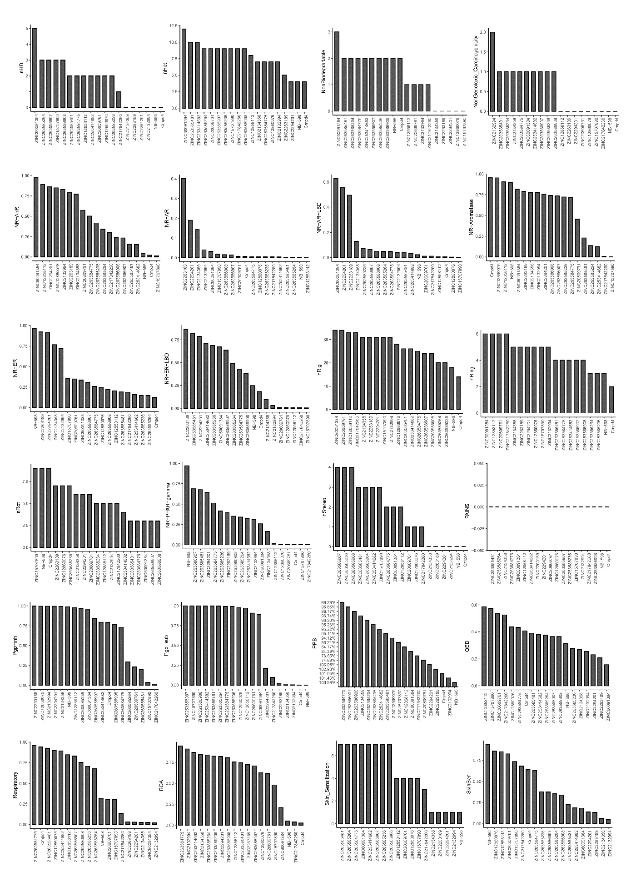
Supplementary Figure 9 The prediction of ADMET properties (Part 2)
The ADMET properties of leading compounds were predicted by ADMETlab2.0. The explanation and full name of each property can be referenced in the “Explanation” part of the ADMETlab2.0 website (https://admetmesh.scbdd.com/explanation/index).

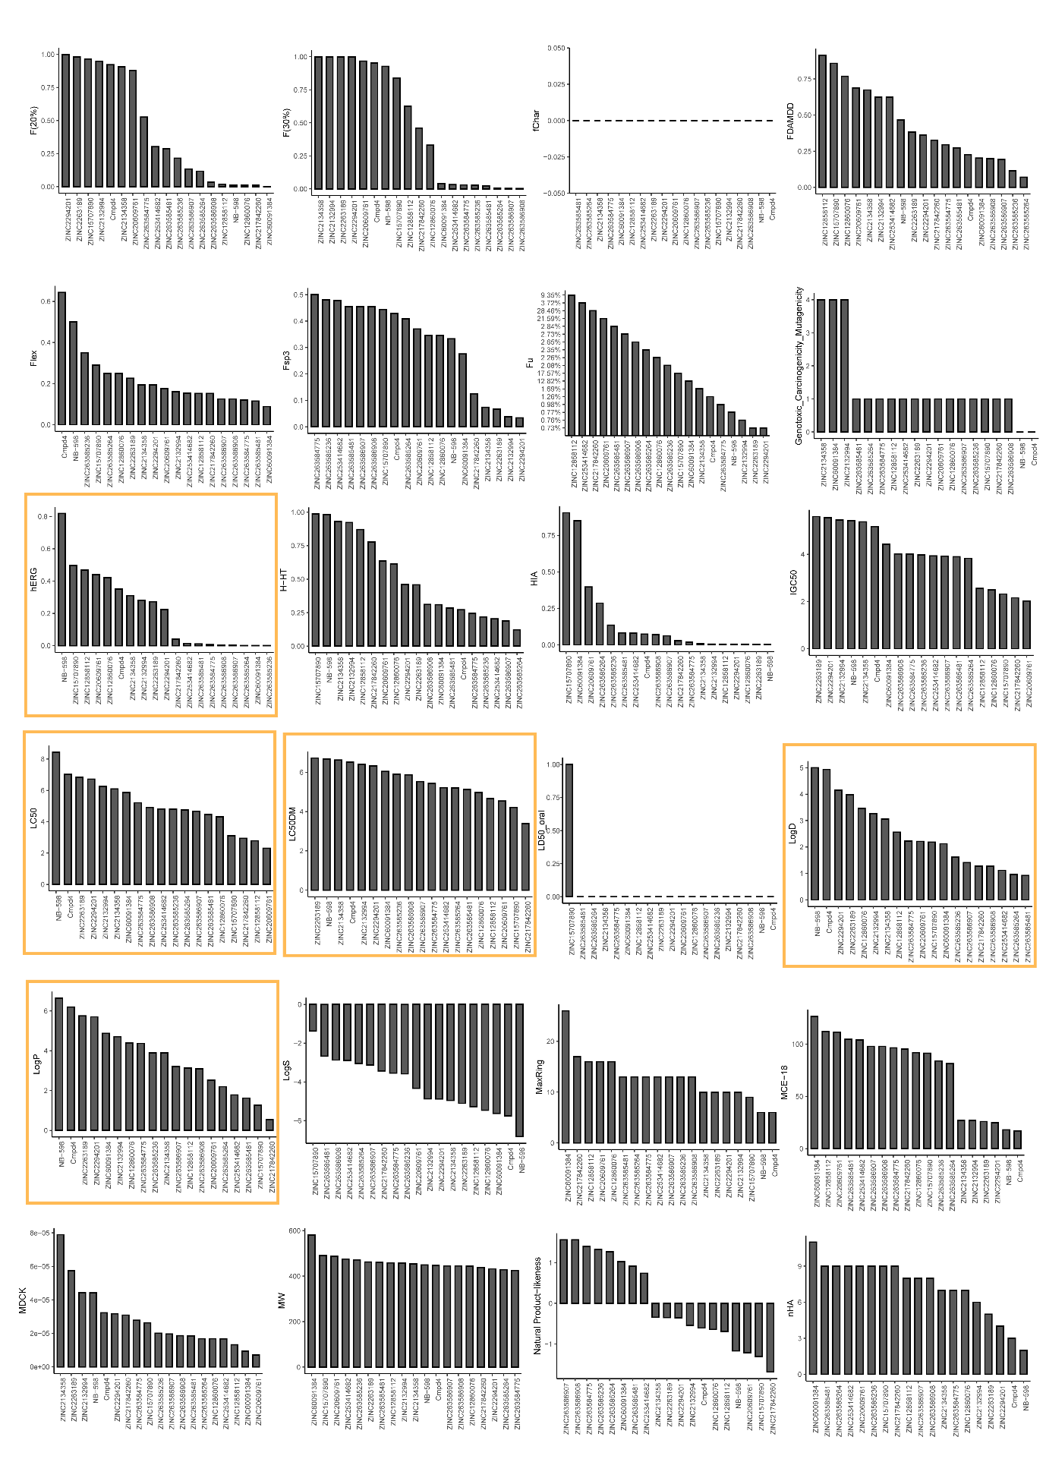
Supplementary Figure 10 The prediction of ADMET properties (part 3)
The ADMET properties of leading compounds were predicted by ADMETlab2.0. The explanation and full name of each property can be referenced in the “Explanation” part of the ADMETlab2.0 website (https://admetmesh.scbdd.com/explanation/index). The barplot of hERG, LogP, LogD, LC50, and LC50DM were circled with yellow boxes.

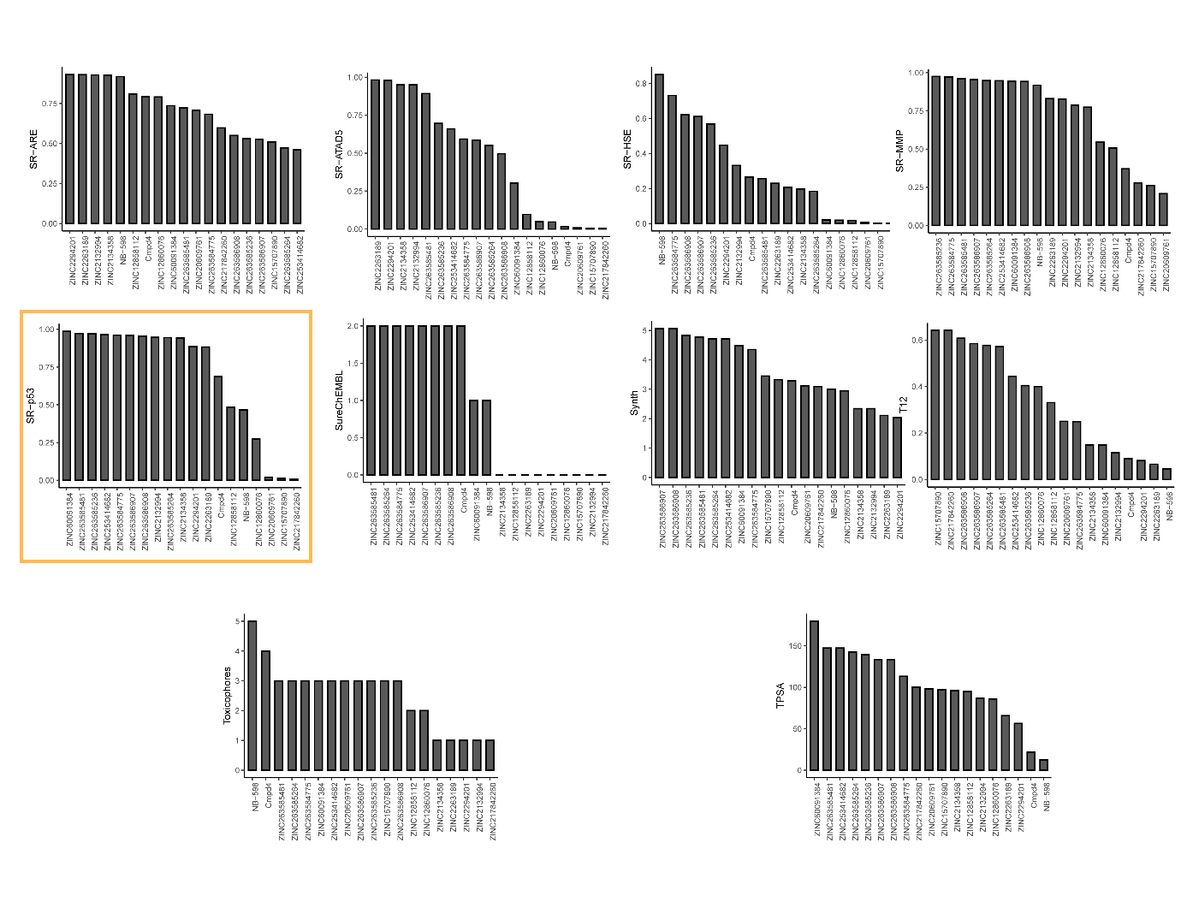Supplementary Figure 11 The prediction of ADMET properties (part 4)
The ADMET properties of leading compounds were predicted by ADMETlab2.0. The explanation and full name of each property can be referenced in the “Explanation” part of the ADMETlab2.0 website (https://admetmesh.scbdd.com/explanation/index). The barplot of SR-p53 was circled with a yellow box.

