Supplemental Figures
Figure A1. Consensus Matrix for ICI clusters (A) and gene clusters (B).
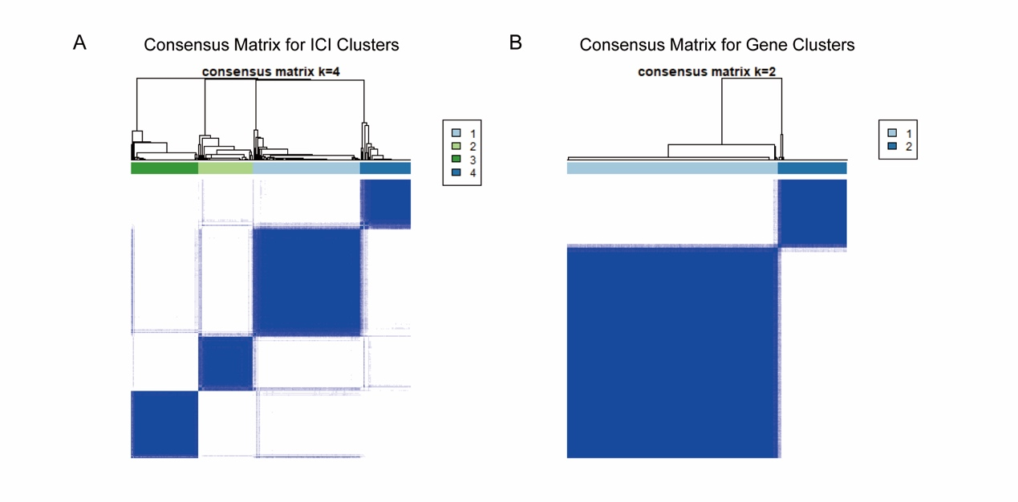

Figure A2. LASSO regression plots and forrest plot of multivariate cox regression during nomogram building. (A) Variation of coefficients with number of variables during LASSO regression. (B) Selection of variables through 1,000 cross validation during LASSO regression. (C) Forrest plot through multivariate cox regression.
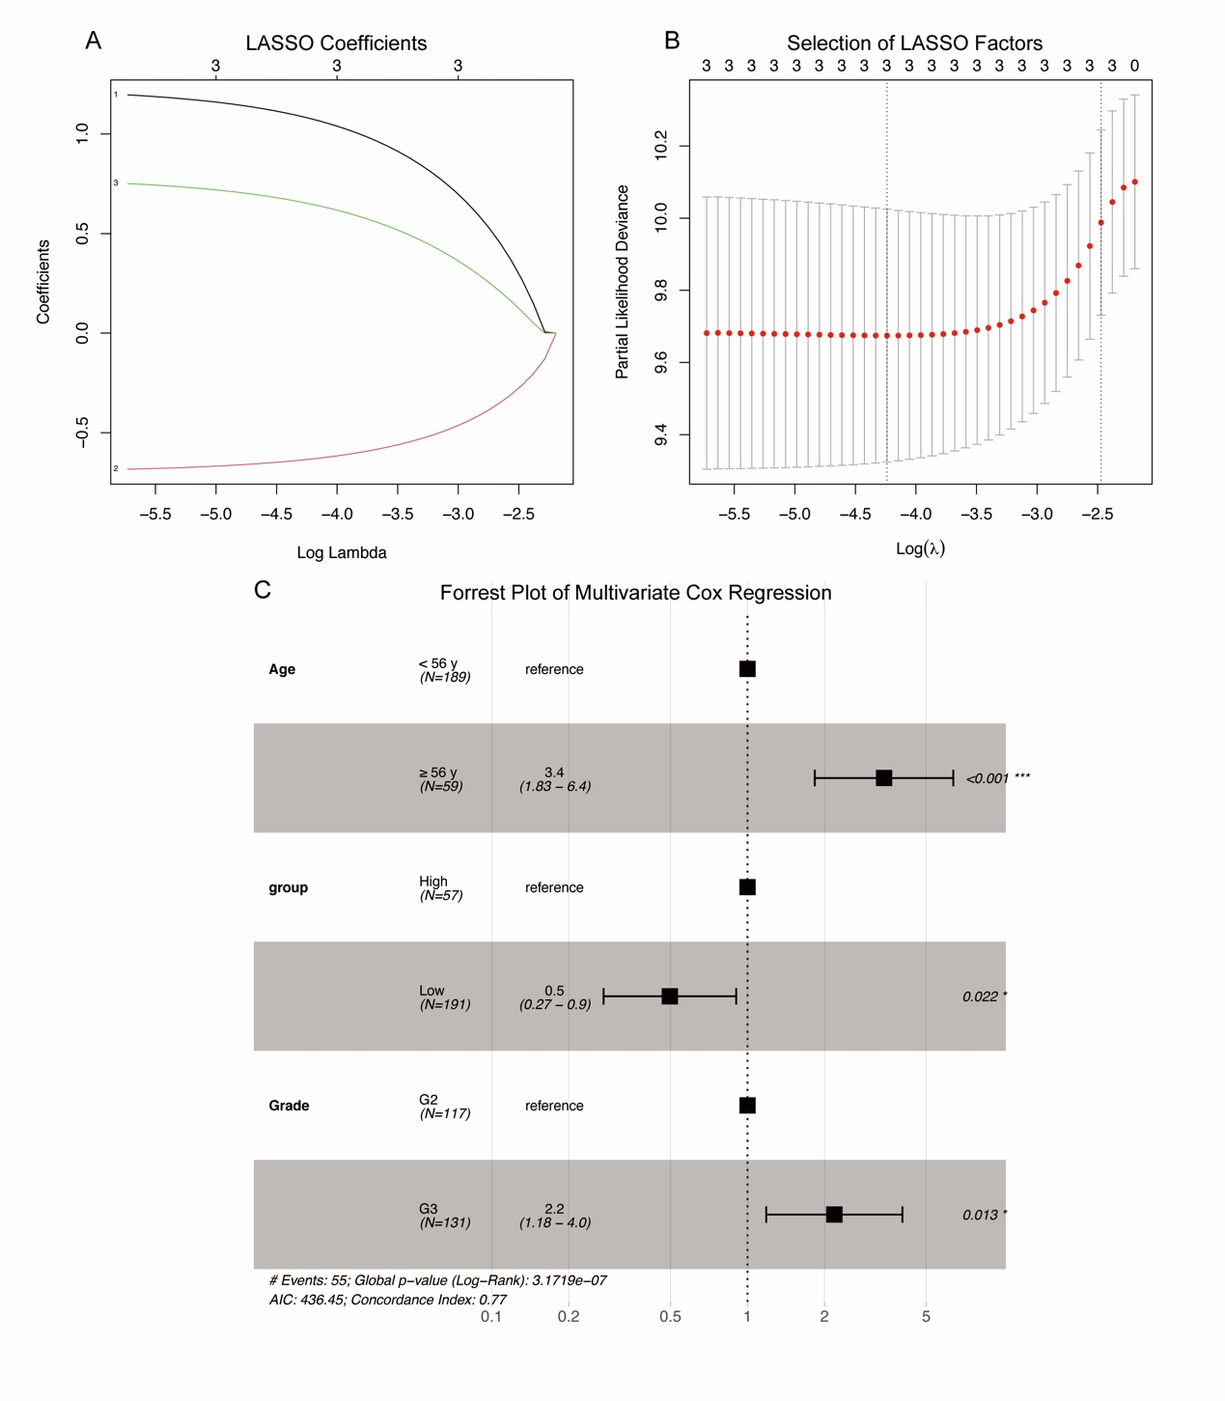

Figure A3. Decision curve analysis (DCA) plots for both internal validation and external validation. (A) 1-year DCA plot through internal validation. (B) 1-year DCA plot through external validation. (C) 5-year DCA plot through internal validation. (D) 5-year DCA plot through external validation.
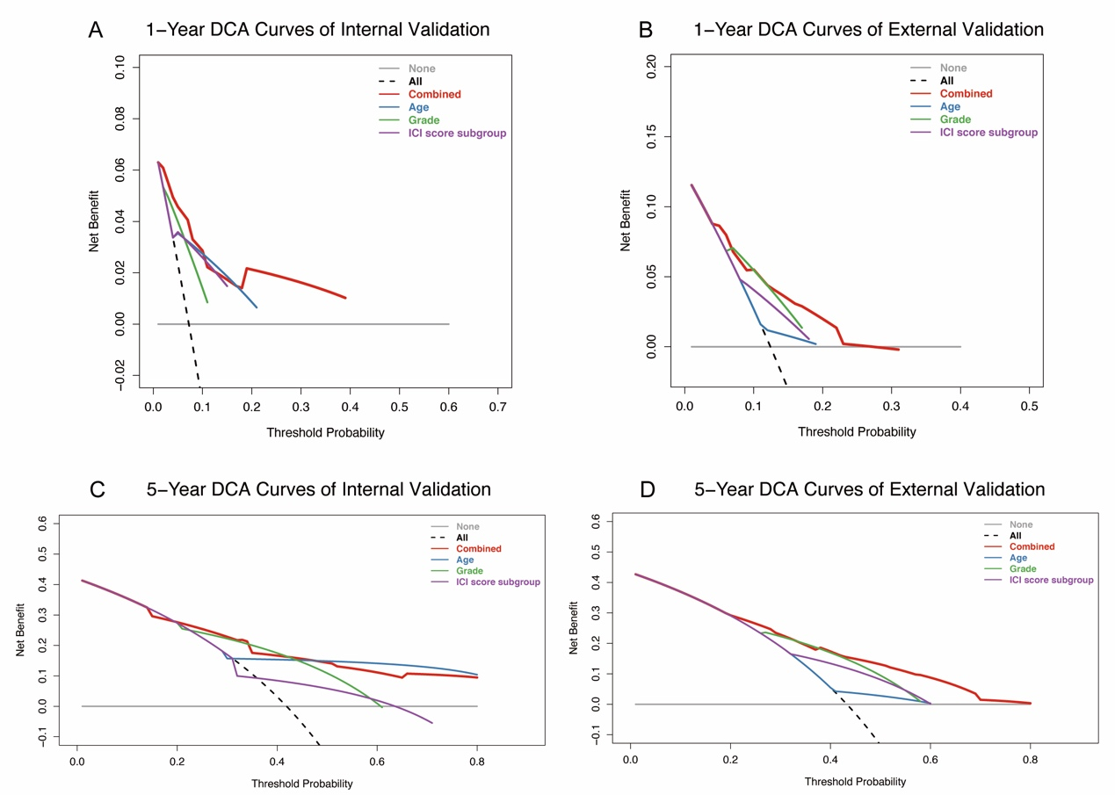

Table A1. All differential genes among four ICI subgroups

IL2RG
CST7
CD3E
CCL5
CD2
IGKC
CCR5
CD52
GZMA
IFI30
IGHG2
IGLC3
AC096579.7
CD3D
TRAC
IGHA1
IGHG1
IGHM
BATF
TRBC2
IGLC2
IGHA2
CSTA
FPR3
CD48
TBC1D10C
TNFRSF1B
LRRC25
LILRB2
IGLC1
IGJ
MS4A6A
GZMK
CTSZ
NCF4
TNFAIP8
MYO1G
DOK2
AMICA1
GZMH
DENND2D
CD14
LCP1
HCK
FCGR3A
CTSC
IL10RA
RAC2
LYZ
GNA15
SQRDL
IGHG3
SLAMF8
FCGR2A
SIGLEC7
SASH3
MS4A4A
NKG7
CD300A
ARPC1B
FCGR2B
CD8A
GPR65
NCF1C
CD4
PLBD1
CASP4
FAM26F
FAM20A
CD68
SERPINA1
FUCA1
IL4I1
CD74
C1QA
ARHGAP9
NCF1B
C2
HLA-DMA
THEMIS2
SIGLEC9
HMOX1
HLA-DMB
HLA-DRA
FERMT3
NCF1
C5AR1
TYROBP
PLEK
IGLL5
S100A4
VAMP8
FMNL1
CTSS
IGHG4
APOBEC3G
LAIR1
PLAUR
LY96
OSCAR
CD7
FBP1
CD163
CTSB
GBP5
BCL2A1
LTB
CPVL
MSR1
HLA-DOA
HK3
CLEC2B
SERPINB1
JAK3
CFD
HCLS1
C1QB
LAPTM5
S100A11
S100A8
ITGB2
RAB32
TYMP
ACP5
HSPA7
IGLV1-51
FTL
S100A9
GPSM3
MAP3K8
CASP1
C1QC
CCR1
ST14
CD53
SRGN
MZB1
RNASE6
SECTM1
HLA-DPA1
MNDA
C1S
NPC2
LILRB3
FPR1
C1R
PRF1
WAS
SPI1
FCER1G
IL1RN
IRF1
SERPING1
TLR2
APOL1
ICAM1
CCL2
PARVG
ALOX5AP
TMEM176B
CTSD
SLC16A3
LCP2
CARD16
TNFAIP2
THBD
ARHGDIB
ALOX5
CCL8
HLA-F
MS4A7
SYNGR2
CYBA
CTSL
ISG20
CLIC1
PTPN6
CREG1
IER3
RP11-290F20.3
GBP2
C15orf48
RNASE2
F13A1
ANXA2
OSM
CEBPB
SAT1
HAMP
IL32
GMFG
CXCR4
MX2
PLAU
HLA-DPB1
GPNMB
MYL12A
SERPINF1
SIGLEC1
TNFRSF14
C1orf162
HSPA6
PYGL
TREM1
PCED1B-AS1
PYCARD
BCL3
IFITM2
CP
GLIPR1
MAFB
SLC15A3
CHI3L2
ODF3B
CD37
IL1R1
METRNL
HEXB
STXBP2
TGFBI
HCST
IFITM3
GLRX
C1RL
VSIG4
NQO1
RRAS
RP11-65J3.1
DUSP23
VASN
HTATIP2
TIMP1
LGMN
CLCF1
PLIN2
SOD2
PDLIM1
MMP19
FCGR2C
UCP2
JUNB
COL1A1
CAPG
AIF1
LUM
OLFML2B
TMEM176A
ANPEP
ARHGAP4
ANXA1
CXCL10
SLC11A1
TCIRG1
PSMB9
SOCS3
ISLR
HLA-B
CCL18
CFI
IFITM1
PTRF
VIM
VMO1
VAMP5
ITGA5
B2M
UBD
STAB1
PRSS23
CHI3L1
FXYD5
C10orf10
IL8
EMILIN2
EMP3
NNMT
PLP2
GPX8
LGALS1
CEBPD
IGFBP6
ABCC3
CCDC109B
COL1A2
TMSB4X
LGALS3
CXCL1
MARCO
SPP1
IL6
RARRES1
GBP1
HLA-DRB1
G0S2
S100A10
BGN
ACAP1
SERPINA3
STEAP3
LTF
TNFRSF12A
MAN1C1
SERPINE1
LST1
ZFP36
GDF15
SPON2
CD44
EVA1B
MYL9
COL6A3
MSN
FOSL1
BST2
FN1
PI3
PLXND1
MGP
IGFBP4
COL18A1
SYNPO
TAGLN2
SRPX2
MIR4435-1HG
COL5A1
PODNL1
LINC00152
NAMPT
SERPINH1
SAA1
COL3A1
ACTA2
COL6A2
CCL20
CLEC5A
RARRES3
CYR61
ACTN1
TAGLN
C3
PRKCDBP
SCIN
FCGR1A
ATF3
SPOCD1
UPP1
SLPI
FTH1
FOLR2
CAV1
FABP5
PTX3
FAM20C
SAA2
COPZ2
LOX
IL1B
PLA2G2A
TUBA1C
IBSP
EMILIN1
SOD3
MAP2
MMP14
LOXL2
RETN
HSPG2
ASS1
RCN3
S100A6
RPL39L
CD248
LOXL1
HSPB1
SELM
SEZ6L
MGST1
DUSP1
ZDHHC22
LAMB1
THBS1
TMSB10
RP11-284F21.7
MMP9
TPSAB1
RARRES2
PHLDA2
SNX10
TNR
KCNIP2
NAPSB
EFEMP1
BCAN
PDPN
APOC2
MMP7
SLIT1
ANGPTL4
DLL3
C8orf4
ACTG2
MT1L
NXPH1
FCGBP
CSPG5
EFEMP2
HLA-C
ESM1
LIF
SLC47A2
NSG2
SHD
ATP1A3
RCOR2
PLEKHA4
CELF3
RGS1
PDLIM4
PCOLCE
FAM57B
SOX8
GRIA2
NCAN
HLA-DQA1
AEBP1
BAI1
IGFBP3
CXCL14
CTHRC1
ASCL1
MAOB
INA
SCG3
JPH3
GDAP1L1
CCL4
BTBD17
CA9
SMOC1
HP
CPLX2
IGFBP2
NKAIN4
ADM
ACTL6B
OCIAD2
EGR1
ATCAY
AC011558.5
RP11-161M6.2
LUZP2
COL4A2
RP11-161H23.5
HLA-DQB1
METTL7B
ASIC4
HES5
LPPR3
OLIG2
NEU4
GPR17
TSTD1
CTD-2192J16.22
PCDH15
COL4A1
POSTN
CCL3
RP11-231C18.1
RP11-195F19.5
HES6
ETNPPL
AC015936.3
CHGA
RBP1
RP5-977B1.11
SLN
COL20A1

