Fluorescent GLP1R/GIPR dual agonist probes to reveal cell targets in the pancreas and brain

Anne de Bray^{1,2}, Jason Tong², Christiane Huhn³, Kilian Roßmann³, Ali H. Shilleh², Wanqing Jiang⁴, Anna G. Roberts⁴, Katrina Viloria^{1,2}, Daniela Nasteska^{1,2}, Abigail Pearce⁵, Satsuki Miyazaki⁶, Jeremy W. Tomlinson², Dylan M. Owen^{7,8,9}, Daniel J. Nieves^{7,8,9}, Julia Ast^{1,11}, Malgorzata Cyranka¹¹, Alexey Epanchintsev¹¹, Carina Ämmälä¹¹, Frank Reimann¹⁰, Graham Ladds⁵, Alice Adriaenssens⁴, Stefan Trapp⁴, Ben Jones¹², Johannes Broichhagen³*, David J. Hodson^{1,2}*

¹Institute of Metabolism and Systems Research (IMSR), and Centre of Membrane Proteins and Receptors (COMPARE), University of Birmingham, Birmingham, UK.
²Oxford Centre for Diabetes, Endocrinology and Metabolism (OCDEM), NIHR Oxford Biomedical Research Centre, Churchill Hospital, Radcliffe Department of Medicine, University of Oxford, Oxford, UK.
³Leibniz-Forschungsinstitut für Molekulare Pharmakologie, Robert-Rössle-Straße 10, 13125 Berlin, Germany.
⁴Centre for Cardiovascular and Metabolic Neuroscience, Department of Neuroscience, Physiology & Pharmacology, UCL, London, UK.
⁵Department of Pharmacology, University of Cambridge, Tennis Court Road, Cambridge CB2 1PD, U.K.
⁶Division of Stem Cell Regulation Research, Center for Medical Research and Education, Osaka University Graduate School of Medicine, 2-2 Yamadaoka, Suita, Osaka 565-0871, Japan.
⁷Institute of Immunology and Immunotherapy, University of Birmingham, Birmingham, UK.
⁸Centre of Membrane Proteins and Receptors, University of Birmingham, Birmingham, UK.
⁹School of Mathematics, University of Birmingham, Birmingham, UK.
¹⁰Institute of Metabolic Science-Metabolic Research Laboratories & MRC-Metabolic Diseases Unit, University of Cambridge, Cambridge, UK
¹¹Novo Nordisk Research Centre Oxford, Innovation Building, Oxford, UK.
¹²Section of Endocrinology and Investigative Medicine, Imperial College London, London, UK.
*Corresponding authors: Broichhagen@fmp-berlin.de, david.hodson@ocdem.ox.ac.uk

 | GLP-1 | GIP | TZP
hGLP1R EC50 best-fit (M) | 3.358E-09 | 0.00004436 | 5.67E-08
hGLP1R EC50 95% CI (M) | 2.507e-009 to 4.459e-009 | N/A | 3.740e-008 to 8.632e-008
mGLP1R EC50 best-fit (M) | 1.297E-09 | 0.00002552 | 2.944E-08
mGLP1R EC50 95% CI (M) | 9.533e-010 to 1.757e-009 | N/A | 2.030e-008 to 4.244e-008
hGIPR EC50 best-fit (M) | 1.072E-07 | 1.18E-10 | 6.414E-10
hGIPR EC50 95% CI (M) | 1.142e-008 to 2.579e-006 | 6.934e-011 to 1.993e-010 | 3.689e-010 to 1.091e-009
mGIPR EC50 best-fit (M) | 6.034E-08 | 5.564E-10 | 1.116E-07
mGIPR EC50 95% CI (M) | N/A | 3.663e-010 to 8.349e-010 | 6.451e-008 to 1.906e-007
 | Tirzepa3 | Tirzepa5
hGLP1R EC50 best-fit (M) | 2.552E-07 | 1.389E-08
hGLP1R EC50 95% CI (M) | 1.549e-007 to 4.372e-007 | 8.683e-009 to 2.167e-008
mGLP1R EC50 best-fit (M) | 6.941E-08 | 5.737E-09
mGLP1R EC50 95% CI (M) | 4.186e-008 to 1.144e-007 | 3.789e-009 to 8.602e-009
hGIPR EC50 best-fit (M) | 5.141E-09 | 2.66E-10
hGIPR EC50 95% CI (M) | 2.936e-009 to 8.892e-009 | 1.432e-010 to 4.861e-010
mGIPR EC50 best-fit (M) | 8.756E-08 | 4.402E-09
mGIPR EC50 95% CI (M) | 4.499e-008 to 1.677e-007 | 2.597e-009 to 7.249e-009

Supplementary Table 1: EC50 values for GLP1, GIP, Tirzepatide (TZP), Tirzepa3 and Tirzepa5 against human GLP1R (hGLP1R), mouse GLP1R (mGLP1R), human GIPR (hGIPR) and mouse GIPR (mGIPR).

 | hGIPR/hGIPR | mGIPR/mGLP1R
TZP | 3.126 | 0.113
Tirzepa3 | 1.754 | 0.340
Tirzepa5 | 1.849 | 0.560

Supplementary Table 2: Ligand selectivity of TZP (tirzepatide), Tirzepa3 and Tirzepa5 for human GLP1R (hGLP1R), human GIPR (hGIPR), mouse GLP1R (mGLP1R) and mouse GIPR (mGIPR), calculated as fold-decrease in cAMP EC50 versus either GLP1 or GIP.

 | hGLP1R | hGIPR
Tirzepa5 Kd best-fit (nM) | 2.177 | 8.701
Tirzepa5 Kd 95% CI (nM) | 1.120 to 3.234 | 2.708 to 14.69
Tirzepa5 Bmax best-fit (nM) | 0.0140 | 0.0080
Tirzepa5 Bmax 95% CI (nM) | 0.0063 to 0.0217 | -0.0026 to 0.0186

Supplementary Table 3: Kd and Bmax values for Tirzepa5 at Nluc-tagged human GLP1R (hGLP1R) and human GIPR (hGIPR).
 | Ex4-Cy5 |  | GIP-Cy5
 | GLP1R + GLP1 | GLP1R + GIP | GIPR + GLP1 | GIPR + GIP
Ki (M) | 3.676E-08 | N.D. | N.D. | 2.085-08
 | Tirzepa5
 | GLP1R + GLP1 | GLP1R + GIP | GIPR + GLP1 | GIPR + GIP
Ki (M) | 2.727-08 | N.D. | N.D. | 2.724E-08

Supplementary Table 4: Ki values for hGLP1R+ GLP1, hGLP1R + GIP, hGIPR + GLP1 and hGIPR + GIP determined using Ex4-Cy5, GIP-Cy5, or Tirzepa5 as the fluorescent probe.

 | Target | Origin | Working concentration | Supplier
Primary antibody | Insulin | Rabbit | 1:500 | Cell Signalling #3014S
Primary antibody | Glucagon | Mouse | 1:2000 | Sigma #G2654
Primary antibody | GLP1R | Mouse | 1:30 | Developmental Studies Hybridoma Bank #Mab7F38
Primary antibody | Somatostatin | Mouse | 1:5000 | Invitrogen eBioscience  #14-9751-80
Secondary antibody | Mouse  Alexa488 | Goat | 1:1000 | Life Technologies #A11001
Secondary antibody | Rabbit  DyLight488 | Donkey | 1:1000 | Thermo Fisher Scientific  #SA5-10038
Secondary antibody | Mouse  Alexa568 | Goat | 1:1000 | Thermo Fisher Scientific #A11004
Secondary antibody | Mouse  DyLight633 | Goat | 1:1000 | Thermo Fisher Scientific #35513
Supplementary Table 5: Primary and secondary antibodies

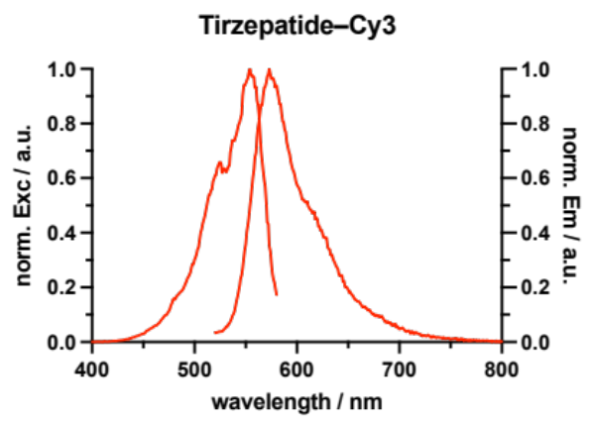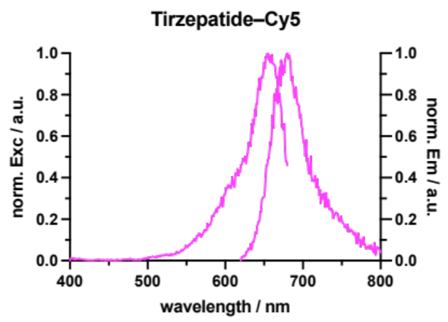
Supplementary Figure 1: Normalized fluorescence excitation and emission spectra of Tirzepatide-Cy3 (Tirzepa3) and -Cy5 (Tirzepa5).

SUPPLEMENTARY METHODS
General chemistry
Chemicals and solvents were purchased from Merck (Merck group, Germany), TCI (Tokyo chemical industry CO., LTD., Japan) and Acros Organics (Thermo Fisher scientific, USA) and used without further purification. Dry solvents were purchased from Acros Organics (Thermo Fisher scientific, USA). Amino acids and resins for SPPS were purchased from Novabiochem (Merck, USA) or Iris Biotech GmbH (Germany).
UPLC-UV/Vis for purity assessment was performed on an Agilent 1260 Infinity II LC System equipped with Agilent SB-C18 column (1.8 µm, 2.1 × 50 mm). Buffer A: 0.1% FA in H₂O Buffer B: 0.1% FA acetonitrile. The typical gradient was from 10% B for 1.0 min gradient to 95% B over 5 min 95% B for 1.0 min with 0.45 mL/min flow or from 30% B for 1.0 min gradient to 95% B over 5 min. Retention times (t_{R}) are given in minutes (min). Chromatograms were imported into Graphpad Prism 8 and purity was determined by calculating AUC ratios.
Preparative or semi-preparative HPLC was performed on an Agilent 1260 Infinity II LC System equipped with columns as followed: preparative column –Reprospher 100 C18 columns (10 μm: 50 x 30 mm at 20 mL/min flow rate; semi-preparative column – 5 μm: 250 x 10 mm at 4 mL/min flow rate. Eluents A (0.1% TFA in H₂O) and B (0.1% TFA in MeCN) were applied as a linear gradient. Peak detection was performed at maximal absorbance wavelength.
For HRMS, samples were analyzed on Orbitrap Fusion mass spectrometer (Thermo Fisher Scientific). MS scans were acquired in a range of 350 to 1500 m/z. MS1 scans were acquired in the Orbitrap with a mass resolution of 120,000 with an AGC target value of 4e5 and 50 ms injection time. MS2 scans were acquired in the ion trap with an AGC target value of 1e4 and 35 ms injection time. Precursor ions with charge states 2-4 were isolated with an isolation window of 1.6 m/z and 40 sec dynamic exclusion. Precursor ions were fragmented using higher-energy collisional dissociation (HCD) with 30% normalized collision energy.

Synthesis of S39C-Tirzepatide
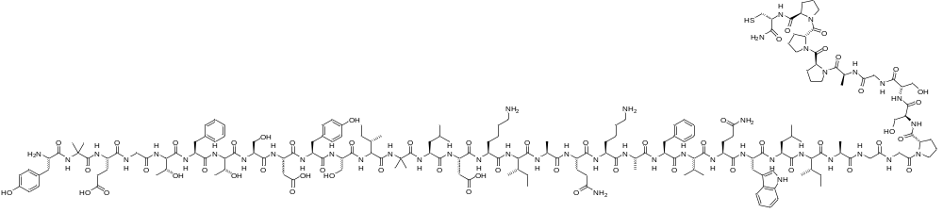
The peptide was synthesized in a 0.05 mmol scale on a Rink amide resin with a loading of 0.78 mmol/g. The synthesis was carried out on a PTI synthesizer with single couplings of each
amino acid (5 eq. amino acid, 5 eq. HCTU, 5eq. Oxyma, 10 eq. DIPEA for 40 min) in DMF. The last amino acid was coupled with a Boc-protected N-terminus. Finally, peptides were cleaved from the resin by treatment with 2 ml of a TFA/TIS/H₂O (95:2.5:2.5) mixture for 1 h and precipitated in cold Et₂O. The crude peptides were purified by semi-preparative HPLC. The combined purified fractions were lyophilized and the S39C-Tirzepatide peptide was obtained as a white TFA salt.

Tirzepa3
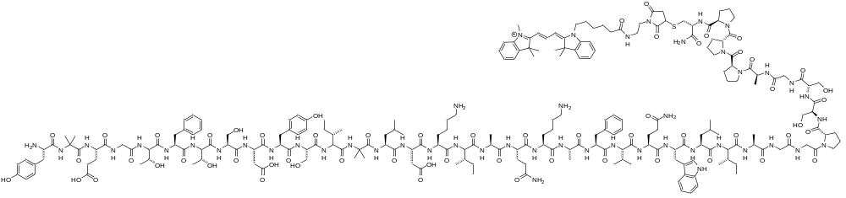
To a fresh solution of S39C-Tirzepatide (2.0 mg, 490 nmol, 1.0 equiv.) in PBS (400 µL) was added Cy3-maleimide (0.59 mg, 980 nmol, 2.0 equiv.) in MeCN (400 µL). The reaction mixture was incubated at 38 °C over night with gentle shaking before being subjected to RP-HPLC purification (water/MeCN gradient, 90/10 10/90 in 60 min). The purified fractions were combined, the concentration was determined via the absorption of the fluorophore at 554 nm and stocks of 5 nmol were prepared and lyophilized to yield Tz-Cy3 (255 nmol, 52%) as TFA salt. Storage was performed at -20 °C.
HRMS (QToF): calc. for C₂₂₄H₃₂₉N₄₉O₅₈S [M+3H]⁴⁺: 1166.8517, found: 1166.8503.
t_{R}: (QToF; MeCN/H₂O/formic acid = 5/95/0.1 to 95/5/0.1 over 10 min) = 4.69 min.
Fluorescence: (λ_{ex} = 544 nm, λ_{em} = 573 nm)

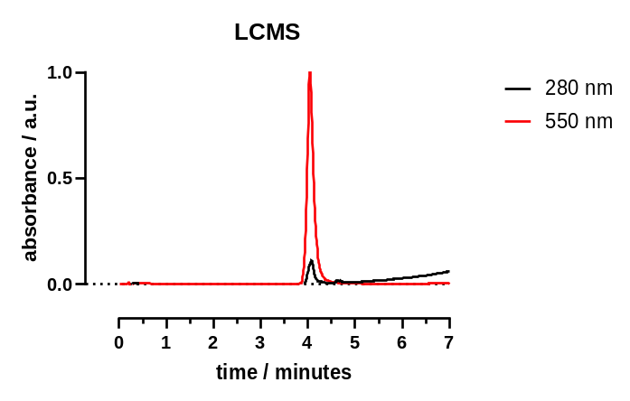

Tirzepa5
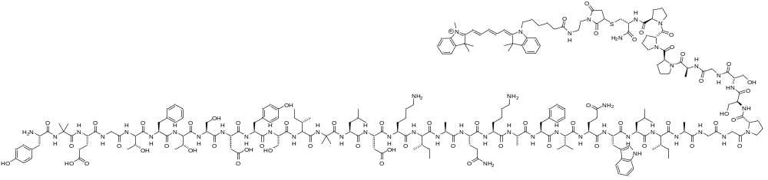
To a fresh solution of S39C-Tirzepatide (2.0 mg, 490 nmol, 1.0 equiv.) in PBS (400 µL) was added Cy5-maleimide (0.59 mg, 980 nmol, 2.0 equiv.) in MeCN (400 µL). The reaction mixture was incubated at 38 °C over night with gentle shaking before being subjected to RP-HPLC purification (water/MeCN gradient, 90/10 10/90 in 60 min). The purified fractions were combined, the concentration was determined via the absorption of the fluorophore at 649 nm and stocks of 5 nmol were prepared and lyophilized to yield Tz-Cy5 (230 nmol, 47%) as TFA salt. Storage was performed at -20 °C.
HRMS (QToF): calc. for C₂₂₆H₃₃₁N₄₉O₅₈S [M+3H]⁴⁺: 1173.3556, found: 1173.5955.
t_{R}: (QToF; MeCN/H₂O/formic acid = 5/95/0.1 to 95/5/0.1 over 10 min) = 4.74 min.
Fluorescence: (λ_{ex} = 660 nm, λ_{em} = 681 nm)

