Supplementary Information
Fig S1. Identify parallel amino acid substitutions between pairs of independent lineages.
Fig S2. Phylogenetically independent contrasts (PICs) test of intestinal fermentation capacity and 10 kinds of dietary compositions (Other parts of plant invertebrates, invertebrates, endothermic vertebrates, ectothermic vertebrates, fish, unknown vertebrates, Scavengers, Fruit, Nectar, Seed) in 107 mammals.
Fig S3. Phylogenetically independent contrasts (PICs) test of the VDR 410th S substitutions and 9 kinds of dietary compositions (invertebrates, endothermic vertebrates, ectothermic vertebrates, fish, unknown vertebrates, Scavengers, Fruit, Nectar, Seed) in 107 mammals.

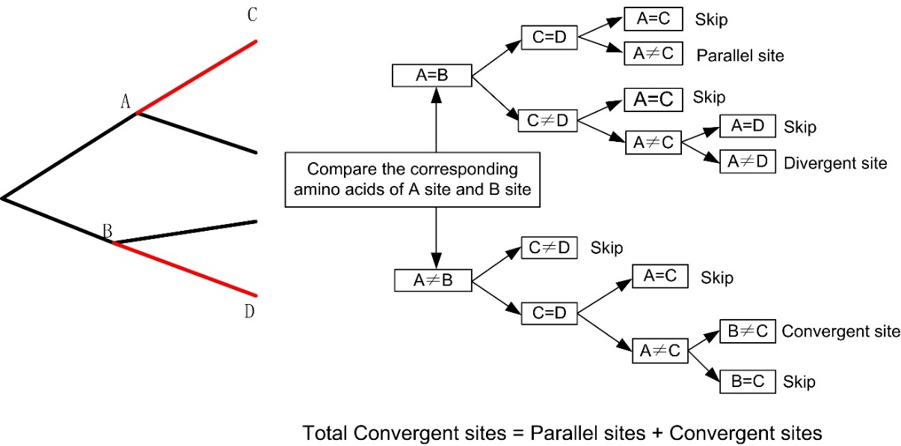
Supplementary Figure S1. Identify parallel amino acid substitutions between pairs of independent lineages.

Fig S2. Phylogenetically independent contrasts (PICs) test of intestinal fermentation capacity and 10 kinds of dietary compositions (Other parts of plant, Seed, Nectar, Fruit, Scavengers, Ectothermic vertebrates, Invertebrates, Endothermic vertebrates, Fish, Invertebrates, Unknown vertebrates) in 107 mammals.

Fig S3. Phylogenetically independent contrasts (PICs) test of the VDR 410th S substitutions (padded VDR sequence data) and 9 kinds of dietary compositions (Unknown vertebrates, Fish, Nectar, Fruit, Seed, Ectothermic vertebrates, Endothermic vertebrates, Scavengers, Invertebrates) in 107 mammals.

