Table 1 Inclusion criteria
Inclusion criteria | Rationales
To meet the diagnostic criteria for CNLBP | Study restricted to CNLBP
Age range 20 to 70 years | Chronic low back pain in children is a result of causes different from those we will study.  The elderly have a higher risk of undiagnosed serious conditions that cause low back pain.
Low back pain duration: ≥3 months | To make sure its low back pain is chronic
Back pain bothersomeness ≥4 points (0 to 10 scale) with degree of low back pain measured by VAS ≥4 points (0 to 10 scale) | Severity to detect improvement
Voluntary participation in research and signing the informed consent form | Understand the benefits and risks of this trial
VAS, Visual Analogue Scale

Table 2 Exclusion criteria
Exclusion criteria | Rationales
A disease with a clear reason that causes low back pain, i.e. lumbar intervertebral disc protrusion, discitis, ankylosing spondylitis, lumbar spinal stenosis, fracture of vertebra, vertebral tumor, vertebral tuberculosis, severe scoliosis, lumbar spondylolisthesis and osteoporosis | Back pain due to or possibly result of specific disease or condition
With other systemic pain that may affect the efficacy judgment including fibromyalgia and rheumatoid arthritis | Condition or circumstance might confound treatment effects or interpretation of data
A patient with severe underlying disease not suitable for this research, for example, severe diabetes, metabolic disease, cardiovascular, cerebrovascular, hematopoietic, digestive system, autoimmune diseases, allergic reactions and suffering from malignant tumors | Condition might increase the risks of adverse events
Participation in research that may bring risks, spinal surgery within previous 2 years, for instance | Back problem is complicated by medical or medicolegal issues
Have obstacles to completing various questionnaires in the study: mental disorder, dementia, visual impairment, hearing disturbance, communication barrier and illiteracy | Condition might make it difficult to finish what is defined in the protocol
Other conditions that investigators believe not suitable for enrollment in the trial | Investigator's comprehensive consideration

Table 3 SSE parameters
SSE consists of two exercise movements (1) Lie on the back and lift legs to enlarge the power of tendons, (2) Touch the feet with both hands to improve renal function
(1) Lie on the back and lift legs to enlarge the power of tendons | 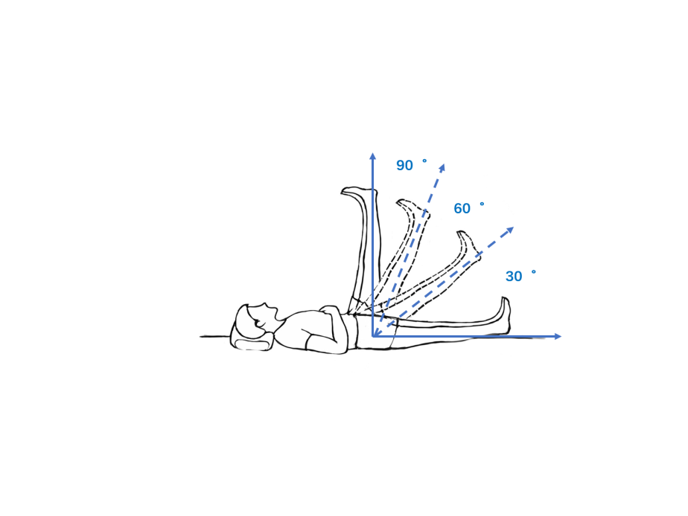
 | ①Tips | Lie on the back, with the body limbs naturally relaxed, keeping legs straight and close together, and then slowly raise two legs at a constant speed. In the process of raising the legs with deep inhalation, the breath is held at the highest position, and the gesture is kept for 3 seconds, followed by putting down the legs slowly at an even speed and exhaling in this process.
 | ②respiration and thoughts | Keep the breathing even during the lifting and lowering of legs. Eliminate distracting thoughts during exercise and concentrate on the low back.
 | ③exercising frequency | According to individual physical condition, 5-10 times every morning and evening. Specific staged exercise requirements: Week 1-4, retention time 3 seconds, 3-5 times; Week 5-8, retention time 5 seconds, 5-8 times; Week 9-12, retention time 8 seconds, 8-10 times.
(2) Touch the feet with both hands to improve renal function | 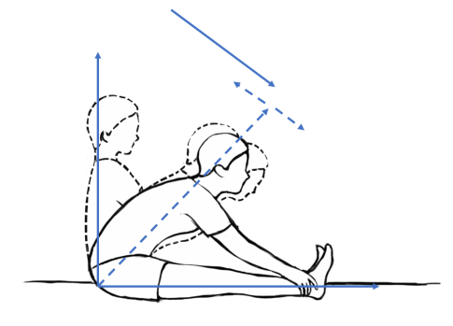
(2) Touch the feet with both hands to improve renal function | ①Tips | Sit on the bed, keeping legs straight and close to the bed, with deep exhalation while the upper body bends forward and the upper limbs straighten, both hands trying to touch the farthest part of the lower limbs. Then look forward and imagine a rope in the mind pulling the mandible towards the toes, during which the breath is held, and the gesture is kept for 3 seconds. Finally, loosen the hands, inhale deeply, return to the sitting position and bend the hip.
(2) Touch the feet with both hands to improve renal function | ②respiration and thoughts | Keep the breathing even during bending the upper body and returning to the sitting position. Eliminate distracting thoughts during exercise and concentrate on the low back.
(2) Touch the feet with both hands to improve renal function | ③exercising frequency | 5-10 times every morning and evening. Specific staged exercise requirements: Week 1-4, retention time 3 seconds, 3-5 times; Week 5-8, retention time 5 seconds, 5-8 times; Week 9-12, retention time 8 seconds, 8-10 times.
notes | ①Patients should gradually increase the amount of exercise according to the recommended dose from small to large. ②If there is any discomfort during the exercise, stop the exercise immediately and contact the doctor. The doctor evaluates whether to continue exercising.
quality control | ①All patients are evaluated by a senior doctor before formal exercise. The assessment mainly relates to whether the patient is suitable for exercise and whether the patient has fully mastered the exercise. ②The doctor provides exercise instruction video materials for all patients, including the purpose, action decomposition, and main points. ③The investigator's mobile phone number is provided for the patient so that he/she can contact the doctor at any time to answer their questions.

Table 4 Content of cognitive-behavioral therapy class sessions
Session | CBT
1 | Rationale and evidence base for CBT, pain neurobiology, overview of skills, rationale for relaxation training, diaphragmatic breathing instruction, introduction to behavioral goal setting (physical activity and home practice)
2 | Behavioral goal setting, physical activity and pacing activity, pleasant event scheduling, pain flare-up plan, diaphragmatic breathing and seven-muscle-group progressive muscle relaxation (PMR) instruction
3 | Role of thoughts and feelings in pain, introduction to the CBT model, thought-monitoring record, diaphragmatic and four-muscle-group PMR instruction, setting and working toward behavioral goals
4 | Challenging automatic thoughts related to pain, setting and working toward behavioral goals, diaphragmatic breathing and four-muscle-group/no-tension PMR instruction
5 | Challenging automatic thoughts and generating alternate thoughts, distraction techniques, brief body scan relaxation instruction, setting and working toward behavioral goals
6 | Alternate thoughts, thought stopping, behavioral activation, mini-relaxation instruction, setting and working toward behavioral goals
7 | Rehearsing pain coping skills, identifying and challenging negative thoughts, setting and working toward behavioral goals, mini-relaxation instruction, sleep tips
8 | Maintenance of coping skills, relapse prevention, personal plan for the future
Table 5 Baseline and follow-up measures
Measures | baseline | 4 wk | 8 wk | 26 wk | 52 wk
Baseline characteristics
Signing a informed consent form | ×
Randomization | ×
Patient characteristics (age, sex, education, height, body mass, marital status,) | ×
Back pain (pain duration, pain sites, seizure frequency, interference with activities, days of pain in previous 6 months) | ×
Expectations for back pain improvement in general and as result of SSE or CBT | ×
Primary outcomes
RMDQ | × | × | × | × | ×
Secondary outcomes
Back pain bothersomeness | × |  | × | × | ×
SF-36 | × |  | × | × | ×
Fat percentage of core muscle group | × |  |  |  | ×
Safety observation
Adverse experiences from classes or home practice |  | × | × | × | ×
New serious health problems since entering study |  | × | × | × | ×
Concomitant therapies | × | × | × | × | ×
Intervention-related information
Self-reported home practice |  | × | × | × | ×
Exercise examination |  | × | × | × | ×
Perceived helpfulness of practice |  |  | × | × | ×
Would recommend program to friends |  |  | × | × | ×

